Lab-1
220962071
Hardik Garg

Q1 Code
<!DOCTYPE html>
<html lang="en">
<head>
<meta charset="UTF-8">
<meta name="viewport" content="width=device-width, initial-scale=1.0">
<title>Mouse Move Effect - Body Moves Away</title>
</head>
<body
style="font-family: 'Times New Roman', Times, serif; background-color: whitesmoke; color: #333; margin: 0; padding: 0; overflow: hidden; transition: transform 0.1s ease-out;"
onmousemove="moveAway(event)">

<!-- Title Bar -->
<header style="background-color: beige; color: brown; text-align: center; padding: 20px 0; font-size: 2em; text-transform: uppercase; box-shadow: 0 4px 8px rgba(0, 0, 0, 0.3);">
A Walk in the Park
</header>

<!-- Poem Content -->
<div class="poem" style="font-size: 1.2em; line-height: 1.8; text-align: center; margin-top: 50px; background-color: beige; padding: 20px; border-radius: 10px; box-shadow: 0 4px 12px rgba(0, 0, 0, 0.5); transition: transform 0.3s ease, box-shadow 0.3s ease;">
<p>I took a stroll in the <b style="font-weight: bold; color: #3498db;">park</b>,<br>
Where trees stood tall and <b style="font-weight: bold; color: #3498db;">dark</b>.<br>
The birds sang songs so <b style="font-weight: bold; color: #3498db;">sweet</b>,<br>
As I walked down the quiet <b style="font-weight: bold; color: #3498db;">street</b>.<br><br>

The flowers bloomed, so <b style="font-weight: bold; color: #3498db;">bright</b>,<br>
Bathed in the soft, warm <b style="font-weight: bold; color: #3498db;">light</b>.<br>
My heart felt light, my mind at <b style="font-weight: bold; color: #3498db;">peace</b>,<br>
As all my worries seemed to <b style="font-weight: bold; color: #3498db;">cease</b>.</p>
</div>

<script>
// JavaScript function to move the body away from the mouse pointer
function moveAway(event) {
var body = document.body;
var mouseX = event.clientX; // Mouse X position
var mouseY = event.clientY; // Mouse Y position

// Get the center of the viewport
var centerX = window.innerWidth / 2;
var centerY = window.innerHeight / 2;

// Calculate the difference from the mouse to the center of the screen
var deltaX = (mouseX - centerX) / 20; // Divide to control sensitivity
var deltaY = (mouseY - centerY) / 20; // Divide to control sensitivity

// Apply a transform to move the body away from the mouse
body.style.transform = 'translate(' + deltaX + 'px, ' + deltaY + 'px)';
}
</script>

</body>
</html>

OUTPUT
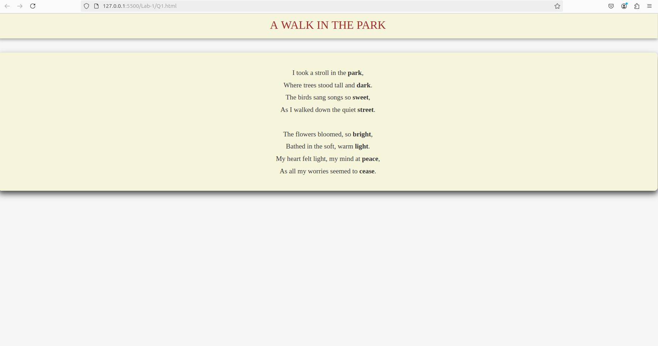
Q2 Code

<!DOCTYPE html>
<html lang="en">
<head>
<meta charset="UTF-8">
<meta name="viewport" content="width=device-width, initial-scale=1.0">
<title>Mouse Move Effect - Body Moves Away</title>
</head>
<body
style="font-family: 'Times New Roman', Times, serif; background-color: whitesmoke; color: #333; margin: 0; padding: 0; overflow: hidden; transition: transform 0.1s ease-out;"
onmousemove="moveAway(event)">

<!-- Title Bar -->
<header style="background-color: beige; color: brown; text-align: center; padding: 20px 0; font-size: 2em; text-transform: uppercase; box-shadow: 0 4px 8px rgba(0, 0, 0, 0.3);">
A Walk in the Park
</header>

<!-- Poem Content -->
<div class="poem" style="font-size: 1.2em; line-height: 1.8; text-align: center; margin-top: 50px; background-color: beige; padding: 20px; border-radius: 10px; box-shadow: 0 4px 12px rgba(0, 0, 0, 0.5); transition: transform 0.3s ease, box-shadow 0.3s ease;">
<p>I took a stroll in the <b style="font-weight: bold; color: #3498db;">park</b>,<br>
Where trees stood tall and <b style="font-weight: bold; color: #3498db;">dark</b>.<br>
The birds sang songs so <b style="font-weight: bold; color: #3498db;">sweet</b>,<br>
As I walked down the quiet <b style="font-weight: bold; color: #3498db;">street</b>.<br><br>

The flowers bloomed, so <b style="font-weight: bold; color: #3498db;">bright</b>,<br>
Bathed in the soft, warm <b style="font-weight: bold; color: #3498db;">light</b>.<br>
My heart felt light, my mind at <b style="font-weight: bold; color: #3498db;">peace</b>,<br>
As all my worries seemed to <b style="font-weight: bold; color: #3498db;">cease</b>.</p>
</div>

<script>
// JavaScript function to move the body away from the mouse pointer
function moveAway(event) {
var body = document.body;
var mouseX = event.clientX; // Mouse X position
var mouseY = event.clientY; // Mouse Y position

// Get the center of the viewport
var centerX = window.innerWidth / 2;
var centerY = window.innerHeight / 2;

// Calculate the difference from the mouse to the center of the screen
var deltaX = (mouseX - centerX) / 20; // Divide to control sensitivity
var deltaY = (mouseY - centerY) / 20; // Divide to control sensitivity

// Apply a transform to move the body away from the mouse
body.style.transform = 'translate(' + deltaX + 'px, ' + deltaY + 'px)';
}
</script>

</body>
</html>

OUTPUT

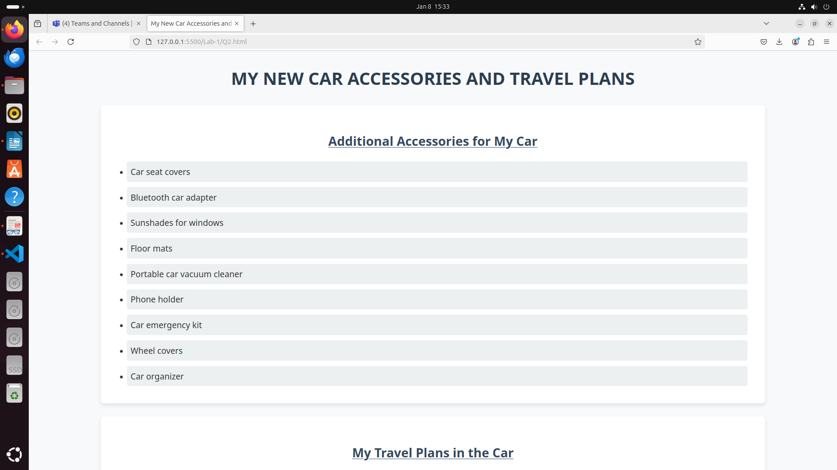
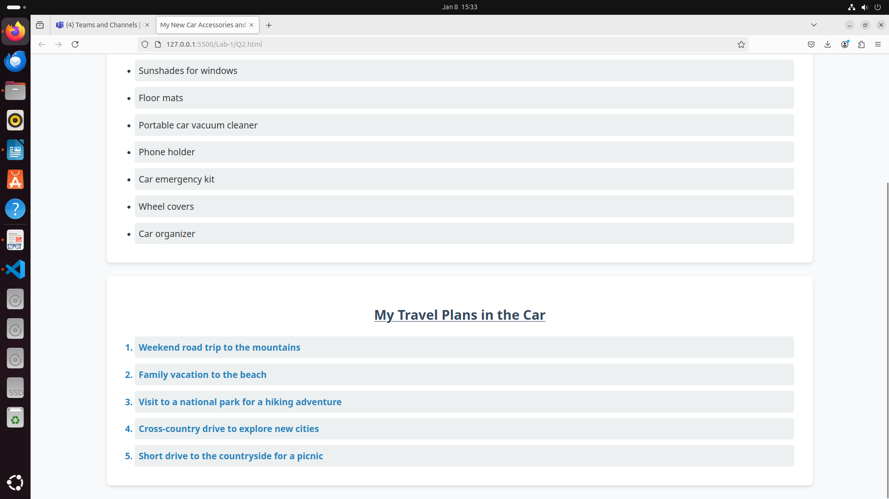
Q3 Code
<!DOCTYPE html>
<html lang="en">
<head>
<meta charset="UTF-8">
<meta name="viewport" content="width=device-width, initial-scale=1.0">
<title>Share Your Winter Vacation Videos</title>
</head>
<body style="font-family: Arial, sans-serif; background: linear-gradient(to bottom, #d1eaff, #ffffff); margin: 0; padding: 0; text-align: center;">

<header style="background-color: #4a90e2; color: white; padding: 20px;">
<h1 style="margin: 0; font-size: 2.5em;">Share Your Winter Vacation Videos</h1>
</header>

<main style="padding: 20px;">
<div style="display: flex; justify-content: center; flex-wrap: wrap; gap: 30px;">

<figure style="border: 2px solid #ddd; border-radius: 10px; box-shadow: 0 4px 8px rgba(0, 0, 0, 0.2); width: 300px; padding: 10px; background: #f9f9f9;">
<video controls style="width: 100%; height: auto; border-radius: 8px;">
<source src="Media/1.mp4" type="video/mp4">
<source src="Media/2.mp4" type="video/mp4">
<source src="Media/3.mp4" type="video/mp4">
Your browser does not support the video tag.
</video>
<figcaption style="margin-top: 10px; font-size: 1.2em; color: #555;">Paris</figcaption>
</figure>

<figure style="border: 2px solid #ddd; border-radius: 10px; box-shadow: 0 4px 8px rgba(0, 0, 0, 0.2); width: 300px; padding: 10px; background: #f9f9f9;">
<video controls style="width: 100%; height: auto; border-radius: 8px;">
<source src="Media/1.mp4" type="video/mp4">
<source src="Media/2.mp4" type="video/mp4">
<source src="Media/3.mp4" type="video/mp4">
Your browser does not support the video tag.
</video>
<figcaption style="margin-top: 10px; font-size: 1.2em; color: #555;">Boat Ride</figcaption>
</figure>

<figure style="border: 2px solid #ddd; border-radius: 10px; box-shadow: 0 4px 8px rgba(0, 0, 0, 0.2); width: 300px; padding: 10px; background: #f9f9f9;">
<video controls style="width: 100%; height: auto; border-radius: 8px;">
<source src="Media/1.mp4" type="video/mp4">
<source src="Media/2.mp4" type="video/mp4">
<source src="Media/3.mp4" type="video/mp4">
Your browser does not support the video tag.
</video>
<figcaption style="margin-top: 10px; font-size: 1.2em; color: #555;">Lake View</figcaption>
</figure>

</div>
</main>

<footer style="background-color: #4a90e2; color: white; padding: 10px; position: fixed; bottom: 0; width: 100%; font-size: 0.9em;">
<p style="margin: 0;">&copy; 2025 Share Your Travels. All rights reserved.</p>
</footer>

</body>
</html>

OUTPUT

