Game Design Document

Fill up the following document

1. Write the title of your project.

Shooting Zombie

1. What is the goal of the game?

We Have To Kill Zombies And win the Game

1. Write a brief story of your game.

A Zombie Have Infected Whole City And Only One Guy Is Left He Have To Kill 10 Zombies And Get Potion To Cure People Who Are Infected

1. Which are the playing characters of this game?

* Playing characters are the ones who respond to the user based on the input from the user.
* Cars, monkeys, dinos, wizards, etc., are the playing characters in the game.

|  |  |  |
| --- | --- | --- |
| Number | Character Name | What can this character do? |
| 1 | A Shooter | This Character Can Shoot Zombies |
| 2 |  |  |
| 3 |  |  |
| 4 |  |  |
| 5 |  |  |
| 6 |  |  |
| 7 |  |  |
| 8 |  |  |

1. Which are the Non-Playing Characters of this game?

* Non-Playing characters are the ones that don't have an action or behavior when the user interacts with the game.
* Hurdles, stones, bananas, coins, etc., are non-playing characters in the game.

|  |  |  |
| --- | --- | --- |
| Number | Character Name | What can this character do? |
| 1 | Zombies | If this Character touch Shooter So Shooter Will Loose |
| 2 |  |  |
| 3 |  |  |
| 4 |  |  |
| 5 |  |  |
| 6 |  |  |
| 7 |  |  |
| 8 |  |  |

Draw your imagination of this game. What does this game look like?

* Draw the game either on your computer or on paper.
* Add images of the game scenes to show each of the playing and non-playing characters at least once.

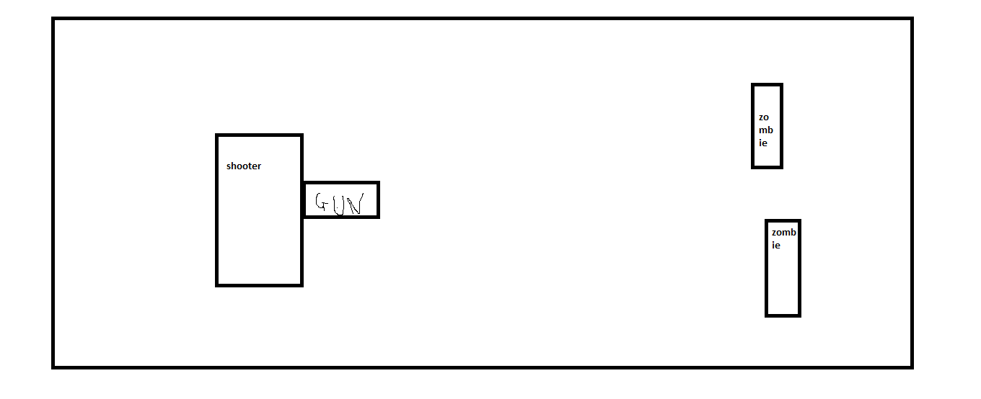

How do you plan to make your game engaging?