
TECHNOLOGICAL UNIVERSITY DUBLIN

ELECTRONIC WORKSHOP LAB EXERCISES

Sept. 2020

Name: Graham King-Abor

Contents
Lab 1 Measure Resistance, Continuity Check, Diode Check 2
Lab 2: Measuring Voltage, Current and setting up the PSU 4
Lab 3 Oscilloscope Measurement 7

Lab 1 Measure Resistance, Continuity Check, Diode Check

Exercise1: Select the following resistors from you kit and fill out the table:

Resistor | Value | Colour code | Measured value
R1 | 1kΩ | Brown, Black, Red | 985Ω
R2 | 10kΩ | Brown, Black, Orange | 9k 9Ω
R3 | 4k7Ω | Yellow, Violet, Red | 4k 5Ω
Select the correct colour codes, lay the resistors out in the
sequence shown and use wires to connect the resistors together.
Total  Resistance | Estimated Value | Measured value
A-B | 4kΩ | 4k 160Ω
Resistor | Value | Measured value
R1 | 1kΩ | 985Ω
R2 | 10kΩ | 3.17kΩ
R3 | 4k7Ω | 3.17kΩ
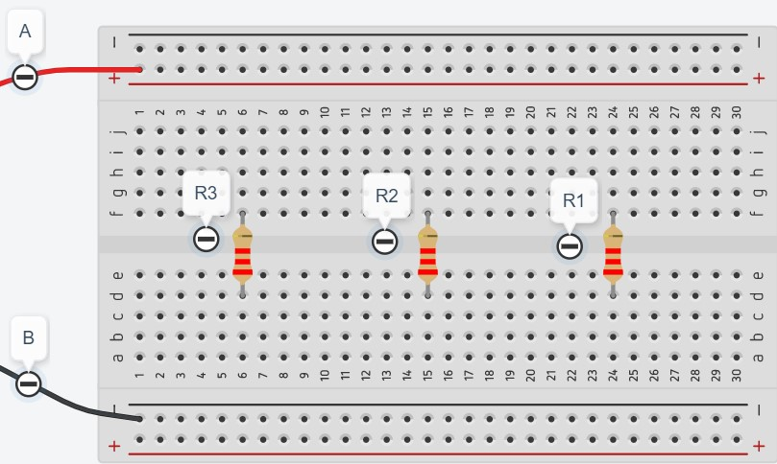
Exercise 2: Build the following circuit on the patch board.

A

R
1

R
2

R
3

B

Estimate the total resistance of the circuit between points A and B.
Measure the total resistance of the circuit between points A and B.

Measure each resistor value again

on the patch-board while they are still connected,

Why are some resistor values different to the expected values? Because all resistors do not have the same resistance

Exercise 3: Use the continuity tester to verify the following: True/False

A not connected to B False
A not connected to either side of R2 True
- not connected to either side of R3 False
- not connected to either side of R1 True
- connected to one side of R1 True
- connected to one side of R2 and R3 False
R1, R2 and R3 connected together True

Exercise 4: Determine the characteristics of an LDR? LDR sensor are sensitive to light, the stronger the light, the lower the resistance

Try to measure its lowest and highest values
 | Min Value | Max value
LDR

What can you conclude about its reaction to light?

Exercise 5: Potentiometer 10kΩ

Determine which pins connect to each side of the resistor and which pin is the wiper.

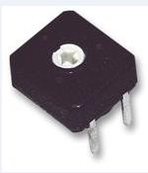

Adjust the wiper and measure its lowest and highest resistance values.

 | Min Value | Max value
Pot 10kΩ | 0 | 10000

Exercise 6: R-Pack
Determine the configuration of each type of R-Pack in your kit, how the resistors are connected and their value. Draw a diagram to show this.
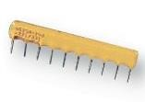
Exercise 7: Use the Diode tester to measure the forward biased voltages and identify the Anode and Cathode for the following diodes:

 | Forward Biased Voltage
1N4148 Signal Diode | 0.6240
1N4001 Rectifier Diode | 0.5919
LED | 1.7656

What have you learned from doing this lab ? I have learned how to measure the resistance of an LDR and resistors and learned how to build a circuit and measure its value

Lab 2: Measuring Voltage, Current and setting up the PSU

Exercise 1: Set up power supply and measure voltage

- Measure the value of each resistor before building the circuit:

R1 = ________ R2 = ________ R3 = ________

- Build the following circuit on your patch board, given resistor layout shown.

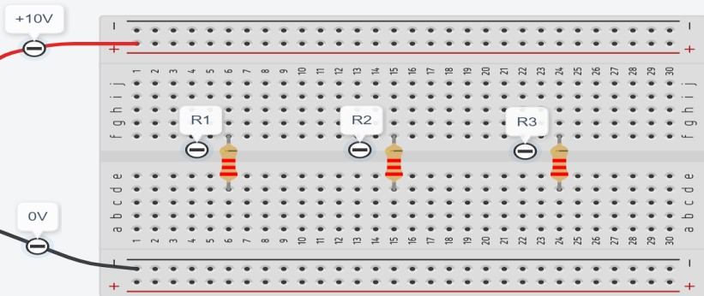
R₁ 1.0k

V
R1

V
R2

V
R3

R
3

k
2.2


R

2
1.2
k


+

_

10
V

- Set up the power supply to 10V DC and a current limit value of 10mA.

- Measure the output voltage on the PSU using the DVM and adjust to exactly 10.00V (the display on the PSU might not be accurate).

- Measure the voltages V_{R1}, V_{R2}, V_{R3}, record values in the following table

Voltage
PSU
V_{R1}
VR2
VR3

- Comment on the voltage values obtained:

- Increase the PSU voltage to 25V and comment on your observations:

Exercise 2: Measuring Current

- Build the following circuit on your patch board.


R
3

2.2
k


R
1

1.0
k


R

2
k
1.2


+

_

10
V

I
1

I
2

I
3

- Set up the power supply to 10V DC and a current limit value of 10mA.
- Measure the output voltage on the PSU using the DVM and adjust to exactly 10.00V.
- Record the current from the PSU display in the following table.
- Using the multi-meter measure the current flowing through each resistor and record values in the following table.

Current
PSU
IR1
IR2
IR3

- Comment on the current values obtained:

- Calculate the current values from the voltage values obtained in exercise 1 and compare to these measurements.

 | Voltage Measurement | Current Measurement | Current calculated  I = V/R
R1
R2
R3

Exercise 3: Dual Power Supply

- For the circuit shown below complete the section on setting up the power supply in multiple supplies for positive and negative configuration.

Use a current limit value of 20mA on each power supply.

Set the voltage on the LHS (left hand side) PSU to 5V.

Set the output voltage on the RHS PSU to 15V.

R1 1k R2 1k

I
3

R
3

k
1


+

_

+15
V

+

_

-
5
V

I
1

I
2

- Using the multi-meter set up to measure DC volts in Auto mode measure and record the following voltages:-

PSU(LHS) ________________

PSU(RHS) ________________

V_{R1}, ________________

V_{R2} ________________

V_{R3} ________________

- Using the multi-meter set up to measure DC current in Auto mode measure and record the following currents:-

I₁, ________________

I₂ ________________

I₃ ________________

Lab 3 Oscilloscope Measurement

Exercise 1: DC voltage from the Power Supply Unit (PSU)

V
0.00

V
5.00

PSU

Oscilloscope

Set the PSU to the following DC voltage values and verify the measurement using the oscilloscope.
Select the appropriate voltage scale on the Oscilloscope to record the most accurate measurement.

PSU Voltage | Oscilloscope Volts/Div | Oscilloscope Number of Divisions | Oscilloscope Voltage
5.00V
15.00V
3.5V
0.10V
200mV
30.00V

2: Measure DC voltages using the oscilloscope Date:____________

- Build the following circuit on the patch board.
- Measure the voltages at points A, B and C.

R
2

k
1
Ω

D1

R1

k
1
Ω

R
3

2
k
2
Ω

A

C

B

10V

Voltage
PSU
V_{A}
V_{B}
V_{C}

Determine the voltage drop across R1 and R2,

Voltage
VR1
VR2
3: Use Function Generator and measure AC voltages with the oscilloscope

- Connect the Function Generator and Oscilloscope as follows:

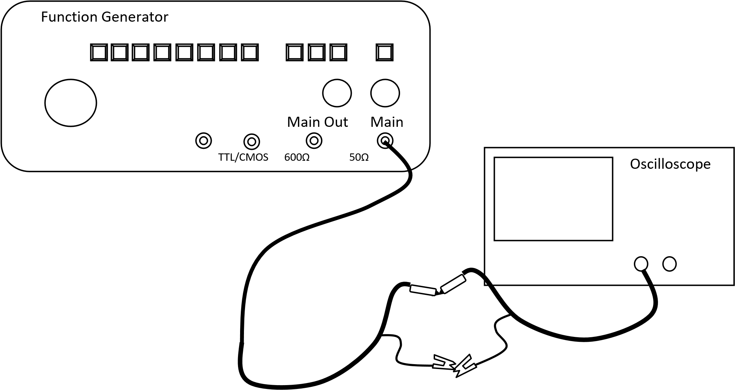

Function  Generator  Peak to Peak, Hz | Oscillosco pe  Volts/Div | Oscillosco pe  Number of  Divisions | Oscillosco pe  Voltage,  Peak to peak | Oscillosco pe  Time/Div | Oscillosco pe  Number of  Divisions | Oscillosco pe  Period | Oscillosco pe  Frequenc  y
5.00V, 1KHz
1.00V, 10KHz
3.5V, 100Hz
0.10V, 2KHz
200mV, 20KHz

4: Measure AC voltages using the oscilloscope Date:

- Disconnect the DC Power Supply Unit and connect the Function Generator

- Build the following circuit on the patch board.

- Set up the function generator for 8V peak to peak and 1 KHz.

- Measure and record the voltages at points A, B and C in the table below.

A

C

B

R
2

k
1
Ω

D1

R1

1
k
Ω

R
3

2
k
2
Ω

4 VP-P

1 KHz

 | VPeak  (Amplitude) | VRMS | Vpk-pk | Period, T | Frequency,  f | VRMS  Multimeter
A (AC mode)
B (DC mode) |  | ======= | =======
C (AC mode)

Change the function generator to give 200mV peak to peak at 10KHz and repeat the measurements.

 | VPeak  (Amplitude) | VRMS | Vpk-pk | Period, T | Frequency,  f | VRMS  Multimeter
A (AC mode)
B (DC mode) |  | ======= | =======
C (AC mode)

Sketch the waveform seen at point B and explain it’s shape.

5: Using the Oscilloscope to make amplitude measurements

- Build the circuit, without the capacitor on patch-board.
1N4001

V
S

1
kΩ

C

- Select the sinusoidal waveform on the function generator and set the frequency to 50 Hz. Connect the 50-ohm output to the circuit and using the oscilloscope set
- Using both channels on the oscilloscope (in DC coupled mode), display the input waveform and measure and record the peak voltage across the load resistor.

V_{P} = _______

- Connect a 22µF capacitor across the load.
- Using the oscilloscope, measure (in AC coupled mode) and record the following voltages:

V
P

V
dc

V
(
p
-
p)
(
ripple
)

V
p
(
ripple
)

Voltage
V_{P}
VDC
VP(ripple)
VP-P(ripple)

- Remove 47uF capacitor from the load and connect a 100uF capacitor across the load.
- Repeat step (d) for 100 µF capacitor and comment on your results.

Voltage
V_{P}
VDC
VP(ripple)
VP-P(ripple)

Exercise 6: Using the Oscilloscope to make amplitude and time measurements

- Set up the Function generator for a 100Hz sine wave with amplitude of 8-volts peak-to-peak.

- Set up the following circuit with R = 1k and C = 1F.

V
S

C

Ch1

Ch2

50Ω

V
C

R

Function
Generator

Oscilloscope

- Vary the amplitude and frequency of the function generator to establish the values in the table below forFrequencyandV_{S}(p-p)

- Now fill in the following table by taking measurements on the circuit as you vary the frequency.

Make sure that V_{S}(p-p) is maintained at 8V.

[ΔT= time delay between V_{S} and V_{C}]

Freq | R(Ω) | Ch1 V/di  v | Ch1 Nº of div | V_{S}(pp) | Ch2 V/di  v | Ch2 Nº of div | V_{C}(pp) | Ch2 –  Ch1  Sec/div | Ch2 – Ch1 Nº of div | ΔT(μs)
100Hz | 1000 | 1V | 8 | 8V | 1V |  |  | 250μs
300Hz | 1000 |  |  | 8V
2kHz | 100 |  |  | 8V
5kHz | 100 |  |  | 8V

