Name :Ghousia B

Date : 19 -04-2025

1. create a Azure cintainer registry

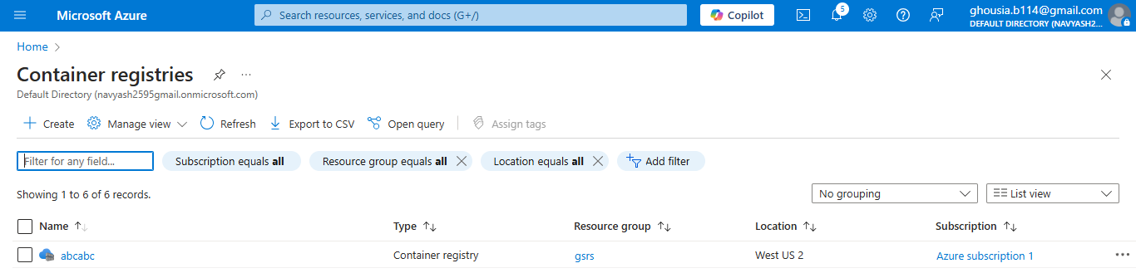

Pushing image into the registry

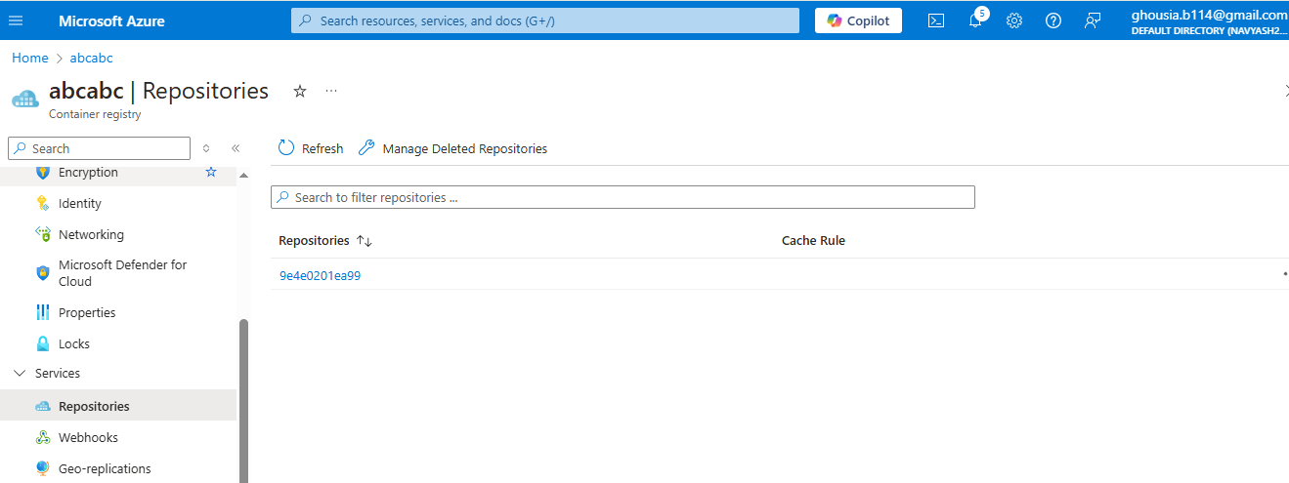

2. create a shell script

2.a takes 1 input (0/1)

2.b hava a conditional check

if 1 -> create a folder and a file inside that at a specific location

if 0 -> delete the folder/s present at that location

#!/bin/bash

TARGET_DIR="home/azureuser/abc/d1"

# Check if input is provided

if [ -z "$1" ]; then

echo "Usage: $0 <0|1>"

exit 1

fi

# Handle input

if [ "$1" -eq 1 ]; then

# Create the directory and a file inside it

mkdir -p "$TARGET_DIR"

touch "$TARGET_DIR/inside_file.txt"

echo "Created $TARGET_DIR and inside_file.txt"

elif [ "$1" -eq 0 ]; then

# Delete the directory if it exists

if [ -d "$TARGET_DIR" ]; then

rm -rf "$TARGET_DIR"

echo "Deleted $TARGET_DIR"

else

echo "No folder to delete at $TARGET_DIR"

fi

else

echo "Invalid input. Please use 0 or 1."

exit 1

fi

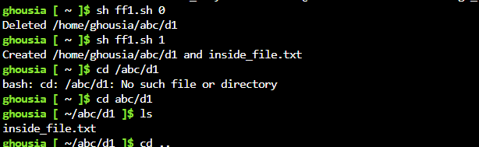

1. Write a multi stage docker file

3.a base stage

-> use ubuntu image and create abc user

-> install cron

-> create specific folder chage owner permission to abc

3.b intermediate stage

-> copy the shell script inside the container

-> chane the permission to execution

-> setup a cronjob for the script

3.c clean up stage

-> run the script as cron with 0 as input as abc user

3.d create stage

-> run the script as cron with 1 as input as abc user

Dockerfile

FROM ubuntu:22.04 AS base

# Install cron and add user abc

RUN apt-get update && \

apt-get install -y cron && \

useradd -ms /bin/bash abc

# Create folder and set ownership to abc

RUN mkdir -p /app/scripts && \

chown -R abc:abc /app/scripts

FROM base AS intermediate

# Copy script into container

COPY myscript.sh /app/scripts/myscript.sh

# Make it executable

RUN chmod +x /app/scripts/myscript.sh

# Setup cron job — the value of INPUT will be passed at runtime via ENV

RUN echo "* * * * * abc INPUT=\$INPUT /app/scripts/myscript.sh >> /var/log/cron.log 2>&1" > /etc/cron.d/myscript-cron && \

chmod 0644 /etc/cron.d/myscript-cron && \

crontab -u abc /etc/cron.d/myscript-cron

FROM intermediate AS cleanup

ENV INPUT=0

CMD ["cron", "-f"]

FROM intermediate AS create

ENV INPUT=1

CMD ["cron", "-f"]

Script.sh

#!/bin/bash

echo "[$(date)] Script executed with input: $INPUT" >> /app/scripts/output.log

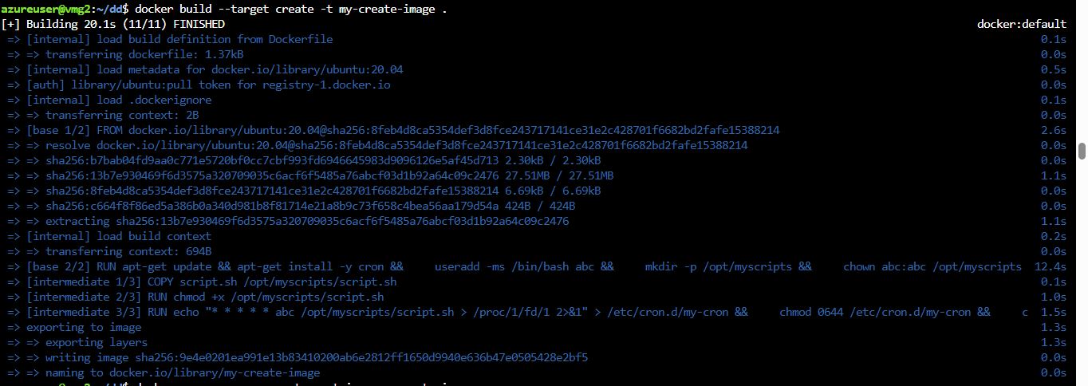



1. publish this image to container registry



1. create a github repository with name ABC-1611 and push the file

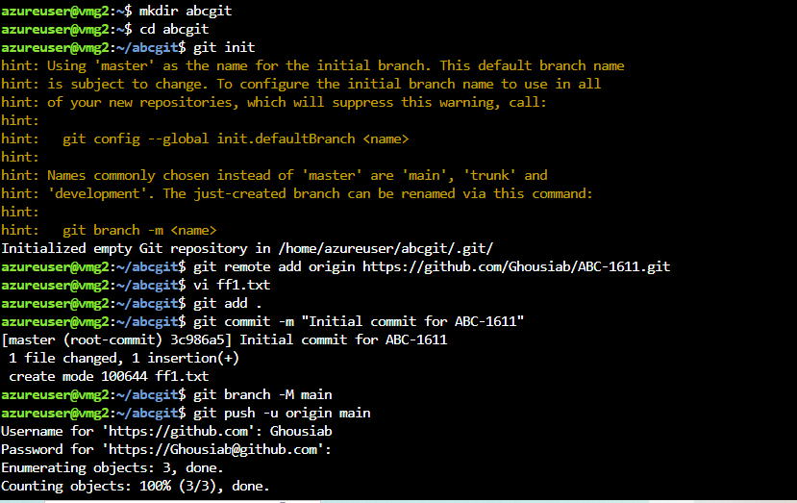

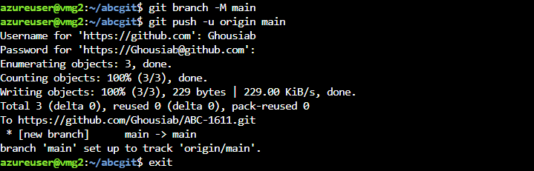

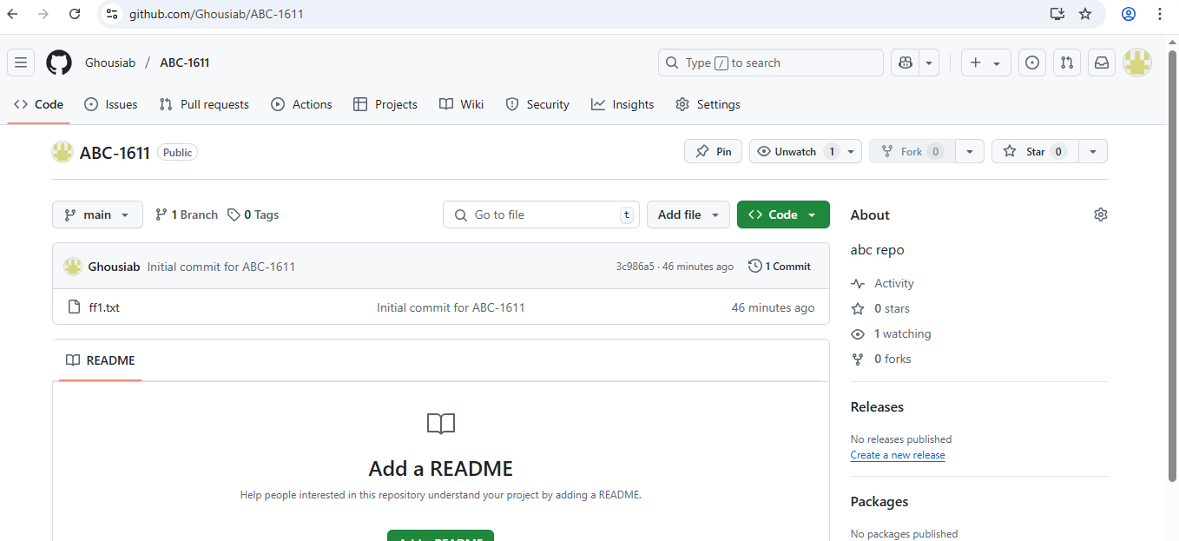

Git hub link

https://github.com/Ghousiab/ABC-1611