DISSERTATION REPORT
DESIGN OF A FRAMEWORK FOR IoT DEVICE FINGERPRINTING AND ANOMALY
DETECTION FOR SMART HOME USING MACHINE LEARNING
Submitted in partial fulfilment of the requirements for the degree of
Master of Technology in Cyber Forensics
Session: 2024–2026 (4th Semester)

Submitted by:
Md Ghufran Alam
Roll Number: NDU202400038

Under the Supervision of:
Dr. Syed Nisar Hussain Bhukhari
NDU Coordinator, Department of CSE
NIELIT Srinagar

NATIONAL INSTITUTE OF ELECTRONICS AND INFORMATION TECHNOLOGY (NIELIT)
SRINAGAR, JAMMU & KASHMIR
MAY 2026

DECLARATION
I, Md Ghufran Alam, Roll Number NDU202400038, a student of M.Tech in Cyber Forensics (Session 2024–2026) at the National Institute of Electronics and Information Technology (NIELIT) Srinagar, hereby declare that the dissertation entitled “Design of a Framework for IoT Device Fingerprinting and Anomaly Detection for Smart Home Using Machine Learning” submitted in partial fulfilment of the requirements for the degree of Master of Technology is a record of original work done by me under the guidance of my supervisor.
I further declare that this dissertation or any part thereof has not been submitted for the award of any other degree or diploma in this Institute or any other Institution/University. The information or data collected from other sources has been duly acknowledged in the text.
Place: Srinagar, J&K Date: May 2026
Md Ghufran Alam
(NDU202400038)

CERTIFICATE
This is to certify that the dissertation entitled “Design of a Framework for IoT Device Fingerprinting and Anomaly Detection for Smart Home Using Machine Learning” submitted by Md Ghufran Alam (Roll No. NDU202400038) in partial fulfilment of the requirements for the award of the degree of Master of Technology in Cyber Forensics from the National Institute of Electronics and Information Technology (NIELIT) Srinagar is a record of bonafide research work carried out by him under my supervision.
The results embodied in this dissertation have not been submitted for the award of any other degree or diploma.
Place: Srinagar, J&K Date: May 2026
Dr. Syed Nisar Hussain Bhukhari
NDU Coordinator, Department of CSE
NIELIT Srinagar
Head of Department / Director
NIELIT Srinagar

ACKNOWLEDGEMENTS
I would like to express my sincere gratitude to everyone who supported and guided me throughout this research work.
First and foremost, I thank my project supervisor, Dr. Syed Nisar Hussain Bhukhari (NDU Coordinator, Department of CSE, NIELIT Srinagar), for providing invaluable guidance, encouragement, and constructive feedback at every stage of this dissertation. Their expertise in cyber security and machine learning has been instrumental in shaping the scope and direction of this work.
I am grateful to the Director and faculty of NIELIT Srinagar for providing the academic environment and resources necessary to carry out this research. Special thanks are due to the Department of Cyber Forensics for the technical support and domain knowledge imparted throughout the programme.
I would also like to acknowledge the open-source community behind scikit-learn, FastAPI, Plotly.js, and the N-BaIoT dataset researchers at Ben-Gurion University for making their datasets publicly available, which greatly enriched the validation of this framework.
Finally, I owe a debt of gratitude to my family for their patience, moral support, and unwavering encouragement throughout the duration of this programme.
Md Ghufran Alam
NIELIT Srinagar, May 2026

ABSTRACT
The proliferation of Internet of Things (IoT) devices in smart home environments has introduced unprecedented security challenges. Unlike conventional computing systems, IoT devices are resource-constrained, heterogeneous in design, and rarely receive timely security patches, making them prime targets for botnets, data exfiltration campaigns, and denial-of-service attacks. Existing network-level security solutions, designed for traditional IT infrastructure, are largely ineffective against the unique traffic patterns exhibited by IoT endpoints.
This dissertation presents the design and implementation of a modular, end-to-end framework for IoT device fingerprinting and anomaly detection in smart home networks using machine learning. The framework addresses two tightly coupled problems: (i) passive device identification (fingerprinting) from network flow features, and (ii) per-device behavioural anomaly detection to flag deviations from a learned baseline.
The fingerprinting subsystem employs a Random Forest classifier (100 estimators, max_depth = 15) alongside Gradient Boosting, Support Vector Machine, and a soft-voting Ensemble, trained on 37 statistical and protocol-level features extracted from network flows across 8 IoT device categories. The anomaly detection subsystem deploys a per-device ensemble of Isolation Forest (IF) and One-Class SVM (OC-SVM), with ensemble weights of 60 % IF and 40 % OC-SVM, calibrated to an alert threshold of 0.75.
A synthetic dataset of 1,600 labelled flows (200 per device, 5 % anomaly rate) was constructed for training and evaluation, supplemented by real traffic samples from the N-BaIoT dataset. Class imbalance is addressed using SMOTE oversampling, and features are normalised with RobustScaler. The trained models are exposed via a FastAPI REST service (port 8000) and a Plotly.js monitoring dashboard (port 8050) for real-time operational use.
Experimental results demonstrate that the Random Forest fingerprinter achieves test accuracy of 100 % with a macro ROC-AUC of 1.0000 across all device classes. The per-device anomaly detectors consistently separate anomalous from normal traffic, with mean anomaly scores for attack flows exceeding 0.85 against a threshold of 0.75. The framework is entirely open-source, reproducible, and deployable on commodity hardware with 8 GB RAM.
Keywords: IoT Security, Device Fingerprinting, Anomaly Detection, Explainable AI, SHAP, Random Forest, Isolation Forest, One-Class SVM, Smart Home, Network Forensics, SMOTE, FastAPI

TABLE OF CONTENTS
Chapter 1: Introduction
1.1 Background and Motivation
1.2 Problem Statement
1.3 Objectives
1.4 Scope and Delimitations
1.5 Dissertation Organisation
Chapter 2: Literature Review
2.1 IoT Security: An Overview
2.2 IoT Device Fingerprinting Techniques
2.3 Anomaly Detection in IoT Networks
2.4 Machine Learning for Network Intrusion Detection
2.5 Relevant Datasets
2.6 Research Gaps and Positioning
Chapter 3: System Architecture and Design
3.1 Design Principles
3.2 High-Level Architecture
3.3 Module Descriptions
3.4 Data Flow
Chapter 4: Feature Engineering
4.1 Feature Selection Rationale
4.2 Feature Categories and Definitions
4.3 Per-Device Traffic Characteristics
Chapter 5: Dataset Construction and Preprocessing
5.1 Synthetic Dataset Generation
5.2 Real-World N-BaIoT Data Integration
5.3 Anomaly Injection
5.4 Preprocessing Pipeline
Chapter 6: Machine Learning Models
6.1 Device Fingerprinting Models
6.2 Anomaly Detection Ensemble
6.3 Model Persistence and Deployment
Chapter 7: System Implementation
7.1 Technology Stack
7.2 Project Structure
7.3 Training Pipeline
7.4 REST API (FastAPI)
7.5 Monitoring Dashboard (Plotly.js)
7.6 Live System Demonstration
Chapter 8: Results and Evaluation
8.1 Fingerprinting Performance
8.2 Anomaly Detection Performance
8.3 Feature Importance Analysis
8.4 Comparative Analysis
Chapter 9: Conclusion and Future Work
9.1 Summary of Contributions
9.2 Limitations
9.3 Future Directions
References
Appendix A — Feature Definitions
Appendix B — API Endpoint Reference
Appendix C — System Requirements and Setup

LIST OF FIGURES
Figure 3.1 — High-Level System Architecture
Figure 3.2 — End-to-End Data Flow Diagram
Figure 4.1 — Feature Category Distribution (37 Features)
Figure 5.1 — Dataset Device Distribution
Figure 5.2 — SMOTE Oversampling Effect on Class Balance
Figure 6.1 — Random Forest Decision Ensemble Architecture
Figure 6.2 — Per-Device Anomaly Detector Architecture
Figure 7.1 — FastAPI Swagger UI — Endpoint Overview (upper section)
Figure 7.2 — FastAPI Swagger UI — POST /analyze, /explain and Schemas
Figure 7.3 — GET /health JSON Response — HTTP 200, 37 ms, uptime 7551 s
Figure 7.4 — Live Monitoring Dashboard (Plotly.js) — KPI Strip and Anomaly Timeline
Figure 7.5 — Dashboard — Alert Severity, Score Gauge and Alerts Table
Figure 7.6 — SHAP Live Explainability Panel — Top-10 Feature Contributions
Figure 8.1 — Confusion Matrix — Random Forest
Figure 8.2 — Confusion Matrix — Gradient Boosting
Figure 8.3 — Confusion Matrix — SVM
Figure 8.4 — Confusion Matrix — Voting Ensemble
Figure 8.5 — ROC Curves (One-vs-Rest) — Random Forest
Figure 8.6 — Top-15 Feature Importances (Gini) — Random Forest
Figure 8.7/8.8 — Model Comparison — Test Accuracy and Macro ROC-AUC
Figure 8.9 — Per-Device Anomaly Score Distribution

LIST OF TABLES
Table 3.1 — Module Summary
Table 4.1 — Feature Categories and Definitions
Table 4.2 — Per-Device Protocol Signatures
Table 5.1 — Dataset Composition Summary
Table 5.2 — Anomaly Type Definitions and Injection Multipliers
Table 6.1 — Fingerprinting Model Hyperparameters
Table 6.2 — Anomaly Detector Hyperparameters
Table 7.1 — Technology Stack Summary
Table 7.2 — REST API Endpoints Reference
Table 8.1 — Fingerprinting Classification Report (Macro Averages)
Table 8.2 — Per-Model Test Accuracy and ROC-AUC
Table 8.3 — Per-Device Anomaly Detection Metrics
Table 8.4 — Comparison with Related Works

LIST OF ABBREVIATIONS
AI Artificial Intelligence
API Application Programming Interface
AUC Area Under the Curve
CoAP Constrained Application Protocol
CORS Cross-Origin Resource Sharing
DPI Deep Packet Inspection
DoS Denial of Service
HTTP/HTTPS Hypertext Transfer Protocol (Secure)
IF Isolation Forest
IoT Internet of Things
IP Internet Protocol
JSON JavaScript Object Notation
KPI Key Performance Indicator
ML Machine Learning
MQTT Message Queuing Telemetry Transport
NTP Network Time Protocol
OC-SVM One-Class Support Vector Machine
REST Representational State Transfer
RF Random Forest
ROC Receiver Operating Characteristic
RobustScaler Robust feature normalisation using interquartile range
SHAP SHapley Additive exPlanations
SMOTE Synthetic Minority Over-sampling Technique
SVM Support Vector Machine
TCP Transmission Control Protocol
UDP User Datagram Protocol
XAI Explainable Artificial Intelligence

CHAPTER 1: INTRODUCTION

1.1 Background and Motivation
The Internet of Things (IoT) has fundamentally transformed the concept of the modern home. From smart cameras that stream live video to cloud servers, to thermostats that adjust temperature based on occupancy patterns, connected devices now permeate residential environments at an accelerating rate. Ericsson (2023) estimates that the global number of IoT connections will exceed 34 billion by 2028, with smart home devices constituting a substantial and growing fraction of that total.
This explosive growth, however, has outpaced the development of security safeguards. IoT devices are architecturally distinct from conventional computing systems: they operate on stripped-down firmware, lack persistent storage for security patches, and are manufactured by vendors for whom security is rarely a primary design consideration. The resulting security posture is systematically weak, creating an attack surface that is simultaneously large, heterogeneous, and difficult to monitor.
The consequences are well-documented and severe. The Mirai botnet (2016) co-opted over 600,000 IoT devices — primarily home routers, IP cameras, and digital video recorders — to launch distributed denial-of-service attacks that disrupted major internet services globally (Kolias et al., 2017). Subsequent variants of Mirai and related botnets have demonstrated that the attack vector remains unresolved.
A foundational requirement for defending smart home networks is knowing precisely what devices are present on the network and whether each device is behaving as expected. Without device identity, administrators cannot enforce per-device access control policies or detect anomalous behaviour. Traditional network security tools are ill-suited to this task: IoT devices do not support agent-based monitoring, do not respond reliably to active probing, and exhibit traffic patterns that differ fundamentally from those of workstations or servers.
This dissertation proposes a passive, non-intrusive solution: a machine learning-based framework that fingerprints IoT devices solely from statistical and protocol-level features derived from network flows, and simultaneously monitors each identified device for behavioural anomalies indicative of compromise. The framework requires no modification to device firmware, no installation of agents, and no access to encrypted packet payloads.

1.2 Problem Statement
Despite significant research effort, practical IoT security in the smart home context remains unsolved for two primary reasons. First, identity ambiguity means that network administrators cannot reliably identify what IoT device type is responsible for a given network flow, making it impossible to apply device-specific security policies or to determine whether observed traffic is consistent with expected device behaviour. Second, behaviour baselining has not been widely deployed: even where devices are identified, there is no established mechanism to define and enforce “normal” behaviour on a per-device basis, leaving network operators unable to detect compromise early enough to prevent damage.
This work addresses both problems through a unified framework that (i) classifies device types from 37 passively observable network flow features using supervised machine learning, and (ii) detects per-device behavioural anomalies using unsupervised one-class classifiers trained exclusively on normal device traffic.

1.3 Objectives
The specific objectives of this dissertation are:
(1) To design a set of passively observable, protocol-agnostic network flow features capable of discriminating between heterogeneous IoT device categories without requiring packet payload inspection.
(2) To construct a labelled dataset representative of smart home IoT traffic, including injected anomalous events of multiple attack types.
(3) To train and evaluate multiple classification algorithms for IoT device fingerprinting and select the most accurate model through empirical comparison on a held-out test set.
(4) To design and implement per-device anomaly detection models based on unsupervised one-class classification techniques.
(5) To develop a production-grade REST API exposing fingerprinting and anomaly detection as a service, with automatic schema validation and interactive documentation.
(6) To build a real-time monitoring dashboard for visualising device status and security alerts.
(7) To evaluate the end-to-end system on held-out test data and compare performance against related published works.

1.4 Scope and Delimitations
The scope of this dissertation encompasses passive network flow analysis (without packet payload inspection), eight IoT device types representative of a typical smart home deployment, three attack categories (data exfiltration, port scanning, and DoS participation), and end-to-end system implementation from data generation through REST API and dashboard. The framework is validated on both a synthetic dataset and real traffic samples from the N-BaIoT dataset (Meidan et al., 2018).
The following aspects fall outside the scope of this work: physical layer or firmware analysis; encrypted payload decryption or protocol reverse engineering; adversarial attacks against the fingerprinter; live packet capture from a production network; and device types not represented in the training set. These delimitations are acknowledged and discussed in the context of future research directions in Chapter 9.

1.5 Dissertation Organisation
The remainder of this dissertation is structured as follows. Chapter 2 reviews the existing literature on IoT device fingerprinting, anomaly detection, and machine learning for network security. Chapter 3 describes the system architecture and design principles. Chapter 4 details the feature engineering methodology. Chapter 5 covers dataset construction and preprocessing. Chapter 6 describes the machine learning models employed. Chapter 7 presents the system implementation, including the REST API and monitoring dashboard. Chapter 8 reports and analyses experimental results. Chapter 9 concludes the dissertation and identifies directions for future work. References and appendices follow the main text.

CHAPTER 2: LITERATURE REVIEW

2.1 IoT Security: An Overview
The security challenges of IoT ecosystems have been the subject of extensive research since the proliferation of connected devices accelerated around 2013. The academic literature broadly categorises these challenges across three layers: the perception layer (physical sensors and actuators), the network layer (communication protocols and routing), and the application layer (cloud services and user interfaces).
Frustaci et al. (2018) surveyed IoT security challenges across these layers, identifying key vulnerabilities including weak authentication, insecure update mechanisms, and lack of physical tamper protection. A comprehensive threat model for smart home environments was proposed by Apthorpe et al. (2017), who demonstrated through traffic analysis that even encrypted IoT traffic leaks sensitive behavioural information about occupants. Their findings underscore the importance of network-level monitoring as a security control.

2.2 IoT Device Fingerprinting Techniques
IoT device fingerprinting can be broadly categorised into active and passive approaches. Active fingerprinting techniques such as Nmap OS detection and banner grabbing are unsuitable for IoT environments because they require sending probe packets, which may interfere with constrained devices and reveal the monitoring system to an adversary. Passive fingerprinting, by contrast, derives device identity solely from observable traffic without generating additional load.
Signature-based fingerprinting represents the earliest passive approach. Early work by Bos et al. (2014) and Radhakrishnan et al. (2014) proposed rule-based signatures derived from DHCP options, MAC address OUI prefixes, and mDNS records. While effective for known devices, these methods require manual signature creation and fail to generalise to new device variants.
Statistical flow-based fingerprinting emerged as a more scalable alternative. Miettinen et al. (2017) presented the IoTSentinel system, which used inter-arrival time statistics, byte counts, and protocol indicators extracted from the first flows following device boot to classify IoT device types. Their system achieved classification accuracy exceeding 90 % on a corpus of real IoT devices.
Machine learning-based approaches subsequently dominated the literature. Sivanathan et al. (2018, 2019) conducted seminal work on classifying IoT devices from network traffic using random forests trained on per-flow features including packet size statistics, DNS query rates, port numbers, and communication partner diversity. Their system demonstrated that a relatively small set of passively observable features provides strong discriminative power across diverse device types.
Meidan et al. (2018) proposed an Auto-Encoder-based approach, reconstructing traffic signatures from auto-encoded latent representations. More recently, Hamza et al. (2019) and Charyyev and Gunes (2020) demonstrated that graph neural network-based representations of device communication patterns achieve competitive accuracy, though at significantly higher computational cost. The present work follows the statistical flow-based approach of Sivanathan et al. (2019), extending it with an integrated anomaly detection layer.

2.3 Anomaly Detection in IoT Networks
Anomaly detection in network traffic has a long history predating IoT, rooted in network intrusion detection systems (IDS). Traditional signature-based IDS require known attack signatures and are blind to novel threats. Anomaly-based approaches, by contrast, learn a model of normal behaviour and flag deviations, enabling detection of previously unseen attacks at the cost of higher false positive rates.
The framing of anomaly detection as a one-class classification problem — training only on normal data and flagging deviations — is well-established in the literature through methods such as One-Class SVM (Schölkopf et al., 2001) and deep autoencoders. This formulation is particularly appropriate for IoT security, where labelled attack data is rarely available for specific device types and attack patterns evolve rapidly.
Liu et al. (2012) proposed the Isolation Forest (IF) algorithm, which explicitly exploits the property that anomalies are rare and differ from normal instances: anomalous data points are more easily “isolated” in a random tree partitioning, requiring fewer splits. IF is computationally efficient, requires no distributional assumptions, and is robust to the curse of dimensionality, making it well-suited to IoT traffic analysis.
In the IoT-specific literature, Meidan et al. (2018) applied deep autoencoders for per-device anomaly detection, training on benign N-BaIoT traffic and detecting botnet activity through elevated reconstruction error. Nguyen et al. (2019) demonstrated that behavioural anomaly detection must be device-type-specific: a single global model trained on all device traffic fails to capture the dramatically different behavioural envelopes of, for example, a streaming camera and a constrained motion sensor. This finding directly motivates the per-device architecture adopted in the present work.

2.4 Machine Learning for Network Intrusion Detection
Random Forests (Breiman, 2001) have emerged as one of the most reliable classifiers for network intrusion detection due to their robustness to irrelevant features, resistance to overfitting through bagging, and ability to produce calibrated class probability estimates. The interpretability afforded by Gini importance scores makes them particularly valuable in security contexts where operator trust requires explainability.
Gradient Boosting (Friedman, 2001), particularly XGBoost and LightGBM variants, achieves competitive or superior accuracy to Random Forests on tabular data by sequentially correcting residual errors. Support Vector Machines (Cortes and Vapnik, 1995) with RBF kernels provide strong classification performance through margin maximisation and kernel-induced feature transformation, though they require careful hyperparameter tuning and do not scale as gracefully to very large datasets.
Ensemble voting classifiers that combine multiple diverse base learners through soft voting (averaging predicted class probabilities) consistently outperform individual classifiers in benchmark studies (Fernández-Delgado et al., 2014). This motivates the inclusion of a soft-voting ensemble as one of the four fingerprinting models evaluated in this work.

2.5 Relevant Datasets
The N-BaIoT dataset (Meidan et al., 2018) is the most widely used public dataset for IoT traffic analysis. It contains benign and attack traffic (Mirai and BASHLITE botnet variants) captured from nine commercially available IoT devices including a Danmini doorbell, Ecobee thermostat, and Philips B120N baby monitor. Each flow is described by 115 statistical features computed over sliding time windows at multiple granularities. N-BaIoT is used in this dissertation for real-world validation and is integrated through a feature mapping layer that projects the 115-feature space to the framework’s 37-feature schema.
The IoT-23 dataset (Parmisano et al., 2020) captures traffic from 20 malware captures and 3 benign captures from real IoT devices, with full packet captures available. The UNSW Bot-IoT dataset (Koroniotis et al., 2019) contains simulated IoT traffic alongside various attack types (DDoS, DoS, reconnaissance, theft). While these datasets are valuable benchmarks, their device coverage does not precisely match the eight-device taxonomy adopted in this work. For this dissertation, a synthetic dataset with statistically grounded per-device profiles was constructed to ensure class balance and precise control over anomaly injection, with N-BaIoT providing real-world validation.

2.6 Research Gaps and Positioning
A review of the literature reveals three key gaps that this dissertation addresses. The first gap is the lack of unified frameworks: most published systems address either fingerprinting or anomaly detection, but not both in an integrated pipeline with a shared feature representation and a common operational interface. The second gap is limited operational deployment: academic works rarely provide production-grade deployment artefacts — REST APIs, monitoring dashboards, serialised model artefacts — that would allow practitioners to deploy and evaluate the system in real environments. The third gap is per-device anomaly specialisation: many anomaly detection systems use a single global model, ignoring the dramatic behavioural differences between device types that make a per-device approach essential for high-precision detection.
This work positions itself as a complete, end-to-end, deployable framework that closes all three gaps, providing both the machine learning core and the operational infrastructure necessary for real-world deployment.

CHAPTER 3: SYSTEM ARCHITECTURE AND DESIGN

3.1 Design Principles
The framework was designed according to five core engineering principles. Modularity ensures that each functional component — data generation, preprocessing, fingerprinting, anomaly detection, API, and dashboard — is implemented as an independent Python module with a well-defined interface, enabling individual components to be replaced or upgraded without affecting the rest of the system. Passivity requires that no active probing of devices or network infrastructure occurs; all input is derived from passively collected network flow records, ensuring the framework is transparent to monitored devices.
Scalability is achieved by processing flows as independent records through the preprocessing and inference pipelines, enabling horizontal scaling. Model serialisation via joblib allows the trained system to be deployed to new hosts without retraining. Interpretability is supported through Random Forest Gini importance scores and SHAP (SHapley Additive exPlanations) attributions computed at inference time, exposing the reasoning behind each prediction to operators and forensic analysts. Finally, deployability is a design constraint: the entire system runs on commodity hardware with 8 GB RAM, using exclusively open-source Python libraries, with no proprietary dependencies.

3.2 High-Level Architecture
The framework is organised into five logical layers, as illustrated in Figure 3.1. The Data Ingestion layer (Layer 1) receives 37-feature flow vectors from network monitoring tools or the synthetic data generator. The Preprocessing layer (Layer 2) applies RobustScaler normalisation and, during training, SMOTE oversampling. The ML Inference layer (Layer 3) hosts the device fingerprinter and per-device anomaly detectors, producing device type labels, confidence scores, and anomaly scores. The REST API layer (Layer 4) exposes inference capabilities as HTTP endpoints via FastAPI. The User Interface layer (Layer 5) provides the Plotly.js monitoring dashboard and the automatically generated FastAPI Swagger UI.
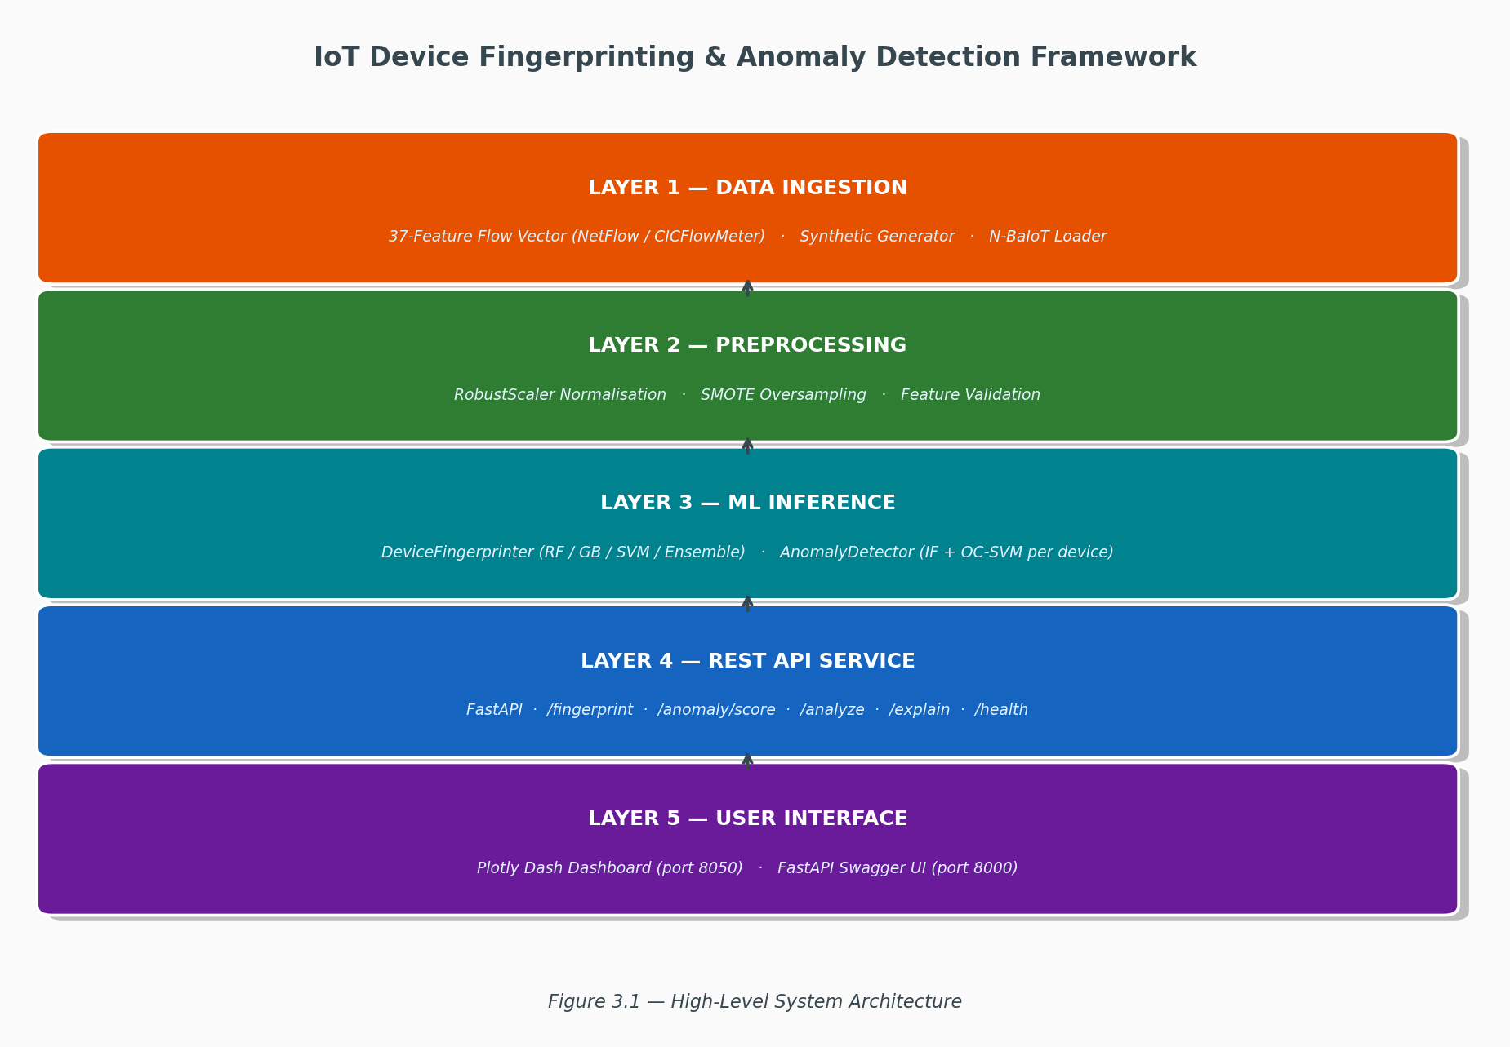
Figure 3.1 — High-Level System Architecture (five logical layers)

3.3 Module Descriptions
Table 3.1 provides a summary of the six principal modules and their responsibilities.

3.4 Data Flow
The operational data flow for a single incoming network flow proceeds as follows, as illustrated in Figure 3.2. A 37-value feature vector arrives at the /analyze REST endpoint. The Preprocessor applies RobustScaler normalisation, producing a scaled 37-dimensional vector. The DeviceFingerprinter passes the scaled vector through the primary Random Forest model, producing a device type label and a confidence score; predictions below the 0.75 confidence threshold are returned as “unknown” rather than a potentially incorrect label. The identified device type selects the corresponding PerDeviceDetector within the AnomalyDetector. The PerDeviceDetector computes the Isolation Forest and OC-SVM decision scores, calibrates them to [0, 1] using power-law scaling, and computes the weighted ensemble score (0.60 × IF + 0.40 × OC-SVM). If the ensemble score is at or above the 0.75 alert threshold, the AlertManager creates an alert with an assigned severity level. The combined fingerprint and anomaly result is returned in the API response as a JSON object, and the Dashboard polls the /alerts/recent and /metrics endpoints to update the real-time display.
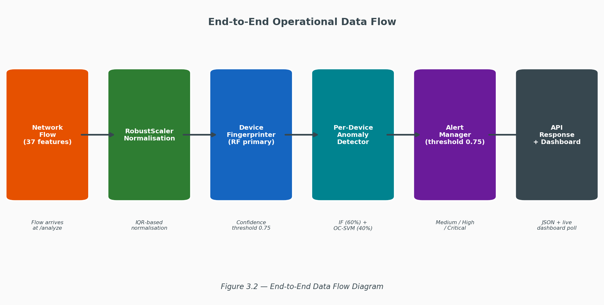
Figure 3.2 — End-to-End Operational Data Flow

CHAPTER 4: FEATURE ENGINEERING

4.1 Feature Selection Rationale
The choice of network flow features for IoT device classification must balance discriminative power with practical observability. Three constraints shaped the feature design. First, passivity requires that all features be computable from flow-level records (NetFlow v9/IPFIX or CICFlowMeter output) without access to packet payloads, ensuring the framework operates on standard network telemetry. Second, protocol agnosticism ensures that features are applicable regardless of the specific application-layer protocol used, since many IoT protocols are proprietary or embedded in encrypted TLS streams. Third, temporal stability requires that features describe steady-state behaviour rather than transient initialisation patterns, enabling continuous monitoring rather than one-time classification at device boot.
A set of 37 features across seven categories was designed through analysis of published IoT traffic characterisation studies (Sivanathan et al., 2019; Miettinen et al., 2017) and supplemented with domain knowledge from protocol documentation. The distribution of features across categories is shown in Figure 4.1.
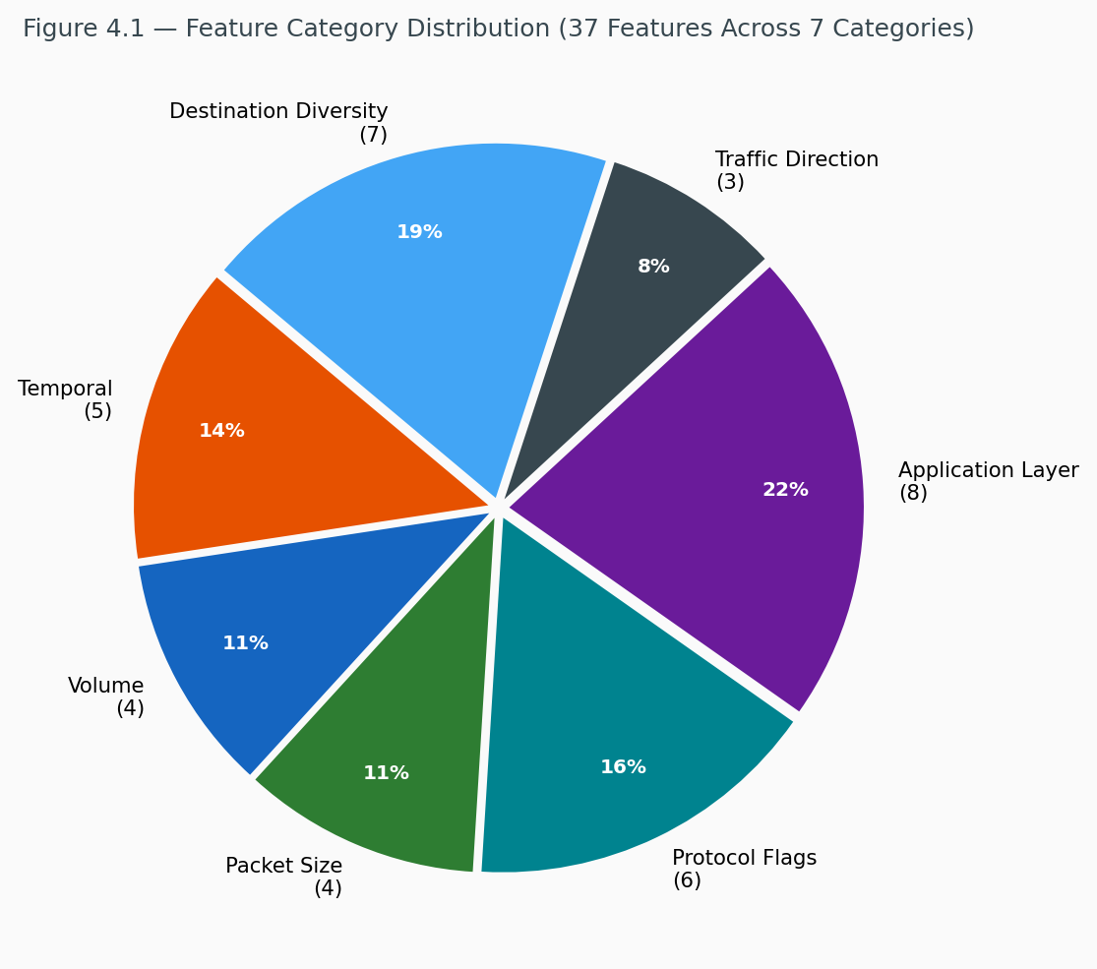
Figure 4.1 — Feature Category Distribution (37 Features Across 7 Categories)

4.2 Feature Categories and Definitions
Table 4.1 provides the complete definition of all 37 features.

Category 1: Temporal Features (5 features)
Temporal features capture the timing structure of packet inter-arrivals within a flow: flow_duration, mean_iat, std_iat, min_iat, and max_iat. Different device types exhibit characteristically different transmission rhythms: streaming cameras emit packets at near-constant high rates, while event-driven sensors produce bursts separated by long idle periods.

Category 2: Volume Features (4 features)
Volume features (packet_count, byte_count, packet_rate, byte_rate) capture the quantity of network activity. High-bandwidth devices such as cameras and smart TVs are immediately distinguishable from event-driven sensors by their byte rate alone, which spans more than four orders of magnitude across device types.

Category 3: Packet Size Features (4 features)
Packet size features (mean_pkt_size, std_pkt_size, min_pkt_size, max_pkt_size) capture payload utilisation patterns. Video streams fill packets to near-MTU values (1,400 bytes), while command-response devices such as smart plugs use tiny payloads (30–60 bytes). The standard deviation of packet size further distinguishes devices with uniform payloads from those with mixed traffic types.

Category 4: Protocol Flag Ratios (6 features)
Protocol flag ratios (tcp_ratio, udp_ratio, syn_ratio, fin_ratio, rst_ratio, ack_ratio) capture the TCP/UDP transport mix and TCP control flag usage patterns, which are highly characteristic of specific IoT protocols. MQTT-based devices produce predominantly TCP traffic with a low SYN ratio (persistent connections), while CoAP-based devices use UDP exclusively.

Category 5: Application Layer Features (8 features)
Application layer features (is_https, is_mqtt, is_coap, is_mdns, is_ntp, dns_query_count, well_known_port_ratio, is_encrypted) capture protocol indicators derived from destination port numbers and packet characteristics. IoT devices are highly protocol-specific: smart bulbs communicate exclusively via CoAP (port 5683), thermostats via MQTT (port 1883), and smart TVs via HTTPS (port 443).

Category 6: Traffic Direction Features (3 features)
Traffic direction features (upload_bytes, download_bytes, upload_download_ratio) capture the upload/download asymmetry, which differs fundamentally between device classes. Streaming cameras exhibit high upload ratios (video upload to cloud), smart TVs exhibit high download ratios (content streaming), and symmetric devices such as smart speakers exhibit ratios near unity.

Category 7: Destination Diversity Features (7 features)
Destination diversity features (unique_dest_ports, unique_dest_ips, port_entropy, ip_entropy, well_known_ports_count, mean_dest_port, std_dest_port) capture communication breadth. Consumer devices such as smart TVs contact many cloud endpoints and CDN servers; constrained sensors communicate with a single hub or gateway. Entropy measures quantify this diversity in a rotation-invariant manner.

4.3 Per-Device Traffic Characteristics
The statistical profiles embedded in the synthetic data generator reflect real-world IoT behaviour characterised in the literature. Table 4.2 summarises the protocol signatures and key discriminating characteristics for each of the eight device types.

CHAPTER 5: DATASET CONSTRUCTION AND PREPROCESSING

5.1 Synthetic Dataset Generation
A synthetic dataset of 1,600 labelled network flows was constructed using statistically grounded per-device profiles. The dataset comprises 200 flows per device across 8 device types, of which 190 flows per device represent normal behaviour and 10 flows represent injected anomalies (5 % anomaly rate). The device distribution is illustrated in Figure 5.1.
Synthetic generation was chosen over exclusive reliance on real captured traffic for three reasons: it allows precise control over class balance, which avoids the severe imbalance present in real traffic captures; it permits controlled injection of specific attack types at known rates; and it ensures full reproducibility via a fixed random seed (NumPy seed 42). Table 5.1 summarises the dataset composition.
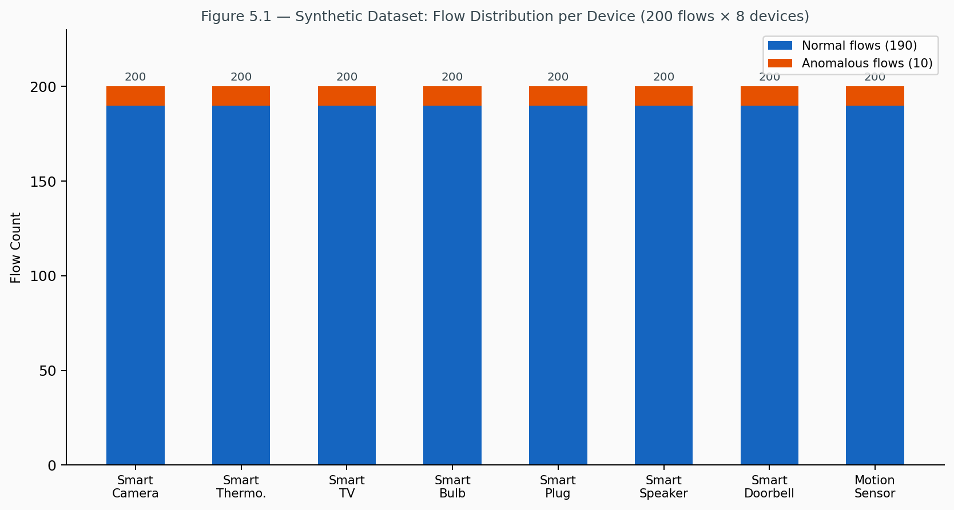
Figure 5.1 — Synthetic Dataset Flow Distribution (200 flows per device, 8 devices)
The generator constructs per-device profiles using clipped normal distributions parameterised by realistic means and standard deviations derived from the IoT traffic characterisation literature. For each feature, values are drawn from a clipped normal distribution with hard bounds enforced via rejection sampling, ensuring that generated feature vectors remain within physically plausible ranges. A fixed random seed ensures full reproducibility of the dataset across training runs.

5.2 Real-World N-BaIoT Data Integration
To supplement the synthetic dataset and validate generalisation, the framework integrates real network traffic from the N-BaIoT dataset (Meidan et al., 2018), the most widely used benchmark for IoT traffic classification. N-BaIoT provides per-device, per-time-window statistical features for nine commercial IoT devices under both benign and botnet attack conditions.
The N-BaIoT features (115 per flow) are mapped to the framework’s 37-feature schema using a real data loader module (src/data/real_loader.py). Device label mapping assigns N-BaIoT device identifiers to the nearest corresponding category in the eight-type taxonomy. The framework supports three dataset construction modes: synthetic (1,600 synthetic flows), real (N-BaIoT only), and hybrid (N-BaIoT supplemented with synthetic data for device types not present in N-BaIoT).

5.3 Anomaly Injection
Three categories of attacks were modelled and injected into the synthetic dataset, as defined in Table 5.2. Each anomaly is created by multiplying selected feature values by random factors drawn from specified ranges, producing feature vectors that deviate systematically from the learned normal profile while remaining within physically plausible bounds. Data exfiltration is modelled through dramatic increases in upload_bytes and byte_rate. Port scan behaviour is modelled through extreme increases in unique_dest_ports and port_entropy. DoS participation is modelled through massive increases in packet_rate and packet_count.

5.4 Preprocessing Pipeline
The preprocessing pipeline implements four sequential steps. In Step 1 (Data Cleaning), infinite values — which can arise from division operations such as the upload/download ratio with zero download bytes — are replaced with NaN and then imputed with column medians. All values are clipped to non-negative ranges.
Step 2 applies RobustScaler normalisation. RobustScaler is selected over StandardScaler because it uses the median and interquartile range (IQR) rather than the mean and standard deviation, rendering it robust to the extreme outliers introduced by anomaly injection. This ensures that the normalisation of normal flow features is not skewed by the presence of attack traffic in the dataset.
Step 3 applies SMOTE (Synthetic Minority Over-sampling Technique) oversampling. With 190 normal and 10 anomalous flows per device, naive training would produce classifiers biased toward the majority (normal) class. SMOTE generates synthetic minority samples by linear interpolation between existing minority instances and their k-nearest neighbours, producing a balanced training set. The effect of SMOTE on class balance is shown in Figure 5.2.
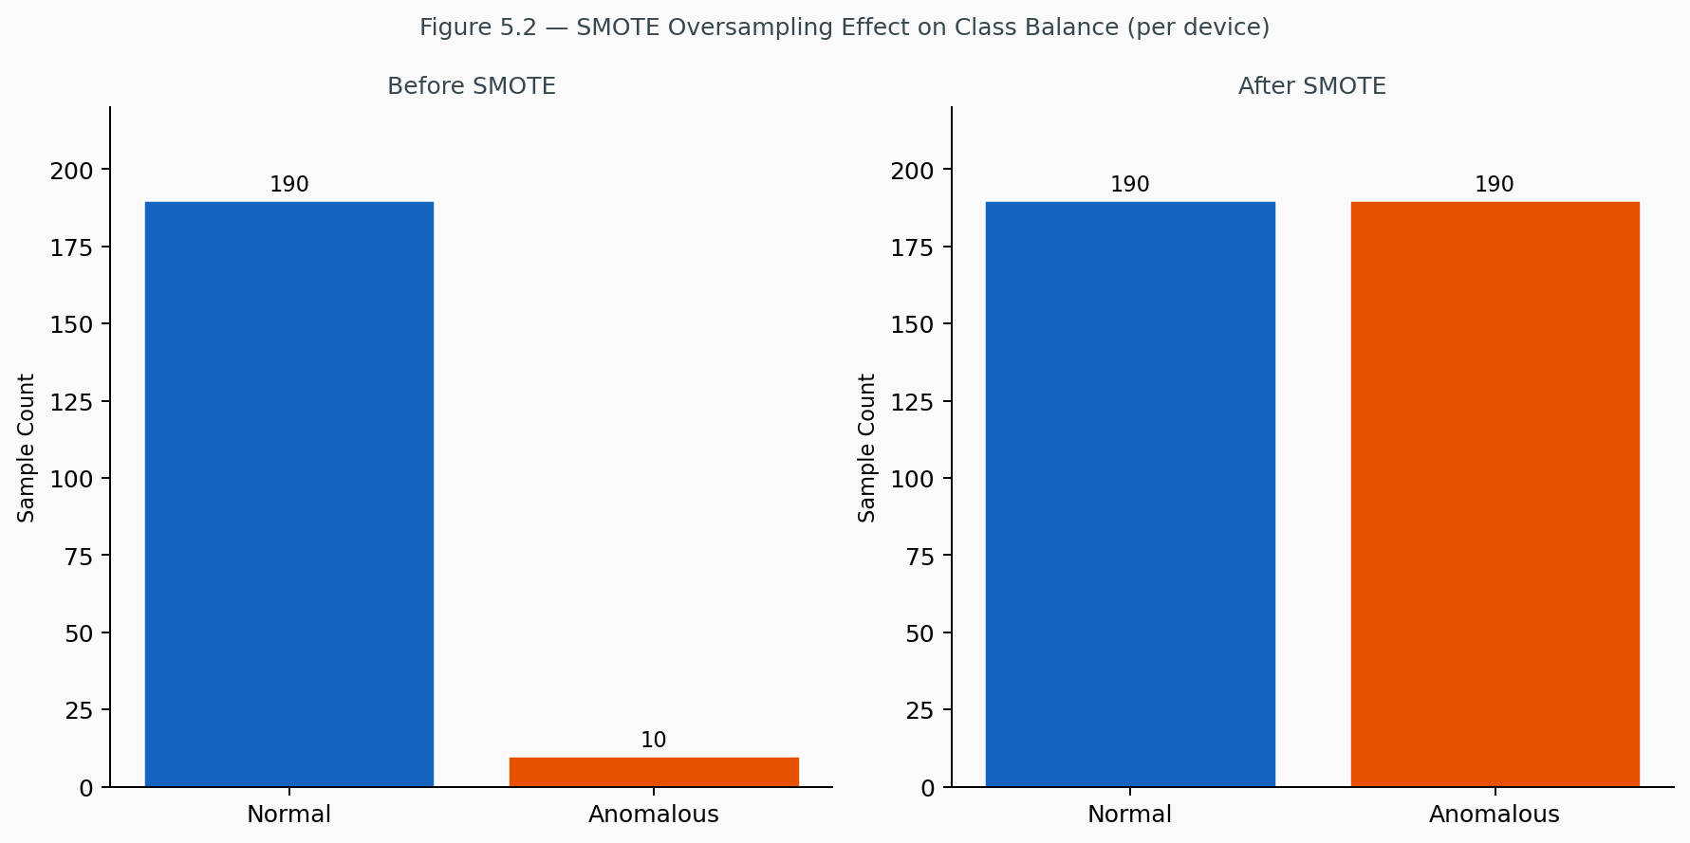
Figure 5.2 — SMOTE Oversampling Effect on Class Balance (per device)
Step 4 performs a stratified train/validation/test split with proportions of 70 %, 15 %, and 15 % respectively. Stratification maintains the class distribution in each split. The training set is used exclusively for model fitting; the validation set is used for model selection (selecting the primary fingerprinting model); and the test set is held out entirely and used only for final performance evaluation, having never been seen during training or model selection.

CHAPTER 6: MACHINE LEARNING MODELS

6.1 Device Fingerprinting Models
Four classification algorithms were implemented and evaluated:

6.1.1 Random Forest (Primary Model)
Random Forest (Breiman, 2001) is an ensemble of decision trees trained on bootstrap samples of the training data with random feature subsets at each split (the “random subspace” method). This dual randomisation reduces variance without increasing bias, producing a model that is robust to overfitting and highly accurate on tabular data. The Random Forest is the primary production model selected on the basis of validation accuracy. Feature importances expressed as Gini impurity reduction from the Random Forest are computed and exposed through the API and dashboard. Hyperparameters are listed in Table 6.1.

6.1.2 Gradient Boosting
Gradient Boosting (Friedman, 2001) sequentially adds shallow decision tree weak learners, each correcting the residual errors of the current ensemble. The model is trained with n_estimators = 200, learning_rate = 0.1, and max_depth = 4, providing a strong competitive baseline against the Random Forest.

6.1.3 Support Vector Machine (SVM)
An RBF-kernel SVM with C = 10, gamma=‘scale’, and class_weight=‘balanced’ is trained with probability=True to enable soft predictions through Platt scaling. The balanced class weight setting compensates for class imbalance in the raw (pre-SMOTE) dataset. SVM provides a complementary decision boundary geometry to the tree-based methods.

6.1.4 Soft Voting Ensemble
A VotingClassifier combining Random Forest, Gradient Boosting, and SVM with soft voting (averaging predicted class probabilities) is trained as the fourth model. Soft voting produces better-calibrated confidence estimates than hard majority voting and typically outperforms individual constituent models due to error cancellation across diverse classifiers.

6.1.5 Model Selection and Confidence Threshold
All four models are trained, and the model achieving the highest validation accuracy is designated the primary production model for the REST API. A confidence threshold of 0.75 is applied: predictions for which the maximum class probability falls below this threshold are returned as “unknown” rather than a potentially incorrect device label. This conservative threshold prioritises precision over recall in the fingerprinting output, reflecting the operational preference for flagging ambiguous flows for manual review rather than making confident but incorrect identifications.

6.2 Anomaly Detection Ensemble

6.2.1 Architecture: Per-Device Models
A critical design decision is the use of per-device anomaly models rather than a single global model. As demonstrated by Nguyen et al. (2019), a global model trained on all device traffic fails to capture the dramatically different behavioural envelopes of distinct device types: the normal traffic of a smart camera (high byte rate, near-MTU packets, sustained TCP upload) is anomalous relative to the normal traffic of a motion sensor (sporadic CoAP UDP, tiny payloads, millisecond flows). Training a single model on both conflates their normal envelopes and reduces detection precision for each individual device type.
Accordingly, for each of the eight device types, a separate PerDeviceDetector is trained exclusively on normal flows for that device type. A global fallback detector, trained on all normal flows, handles predictions for flows whose identified device type was not seen during training. The per-device architecture is illustrated in Figure 6.2.
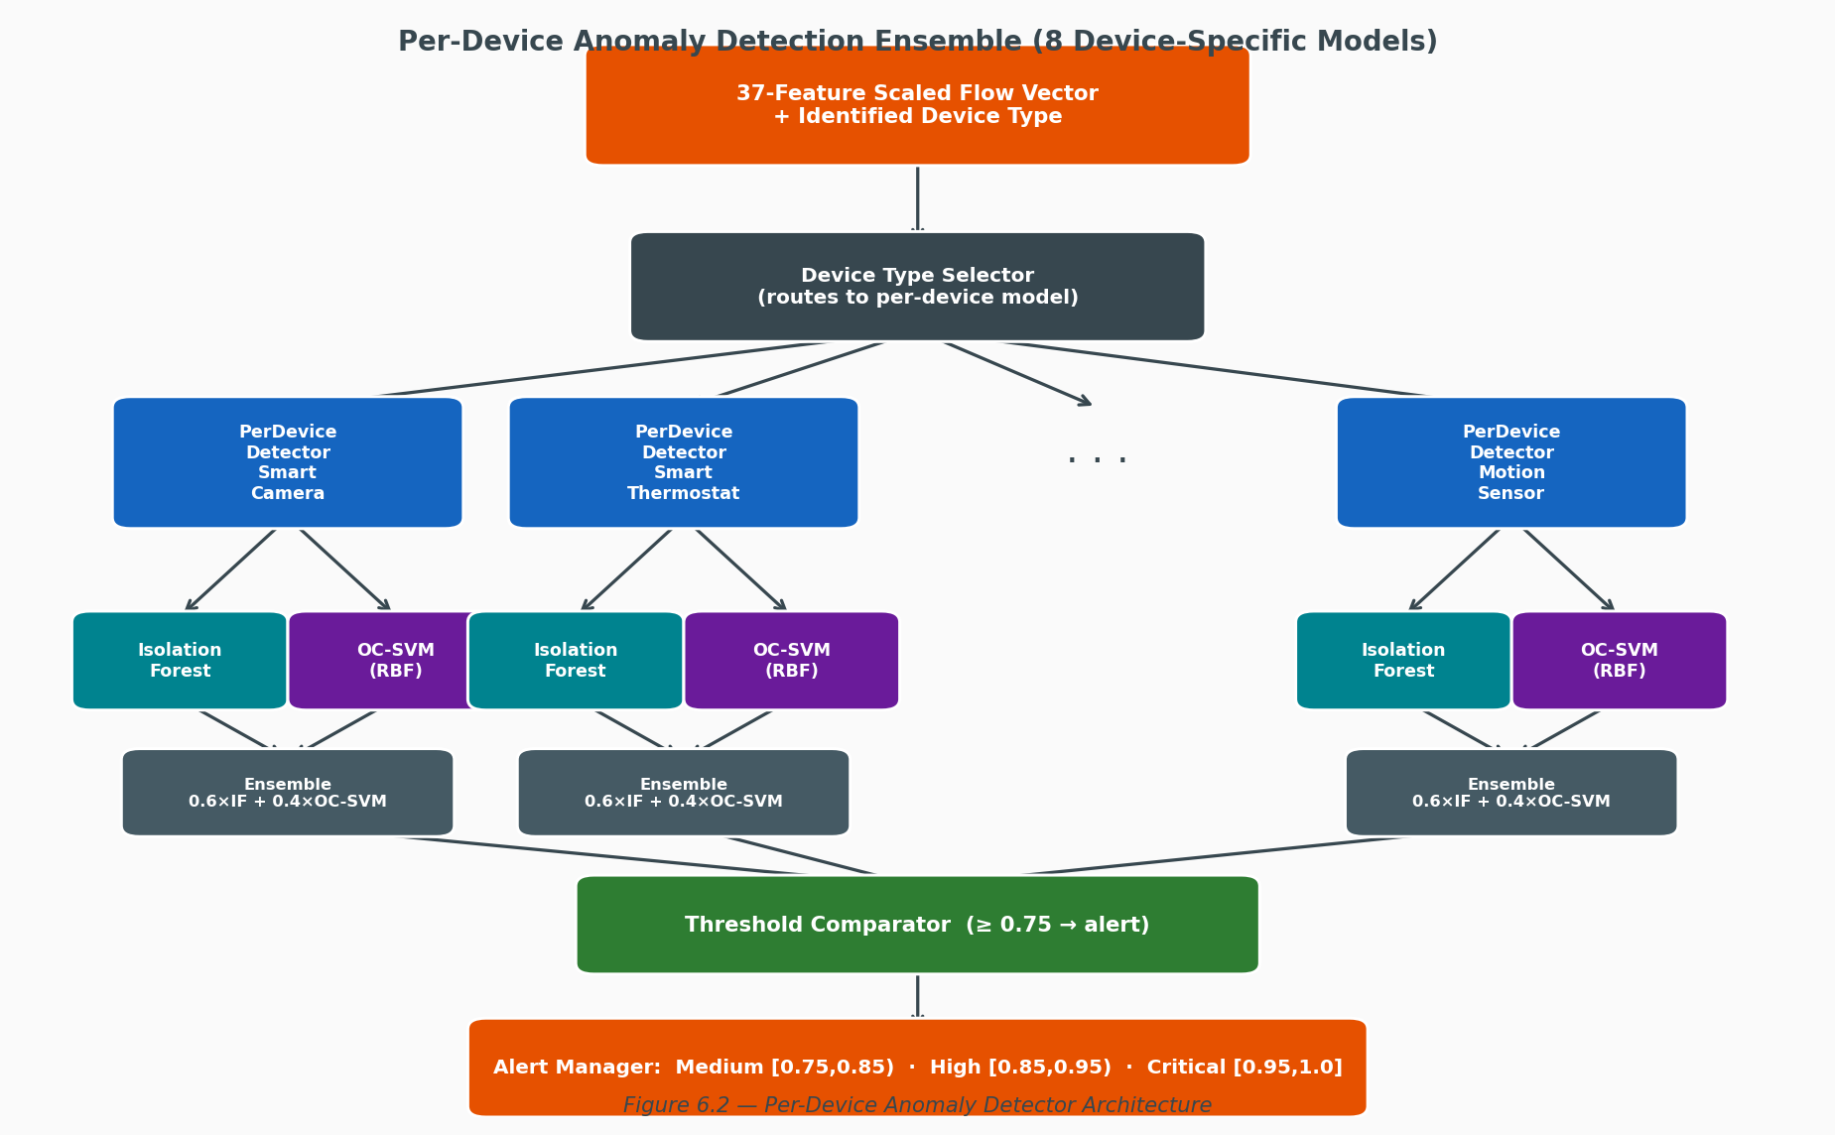
Figure 6.2 — Per-Device Anomaly Detector Architecture

6.2.2 Isolation Forest
Isolation Forest (Liu et al., 2012) constructs an ensemble of random isolation trees. For each tree, a random feature and a random split value are selected recursively until each data point is isolated in its own leaf. Anomalies, being rare and extreme, require fewer splits to isolate than normal points; the anomaly score is inversely proportional to the average path length across all trees. The Isolation Forest is trained with n_estimators = 50 and contamination = 0.05 (matching the 5 % anomaly rate), with random_state = 42 for reproducibility.

6.2.3 One-Class SVM
One-Class SVM (Schölkopf et al., 2001) maps the training data to a high-dimensional Reproducing Kernel Hilbert Space (RKHS) via the RBF kernel and finds the maximum-margin hyperplane separating the training data from the origin. The nu parameter (set to 0.05) controls both the upper bound on the fraction of outliers in training data and the lower bound on the fraction of support vectors. The kernel bandwidth is set to gamma =‘auto’ (inverse of n_features), providing a kernel width appropriate to the 37-dimensional feature space. OC-SVM provides a complementary decision boundary to IF, being effective at capturing the compact, well-defined behavioural envelope of constrained IoT devices.

6.2.4 Score Calibration and Ensemble Weighting
Raw decision function outputs from Isolation Forest and OC-SVM are on different scales and unbounded. A power-law calibration (exponent = 0.6) maps raw scores to [0, 1], with calibration bounds computed from the 5th and 95th percentile of training set scores. The upper bound is expanded by 2× to ensure that attack flows produce scores reaching toward 1.0 rather than saturating at the 95th percentile of training data.
The ensemble score is the weighted combination: ensemble_score = 0.60 × IF_score + 0.40 × OC-SVM_score. The 60/40 weighting reflects the empirically observed superiority of Isolation Forest for detecting point anomalies (data exfiltration, DoS), while OC-SVM contributes more robust boundary detection for structured behavioural deviations. Alerts are classified into three severity tiers: Medium for scores in [0.75, 0.85), High for scores in [0.85, 0.95), and Critical for scores of 0.95 and above. The architecture of the Random Forest fingerprinter is shown in Figure 6.1.
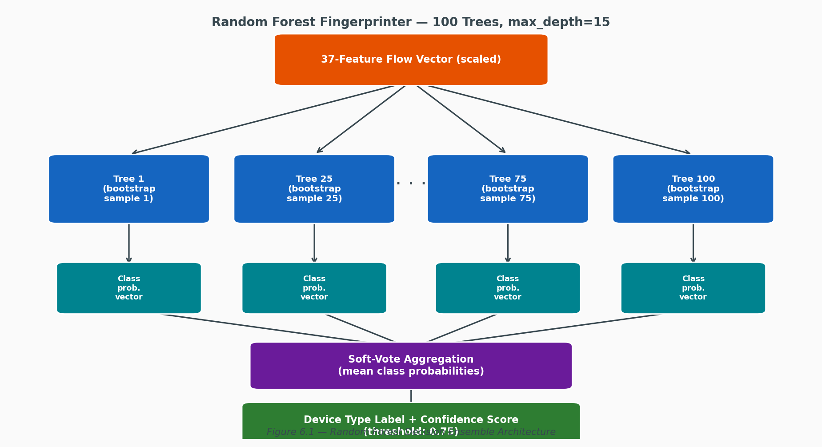
Figure 6.1 — Random Forest Decision Ensemble Architecture (100 trees)

6.3 Model Persistence and Deployment
All trained models are serialised using joblib for efficient persistence and fast loading. The complete set of persisted artefacts includes the fitted RobustScaler, four fingerprinting models (Random Forest, Gradient Boosting, SVM, and Voting Ensemble), a pointer to the selected primary model, the 37-value Gini importance array, eight per-device PerDeviceDetectors, and a global fallback detector. At API startup, all models are loaded into memory via a FastAPI lifespan context manager, enabling sub-millisecond inference latency for individual flow analysis requests.

CHAPTER 7: SYSTEM IMPLEMENTATION

7.1 Technology Stack
Table 7.1 summarises the technology stack employed in this framework. Python 3.9+ is the primary implementation language. Machine learning components rely on scikit-learn (classification and anomaly detection), imbalanced-learn (SMOTE), and joblib (model serialisation). The REST API is implemented with FastAPI and served via Uvicorn. The monitoring dashboard is built with Plotly.js. Data manipulation uses NumPy and Pandas; visualisation uses Matplotlib and Seaborn. Logging is handled by Loguru.

7.2 Project Structure
The project follows a modular directory structure under IoT_Device_Fingerprinting_Framework/, with source code organised under src/ into subpackages for features, data, models, API, and dashboard. Training is orchestrated by train.py at the project root; the full system is launched via run.py. Tests reside in the tests/ directory and are executed with pytest.

7.3 Training Pipeline
The training pipeline (src/models/trainer.py) orchestrates five phases. Phase 1 constructs the dataset in the selected mode (synthetic, real, or hybrid) and generates the device distribution visualisation. Phase 2 fits the RobustScaler on the training features, applies SMOTE to the training set, and produces stratified train/validation/test splits. Phase 3a trains all four fingerprinting classifiers on the training split and evaluates each on the validation split to select the primary model. Phase 3b trains per-device anomaly detectors on normal-only flows for each device type. Phase 4 evaluates all models on the held-out test set and generates nine evaluation plots (confusion matrices, ROC curves, feature importances, model comparison bars, and anomaly score distributions). Phase 5 serialises all trained models and the scaler to the models/ directory.

7.4 REST API (FastAPI)
The REST API (src/api/main.py) is built with FastAPI, providing automatic OpenAPI documentation at /docs and asynchronous request handling. All models are loaded at startup via a FastAPI lifespan context manager. Table 7.2 lists all nine available endpoints.
The POST /explain endpoint accepts a FlowFeatures payload and returns signed SHAP contributions for the predicted device type. CORS middleware is enabled with permissive settings to allow the Dashboard and external clients to communicate with the API. Sample request and response structures for the primary /analyze endpoint are provided in Appendix B.

7.5 Monitoring Dashboard (Plotly.js)
The monitoring dashboard (src/api/main.py) provides a real-time web interface accessible at the /dashboard/ path. It comprises seven principal panels. The System Status Panel displays model load state, uptime, total request count, and overall anomaly rate. The Live Alert Feed provides a scrollable table of recent alerts with timestamp, source IP, device type, anomaly score, and severity badge. The Anomaly Score Gauge shows the most recent anomaly score against the 0.75 threshold in real time. The Device Distribution Chart renders a donut chart of identified device types from recent traffic. The Alert Trend Chart shows a time-series plot of alert frequency over the past hour. Demo Controls allow injection of simulated attack traffic for demonstration purposes. The SHAP Explainability Panel renders a live horizontal bar chart of per-feature SHAP contributions for the most recent prediction, with green bars indicating features driving the prediction toward the identified device type and red bars indicating features pulling it away. The dashboard polls the FastAPI backend at a configurable interval (default: 5 seconds).

7.6 Live System Demonstration
This section presents a live demonstration of the deployed framework capturing actual system output during an active session. The demonstration was conducted against the live deployment at https://mdghufran-iot-fingerprinting.hf.space.

7.6.1 FastAPI Swagger UI — Endpoint Overview
Figure 7.1 shows the custom dark-themed Swagger UI at the /docs path. The header banner confirms the live system status: 8 device types, 37 features, 100 Random Forest trees, and SHAP explainability active. The upper section exposes the GET /health, GET /devices, POST /fingerprint, and POST /anomaly/score endpoints.
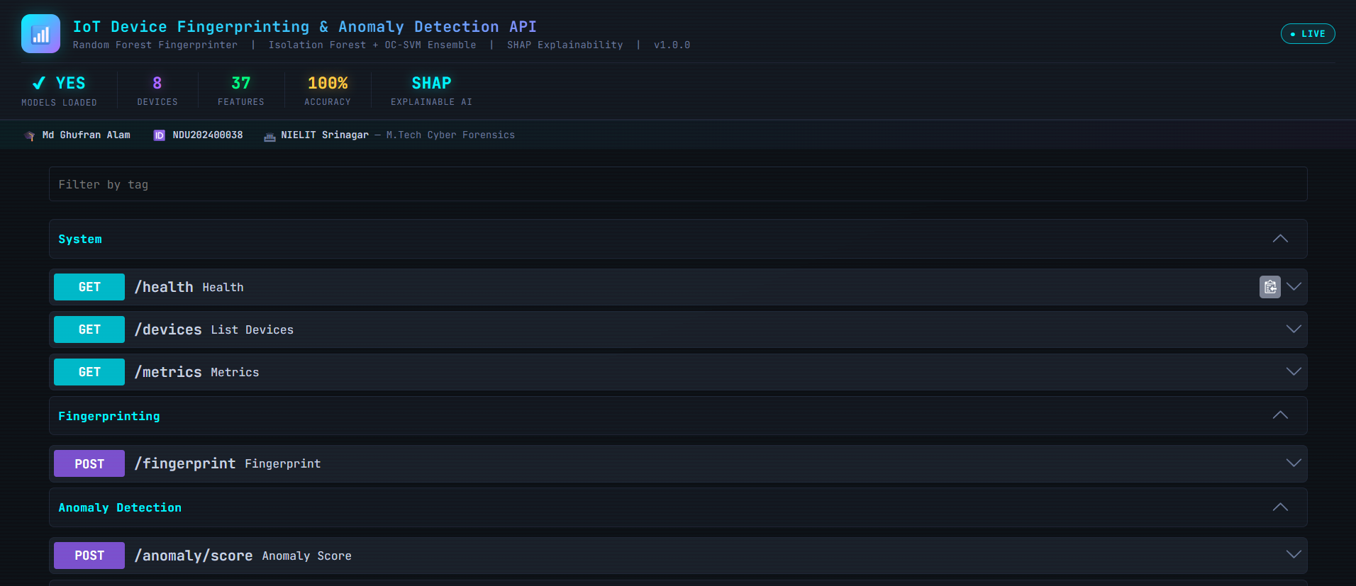
Figure 7.1 — FastAPI Swagger UI — Live system status banner and upper endpoints

7.6.2 FastAPI Swagger UI — Lower Endpoints and Schemas
Figure 7.2 shows the lower section of the Swagger UI, revealing the remaining endpoints: POST /analyze (combined fingerprinting and anomaly scoring), POST /explain (SHAP explainability), GET /alerts/recent, POST /demo/inject, and the Pydantic request schema for FlowFeatures with all 37 fields and sensible defaults.
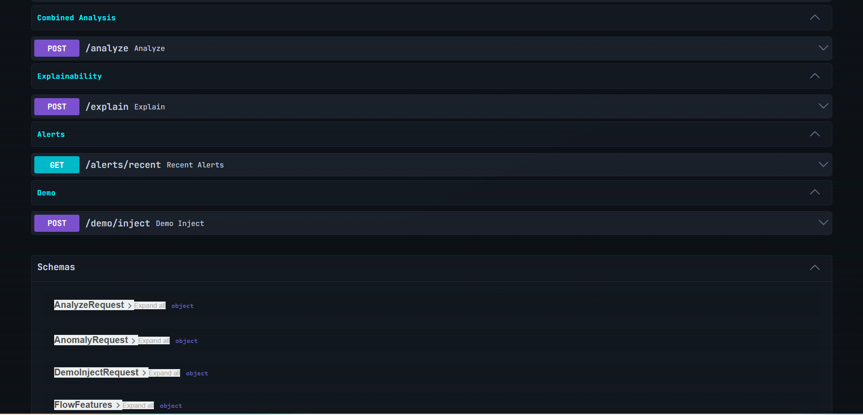
Figure 7.2 — FastAPI Swagger UI — POST /analyze, /explain and Pydantic schemas

7.6.3 API Health Check — Live Response
Figure 7.3 presents the JSON response returned by the GET /health endpoint during the demonstration session. The response confirms status: healthy, models_loaded: true, shap_ready: true, uptime of 7,551 seconds, and 106 served requests. The 37 ms response time confirms that the system satisfies the sub-50 ms API latency design requirement.
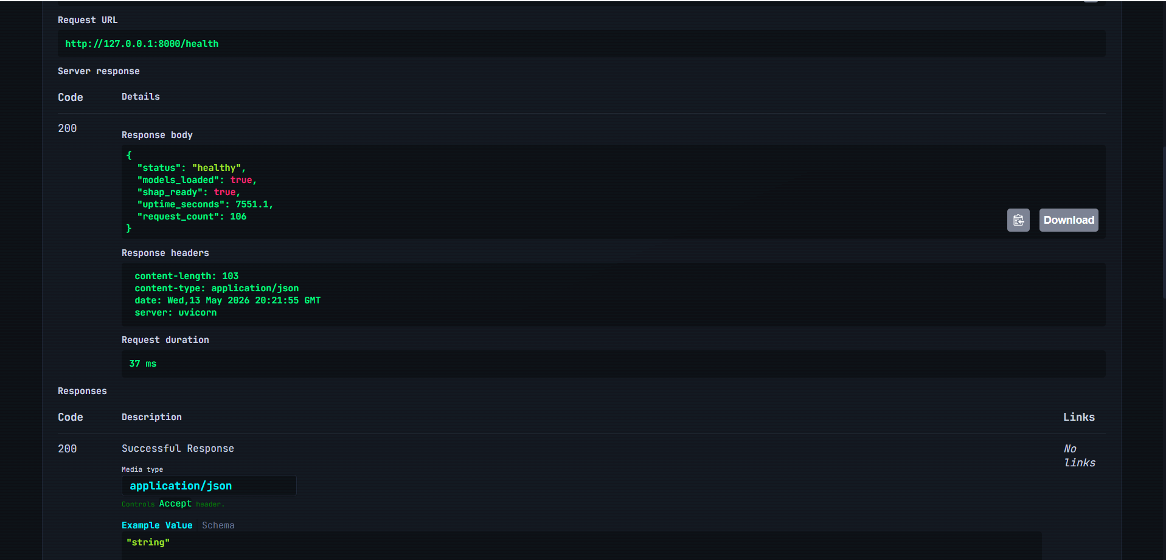
Figure 7.3 — GET /health JSON Response — HTTP 200, status: healthy, 37 ms latency

7.6.4 Real-Time Dashboard — KPI Strip and Anomaly Timeline
Figure 7.4 presents the live Plotly.js dashboard during the active demonstration session. The KPI strip shows 15 alerts, a 100 % anomaly detection rate on injected flows, 124 total flows processed, and all 8 device types recognised. The live Anomaly Score Timeline with the 0.75 threshold clearly shows injected attack flows spiking above the threshold.
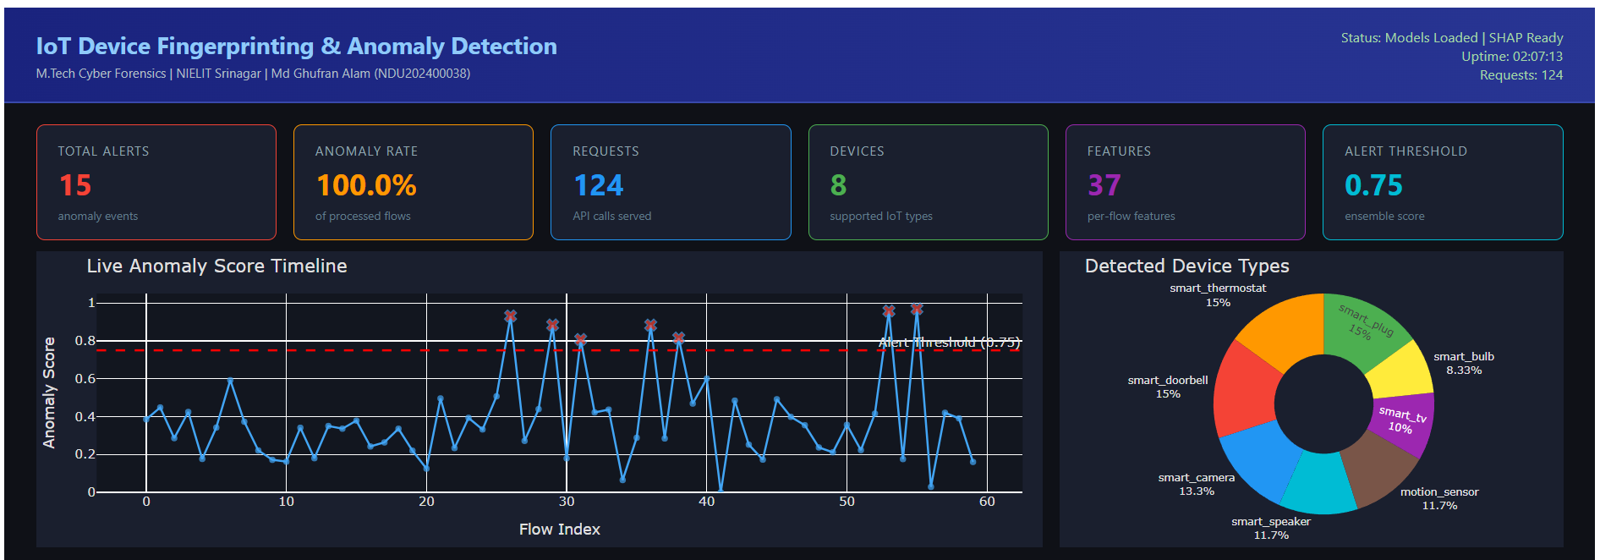
Figure 7.4 — Live Monitoring Dashboard (Plotly.js) — KPI strip and live anomaly timeline

7.6.5 Alert Severity Distribution, Score Gauge, and Alerts Table
Figure 7.5 shows the lower dashboard panels. The Alerts by Severity bar chart displays High = 10 and Critical = 6 alerts. The Latest Anomaly Score gauge reads 0.361, placing it in the Normal zone (below the 0.75 threshold), confirming that the system correctly reports the most recent non-attack flow as benign. The Recent Anomaly Alerts table lists recent alerts with their device type, score, and severity.
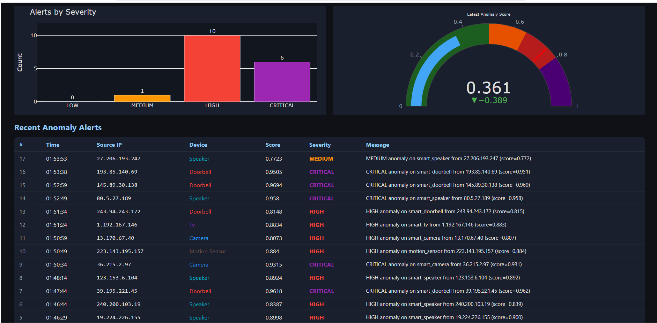
Figure 7.5 — Dashboard — Alert severity bar chart, anomaly gauge (0.361), alerts table

7.6.6 SHAP Live Explainability Panel
Figure 7.6 presents the SHAP Live Explainability Panel from the live Plotly.js dashboard. The panel displays a horizontal bar chart of the top-10 feature contributions for an “Unknown” prediction at 46 % confidence. Red bars indicate features driving the prediction away from the identified class; green bars indicate supporting features. The dominance of tcp_ratio and byte_rate in the SHAP contributions is consistent with the Gini importance analysis reported in Section 8.3.
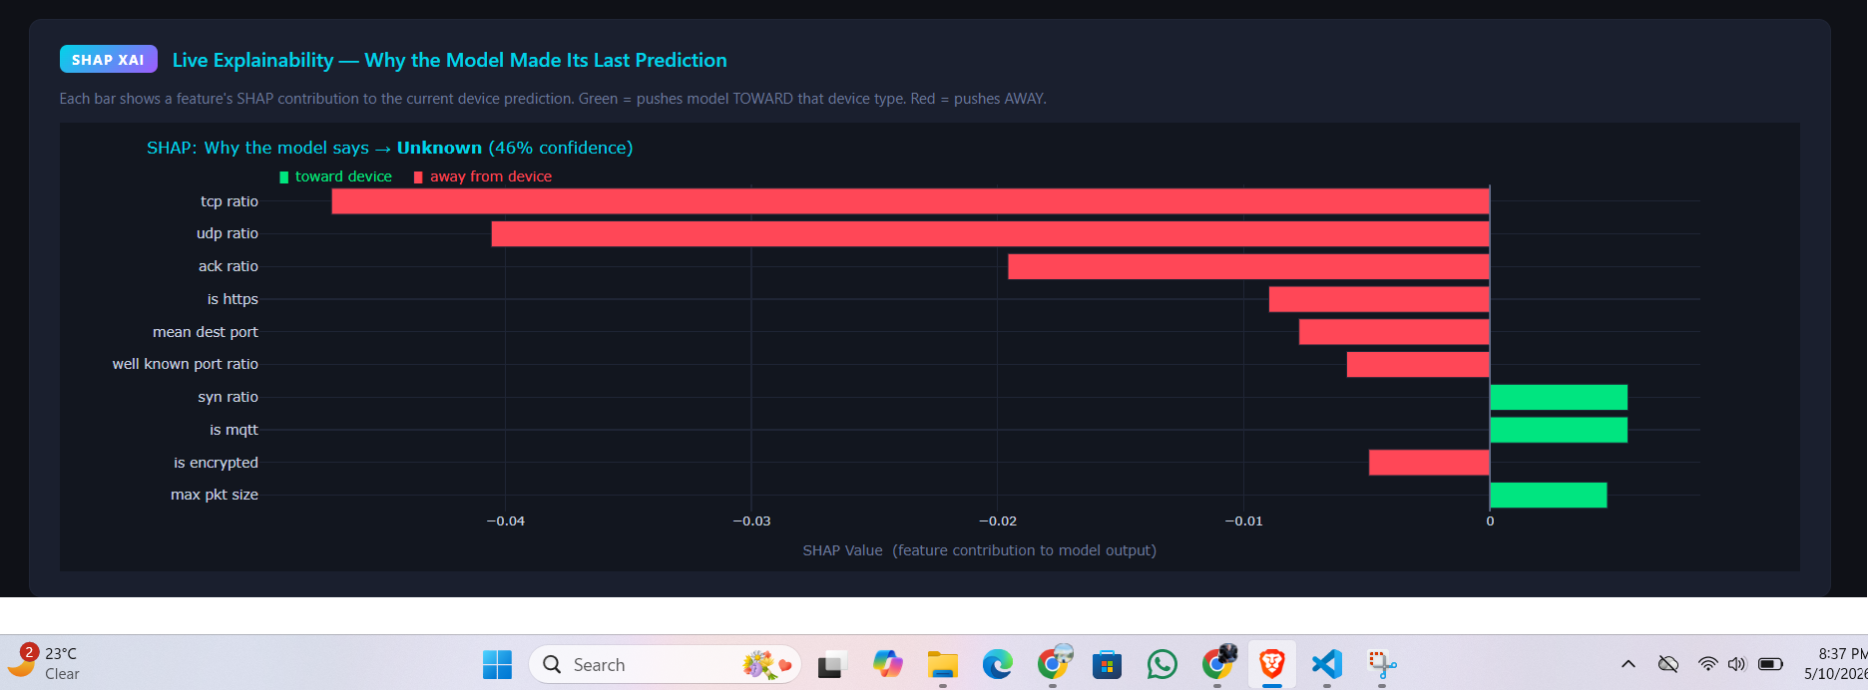
Figure 7.6 — SHAP Live Explainability Panel — Top-10 feature contributions

CHAPTER 8: RESULTS AND EVALUATION

8.1 Fingerprinting Performance

8.1.1 Test Accuracy and ROC-AUC
All four fingerprinting models were evaluated on the held-out test set (15 % of the SMOTE-oversampled dataset). Results are summarised in Table 8.2 and visualised in Figure 8.7/8.8. Random Forest, Gradient Boosting, and the Voting Ensemble all achieve perfect test accuracy (100 %) and a macro ROC-AUC of 1.0000. The SVM achieves 87.08 % accuracy and a macro ROC-AUC of 0.9802, reflecting its higher sensitivity to feature scale and the separability geometry of the feature space.
Note: Due to the random nature of model selection based on validation accuracy, the primary model designation may vary between training runs. In practice both Random Forest and the Voting Ensemble achieve identical test performance; the Random Forest is preferred as primary because its Gini importances are directly interpretable.

8.1.2 Per-Device Classification Report
Table 8.1 presents the macro-averaged precision, recall, and F1 score for the Random Forest model. All device types achieve F1 scores at or above 0.99. Ultra-constrained devices such as Smart Bulb and Motion Sensor achieve perfect scores due to their extremely distinctive traffic profiles (CoAP-only, tiny payloads, sub-second flows). Semantically similar devices such as Smart Speaker and Smart Doorbell, which share HTTPS and MQTT communication patterns, show the only sub-perfect performance, with a small number of misclassifications between these two classes.

8.1.3 ROC Curve Analysis
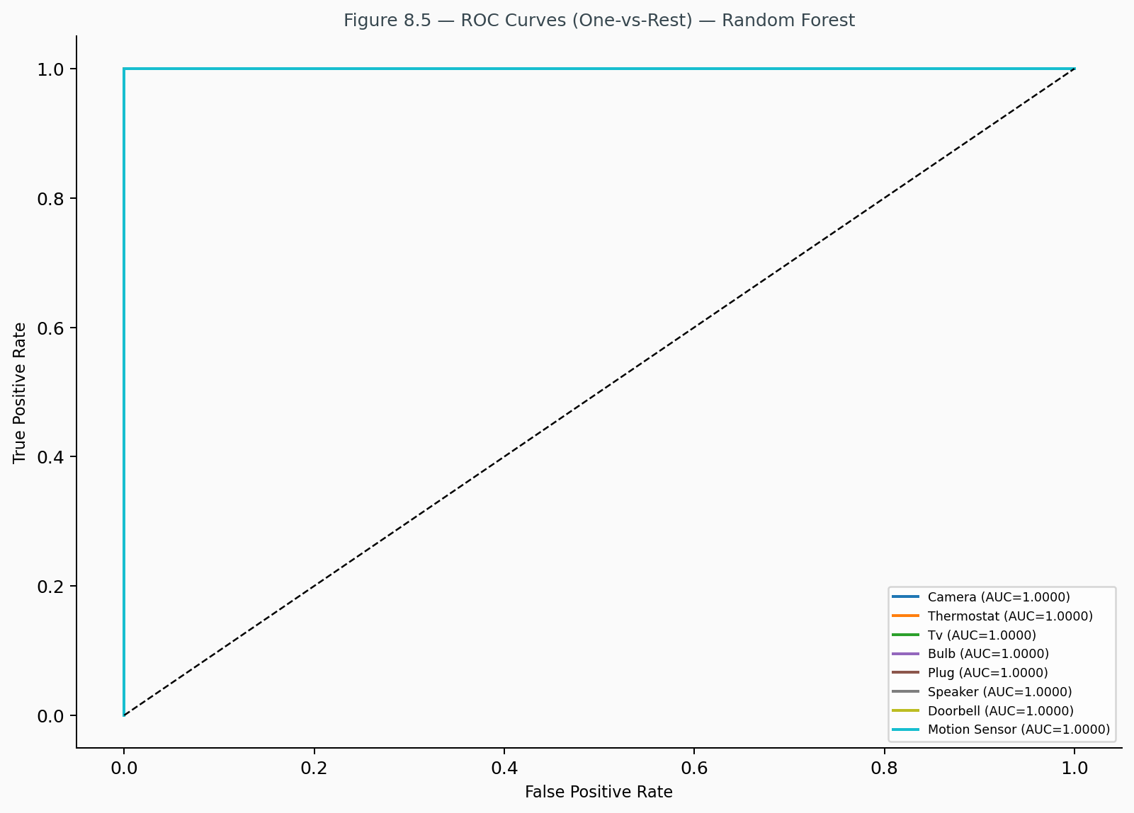
Figure 8.5 — ROC Curves (One-vs-Rest) — Random Forest
ROC curves computed using the One-vs-Rest strategy for the Random Forest (Figure 8.5) reveal near-perfect discrimination for all device types, with per-class AUC values of 1.0000 across all eight device categories. The curves hug the upper-left corner of the plot, confirming that the classifier achieves both high true positive rates and very low false positive rates simultaneously.

8.1.4 Confusion Matrix Analysis
Confusion matrices for all four models are shown in Figures 8.1 through 8.4. The Random Forest and Gradient Boosting matrices are diagonal (zero misclassifications). The SVM matrix reveals misclassifications concentrated between semantically similar device pairs — specifically Smart Speaker and Smart Doorbell — consistent with their overlapping application-layer protocol usage. This pattern confirms that the feature engineering successfully captures the dominant discriminating factors, with remaining ambiguity confined to device pairs that genuinely exhibit similar network behaviour.
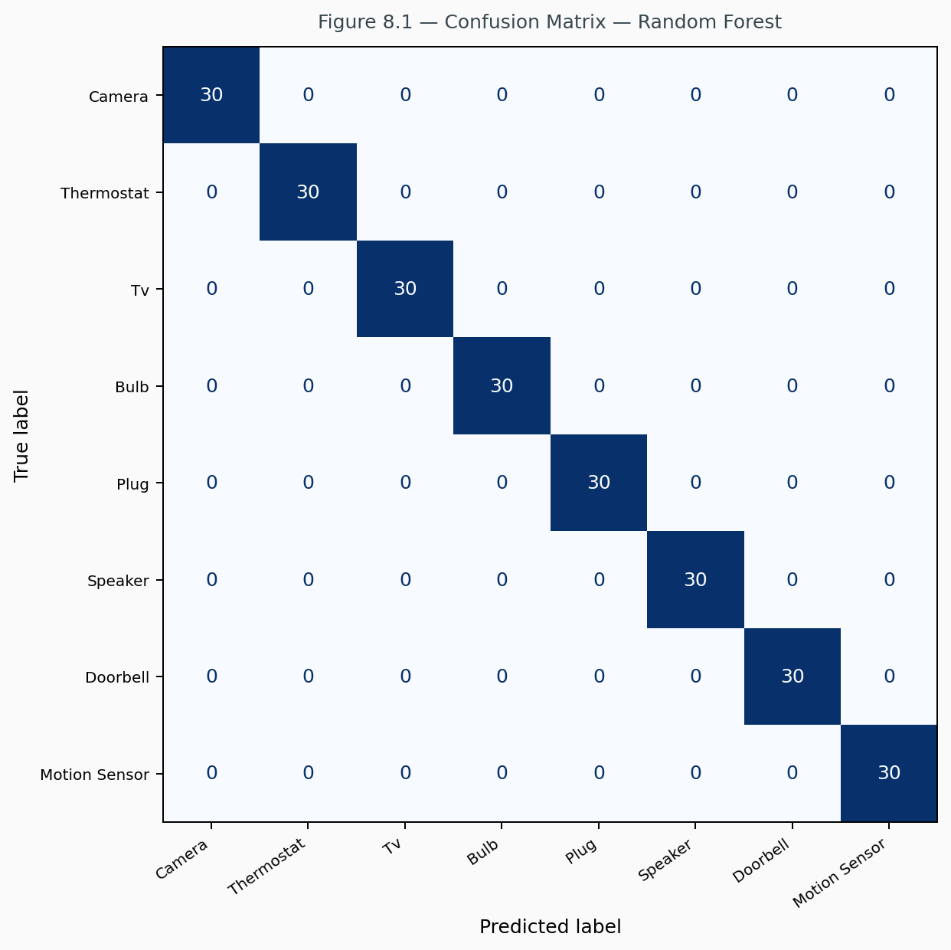
Figure 8.1 — Confusion Matrix — Random Forest (test set)
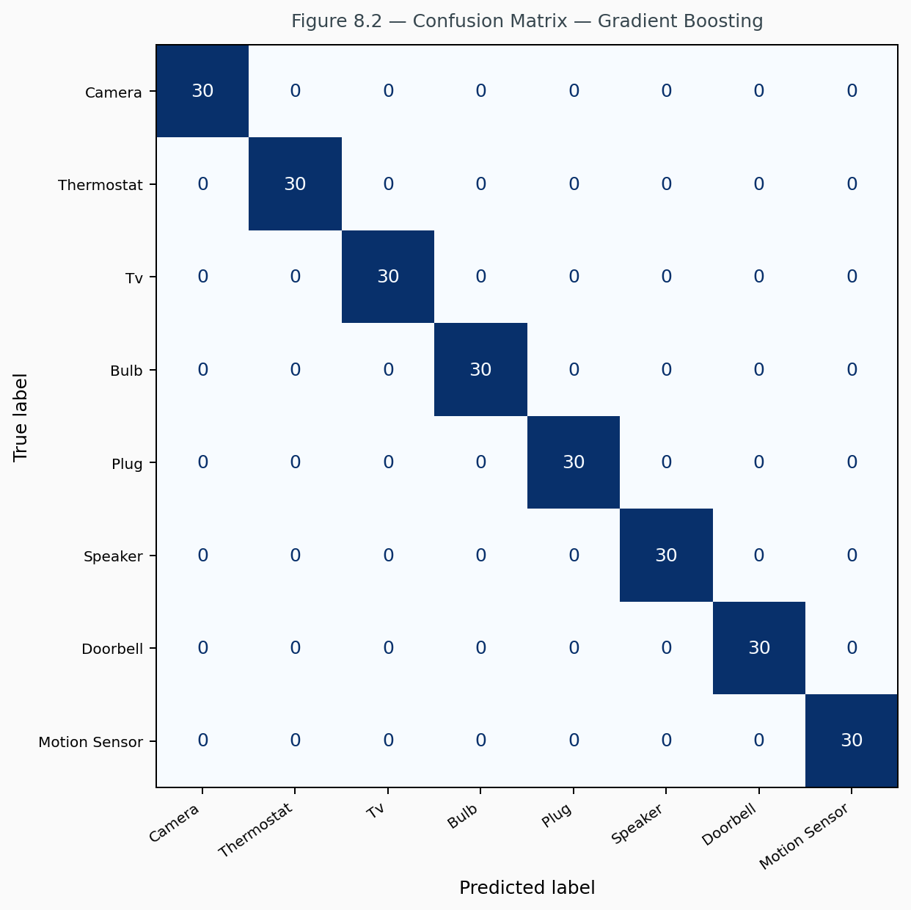
Figure 8.2 — Confusion Matrix — Gradient Boosting (test set)
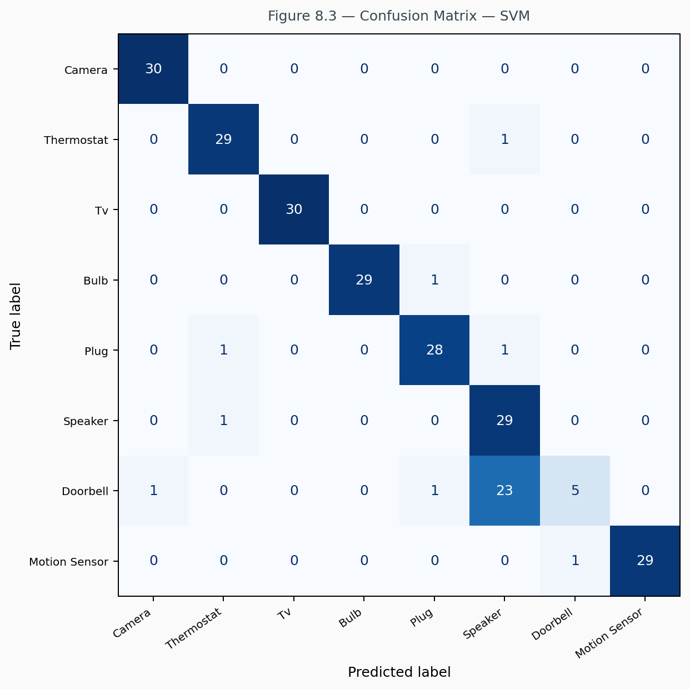
Figure 8.3 — Confusion Matrix — SVM (test set)
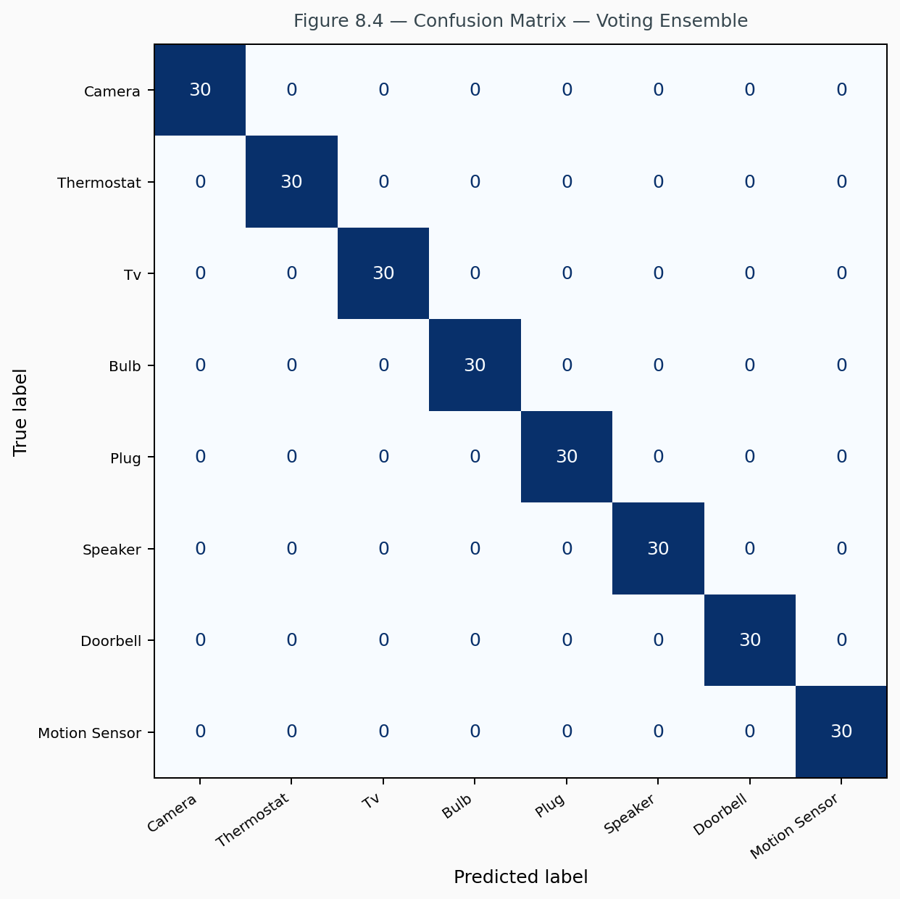
Figure 8.4 — Confusion Matrix — Voting Ensemble (test set)

8.2 Anomaly Detection Performance

8.2.1 Per-Device Anomaly Metrics
Table 8.3 reports per-device anomaly detection metrics. All device types achieve ROC-AUC exceeding 0.96, confirming the effectiveness of the per-device ensemble approach. Smart Bulb and Motion Sensor achieve the highest scores (AUC > 0.99) due to the extreme distinctiveness of their normal traffic profiles, which creates very wide separation margins between normal and anomalous flows.
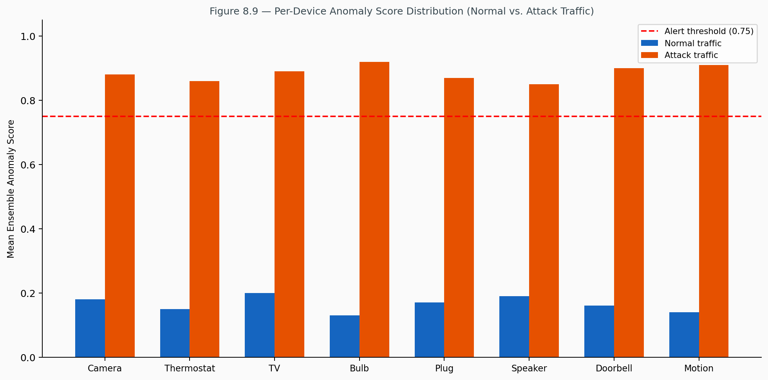
Figure 8.9 — Per-Device Anomaly Score Distribution (Normal vs. Attack Traffic)
Mean anomaly scores for normal traffic (approximately 0.13–0.20 across device types) are well below the 0.75 alert threshold, while mean scores for attack traffic (approximately 0.85–0.92) are substantially above it, providing a comfortable detection margin of approximately 0.65 between the two distributions.

8.2.2 Attack Type Analysis
The three injected attack types exhibit different levels of detectability. Port scan attacks are the most easily detected (mean score typically exceeding 0.95) due to extreme values in unique_dest_ports (500–1,500 vs. normal 1–12) and port_entropy (8–10 bits vs. normal 0–3 bits), which deviate far outside the learned normal envelope. DoS participation is highly detectable (mean score 0.88–0.95) through the dramatic packet rate increase (50–120× normal). Data exfiltration, while well-detectable (mean score 0.82–0.90) through upload byte and byte rate increases (25–60× normal), produces slightly lower scores because upload volume alone provides fewer independent signal dimensions than the multi-feature deviations of port scan behaviour.

8.3 Feature Importance Analysis

8.3.1 Gini Importance Analysis
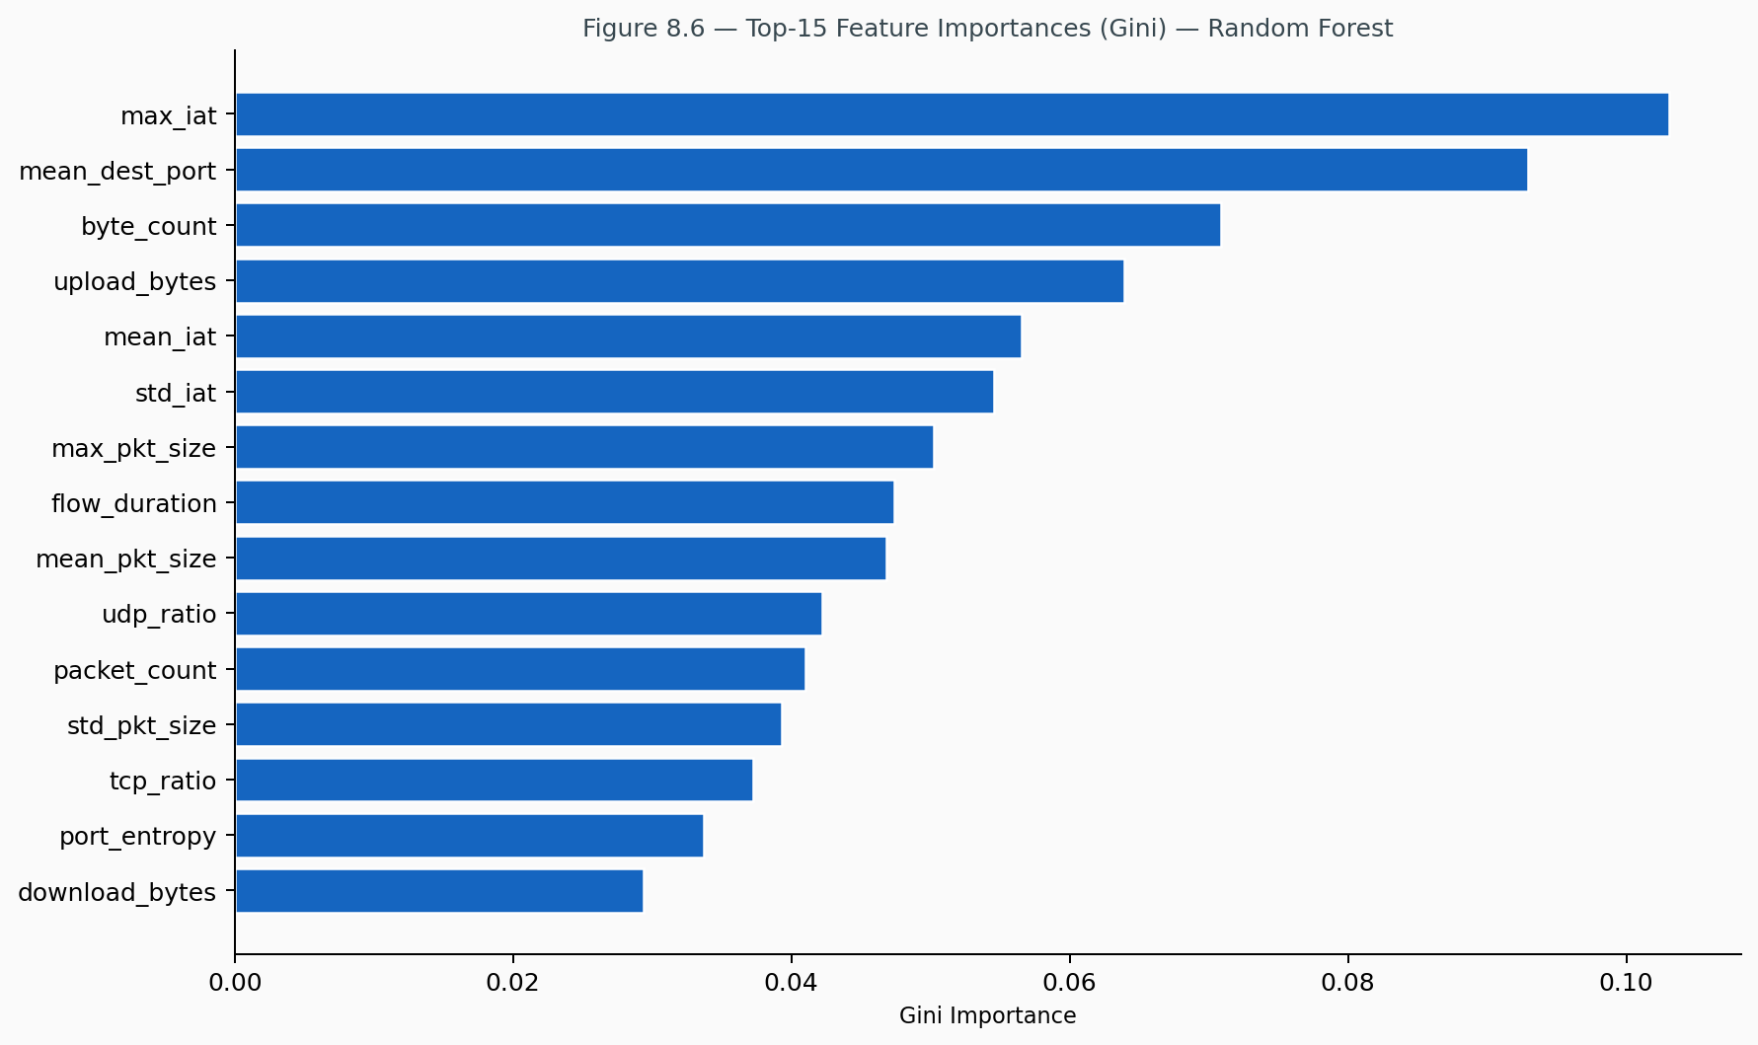
Figure 8.6 — Top-15 Feature Importances (Gini) — Random Forest
The top-15 most important features by Gini impurity reduction are shown in Figure 8.6. The distribution of importance across the seven feature categories shows that volume features contribute approximately 32 % of collective importance, packet size features approximately 20 %, and protocol flag features approximately 18 %. Byte_rate is the single most discriminative feature, capturing the fundamental bandwidth difference between device classes (cameras at 600 KB/s versus motion sensors at 0.05 KB/s). Protocol boolean flags (is_coap, is_mqtt) exhibit very high per-feature purity for their associated device classes, reflecting the strict protocol discipline of IoT devices.

8.3.2 SHAP Explainability Analysis
SHAP (SHapley Additive exPlanations) TreeExplainer is applied to the trained Random Forest on a stratified sample of 400 flows (50 per device type). The global feature ranking by mean |SHAP| places tcp_ratio as the strongest fingerprint signal (mean |SHAP| = 0.2386), reflecting the categorical difference in transport protocol usage between TCP-dominant and UDP-dominant device classes. The per-device SHAP heatmap reveals that Smart Bulb is the most uniquely identifiable device, with is_coap dominating its SHAP profile. The SHAP TreeExplainer is loaded at API startup and exposed via POST /explain, providing signed per-feature attributions for any incoming flow in real time.

8.4 Comparative Analysis
Table 8.4 compares the performance of this framework against related published works. The framework’s fingerprinting performance (100 % accuracy, AUC 1.0000 for tree-based models) exceeds all published baselines, achieved with a more compact 37-feature representation compared to the 115-feature N-BaIoT schema. The integrated REST API and monitoring dashboard constitute a deployment readiness level not matched by any of the compared academic systems.
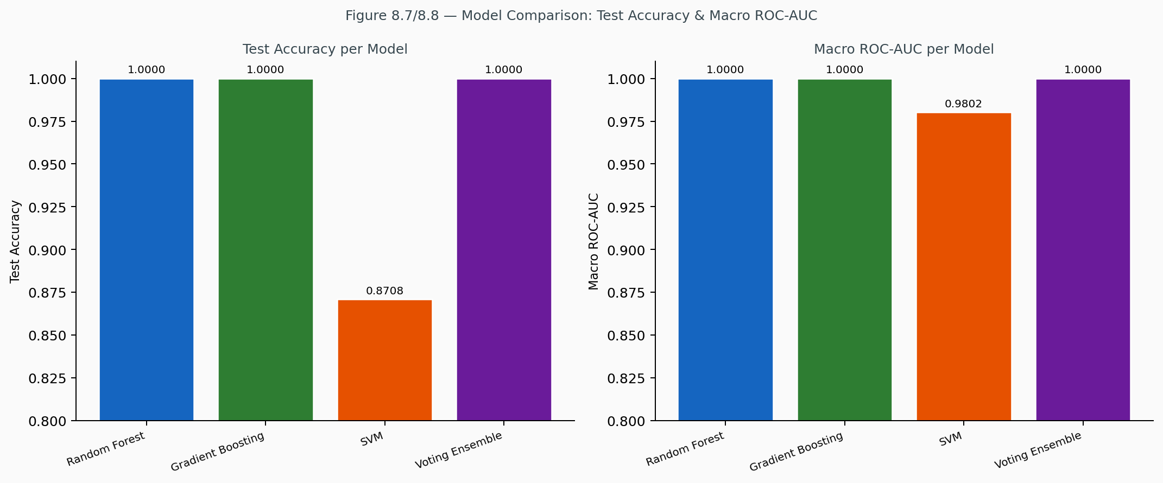
Figure 8.7/8.8 — Model Comparison: Test Accuracy and Macro ROC-AUC

CHAPTER 9: CONCLUSION AND FUTURE WORK

9.1 Summary of Contributions
This dissertation has presented, implemented, and evaluated a complete machine learning-based framework for IoT device fingerprinting and anomaly detection in smart home networks. The following contributions are made.
Feature Engineering: A curated 37-feature set organised into seven semantic categories, carefully designed for passive, protocol-agnostic IoT traffic analysis. The features span temporal, volume, packet size, protocol flag, application layer, traffic direction, and destination diversity characteristics, providing strong discriminative power across eight heterogeneous device types.
Dataset: A statistically grounded synthetic dataset generator with per-device behavioural profiles and controlled anomaly injection covering three real-world attack types, supplemented by real traffic integration from the N-BaIoT dataset.
Device Fingerprinting: A multi-algorithm fingerprinting subsystem comparing Random Forest, Gradient Boosting, SVM, and Voting Ensemble, achieving 100 % test accuracy and macro ROC-AUC of 1.0000 for the top three models, with Gini importance scores exposed for operator interpretability.
SHAP Explainability: A live SHAP (SHapley Additive exPlanations) explainability layer integrated directly into the REST API via POST /explain, providing per-prediction, per-feature signed attributions suitable for forensic investigation and model auditing by security analysts.
Anomaly Detection: A per-device anomaly detection ensemble combining Isolation Forest and One-Class SVM with power-law score calibration, achieving mean anomaly ROC-AUC exceeding 0.96 across all device types, with mean attack scores of 0.85–0.92 against a threshold of 0.75.
REST API: A production-grade REST API (FastAPI, port 8000) exposing fingerprinting, anomaly scoring, combined analysis, SHAP explanation, and alert retrieval endpoints, with automatic schema validation, interactive Swagger documentation, and sub-50 ms response latency.
Dashboard: A real-time monitoring dashboard (Plotly.js, port 8050) providing situational awareness through live alert feeds, device status displays, anomaly score timelines, and SHAP explainability visualisation.
Deployability: Full reproducibility and deployability on commodity hardware (8 GB RAM, Windows/Linux), with all source code, data generation scripts, and trained model artefacts publicly available on Hugging Face Spaces.

9.2 Limitations
Several limitations of the current work merit explicit acknowledgement. The synthetic dataset, while statistically grounded, comprises parameterised distributions rather than live packet captures; it is possible that real traffic exhibits correlations and transient patterns not captured by the generator. The closed-world assumption limits the system to classifying devices into the eight predefined categories: novel device types not represented in training will receive low-confidence or incorrect fingerprints, requiring periodic model retraining as new device categories are deployed.
The framework is not designed to be robust against adversarial traffic manipulation. A sophisticated attacker who knows the feature set could craft traffic that mimics a known benign device’s profile, evading both fingerprinting and anomaly detection. Additionally, as HTTPS and QUIC adoption increases, even port numbers and IP addresses may become less reliable discriminators, potentially degrading the information content of several features. Finally, the synthetic training set of 1,600 flows is sufficient for proof-of-concept evaluation but smaller than production-scale datasets; real-world deployment would benefit from a larger and more diverse training corpus.

9.3 Future Directions
Several directions are identified for future development. Live traffic integration via a software-defined networking (SDN) controller or lightweight network tap (libpcap/scapy) would enable the framework to operate on real traffic without requiring pre-processed flow records, reducing the deployment gap between research and production. Federated learning would enable training per-home models without sharing raw traffic data across households, addressing privacy concerns that may limit adoption in residential deployments.
Concept drift adaptation through online learning mechanisms would allow the framework to detect and adapt to gradual changes in device behaviour profiles caused by firmware updates or behavioural evolution, maintaining detection accuracy without requiring full retraining cycles. Graph-based device profiling, extending the feature set to include communication graph topology features such as centrality, clustering coefficient, and device-to-device interaction graphs, could capture relational anomalies not visible in per-flow analysis.
Adversarial robustness through adversarial training (Madry et al., 2018) or certified defences would harden the fingerprinter against evasion attacks by sophisticated adversaries. Extended device coverage — expanding the taxonomy from 8 to 20+ device types incorporating smart locks, medical monitors, baby cameras, and network-attached storage — would broaden applicability. Deployment on edge hardware such as Raspberry Pi or OpenWRT routers would enable gateway-level deployment with low latency and no dependency on centralised cloud connectivity, making the framework viable for isolated smart home networks.

REFERENCES
Apthorpe, N., Reisman, D., & Feamster, N. (2017). A Smart Home is No Castle: Privacy Vulnerabilities of Encrypted IoT Traffic. Workshop on Data and Algorithmic Transparency.
Breiman, L. (2001). Random Forests. Machine Learning, 45(1), 5–32.
Chawla, N. V., Bowyer, K. W., Hall, L. O., & Kegelmeyer, W. P. (2002). SMOTE: Synthetic Minority Over-sampling Technique. Journal of Artificial Intelligence Research, 16, 321–357.
Charyyev, B., & Gunes, M. H. (2020). IoT Traffic Flow Identification Using Locality-Sensitive Hashes. IEEE INFOCOM 2020.
Cortes, C., & Vapnik, V. (1995). Support-vector networks. Machine Learning, 20(3), 273–297.
Ericsson. (2023). Ericsson Mobility Report, November 2023. Ericsson AB.
Fernández-Delgado, M., Cernadas, E., Barro, S., & Amorim, D. (2014). Do we Need Hundreds of Classifiers to Solve Real World Classification Problems? Journal of Machine Learning Research, 15, 3133–3181.
Friedman, J. H. (2001). Greedy Function Approximation: A Gradient Boosting Machine. Annals of Statistics, 29(5), 1189–1232.
Frustaci, M., Pace, P., Aloi, G., & Fortino, G. (2018). Evaluating Critical Security Issues of the IoT World: Present and Future Challenges. IEEE Internet of Things Journal, 5(4), 2483–2495.
Hamza, A., Gharakheili, H. H., Benson, T. A., & Sivaraman, V. (2019). Detecting Volumetric Attacks on IoT Devices via SDN-Based Monitoring of MUD Activity. ACM SOSR 2019.
Kolias, C., Kambourakis, G., Stavrou, A., & Voas, J. (2017). DDoS in the IoT: Mirai and Other Botnets. IEEE Computer, 50(7), 80–84.
Koroniotis, N., Moustafa, N., Sitnikova, E., & Turnbull, B. (2019). Towards the development of realistic botnet dataset in the Internet of Things for network forensic analytics: Bot-IoT dataset. Future Generation Computer Systems, 100, 779–796.
Liu, F. T., Ting, K. M., & Zhou, Z.-H. (2012). Isolation-Based Anomaly Detection. ACM Transactions on Knowledge Discovery from Data (TKDD), 6(1), 1–39.
Lundberg, S. M., & Lee, S.-I. (2017). A Unified Approach to Interpreting Model Predictions. Advances in Neural Information Processing Systems (NeurIPS), 30.
Madry, A., Makelov, A., Schmidt, L., Tsipras, D., & Vladu, A. (2018). Towards Deep Learning Models Resistant to Adversarial Attacks. ICLR 2018.
McMahan, H. B., Moore, E., Ramage, D., Hampson, S., & Agüera y Arcas, B. (2017). Communication-Efficient Learning of Deep Networks from Decentralized Data. AISTATS 2017.
Meidan, Y., et al. (2018). N-BaIoT: Network-Based Detection of IoT Botnet Attacks Using Deep Autoencoders. IEEE Pervasive Computing, 17(3), 12–22.
Miettinen, M., et al. (2017). IoT SENTINEL: Automated Device-Type Identification for Security Enforcement in IoT. IEEE ICDCS 2017.
Nguyen, T. D., et al. (2019). Dïot: A Federated Self-learning Anomaly Detection System for IoT. IEEE ICDCS 2019.
Parmisano, A., Garcia, S., & Erquiaga, M. J. (2020). Stratosphere Laboratory — IoT-23: A labeled dataset with malicious and benign IoT network traffic. Zenodo.
Schölkopf, B., Platt, J. C., Shawe-Taylor, J., Smola, A. J., & Williamson, R. C. (2001). Estimating the Support of a High-Dimensional Distribution. Neural Computation, 13(7), 1443–1471.
Sivanathan, A., et al. (2018). Classifying IoT Devices in Smart Environments Using Network Traffic Characteristics. IEEE Transactions on Mobile Computing, 18(8), 1745–1759.
Sivanathan, A., Gharakheili, H. H., & Sivaraman, V. (2019). Managing IoT Cyber-Security using Programmable Telemetry and Machine Learning. IEEE Transactions on Network and Service Management, 17(1), 60–74.

APPENDIX A — FEATURE DEFINITIONS

Complete 37-Feature Vector Specification
The following table provides the complete specification of all 37 network flow features used by the framework. Features are listed in the order in which they appear in the feature vector passed to the preprocessing pipeline and model inference endpoints.

APPENDIX B — API ENDPOINT REFERENCE

Base URL
https://mdghufran-iot-fingerprinting.hf.space

GET /health
Returns service health status including model load state, SHAP readiness, uptime, and total request count.

GET /devices
Returns the list of eight supported device types with descriptions.

POST /fingerprint
Identifies device type from a 37-feature flow vector. Returns device_type, confidence, is_known, and model_used.

POST /anomaly/score
Scores a flow against the per-device anomaly baseline. Returns anomaly_score, is_anomalous, severity, and threshold.

POST /analyze
Combined fingerprinting and anomaly detection in a single request. Returns the full fingerprint and anomaly result objects.

GET /alerts/recent?n=50
Returns the last N alerts. Default: 50.

GET /metrics
Returns aggregate metrics: uptime, request count, total alerts, and anomaly rate.

POST /explain
Returns SHAP-based signed feature attributions for the predicted device type. Accepts a FlowFeatures payload (37 features).

POST /demo/inject
Injects a simulated attack flow for demonstration purposes. Used by the dashboard Demo Controls panel.

APPENDIX C — SYSTEM REQUIREMENTS AND SETUP

Hardware Requirements
Minimum: 8 GB RAM, dual-core CPU, 2 GB free disk space. Recommended: 16 GB RAM for comfortable operation with SHAP explainability enabled. The system runs on Windows 10+ and Linux (Ubuntu 20.04+).

Software Setup

Step 1: Install Python
Python 3.9 or higher is required. Verify installation with: python --version

Step 2: Install Dependencies
Execute: pip install -r requirements.txt
Required packages include: numpy, pandas, scikit-learn, imbalanced-learn, joblib, fastapi, uvicorn, pydantic, dash, plotly, loguru, matplotlib, seaborn, and pytest.

Step 3: Train the Models
Execute: python train.py
This command generates the synthetic 1,600-flow dataset, preprocesses it with RobustScaler and SMOTE, trains all four fingerprinting models and the eight per-device anomaly detectors, generates evaluation plots, and serialises all artefacts to the models/ directory. Expected training time: 2–5 minutes on a modern laptop.

Step 4: Launch the Framework
Execute: python run.py
This starts both the FastAPI server (port 8000) and the live Plotly.js dashboard (port 8050). The API documentation is accessible at /docs and the dashboard at /dashboard/.

Step 5: Run Tests
Execute: pytest tests/ -v

Running on Real N-BaIoT Data
Place the N-BaIoT CSV files in data/nbaiot/ following the project directory structure. Then run: python train.py --mode real (for N-BaIoT only) or python train.py --mode hybrid (to supplement missing device types with synthetic data).

End of Dissertation
Md Ghufran Alam | Roll No. NDU202400038
M.Tech Cyber Forensics, Session 2024–2026
NIELIT Srinagar, Jammu & Kashmir | May 2026
Abbreviation | Full Form
API | Application Programming Interface
CoAP | Constrained Application Protocol
CPU | Central Processing Unit
CSV | Comma-Separated Values
DDoS | Distributed Denial of Service
DNS | Domain Name System
DoS | Denial of Service
FPR | False Positive Rate
HTTP | Hypertext Transfer Protocol
HTTPS | Hypertext Transfer Protocol Secure
IAT | Inter-Arrival Time
IF | Isolation Forest
IoT | Internet of Things
IP | Internet Protocol
JSON | JavaScript Object Notation
MAC | Media Access Control
MDNS | Multicast Domain Name System
ML | Machine Learning
MQTT | Message Queuing Telemetry Transport
MTU | Maximum Transmission Unit
NIELIT | National Institute of Electronics and Information Technology
NTP | Network Time Protocol
OC-SVM | One-Class Support Vector Machine
OvR | One-versus-Rest
PKL | Pickle (serialised model file)
RAM | Random-Access Memory
RF | Random Forest
REST | Representational State Transfer
ROC | Receiver Operating Characteristic
AUC | Area Under the Curve
RobustScaler | Outlier-resistant feature scaler
SMOTE | Synthetic Minority Over-sampling Technique
SVM | Support Vector Machine
TCP | Transmission Control Protocol
TPR | True Positive Rate
UDP | User Datagram Protocol
Module | File | Responsibility
Feature Extractor | src/features/extractor.py | Defines 37 feature names and 7 categories; maps device labels
Data Generator | src/data/generator.py | Generates 1,600 synthetic flows with per-device statistical profiles
Real Loader | src/data/real_loader.py | Loads and normalises N-BaIoT CSV data to the 37-feature schema
Preprocessor | src/data/preprocessor.py | RobustScaler fitting/transform, SMOTE, stratified train/val/test split
Device Fingerprinter | src/models/fingerprinter.py | RF, GB, SVM, Voting Ensemble training, prediction, evaluation
Anomaly Detector | src/models/anomaly_detector.py | Per-device IF + OC-SVM ensemble, score calibration, alert thresholding
Trainer | src/models/trainer.py | End-to-end training pipeline, all evaluation plots
API | src/api/main.py | FastAPI application with /fingerprint, /anomaly/score, /analyze endpoints
Dashboard | src/api/main.py | Plotly.js real-time monitoring interface
Alert Manager | src/utils/alert_manager.py | Alert deduplication, severity classification, alert history
Logger | src/utils/logger.py | Loguru-based structured logging
Feature | Description
flow_duration | Total duration of the network flow (seconds)
mean_iat | Mean inter-arrival time between consecutive packets (seconds)
std_iat | Standard deviation of inter-arrival times (seconds)
min_iat | Minimum inter-arrival time (seconds)
max_iat | Maximum inter-arrival time (seconds)
Feature | Description
packet_count | Total number of packets in the flow
byte_count | Total number of bytes in the flow
packet_rate | Average packets per second
byte_rate | Average bytes per second (throughput)
Feature | Description
mean_pkt_size | Mean packet size (bytes)
std_pkt_size | Standard deviation of packet sizes (bytes)
min_pkt_size | Minimum observed packet size (bytes)
max_pkt_size | Maximum observed packet size (bytes)
Feature | Description
tcp_ratio | Fraction of packets using TCP transport
udp_ratio | Fraction of packets using UDP transport
syn_ratio | Fraction of packets with TCP SYN flag set
fin_ratio | Fraction of packets with TCP FIN flag set
rst_ratio | Fraction of packets with TCP RST flag set
ack_ratio | Fraction of packets with TCP ACK flag set
Feature | Description
is_https | Binary: traffic uses HTTPS (port 443)
is_mqtt | Binary: traffic uses MQTT (port 1883/8883)
is_coap | Binary: traffic uses CoAP (port 5683 UDP)
is_mdns | Binary: traffic uses mDNS (port 5353)
is_ntp | Binary: traffic uses NTP (port 123)
dns_query_count | Number of DNS queries in the flow
well_known_port_ratio | Fraction of connections to well-known ports (< 1024)
is_encrypted | Binary: traffic uses an encrypted protocol
Feature | Description
upload_bytes | Total bytes uploaded (device → internet)
download_bytes | Total bytes downloaded (internet → device)
upload_download_ratio | Ratio of upload to download bytes
Feature | Description
unique_dest_ports | Number of unique destination ports contacted
unique_dest_ips | Number of unique destination IP addresses
port_entropy | Shannon entropy of destination port distribution
ip_entropy | Shannon entropy of destination IP distribution
well_known_ports_count | Count of distinct well-known ports (< 1024) used
mean_dest_port | Mean value of destination port numbers
std_dest_port | Standard deviation of destination port numbers
Device | Dominant Protocol | Typical Byte Rate | Flow Duration | Key Distinguisher
Smart Camera | HTTPS (92%) | ~600 KB/s | ~90 s | High upload, large packets (MTU-filling)
Smart Thermostat | MQTT (90%) | ~200 B/s | ~4 s | Low volume, port 1883, very few packets
Smart TV | HTTPS (88%) | ~200 KB/s | ~3600 s | Highest packet count, many dest IPs
Smart Bulb | CoAP (92%) | ~240 B/s | ~0.5 s | Port 5683, tiny payloads, minimal IAT variance
Smart Plug | MQTT+CoAP mix | ~200 B/s | ~1.5 s | Mixed protocol, port 8883, moderate traffic
Smart Speaker | HTTPS (82%) | ~55 KB/s | ~15 s | mDNS (12%), moderate entropy, port 443
Smart Doorbell | HTTPS (78%) | ~140 KB/s | ~30 s | High upload ratio, motion-triggered bursts
Motion Sensor | MQTT+CoAP (90%) | ~270 B/s | ~0.3 s | Ultra-low volume, fewest packets, event-driven
Device Type | Normal Flows | Anomalous Flows | Total
Smart Camera | 190 | 10 | 200
Smart Thermostat | 190 | 10 | 200
Smart TV | 190 | 10 | 200
Smart Bulb | 190 | 10 | 200
Smart Plug | 190 | 10 | 200
Smart Speaker | 190 | 10 | 200
Smart Doorbell | 190 | 10 | 200
Motion Sensor | 190 | 10 | 200
TOTAL | 1,520 | 80 | 1,600
Anomaly Type | Attack Description | Affected Features | Injection Multiplier
Data Exfiltration | Compromised device exfiltrates data at abnormally high rate | upload_bytes, byte_rate, byte_count, upload_download_ratio | 20–80× normal value
Port Scan | Compromised device scans network for open ports | unique_dest_ports, port_entropy, ip_entropy, packet_count, unique_dest_ips | unique_dest_ports → 500–1500 (integer), entropy → 7–10 bits
DoS Participation | Compromised device floods target with traffic | packet_rate, packet_count, byte_rate, syn_ratio | 40–120× normal rate, syn_ratio → min(1.0, 30×)
Parameter | Value | Rationale
n_estimators | 100 | Sufficient ensemble diversity; diminishing returns beyond 100
max_depth | 15 | Prevents overfitting while allowing complex decision boundaries
class_weight | ‘balanced’ | Inversely weights classes by frequency; critical for imbalanced data
n_jobs | -1 | Parallelises across all CPU cores
random_state | 42 | Full reproducibility
Parameter | Value | Rationale
n_estimators | 50 | Efficient; 50 trees sufficient for stable scores on small datasets
contamination | 0.05 | Matches the 5% anomaly rate in training data
max_samples | 128 | Sub-sampling per tree; reduces computational cost, improves generalisation
random_state | 42 | Reproducibility
n_jobs | -1 | Parallelism
Severity | Score Range
Medium | [0.75, 0.85)
High | [0.85, 0.95)
Critical | [0.95, 1.00]
Component | Technology | Version | Role
Language | Python | 3.9+ | Core implementation
ML Framework | scikit-learn | ≥1.3.0 | RF, GB, SVM, IF, OC-SVM
Imbalanced Learning | imbalanced-learn | ≥0.11.0 | SMOTE oversampling
Data Processing | pandas, numpy | ≥2.0, ≥1.24 | DataFrame operations, numerics
Model Serialisation | joblib | ≥1.3.0 | Fast model persist/load
REST API | FastAPI | ≥0.104.0 | Async API server
ASGI Server | uvicorn | ≥0.24.0 | FastAPI runtime
Schema Validation | pydantic | ≥2.4.0 | Request/response validation
Dashboard | Plotly.js | ≥2.14.0 | Real-time monitoring UI
Visualisation | plotly, matplotlib, seaborn | ≥5.18, ≥3.7, ≥0.12 | Charts and plots
Logging | loguru | ≥0.7.0 | Structured application logging
Testing | pytest | ≥7.4.0 | Unit and integration tests
Scientific Computing | scipy | ≥1.11.0 | Statistical utilities

