Food Wastage EDA Project Report

# Introduction

This project aims to analyze food wastage in relation to staff experience, special events, temperature, and humidity. By understanding patterns in the dataset, we can propose strategies to minimize food waste and optimize staff allocation. The dataset includes key variables such as food wastage (in kg), staff experience levels (Beginner, Intermediate, etc.), special event occurrence (0 = No, 1 = Yes), ambient temperature, and humidity percentage.

# Data Cleaning

* **Missing Values:** Checked for missing entries; none found in key variables.
* **Duplicates:** After removing the ID column, duplicate rows were identified and removed to avoid skewing the analysis.
* **Data Types:** Variables were properly typed: food wastage, temperature, and humidity as numerical, while staff experience and special events as categorical.
* **Categorical Data:** Staff experience was treated as an ordered categorical variable (Beginner < Intermediate < Expert…). Special event was treated as binary categorical (0=No or 1=Yes).
* **Feature Transformation**: The past_waste_kg column represented food waste from the **previous day**. To better align the variable with current-day analysis, it was shifted using.shift(-1) to create a new column today_waste_kg, effectively making the data more relevant for day-level comparisons. The original past_waste_kg column was then dropped.

# Exploratory Data Analysis (EDA)

* **Summary Statistics:**
  + Food wastage had a right-skewed distribution, with most values between 0-500kg.
  + Temperature mostly ranged between 10°C and 40°C.
  + Humidity ranged between 30% and 90%.
* **Visualizations:**
  + Histogram: To understand the distribution of numerical features like meals_served, temperature_C, humidity_percent, and today_waste_kg.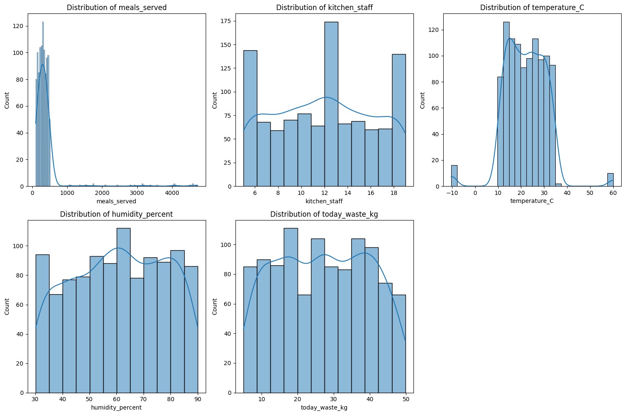Box Plot: To detect outliers and understand the spread of the data. 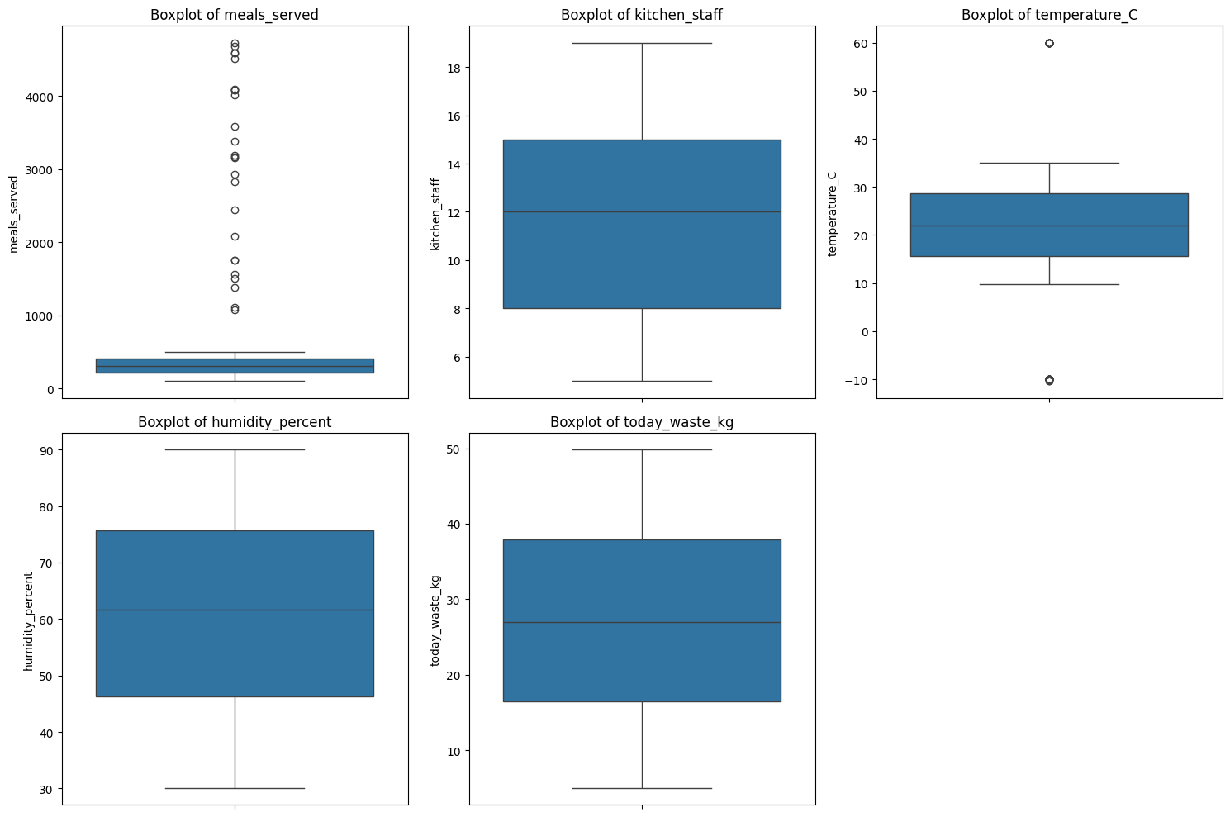
  + Bar Chart:  To visualize categorical variables like staff_experience and waste_category. 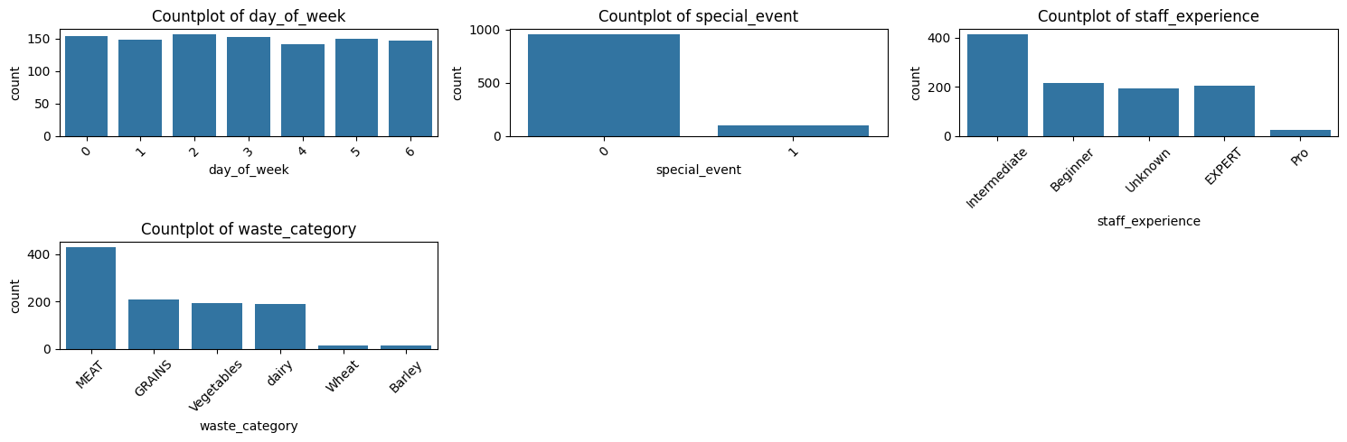
* **Key Trends:**
  + There were outliers in meals served and temperature kept these outliers because meals served are higher on special events, and it’s a true fact, similarly temperature is a natural phenomenon.

# Correlation Analysis

* **Heatmap:**
  + Very little Positive correlation between food wastage and special events.
  + Mild correlation between food wastage and temperature.
  + Very little correlation between food wastage and humidity. 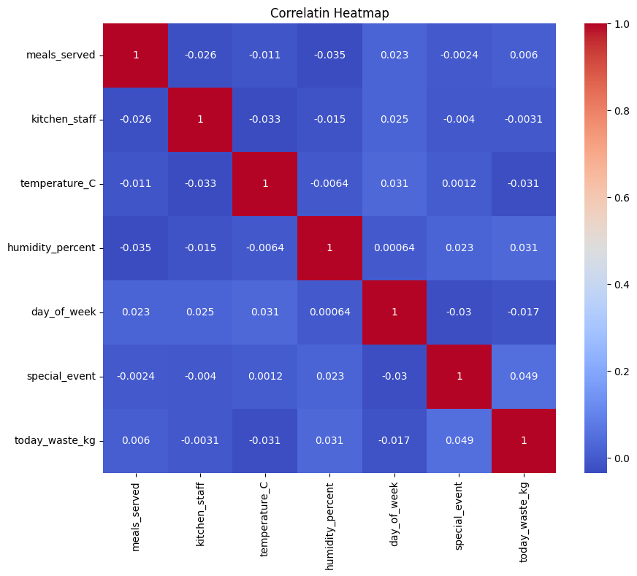
* **Grouped Box Plot:**
  + By seeing this plot, it can be seen that food wastage was lower on average when the staff was more experienced.

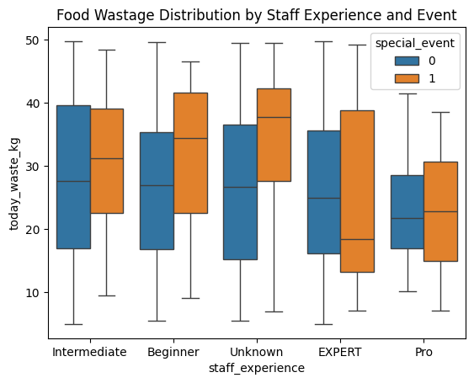

* **Interpretation:**
  + By seeing heatmap it can be seen that food wastage is not related to number of meals served, temperature and humidity, or any other variable.
  + By seeing this grouped box plot it can be seen that food wastage was lower when the staff was more experienced.

# Hypothesis Testing

**Impact of Kitchen Staff on Food Waste:**

* **Hypotheses:**
  + **H0:** There is no relationship between the number of kitchen staff and food waste.
  + **H1:** The number of kitchen staff significantly affects food waste.
* **Tests Used:**
  + Conducted a **one-way ANOVA** to compare food waste across low, medium, and high staff levels.
* **Results:**
  + The **F-statistic was 1.765** and the **p-value was 0.172,** which is **greater than 0.05.**
* **Conclusion:**
  + **Null hypothesis is true**, there is **no statistically significant evidence** that the number of kitchen staff affects food waste.

**Special Events and Food Waste:**

* **Hypotheses:**
  + **H0:** There is no significant difference in food wastage between special event days and normal days.
  + **H1:** Food wastage is significantly higher on special event days.
* **Tests Used:**
  + Conducted an **independent samples t-test** between food wastage on event vs. non-event days.
* **Results:**
  + The **t-statistic was 1.554** with a **p-value of 0.123**, which is **greater than 0.05**.
* **Conclusion:** **Null hypothesis is true**, there is **no statistically significant evidence** that food wastage is higher during special events.

# Key Insights and Recommendations

* **Insights:**
  + There is **no statistically significant evidence** that the number of kitchen staff affects food waste.
  + There is **no statistically significant evidence** that food wastage is higher during special events.
  + There is **no statistically significant evidence** that food wastage is dependent on temperature or humidity.
  + **Food wastage tends to be lower** when **more experienced staff** areinvolved**.**
* **Recommendations:**
  + **Prioritize assigning more experienced staff** to kitchen shifts, especially during high-demand periods or special events.
  + **Invest in staff training and development** to improve overall experience levels and reduce food waste over time.

# Conclusion

In conclusion, the analysis shows clear patterns between staff experience and food wastage. Training for beginners could significantly help reduce food wastage. Although temperature has a small effect, it is not as impactful as staff experience. Future analysis could explore other factors like customer count, menu types, and inventory management.