

Department of Computer Science Course Code: CNS 303
Course Title: Cloud Computing Fundamentals

Spring 2026

Lab 03

Objective:
Implementation of SAAS and PAAS services.

Student Information

Student Name | Ghulam Abbas
Student ID | 23SP-039-CS
Date
Assessment
Marks Obtained
Remarks
Signature

What are the types of cloud computing?
Cloud computing is providing developers and IT departments with the ability to focus on what matters most and avoid undifferentiated work like procurement, maintenance, and capacity planning. As cloud computing has grown in popularity, several different models and deployment strategies have emerged to help meet the specific needs of different users. Each type of cloud service, and deployment method, provides you with different levels of control, flexibility, and management. Understanding the differences between traditional cloud computing models—Infrastructure as a Service (IaaS), Platform as a Service (PaaS), and Software as a Service (SaaS)—and what deployment strategies you can use can help you decide what set of services is right for your needs.
While the industry has traditionally used terms like IaaS, PaaS, and SaaS to group cloud services, at Cloud provider is focusing on solutions to your needs, which can span many service types. This page uses the traditional service grouping of IaaS, PaaS, and SaaS to help you decide which set is right for your needs and the deployment strategy that works best for you.
IaaS
Contains the basic building blocks for cloud IT and typically provides access to networking features, computers (virtual or on dedicated hardware), and data storage space. IaaS vendors can help you with the highest level of flexibility and management control over your IT resources and is the type most similar to existing IT resources that many IT departments and developers are familiar with.
PaaS
Vendors remove the need for organizations to manage the underlying infrastructure (usually hardware and operating systems), and this integration allows you to focus on the deployment and management of your applications. This helps you be more efficient, as you don’t need to worry about resource procurement, capacity planning, software maintenance, patching, or any of the other undifferentiated heavy lifting involved in running your application.
SaaS
Vendors provide you with software applications that are run and managed by the vendor. In most cases, people referring to SaaS are referring to third-party end-user applications. With a SaaS offering you do not have to worry about how the service is maintained or how the underlying infrastructure is managed; you only need think about how you will use that particular piece of software. A common example of a SaaS application is web-based email where you can send and receive email without having to manage feature additions or maintain the servers and operating systems that the email program is running on.
Hybrid
Deployment is a way to connect infrastructure and applications between cloud-based resources and existing resources that are not located in the cloud. The most common method of hybrid deployment is between the cloud and existing on-premises infrastructure, to extend and grow an organization's infrastructure into the cloud while connecting cloud resources to internal system.

Odoo Inventory as a SaaS Solution
Feature | Description
Name | Odoo Inventory Management
Type | SaaS-based ERP Module
Delivery | Hosted on Odoo’s cloud platform – accessed via browser
Users | Businesses managing stock, warehouses, purchase, and sales orders

How Odoo Inventory Works as SaaS

Cloud Deployment
Odoo hosts the application and database on its servers.
Users log in via a web browser (https://www.odoo.com) – no local installation needed.

Multi-Tenant Architecture
Multiple clients use the same Odoo platform, but each has its own isolated data.
This ensures security and scalability.

Subscription-Based Access
Businesses pay per user/month for access.
Plans scale with business size and features.

Automatic Updates & Maintenance
Odoo handles software updates, bug fixes, and server maintenance automatically.
Users always work with the latest version.

Scalability
As inventory operations grow (e.g., new warehouses, SKUs, or users), the SaaS system scales without needing new hardware or local setup.

Using Odoo

Create an account

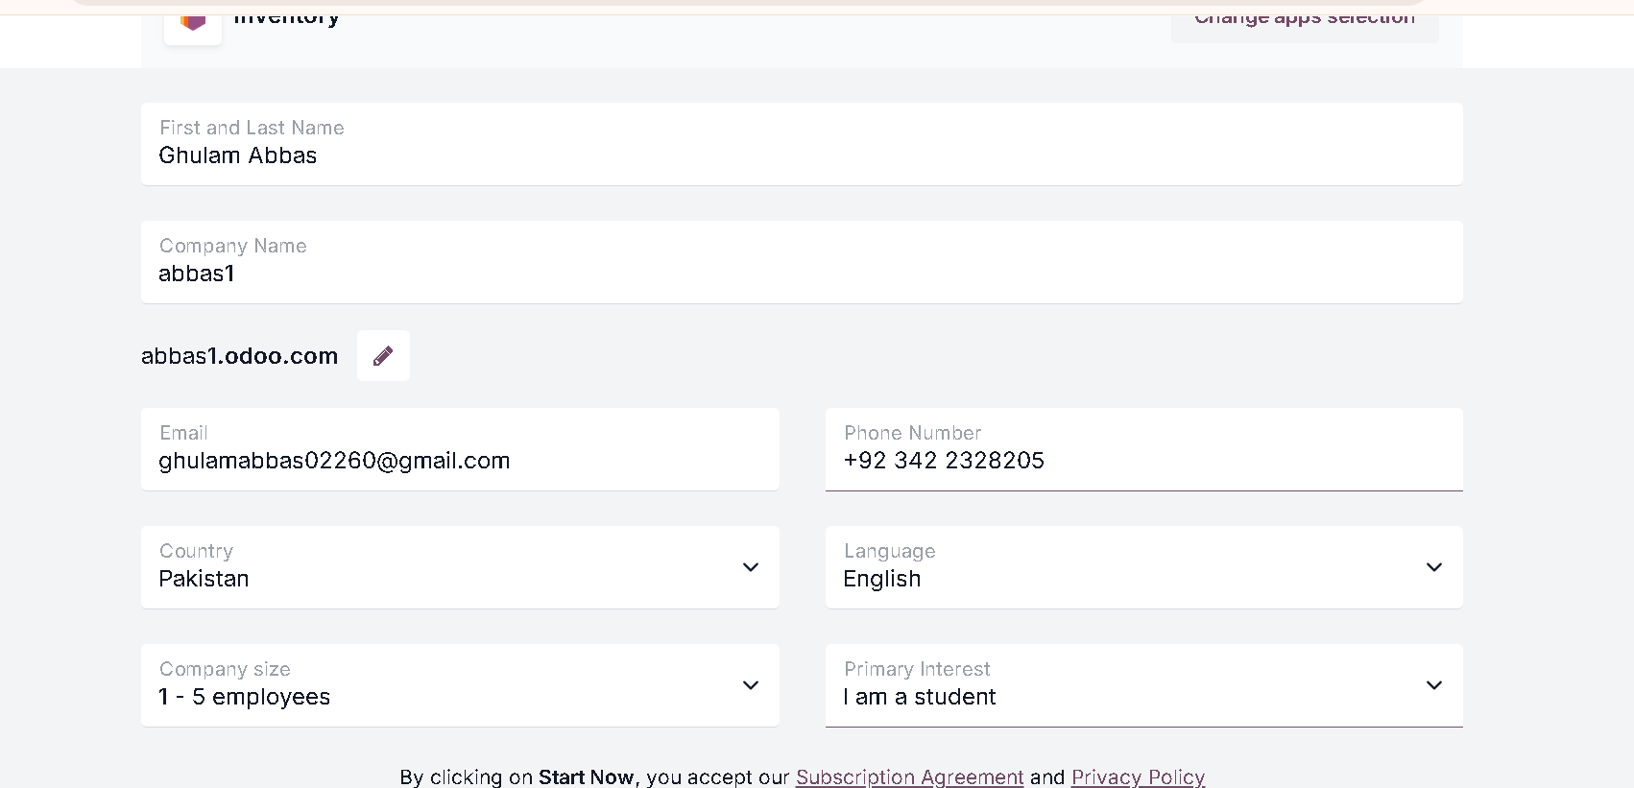

Odoo Dashboard with recent notification
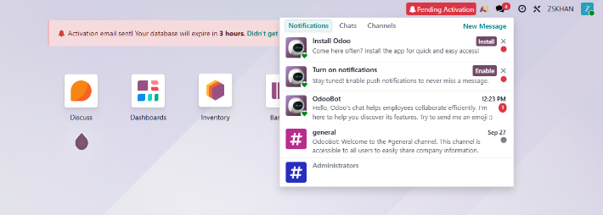
Activation required else account expire in 3hrs
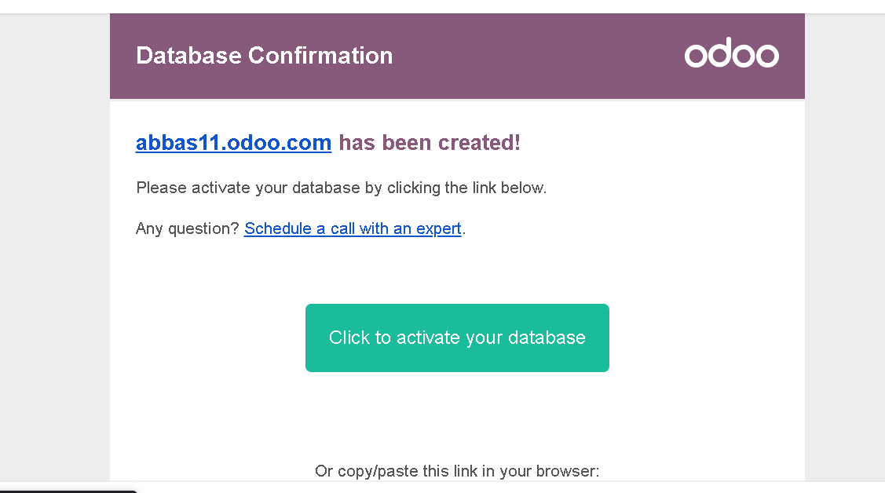

Prompt Appear After successful activation
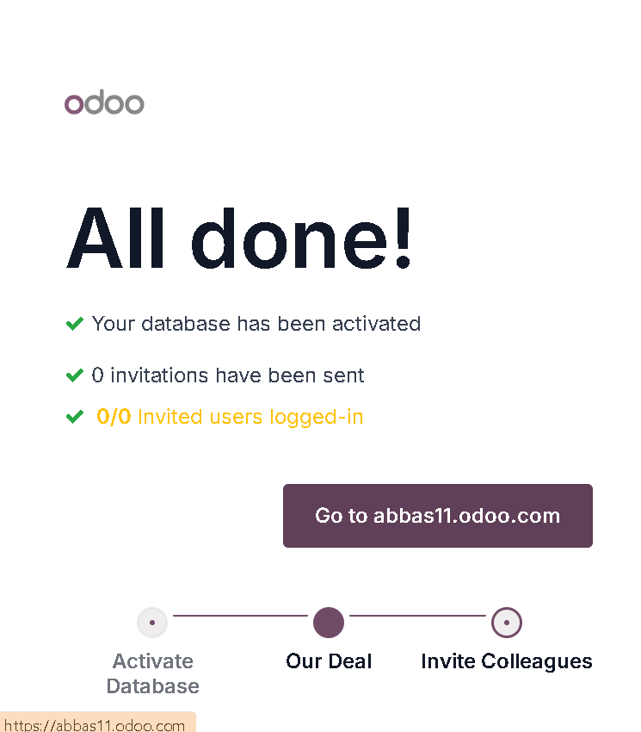

Odoo dashboard

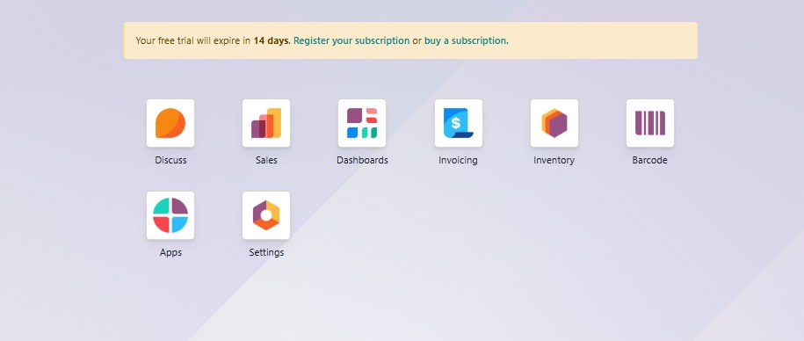

Using Odoo for inventory (Product and receipt)

Step 1 – Add a Product
Go to Inventory → Products → Products → Create
Fill in:
Product Name
Product Type → Stockable Product
Unit of Measure → (e.g., Units)
(Optional) Under Inventory tab: enable Tracking (if you want lots/serial numbers).
Click Save
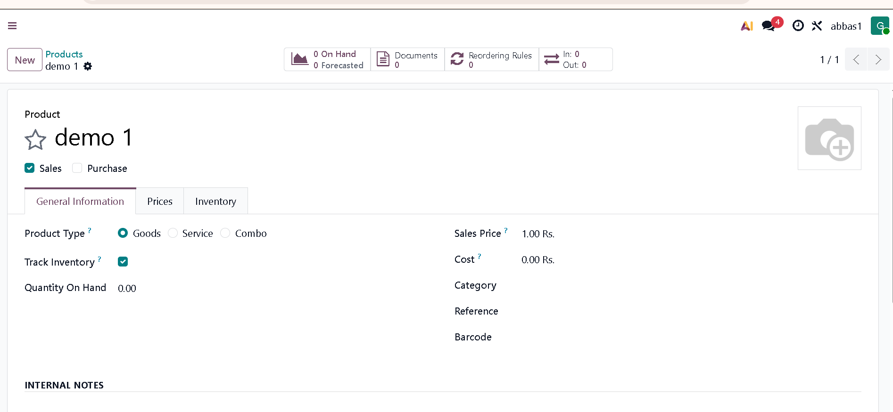
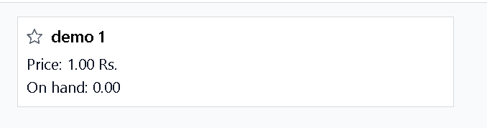
Step 2 – Receive Products (Inbound / Receipt)
Go to Inventory → Operations → Receipts
Click Create
Select Vendor and Add Product
Enter quantity and Save
Click Validate to confirm the receipt
Inventory stock will increase.

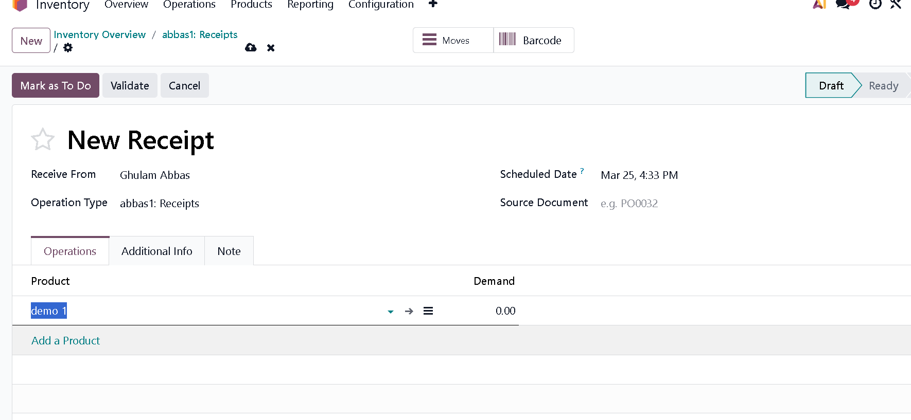
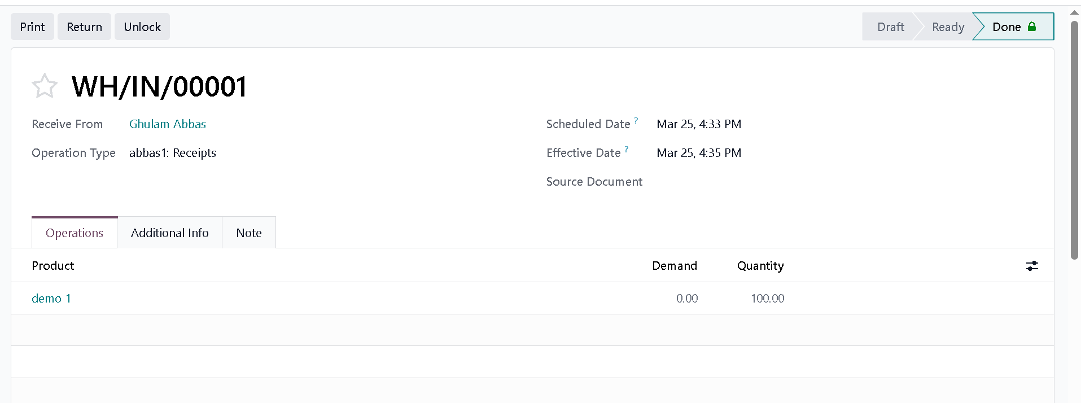

Step 3 – Deliver Products (Outbound / Delivery)
Go to Inventory → Operations → Delivery Orders
Click Create
Select Customer and Add Product
Enter quantity and Save
Click Validate to complete the delivery
Inventory stock will decrease.
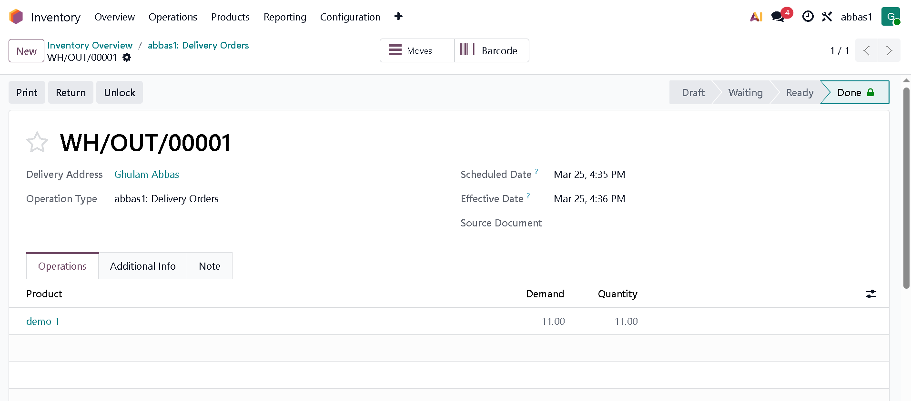

PAAS Deployment On NETLIFY
Deploying your GitHub project on Netlify offers a straightforward way to bring your web applications to life. This guide provides a detailed, step-by-step process to help you deploy your project efficiently.

Step 1: Log Into Netlify
Begin by navigating to Netlify’s website. Click on “Log in” to access your account or create one if you haven’t already.
Press enter or click to view image in full size
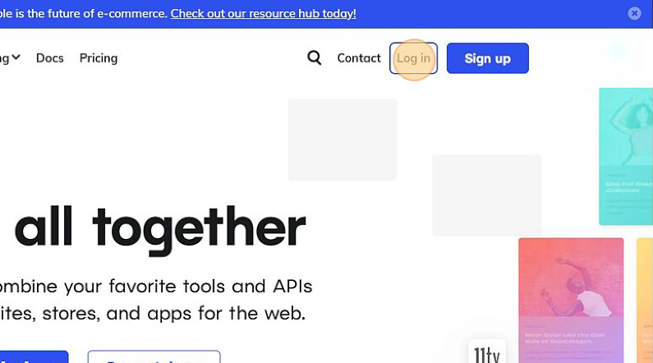

Step 2: Start a New Site
Once logged in, click on “Add new site” from the main dashboard to initiate the process of setting up a new site.
Press enter or click to view image in full size
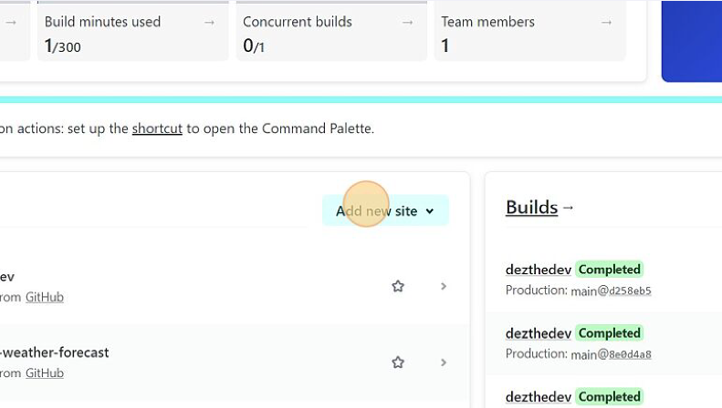
Step 3: Import Your Project
Select “Import an existing project” to proceed with deploying a project that you have hosted on GitHub.
Press enter or click to view image in full size
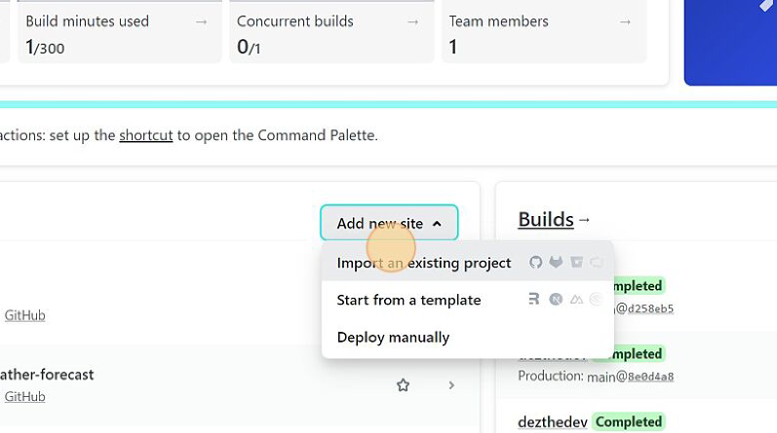
Step 4: Connect to GitHub
Click on “GitHub” to link Netlify to your GitHub account. This action allows Netlify to access your repositories.
Press enter or click to view image in full size
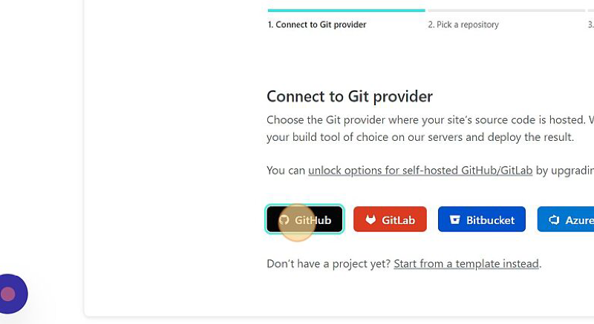
Step 5: Select Your Repository
In the “Search repos” field, type the name of your repository and press ENTER. Select the desired repository from the list that appears.
Press enter or click to view image in full size
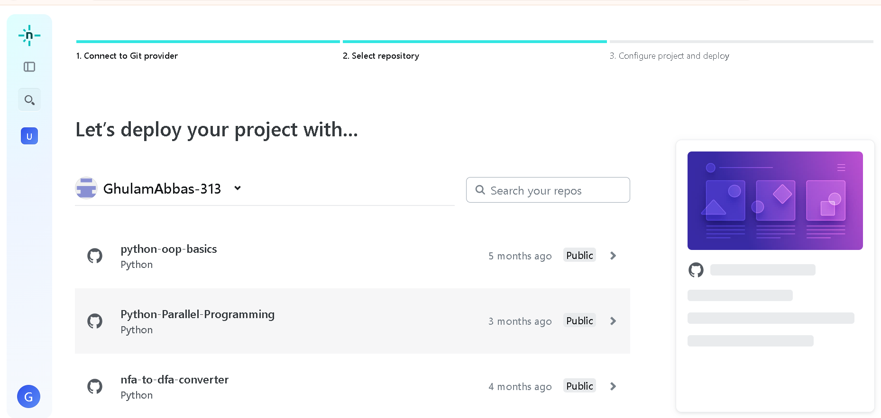
Press enter or click to view image in full size

Step 6: Advanced Settings (Optional)
If you need to add environment variables or modify build settings, click on “Show advanced.” Here, you can configure additional settings based on your project’s requirements.
Press enter or click to view image in full size
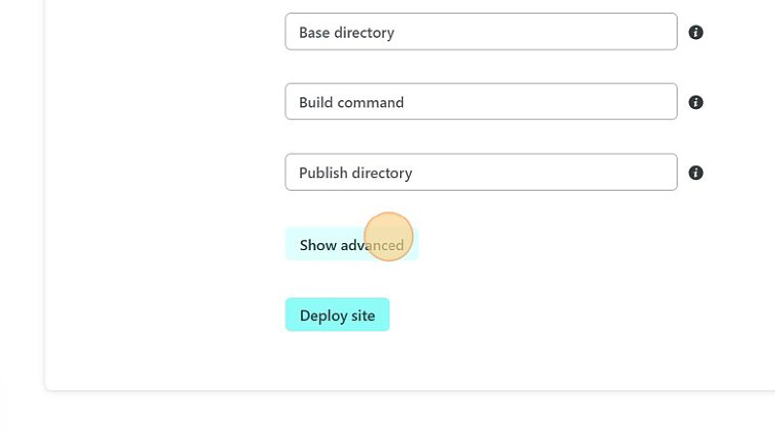
Step 7: Deploy Your Site
After configuring your settings, click on “Deploy site.” Netlify will start building and deploying your project, which may take a few minutes.
Press enter or click to view image in full size
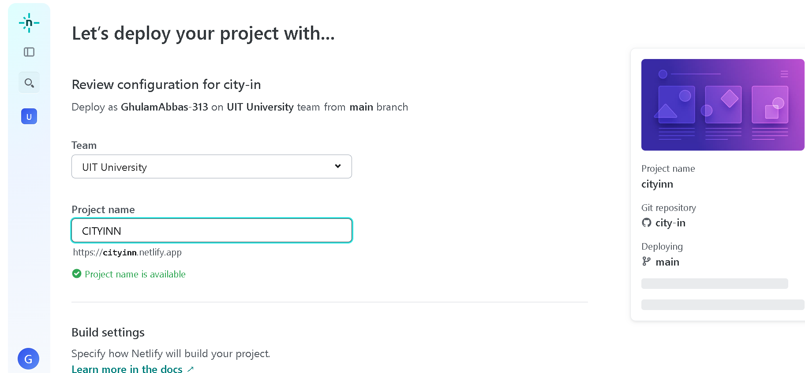

Step 8: Configure Site Settings
Post-deployment, click on “Site settings” and then “Change site name” if you wish to customize the default URL assigned by Netlify.

Step 9: Update Site Name
In the “Site name” field, type the new name for your website. This name will become part of your project’s URL on Netlify.

Step 10: Save and Go Live
Click “Save” to apply your changes. Wait a few minutes for Netlify to update your settings, then click on your website link to view your hosted website.
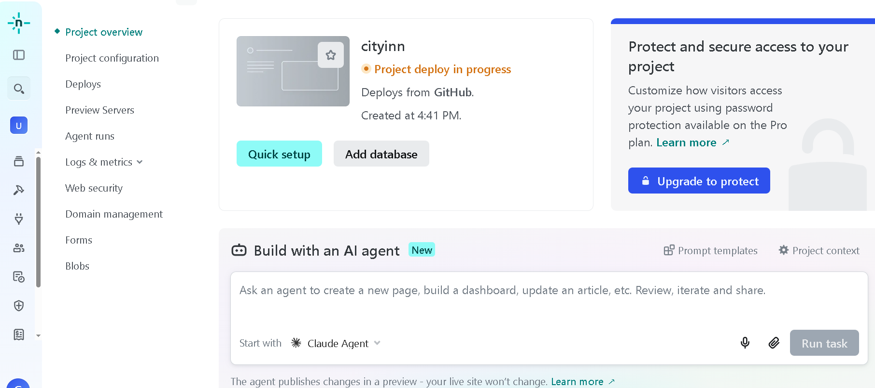
TASK:

- Configure the Odoo Inventory and sales for an small organisation.
- Deploy the website over netlify through the git directory.

