

Department of Computer Science Course Code: CNS 303
Course Title: Cloud Computing Fundamentals

Spring 2026

Lab 06

Objective:
Implementation of applications over Containers

Student Information

Student Name | Ghulam Abbas
Student ID | 23sp-039-cs
Date
Assessment
Marks Obtained
Remarks
Signature

Docker Networking Concepts & Lab Manual (Beginner to Advanced)

Task:
- Create 3 containers two of them ping each other and one cannot ping to other two.

Two cont on same network

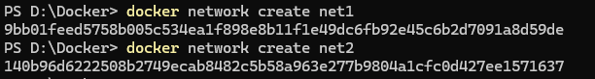

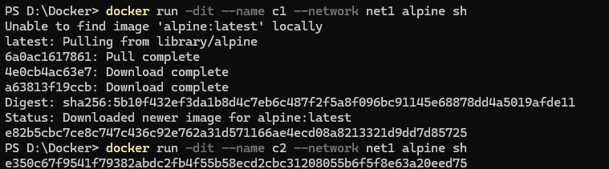

Net 3 open diff network

Ping C2
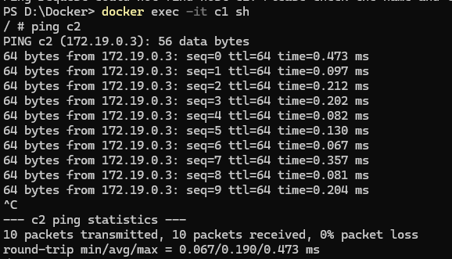

Ping c1
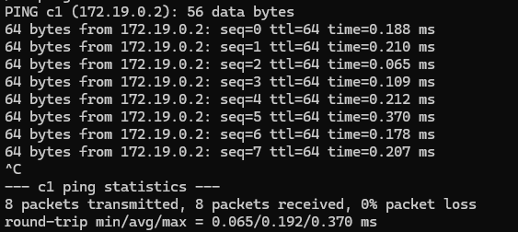

- Push react/Flutter base website front end to the docker hub.

React website:
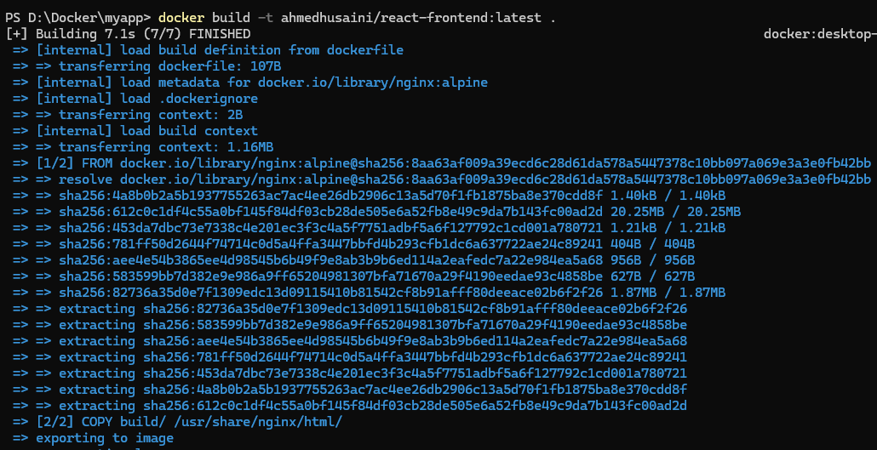

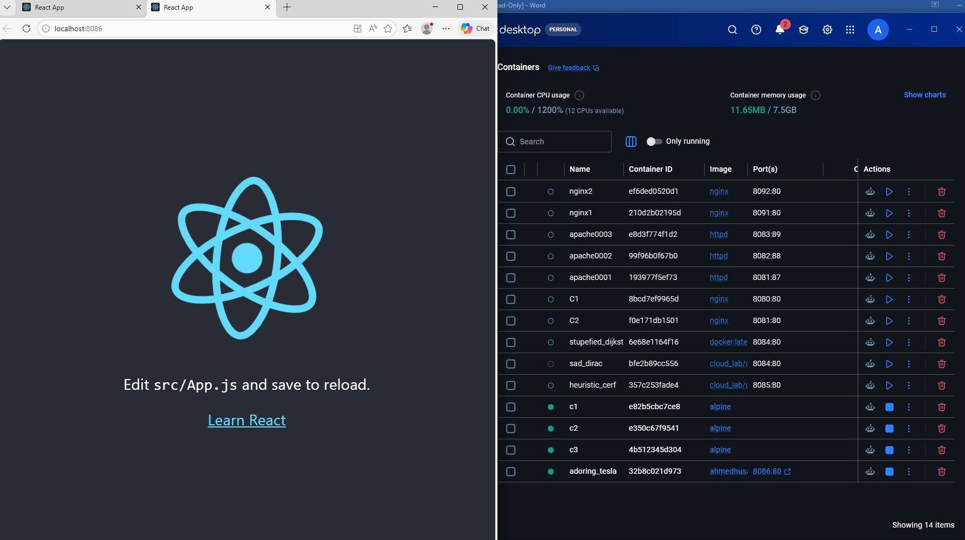

- Pushed website will be accessible to other nodes.

