

Department of Computer Science Course Code: CNS 303
Course Title: Cloud Computing Fundamentals

Spring 2026

Lab 08

Objective:
Implementation of applications over Containers

Student Information

Student Name | Ghulam Abbas
Student ID | 23sp-039-cs
Date
Assessment
Marks Obtained
Remarks
Signature

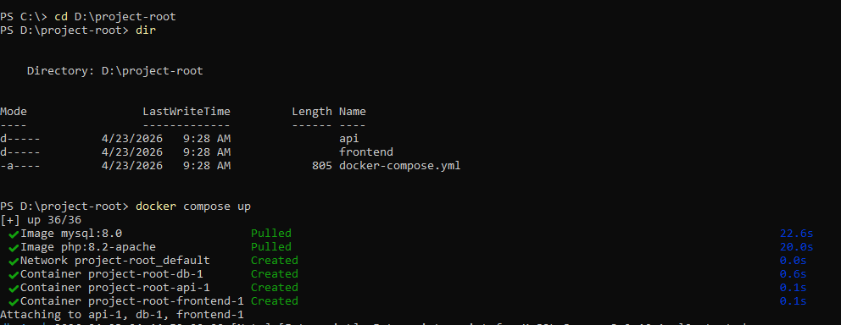
- Open terminal in the project root directory.

- Execute "docker-compose up -d" to build and start services.
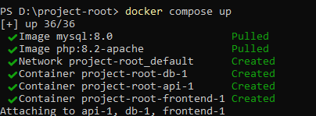
- Check status with "docker-compose ps".

- Open http://localhost:8080 in your browser.

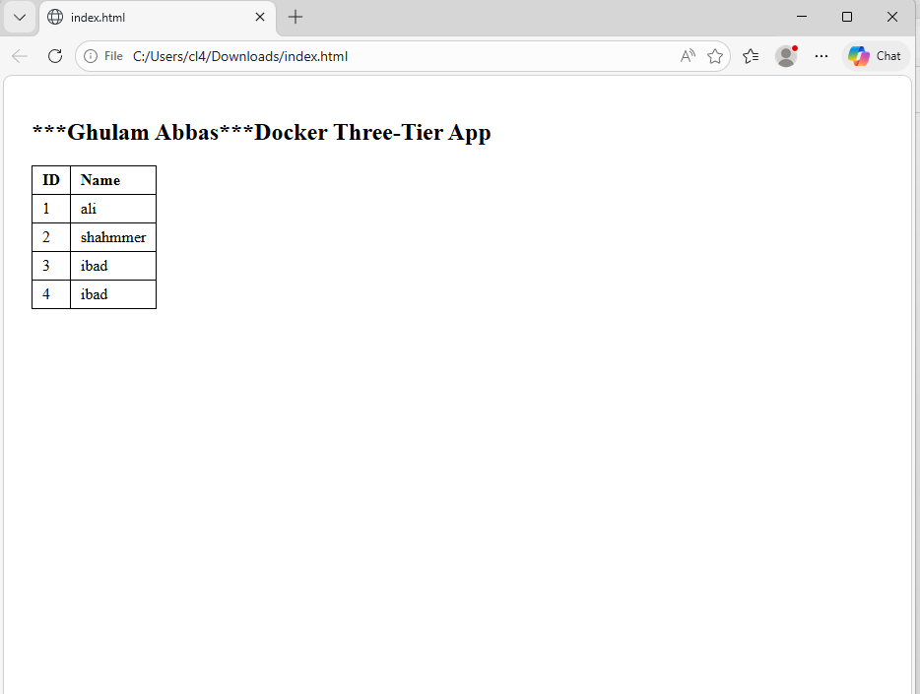

- To stop the lab, use "docker-compose down".
