**THE SCHOLAR’S GRAMMAR SCHOOL**

Final Term Examinations, March 2016

Class : III Date : --2016

Subject : Computer Time : 3 Hours

Student’s Name : _________________ Max. Marks : 100

**Attempt all questions.**

**Q. No. 1.** Fill in the blanks. (05)

1. Laptop computer is very ________.
2. Esc is a short form of ________.
3. The longest key on the keyboard is ________.
4. Computer never gets ________.
5. The work of pressing the key is called ________.

**Q. No. 2.** Write the missing letters. (08)

i) INT__RN__T ii) WINDO__S iii) VI__US

iv) R__M v) SCA__ __NER vi) ABAC__S

**Q. No. 3.** Matching the correct keys. (06)

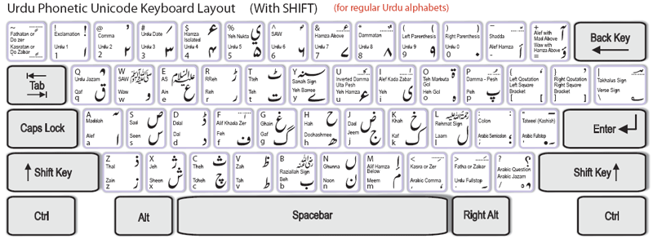

Used with other key

 Used as eraser

 Gives space between two words

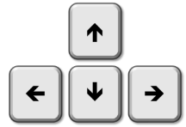 Moves the cursor to the next line

 If ON, types capital letters

Moves the cursor around the screen

**Q. No. 4.** Answer the following questions. (15)

1. Where the deleted folder goes? Describe.
2. How to change the clicking of mouse?
3. How to refresh the page?
4. What is control panel?
5. How to change the screen saver in Windows 7?

**Q. No. 5.** Write a short note on “Printer”. (06)

**Q. No. 6.** Practical of: **Professional Skills on computer.** (60)