**THE SCHOLAR’S GRAMMAR SCHOOL**

Final Term Examinations, March 2016

Class : VI Date : --2016

Subject : Mathematics Time : 3 Hours

Student’s Name : _________________ Max. Marks : 100

**Attempt all questions.**

**Q. No. 1.** **(a)** Add the following. (05)

i) 8.074 + 69.908 + 576.654 ii) 287.6938 + 63.574 + 0.9756 + 9.027

**(b)** Multiply the following. (05)

i) 37.064 × 235 ii) 7.28 × 29

**Q. No. 2.** Round of data. (05)

i) 59 ii) 548 iii) 1493 iv) 985 v) 4650

**Q. No. 3.** Are the following numbers divisible by 2, 3, 4 and 6. (write answer is in yes or no) (05)

i) 128 ii) 345 iii) 750 iv) 1250 v) 446

**Q. No. 4.** Find the factors of the following up to 15. (05)

i) 100 ii) 80 iii) 92 iv) 110 v) 75

**Q. No. 5.** Solve the brackets. (10)

i) $[\{\left(2×2\right)+\left(4+2\right)\}×3]$ ii) $[\{\left(5+1\right)-2\}×4]$

**Q. No. 6.** **(a)** Add the following. (05)

i) $6a+7a+2a$ ii) $23b+4b+17b+2a$

**(b)** Subtract (05)

i) ${-x}^{4}+{3x}^{3}-x^{2}+x-8 from {2x}^{4}+{5x}^{3}+{3x}^{2}-x+2$

ii) ${-2b}^{2}+6 from {2b}^{2}+2$

**Q. No. 7.** **(a)** Find the union of the following. (10)

i) $X=\left\{a,b,c,d,e,f\right\}$, $Y=\left\{a,e,i,o,u\right\}$ ii) $A=\left\{3, 4, 5\right\}$, $B=\left\{2, 4, 5, 6, 7\right\}$

iii) $X=\left\{a,b,c,d\right\}$, $Y=\left\{a,d,b,c\right\}$ iv) $A=\left\{3, 4, 5\right\}$, $B=\left\{5, 6, 7\right\}$

**Q. No. 8. (a)** Draw a circle of the following measurements with help of compass. (10)

i) 3.5 cm ii) 2.5 cm iii) 4 cm iv) 1.9 cm

**(b)** Draw angles of the following measurement with the help of protector. (10)

i) 600 ii) 900 iii) 450 ii) 1200

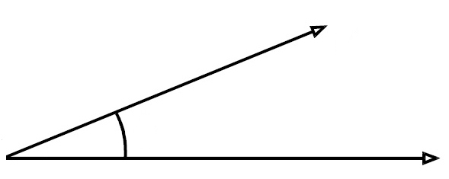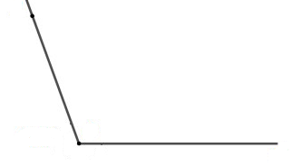**(c)** Measure the following angles with the help of compass. (05)

i) ii)

**Q. No. 9.** Game (10)

How many squares are there in the given square?

**Q. No. 10.** Oral Tables (10)