Cribbage Pegboard Mobile App Report

Aime Celeste Thayer

Western Governors University

**Table of Contents**

Summary 3

Review of Other Work 3

Changes to the Project Environment 4

Methodology 5

Project Goals and Objectives 5

Project Timeline 6

Unanticipated Requirements 7

Conclusions 7

Project Deliverables 7

References 9

# Summary

The cribbage pegboard mobile app allows a user to carry around only two items (their phone + playing cards) where before, enthusiasts had to carry around three items (playing cards + a cribbage pegboard, while presumably their phone always goes with them everywhere). The mobile application also saves users’ win record and scores (either 121 for wins, or the exact score value =<120 if lost) to enable betting/settling wagers based on relative scores. People enjoy the speed of the game, the chance to use basic math skills, and potentially the competitive aspects.

In this project, we experienced four phases of work: first, program estimation; second, creation of wireframes and artwork; third, software implementation, and finally, quality assurance. We also wrote two reports related to the program and its execution, a proposal document and this final report.

# Review of Other Work

In addition to the review of other work completed in the proposal document and included in Prior Review section (following), we found additional artifacts that supported the development of our cribbage pegboard mobile app.

First, we watched a compilation video of talks from GDC (Game Developer’s Conference) called Tech Toolbox for Game Programmers (Various, 2017). This gave the student developer a good idea of some of the best practices, tools, and other solutions that we used to help guide game development, and open the student’s eyes to sometimes nontraditional “hacks” that helped with brainstorming solutions whenever she got stuck.

Next, we took lots of valuable information on Java from the Oracle documentation. (n.a., n.d.) We looked at the Essential Java Classes, Date-Time APIs, and 2D Graphics sections at times we needed more information – first, just to get started with Essential Java Classes, and then later to access details of the Date, Time, and Graphics sections when those became relevant during our development process.

The final resource that we used to support the development of our application is a tutorial on hooking up a MySQL database to a Java application (Sridhar, 2018), because that’s where our developer experienced some issues that required additional guidance. Primarily, we examined the drivers section and the specific example code so that we could find mistakes in syntax and driver usage.

**Prior Review**

When reviewing relevant related works, we reviewed four online articles from both academic / educational and news sources. These primarily had to do with the rules and experience of playing cribbage, as there are few online or mobile cribbage apps, and no related white papers or research studies (at least, not that we were able to find).

Using these resources, we settled on an authoritative rule set and developed guidelines to attempt to craft an experience that is equivalent to those described online. Some players play cribbage competitively, and we wanted to develop a mobile app which was suitable for both casual players and more-serious competitors. For example, one user stated “I like the speed of the game and having to make decisions quickly…With all the adding and counting, it helps keep you sharp.” Another user in that same article stated “You can’t predict the outcome…Things can change in a flash. You might be at the end of a game and need two points to win while your opponent needs 22 and he can end up beating you. It’s not over until it’s over.” (Klemenc, 2013)

## Relation of Prior Review, Above, to Project Development

In “Cribbage: it’s not just a game, it’s an obsession”, we found anecdotes explaining why users choose to play cribbage and information about how cribbage tournaments might be run. We also learned that a wide variety of people (i.e. different ages, professions, and relationships to one another) play cribbage. These users also play cribbage frequently – some as often as daily. We found this an encouraging reason to develop a cribbage app – since it’s only a fun game if people play it!

When reading about tournaments in this same article, we learned, “small local tournaments where players typically are seated at a long table and play nine games with different opponents, with play normally taking two to three hours. Players ante up $7 a night to play, with $5 going into the winners’ kitty and $2 toward expenses and various grass root prizes, plaques, certificates, jackets, clocks and trophies, which are awarded throughout the year depending on various accomplishments. … Winners also may accumulate grass roots points that help their ACC standing.” (Klemenc, 2013) which may offer interesting aspects for future releases of the cribbage app! At first we’ll replicate the scoring only, but in the future we might add relevant tutorials or tournament gameplay aspects.

In the “Rules of Cribbage”, we learned the official rules of cribbage, including the mechanics of play, how to shuffle and cut the cards, how to deal, where to put the crib cards, choosing a starter card, play order and rules of play, how to peg one’s points, how to count, and many other details of the game mechanics – all of this information either directly informs the gameplay of cribbage in our app, or the help text / tutorial we could choose to include in the app or future versions of it. (The American Cribbage Congress, 2018)

In “Amusing Cribbage Facts”, we learned some of the statistics relevant to cribbage play, details on how to call out one’s score, and the relative percentage likelihood of drawing certain card combinations. We also learned that scoring a Jack in-hand is called “his nobs”, but not the origin of the phrase (unfortunately). (Lumetta, n. d.)

Lastly, in the brief article “Facts about cribbage”, we learned about some of the discrepancies of gameplay, e.g. “The first dealer in a game wins 55% to 60% of the time.” (Cribbage Corner, 2010) We also learned more of the language or jargon of playing cribbage, like “There are several 'impossible totals' - point counts which cannot be made with any hand. The lowest such total is 19 - hence the expression 'a nineteen hand', or 'I have nineteen', almost universally (perhaps sarcastically) used to describe a zero-point hand.” (Cribbage Corner, 2010) but perhaps most interesting was the link out to the ***5 scores 2 conjecture*** which demonstrated that any hand containing a 5 card would be worth at least two points, including a Perl program which the interested reader could use to prove that conjecture by simulating a wide variety of hands.

# Changes to the Project Environment

As we outlined in the project proposal: We have a development team consisting of one student. Thus, we found it challenging to do much parallelization in order to speed the program up. However, we did do the simple and straightforward method of clearly outlining the project steps, and then seeing what tasks form the critical path. From there, we kept chugging along.

In order to prepare our student for a career in technology in the future, we performed a form of Agile development, with a “backlog” consisting of all the development steps, and the developer estimating each task before scheduling it. From there, our student tackled the task, saw how close the estimation was, and then picked up a subsequent task. At the end of the program development cycle, our student also did the QA and acceptance testing, comparing what they developed to the expected result.

There are no pre-existing systems and the status is reported / reportable by a single person.

We did experience some changes to the aforementioned environment, primarily in the parallelization of tasking. Our student developer didn’t realize how much time could be lost when stuck on one task or another, so quickly found that, when a task becomes frustrating, switching context is key. This sped up some of the development tasks, such as connecting to a database, where the developer started to get stuck. Moving on to something productive, then reaching out to the internet or a friend for advice, made it quicker to progress forward – spending little or no time on spinning wheels meant that the program development could continue to move along.

# Methodology

In order to develop a cribbage application, we chose a modified form of Agile development, where the developer curated a backlog of tasks and tackled them mostly in order. The student developer estimated each task before taking it on. We then iterated, seeing how close the original estimation was to the total task time required, and then picked up the next task for completion.

We chose to do a sprint retrospective at the end of every day (originally we expected the end of every week, but for one person it made sense to continually see what was working or not). This consisted of a ten minute reflection at the end of each day, proving to be a useful source of self-regulation and feedback for the developer.

# Project Goals and Objectives

The first project goal was to estimate the project and create a set of written artifacts that support the future app development. The written artifacts include the schedule, including all tasks and their proper order; a formal report that codifies the schedule and deliverables; and a user guide that documents the program functionality and its use.

We successfully created these artifacts and consider this goal to be met.

The second project goal is to create the user interface wireframes and all image artifacts, such as the cribbage boards and any icons found within the app and its menus, as well as the main home icon found on the Android apps list on the user’s mobile device.

We successfully created these artifacts and consider this goal, too, to be met.

The third project goal is to implement the software itself, including creating a DB and its schema and hook up all software functionality to the relevant image artifacts.

We successfully implemented a mobile app that links up to a network MySQL DB, created the schema for tables of users and their games / scores, and hooked up the image artifacts to the software functionality. We had some issues with the MySQL DB link to the mobile app, but were able to troubleshoot that with only minimal delay to the project timeline.

The last project goal is to QA that the project behaves as designed, and to write up those findings in an addendum to the project report from goal #1.

We successfully QA’d the program, and verified that it added new users, tracked scores ongoing with the current game, saved new games and allowed users to access old scores, and were able to change between several digital cribbage boards. We consider this project to have met, at a macro level, the project goals and objectives as originally stated.

# Project Timeline

Below, you will find the project timeline table, with milestones for the project including the duration and start and end dates of each milestone. The projected start and anticipated end dates do not always match with the duration because there may be weekends or break days involved; since the student developer works full time as well as attends WGU, the break days do not always correspond with calendar weekends as they might in a typical office environment. Other variances include incorrect duration projections, either tasks moving faster or taking more time than anticipated.

|  |  |  |  |  |  |  |
| --- | --- | --- | --- | --- | --- | --- |
| **Milestone or deliverable** | **Duration**  **(hours or days)** | **Projected start date** | **Anticipated end date** | **Actual start date** | **Actual end date** | **Reason for variance** |
| **Project schedule** | 2 days | 8/1/2018 | 8/3/2018 | 8/1/2018 | 8/3/2018 | n/a |
| **Formal report** | 4 days | 8/4/2018 | 8/10/2018 | 8/4/2018 | 8/8/2018 | Did not take break between tasks |
| **User guide** | 2 days | 8/10/2018 | 8/12/2018 | 8/9/2018 | 8/11/2018 | Prior task finished a little early |
| **Wireframes** | 2 days | 8/14/2018 | 8/16/2018 | 8/13/2018 | 8/15/2018 | Continue to be a little early |
| **Image artifacts** | 3 days | 8/17/2018 | 8/21/2018 | 8/16/2018 | 8/19/2018 | Did not take a break |
| **Icons** | 1 day | 8/22/2018 | 8/22/218 | 8/19/2018 | 8/20/2018 | Continue to be a little early |
| **Software app** | 10 days | 8/23/2018 | 9/5/2018 | 8/21/2018 | 8/29/2018 | Continue to be a little early |
| **QA testing** | 9 days | 9/6/2018 | 9/17/2018 | 8/30/2018 | 9/08/2018 | Continue to be a little early |
| **QA report updates** | 3 days | 9/18/2018 | 9/20/2018 | 9/08/2018 | 9/09/2018 | This went faster than anticipated |

# Unanticipated Requirements

We had surprisingly few unanticipated requirements. Having completed another mobile app for WGU recently, we knew the basic structure and elements of developing a mobile app, and we have had several friends and coworkers develop mobile games that they’ve sold on the App Store and Google Play. Most of the problems we encountered were minor, and related to syntax or logic that was easily managed by either reading online, referring to old coursework, or asking a friend.

Notably, we had the most difficulty troubleshooting our initial DB connection, and read a bit online in order to manage the problems we had with establishing that connection (Sridhar, 2018). Luckily, the steps in that tutorial illuminated the issues we were having related to our driver imports.

# Conclusions

The cribbage pegboard mobile app allows a user to carry around only two items (their phone + playing cards) where before, enthusiasts had to carry around three items (playing cards + a cribbage pegboard, while presumably their phone always goes with them everywhere). The mobile application also saves users’ win record and scores (either 121 for wins, or the exact score value =<120 if lost) to enable betting/settling wagers based on relative scores. We consider this project to be a success now that we have a cribbage application, supporting user guide/documentation, and this final report (inclusive of the results of QA testing). This program is also a success now that we have evaluated that the program as developed matches the proposed project, and our findings have been written into the final report.

We had some of our peers and friends try the application and they enjoy its functionality and ease of use. They offered a good deal of feedback on things like controls that we could iterate upon in future releases.

# Project Deliverables

**Java code:**

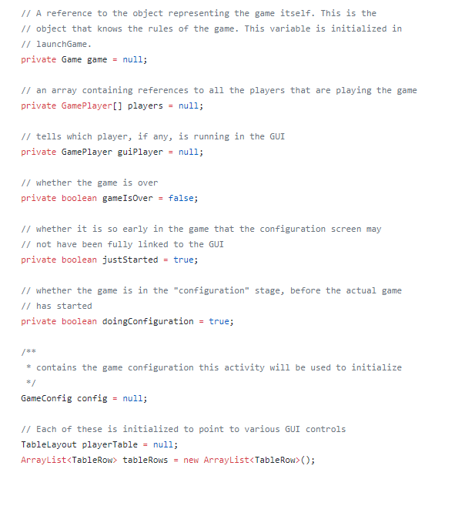  
We wrote code in Java, using the Android Studio application.

**App icons:**



We used app icons in the “Vintage Tiles” style from the app icon maker at iconion.com

**Cribbage boards:**

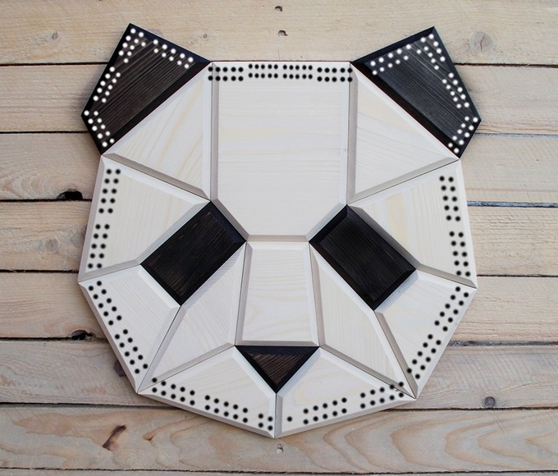

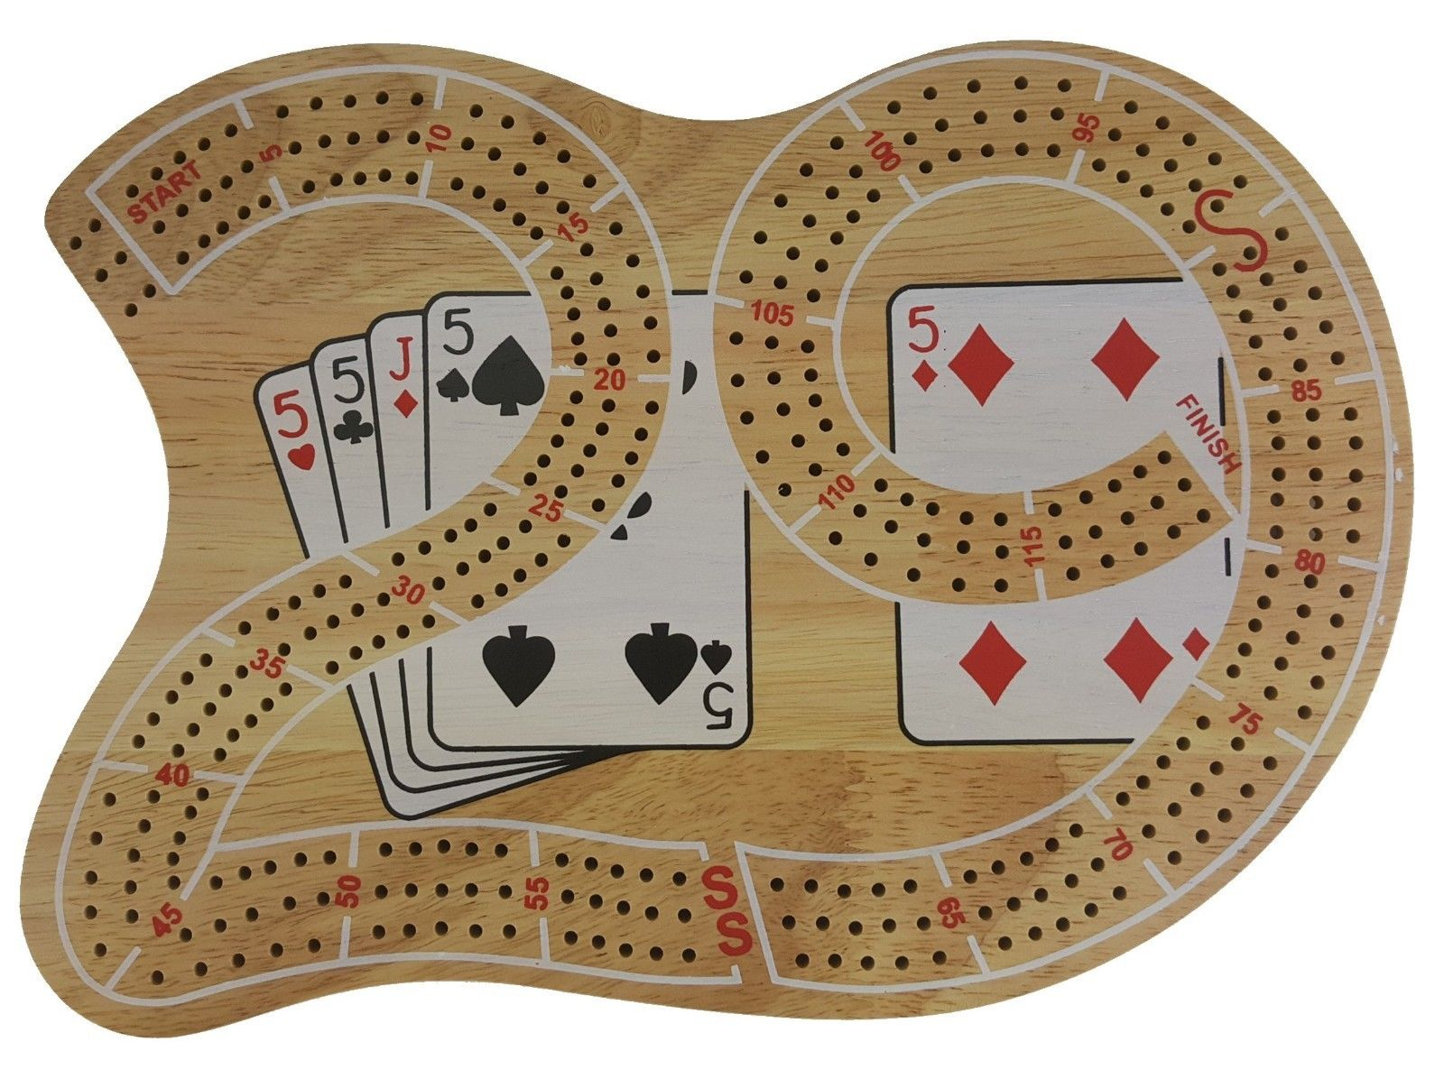

We generated a custom panda cribbage board and a standard 29 board.

**MySQL DB:**

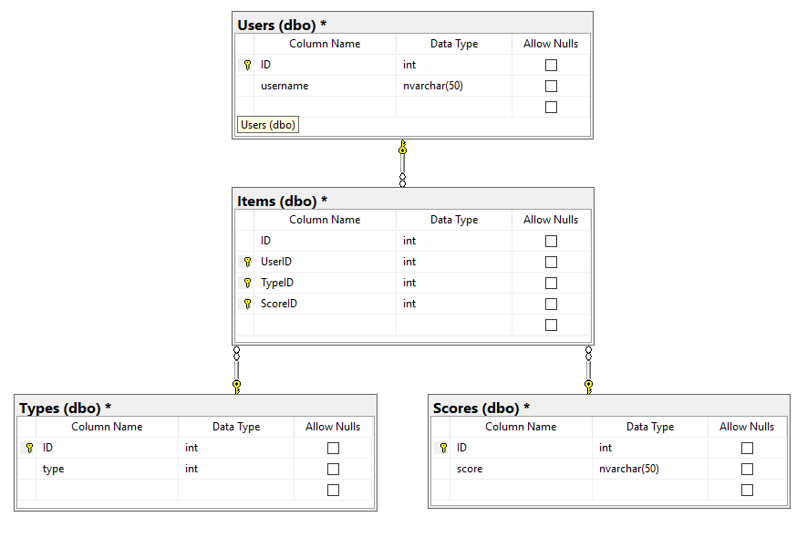

We wrote game end state and user stats to a MySQL DB.

# References

Following is a list of all the outside sources that the narrative refers to in-text:

No author. (No date). The Java™ Tutorials. Retrieved from

<https://docs.oracle.com/javase/tutorial/>

Various. (2017). Tech Toolbox for Game Programmers. Retrieved from https://youtu.be/W_okgL6HJX8

Sridhar, Jay. (2018). How to connect to a MySQL database with Java. Retrieved from <https://www.makeuseof.com/tag/connect-mysql-database-java/>

Klemenc, Stacey Enesey. (2013). Cribbage: It’s not just a game, it’s an obsession. Retrieved from <https://www.militarynews.com/norfolk-navy-flagship/entertainment/on_liberty/cribbage-it-s-not-just-a-game-it-s-an/article_fb6049b2-7b72-50ad-88df-cbb6e9decad7.html>

The American Cribbage Congress. (2018). Rules of Cribbage. Retrieved from <http://www.cribbage.org/NewSite/rules/default.asp>

Lumetta, Steve S. (Accessed August 31, 2018). Amusing Cribbage Facts. Retrieved from <https://web.archive.org/web/20080516084713/http://www.crhc.uiuc.edu/~steve/humor/cribbage.html>

Cribbage Corner. (2010) Facts about cribbage. Retrieved from <http://cribbagecorner.com/facts>