**Coursework 2 – Sequential Circuit Design using Quartus  
Ghusharib Chohan – CID 01500954**

My short-code is MGC18 and hence I was given the number 0029, and so (1+29 = 30) which in binary is 11110. Hence my input code would be 11110. This created the following state transition diagram:

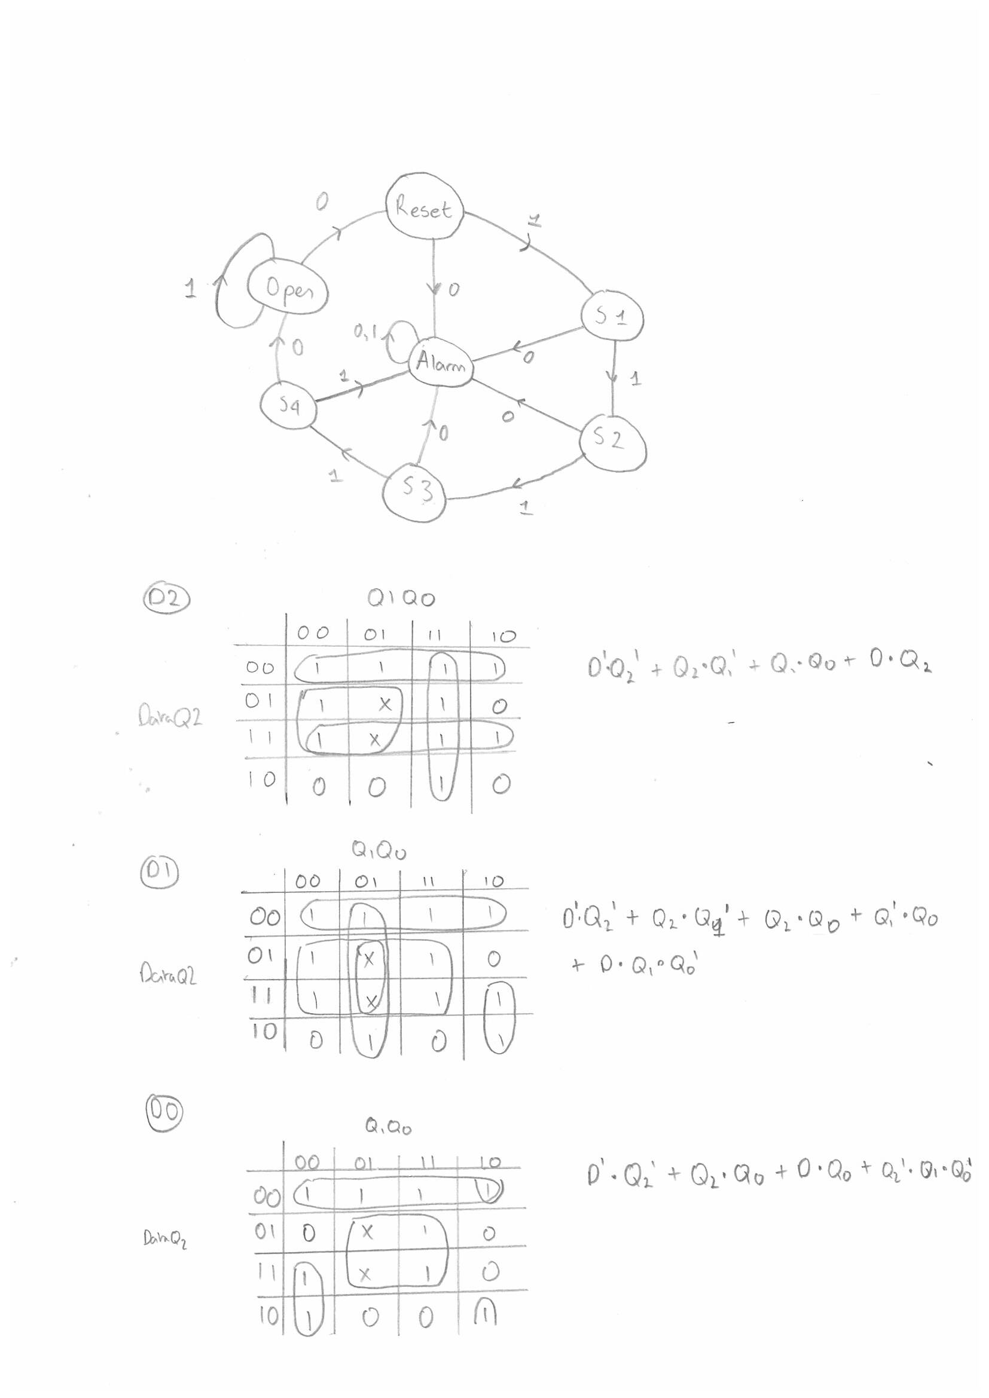

From this I created the truth table:

|  |  |  |  |  |  |  |  |  |
| --- | --- | --- | --- | --- | --- | --- | --- | --- |
| **DATA** | This State | Q2 | Q1 | Q0 | Next State | D2 | D1 | D0 |
| 0 | Reset | 0 | 0 | 0 | Alarm | 1 | 1 | 1 |
| 0 | S1 | 0 | 0 | 1 | Alarm | 1 | 1 | 1 |
| 0 | S2 | 0 | 1 | 0 | Alarm | 1 | 1 | 1 |
| 0 | S3 | 0 | 1 | 1 | Alarm | 1 | 1 | 1 |
| 0 | S4 | 1 | 0 | 0 | Open | 1 | 1 | 0 |
| 0 |  | 1 | 0 | 1 | X | X | X | X |
| 0 | Open | 1 | 1 | 0 | Reset | 0 | 0 | 0 |
| 0 | Alarm | 1 | 1 | 1 | Alarm | 1 | 1 | 1 |
| 1 | Reset | 0 | 0 | 0 | S1 | 0 | 0 | 1 |
| 1 | S1 | 0 | 0 | 1 | S2 | 0 | 1 | 0 |
| 1 | S2 | 0 | 1 | 0 | S3 | 0 | 1 | 1 |
| 1 | S3 | 0 | 1 | 1 | S4 | 1 | 0 | 0 |
| 1 | S4 | 1 | 0 | 0 | Alarm | 1 | 1 | 1 |
| 1 |  | 1 | 0 | 1 | X | X | X | X |
| 1 | Open | 1 | 1 | 0 | Open | 1 | 1 | 0 |
| 1 | Alarm | 1 | 1 | 1 | Alarm | 1 | 1 | 1 |

I then created Karnaugh Maps for the above truth table which gave me the following:



**The Boolean equations generated from this**

D2 = DATA’.Q2’ + Q2.Q1’ + Q1.Q0 + DATA.Q2   
 = DATA’.Q2’ + Q2.(DATA+Q1’) + Q1.Q0

D1 = DATA’.Q2’ + Q2.Q1’ + Q2.Q0 + Q1’.Q0 + DATA.Q1.Q0’  
 = DATA’.Q2’ + Q2.(Q1’+Q0) + Q1’.Q0 + DATA.(Q1.Q0’)

D0 = DATA’.Q2’ + Q2.Q0 + DATA.Q1’.Q0’ + Q2’.Q1.Q0’   
 = DATA’.Q2’ + Q2.Q0 + Q0’.((DATA.Q1’)+(Q2’.Q1))

The good thing to notice from my boolean equations is that the highlighted red equation is common in all three of my equations so it will only need to be implemented once in hardware. Any other simplifications to the circuit will be done at a later point

**Output Logic**

­LOCK – The state for open is 110 so in any other state, the lock should be on. This gives the boolean equation (Q2.Q1.Q0’)’

ALARM - The state for alarm being on is 111 so this gives the boolean equation Q2.Q1.Q0

**Checking the Don’t Cares**

|  |  |  |  |  |  |  |  |  |
| --- | --- | --- | --- | --- | --- | --- | --- | --- |
| **DATA** | This State | Q2 | Q1 | Q0 | Next State | D2 | D1 | D0 |
| 0 | Reset | 0 | 0 | 0 | Alarm | 1 | 1 | 1 |
| 0 | S1 | 0 | 0 | 1 | Alarm | 1 | 1 | 1 |
| 0 | S2 | 0 | 1 | 0 | Alarm | 1 | 1 | 1 |
| 0 | S3 | 0 | 1 | 1 | Alarm | 1 | 1 | 1 |
| 0 | S4 | 1 | 0 | 0 | Open | 1 | 1 | 0 |
| 0 |  | 1 | 0 | 1 | Alarm | 1 | 1 | 1 |
| 0 | Open | 1 | 1 | 0 | Reset | 0 | 0 | 0 |
| 0 | Alarm | 1 | 1 | 1 | Alarm | 1 | 1 | 1 |
| 1 | Reset | 0 | 0 | 0 | S1 | 0 | 0 | 1 |
| 1 | S1 | 0 | 0 | 1 | S2 | 0 | 1 | 0 |
| 1 | S2 | 0 | 1 | 0 | S3 | 0 | 1 | 1 |
| 1 | S3 | 0 | 1 | 1 | S4 | 1 | 0 | 0 |
| 1 | S4 | 1 | 0 | 0 | Alarm | 1 | 1 | 1 |
| 1 |  | 1 | 0 | 1 | Alarm | 1 | 1 | 1 |
| 1 | Open | 1 | 1 | 0 | Open | 1 | 1 | 0 |
| 1 | Alarm | 1 | 1 | 1 | Alarm | 1 | 1 | 1 |

So upon start-up it could go straight to the alarm state. Oh well. However, this is not a concern because in the actual circuit we are given a reset pin, which when it is set to 1, the lock is put into the reset state. So upon start-up we could simply set the reset pin to 1 and it would go from Alarm State into reset state.

**Implementing the initial design into hardware**

Note this is not the final circuit, as it requires a lot more simplification, but is purely for testing purposes. I implemented the following circuit into hardware:

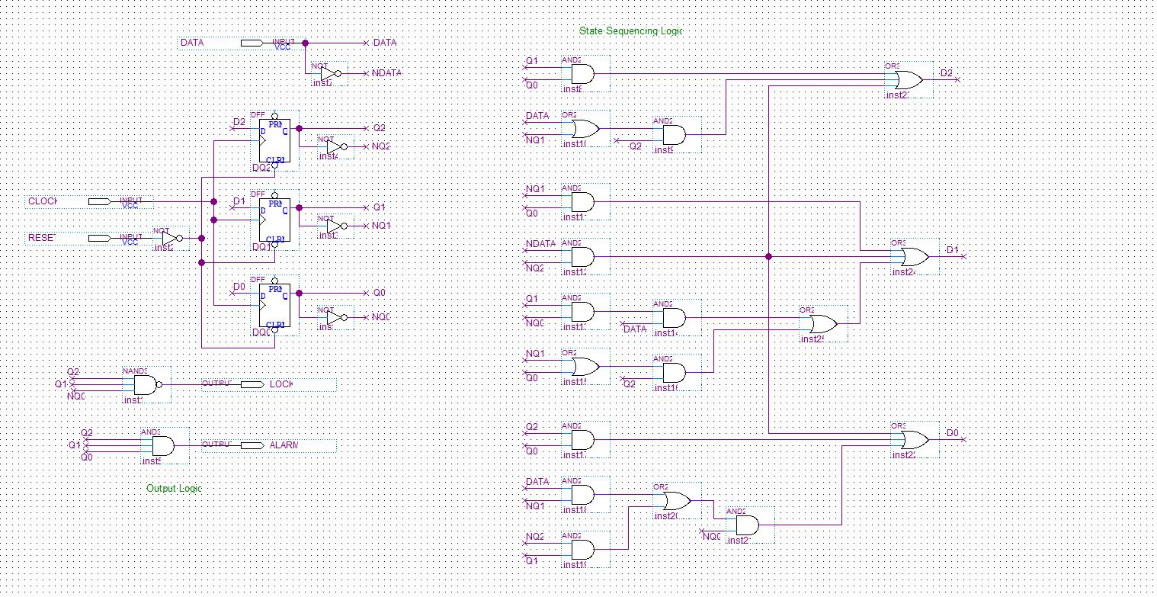

This gave the following output on ModelSim:

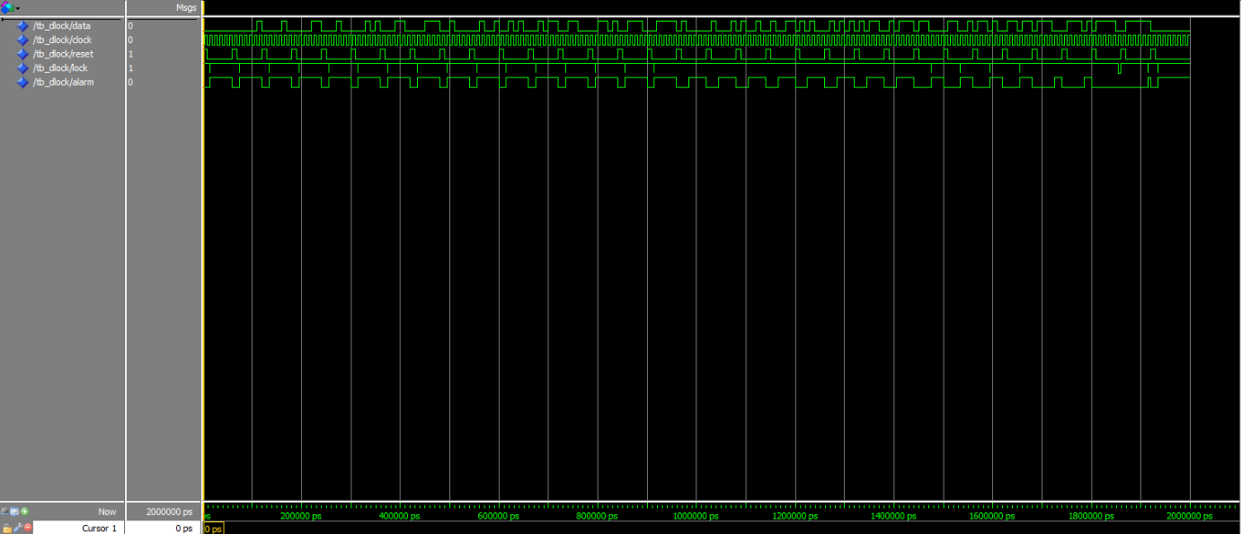

It can be seen that the circuit does unlock for the correct input (11110) but unfortunately we have many spikes in the circuit for the lock. Though these occur for mere picoseconds, they are still a cause for concern and it is better if there were no spikes at all. The problem lies in the output logic:



Q2 and Q1 both feed directly into the NAND3 gate, but Q0 goes through a NOT gate before being fed into the NAND3 gate (hence why it is NQ0). This causes a timing issue and is the cause of the spike. I fixed this by changing the logic to the following:

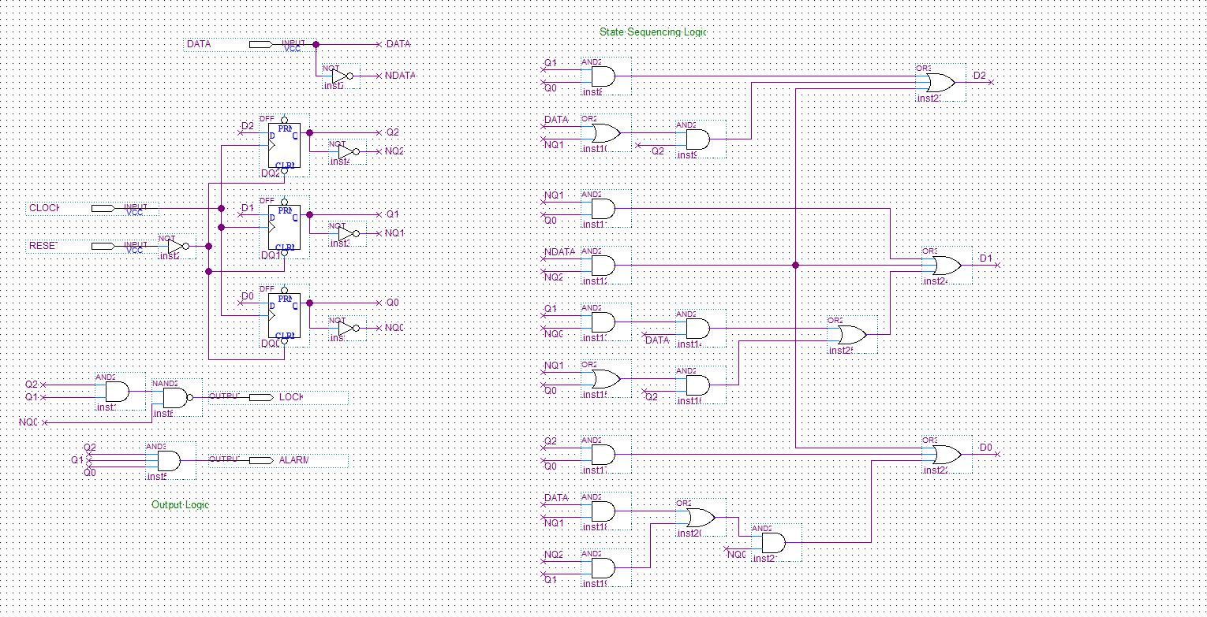

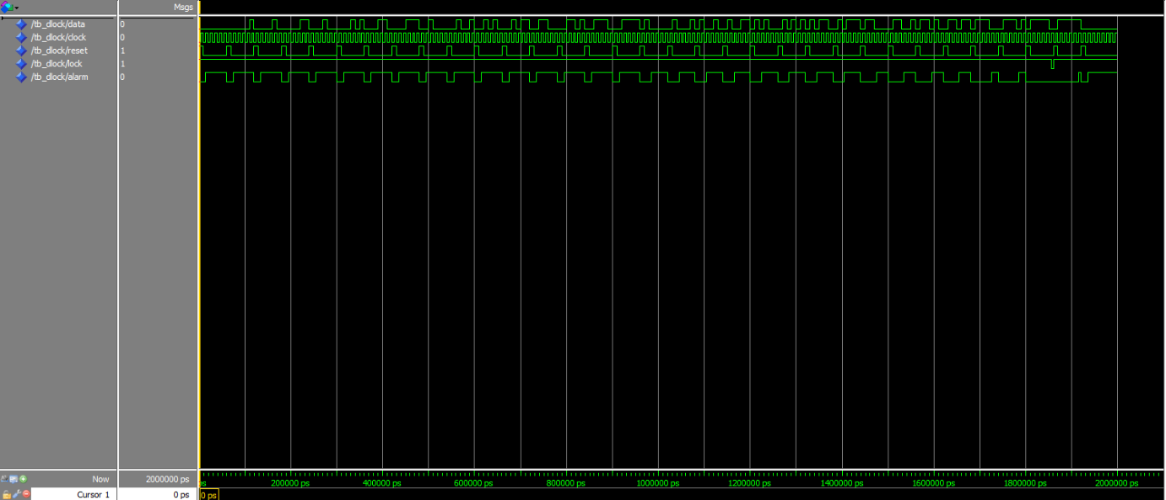This results in all three inputs having to go through some gate before being fed into the NAND2 gate. This increases the area (which is a trade-off) but gets rid of the spikes as can be seen on the next ModelSim diagram.

**Simplifying the circuit**

The above circuit is not at all ideal. It uses up far too much area. Currently, the total area calculation for the circuit is as follows:

|  |  |  |
| --- | --- | --- |
| **Gate Name** | **Amount** | **Total Area** |
| DFF | 3 | 300 |
| INPUT | 3 | 0 |
| OUTPUT | 2 | 0 |
| NOT | 5 | 75 |
| AND2 | 12 | 324 |
| AND3 | 1 | 34 |
| NAND2 | 1 | 20 |
| OR2 | 4 | 112 |
| OR3 | 3 | 102 |
|  | **TOTAL** | 967 |

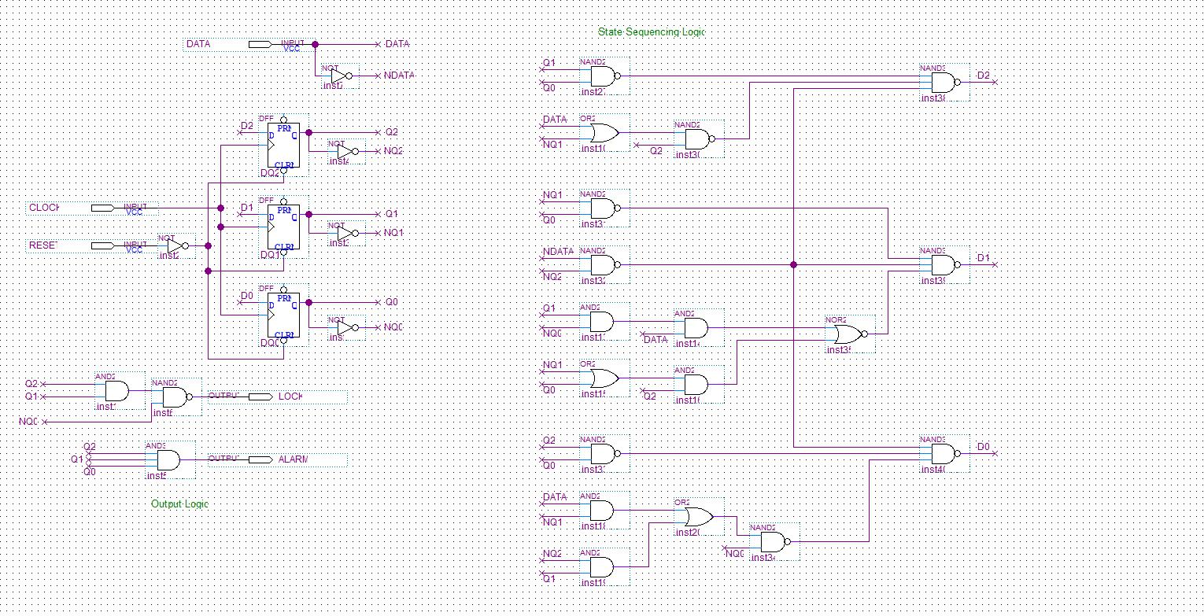I took the following steps to simplify my circuit

Firstly, using De Morgan’s law, I can change all three NOR3 gates to NAND3 gates given that I not their inputs.

This results in the creation of 6 NAND gates and a NOR gate.

All of these are circled

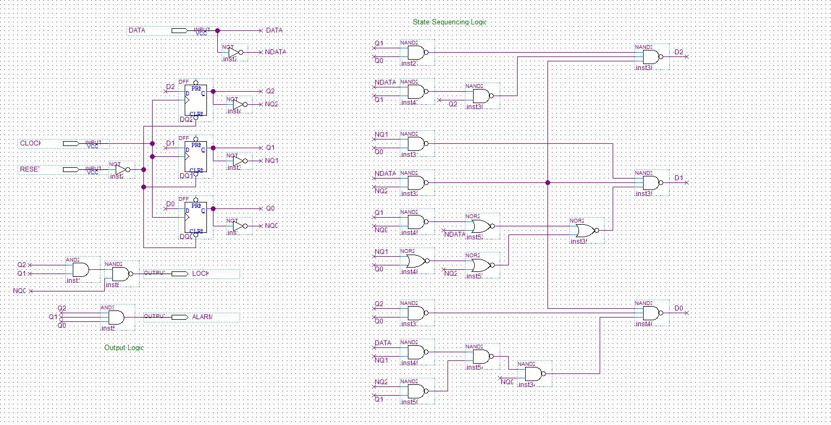I then used the exact same principles to convert AND gates into NOR gates and as a result got many more NAND and NOR gates from my circuit. The purple represents the conversion from AND to NOR or OR to NAND, and the red represents the negation required in order to carry this out.

The final simplification comes from a realistation that AND3 gates are normally far better than two NAND2 gates or similar. At the start it can be noted that I had a AND2 gate’s output feeding into another AND2 gate:



This should really instead have been an AND3 gate and as a result, we should backtrack to step 2. There, I convert the AND2 gate into a NOR2 gate but if already had an AND3 gate there, that would save a lot more space. Hence, the circuit is changed to become this (see next page):

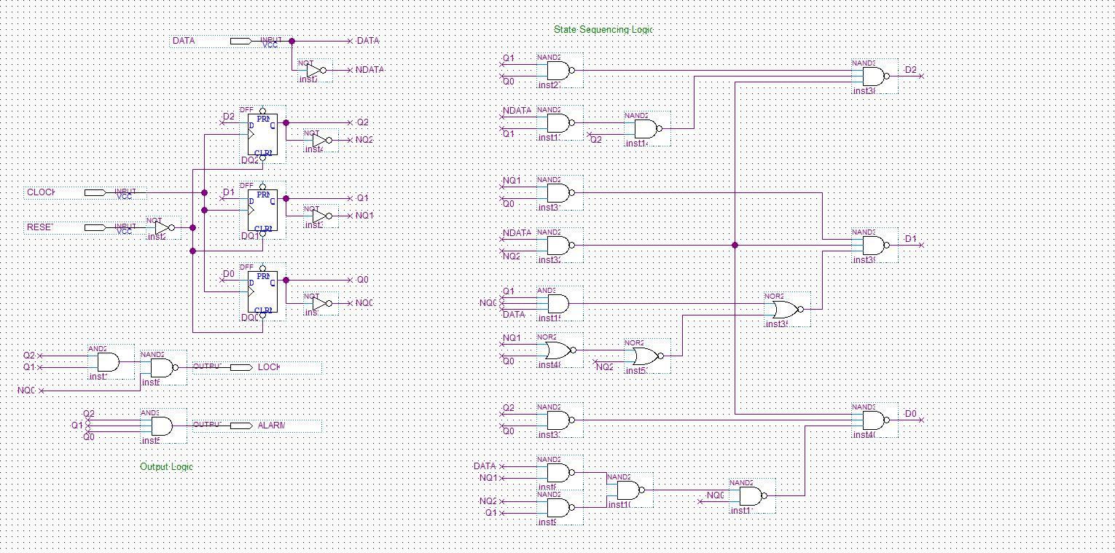

And so the circuit is now in it’s simplest form. The calculation for area can now be made:

|  |  |  |
| --- | --- | --- |
| **Gate Name** | **Amount** | **Total Area** |
| DFF | 3 | 300 |
| INPUT | 3 | 0 |
| OUTPUT | 2 | 0 |
| NOT | 5 | 75 |
| AND2 | 1 | 27 |
| AND3 | 2 | 68 |
| NAND2 | 11 | 220 |
| NAND3 | 3 | 84 |
| NOR2 | 3 | 57 |
|  | **TOTAL** | 831 |

**Final Circuit**

**ModelSim Zoomed into 11110**

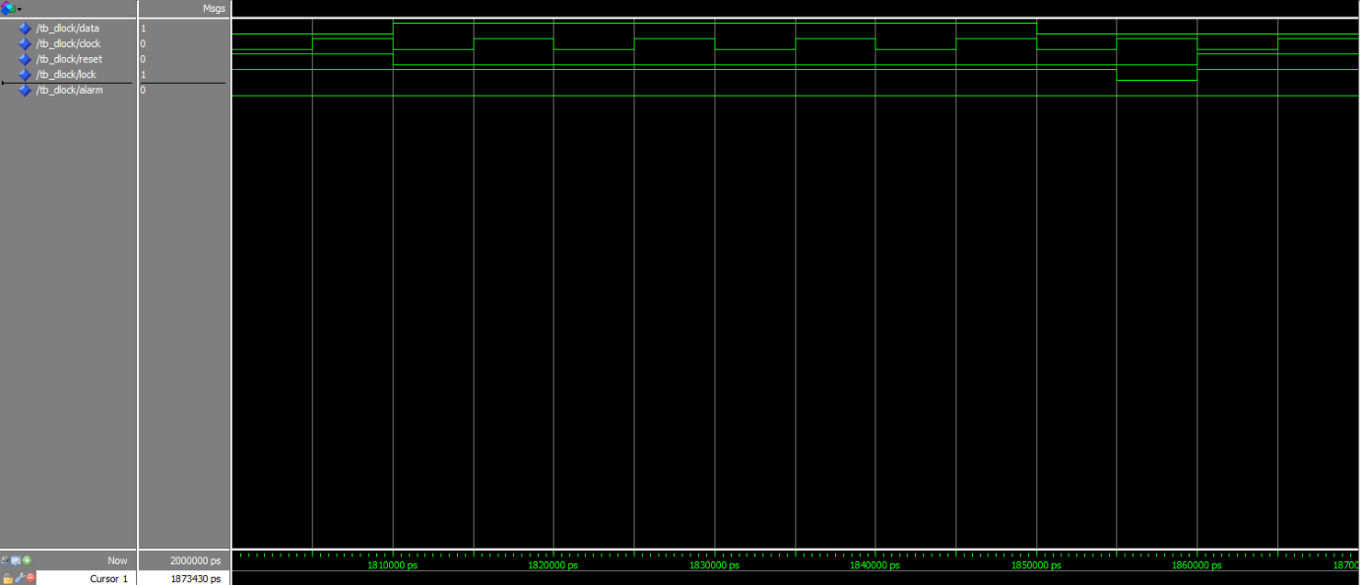

**ModelSim full**

