Had function to display pieces, but pieces weren’t being displayed. Forgot to call the function within drawboard().

Changed so check draws/wins with evaluation

Adding Input so moves change on board, works but crashes because always running so cant close page etc. Tried to see if way around.

Added an input box to grab moves

basic minimax algorithm, found examples online etc. used old text based system to find bugs as easier to implement.

board wasn’t being cleared!

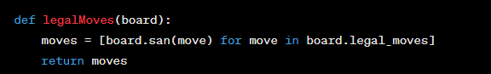

Was cutting off the end if the depth was > 2.

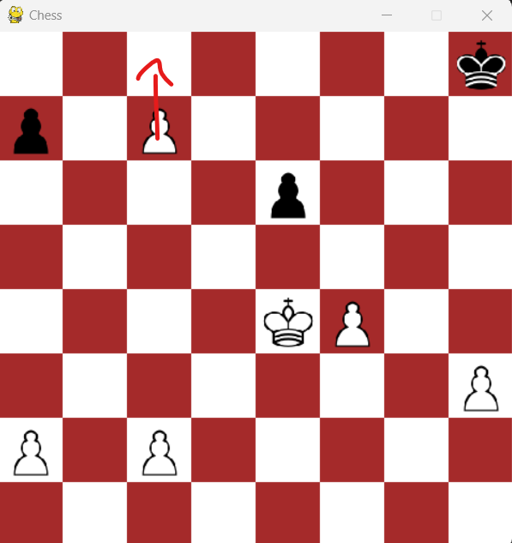

Tried to promote when testing, however it doesn’t work. Because haven’t added it yet. Thought about it, also haven’t added en passent.

was preferring to lose a knight, and get out a knight due to this being a +5 move, even though losing a knight worth 3. I was meant to change the knights value not add value!! Should have changed the value of the knight individually, but it is the same thing as changing overall score.