QA Test Report — The Greatest Factorial Calculator
Product Quality Engineer — Technical Assessment

Tester: Geovanna Versati Application: http://qainterview.pythonanywhere.com/
Environment: Brave Browser (Chromium-based), Windows; Command Prompt (curl) for direct API/HTTP testing; Brave DevTools mobile emulation (Samsung Galaxy A51/71) for responsiveness.
1. Executive Summary
This report documents functional, API, security, and usability testing of the Factoriall calculator. The core mathematical logic works correctly for standard inputs (including the edge cases described in the FAQ: 0!, negative numbers being rejected, and "Infinity" as a valid output for very large results). However, testing identified 9 defects, including 3 of Critical/High severity related to missing server-side input validation and silent failures with no user feedback — issues that would affect real users and that a security-minded review of the API surface (via direct requests, bypassing the UI) was able to confirm and reproduce consistently.
Given the severity and nature of BUG-01 and BUG-02 in particular (unhandled server errors and silent failures reaching real, valid user inputs), I would not recommend launching this application to production users without addressing them first.
2. Scope & Approach
Methodology note
This report was structured and formatted with the help of an AI writing assistant to organize the content clearly. All test execution, exploration, technical analysis, and findings were performed manually by the author.
Techniques applied
- Exploratory testing
- Equivalence Partitioning and Boundary Value Analysis
- Negative testing and input validation testing
- Direct API testing via curl, bypassing the front-end
- Basic security testing (response headers, HTTP method handling)
- Cross-referencing results against independent reference factorial calculators for correctness validation
- Mobile responsiveness testing via emulation
Scope boundaries
Per the assessment FAQ, the "About" and "Qxf2 Services" sections were excluded from scope and were not tested or interacted with beyond what appears on the main page by default.
"Terms and Conditions" and "Privacy" were not explicitly mentioned in the FAQ exclusion list; they were treated as out of scope as well, by analogy (auxiliary/legal pages, not part of the core calculator functionality), and this assumption is being flagged here for visibility.
A footer copyright inconsistency ("© Qxf2 Services 2026 – 2026," instead of the company's actual founding year, 2013) was observed. Since this text is part of the "Qxf2 Services" credit explicitly excluded from scope by the FAQ, it is not logged as a formal defect — it is noted only in the Quality Observations section for completeness.

3. Test Cases Executed
ID | Test Case | Input | Expected Result | Actual Result | Status
FUNC-01 | Valid factorial calculation | 5 | 120 | 120 | Pass
FUNC-02 | Valid factorial calculation | 10 | 3,628,800 | 3628800 | Pass
FUNC-03 | Zero factorial (REQ-02) | 0 | 1 | 1 | Pass
FUNC-04 | Factorial of one | 1 | 1 | 1 | Pass
FUNC-05 | Large number precision | 33 | Exact 37-digit integer | 8.683317618811886e+36 (scientific notation, precision loss) | Fail
FUNC-06 | Large number precision | 50 | Exact 65-digit integer | 3.0414093201713376e+64 (scientific notation, precision loss) | Fail
FUNC-07 | Large number precision | 100 | Exact 158-digit integer | 9.332621544394415e+157 (scientific notation, precision loss) | Fail
FUNC-08 | Overflow threshold (REQ-04) | 171 / 345 | Infinity is an accepted output per FAQ, but reference calculators still return the exact finite value at this magnitude | Infinity (returned earlier than mathematically necessary — see Section 5 observation) | Pass (with observation)
FUNC-09 | Negative number handling (REQ-03) | -1 / -89 | Some form of treatment: block or clear message | No UI message at all; request still sent; backend returns 500 | Fail
FUNC-10 | Large valid positive integer | 1000 | Correct result or a graceful, user-visible error | Silent failure — no UI message; backend returns 500 | Fail
FUNC-11 | Decimal input | 2.5 | Input rejected and submission blocked | "Please enter an integer" is shown, but the POST request is still sent to the backend | Fail
FUNC-12 | Non-numeric text | "abc" / "@@@" | Rejected with clear message | "Please enter an integer" shown; no request sent | Pass
FUNC-13 | Empty field submission | (empty) | Clear message, no crash | "Please enter an integer" shown; console shows the click handler still processes the blank value before stopping | Pass (minor note)
FUNC-14 | Submit via Enter key (TC-14) | 7 + Enter | Calculates the same as clicking "Calculate!" | Nothing happens; page remains static; no console errors | Fail
FUNC-15 | Rapid repeated clicks | Multiple clicks on "Calculate!" (value 50) | Button is disabled or shows a loading state to prevent duplicate requests | Multiple simultaneous requests sent; no debounce or lock | Fail
FUNC-16 | Mobile viewport responsiveness | Samsung Galaxy A51/71 emulation | Fully usable, proportional layout | Overall responsive, but footer links are small/close together and the title does not scale down | Pass (with notes)
FUNC-17 | Extremely long numeric input (no length limit) | A very long pasted digit string | A reasonable maximum length is enforced, or the request is rejected quickly with a clear error | No limit enforced; repeated 500 errors and network instability observed | Fail
API-01 | Valid POST request | number=5 | 200 OK, {"answer":120} | 200 OK, {"answer":120} | Pass
API-02 | Non-numeric value via direct POST | number=teste | 400 Bad Request with a clear message | 500 Internal Server Error (unhandled exception) | Fail
API-03 | Missing/incorrect parameter name | CHAVE=5 (instead of number=5) | 400 Bad Request with a clear message | 500 Internal Server Error (unhandled exception) | Fail
API-04 | HEAD request to root URL | curl -Iv (HEAD) | 200 OK with headers | 500 Internal Server Error | Fail
SEC-01 | Security response headers | Inspect response headers | HSTS, X-Frame-Options / CSP present | None of the standard security headers were found | Fail
SEC-02 | Direct endpoint access (bypass UI) | POST directly to /factorial via curl | Architecture observation | Confirmed possible — enables API-02/API-03 findings | Confirmed

4. Defects Found
9 defects were identified and consolidated from the 14 failing test cases above (several test cases share the same root cause and are reported as a single defect with multiple reproduction paths).
BUG-01 — Backend returns unhandled 500 instead of 400 for invalid API requests
Severity: Critical Priority: P1
Steps to reproduce:
1. Identify the /factorial endpoint via DevTools Network tab.
2. Send a direct POST request with a non-numeric value (number=teste), or with an incorrect/missing parameter name (CHAVE=5 instead of number=5), bypassing the front-end.
3. Observe the response.
Expected: A 400 Bad Request response with a clear, structured error message (e.g., {"error": "The 'number' parameter is required and must be numeric."}).
Actual: A 500 Internal Server Error is returned along with a generic HTML error page, indicating an unhandled exception in the backend. There is no try/catch or input validation layer protecting the calculation route.
Note: Confirmed via direct curl requests to the endpoint, independent of the front-end.
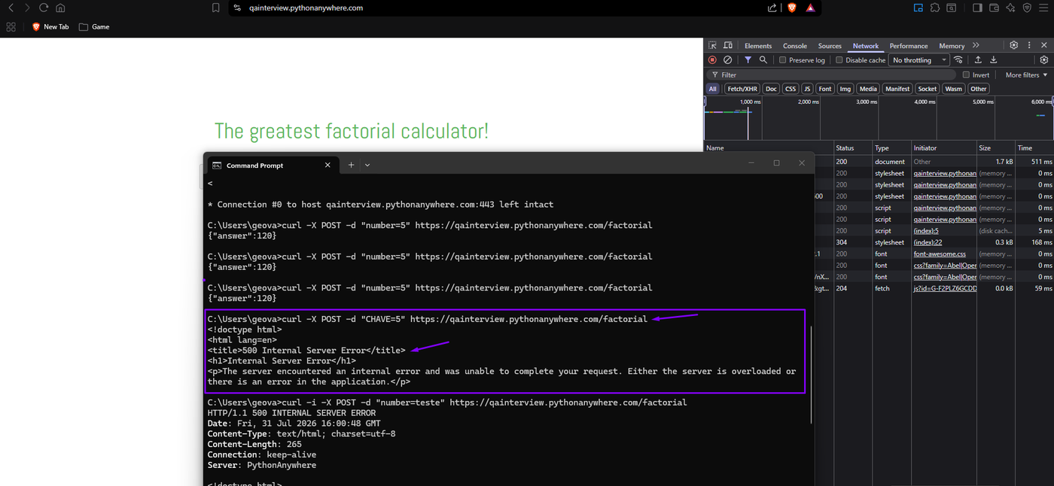
Evidence: PostValidation1.png
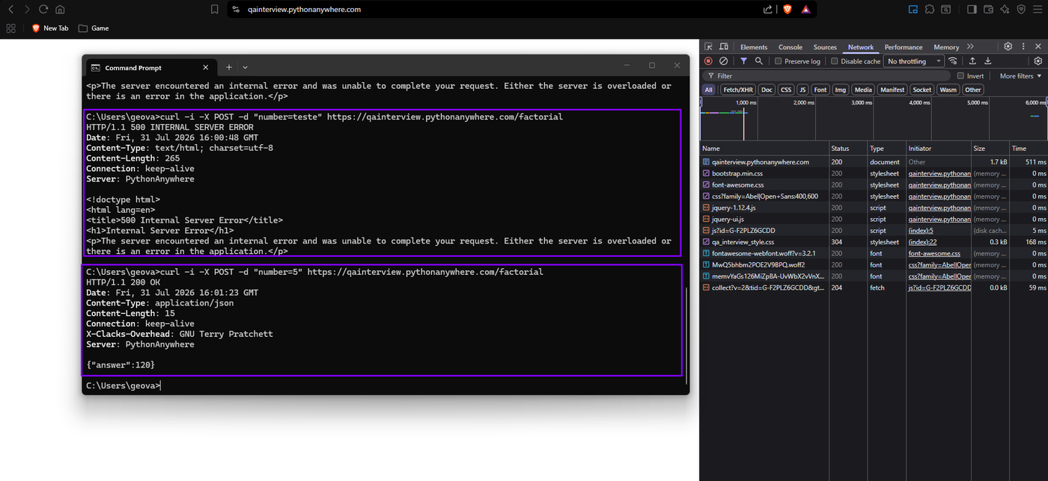
Evidence: PostValidation1_1.png
BUG-02 — Silent failures with no user-facing error message for negative numbers and certain large valid integers
Severity: Critical Priority: P1
Steps to reproduce:
1. Enter a negative number (e.g., -89) or a large valid positive integer (e.g., 1000) into the input field.
2. Click "Calculate!".
3. Observe the page and the browser console.
Expected: Per the FAQ, negative numbers require some form of treatment (block or message). Valid large integers should return a correct result or a graceful, visible error.
Actual: The page remains static with absolutely no visible feedback to the user. Only by opening the browser console can a 500 Internal Server Error be observed. A regular user with no technical background would be left stuck on the page with no indication of what went wrong or why.
Note: This is the most user-impacting defect found: it affects both an explicitly out-of-domain input (negative) and an in-domain, valid input (1000) — the latter is more severe, since a legitimate use case fails silently, with no explanation given to the user.
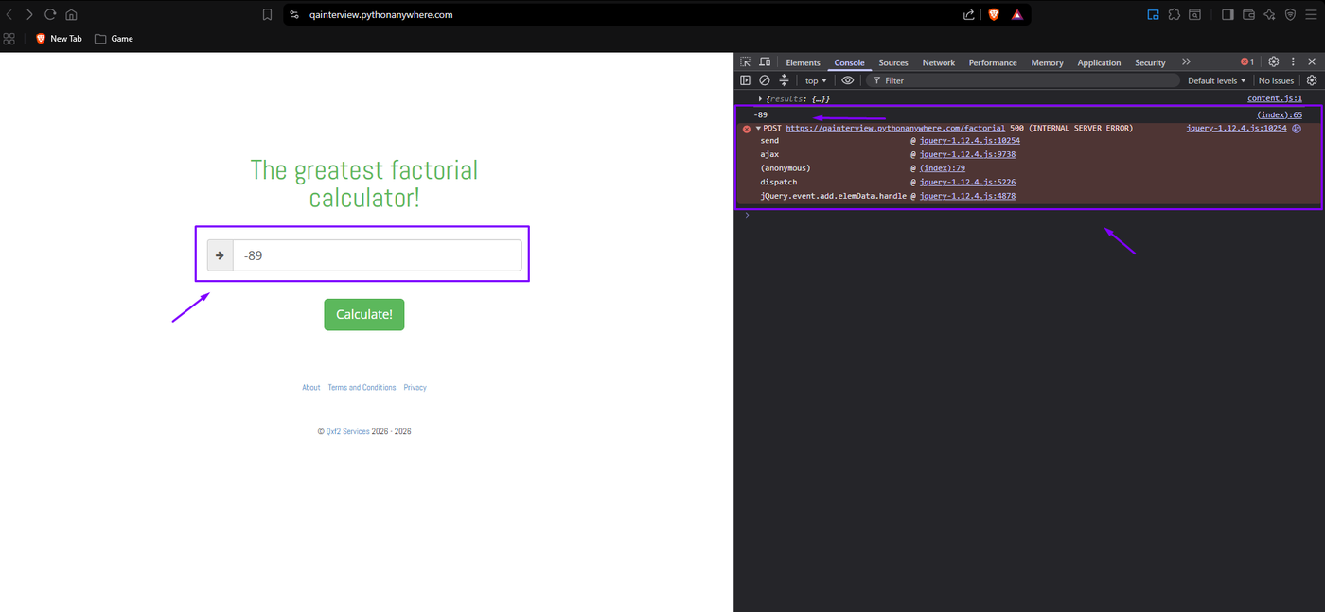
Evidence: Req03.png
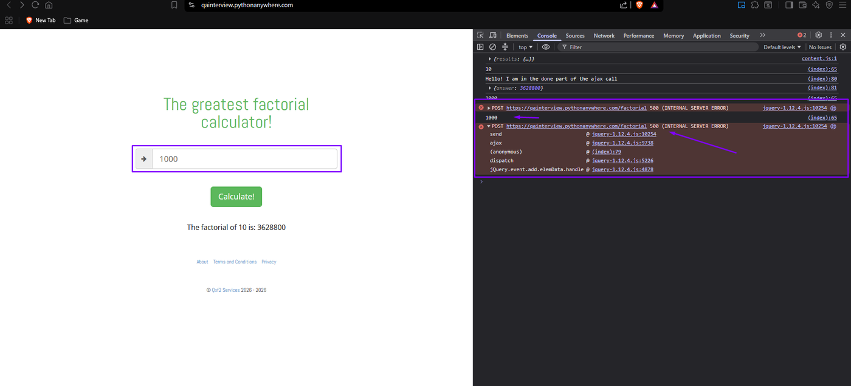
Evidence: Req04.png
BUG-03 — Server crashes (500) on standard HTTP HEAD requests
Severity: High Priority: P2
Steps to reproduce:
1. Run curl -Iv https://qainterview.pythonanywhere.com/ from a terminal.
2. Observe the response.
Expected: HTTP/1.1 200 OK with the page headers, since HEAD is a standard, widely supported HTTP method (identical to GET but without the response body).
Actual: HTTP/1.1 500 Internal Server Error. This indicates the backend framework has no route/handler configured for the HEAD method, causing an unhandled exception.
Note: A healthy web server should support HEAD requests without crashing; this points to a gap in basic server/framework configuration.
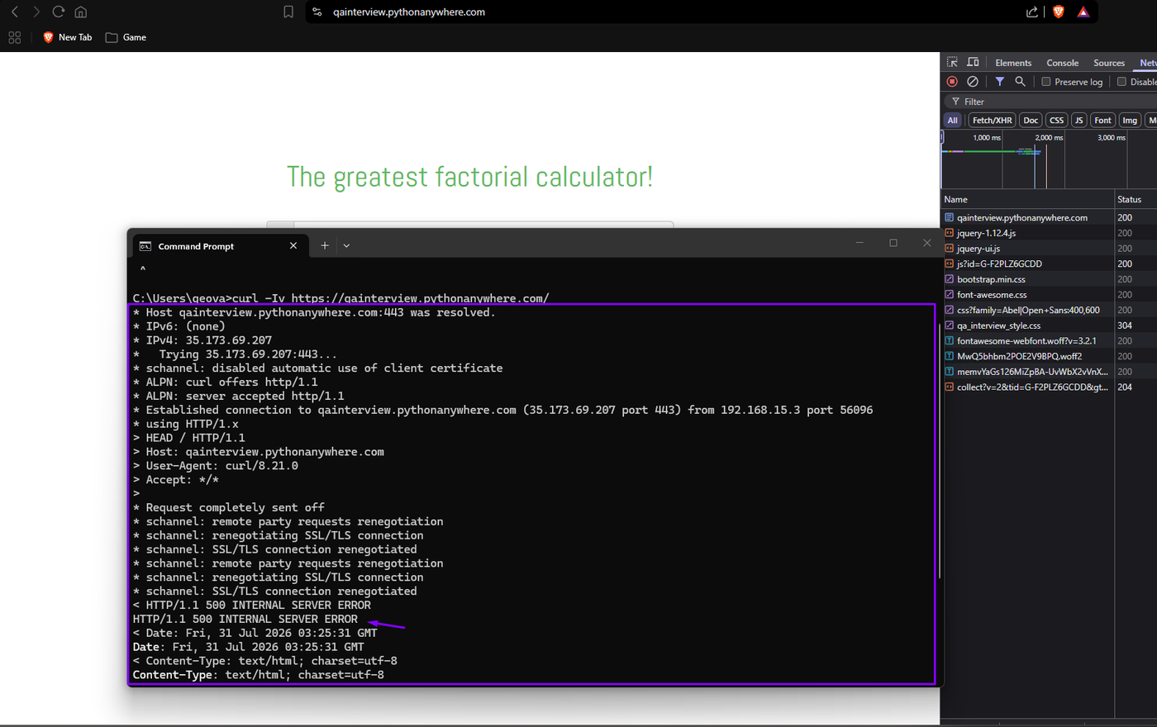
Evidence: ReqCurlSecurity.png
BUG-04 — Decimal input validation is cosmetic only — the request is still sent to the backend
Severity: Medium Priority: P2
Steps to reproduce:
1. Enter a decimal value (e.g., 2.5) into the input field.
2. Click "Calculate!".
3. Open the Network tab and observe.
Expected: If the front-end displays "Please enter an integer," the request should not be sent at all.
Actual: The warning message is shown correctly, but the Network tab confirms the POST request is still dispatched to the server. The front-end code fails to actually stop the submission, generating unnecessary traffic and backend processing.
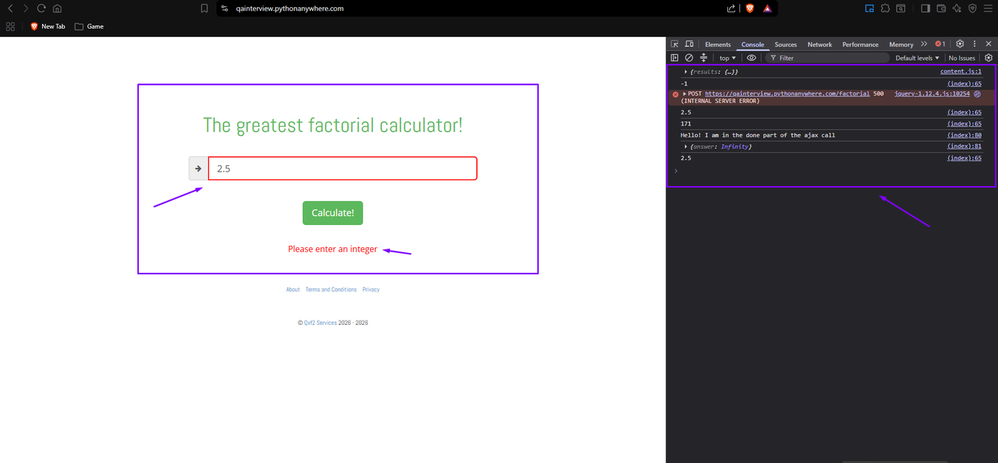
Evidence: BusinessTest.png
BUG-05 — Loss of numeric precision for large factorial results
Severity: Medium Priority: P3
Steps to reproduce:
1. Calculate the factorial of a large number that does not overflow to "Infinity" (e.g., 33, 50, 100).
2. Compare the result against a reference arbitrary-precision calculator.
Expected: The exact integer result (e.g., a full 37-digit number for 33!).
Actual: The result is displayed in JavaScript's default floating-point scientific notation (e.g., 8.683317618811886e+36), which is not exact beyond roughly 15-17 significant digits — the true value has 37 exact digits. The application appears to rely on a standard numeric type (float/double) rather than arbitrary-precision arithmetic (e.g., BigInt).
Note: Not a crash — a precision/correctness limitation. A reference calculator returned the exact digit sequence for the same input.
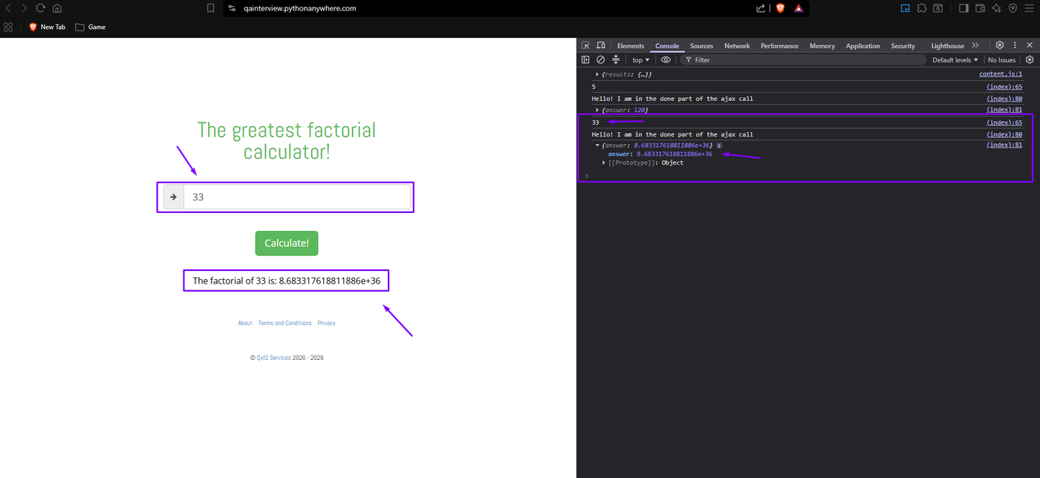
Evidence: Req01.png
BUG-06 — No protection against rapid repeated clicks (missing debounce/loading state)
Severity: Medium Priority: P3
Steps to reproduce:
1. Enter a valid number.
2. Click "Calculate!" multiple times in rapid succession.
3. Observe the Network/Console tabs.
Expected: The button should be temporarily disabled or show a loading state while a request is in flight, preventing duplicate submissions.
Actual: The button can be clicked an unlimited number of times, firing multiple simultaneous requests and generating excessive logging/load with no client-side lock.
Note: A recognized usability/architecture best practice gap, not merely cosmetic — it can create unnecessary server load.
BUG-07 — Pressing Enter does not submit the form
Severity: Medium Priority: P3
Steps to reproduce:
1. Type a number into the input field.
2. Press Enter instead of clicking the button.
Expected: The calculation should trigger the same way it does on a button click.
Actual: Nothing happens. The page remains static and no calculation is triggered; no errors are logged in the console.
Note: Likely cause: the calculate function is bound only to the button's onClick event, and the input field is either not wrapped in a <form> tag or has no keypress listener for the Enter key. Since this defect produces no visible state change, the screenshot documents the relevant elements (the input with "7" entered and Enter pressed, and the separate "Calculate!" button that is the only element that actually triggers the calculation) alongside the reproduction steps above.
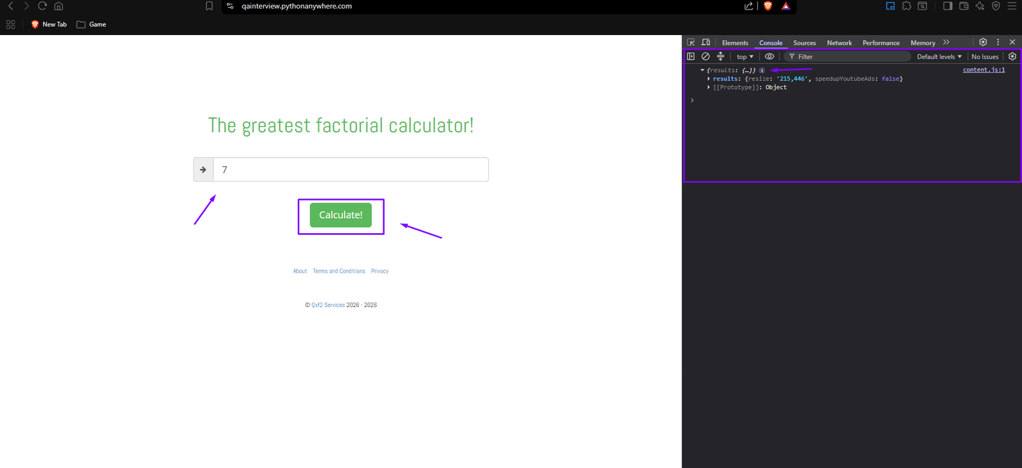
Evidence: SubmitionButton.png
BUG-08 — No standard security response headers
Severity: Medium Priority: P3
Steps to reproduce:
1. Inspect the HTTP response headers of a successful request (via curl -i or DevTools Network tab).
Expected: Standard, market-recognized security directives should be present (HSTS, X-Frame-Options or Content-Security-Policy, etc.).
Actual: None of these headers were found among the response headers, leaving the application without baseline protection against clickjacking and protocol-downgrade risks.
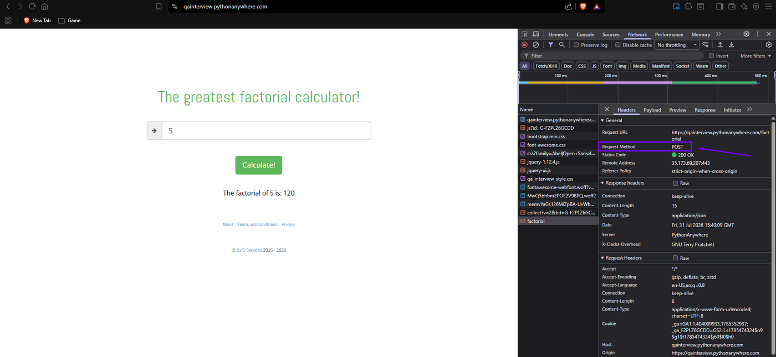
Evidence: PostValidation.png
BUG-09 — No maximum length validation on the input field
Severity: Medium Priority: P3
Steps to reproduce:
1. Paste an extremely long numeric string (well beyond any reasonable factorial input) into the field.
2. Click "Calculate!".
3. Observe the Console and Network tabs.
Expected: The field should enforce a reasonable maximum length, or the backend should reject oversized input quickly with a clear error.
Actual: No length limit is enforced on the input. The console shows repeated 500 Internal Server Errors, and the Network tab shows requests taking unusually long (500ms+) and becoming unstable under this load. The page itself does not freeze, but the server-side handling clearly struggles with unbounded input size.
Note: A basic input-length safeguard (both client- and server-side) would prevent unnecessary load and potential abuse.
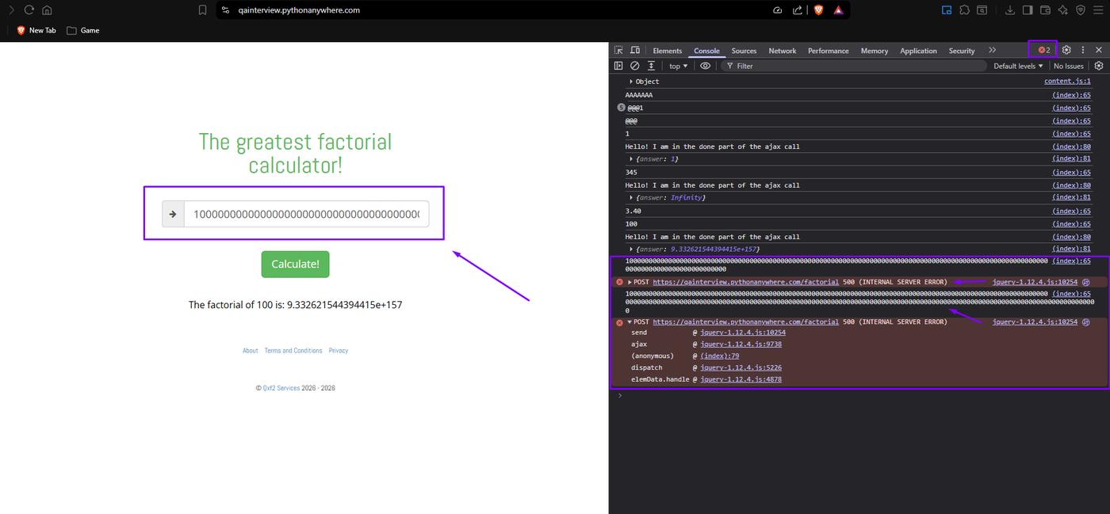
Evidence: Evidence2.png
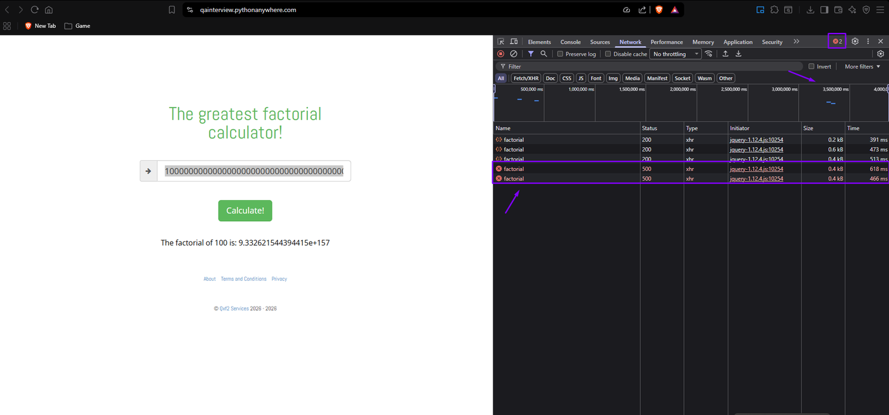
Evidence: Evidence2_1.png

5. Quality Observations (non-bug)
Visual design and UX
- The calculation result has no visual emphasis (no bold, color, or larger font size) and gets visually lost against the white background.
- The arrow icon (→) next to the input field visually resembles a submit affordance, which may confuse users given there is already a separate, clearly labeled "Calculate!" button below it.
Evidence: SubmitionButton.png — the arrow icon and the "Calculate!" button both appear to invite a submit action
- Vertical spacing between elements is inconsistent and disproportionately large in places — for example, between the "Calculate!" button and the About/Terms/Privacy footer links.
Numeric precision (related to BUG-05)
For inputs in the 171-345 range, the application returns "Infinity" — which is an accepted, valid output per the FAQ, so this is not logged as a requirement violation. However, a reference calculator returns the full exact value at this same magnitude (a finite number with 310+ digits for 345!). The threshold is reached earlier than mathematically necessary because standard floating-point numbers overflow around 1.8e+308, while an arbitrary-precision implementation (e.g., BigInt) would not. Noted here as a natural companion to BUG-05, since both stem from the same underlying design choice (standard numeric types instead of arbitrary-precision arithmetic).
Responsiveness (mobile)
- The layout is overall responsive, but the footer links ("About," "Terms and Conditions," "Privacy") are small and closely spaced — a real touch-target risk on mobile devices, where a user could easily tap the wrong link.
- The main title font size does not scale down proportionally on smaller viewports relative to the rest of the page content — the CSS does not appear to adjust font sizing dynamically as the screen shrinks.
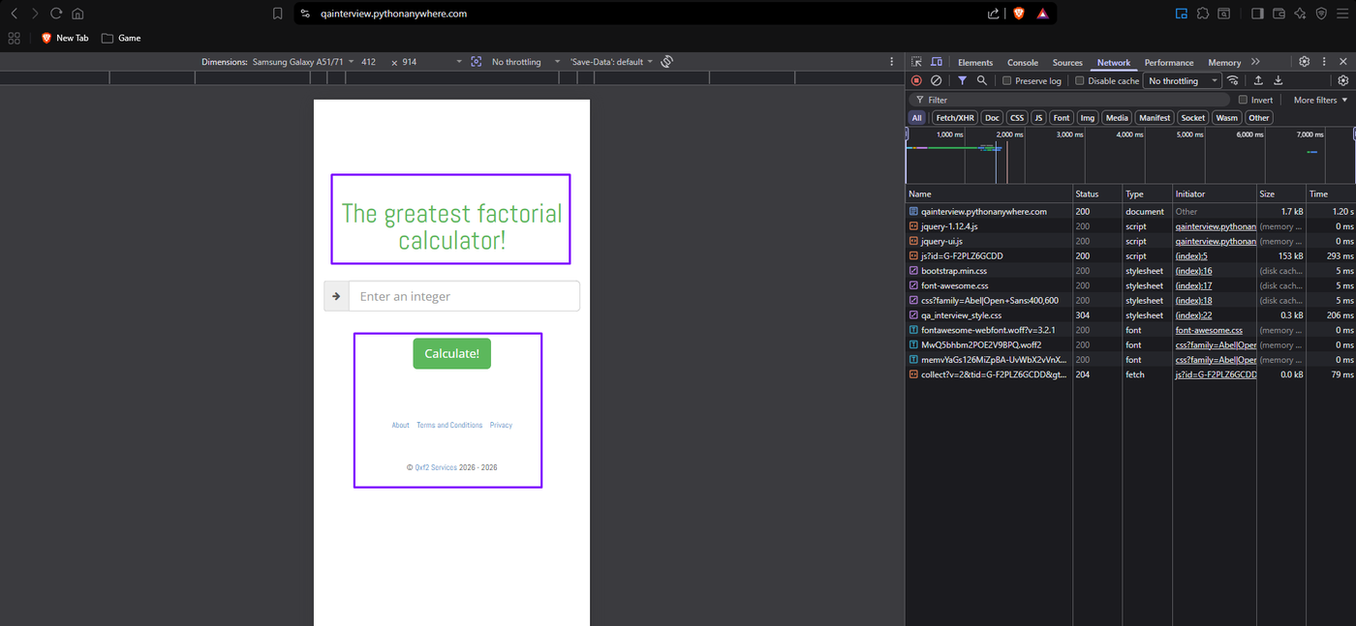
Evidence: MobileNotWorkingApropriate.png — mobile viewport emulation (Samsung Galaxy A51/71)
Footer / scope-adjacent observation
A copyright date inconsistency was observed in the footer ("© Qxf2 Services 2026 – 2026"; the company was actually founded in 2013). As noted in Section 2, this text belongs to the "Qxf2 Services" credit, which the FAQ explicitly excludes from the test scope — this is logged here only as an observation, not as a defect.
Positive observation
A hidden header, "X-Clacks-Overhead: GNU Terry Pratchett," was found on successful (200 OK) responses (visible in the same response headers inspected for BUG-08). This is a known developer tribute referencing author Terry Pratchett and the "clacks" communication network from his Discworld novels — a nice touch, unrelated to any functional or quality issue.

6. Test Metrics
Metric | Detail | Result
Test Coverage | 23 / 23 planned cases executed | 100%
Pass Rate | 9 Pass out of 22 binary-outcome cases (excluding 1 architecture observation, SEC-02) | 40.9%
Defect Density | 9 confirmed defects across 22 executable cases | 0.41 defects/case
Severity Distribution | Critical: 2 · High: 1 · Medium: 6 · Low: 0 | 9 total
Requirements Coverage (FAQ functional requirements, REQ-01–04) | REQ-01 ✓ (precision caveat, BUG-05) · REQ-02 ✓ · REQ-03 ✗ (BUG-02) · REQ-04 ✓ (see Section 5 note) | 3 / 4 met (1 with a caveat) · 1 failed

7. Recommendations
Blocking (should be fixed before launch):
- BUG-01 and BUG-02 — implement proper server-side input validation with try/catch handling, returning structured 400 responses instead of unhandled 500 errors, and ensure the front-end always surfaces a visible error message to the user when a request fails.
- BUG-03 — add a route/handler for the HEAD HTTP method, or configure the framework to handle it by default.
- BUG-08 — add standard security headers (HSTS, X-Frame-Options or CSP) at the server/framework level.
High value, can follow shortly after launch:
- BUG-04 — make front-end validation actually block submission, not just display a message.
- BUG-05 — consider an arbitrary-precision (BigInt) implementation for exact results; this would also raise the threshold before results return "Infinity" (see the related observation in Section 5).
- BUG-06 / BUG-07 — disable the button (or show a loading state) during requests, and bind the calculate action to form submission so Enter works as expected.
- BUG-09 — enforce a reasonable maximum input length on both the front-end and the backend.
Lower priority, quality-of-life improvements:
- Add visual emphasis to the result text; clarify or remove the arrow icon; review vertical spacing; increase footer link size/spacing for touch; add responsive typography for the title.
8. Conclusion
The core factorial calculation logic is correct for the primary happy-path cases and for the specific edge cases the FAQ calls out (0!, rejection of negative numbers at a basic level, and "Infinity" as an accepted output). However, the application has real gaps in server-side input validation, error handling, and user feedback — most notably, valid and invalid inputs alike can trigger an unhandled 500 error with zero indication to the end user that anything went wrong. Combined with the missing security headers and the HEAD-request crash, this points to a backend that has not been hardened against anything beyond the exact happy path the UI sends it.
Recommendation: Not ready for production launch as-is. The front-end and core calculation experience are solid, but BUG-01, BUG-02, and BUG-03 should be addressed first, since they affect application reliability and basic user trust.

