

SPORTS CENTER MANAGEMENT SYSTEM
Software Requirement Document

– HCM, Sep 2026

Table of Contents
I. Overview 4
1. Introduction 4
2. Existing Systems 5
2.1 Gymaster 5
2.2 Mindbody 6
3. Business Process 7
4. System Functions 13
5. Entity Relationship Diagram 16
6. State transition diagram 18
II. Functional Requirements 21
1. User & Membership Management 21
2. Class & Schedule Management 22
3. Class & Schedule Management 23
4. Training & Attendance Management (Optional) 24
5. AI Features (Optional) 25
6. Access Control & Reception Support 26
III. Database Design 27
1. Database Schema 27
2. Table Detail 30

I. Overview

1. Introduction
The Sports Center Management System (SCMS) is a web-based application intended to centralize the daily operations of a sports center. It supports member account and profile management, membership packages and renewals, class and schedule management, class registration, membership payments, invoice generation, attendance tracking, and management reporting. Optional extensions include training plans and progress tracking, AI-based exercise recommendations, and an AI assistant for common questions.
The main user roles are Member, Receptionist, Coach, and Center Manager. Members use the system to manage personal information, view membership packages and status, register for or cancel classes, review payments, and access personal training information when the optional module is enabled. Receptionists support member registration, membership renewal, payment recording, invoice printing/export, class registration assistance, attendance recording, and support requests. Coaches manage assigned training activities and view their teaching schedules. Center Managers configure the system and maintain operational data and reports.
The planned technology stack is React.js with Material UI for the frontend, Java Spring Boot exposing RESTful APIs for the backend, SQL Server with Spring Data JPA/Hibernate for persistence, and Spring Security with JWT for authentication and authorization. Git/GitHub, Figma, Postman, Jira, and VS Code/IntelliJ IDEA are the supporting development tools identified in the project notes.
Assumptions: The application is accessed through a modern web browser. Each staff user is assigned a role by the Center Manager. A membership becomes Active only after a successful payment is confirmed. A receptionist may complete selected operations on behalf of a member at the reception desk.
Dependencies: The online payment flow depends on MoMo integration and its transaction result/callback. Notification delivery (in-app, email, SMS, or another channel) must be selected before implementation. The team will use Figma prototypes to finalize detailed layouts.
Constraints: The core release should prioritize User & Membership Management, Class & Schedule Management, and Payment & Report Management. Training & Attendance and AI features are optional and may be deferred without blocking the core release.
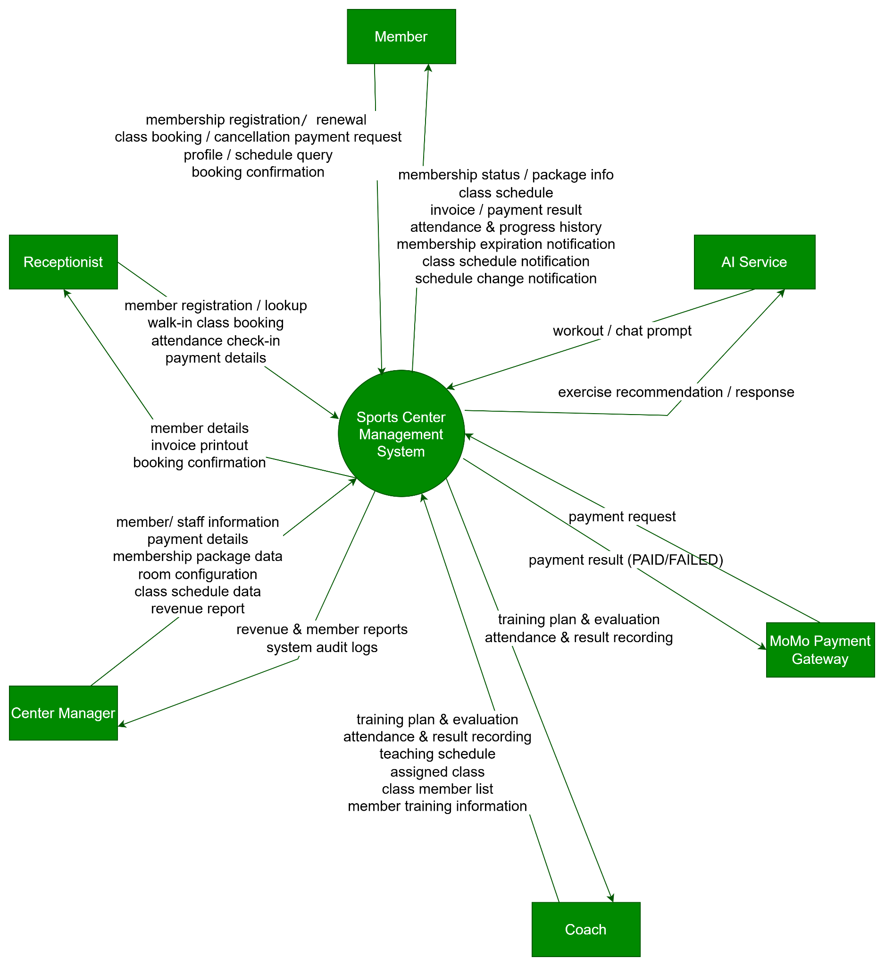

2. Existing Systems
The supplied topic does not prescribe one particular commercial product as the customer’s required system. The systems below are reference candidates for studying common workflows, terminology, and screen patterns only; they do not define additional requirements for SCMS.

2.1 GymMaster
Website: https://gymmaster.vn/en
Relevant areas: Member and membership management, class timetables and booking, billing, coach/trainer management, attendance, and reporting are presented on the product website.
Potential value for this project: Useful reference for end-to-end workflows that connect member records, membership status, booking, payment and staff operations.
Limitations for our study: The commercial product includes functionality beyond this project scope. Public marketing pages do not establish its internal data model or implementation architecture; SCMS should implement only its approved requirements.

2.2 Mindbody
Website: https://www.mindbodyonline.com/business/fitness/gym-software
Relevant areas: The official product page presents fitness business management, schedule-related web tools, staff coordination and business reporting.
Potential value for this project: Useful reference for member-facing schedule discovery and management-oriented dashboards/reports.
Limitations for our study: Feature availability and commercial conditions can vary. The team should verify current product behavior directly if it needs deeper comparison; the system is not a required integration for SCMS.

3. Business Process
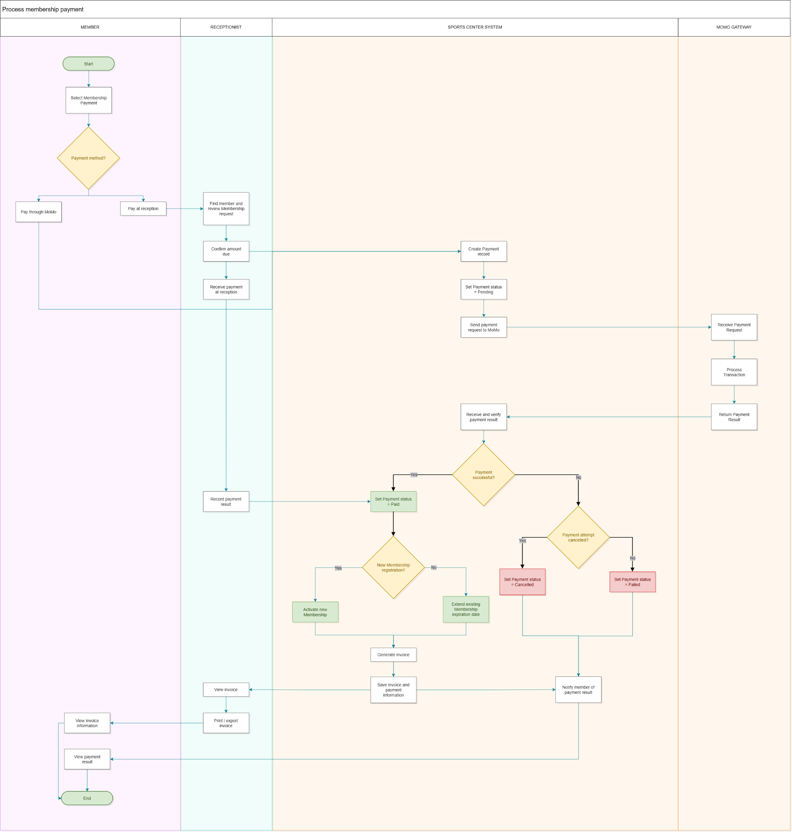

# | Process Step | Lane / Actor | Description
1 | Select membership payment | Member | The member opens the membership payment function of the sports center system and selects the membership fee that needs to be paid. This event starts the payment process.
2 | Choose payment method | Member | The member decides how to pay: through the MoMo e-wallet (gateway path) or directly at the reception desk (counter path). The decision determines which lane the process continues in.
3 | Pay through MoMo | Member | The member opens the MoMo app and confirms the transfer of the membership fee. The member-side flow pauses here until the MoMo gateway returns the transaction result.
4 | Pay at reception | Member | The member goes to the reception desk and pays the membership fee in cash or by card. From this point the receptionist lane continues the process.
5 | Find member and review membership request | Receptionist | The receptionist searches for the member's profile in the system and reviews the submitted membership request to verify the member's identity and the package/period requested.
6 | Confirm amount due | Receptionist | The receptionist confirms the membership fee payable by the member. The confirmed amount is used by the system to create the payment record.
7 | Receive payment at reception | Receptionist | The receptionist collects the payment from the member at the counter (cash or card) and checks that the amount received matches the amount due.
8 | Create payment record | Sports Center System | The system creates a payment record for the membership, holding the member, the membership period and the amount due, so that the transaction can be tracked with a unique reference.
9 | Set payment status to 'Pending' | Sports Center System | The newly created payment record is initialised with the status 'Pending' while the system waits for the gateway's transaction result.
10 | Send payment request to MoMo | Sports Center System | The system sends a payment request containing the amount, the payment reference and the member/order information to the MoMo gateway.
11 | Receive payment request | MoMo Gateway | The MoMo gateway receives the payment request from the sports center system and validates its content and signature before processing.
12 | Process transaction | MoMo Gateway | The MoMo gateway processes the transaction on the member's wallet: it checks the token/balance, debits the amount and records the transaction.
13 | Return payment result | MoMo Gateway | The MoMo gateway returns the transaction result (success, failure or cancellation) together with the transaction reference to the sports center system.
14 | Receive and verify payment result | Sports Center System | The system receives the MoMo response and verifies its authenticity (signature/checksum, amount and reference) before using it to update the payment record.
15 | Check payment success | Sports Center System | The system evaluates the verified result: if the payment is successful the process follows the success path; otherwise it goes to the failure-handling path.
16 | Check whether the payment attempt was cancelled | Sports Center System | For an unsuccessful payment, the system determines whether the failure was caused by the member cancelling the payment attempt on MoMo, or by another reason (insufficient balance, timeout, gateway error, ...).
17 | Set payment status to 'Cancelled' | Sports Center System | If the member cancelled the payment attempt, the payment record is updated to 'Cancelled'.
18 | Set payment status to 'Failed' | Sports Center System | If the failure was not a cancellation, the payment record is updated to 'Failed'.
19 | Set payment status to 'Paid' | Sports Center System | When the payment is confirmed successful, the system updates the payment record to 'Paid' so that the membership can be activated or extended. (The same update is triggered when the receptionist records a successful payment at the counter.)
20 | Check whether it is a new membership registration | Sports Center System | The system determines whether the paid fee belongs to a new registration or to the renewal of an existing membership, because the follow-up handling differs.
21 | Activate new membership | Sports Center System | For a new registration, the system creates and activates the membership, setting its start date, package and expiration date.
22 | Extend existing membership expiration date | Sports Center System | For a renewal, the system extends the expiration date of the member's existing membership by the purchased period.
23 | Generate invoice | Sports Center System | The system generates the invoice for the successful payment, containing the member information, the membership package and period, and the amount paid.
24 | Save invoice and payment information | Sports Center System | The invoice together with its linked payment information is stored in the system so it can be viewed, printed or exported later.
25 | Record payment result | Receptionist | For a payment made at the counter, the receptionist records the payment result in the system, which updates the payment status (Paid) in the same way as a gateway result.
26 | Notify member of payment result | Sports Center System | The system notifies the member of the payment result (in-app, SMS or email) on both the success and the failure path, including the reason in case of failure.
27 | View invoice | Receptionist | The receptionist opens the generated invoice of the member's payment in order to check it and hand it over to the member.
28 | Print / export invoice | Receptionist | The receptionist prints the invoice or exports it (e.g. PDF) to give to the member or to keep it as a document for accounting.
29 | View invoice information | Member | The member views the invoice information (amount, membership package and period, payment reference) to confirm the details of the payment.
30 | View payment result | Member | The member views the final payment result and the status of the membership (activated or extended). This is the last step before the process ends.

4. System Functions

a. Screen Flow
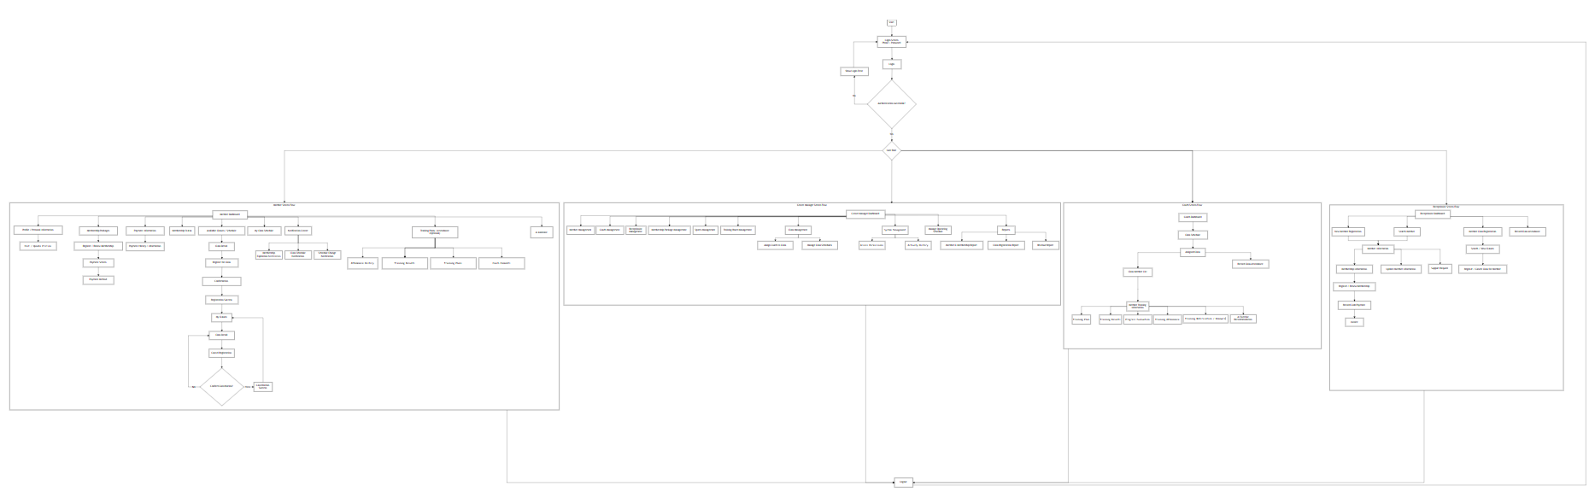

Role | Main navigation summary
Member | Home / Register / Login → Member Dashboard → Profile, Membership Packages, Classes, Payment History / Invoice, Notifications, and optional Training / AI.
Receptionist | Login → Search or Register Member → View Membership → Register / Renew → Record Payment → Generate / Print Invoice; also supports class registration, attendance and support requests.
Center Manager | Login → Management Dashboard → Users / Packages / Sports / Rooms / Classes / Schedules / Coach Assignment → Reports, Permissions and Activity History.
Coach | Login → Teaching Schedule → Assigned Class → Member List → optional Training Plan, Result, Progress, Attendance and Recommendation.

b. Screen Details

# | Feature | Screen | Description
1 | Authentication | Login / Register | Authenticate users and allow a new member to create a member account.
2 | Member | Member Dashboard | Summarize membership status/expiry, upcoming classes, notifications and recent payments.
3 | Member | My Profile | View and update permitted personal information.
4 | Membership | Membership Packages | List active packages with price, duration and description.
5 | Membership | Register/ Renew Membership | Select a package and initiate a new membership or renewal.
6 | Payment | MoMo Checkout / Result | Create a payment request, redirect to MoMo and display confirmed result.
7 | Payment | Payment History | Show the signed-in member’s transactions and current statuses.
8 | Payment | Invoice Details | Display invoice details and provide print/export actions to authorized users.
9 | Classes | Available Classes | Browse published classes, sport category, schedule, room and available capacity.
10 | Classes | Class Details / Registration | View class details and register when the class is eligible and has capacity.
11 | Classes | My Class Registrations | View registered classes and cancel eligible registrations.
12 | Coach | Teaching Schedule / Class Members | Show assigned sessions and the members registered for each class.
13 | Reception | Member Search / Details | Search for a member and view the information needed for counter service.
14 | Management | Member & Staff Management | Create/update permitted member, coach and receptionist records.
15 | Management | Membership Package Management | Create, update, activate or deactivate membership packages.
16 | Management | Sport / Room / Class Management | Maintain sports, rooms, class details, capacity and assigned coaches.
17 | Management | Schedule Management | Create sessions, set date/time/room and publish or cancel a session.
18 | Reception / Coach | Attendance | Record present/absent status and correct a previously recorded status.
19 | Training (Optional) | Training Plans / Results | Create plans, record results, evaluate progress and publish comments/homework.
20 | Reports | Management Dashboard / Reports | Show member counts/status, class-registration status and revenue over a selected period.
21 | Administration | Permissions / Activity History | Configure role permissions and inspect important system activity.
22 | Support | Support Request | Record and follow up on a member support request.
23 | AI (Optional) | Exercise Recommendation / AI Assistant | Generate training suggestions or answer questions using the configured AI service.

c. User Authorization
X means that the role is permitted to access the listed screen/function. Row-level restrictions such as “own data” and “assigned classes only” still apply. MoMo is an external payment service, not a system user role, so it is described separately in the payment requirements.
Screen / Activity | Member | Receptionist | Coach | Center Manager
Login / Logout | X | X | X | X
Register Member Account | X | X | — | X
View / Update Own Profile | X | X | X | X
Search / View Member Information | Own only | X | Limited* | X
Manage Member / Coach / Receptionist Accounts | — | Limited* | — | X
Manage Access Permissions / Activity History | — | — | — | X
View Membership Packages | X | X | — | X
Create / Update Membership Packages | — | — | — | X
Register / Renew Membership | X | X on behalf | — | X
View Membership Status / Expiry | Own only | X | — | X
Initiate / View Payments | Own only | X | — | X reports
Record Counter Payment | — | X | — | —
View / Print / Export Invoice | Own view | X | — | Authorized view
View Available Classes / Register / Cancel | X | X on behalf | — | X
Manage Sports / Rooms / Classes / Schedules | — | — | Assigned view | X
View Teaching Schedule / Class Member List | — | — | Assigned only | X
Record Attendance | — | X | X | X
View Own Attendance / Training Records | X | Limited* | — | X reports
Manage Training Plan / Results / Comments (Optional) | View own | — | X | X oversight
Generate Exercise Recommendation / Ask AI (Optional) | X | — | X recommendation | X oversight
View Management Reports | — | — | — | X
Record / Follow Up Support Requests | Submit own | X | — | X

*Limited means only the subset needed for that role: e.g., a coach can see assigned class members, and receptionists can handle member-service operations but cannot change system roles. Exact permissions should be configured in Spring Security and enforced by backend APIs, not only by hiding frontend controls.
Member: A registered customer who manages their own profile, membership, classes, payments, and optional training information.
Receptionist: A staff member who supports counter operations such as member lookup/registration, membership renewal, payment recording, invoice printing/export, class-registration assistance, attendance and support requests.
Coach: A staff member who views assigned schedules and class members and, if the optional module is enabled, manages training plans, attendance, results and comments.
Center Manager: An administrator who manages staff and operational data, configures permissions, and views system reports/activity history.

5. Entity Relationship Diagram
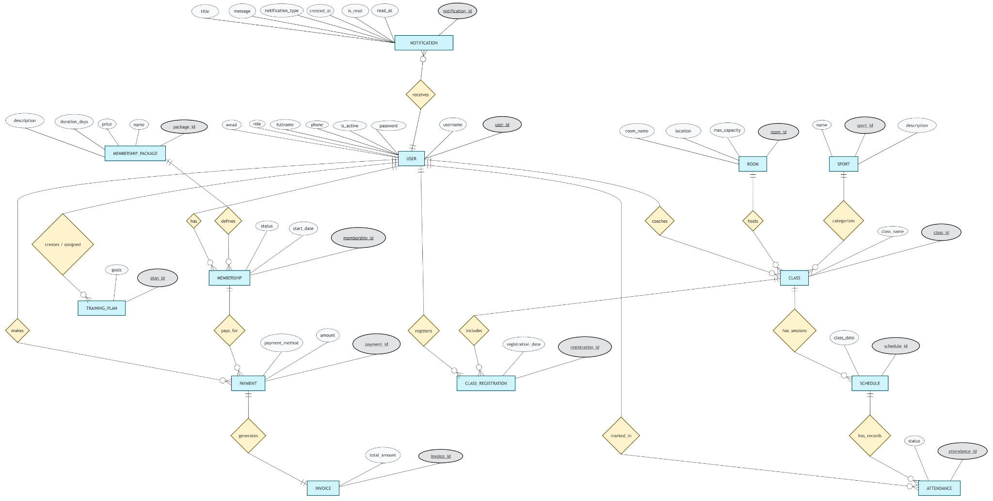
Entities Description
# | Entity | Description
1 | USER | Stores user account information, including username, password hash, full name, email, phone number, role and account status. The system supports Manager, Coach, Member and Receptionist roles.
2 | MEMBERSHIP_PACKAGE | Stores available membership packages, including package name, description, duration and price.
3 | MEMBERSHIP | Records membership registration and renewal information for members, including the associated package, start date, end date and membership status.
4 | ROOM | Stores training room information, including room name, location and maximum capacity.
5 | SPORT | Stores the sports categories supported by the sports center.
6 | CLASS | Stores class information, including class name, associated sport, training room, assigned coach and class status.
7 | SCHEDULE | Stores the date, start time and end time of each scheduled class session.
8 | CLASS_REGISTRATION | Records member registrations for classes, including registration date and registration status.
9 | ATTENDANCE | Records whether a registered member attended a scheduled class session, together with attendance status and notes.
10 | TRAINING_PLAN | Stores training plans created by coaches for members, including training goals, optional AI-generated recommendations and creation date. This entity supports an optional feature.
11 | PAYMENT | Records membership payments, including payment amount, payment date, payment method, payment status and MoMo transaction information when applicable.
12 | INVOICE | Stores invoices generated for successful payments, including issue date, total amount and invoice URL.
13 | NOTIFICATION | Stores notifications delivered to users, including notification title, message, type, creation time and read status. It supports membership reminders, class schedule updates and other system notifications.

6. State transition diagram
The supplied state-transition diagram covers Membership, Registration, Class, Attendance and Payment. It is included below and followed by the allowed transitions in text.
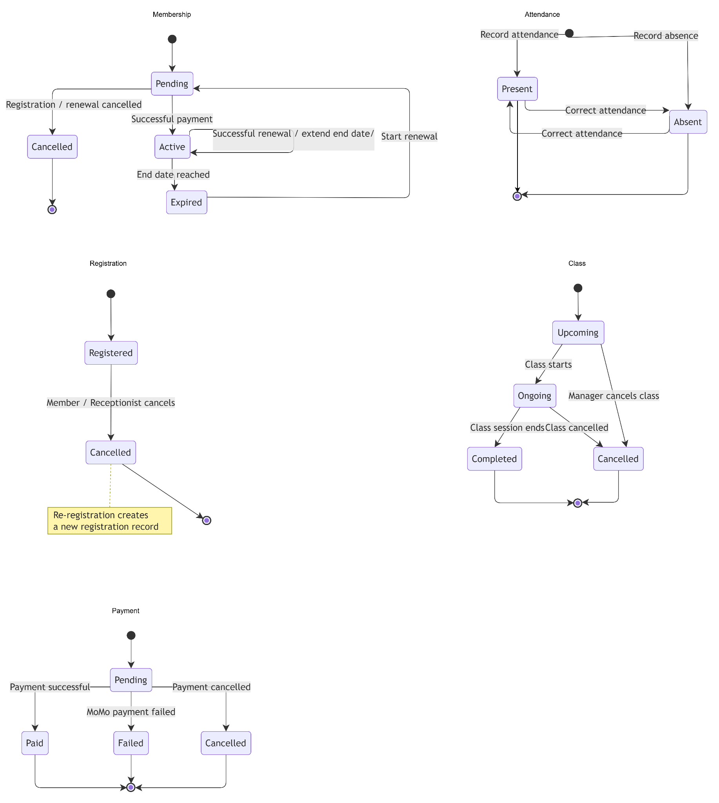

Entity | States | Transition Rules
Membership | Pending, Active, Expired, Cancelled | Pending → Active after successful payment; Pending → Cancelled if registration/renewal is cancelled; Active → Expired when end date is reached; Expired → Pending when renewal starts; successful renewal returns to Active and extends the end date.
Class Registration | Registered, Cancelled | Registered → Cancelled when the member or receptionist cancels; a later re-registration creates a new registration record.
Class | Upcoming, Ongoing, Completed, Cancelled | Upcoming → Ongoing when the session starts; Ongoing → Completed when it ends; an upcoming or ongoing session can become Cancelled by an authorized manager.
Attendance | Present, Absent | The authorized recorder sets Present or Absent; an allowed correction can change the status.
Payment | Pending, Paid, Failed, Cancelled | Pending → Paid on confirmed payment; Pending → Failed when MoMo reports failure; Pending → Cancelled when the payment attempt is cancelled. Failed/Cancelled attempts are not treated as paid.

II. Functional Requirements
Each function below describes its trigger, actors, purpose, primary layout and business rules. Visual screen mockups were not included in the source files; the layout descriptions are intended to guide later Figma design rather than replace final prototypes.

1. User & Membership Management

a. Account Registration, Login and Logout
Function trigger: A visitor opens Register or Login; an authenticated user selects Logout from the account menu.
Actors: Visitor, Member, Receptionist, Coach, Center Manager.
Function description: Create member accounts and provide secure access to authorized system functions. Self-registration creates a Member account; staff accounts are created/managed by authorized staff.
Screen layout: Register: full name, username or agreed login identifier, phone, email, password and confirmation. Login: login identifier and password. Show field-level errors and a post-login role-based landing page.
Function details / validations: Required fields must be validated. Username, phone and email must follow the uniqueness rules selected by the team. Passwords must be stored as a secure hash. Failed authentication must not reveal whether a password is correct. Users must not choose a privileged role during public registration. Logout invalidates the current authenticated session/token according to the security implementation.

b. Profile and Staff Account Management
Function trigger: Member opens My Profile; Center Manager opens User/Staff Management; Receptionist opens Member Search.
Actors: Member, Receptionist, Center Manager; Coach may update their own allowed profile fields.
Function description: Allow users to view and update permitted personal details, and allow authorized staff to search and maintain member, coach and receptionist records.
Screen layout: Profile page contains personal details and an Edit action. Staff management provides a searchable list, detail form, role/status controls and save/cancel actions.
Function details / validations: Members may update only their own permitted fields. Only Center Manager may assign/change privileged roles and deactivate staff accounts. Receptionist access is limited to service-related member data. The system should prevent deleting or disabling the last active Center Manager account. Duplicate unique identifiers must produce a clear validation message.

c. Membership Package, Registration, Renewal and Expiry
Function trigger: Member opens Membership Packages and selects a package; Receptionist searches a member and chooses Register/Renew at the counter; Center Manager maintains the package catalogue.
Actors: Member, Receptionist, Center Manager, SCMS.
Function description: Display available packages and create or renew the member’s membership. Membership status and expiration must be tracked and made visible to the member and authorized staff.
Screen layout: Package list shows name, description, fee and duration. Registration/renewal form displays the selected package, member, price and payment option. Membership detail shows status, start date and end date.
Function details / validations: Inactive packages cannot be newly selected. A membership remains Pending until payment is confirmed. Successful payment activates a new membership or extends the current membership according to the final renewal policy. When the end date is reached, Active transitions to Expired. The team must define whether a renewal starts immediately or after the current end date; do not allow a failed/cancelled payment to activate the membership. Send/display expiry notifications according to the chosen delivery channel.

2. Class & Schedule Management

a. Manage Sports, Rooms, Classes and Schedules
Function trigger: Center Manager opens the management dashboard and selects Sports, Rooms, Classes or Schedules.
Actors: Center Manager; Coach may view assigned information.
Function description: Maintain the class catalogue, room capacity, scheduled sessions and coach assignment, then publish sessions for members to view.
Screen layout: Management lists provide search/filter, create/edit forms, class status, sport, room, date, start/end time, assigned coach and publish/cancel actions.
Function details / validations: Required references must exist before a class/session can be published. The scheduled end time must be after the start time. A room cannot host overlapping sessions unless a future requirement explicitly allows it. A session cannot exceed the room’s maximum capacity. Coach assignments must be valid and should not conflict with another assigned session. Cancelled classes must no longer accept registrations; existing registrations should be retained for history and members should be notified.

b. Browse Classes, Register and Cancel Registration
Function trigger: Member opens Available Classes and selects a class; Receptionist can search a member and perform the same action on their behalf.
Actors: Member, Receptionist, SCMS.
Function description: Let members discover available classes, register for a class and cancel an existing registration when permitted. The system updates the displayed capacity/availability.
Screen layout: Class list includes sport, class name, date/time, room, coach, capacity and status. Class detail shows description and Register/Cancel controls. My Class Registrations lists current and past registrations.
Function details / validations: Only published, non-cancelled classes/sessions are available for registration. The system checks capacity before creating a registration and prevents duplicate active registrations for the same member and class. Cancellation changes the existing registration to Cancelled; re-registration creates a new record, as shown by the state diagram. The system must give a clear message when a class is full or registration is no longer available. Whether Active membership is mandatory for booking is a business rule to confirm before implementation.

c. Coach Teaching Schedule and Member List
Function trigger: Coach opens Teaching Schedule or selects an assigned class.
Actors: Coach, Center Manager.
Function description: Show coaches the sessions assigned to them and the members registered for each class.
Screen layout: A calendar/list view groups sessions by date. Session details show class name, room, time, registration list and attendance action if the optional module is enabled.
Function details / validations: Coaches can view only assigned classes unless the Center Manager grants additional permission. Member personal information should be limited to fields needed for training/attendance. Schedule changes should be reflected in the coach view and trigger notifications to affected users according to configured rules.

3. Payment & Report Management

a. Online Membership Payment via MoMo
Function trigger: After selecting Register/Renew Membership, the Member chooses online payment and confirms the payment request.
Actors: Member, SCMS, MoMo Payment Gateway.
Function description: Create a pending payment, direct the member to MoMo, receive the payment result and activate/renew the membership only after a successful verified result.
Screen layout: Checkout shows membership package, amount, payment method and a Confirm Payment action. Result page shows Pending/Success/Failed/Cancelled with a link to membership and payment history.
Function details / validations: The amount must be calculated by the backend from the selected package, not trusted from a client-submitted value. Store the payment as Pending before redirecting. Verify the MoMo response/callback and transaction reference server-side. Handle repeated callbacks idempotently so one transaction cannot activate a membership twice. Only a confirmed successful transaction becomes Paid and triggers membership activation/renewal plus invoice generation. Failed or cancelled attempts must display an understandable message and must not activate the membership. MoMo credentials/secrets must not be exposed in frontend code.

b. Reception Desk Membership Registration, Renewal and Payment
Function trigger: Member requests service at the reception desk; Receptionist searches an existing member or creates a new member record, then selects Register/Renew.
Actors: Member, Receptionist, SCMS.
Function description: Support in-person member registration and membership purchase/renewal with payment recorded by the receptionist.
Screen layout: Reception flow links Member Search/Registration, Membership Information, Package Selection, Record Payment, Membership Status and Invoice. Provide a review step before saving.
Function details / validations: The receptionist must verify the member record to avoid duplicates. Required member information must be completed before registration. Record the actual payment method, amount, timestamp and staff user who received it. Do not mark a membership Active until the payment record has a successful/paid status. If payment cannot be completed, preserve a Pending or Failed transaction rather than creating a paid invoice.

c. Payment History, Invoice Generation and Export
Function trigger: Member opens Payment History; Receptionist opens a payment record; the system receives a confirmed successful payment.
Actors: Member, Receptionist, SCMS; Center Manager according to reporting permissions.
Function description: Allow authorized users to view payment records and generate, print or export invoices for successful membership payments.
Screen layout: Payment history lists date, amount, method, status and transaction reference. Invoice detail shows invoice number, member, package/payment reference, total amount and issue date, with Print/Export action where permitted.
Function details / validations: Members can access only their own payment and invoice records. An invoice is generated only for a successful payment; one payment should not create duplicate invoices. The invoice total must match the recorded payment amount. Failed/cancelled transactions may appear in history but must not appear as revenue. Print/export must use the saved invoice data rather than client-edited values.

d. Management Reports
Function trigger: Center Manager selects a report from the management dashboard and specifies a date range or filter.
Actors: Center Manager.
Function description: Provide reports on member count and membership status, class-registration status, and revenue over time.
Screen layout: Dashboard/report pages provide date filters, summary totals and a table/chart with clear labels. Revenue view groups successful payments by a selected time interval.
Function details / validations: Member reports must clearly distinguish Active, Pending, Expired and Cancelled memberships. Class reports must distinguish Registered and Cancelled registrations and show the reporting period. Revenue totals should include only Paid transactions and must use a consistent time basis. Empty reports should display zero/empty-state messaging. Only authorized manager roles may access the report APIs.

4. Training & Attendance Management (Optional)

a. Training Plans, Results and Progress
Function trigger: Coach opens an assigned member or class and selects Training Plan, Record Result or Evaluate Progress.
Actors: Coach; Member can view their own records.
Function description: Allow coaches to create training plans, record session results, evaluate progress and share comments or homework. Members can view their training history when this optional module is enabled.
Screen layout: Plan form includes goal, plan details/exercises, target member or class, created date and coach. Results/history pages show dated results, progress evaluation, coach comments and homework.
Function details / validations: The assigned coach must be authorized for the target member/class. Each result should be associated with a date/session and author. Members may view but not modify coach-entered plans/results. If AI-generated suggestions are used, the coach should review them before using them as a final training plan.

b. Record and Review Attendance
Function trigger: Receptionist or Coach opens a scheduled session and selects the attendance list; authorized staff may correct an existing record.
Actors: Receptionist, Coach; Member can view their own attendance history; Center Manager can review aggregate information.
Function description: Record each member as Present or Absent for a scheduled session and allow permitted corrections.
Screen layout: Session attendance screen lists registered members with Present/Absent status, timestamp and recorder. Member history shows session/date and status.
Function details / validations: A member should have no more than one attendance record per scheduled session. Only authorized staff may create/correct attendance. The system records who made the change and when. Corrections should update the existing record rather than silently creating duplicates.

5. AI Features (Optional)

a. Exercise Recommendation
Function trigger: Coach or Member opens the recommendation feature and requests suggestions based on the member’s training profile.
Actors: Coach, Member, SCMS and a configured AI API if adopted.
Function description: Generate exercise suggestions from available goals, fitness level and training history. Coaches may use the suggestions while preparing training plans.
Screen layout: Request form shows relevant goals/profile inputs; result view lists recommended exercises and a short explanation. Provide an option to save reviewed suggestions into a training plan if that workflow is implemented.
Function details / validations: Use only information required for the recommendation and apply role-based access. If training history is unavailable, explain that the recommendation may be limited. Treat generated suggestions as suggestions, not verified professional advice. AI use is optional and must not block core membership, booking or payment flows.

b. AI Assistant
Function trigger: Member opens the assistant and submits a question about schedules, exercises or sports-center services.
Actors: Member, SCMS and a configured AI API if adopted.
Function description: Provide AI-generated answers grounded in available sports-center information.
Screen layout: Chat-style interface with message history, input area, send action and clear fallback when no answer is available.
Function details / validations: The assistant should not invent schedules, prices or membership status; such answers should be retrieved from system data where possible. Do not expose another member’s information. If the AI service is unavailable, show a friendly error and keep normal system functions available.

6. Access Control & Reception Support

a. Access Permissions and Activity History
Function trigger: Center Manager opens System Settings, Role Permissions or Activity History.
Actors: Center Manager.
Function description: Configure which roles can access major screens/actions and view important system activity for auditing.
Screen layout: Permission matrix lists roles and actions. Activity history shows actor, action, target entity, timestamp and relevant detail.
Function details / validations: Authorization must be enforced by backend APIs as well as the frontend. Permission changes should be restricted to authorized managers and written to the audit history. Secrets and sensitive credential values must not be recorded in audit detail. The system should retain enough information to investigate important changes without storing unnecessary personal data.

b. Support Requests, Reception Assistance and Notifications
Function trigger: Member submits a support request or the Receptionist receives one at the desk; the system detects membership expiry or a class schedule change.
Actors: Member, Receptionist, Center Manager, SCMS.
Function description: Record and track support requests and notify members about important membership/class events using the delivery channel selected for the project.
Screen layout: Support form includes category/subject, description and submission confirmation. Reception view lists new/in-progress/resolved requests. Notifications appear in the member dashboard or configured notification channel.
Function details / validations: Requests should have a status and creation timestamp. Members can view their own requests; receptionists can manage requests for service; manager access follows configured permissions. Notification text should identify the relevant membership/class and action required. The team must confirm whether notification delivery is in-app only or also uses email/SMS/push.

III. Database Design

1. Database Schema
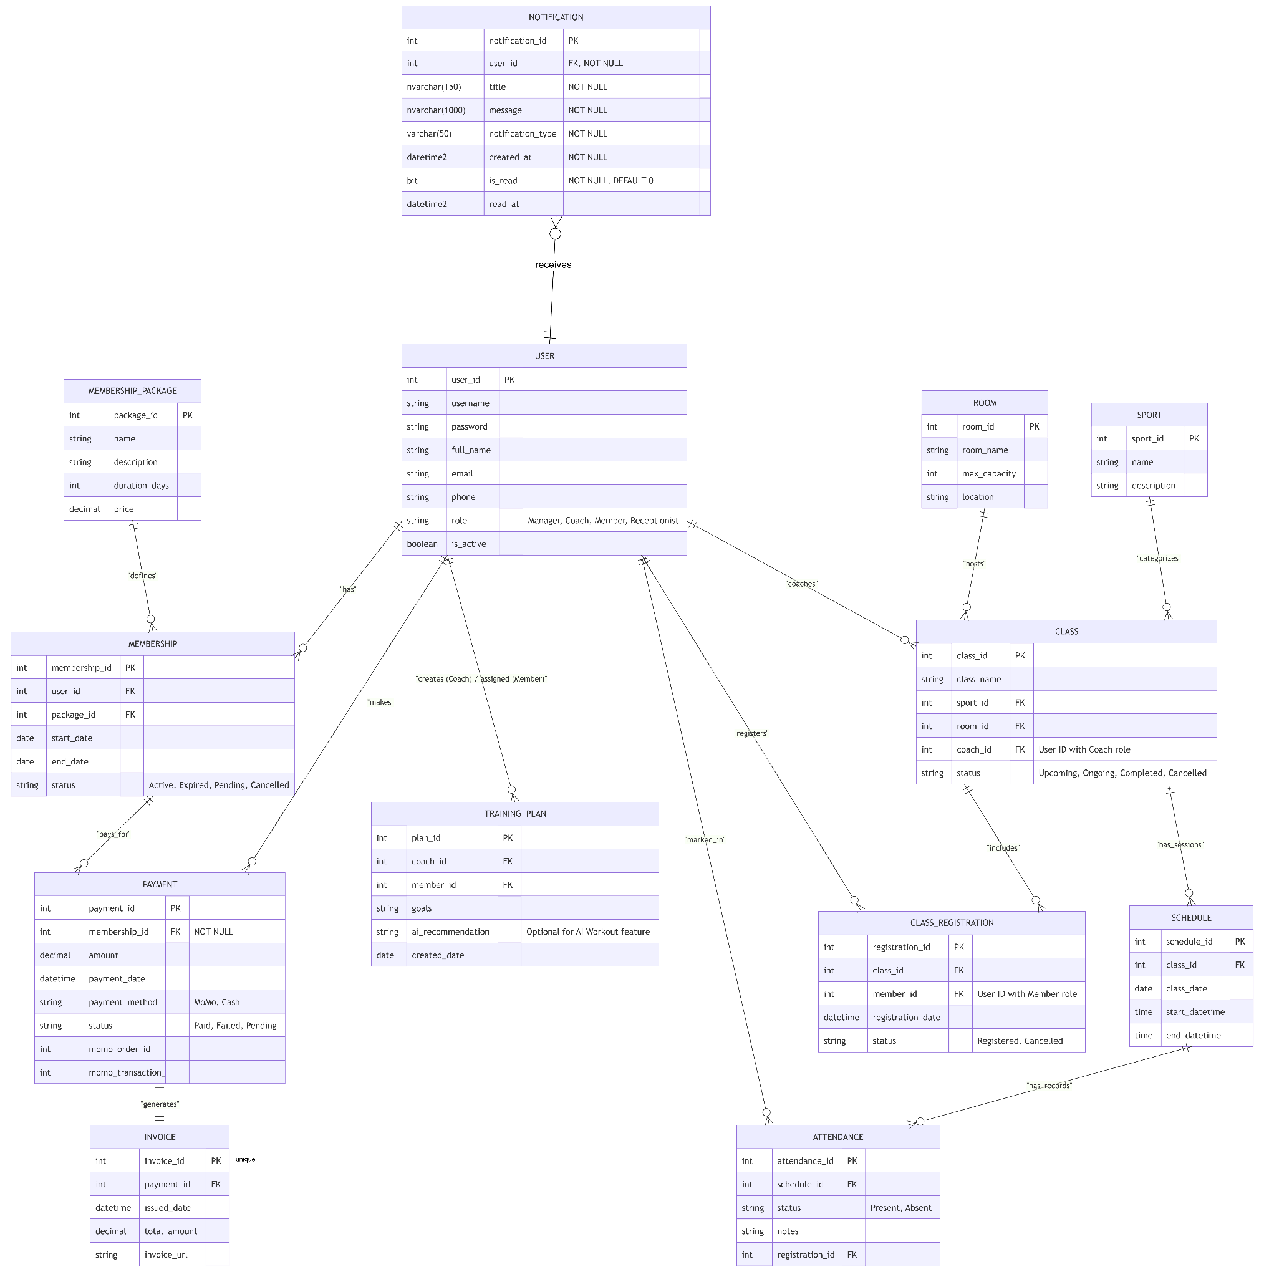

Table Description
# | Table | Description
1 | Users | Stores system user accounts and role information.
2 | MembershipPackages | Stores membership package details, duration and pricing.
3 | Memberships | Records membership registrations, renewals and membership status.
4 | Rooms | Stores training room information and maximum capacity.
5 | Sports | Stores the sports categories available at the center.
6 | Classes | Stores class information and links each class to a sport, room and coach.
7 | Schedules | Stores the scheduled dates and times of class sessions.
8 | ClassRegistrations | Records member registrations for classes and their current registration status.
9 | Attendance | Records attendance for registered members in scheduled sessions.
10 | TrainingPlans | Stores individual training plans created by coaches. This table supports an optional feature.
11 | Payments | Stores membership payment records and payment gateway transaction information.
12 | Invoices | Stores invoices generated from successful payment records.
13 | Notifications | Stores user-specific notifications and tracks whether each notification has been read.

Database Relationships
# | Relationship | Description
1 | Users — Memberships | One user can have multiple membership records. Each membership belongs to one user.
2 | MembershipPackages — Memberships | One package can be associated with multiple membership records. Each membership references one package.
3 | Memberships — Payments | One membership can have multiple payment records. Each payment belongs to one membership.
4 | Payments — Invoices | One payment can generate at most one invoice. Each invoice references one payment.
5 | Users — Notifications | One user can receive zero or multiple notifications. Each notification belongs to exactly one user.
6 | Users — TrainingPlans | A user may be referenced as a coach or a member in multiple training plans.
7 | Sports — Classes | One sport can categorize multiple classes. Each class belongs to one sport.
8 | Rooms — Classes | One room can host multiple classes over time. Each class is assigned to one room.
9 | Users — Classes | A coach can be assigned to multiple classes. Each class references one coach account.
10 | Classes — Schedules | One class can have multiple scheduled sessions. Each schedule belongs to one class.
11 | Classes — ClassRegistrations | One class can have multiple registration records. Each registration references one class.
12 | Users — ClassRegistrations | One member can have multiple registration records. Each registration references one member account.
13 | Schedules — Attendance | One schedule can have multiple attendance records. Each attendance record references one scheduled session.
14 | ClassRegistrations — Attendance | One registration can have attendance records for multiple scheduled sessions. Each attendance record references one registration.
Database Views
# | View | Description
1 | vw_ActiveMemberships | Displays active membership records together with user information and membership package details.
2 | vw_ClassScheduleCapacity | Displays class and schedule information, room capacity, registered member counts and remaining capacity.
The foreign key relationships enforce referential integrity. Additional constraints and indexes are used to enforce data validity and improve query performance. Business rules such as validating user roles, checking available class capacity and verifying MoMo payment results must also be enforced by the application.

2. Table Detail
Notation:
- PK: Primary Key
- FK: Foreign Key
- Unique: The value must be unique.
- NOT NULL: A value is required.
- NULL: A value is optional.
- Identity: The value is automatically generated.
- Default: The value assigned when no value is provided during insertion.

2.1 Users
Stores system user accounts and profile information.
# | Field name | Type | Size | Unique | Not Null | PK/FK | Notes
1 | user_id | INT | — | Yes | Yes | PK | Identity, auto-generated.
2 | username | VARCHAR | 50 | Yes | Yes | — | Unique username.
3 | password | VARCHAR | 255 | No | Yes | — | Stores a BCrypt password hash, never plaintext.
4 | full_name | NVARCHAR | 100 | No | Yes | — | User's full name.
5 | email | VARCHAR | 255 | No | No | — | Optional email address.
6 | phone | VARCHAR | 15 | Yes | Yes | — | Unique phone number; used for login.
7 | role | VARCHAR | 20 | No | Yes | — | Manager, Coach, Member or Receptionist.
8 | is_active | BIT | — | No | Yes | — | Default: 1. Indicates whether the account is active.

2.2 MembershipPackages
Stores available membership packages.
# | Field name | Type | Size | Unique | Not Null | PK/FK | Notes
1 | package_id | INT | — | Yes | Yes | PK | Identity, auto-generated.
2 | name | NVARCHAR | 100 | Yes | Yes | — | Unique package name.
3 | description | NVARCHAR | 500 | No | No | — | Optional package description.
4 | duration_days | INT | — | No | Yes | — | Must be greater than 0.
5 | price | DECIMAL | 18,2 | No | Yes | — | Package price; must be non-negative.

2.3 Memberships
Records membership registration and renewal information.
# | Field name | Type | Size | Unique | Not Null | PK/FK | Notes
1 | membership_id | BIGINT | — | Yes | Yes | PK | Identity, auto-generated.
2 | user_id | INT | — | No | Yes | FK | References Users(user_id).
3 | package_id | INT | — | No | Yes | FK | References MembershipPackages(package_id).
4 | start_date | DATE | — | No | Yes | — | Membership start date.
5 | end_date | DATE | — | No | Yes | — | Must be on or after start_date.
6 | status | VARCHAR | 20 | No | Yes | — | Default: Pending. Allowed values: Active, Expired, Pending, Cancelled.
Business constraint: A user can have only one Active membership at a time, enforced by a filtered unique index.

2.4 Rooms
Stores training room details and capacity.
# | Field name | Type | Size | Unique | Not Null | PK/FK | Notes
1 | room_id | INT | — | Yes | Yes | PK | Identity, auto-generated.
2 | room_name | NVARCHAR | 100 | Yes | Yes | — | Unique room name.
3 | max_capacity | INT | — | No | Yes | — | Must be greater than 0.
4 | location | NVARCHAR | 255 | No | No | — | Optional room location.

2.5 Sports
Stores available sports categories.
# | Field name | Type | Size | Unique | Not Null | PK/FK | Notes
1 | sport_id | INT | — | Yes | Yes | PK | Identity, auto-generated.
2 | name | NVARCHAR | 100 | Yes | Yes | — | Unique sport name.
3 | description | NVARCHAR | 500 | No | No | — | Optional description.

2.6 Classes
Stores classes and their assigned sport, room and coach.
# | Field name | Type | Size | Unique | Not Null | PK/FK | Notes
1 | class_id | INT | — | Yes | Yes | PK | Identity, auto-generated.
2 | class_name | NVARCHAR | 150 | No | Yes | — | Name of the class.
3 | sport_id | INT | — | No | Yes | FK | References Sports(sport_id).
4 | room_id | INT | — | No | Yes | FK | References Rooms(room_id).
5 | coach_id | INT | — | No | Yes | FK | References Users(user_id); application must validate Coach role.
6 | status | VARCHAR | 20 | No | Yes | — | Default: Upcoming. Allowed values: Upcoming, Ongoing, Completed, Cancelled.
Business constraint: Class capacity is derived from Rooms.max_capacity; no separate capacity field is stored in Classes.

2.7 Schedules
Stores the scheduled sessions of classes.
# | Field name | Type | Size | Unique | Not Null | PK/FK | Notes
1 | schedule_id | BIGINT | — | Yes | Yes | PK | Identity, auto-generated.
2 | class_id | INT | — | No | Yes | FK | References Classes(class_id).
3 | class_date | DATE | — | No | Yes | — | Date of the session; must match the date of start_datetime.
4 | start_datetime | DATETIME2 | — | No | Yes | — | Session start date and time.
5 | end_datetime | DATETIME2 | — | No | Yes | — | Must be later than start_datetime.
Business constraint: A class cannot have two schedule records with the same start_datetime. Preventing overlapping schedules in the same room must also be handled by the application.

2.8 ClassRegistrations
Records member registration for classes.
# | Field name | Type | Size | Unique | Not Null | PK/FK | Notes
1 | registration_id | BIGINT | — | Yes | Yes | PK | Identity, auto-generated.
2 | class_id | INT | — | No | Yes | FK | References Classes(class_id).
3 | member_id | INT | — | No | Yes | FK | References Users(user_id); application must validate Member role.
4 | registration_date | DATETIME2 | — | No | Yes | — | Default: current database date and time.
5 | status | VARCHAR | 20 | No | Yes | — | Default: Registered. Allowed values: Registered, Cancelled.
Business constraint: A member can have only one Registered record for the same class at a time. After cancellation, a new registration record may be created.

2.9 Attendance
Stores attendance records for registered members in scheduled sessions.
# | Field name | Type | Size | Unique | Not Null | PK/FK | Notes
1 | attendance_id | BIGINT | — | Yes | Yes | PK | Identity, auto-generated.
2 | schedule_id | BIGINT | — | No | Yes | FK | References Schedules(schedule_id).
3 | status | VARCHAR | 20 | No | Yes | — | Allowed values: Present, Absent.
4 | notes | NVARCHAR | 500 | No | No | — | Optional attendance notes.
5 | registration_id | BIGINT | — | No | Yes | FK | References ClassRegistrations(registration_id).
Business constraint: The combination of schedule_id and registration_id must be unique. The application must ensure that the registration belongs to the same class as the scheduled session.

2.10 TrainingPlans
Stores optional training plans created by coaches.
# | Field name | Type | Size | Unique | Not Null | PK/FK | Notes
1 | plan_id | BIGINT | — | Yes | Yes | PK | Identity, auto-generated.
2 | coach_id | INT | — | No | Yes | FK | References Users(user_id); must have Coach role.
3 | member_id | INT | — | No | Yes | FK | References Users(user_id); must have Member role.
4 | goals | NVARCHAR | 1000 | No | Yes | — | Training goals.
5 | ai_recommendation | NVARCHAR | 2000 | No | No | — | Optional AI-generated exercise recommendation.
6 | created_date | DATE | — | No | Yes | — | Defaults to the current date.

2.11 Payments
Records payments for membership registration and renewal.
# | Field name | Type | Size | Unique | Not Null | PK/FK | Notes
1 | payment_id | BIGINT | — | Yes | Yes | PK | Identity, auto-generated.
2 | membership_id | BIGINT | — | No | Yes | FK | References Memberships(membership_id).
3 | amount | DECIMAL | 18,2 | No | Yes | — | Must be greater than 0.
4 | payment_date | DATETIME2 | — | No | Yes | — | Defaults to the current date and time.
5 | payment_method | VARCHAR | 10 | No | Yes | — | Allowed values: MoMo, Cash.
6 | status | VARCHAR | 15 | No | Yes | — | Default: Pending. Allowed values: Paid, Failed, Pending.
7 | momo_order_id | VARCHAR | 100 | Yes* | No | — | Optional MoMo order ID; unique when provided.
8 | momo_transaction_id | VARCHAR | 100 | Yes* | No | — | Optional MoMo transaction ID; unique when provided.
The unique indexes apply only to non-NULL MoMo identifiers.
Business constraint: A MoMo payment must not be marked Paid until the application verifies a valid payment result or callback from the payment provider.

2.12 Invoices
Stores invoices generated from successful payment records.
# | Field name | Type | Size | Unique | Not Null | PK/FK | Notes
1 | invoice_id | BIGINT | — | Yes | Yes | PK | Identity, auto-generated.
2 | payment_id | BIGINT | — | Yes | Yes | FK | References Payments(payment_id); unique, allowing at most one invoice per payment.
3 | issue_date | DATETIME2 | — | No | Yes | — | Defaults to the current date and time.
4 | total_amount | DECIMAL | 18,2 | No | Yes | — | Must be greater than 0.
5 | invoice_url | VARCHAR | 1000 | No | No | — | Optional URL or path to the invoice file.
Business constraint: An invoice should be generated only after the related payment is successful.

2.13 Notifications
Stores notifications delivered to individual users and tracks their read status.
# | Field name | Type | Size | Unique | Not Null | PK/FK | Notes
1 | notification_id | INT | — | Yes | Yes | PK | Identity, auto-generated.
2 | user_id | INT | — | No | Yes | FK | References Users(user_id); identifies the recipient.
3 | title | NVARCHAR | 150 | No | Yes | — | Notification title.
4 | message | NVARCHAR | 1000 | No | Yes | — | Notification content.
5 | notification_type | VARCHAR | 50 | No | Yes | — | Examples: MembershipExpiration, ClassScheduleChange, ClassReminder.
6 | created_at | DATETIME2 | — | No | Yes | — | Defaults to the current date and time.
7 | is_read | BIT | — | No | Yes | — | Default: 0, indicating unread.
8 | read_at | DATETIME2 | — | No | No | — | Timestamp when the notification is read; NULL if unread.
Business constraint: Each notification belongs to one user. A user may have zero or multiple notifications. Notifications should be retrieved according to the currently authenticated user to prevent users from accessing another user's notifications.

Database Implementation Notes
- The database uses SQL Server data types, including INT, BIGINT, VARCHAR, NVARCHAR, DECIMAL, DATE, DATETIME2 and BIT.
- Primary keys use IDENTITY where specified to generate identifiers automatically.
- Foreign keys maintain relationships between users, memberships, classes, registrations, attendance, payments, invoices and notifications.
- The application must validate role-specific relationships because foreign keys alone do not ensure that a referenced user has the correct role.
- The application must check room capacity, schedule conflicts and attendance consistency before accepting changes.
- The application must store password hashes instead of plaintext passwords and verify MoMo payment results before marking payments as successful.
- Notifications are stored per recipient. The application can use is_read and read_at to display unread notifications and update their read status.

