 | HIBERNATE
Author: GTN | Document type: Self-training roadmap
Review: QVR
Date: 05.06.2023
Version: 1.8
/
Self-Training for Hibernate
Table of contents
1. Introduction 1
2. Prerequisites 2
3. References 2
4. Glossary 2
5. Training plan 3
5.1. Basic 3
5.2. Advanced (optional) 10

Introduction
Working with both Object-Oriented software and Relational Databases can be cumbersome and time consuming. Development costs are significantly higher due to a paradigm mismatch between how data is represented in objects versus relational databases.
Hibernate is an ORM solution for Java environments framework which is created to ease developers’ job when working with database. The term ORM refers to the technique of mapping data from an object model representation to a relational data model representation (and vice versa). And it has been used in most Java projects at ELCA, either directly or as an implementation of JPA .
In your project, you will be most frequently assigned to:
- Map tables to JPA/Hibernate entities and vice versa.
- Use API provided by JPA/Hibernate to query data from and persist data to the database.
This document will show you the roadmap that you will need to go through to work with the framework. It also introduces 2 powerful frameworks that are usually used with Hibernate/JPA in ELCA:
- spring-data-jpa: Aims to significantly improve the implementation of data access layers by reducing the effort to the amount that's actually needed.
- QueryDSL: An alternative to both JPQL and Criteria queries. It combines the dynamic nature of Criteria queries with the expressiveness of JPQL and all that in a fully typesafe manner.
Now, let’s move on!

Prerequisites
Having basic knowledge about:
- Java
- Spring Framework (refer to [RM-SRPINGMVC])
Having the following software installed:
- Java SDK 8+
- Maven (3.2.5+)
- IntelliJ 2020+

References
JPWH | Christian Bauer, Gavin King. Java Persistence with Hibernate, Manning Publications
ANNOT | Hibernate Annotations - Reference Guide  http://docs.jboss.org/hibernate/annotations/3.5/reference/en/html_single/
SPRING | Craig Walls. Spring In Action, 3rd Edition, Manning Publications 2011
RM-SPRINGMVC | Roadmap to Spring MVC (that contains the introduction to Spring framework)

Glossary
Persistence | When we talk about persistence in Java, we’re normally talking about storing data in a relational database using SQL.
Persistence layer | The persistence layer is a group of classes and components responsible for storing data to, and retrieving it from, one or more data stores.
POJO | Plain Old Java Objects which means a normal java object or more exactly a JavaBean
DDL | A Data Definition Language (DDL) is a part of SQL that deals with defining data structure such as creating table …
JPA | The Java Persistence API (JPA) is a Java application programming interface specification that describes the management of relational data in applications using Java Platform, Standard Edition and Java Platform, Enterprise Edition.
ORM | Object Relational Mapping is a programming technique for converting data between incompatible type systems in object-oriented programming languages. This creates, in effect, a "virtual object database" that can be used from within the programming language. There are both free and commercial packages available that perform object-relational mapping, although some programmers opt to create their own ORM tools.

Training plan

Basic
These steps are mandatory and should be completed by all trainees.

No. | Type | Task | Description | Estimated  Time (h)
 | R | Acquire basic knowledge about ORM | Read chapter 1 (Understanding object/relational persistence) of [JPWH] to get introduced to the object/relational paradigm mismatch and the fundamentals behind ORM.  Persistence is one of the fundamental concepts in application development.  Object persistence means individual objects can outlive the application process; they can be saved to a data store and be re-created at a later point in time.  Persistence in Java, we’re normally talking about mapping and storing object instances in a database using SQL.  This allows business logic to use sophisticated object-oriented concepts such as inheritance and polymorphism.  In a nutshell, object/relational mapping is the automated (and transparent) persistence of objects in a Java application to the tables in an SQL database, using metadata that describes the mapping between the classes of the application and the schema of the SQL database.  The benefits of Hibernate:  Productivity—Hibernate eliminates much of the grunt work and lets you concentrate on the business problem.  Maintainability —Automated ORM with Hibernate reduces lines of code (LOC), making the system more understandable and easier to refactor  Performance- Hibernate allow the use of many optimizations at all times.  Vendor independence—Hibernate can help mitigate some of the risks associated with vendor lock-in. Even if you plan never to change your DBMS product, ORM tools that support a number of different DBMSs enable a certain level of portability. In addition, DBMS independence helps in development scenarios where engineers use a lightweight local database but deploy for testing and production on a different system.  The JPA specification defines the following:  ○ A facility for specifying mapping metadata—how persistent classes and their properties relate to the database schema. JPA relies heavily on Java annotations in domain model classes, but you can also write mappings in XML files.  ○ APIs for performing basic CRUD operations on instances of persistent classes, most prominently javax.persistence.EntityManager to store and load data.  ○ A language and APIs for specifying queries that refer to classes and properties of classes. This language is the Java Persistence Query Language (JPQL) and looks similar to SQL. The standardized API allows for programmatic creation of criteria queries without string manipulation.  ○ How the persistence engine interacts with transactional instances to perform  dirty checking, association fetching, and other optimization functions. The latest JPA specification covers some basic caching strategies.  Hibernate implements JPA and supports all the standardized mappings, queries, and programming interfaces | 1
 | R | Study JPA annotations | Read carefully the whole chapter 2.2 (Mapping with JPA) of [ANNOT] to learn how to use JPA/Hibernate annotations for:  Annotations can be split in two categories, the logical mapping annotations (describing the object model, the association between two entities etc.) and the physical mapping annotations (describing the physical schema, tables, columns, indexes, etc).  - (2.2.1) Marking a POJO as persistent entity  @Entity declares the class as an entity (i.e. a persistent POJO class)  @Table is set at the class level; it allows you to define the table, If no @Table is defined the default values are used: the unqualified class name of the entity.  @Id declares the identifier property of this entity.  as @Transient, and will be ignored by the entity manager.  the @Access annotation is used to define the access strategy for a persistent entity or its properties.  AccessType.FIELD indicates that Hibernate should use field access to read/write the entity's state.  AccessType.PROPERTY indicates that Hibernate should use getter/setter methods to read/write the entity's state.  - (2.2.2) Mapping simple properties  - (2.2.3) Mapping identifier properties  - (2.2.5) Mapping entity associations/relationships  Notes:  - You should read twice about “mappedBy” which is the most confusing when mapping entities together.  One-to-One:  There are three cases for one-to-one associations:  either the associated entities share the same primary keys values,  The @PrimaryKeyJoinColumn annotation does say that the primary key of the entity is used as the foreign key value to the associated entity.  a foreign key is held by one of the entities  or a association table is used to store the link between the 2 entities  - In addition, the following terms should be carefully understood:  - Cascade type (more information regarding Hibernate’s “transitive persistence” can be found here: https://docs.jboss.org/hibernate/stable/core.old/reference/en/html/objectstate-transitive.html)  - Fetching mode (a short introduction to Hibernate “lazy load” can be found here: https://howtoprogramwithjava.com/hibernate-eager-vs-lazy-fetch-type/)  - If you have any further question, the answer should be found in [JPWH] | 4
 | E | Setup development environment | Check out the project pim-tool-back from Git (link should be given by your coach).  There are 2 ways to compile the project code:  - Command line  Configure file etc/env/setenv.bat  - Set JAVA_HOME to the directory where Java is installed  - Set M2_HOME to the directory where Maven is installed  Copy etc/maven/settings.xml to your local M2_HOME\conf.  Bootstrap the project with Maven commands:  - From the directory on-boarding-exercise, open command line, type ..\etc\env\setenv.bat.  - Verify versions of Java and Maven by executing the following commands:  - java –version  - mvn -version  - Type mvn clean install to clean and build the whole project. In this step, missing dependencies will be downloaded to the local repository and you should see “BUILD SUCCESS” in the command line at the end.  - IntelliJ  Configure Project Structure and Settings to use your installed Maven and Java versions.  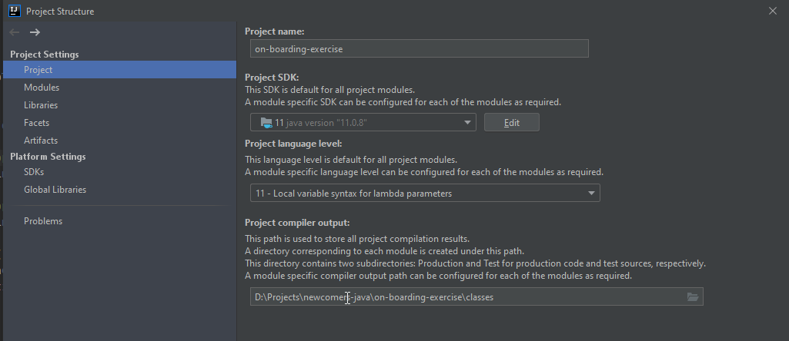  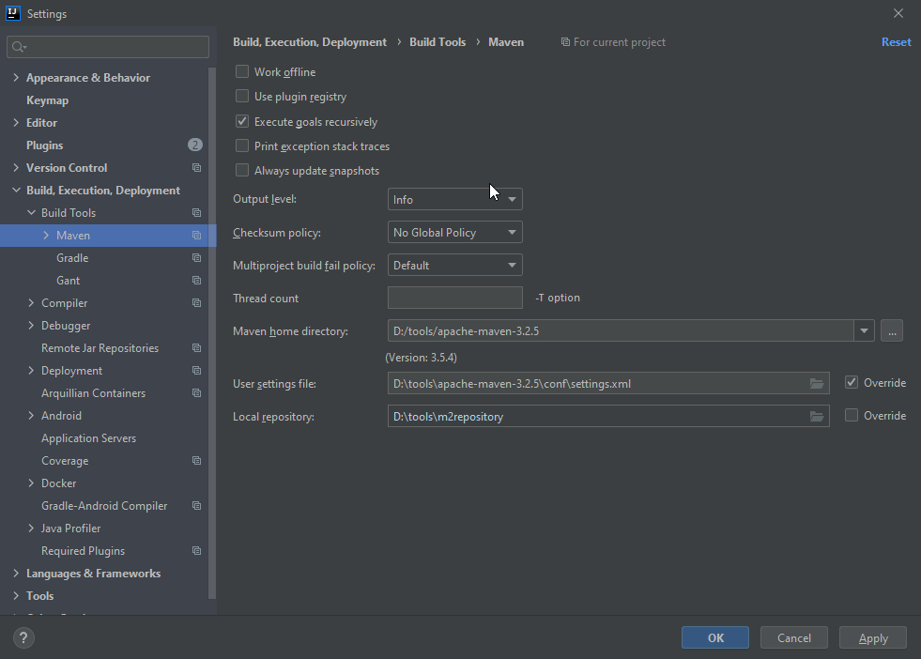  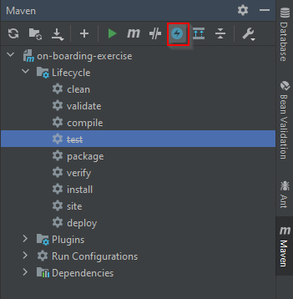  Toggle “Skip tests” mode on.  - Run “Clean” and “Install” steps from lifecycle. In this step, missing dependencies will be downloaded to the local repository and you should see “BUILD SUCCESS” in the command line at the end.
 | R | Mapping relations | Research and read about how to do mapping for different types of relations:  - Attribute “mappedBy” in @OneToMany  - Attribute “cascade” and its options in @OneToMany and @ManyToOne  - Attribute “fetch” and its options in @OneToMany and @ManyToOne  - Why there are duplication classes (i.e. @Table, @Entity, …) between package org.hibernate.annotations and javax.persistence? What should we used typically? | 2
 | R | Study Spring Data JPA | Read the following sections from chapter 3 (Working with Spring Data Repositories) from spring-data-jpa’s reference to gain knowledge about this framework: https://docs.spring.io/spring-data/jpa/docs/current/reference/html/#repositories:  - (3.1) Core concepts  The central interface in the Spring Data repository abstraction is Repository  JpaRepository extends CRUDRepository  - (3.2) Query methods  Defining Repository Interfaces  Defining Query Methods  Creating Repository Instances  Custom Implementations for Spring Data Repositories  - (3.3) Defining repository interfaces  The interface must extend Repository and be typed to the domain class and an ID type.  - (3.4) Defining query methods  By deriving the query from the method name directly.  By using a manually defined query.  - (4.6.1) Adding custom behavior to single repositories  Create an interface extend Repository<1,2>  @Query annotation to querry | 2
 | R | Study QueryDSL | Read the listed sections from the following link to study how to use QueryDSL to write type-safe queries on top of a JPA model http://www.querydsl.com/static/querydsl/2.1.0/reference/html/ch02s02.html:  - (2.2.1) Maven integration  - (2.2.4) Using query types  - (2.2.5) Querying  - (2.2.6) Using joins  - (2.2.7) General usage  - (2.2.8) Ordering  - (2.2.9) Grouping  - (2.2.12) Subqueries | 2
 | R | Lifecyle of Hibernate entities | Research and read about these topics:  A persistence context is a set of entity instances in which for any persistent entity identity there is a unique entity instance. Within the persistence context, the entity instances and their lifecycle are managed.  - List all available states of entities in Hibernate.  Transient:  State of newly instantiated entity, it not represent any record yet  Like a basis Java Object because without any connection to Database and not able to use any JPA function  Method: persist(entity) -> Managed  Managed:  Can go from transient to managed by persist from entityManager  Can go from DB to managed by method find, querries…  Can go from managed to DB by flush() (method to synchronize )  Now entity is attached to persistence context  PersistentProvider(Hibernate) can detect any changes of entity then generate sql statement  Operations such as saving, updating, or deleting the entity can be performed.  Removed  Transition to the removed state occurs when an entity is explicitly marked for deletion using the delete or remove operation.  The entity will be deleted from the database when the transaction is committed.  Detached  Entity gets detached when persistent context close (usually after a request proceed: database transaction commit, context close, entity return to caller )  Transition to the detached state occurs when the entity is no longer associated with a Hibernate session or persistent context.  The entity was previously persistent but has been disconnected from the Hibernate session.  Changes made to the entity in the detached state are not automatically synchronized with the database.  Caller get entity object from the detached state  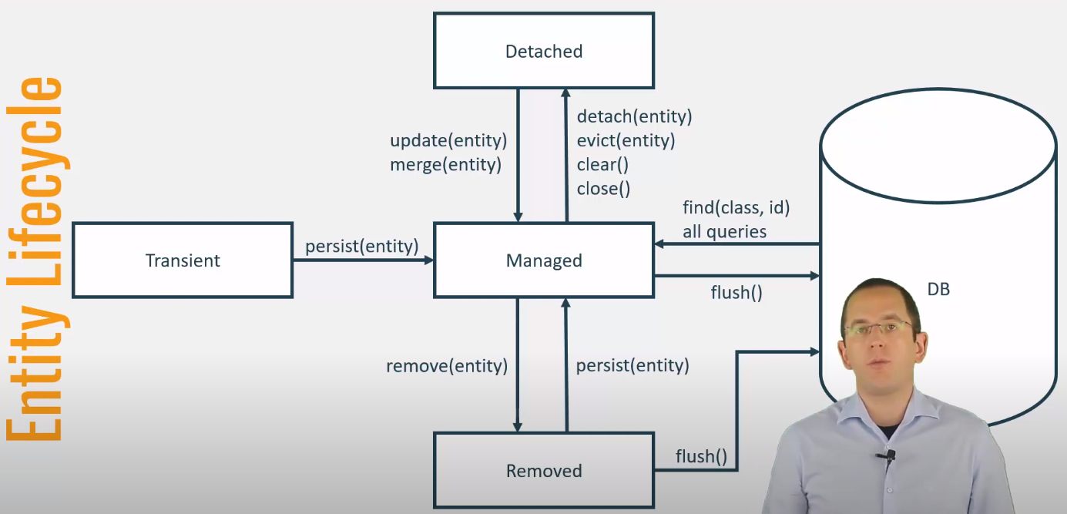  - List all possible transitions of entities from one state to another.  - For each possible transition listed above, identify the appropriate Hibernate API to make the transition.  - In which state, a Hibernate entity can be garbage collected by the JVM?  Once an entity is detached and no longer referenced by any application code or held in the Hibernate session, it becomes eligible for garbage collection like any other Java object. | 2
 | E | Work with Spring Data Repositories and QueryDSL | Define a new repository for entity Group named GroupRepository in package vn.elca.training.dao and create a JUnit test to verify that it works.  Enhance the existing ProjectRepositoryTest with the following test:  - To verify the saving of one project via ProjectRepository  - To verify the saving of multiple projects to achieve the data represented by the following tree via ProjectRepository  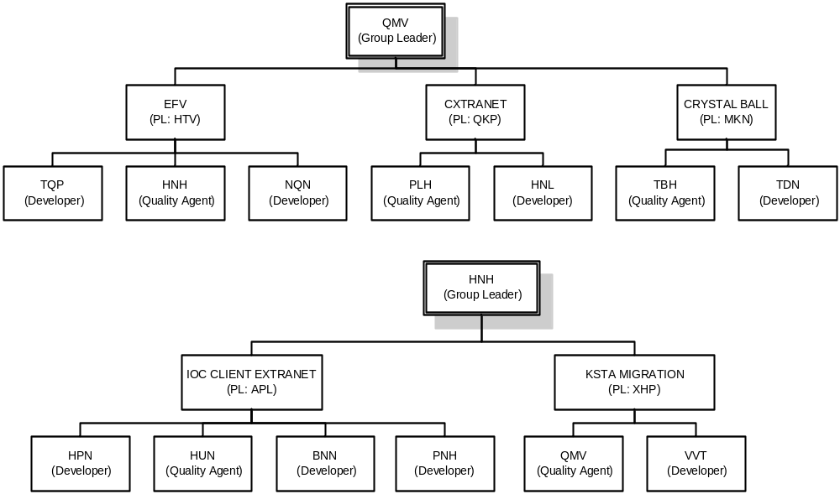  - To verify the deletion of a project via ProjectRepository  - To verify a simple query written in QueryDSL to query projects based on their own attributes (i.e. name and status)  - To verify a complex query written in QueryDSL to query projects based on their own and relations’ attributes (i.e. name, status + group’s and customer’s attributes)  - Verify your created tables by accessing the H2 database at: localhost:8080/h2console with the data source url is jdbc:h2:mem:onboardingexercise | 4
 | C | Verify the implementation from previous step | All repository and unit test implementation must be verified by coach to ensure:  - The repository is created correctly.  - The unit test for the newly added repository is created correctly.  - All enhancements for ProjectRepositoryTest are done properly, especially:  - The way the object graph is created.  - The way the created data is verified.  - The way the queries are written.
 | E | Study how to handle transaction with Spring | Spring’s AOP adds the ability to handle transaction for a bean. Please read how it works here: https://spring.io/blog/2012/05/23/transactions-caching-and-aop-understanding-proxy-usage-in-spring.  Inside Spring generic configuration, we have used <tx:annotation-driven /> . It means that all @Transactional annotations should be scanned at startup time and the targeted methods should become transactional.  At startup time, a new class is created, called proxy. This one is in charge of adding Transactional behavior as follows:  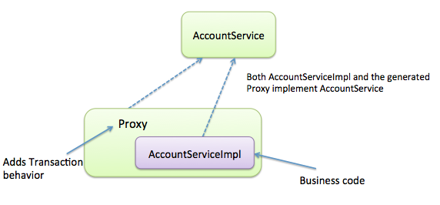  At shutdown (eg. When the application is stopped), the proxy class will be destroyed and you will only have AccountService and AccountServiceImpl on the file system | 2
 | E | Handle transaction with Spring | Introduce a new feature in ProjectService with the following requirements to create a maintenance project from an existing one and ensure that it is running inside one transaction:  - Name of the new project will be constructed as following: <old project’s name> + Maint. + <current year>. The old project will be inactive (activated = false) as soon as the maintenance one is created.  - In the process of creating the maintenance project, if there is any problem (exception) the new project must not be persisted into DB and the development one must not be updated.  - Can you find a way to prove that your implementation is “truly” transactional? | 2
- 2 | E | Solve the LazyInitializationException | Preparation: Disable the annotation “@Ignore” in TaskServiceTest class first.  In the exercise, please solve the failed test case “testListNumberOfTasks” in the test class TaskServiceTest.  Here is the scenario of this test case: this test case queries all the projects which have tasks with name “Task 1”. For each project found, shows number of tasks in it.  - Do you have any suggestion to solve the exception in this case?  - Any other change in TaskServiceTest is not allowed.  - Changing the mapping for field “tasks” in Project entity is not allowed). | 1
 | E | Remove “SELECT N + 1” issue | In the exercise, let see the test case “testShowProjectNameOfTopTenNewTasks” in the test class TaskServiceTest  When executing this unit test you will see these lines in the log file:  -----------------------------------------------------------------------------------------------------------  >>>>>>> Start Test case  2016-11-17 16:35:35.799 DEBUG 5624 --- [ main] org.hibernate.SQL : select task0_.id as id1_1_, task0_.deadline as deadline2_1_, task0_.name as name3_1_, task0_.project_id as project_4_1_ from task task0_ order by task0_.id desc limit ?  2016-11-17 16:35:35.819 DEBUG 5624 --- [ main] org.hibernate.SQL : select project1_.id as id1_0_, project1_.finishing_date as finishin2_0_, project1_.name as name3_0_ from task task0_ inner join project project1_ on task0_.project_id=project1_.id order by task0_.id desc limit ?  2016-11-17 16:35:35.831 DEBUG 5624 --- [ main] org.hibernate.SQL : select project0_.id as id1_0_0_, project0_.finishing_date as finishin2_0_0_, project0_.name as name3_0_0_ from project project0_ where project0_.id=?  2016-11-17 16:35:35.834 DEBUG 5624 --- [ main] org.hibernate.SQL : select project0_.id as id1_0_0_, project0_.finishing_date as finishin2_0_0_, project0_.name as name3_0_0_ from project project0_ where project0_.id=?  2016-11-17 16:35:35.835 DEBUG 5624 --- [ main] org.hibernate.SQL : select project0_.id as id1_0_0_, project0_.finishing_date as finishin2_0_0_, project0_.name as name3_0_0_ from project project0_ where project0_.id=?  2016-11-17 16:35:35.836 DEBUG 5624 --- [ main] org.hibernate.SQL : select project0_.id as id1_0_0_, project0_.finishing_date as finishin2_0_0_, project0_.name as name3_0_0_ from project project0_ where project0_.id=?  2016-11-17 16:35:35.836 DEBUG 5624 --- [ main] org.hibernate.SQL : select project0_.id as id1_0_0_, project0_.finishing_date as finishin2_0_0_, project0_.name as name3_0_0_ from project project0_ where project0_.id=?  2016-11-17 16:35:35.836 DEBUG 5624 --- [ main] org.hibernate.SQL : select project0_.id as id1_0_0_, project0_.finishing_date as finishin2_0_0_, project0_.name as name3_0_0_ from project project0_ where project0_.id=?  2016-11-17 16:35:35.837 DEBUG 5624 --- [ main] org.hibernate.SQL : select project0_.id as id1_0_0_, project0_.finishing_date as finishin2_0_0_, project0_.name as name3_0_0_ from project project0_ where project0_.id=?  2016-11-17 16:35:35.837 DEBUG 5624 --- [ main] org.hibernate.SQL : select project0_.id as id1_0_0_, project0_.finishing_date as finishin2_0_0_, project0_.name as name3_0_0_ from project project0_ where project0_.id=?  -----------------------------------------------------------------------------------------------------------  Please pay attention to the lines in red. As you can see, we have a service method called “showProjectNameOfTopTenNewTasks”. Its purpose is to show the project name of the top 10 new tasks created. In this case we have problem of unnecessary queries that will slow down the function (the red lines).  - Do you have any suggestion to solve this issue?  - Any change in TaskServiceTest is not allowed. | 1
 |  | Remove “SELECT N + 1” issue | The same issue happens for the test case  “testListTasksById” in the test class TaskServiceTest  In this case, the root cause is due to inefficient implementation in class TaskServiceImpl  - Do you have any suggestion to solve this issue?  - Changes in TaskServiceTest, application.properties are not allowed. | 1
 | E | Solve a violation of the single-unit-of-work pattern | Please solve the failed test case “TaskServiceTest.testUpdateDeadline”.  - Why the data of the task is not rollbacked even an exception is thrown? Please change the code to make the data of the task rollbacked in this case.  - To make it safer, what do you suggest to do at service level with the @Transactional annotation from Spring?  - Changes in TaskServiceTest, application.properties are not allowed. | 1
 | E | Make audit log data saved | Use case: When creating task for a project, there is a requirement that in case an exception occurs with the service, all data should be rollbacked except the audit log of the task because admin needs it for tracing purpose. To do it, we log audit data for the task when it is inserted, updated or deleted. In case the task failed to saved, an audit log with detail message shows why it can’t be saved to DB.  - We have the failed test case “testCreateTaskForProject”. Please fix it while keeping the above business correct.  - Changes in TaskServiceTest, TaskServiceImpl, application.properties are not allowed. | 1
 | E | Make tasks added for user | Preparation: Import the following collections to Postman.    - Send request for users/{username}/addTasks  - Verify that the tasks are added with request users/{username}  The second get request is not able to get the newly added list of tasks.  Check the database, are the tasks added properly?  - Can you explain why and fix this issue?  Problem : Add new tasks into user but the Task.User is not updated yet.  - Add Task.SetUser inside UserServiceImpl | 1
 | E | Recursive entity in request response | - Send request for users/id/{id}  - Inspect the response  - Can you explain why and suggest solutions for this issue?  @JsonIgnore //solution for infinity loop of entity in fetching data  // the @JsonIgnore should be placed at children entity property ('Many' side) | 1
 | C | Verify the exercises | The trainee explains how their solutions work, what does Hibernate do behind the scene before your fix and after your fix?
 | C | Expert validation | Validate the training result with expert:

Advanced (optional)
These steps are for experienced trainees and should be used only when the basic plan is completed under the estimated time.

No. | Type | Task | Description | Estimated  Time (h)
 | R, E | BatchSize, FetchMode | Please help to:  - List all available FetchMode and how do they work: https://www.baeldung.com/hibernate-fetchmode  - How does BatchSize work?  - Write a unit test demonstrate your understanding of these annotations. | NA
 | R, E | Understand important Hibernate APIs | Please help to:  - Explain the purpose of the following APIs on org.hibernate.Session:  - org.hibernate.Session.get(Class, Serializable)  - org.hibernate.Session.load(Class, Serializable)  - org.hibernate.Session.persist(Object)  - org.hibernate.Session.save(Object)  - org.hibernate.Session.saveOrUpdate(Object)  - org.hibernate.Session.merge(Object)  - Explain the differences between the following APIs on org.hibernate.Session:  - get() vs load()  - saveOrUpdate() vs perist()/save()  - saveOrUpdate() vs merge()  - Is it possible to get different instances of the same entity with same ID by invoking org.hibernate.Session.get(Class, Serializable) multiple times on the same Hibernate session? Regardless of the outcome of your answer, can you give a reason why you think Hibernate behaves like that?  - Regarding the last 2 questions, please write unit tests to verify your answers. | NA
 | R, E | Understand how Hibernate session and transaction work together | Please help to:  - Identify where Hibernate session and transaction are started and finished in the existing unit test.  - Propose a solution to support nested transactional scenario (where a brand-new transaction has to be opened/commited independently inside the scope of another transaction).  - Write unit test to verify the proposed solution. | NA

R = Reading, E = Exercise, C = Checkpoint, S = Setup, P = Presentation
R = Reading, E = Exercise, C = Checkpoint, S = Setup, P = Presentation

