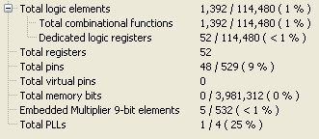

assign red = CounterX \* CounterX - CounterY \* CounterY \* CounterY;

assign green = (CounterX | CounterY)/(CounterX ^ CounterY) \* (CounterX & CounterY + CounterX \* CounterY);

assign blue = (3 \* CounterX / (red - green));