**Supplemental Materials for ‘Two-factor designs reveal more than you think: A perspective from experimental mediation analysis’**

# S1 Additional Results under ADF Assumptions

**Table S1**

*Estimation Bias of the Natural Indirect Effect under the ADF Assumption*

|  |  |  |  |  |  |  |  |  |  |  |  |  |  |  |  |  |  |  |
| --- | --- | --- | --- | --- | --- | --- | --- | --- | --- | --- | --- | --- | --- | --- | --- | --- | --- | --- |
|  |  |  | **UPNIE** | | | | **APNIE** | | | | **UTNIE** | | | | **ATNIE** | | | |
|  |  |  |  | Mean | Min | Max |  | Mean | Min | Max |  | Mean | Min | Max |  | Mean | Min | Max |
| M1 |  |  |  |  |  |  |  |  |  |  |  |  |  |  |  |  |  |  |
|  |  |  |  |  |  |  |  |  |  |  |  |  |  |  |  |  |
|  |  |  |  |  |  |  |  |  |  |  |  |  |  |  |  |  |
|  |  |  |  |  |  |  |  |  |  |  |  |  |  |  |  |  |  |
|  |  |  |  |  |  |  |  |  |  |  |  |  |  |  |  |  |
|  |  |  |  |  |  |  |  |  |  |  |  |  |  |  |  |  |
|  |  |  |  |  |  |  |  |  |  |  |  |  |  |  |  |  |  |
|  |  |  |  |  |  |  |  |  |  |  |  |  |  |  |  |  |
|  |  |  |  |  |  |  |  |  |  |  |  |  |  |  |  |  |
|  |  |  |  |  |  |  |  |  |  |  |  |  |  |  |  |  |  |  |
| 67M2 |  |  |  |  |  |  |  |  |  |  |  |  |  |  |  |  |  |  |
|  |  |  |  |  |  |  |  |  |  |  |  |  |  |  |  |  |
|  |  |  |  |  |  |  |  |  |  |  |  |  |  |  |  |  |
|  |  |  |  |  |  |  |  |  |  |  |  |  |  |  |  |  |  |
|  |  |  |  |  |  |  |  |  |  |  |  |  |  |  |  |  |
|  |  |  |  |  |  |  |  |  |  |  |  |  |  |  |  |  |
|  |  |  |  |  |  |  |  |  |  |  |  |  |  |  |  |  |  |
|  |  |  |  |  |  |  |  |  |  |  |  |  |  |  |  |  |
|  |  |  |  |  |  |  |  |  |  |  |  |  |  |  |  |  |

*Note.* M1 and M2 respectively represent the modeling approach expressed in Equation (6) and (7) and the Imai’s approach expressed in Equation (4) and (5); and represent the unstandardized regression coefficients of the and paths in the model shown in Figure 3. denotes the true parameter, quantified as . UPNIE, APNIE, UTNIE, and ATNIE respectively denote the unaltered pure, altered pure, unaltered total, and altered total natural indirect effects. Given that the conditions of the manipulation effectiveness of on () and the sample size () had no apparent effect on the simulation results regarding the Estimation Bias of the NIE, we exhibit the mean, minimum, and maximum Estimation Bias of the conditions with the combinational settings of and .

**Table S2**

*Coverage Rate (%) of the Indirect Effect under the Normality Assumption*

|  |  |  |  |  |  |  |  |  |  |  |  |  |  |  |  |  |  |  |
| --- | --- | --- | --- | --- | --- | --- | --- | --- | --- | --- | --- | --- | --- | --- | --- | --- | --- | --- |
|  |  |  | **UPNIE** | | | | **APNIE** | | | | **UTNIE** | | | | **ATNIE** | | | |
|  |  |  |  | Mean | Min | Max |  | Mean | Min | Max |  | Mean | Min | Max |  | Mean | Min | Max |
| M1 |  |  |  | 91.2 | 88.7 | 94.8 |  | 90.9 | 88.8 | 94.6 |  | 93.0 | 91 | 95.1 |  | 92.9 | 90.4 | 94.4 |
|  |  | 97.9 | 93.1 | 99.6 |  | 98.3 | 93.3 | 99.8 |  | 92.9 | 90.9 | 94.4 |  | 93.3 | 91.3 | 95.2 |
|  |  | 90.9 | 87.3 | 94.1 |  | 90.8 | 88.6 | 93.4 |  | 95.1 | 94.4 | 96.2 |  | 95.0 | 94.2 | 96.1 |
|  |  |  | 99.6 | 99.2 | 99.9 |  | 91.6 | 89 | 93.7 |  | 99.8 | 99.2 | 1 |  | 95.0 | 92.3 | 96.5 |
|  |  | 99.9 | 99.8 | 1 |  | 94.7 | 88.8 | 98.8 |  | 98.4 | 96.4 | 99.7 |  | 94.2 | 90.6 | 97 |
|  |  | 98.2 | 96.1 | 99.6 |  | 91.1 | 89.3 | 93.4 |  | 95.8 | 94.3 | 97.8 |  | 94.3 | 93 | 96.2 |
|  |  |  | 90.7 | 87.6 | 93.5 |  | 91.1 | 86.9 | 95 |  | 95.2 | 92.9 | 97.1 |  | 96.3 | 95.7 | 97.4 |
|  |  | 93.9 | 88 | 99.2 |  | 90.9 | 86 | 94.7 |  | 93.7 | 91.8 | 95.9 |  | 95.8 | 94.5 | 96.4 |
|  |  | 90.5 | 88.1 | 93.1 |  | 91.3 | 87.5 | 93.9 |  | 94.2 | 91.9 | 96.4 |  | 94.7 | 93.5 | 96.2 |
|  |  |  |  |  |  |  |  |  |  |  |  |  |  |  |  |  |  |  |
| M2 |  |  |  | 50.4 | 4.1 | 93.4 |  | 52.5 | 4.9 | 95.8 |  | 46.4 | 1.9 | 94.1 |  | 45.7 | 1.8 | 89 |
|  |  | 99.9 | 99.6 | 1 |  | 99.9 | 99.6 | 1 |  | 31.3 | .8 | 71.4 |  | 31.4 | .3 | 65.8 |
|  |  | 33.3 | .5 | 67.1 |  | 33.9 | .6 | 70.2 |  | 27.6 | 0 | 63.5 |  | 27 | 0 | 63.8 |
|  |  |  | 75 | 48.3 | 95.1 |  | 76.2 | 56.9 | 87.8 |  | 70.1 | 33.3 | 96.1 |  | 68.8 | 41 | 83.5 |
|  |  | 96.0 | 93.1 | 98.1 |  | 96 | 93.1 | 98.1 |  | 38.9 | .2 | 87.4 |  | 48.7 | 8.6 | 76 |
|  |  | 44.2 | 3.3 | 84.4 |  | 55.1 | 18.5 | 80.5 |  | 25.5 | 0 | 68 |  | 34 | .7 | 66.5 |
|  |  |  | 92.6 | 89.4 | 94.9 |  | 91.6 | 89.6 | 93.4 |  | 91 | 85.5 | 94.5 |  | 90.8 | 87 | 93.9 |
|  |  | 94.4 | 93.2 | 95.2 |  | 94.4 | 93.2 | 95.2 |  | 81 | 61.9 | 92.7 |  | 78.4 | 60.9 | 88.2 |
|  |  | 85.1 | 74.9 | 93.6 |  | 84.9 | 74.3 | 91.9 |  | 51.5 | 8 | 85.3 |  | 52.5 | 12.1 | 77.6 |

*Note.* Notations in this table are the same as in Table 3.

# S2 Estimation Bias of the Standard Error Estimates

**Figure S1.**

*Estimation Bias of the Standard Error Estimates of the NIEs Using Method 1*

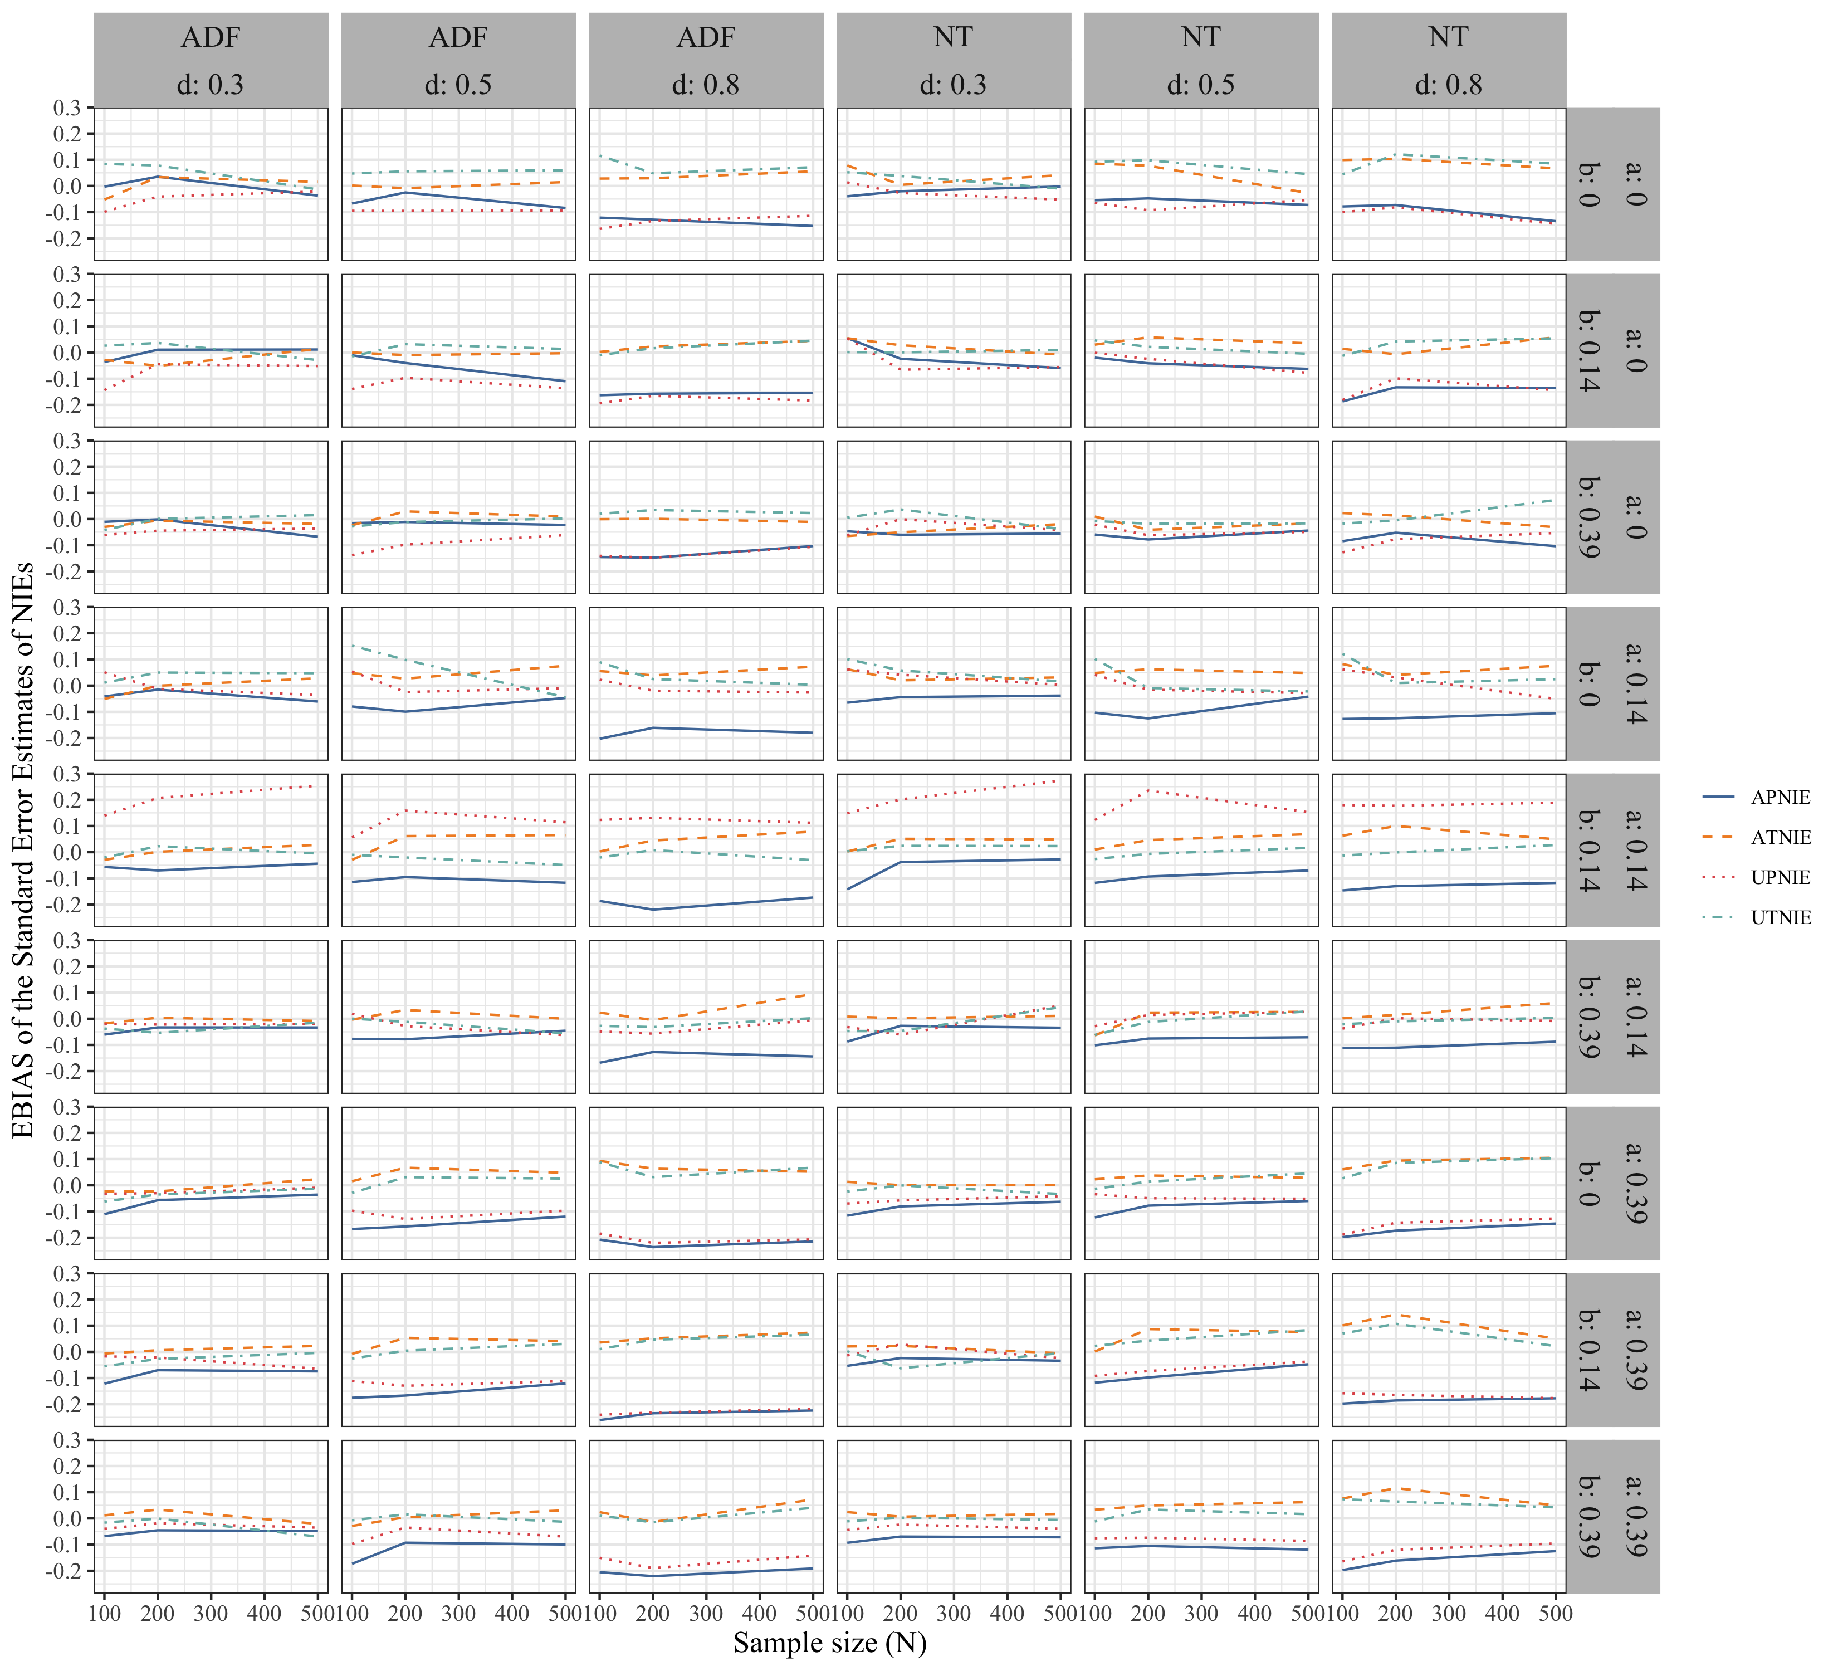

*Note.* UPNIE, APNIE, UTNIE, and ATNIE respectively denote the unaltered pure, altered pure, unaltered total, and altered total natural indirect effects. NT and ADF respectively represent the normality and asymptotically distribution free assumptions.