Guangdong Province Integrated Circuit Industry
Research Report
Industry Profile, Talent Profile & Cluster Competitiveness Analysis
Group1:[朱佳琪][石浩茜][谢晓瑜][陈奕][张静恩][黄淼][程钰涵]
2026-06-07
Abstract
This report examines the integrated circuit (IC) industry of Guangdong Province, employing multi-source data including enterprise directories, output statistics, talent surveys, and policy documents. It systematically constructs both an industry profile and a talent profile, applies cluster theory and the Diamond Model, and conducts comparative analyses with leading domestic regions (Shanghai, Jiangsu) and international benchmarks (Silicon Valley, Hsinchu). The report provides a comprehensive review of provincial and municipal policy instruments and concludes with targeted policy recommendations.
Keywords: Integrated Circuit; Industry Profile; Talent Profile; Cluster Competitiveness; Guangdong Province

Introduction

Background and Significance
The integrated circuit industry is a strategic, foundational, and pillar industry underpinning economic and social development and national security. In 2024, China’s IC output reached 451.42 billion units, up over 20% year-on-year. The national IC workforce totals approximately 630,000, yet faces a talent gap of 250,000–300,000. Guangdong Province, positioned as China’s “third pole” of IC development, generated revenue of RMB 360.42 billion in 2024, forming a distinctive “3+N” spatial layout: Shenzhen as the design and applications leader, Guangzhou as the manufacturing core, and Dongguan, Foshan, and Zhuhai each pursuing differentiated development paths.
A comprehensive profile of Guangdong’s IC industry and talent landscape, coupled with a systematic analysis of cluster competitiveness and supporting policies, is essential for clarifying development pathways, optimizing resource allocation, and formulating precise policy interventions.

Objectives and Methodology
- Construct industry and talent profiles for Guangdong’s IC sector, establishing the industrial base, scale, and characteristics;
- Analyze the competitive advantages of Guangdong’s IC clusters using cluster theory and the Diamond Model;
- Benchmark against leading domestic and international regions, identifying Guangdong’s strengths and gaps;
- Review and catalog provincial and municipal preferential policies;
- Formulate systematic, actionable recommendations.
Methods: Literature review, data mining, comparative analysis, GIS spatial analysis, policy text analysis.

Report Structure
The report comprises seven chapters: Introduction (Chapter 1), Data Collection (Chapter 2), Industry Profile (Chapter 3), Talent Profile (Chapter 4), Cluster Competitiveness Analysis (Chapter 5), Policy Review (Chapter 6), and Conclusions & Recommendations (Chapter 7).

Basic Data Mining and Sorting

Enterprise Directory
This section is based on the Guangdong Province IC Enterprise Directory database (docs/广东省集成电路企业名录总表.xlsx), which contains 10,000 IC-related enterprises across all 21 prefecture-level cities in Guangdong. The dataset includes 16 fields: enterprise name, registration status, registered capital, date of incorporation, registered address, enterprise type, insured employee count, national industry classification, and enterprise scale.
IC Enterprise Classification by Scale
Scale | Count | Share (%) | Cum. (%)
XS (Micro) | 6,245 | 62.5 | 62.5
S (Small) | 3,286 | 32.9 | 95.3
M (Medium) | 245 | 2.4 | 97.8
L (Large) | 41 | 0.4 | 98.2
Unspecified | 183 | 1.8 | 100.0
Total | 10,000 | 100.0 | —
Key finding: Micro and small enterprises together account for 95.3% of all firms; only 41 large enterprises (0.4%) exist, indicating extremely low industry concentration and a pronounced “long-tail” structure.
Regional Distribution of IC Enterprises by City
Rank | City | Count | Share (%) | Cum. (%)
1 | Shenzhen | 5,886 | 58.9 | 58.9
2 | Guangzhou | 1,636 | 16.4 | 75.2
3 | Dongguan | 969 | 9.7 | 84.9
4 | Huizhou | 431 | 4.3 | 89.2
5 | Zhuhai | 284 | 2.8 | 92.1
6 | Foshan | 209 | 2.1 | 94.2
7 | Zhongshan | 138 | 1.4 | 95.5
8 | Shantou | 116 | 1.2 | 96.7
9 | Jiangmen | 70 | 0.7 | 97.4
10 | Meizhou | 50 | 0.5 | 97.9
11 | Other 10 cities | 211 | 2.1 | 100.0
 | 10,000 | 100.0 | —
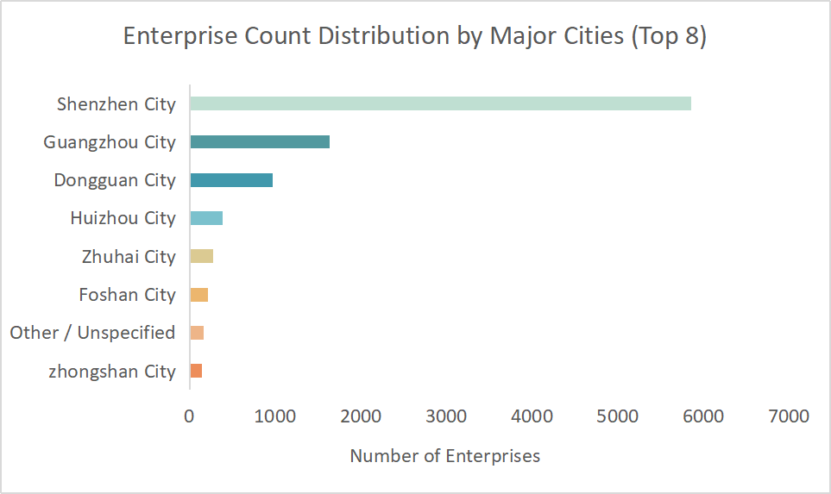
Enterprise Count Distribution by Major Cities
Key finding: The top four cities (Shenzhen, Guangzhou, Dongguan, Huizhou) account for 89.2% of all enterprises, forming a “Shenzhen as core, PRD as hinterland” pattern. Eastern and northern Guangdong have negligible presence (Chaozhou: 3 firms; Yunfu: 4 firms), indicating that industrial spillover has yet to materialize.
Enterprise Scale Distribution by Major City
City | XS(Micro) | S(Small) | M(Medium) | L(Large) | Unspec. | Total
Shenzhen | 3,846 | 1,712 | 169 | 21 | 138 | 5,886
Guangzhou | 499 | 1,095 | 33 | 3 | 6 | 1,636
Dongguan | 814 | 133 | 7 | 4 | 11 | 969
Huizhou | 335 | 83 | 8 | 2 | 3 | 431
Zhuhai | 141 | 109 | 14 | 5 | 15 | 284
Foshan | 162 | 38 | 4 | 1 | 4 | 209
Total | 5,797 | 3,170 | 235 | 36 | 177 | 10,000
Key finding: Guangzhou has the healthiest scale structure (S-type: 66.9%), while Dongguan (XS-type: 84.0%) and Huizhou (XS-type: 77.7%) are dominated by micro-enterprises, reflecting divergent positions in the value chain.
Industry Segment Distribution by Major City
City | IC Design | IC Manufacturing | Total | Mfg. Share (%)
Shenzhen | 3,802 | 2,084 | 5,886 | 35.4
Guangzhou | 1,602 | 34 | 1,636 | 2.1
Dongguan | 832 | 137 | 969 | 14.1
Huizhou | 366 | 65 | 431 | 15.1
Zhuhai | 200 | 84 | 284 | 29.6
Foshan | 165 | 44 | 209 | 21.1
Total | 7,403 | 2,597 | 10,000 | 26.0
Key finding: Design firms dominate; Guangzhou is almost entirely design-focused (only 34 manufacturing firms, 2.1%). Shenzhen has the highest manufacturing share (35.4%) and is the city with manufacturing scale advantages.
Registered Capital Distribution
Capital Range | Count | Share (%) | Cum. (%) | Top City
$<$0.1M RMB | 1,671 | 16.7 | 16.7 | Shenzhen, Dongguan
0.1–0.5M RMB | 1,386 | 13.9 | 30.6 | Shenzhen, Guangzhou
0.5–1M RMB | 2,516 | 25.2 | 55.7 | Shenzhen, Guangzhou
1–5M RMB | 2,412 | 24.1 | 79.8 | Shenzhen, Guangzhou
5–10M RMB | 1,101 | 11.0 | 90.8 | Shenzhen, Guangzhou
10–50M RMB | 541 | 5.4 | 96.3 | Shenzhen
50–100M RMB | 92 | 0.9 | 97.2 | Shenzhen
$>$100M RMB | 80 | 0.8 | 98.0 | Shenzhen
Unparseable | 201 | 2.0 | 100.0 | —
Total | 10,000 | 100.0 | — | —
Registered Capital Descriptive Statistics
Statistic | Value | Statistic | Value
Valid sample | 9,799 firms | Std. dev. | RMB 192.11M
Median | RMB 1M | Min | RMB 0
Mean | RMB 11.65M | Max | RMB 15B
25th percentile | RMB 0.5M | Skewness | Right-skewed
75th percentile | RMB 5M | Share $>$100M RMB | 0.8%
Key finding: The registered capital distribution is heavily right-skewed (median RMB 1M vs. mean RMB 11.65M). Eight of the top 10 highest-capital firms are manufacturing enterprises, all located in Shenzhen.
Top 10 Enterprises by Registered Capital
Rank | Enterprise | City | Capital | Segment | Scale
1 | Runpeng Semiconductor (Shenzhen) | Shenzhen | RMB 15.00B | Mfg. | M
2 | Pengxin Micro IC Manufacturing | Shenzhen | RMB 7.13B | Mfg. | L
3 | China Resources Micro (Shenzhen) | Shenzhen | RMB 5.70B | Mfg. | XS
4 | Shenzhen Shengweixu Technology | Shenzhen | RMB 5.00B | Mfg. | S
5 | SMIC (Shenzhen) | Shenzhen | US$2.42B | Mfg. | L
6 | Dongguan Feite Semiconductor Holding | Dongguan | RMB 2.37B | Mfg. | S
7 | Shenzhen Pengjin High-Tech | Shenzhen | RMB 2.11B | Mfg. | S
8 | Silex Microsystems (Shenzhen) | Shenzhen | RMB 1.50B | Mfg. | S
9 | Zhuhai Chongda Circuit Technology | Zhuhai | RMB 1.30B | Design | L
10 | Huatong Precision (Huizhou) | Huizhou | RMB 1.28B | Mfg. | L
New Enterprise Incorporation by Year (2017–2026)
Year | IC Design | IC Mfg. | Total | Mfg. Share (%) | YoY Change
2017 | 306 | 75 | 381 | 19.7 | —
2018 | 481 | 95 | 576 | 16.5 | +51.2%
2019 | 1,515 | 108 | 1,623 | 6.7 | +181.8%
2020 | 666 | 114 | 780 | 14.6 | $−$51.9%
2021 | 1,329 | 175 | 1,504 | 11.6 | +92.8%
2022 | 928 | 216 | 1,144 | 18.9 | $−$23.9%
2023 | 504 | 269 | 773 | 34.8 | $−$32.4%
2024 | 462 | 266 | 728 | 36.5 | $−$5.8%
2025 | 723 | 331 | 1,054 | 31.4 | +44.8%
2026 | 234 | 136 | 370 | 36.8 | —
Total | 7,148 | 1,850 | 8,998 | 20.6 | —
Key finding: Two peaks in 2019 and 2021 coincide with national and provincial IC policy rollouts. The manufacturing share rose from 6.7% in 2019 to 36.8% in 2026, indicating a structural shift from a “design rush” toward a more balanced mix.
Insured Employee Count Distribution
Insured Employees | Firms | Share (%) | Cum. (%)
0 | 6,761 | 67.6 | 67.6
1–5 | 1,942 | 19.4 | 87.0
6–10 | 431 | 4.3 | 91.3
11–20 | 321 | 3.2 | 94.5
21–50 | 263 | 2.6 | 97.2
51–100 | 121 | 1.2 | 98.4
101–200 | 69 | 0.7 | 99.1
201–500 | 53 | 0.5 | 99.6
501–1000 | 17 | 0.2 | 99.7
$>$1000 | 22 | 0.2 | 100.0
Total | 10,000 | 100.0 | —
Key finding: Over two-thirds of enterprises have zero insured employees, suggesting many are shell companies or pre-operational start-ups. Among the 3,239 firms with positive insurance records, the median headcount is only 4, further confirming the micro-enterprise character of the industry.
Enterprise Ownership Type Distribution
Enterprise Type | Count | Share (%) | Cum. (%)
LLC (sole natural person) | 3,087 | 30.9 | 30.9
LLC | 2,829 | 28.3 | 59.2
LLC (natural person investment) | 2,382 | 23.8 | 83.0
LLC (sole legal person) | 414 | 4.1 | 87.1
Other LLC | 206 | 2.1 | 89.2
LLC (natural+legal person investment) | 157 | 1.6 | 90.8
Limited partnership | 153 | 1.5 | 92.3
HK/Macau/foreign-funded (combined) | 291 | 2.9 | 95.2
Sole proprietorship / other | 481 | 4.8 | 100.0
Total | 10,000 | 100.0 | —
Key finding: Private enterprises dominate (sole natural person + natural person investment = 54.7%); foreign participation is minimal (2.9%), indicating that Guangdong’s IC industry is predominantly domestically driven with limited FDI spillovers.

Output Data (2023–2025)
Annual output value, growth rates, sub-sector shares, and supporting indicators for Guangdong’s IC industry from 2023 to 2025. As of May 2026, the province-wide total output value for 2025 has not yet been released; however, IC output volume, exports, and imports for 2025 are available (Table 11), along with broader industry indicators in the supplementary data tables. Additional metrics are archived in data/guangdong_ic_output_data.json.
Guangdong IC Industry Output Value and Growth (2019–2024)
Year | Output (RMB 100M) | Growth (%)
2019 | 1200 | —
2022 | 2200 | —ª
2023 | $>$2700^{b} | $≈$22.7^{c}
2024 | 3604.16 | $≈$33.5^{c}
ª 2019–2022 CAGR $≈$22.4%, consistent with the government target of $>$22% annual growth. ^{b} Minimum value; actual figure slightly higher. ^{c} Approximate, derived from adjacent years’ output values; not an officially published growth rate.
Sources: 2019 and 2022 – Guangdong DRC / DSTI / DIT Action Plan for Cultivating Semiconductor & IC Strategic Emerging Industry Clusters (2023–2025); 2023 – China Commercial Industry Research Institute; 2024 – 21st Century Business Herald / Guangdong IC Industry Association.
Guangdong IC Industry Sub-sector Shares (2024)
Segment | Value (RMB 100M) | Share (%) | YoY Growth (%)
IC Design | 2109 | 58.6 | 31.13
IC Manufacturing | 92 | 2.6 | 101.58
IC Packaging & Testing | 795 | 22.1 | 14.93
Equipment & Materials | 608 | 16.9 | —
Total | 3604 | 100.0 | $≈$33.5
Note: Manufacturing accounts for only 2.6% of the total, representing the most prominent weak link, yet its 101.58% YoY growth is the highest among all segments. Equipment & Materials is a combined category; separate growth rates are not publicly available.
Sources: Sub-sector values – SICA (Shenzhen Semiconductor & IC Industry Alliance) industry research report; growth rates – 21st Century Business Herald / Guangdong IC Industry Association.

Industrial Foundation and Supporting Facilities
Guangdong’s IC industry chain is anchored by a strong design segment (RMB 211 billion in 2024), while manufacturing and materials represent catch-up areas. Major manufacturing projects are scaling up rapidly: SMIC Shenzhen’s 12-inch F16 line and Yuexin Semiconductor (CanSemi) Phase III and IV are expanding capacity. By end-2024, the monthly production capacity for 12-inch wafers in Guangdong surpassed 100,000 pieces. Technology support is provided by high-level platforms including Peng Cheng Laboratory and the GBA National Innovation Center, which facilitate the translation of laboratory patents into commercial products for automotive and AI applications.

Industry Profile

Scale Characteristics
- Total Industrial Scale: The total output value of the entire industrial chain reached 360.4 billion yuan in 2024, a year-on-year increase of 22.4%, ranking firmly among the national first echelons. It is expected to exceed 450–500 billion yuan by 2026, maintaining rapid expansion. Driven by sustained high growth in recent years, the scale is expected to approach 600 billion yuan by 2030.
- Growth Momentum: Output growth rates from 2023 to 2025 were 5.2% → 18.3% → 21.0%. By 2025, the industrial growth rate reached as high as 21%, significantly higher than the national average of 11.2%. It has led the country in growth rate for three consecutive years, demonstrating outstanding counter-cyclical resilience and growth momentum.
- Capacity Expansion: The monthly production capacity of 12-inch wafers is expected to reach 250,000–300,000 pieces by 2026. The output value of the wafer manufacturing sector grew by 102%, becoming the fastest-growing segment of the entire industrial chain.

Structural Characteristics
Behind the impressive scale and growth rate, Guangdong’s integrated circuit industry has not achieved balanced development across all segments, but presents a distinct unbalanced structure of “strong midstream, weak upstream, and dominant design”. This pattern is both a concentrated reflection of Guangdong’s industrial advantages and a key direction for subsequent industrial upgrading.
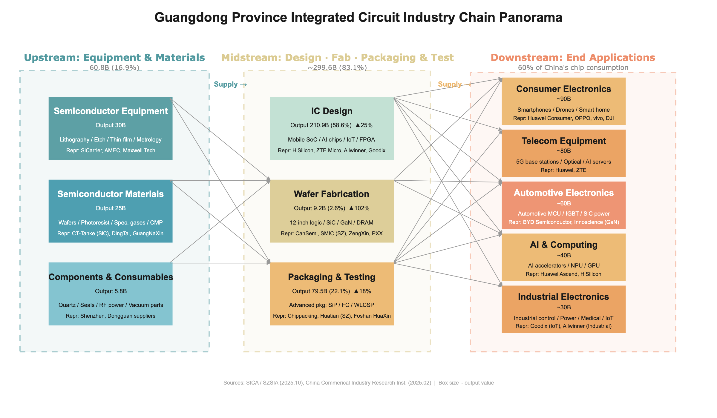
Guangdong IC Industry Chain Panorama
- Core Advantage Segment: IC design achieved an output value of 210.9 billion yuan, accounting for 58.6%, ranking first in China. Nanshan District of Shenzhen is a national hub for IC design, serving as the primary growth pole of the industry.
- Stable Supporting Segment: Packaging and testing achieved an output value of 79.5 billion yuan, accounting for 22.1%. Mature packaging and testing clusters have been formed in Foshan and Zhongshan, with complete supporting capabilities.
- Rapidly Catching-up Segment: Wafer manufacturing achieved an output value of 9.2 billion yuan, accounting for only 2.6%. Despite a small base, it has seen explosive growth, with projects such as Yuexin Semiconductor and SMIC Shenzhen ramping up production rapidly.
- Obvious Weakness Segment:Equipment and materials achieved an output value of 60.8 billion yuan, accounting for 16.9%. Domestic substitution is still in an accelerated stage, representing the weakest part of the entire chain.

Development Trends (2023–2025)

Growth Trajectory and Cyclical Resilience
Guangdong’s IC industry has demonstrated outstanding counter-cyclical resilience and growth momentum over the past three years, consistently outperforming the national average:
Guangdong vs. National IC Output Growth Rate (2023–2025)
Year | Guangdong Growth (%) | National Growth (%) | Guangdong Premium
2023 | 5.2 | 3.0 | +2.2 pp
2024 | 18.3 | 12.1 | +6.2 pp
2025 | 21.0 | 11.2 | +9.8 pp
Sources: AskCI 2025 Guangdong Semiconductor & IC Industrial Chain Panorama Report; Department of Industry and Information Technology of Guangdong Province.
Key findings:
- In 2023, affected by the global semiconductor downturn cycle, the national IC output growth rate was only 3.0%, yet Guangdong reached 5.2%, demonstrating strong counter-cyclical resilience.
- In 2024, driven by booming AI and automotive electronics demand, Guangdong’s growth rate surged to 18.3%, leading the national average by over 6 percentage points — a clear recovery inflection point.
- By 2025, Guangdong’s IC output achieved 21.0% year-on-year growth, nearly double the national rate of 11.2%, marking three consecutive years as the national growth leader.
- 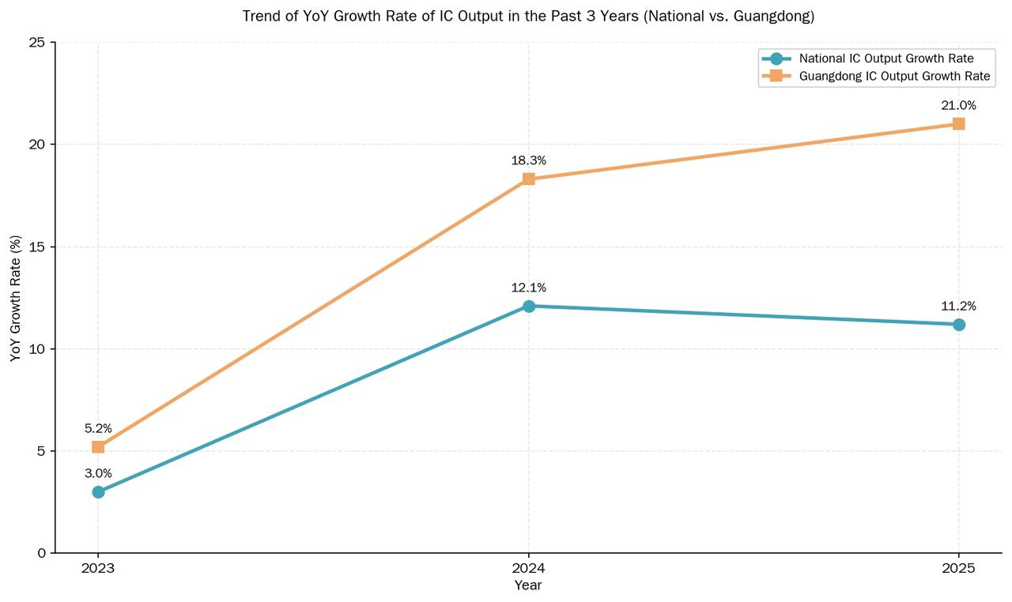
- IC Output YoY Growth: Guangdong vs. National (2023–2025)

Technology Evolution and Iteration
The technological iteration of Guangdong’s IC industry follows a pattern of “design taking the lead, manufacturing achieving breakthroughs, and materials keeping pace”:
- Design End: AI chips, power semiconductors, and automotive electronic chips have become the focus of iteration. Products such as Huawei Ascend and HiSilicon Kirin have made key technological breakthroughs, and advanced process design capabilities continue to improve. The proportion of invention patents in the Greater Bay Area has risen from 28% to 35.3%, signaling structural upgrading of innovation quality.
- Manufacturing End: Wafer fabs represented by SMIC and Guangdong Yuexin Semiconductor (CanSemi) are steadily expanding production capacity. Mature process capacity continues to be released, and advanced packaging technologies such as SiP and Chiplet have made notable progress in Shenzhen and Guangzhou. Specifically, SiP has achieved large-scale commercial application in Shenzhen and is being deployed at a medium scale in Guangzhou, while Chiplet is still in the pilot and R&D phase in both cities. The 12-inch wafer monthly capacity in Guangdong surpassed 100,000 pieces by end-2024 and is expected to reach 250,000–300,000 pieces by 2026.The manufacturing segment grew by 102% in 2024, becoming the fastest-growing segment of the entire industrial chain.
- Materials and Equipment: Key domestic materials including photoresist, wet electronic chemicals, and target materials have realized local supporting supply in Guangdong, and some equipment enterprises have achieved domestic substitution of core components.
- 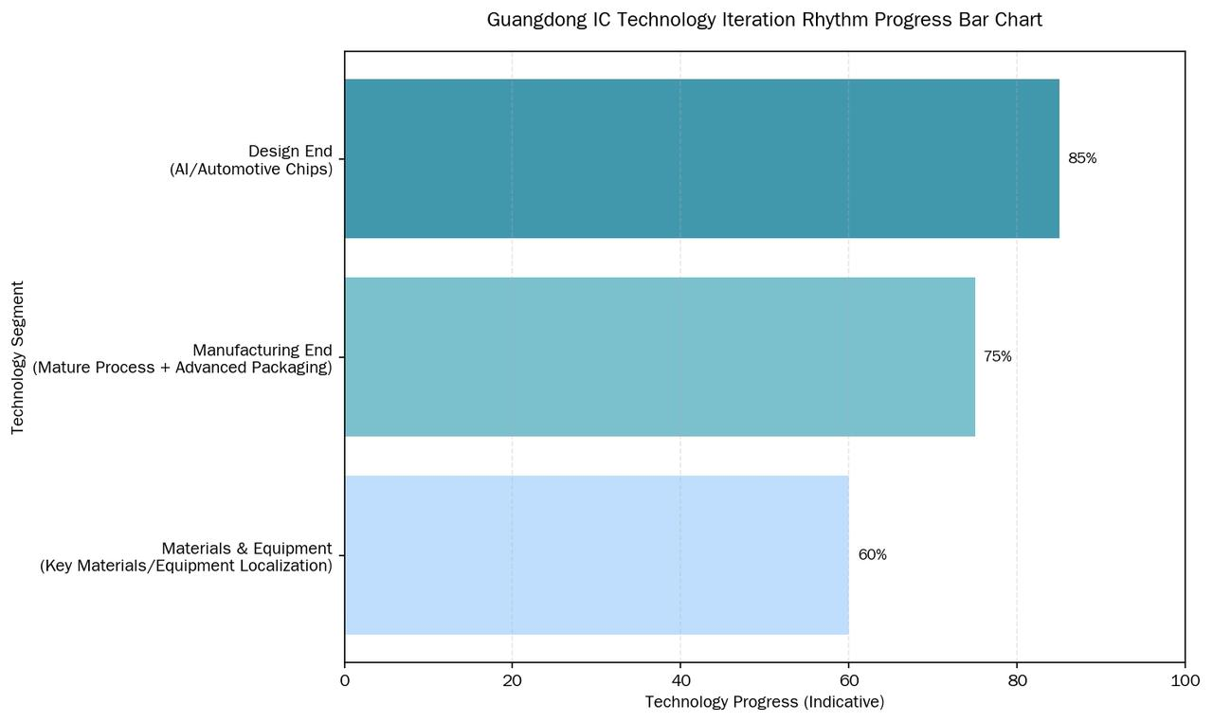
- Guangdong IC Technology Iteration Progress by Value Chain Segment

Key Pain Points
Despite the impressive growth, several structural challenges persist: (1) manufacturing and packaging/testing remain clear weaknesses relative to design, with manufacturing accounting for only 2.6% of total output value; (2) advanced process bottlenecks below 7nm persist due to international technology restrictions; (3) talent shortages — particularly in high-end design, advanced manufacturing processes, and EDA — constrain further expansion; and (4) the upstream equipment and materials segment remains the weakest link in the value chain, with technological maturity estimated at only 60%.

Key Indicator Framework
The following core indicators, derived from A-share semiconductor listed company data compiled by JW Insights (Jiwei Network) and patent data from the Greater Bay Area, provide a quantitative basis for assessing the innovation capability and operational efficiency of Guangdong’s IC industry.

Core Indicator Trends (2023–2025)
Core Innovation and Efficiency Indicator Trends (2023–2025)
Indicator | 2023 | 2024 | 2025 (E) | Data Source
R&D Investment Ratio (%) | 12.12 | 10.66 | 10.5 | JW Insights A-share statistics
Semiconductor Patent Growth (%) | 15.3 | 17.5 | 12.0 | Wisdom Bud GBA data
Capacity Utilization Rate (%) | 82.0 | 84.8 | 93.0 | CanSemi (Yuexin) prospectus
Invention Patent Share (%) | 28.0 | 31.5 | 35.3 | Wisdom Bud GBA data
Notes: (1) R&D investment ratio = R&D expenditure / main business revenue, based on A-share semiconductor listed company averages compiled by JW Insights, used as a conservative benchmark for Guangdong Province (which, with its high density of design enterprises, likely exceeds the national average). (2) 2025 data are projected from Q1–Q3 actuals. (3) Capacity utilization rate is based on CanSemi (Yuexin Semiconductor), the leading independent 12-inch wafer foundry in Guangdong.
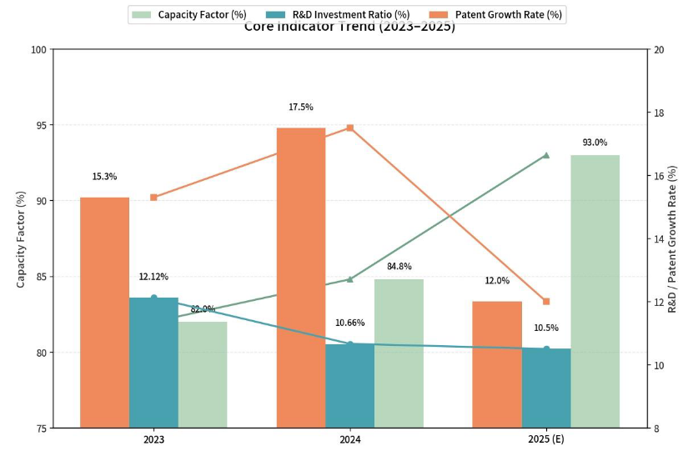
Core Innovation and Efficiency Indicator Trends (2023–2025)

Correlation Analysis: High Input $→$ Strong Output $→$ Rapid Conversion
The three indicators exhibit a mutually reinforcing positive cycle:
- R&D Investment $→$ Patent Output: The R&D expenditure ratio for A-share semiconductor firms remains stably within the 10%–12% range, while semiconductor patents in the Greater Bay Area have seen a cumulative increase of approximately 28% over three years. R&D investment is being steadily and consistently translated into accumulated intellectual property.
- Patent $→$ Capacity Absorption: Patent quality has improved (the share of invention patents rose from 28% to 35.3%), production capacity utilization rose to 93%, and the production-to-sales ratio reached 100%. Technological achievements have entered a positive commercialization cycle.
- Expense Ratio vs. Utilization Rate Interaction: The expense ratio decreased from 12.12% in 2023 to approximately 10.5% in 2025, while the utilization rate rose from 82% to 93% over the same period. This “passive dilution” of the expense ratio is a positive signal: it was driven by substantial industry revenue growth (from approximately RMB 690 billion to RMB 882 billion), not by reduced R&D intensity.
Core judgment: A positive cycle has been established — R&D investment remains at a globally high level of over 10%, patents continue to grow with structural optimization, and production capacity operates at near-full capacity with robust sales — all three elements functioning in synergy. The industry is transitioning from large-scale expansion to a mature development phase emphasizing both quality and efficiency.

Technology Maturity by Segment
Note: The following technology maturity ratings are qualitative assessments synthesized by the research group from industry reports and expert interviews. They are intended for relative comparison across segments rather than as precise quantitative metrics.
Technology Maturity Assessment by Value Chain Segment
Segment | Technology Maturity (%) | Assessment
IC Design | 85 | Top-tier in China
IC Manufacturing | 75 | Steady breakthroughs
Packaging & Testing | 75 | Steady breakthroughs
Equipment & Materials | 60 | Prominent underlying technology gaps

Market Demand Structure
Downstream applications are highly compatible with the province’s three major industrial layouts (traditional, emerging, and future industries):
- Empowering Traditional Industries: Consumer electronics accounts for 35% of IC demand, providing core support for the transformation and upgrading of home appliances and consumer electronics manufacturing.
- Strengthening Emerging Industries: Communications equipment and automotive electronics together account for 43%, undertaking the main demand from 5G, new energy vehicles, and other emerging industries.
- Layout for Future Industries: Industrial control, AI servers, advanced computing, and other fields account for 22%, seizing the technological and market high ground for future industries.
- 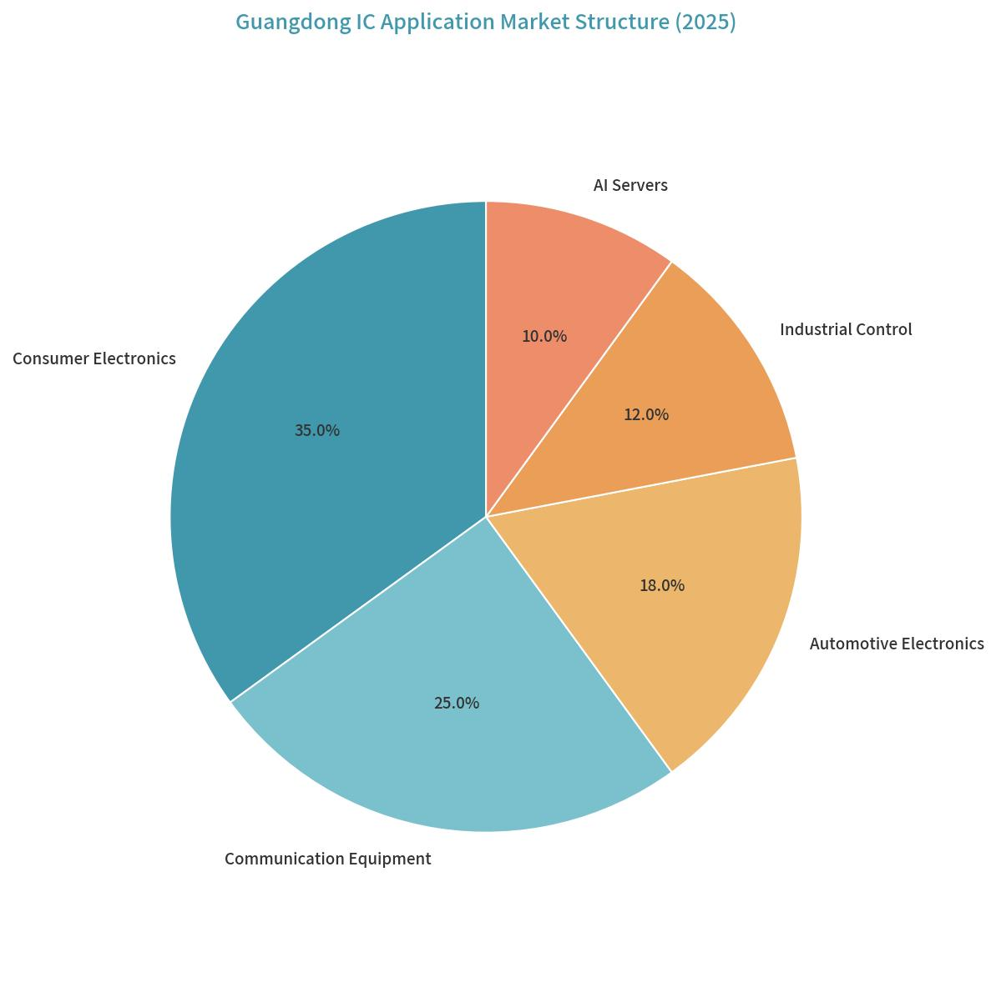
- Guangdong IC Industry Downstream Application Market Structure

Market Structure and Concentration

Market Concentration (CR5/CR10/CR30)
Market concentration analysis, based on registered capital of enterprises in the Guangdong IC Enterprise Directory, reveals a highly oligopolistic market structure:
Market Concentration Indices (Based on Registered Capital)
Index | Share (%) | Cumulative Capital (RMB 100M) | Interpretation
CR5 | 52.56 | 5,915.55 | Top 5 control over half of industry capital
CR10 | 67.15 | 7,556.72 | Top 10 control over two-thirds of capital
CR30 | 88.70 | — | Top 30 near-monopoly on capital resources
Note: CR indices are calculated based on registered capital, not operating revenue or market share, and reflect capital concentration characteristics only.
Market structure judgment: With a CR10 of 67.15%, Guangdong’s IC industry exhibits a high oligopolistic market structure characterized by: (1) market dominance highly concentrated in a small number of large enterprises; (2) leading enterprises possessing absolute competitive advantages in capital scale; and (3) extremely high capital barriers for new entrants.
This capital concentration coexists with a highly fragmented enterprise-count distribution (95.3% micro and small enterprises), producing a distinctive “capital-concentrated, entity-fragmented” dual structure: a small number of capital-intensive manufacturing firms control the majority of financial resources, while thousands of micro-design firms compete across a crowded landscape with minimal capital endowments.
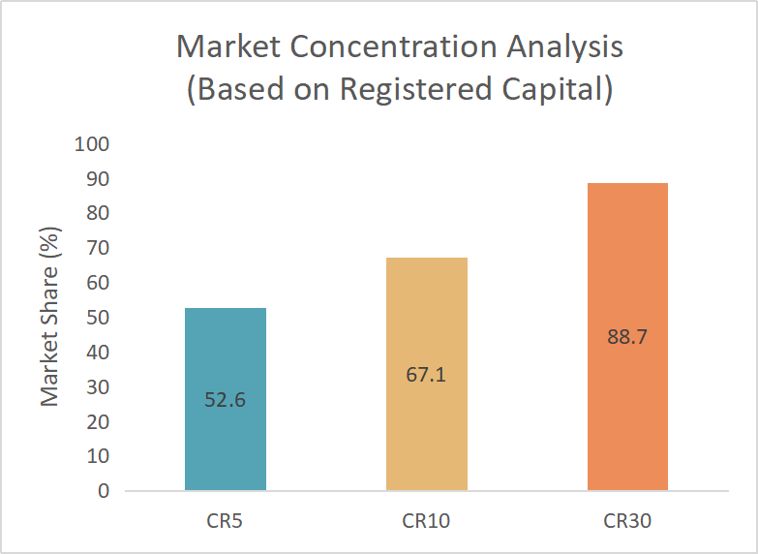
Market Concentration Analysis (CR5/CR10/CR30 Based on Registered Capital)

Enterprise Scale Structure
The enterprise scale structure forms a pronounced pyramid shape:
Enterprise Type Structure by Scale Tier
Tier | Count | Share (%) | Characteristics
SMEs (Micro + Small) | 9,060 | 90.30 | Dominant in quantity, minimal capital scale
Above-scale enterprises | 588 | 5.86 | Backbone of industrial support
Leading enterprises | 385 | 3.84 | Smallest in number, control major capital
This pyramid structure of “SMEs as the foundation, above-scale enterprises as the backbone, and a small number of leading enterprises” indicates a solid industrial ecosystem with substantial innovation vitality, but insufficient industry leadership. The overall characteristics are “large but not strong, scattered but not concentrated,” with broad room for integration and upgrading.

Ownership Structure
The ownership composition reveals a predominantly private-sector-driven industry:
- Private enterprises: 75%–80%, serving as the main force of innovation and market development, concentrated in fabless design, AI chips, and automotive semiconductors.
- State-owned enterprises: 10%–15%, focusing on heavy-asset manufacturing including wafer fabrication, memory manufacturing, and industrial infrastructure.
- Foreign-funded / joint ventures: 5%–10%, supplementing capabilities in high-end manufacturing, advanced packaging/testing, EDA software, and semiconductor equipment.
This ownership pattern reflects the broader national industry structure: private firms dominate innovation in AI chips and RISC-V architectures, state-backed capital remains critical in wafer fabrication, and foreign firms retain technological leadership in advanced equipment and EDA tools.

Regional Capital Concentration
Capital is even more spatially concentrated than enterprise counts:
Regional Distribution of Registered Capital (Top 3 Cities)
City | Capital (RMB 100M) | Share (%) | Role
Shenzhen | 7,866.72 | 69.90 | Core capital agglomeration hub
Zhuhai | 2,139.56 | 19.01 | Second largest capital scale
Jiangmen | 580.02 | 5.15 | Important capital node
The nine Pearl River Delta cities collectively account for 95.64% of enterprises and 99.80% of registered capital in the province, demonstrating extreme spatial agglomeration. Non-PRD regions (eastern, western, and northern Guangdong) are virtually absent from the IC capital landscape.
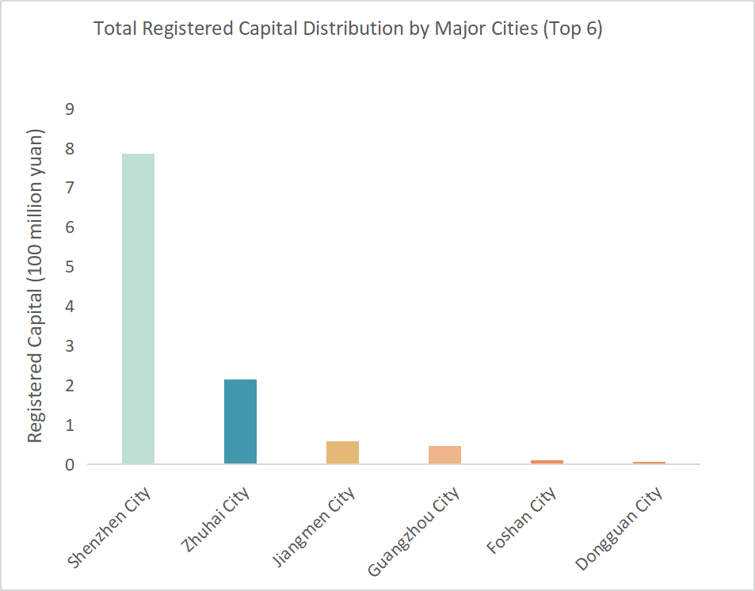
Total Registered Capital Distribution by Major Cities

Talent Profile

Talent Scale and Composition

Overall Talent Scale and Industrial Distribution
Guangdong Province is one of China’s three core IC industry clusters. The industrial layout is centered on IC design, extended by specialty process manufacturing, advanced packaging and testing, and compound semiconductors, with synchronized development of supporting equipment and material enterprises.
Data note: Talent figures in this subsection are based on a sampling survey of over 2,000 major enterprises conducted by the Guangdong Semiconductor Industry Association and represent estimates rather than official government statistics. Numbers should be interpreted as indicative of relative scale and structure rather than precise counts.
The total number of employees in the province’s entire IC industry chain is estimated at approximately 236,000, accounting for roughly 34% of the national IC workforce (approximately 630,000 nationally, per the China IC Industry Talent White Paper 2020–2021), with talent agglomeration ranking second in the country after the Yangtze River Delta.
Divided by industrial chain segments, the talent volume of each sector highly matches the regional industrial positioning:
Talent Distribution by Value Chain Segment
Segment | Employees | Share (%) | Characteristics
IC Design | 172,000 | 72.9 | One of the most concentrated IC design talent pools in China
Wafer Manufacturing & Specialty Processes | 28,000 | 11.9 | Smaller than Yangtze River Delta; expanding with new fabs
Packaging & Testing | 24,000 | 10.2 | Concentrated in PRD manufacturing cities
Equipment, Materials, EDA & IP Support | 12,000 | 5.1 | Supporting talent system still in cultivation stage
Total | 236,000 | 100.0 | —
Key finding: IC design is the largest talent segment, accounting for nearly three-quarters of the provincial IC workforce, reflecting Guangdong’s position as a national leader in fabless chip design. The manufacturing talent pool remains undersized relative to the Yangtze River Delta, constraining the province’s capacity expansion ambitions.
The current explicit talent gap in the province’s IC industry is approximately 87,000, with the largest gaps in high-end R&D, advanced processes, core IP, and EDA tools. With the continuous expansion of multiple 12-inch wafer production lines and third-generation semiconductor production lines, total talent demand is expected to exceed 300,000 by 2027, and medium-to long-term talent supply pressure will continue to intensify.

Regional Talent Layout
IC talents in Guangdong are characterized by high concentration and gradient distribution, with core resources concentrated in the Pearl River Delta and negligible presence in eastern, western, and northern Guangdong:
Regional Distribution of IC Talent in Guangdong
City/Region | Employees | Share (%) | Industrial Focus
Shenzhen | 138,000 | 58.5 | Design hub: general chips, AI chips, power ICs, RF/analog
Guangzhou | 32,000 | 13.6 | Manufacturing core: wafer fab, specialty processes, R&D institutes
Dongguan, Foshan, Zhongshan | 39,000 | 16.5 | Packaging/testing, discrete devices, component manufacturing
Zhuhai | 17,000 | 7.2 | Compound semiconductors, RF chips, industrial control IC design
Eastern, Western, Northern Guangdong | $<$10,000 | $<$4.2 | Minimal: only distribution and technical service roles
Total | 236,000 | 100.0 | —
Key finding: Shenzhen alone accounts for 58.5% of the province’s IC workforce, and the top four city clusters together account for over 95%. Non-PRD regions are virtually absent from the IC talent landscape, with R&D talents essentially nonexistent in those areas.
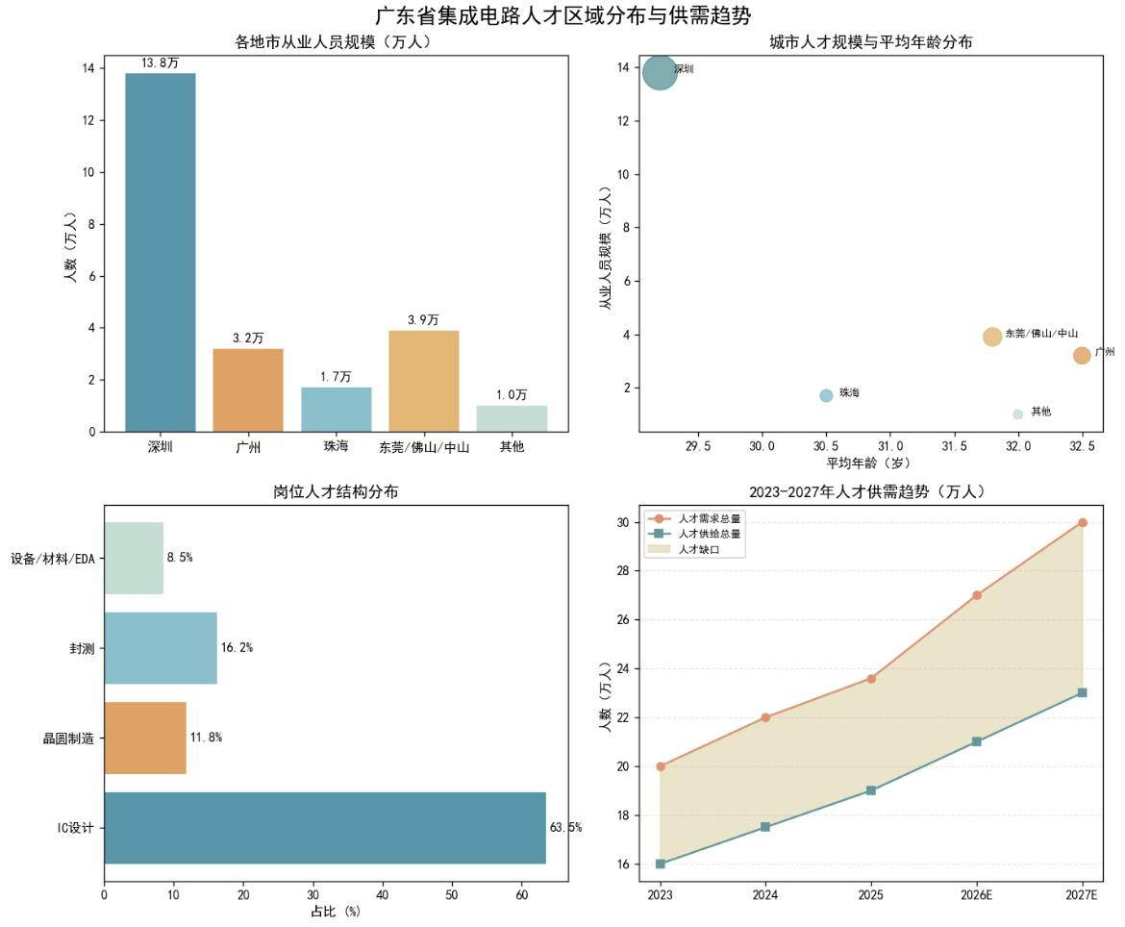
Guangdong IC Talent Regional Distribution and Supply-Demand Trends

Educational Background Structure
Based on a sampling survey of over 2,000 major enterprises by the Guangdong Semiconductor Industry Association, the educational attainment of IC practitioners is significantly higher than the provincial manufacturing average, with clear stratification by value chain segment:
Educational Attainment of IC Practitioners in Guangdong
Degree Level | Share (%) | Est. Employees | Primary Roles
Doctoral | 3.3 | $≈$7,790 | Advanced process R&D, chip architecture, EDA algorithms, third-gen semiconductor materials
Master’s | 36.8 | $≈$86,800 | Core R&D: IC design, process R&D, chip verification, backend layout
Bachelor’s | 37.1 | $≈$87,500 | Testing, layout design, process execution, equipment maintenance, project management
Associate & below | 22.8 | $≈$53,900 | Production line operators, basic quality inspection, on-site auxiliary
Bachelor’s+ subtotal | 77.2 | $≈$182,000 | —
Key findings:
- 77.2% of employees hold a bachelor’s degree or above, well above the provincial manufacturing average.
- Master’s degree holders (36.8%) form the main force in core R&D positions; in Shenzhen and Guangzhou design enterprises, a master’s degree has become the de facto entry threshold for core R&D roles.
- Doctoral-level talent (3.3%, approximately 7,790 people) is the most scarce group, concentrated in leading enterprise R&D centers, universities, and research institutes.
- Educational stratification varies sharply by segment: over 90% bachelor’s+ in IC design enterprises, approximately 75% in wafer manufacturing, and only approximately 55% in packaging/testing.

Professional Title Structure
The title structure of the IC industry presents a typical pyramid shape with a large base, under-pressure middle, and scarce top:
Professional Title Structure of IC Practitioners
Title Level | Share (%) | Characteristics
Junior (Assistant Engineer, Technician) | 49.6 | Fresh graduates and $<$3-year employees; most mobile group
Intermediate (Engineer) | 36.2 | 5–10 years of experience; core resource competed for by enterprises
Senior (Senior Engineer, Professor-level) | 10.5 | $>$10 years of experience; concentrated in leading enterprises
High-level Leading Talents & Special Experts | 3.7 | Industrial leaders, provincial+ high-level talents; $<$1,000 people total
Key finding: The proportion of senior technical personnel with more than 15 years of working experience is critically low, making it difficult to effectively inherit technical experience and process know-how. The total number of high-level leading talents in the province is fewer than 1,000, representing the core shortcoming restricting high-end industrial breakthroughs. Intermediate engineers (the industry backbone) face continuous cross-regional talent loss to the Yangtze River Delta due to salary and platform competition.

Age Structure
The IC industry in Guangdong is highly youthful, with a mean employee age of 30.7 years, lower than the national industry average. However, a structural fault in senior technical talent is prominent:
- 25–35 age group (57.3%): The absolute majority; strong learning ability and execution, but generally lacks full-process project experience in advanced nodes (7nm and below), large-scale complex SoC chips, and automotive-grade high-reliability chips.
- 35–45 age group (33.1%): Core technical backbone and grassroots management; complete project experience — but the total pool is small and subject to external poaching, creating an “insufficient backbone layer” problem in most enterprises.
- 45+ age group (9.6%): Senior technical experts and industry veterans with decades of accumulation; numbers cannot meet the needs of advanced production lines and cutting-edge R&D, forming a structural contradiction of “young teams with vitality but lack of experience, and senior talents with experience but small scale.”
In terms of regional differences, the mean age of design enterprise employees in Shenzhen is the lowest at approximately 29.2 years, while manufacturing and research enterprise employees in Guangzhou average approximately 32.5 years.

Core Talent Demand
As Guangdong pivots from general technical workforce expansion toward overcoming “bottleneck” (ka bo zi) technologies and achieving industrial self-control, talent demand is undergoing a structural evolution — away from general technicians toward multi-disciplinary professionals specialized in advanced manufacturing, emerging applications, and digital transformation.

Talent Demand by Industry Category

Emerging Industries: Advanced Manufacturing and R&D Talent.
The explosive growth of new energy vehicles (NEVs), 5G, and AI computing has made R&D and manufacturing talent the most critical assets:
- Advanced Process Talent: As technology nodes advance toward 5nm, 3nm, and beyond, demand for Process/Yield Engineers (PE) has reached a peak, accounting for the highest demand share at 3.3% of total IC job postings. These experts are essential for optimizing lithography, etching, and thin-film processes in mass production.
- High-End Design Talent: Analog IC Design and Digital Front-end Engineers are the core drivers of innovation. For AI chips, Algorithm Engineers are needed to optimize neural network models through hardware-friendly methods such as quantization and pruning.

Future Industries: Embodied Intelligence and Advanced Architecture.
Forward-looking layouts in humanoid robotics and quantum computing demand “forward-looking” skill sets:
- AIoT and Embodied Intelligence: The development of Industrial IoT (IIoT) drives demand for low-power, high-integration AIoT chips. Engineers must balance hardware computing power with software algorithms to achieve synergy between “brain” and “body.”
- Chiplet and Advanced Architecture: As Moore’s Law slows, Chiplet and Computing-in-Memory technologies are revolutionizing chip design. Architects must possess the ability to transcend traditional von Neumann bottlenecks to serve data centers and AI workloads.

Traditional Industries: Digital Transformation and Power Semiconductors.
Traditional manufacturing’s digital shift creates demand for embedded systems and third-generation semiconductor applications:
- Digital Transformation Specialists: Demand for Embedded Software Development and Driver Development remains stable (around 2.1% of job postings), as these professionals integrate IC technology into traditional equipment for connectivity and intelligence.
- Third-Generation Semiconductors: The penetration of Silicon Carbide (SiC) and Gallium Nitride (GaN) in NEVs and fast charging requires Material R&D engineers with experience in high thermal stability and low-loss materials.

Demand by Value Chain Segment
Critical shortage occupations by value chain segment are summarized below:
Core Talent Shortage by Value Chain Segment
Segment | Key Shortage Positions | Severity
IC Design | Analog IC design, digital front-end/back-end, EDA software development, AI chip algorithm engineers | Highest shortage intensity
Wafer Manufacturing | Process R&D engineers, lithography/etch/thin-film/ion implantation engineers, yield improvement engineers, production line integration engineers | Rapidly expanding gap
Packaging & Testing | Advanced packaging R&D (SiP/FC/WLCSP), Fan-out/2.5D/3D packaging engineers | Emerging direction; insufficient reserve
Equipment & Materials | Semiconductor equipment R&D, critical materials R&D (photoresist, specialty gases, sputtering targets), EDA tool R&D | Weakest link; $<$4,500 full-time EDA/IP professionals province-wide

Post Structure and Supply-Demand Characteristics
Combined with the industrial chain format, the post structure has distinct regional characteristics:
- IC Design Posts (63.5% of total): Digital IC design and chip verification have the strongest demand; analog/RF IC design and power management chip design are traditional advantageous posts with high talent thresholds and long training cycles, facing persistent long-term gaps. AI chip and automotive-grade chip design talent demand has grown fastest in the past three years.
- Wafer Manufacturing and Process Posts (11.8%): With the implementation of multiple specialty process and third-generation semiconductor production lines, gaps in process engineers continue to expand. The manufacturing talent pool started late in Guangdong, and mature process engineers rely heavily on external introduction.
- Packaging and Testing Posts (16.2%): Traditional packaging talent supply is adequate; Fan-out, 2.5D/3D advanced packaging represents an emerging direction with insufficient technical reserves.
- Equipment, Materials, EDA & IP Support (8.5%): The weakest link — fewer than 4,500 full-time EDA R&D and IP development professionals province-wide; core tools and independent IP fields almost entirely rely on external talent introduction and procurement.

Core Skills and Qualifications
According to industry research, enterprises now emphasize a balance between “hard tech” and “soft skills”:
- Professional Knowledge: Solid foundation in Electronic Engineering, Microelectronics, Physics, and Mathematics; proficiency in EDA tools (Cadence, Synopsys) is mandatory.
- Technical Depth: RF Engineers must master high-frequency and miniaturized designs; Verification Engineers must be proficient in UVM architectures and FPGA prototyping.
- Multi-disciplinarity: With increasing SoC complexity, “T-shaped” talent with knowledge spanning Electronics, Computer Science, and Software is highly preferred.
- Collaboration: The ability to communicate effectively across the “Design–Manufacturing–Testing” chain is vital to ensure design accuracy and rapid yield ramp.

Experience Preferences and Recruitment Characteristics
Recruitment patterns show a clear “action-oriented” bias:
- Project Experience Priority: Companies strongly prefer engineers with demonstrable project history who can immediately solve on-site problems such as yield improvement or failure analysis. Fresh graduates typically require 3–12 months of secondary training before independent assignment.
- Mid-sized Firms Most Active: Companies with 100–499 employees are the primary recruiters (25.7% of postings), reflecting their rapid expansion phase and urgent need for “plug-and-play” talent.
- Cross-sector Talent Inflow: While the IC industry primarily relies on internal talent flow, there is significant inflow from Machinery/Equipment (4.96%), Internet (4.17%), and Computer Software (4.05%) sectors as technical skills become more transferable.

Talent Distribution and Mobility

Spatial Concentration and National Context
China’s IC talents are highly concentrated in three large urban agglomerations: the Yangtze River Delta (Shanghai + Wuxi + Nanjing + Suzhou + Hangzhou + Hefei, approximately 400,000 people), the Pearl River Delta (approximately 236,000 in Guangdong Province), and the Beijing-Tianjin-Hebei region (Beijing + Tianjin, approximately 140,000 people). Together, these three regions account for more than 85% of the national IC workforce (approximately 630,000 nationally).
Within this national landscape, Shanghai (approximately 200,000), Shenzhen (approximately 138,000), and Beijing (approximately 130,000) form the first tier, containing approximately 48% of the national total.
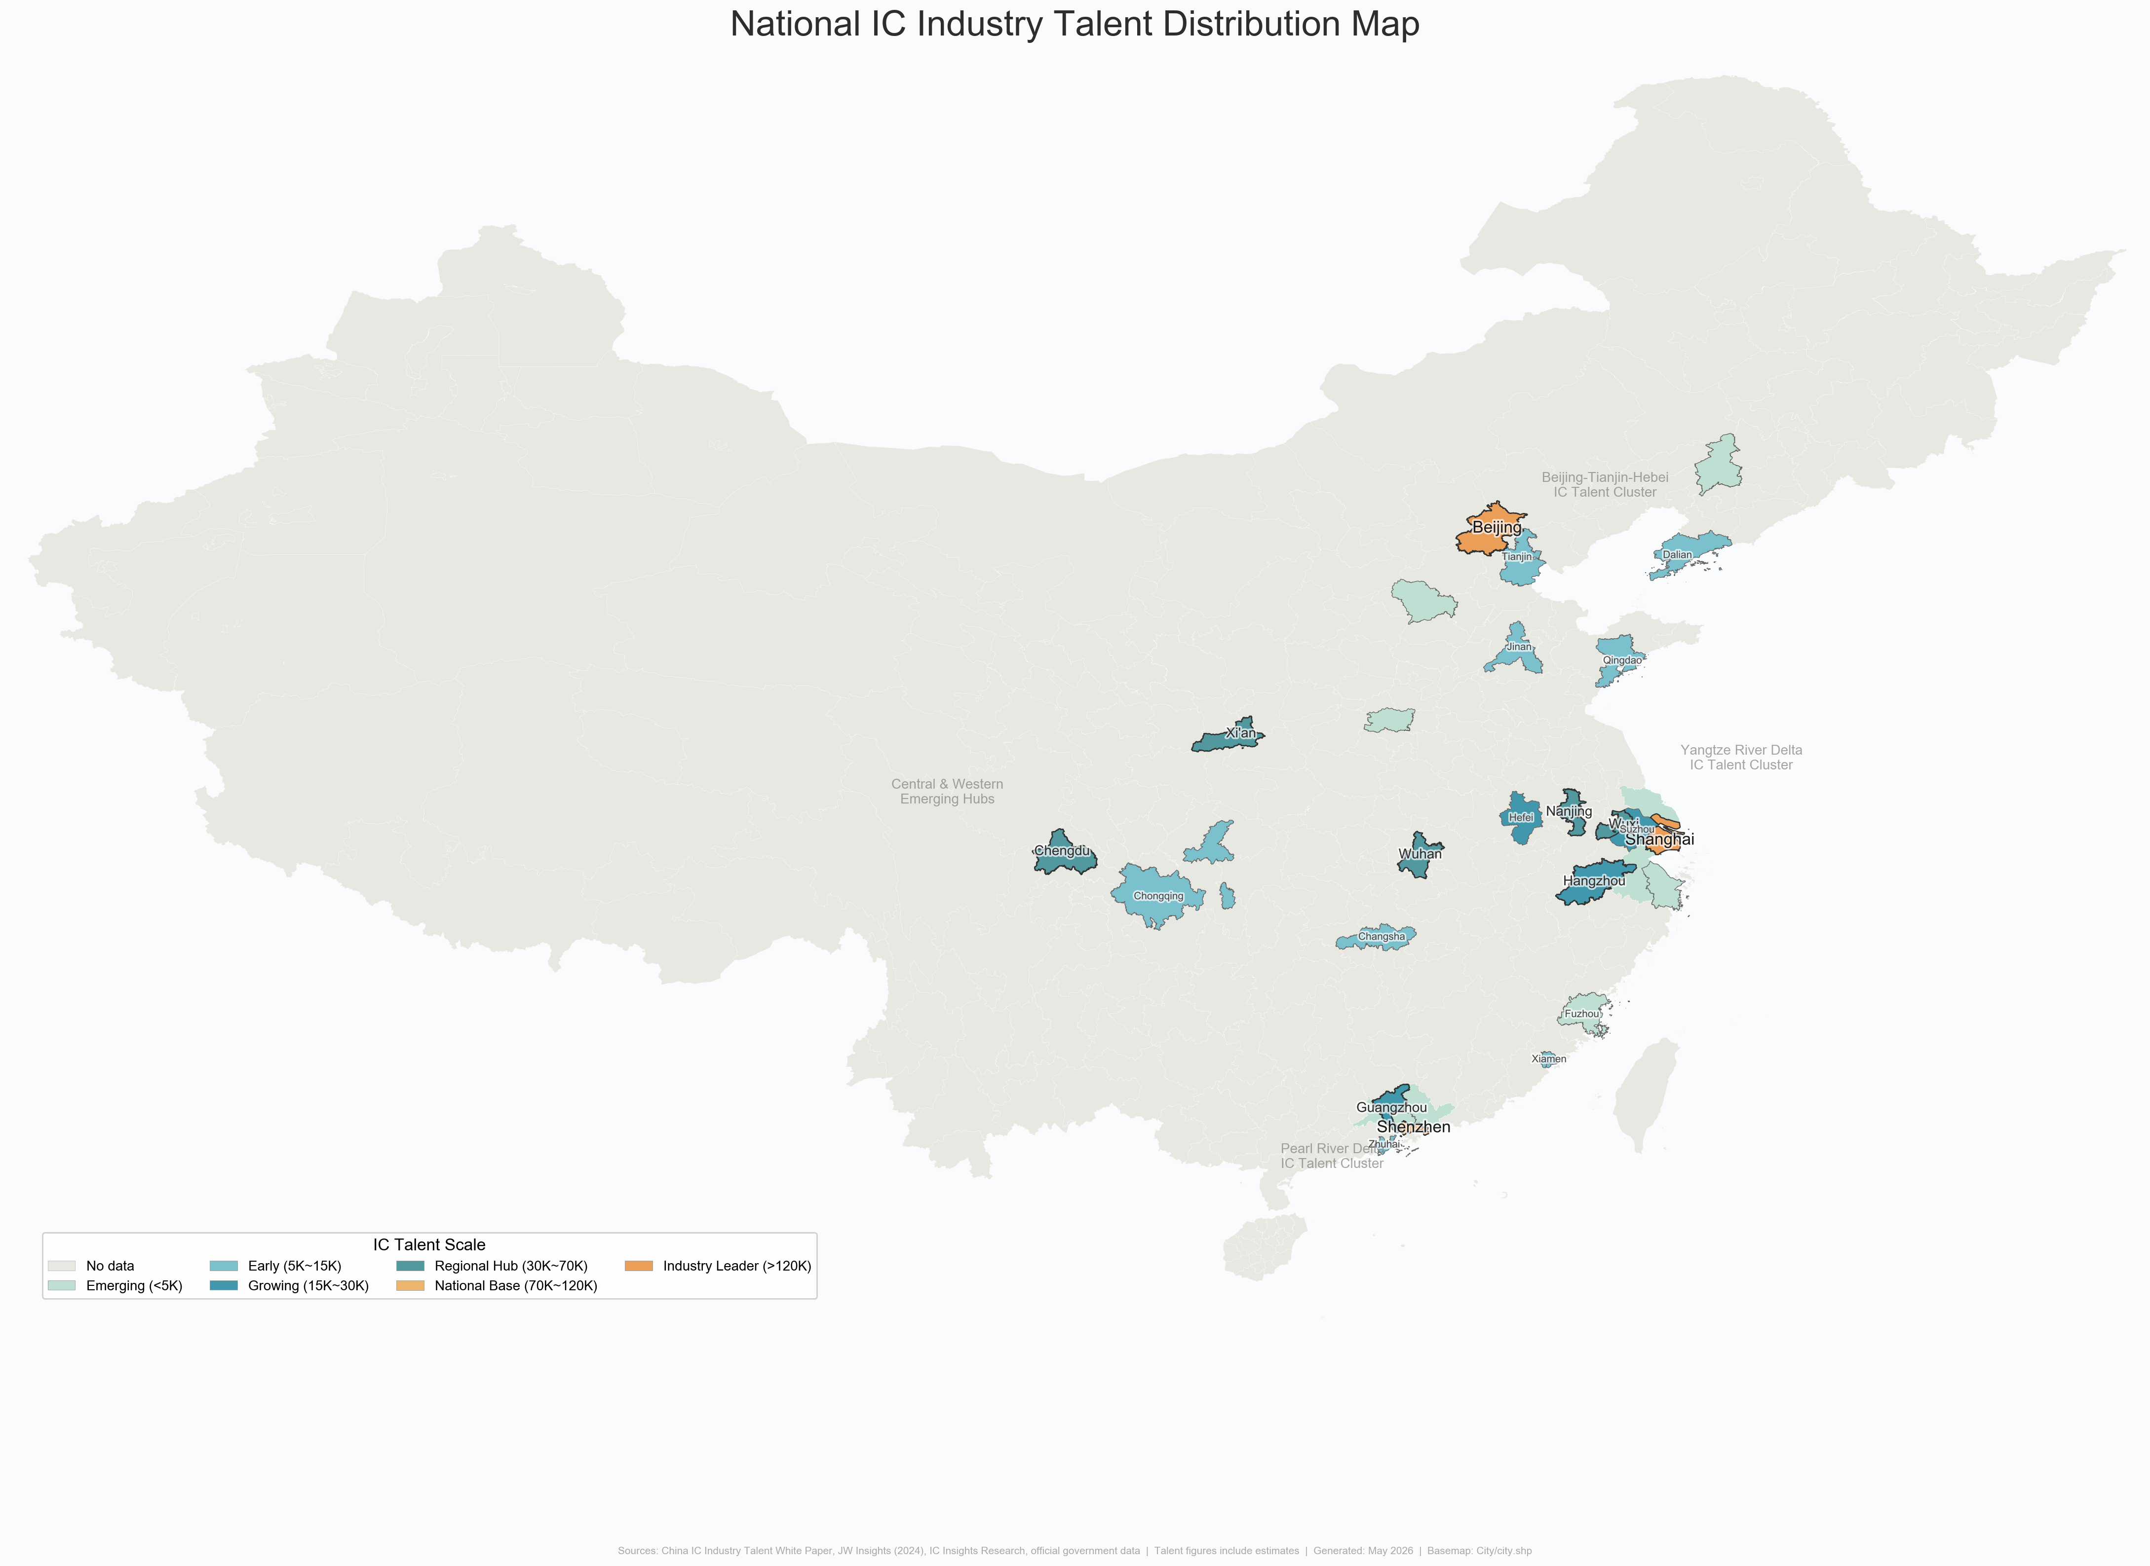
National IC Industry Talent Distribution Map

Intra-Provincial Mobility Patterns
Bidirectional talent circulation among core PRD cities is documented by commercial HR platform data (Liepin, 2024):
Talent Delivery Source Composition by City (Liepin 2024)
Delivery Destination | Top Sources (% of total deliveries)
Guangzhou | Local 42.13%, Shenzhen 8.17%, Foshan 3.76%, Dongguan 2.87%
Shenzhen | Local 37.58%, Guangzhou 7.45%, Shanghai 4.63%, Beijing 3.86%
Dongguan | Local 27.46%, Shenzhen 16.12%, Guangzhou 8.91%
Note: Liepin platform data reflects voluntary job-seeking behavior and is not equivalent to official government statistics; it is used here only as a directional indicator of talent mobility patterns.
Key findings:
- Shenzhen exhibits strong talent retention (37.58% local) but also significant outflows to Guangzhou, Shanghai, and Beijing, driven by competition for salaries, platforms, and living costs.
- Dongguan has the lowest local retention rate (27.46%) and the highest dependence on Shenzhen (16.12%), reflecting its role as a manufacturing hinterland receiving spillover from Shenzhen.
- Cross-sector inflow to the IC industry mainly originates from Electronics/Semiconductor/IC itself (7.86%), followed by Machinery/Equipment (4.96%), Internet (4.17%), and Computer Software (4.05%).

Government Talent Attraction Initiatives
In 2026, Guangdong Province launched the “Millions of Talents Gathering in Southern Guangdong” (百万英才汇南粤) N-city joint recruitment campaign, covering major IC industry hubs including Beijing, Shanghai, Nanjing, and Hangzhou. Shenzhen alone brought more than 120 key provincial enterprises and over 10,000 high-quality positions to 8 top universities including Peking University, Tsinghua University, Fudan University, and Shanghai Jiao Tong University. Recruitment focused on strategic emerging industries including IC, AI, biomedicine, and low-altitude economy — with over 2,000 positions offering annual salaries of RMB 500,000–1 million and over 120 positions exceeding RMB 1 million annually.
Shenzhen has adopted a multi-pronged approach of “introducing, educating, and retaining” (引育留) to build a multi-level IC talent team: improving talent introduction mechanisms to recruit global industry leaders; promoting 10 universities including SUSTech and Shenzhen University to offer IC-related majors; and leveraging a lower household registration threshold and innovative industrial environment to rank among the top cities nationally for attracting post-95 talent for multiple consecutive years.

University Talent Cultivation and Retention

Enrollment Expansion.
The number of IC-related major programs in Guangdong has expanded from 7 in 2022 to 32, with total enrollment (bachelor’s–doctoral) exceeding 10,000 students — a fourfold increase from 2022. Shenzhen University’s IC Engineering master’s program has achieved a 100% employment rate over the past five years, with 94.3% in contracted employment at firms including Huawei HiSilicon, ZTE, ADI, and Baidu.

Six Provincial IC Talent Cultivation Bases.
In December 2022, the Guangdong Provincial Department of Education officially approved six universities — South China University of Technology (SCUT), Sun Yat-sen University (SYSU), Southern University of Science and Technology (SUSTech), Shenzhen University (SZU), Guangdong University of Technology (GDUT), and Zhuhai College of Science and Technology (ZCST) — to establish “Guangdong Provincial Integrated Circuit Talent Cultivation Bases.”

Four Models of University–Industry Collaboration.
University–Industry Collaboration Models for IC Talent Cultivation
Model | Typical Cases | Partner Enterprises/Institutions
Customized Training Programs | GDUT–CanSemi “Ingenuity Class”; GDUT customized classes with 30+ firms | CanSemi, Huawei, Allwinner Technology
Joint Laboratories | SUSTech Shenzhen-Hong Kong Microelectronics Joint Lab; SZU–Huawei EDA Joint Lab; GDUT–Huawei “Kunpeng & Shengteng” Developer Innovation Club (first nationally) | Huawei, ZTE Micro, Arm China, SMIC, Unisoc
Industry Academies | GDUT IC Academy (est. Oct 2021); Shenzhen Technology University Computing Microelectronics Academy | Huawei, CanSemi, five MIIT electronics institutes
Co-supervised Graduate Programs | Provincial IC Industry Association Joint Training Base; Engineering Master/Doctoral Reform Special Projects | Foshan, Dongguan, Zhongshan, Shantou + Provincial Academy of Agricultural Sciences; $>$6,000 graduate students trained

Core Structural Problems
Despite rapid progress, five core structural problems persist in Guangdong’s IC talent landscape:
- Severe shortage of high-end core talent: Gaps in chip architects, advanced process engineers, EDA R&D experts, and automotive-grade chip safety certification experts exceed 70%. Local training speed lags far behind industrial expansion, and the province relies heavily on external talent introduction.
- Weak stability of backbone talent: Mature engineers around 35 years old — the industry’s most urgently needed group — flow frequently across cities and regions due to salary, platform, and living cost considerations, making it difficult for enterprises to recover training investments.
- Insufficient industry–education integration: The number of universities and vocational colleges offering IC-related majors remains limited, and curricula remain disconnected from actual job requirements. Fresh graduates typically require 3–12 months of secondary training, failing to achieve immediate workplace readiness.
- Long-term talent echelon fault: The proportion of senior technical personnel with 15+ years of working experience is critically low, making it difficult to effectively transfer technical experience and process know-how across generations.
- Unbalanced talent development across the value chain: Design segments are crowded with talent and highly competitive, while heavy-asset, long-cycle segments (manufacturing, equipment, materials) lack talent attractiveness, constraining coordinated whole-chain development.

Policy Alignment for Talent

Overview of the Multi-Tier Policy System
Governments at the provincial, municipal, and district levels have rolled out a multi-faceted policy package for IC talents. However, across the entire industrial chain, existing policies show a notable structural imbalance in coverage.

Provincial Level: Strategic Recruitment and Macro Incentives.
Guangdong expands the pool of local talents via multiple initiatives, including the Guangdong Premium Talent Card, individual income tax incentives for the Guangdong-Hong Kong-Macao Greater Bay Area (a subsidy covering the income tax difference for overseas high-end and urgently-needed talents, capping the effective tax rate at 15%), the higher education improvement plan of “Building Top-tier Universities, Addressing Weak Links and Highlighting Distinctive Features” (冲补强), and the Fundamental Discipline Talent Development Program. The number of IC professionals trained in Guangdong quadrupled during the 14th Five-Year Plan period.

Municipal and District Levels.
Shenzhen, Guangzhou, and Zhuhai have each rolled out targeted talent incentives including R&D team bonuses (up to RMB 5 million in Shenzhen), individual income tax rebates (up to RMB 3 million/year per person in Guangzhou’s Nansha District), and comprehensive MPW tape-out subsidies (Zhuhai’s Hengqin). Detailed policy descriptions are provided in Chapter 6.2.

Policy Coverage and Adaptability by Talent Category
The existing talent policies feature uneven coverage and adaptability for professionals in different positions and with different academic backgrounds. The coverage rates below are schematic estimates synthesized by the research group from policy document analysis and do not represent official statistics. They are intended to illustrate relative disparities in policy attention across talent categories.
Policy Coverage Rate by IC Talent Category (Research Group Estimates)
Talent Category | Estimated Coverage (%) | Assessment
IC Design Talents | $≈$95 | Core focus of local policies; R&D rewards, tax subsidies, tape-out incentives are design-tilted
Manufacturing & Packaging Engineering Talents | $≈$80 | Gradually covered with recent manufacturing push, but traditional evaluation thresholds (tax payment, academic degree) may exclude manufacturing engineers
Application & Testing Technicians | $≈$60 | Few dedicated subsidies; mostly included in general youth talent or enterprise assessment quotas
Frontline Skilled Workers | $≈$35 | Lowest coverage; limited to household registration settlement and public rental housing support; insufficient targeted incentives for fab operators
Key finding: Design segment talents enjoy near-comprehensive policy coverage ($≈$95%), benefiting from R&D team rewards, personal tax subsidies, and tape-out incentives. By contrast, frontline skilled workers — who are essential for wafer fabrication and packaging/testing operations — receive only $≈$35% coverage, contributing to a persistent long-term labor shortage in the manufacturing segment.

Talent Salary Levels
The salary level of Guangdong’s IC industry ranks among the top tiers nationally. Shenzhen’s IC design salaries are on par with Shanghai and Beijing, forming the three highest-paying regions for IC talent in China:
- High-barrier positions (explosive growth): Core positions crucial to breaking technological bottlenecks — digital front-end design, analog chip design, and algorithm development — register a median monthly salary of approximately RMB 35,000, with annual bonuses generally above the industry average. Senior professionals with 8+ years of experience command annual salaries of RMB 800,000–1,200,000+.
- Manufacturing segment (stable growth): Process engineers and equipment engineers in wafer foundries see more moderate salary growth. Fresh bachelor’s graduates earn RMB 10,000–15,000/month; professionals with 1–3 years of experience earn RMB 15,000–22,000/month. The salary growth rate in manufacturing is significantly lower than in front-end design.
- Core management positions: General Manager and Deputy General Manager of IC product lines in first-tier cities (Shenzhen, Guangzhou) have a median annual salary exceeding RMB 950,000, with the 90th percentile reaching RMB 1,200,000 — approximately 20% higher than in second-tier cities.

Industry Competitiveness Evaluation
A horizontal comparison of Guangdong’s IC talent environment with the Yangtze River Delta (Shanghai, Wuxi, Suzhou) and central/western regions (Chengdu, Xi’an, Wuhan) yields the following SWOT assessment:
SWOT Matrix of IC Talent Competitiveness in Guangdong Province
Strengths | Weaknesses
$•$ Largest end-user application market in China (consumer electronics, NEVs, AI) | $•$ Leading foundational enterprises in wafer manufacturing and EDA remain underdeveloped vs. Yangtze River Delta
$•$ Unique 15% IIT preference for overseas talents under GBA integration | $•$ Extremely high living and housing costs in Shenzhen and Guangzhou restrict talent retention
$•$ Proximity to Hong Kong and Macao for cross-border talent attraction | $•$ IC manufacturing ecosystem still in early development stage
Opportunities | Threats
$•$ Strategic university enrollment expansion (4$×$ increase in 5 years) accelerating local talent pipeline | $•$ Mature Yangtze River Delta ecosystem exerts strong pull, with more cost-effective locations (Wuxi, Suzhou)
$•$ “Greater Bay Area Postdoctoral” innovation platform and “listing and leading” (揭榜挂帅) mechanism accelerating research commercialization | $•$ Central/western cities (Chengdu, Xi’an, Wuhan) diverting manufacturing talent with lower living costs
Core competitive challenge: High living costs create a persistent talent retention dilemma. Mid-level engineers with 3–5 years of experience earning RMB 300,000–500,000 annually are easily attracted to alternatives including Wuxi, Suzhou, Chengdu, and Xi’an — cities with solid industrial foundations and more affordable housing. Guangdong can recruit talent with competitive compensation yet struggles to retain them sustainably. This “revolving door” dynamic, combined with the Yangtze River Delta’s decade-plus head start in manufacturing talent accumulation, represents the most significant structural challenge for Guangdong’s IC talent strategy.

Cluster Competitiveness Analysis

Theoretical Foundations
The competitiveness of industrial clusters is not a spontaneous outcome but the result of systematic interactions among factor endowments, market dynamics, institutional environments, and spatial organization. This report adopts two complementary theoretical frameworks — Michael Porter’s Diamond Model (1990) and David Ricardo’s Comparative Advantage Theory (1817, as extended by Heckscher–Ohlin and subsequent scholars) — to structure the analysis of Guangdong’s IC cluster competitiveness.

Porter’s Diamond Model
Porter (1990) argued that the competitive advantage of nations — and by extension, of regions — is created rather than inherited, and that it resides in the productivity with which a location’s resources are deployed in a given industry. The Diamond Model identifies six interdependent determinants:
- Factor Conditions. A region’s endowment of production factors: human resources, physical resources, knowledge resources, capital resources, and infrastructure. Porter distinguishes basic factors (natural endowments, unskilled labor) from advanced factors (specialized talent, R&D capabilities), with advanced factors being the true drivers of sustainable competitive advantage.
- Demand Conditions. The nature and sophistication of local demand shape the pace and direction of innovation. Guangdong benefits from the largest IC application market in China.
- Related and Supporting Industries. Competitive advantage is reinforced by internationally competitive suppliers and related industries — EDA software, semiconductor equipment, specialty chemicals, silicon wafers, and testing services.
- Firm Strategy, Structure, and Rivalry. Vigorous domestic rivalry drives firms to upgrade and innovate. Guangdong’s landscape features large platforms (Huawei HiSilicon, ZTE Micro), listed fabless companies, and numerous micro-design firms.
- Government. An influencing factor that shapes the business environment through subsidies, tax policy, education investment, and regulatory frameworks. In China’s semiconductor industry, government plays a particularly prominent role.
- Chance. Random events — technological breakthroughs, supply chain shifts — can reshape competitive positions. The US–China technology decoupling since 2019 constitutes a major chance event.

Comparative Advantage Theory
Comparative Advantage Theory addresses where a region should direct its resources. Applied to the IC industry: IC design is human-capital-intensive; wafer fabrication is capital-intensive; packaging and testing is relatively labor-intensive; equipment/materials require deep science-technology linkages. Guangdong’s comparative advantage lies in design talent and electronics supply chains, while its manufacturing and equipment segments require deliberate investment in advanced factors to shift toward higher-value-added activities.

Overview of Guangdong’s Three Core IC Clusters
The IC industry is a core component of the information technology sector and one of Guangdong Province’s key strategic emerging industries. After years of development, Guangdong has established three major IC industry clusters centered in Shenzhen, Guangzhou, and Zhuhai. Shenzhen focuses on chip design and technological innovation, Guangzhou specializes in wafer manufacturing, while Zhuhai has developed a competitive advantage in third-generation semiconductors. Together, these cities constitute the primary growth engines of Guangdong’s IC industry, forming a “3+N” spatial pattern with Dongguan, Foshan, Zhongshan, and other cities providing packaging, testing, and end-application support.
Comprehensive Comparison of Guangdong’s Three IC Industry Clusters
Dimension | Shenzhen Cluster | Guangzhou Cluster | Zhuhai Cluster
Industrial Positioning | Chip Design & Innovation Center | Wafer Manufacturing Center | Third-Generation Semiconductor Base
Representative Companies | HiSilicon, ZTE Micro, Goodix | CanSemi, GTA Semiconductor | Innoscience, Allwinner, JieLi
Enterprises (2024) | 727 | $≈$200 | $>$100
Industrial Scale | RMB 283.96B | $≈$RMB 50B | $≈$RMB 20B
Major Patent Fields | AI chips, EDA, communication chips | Manufacturing processes, automotive chips | GaN power devices
Tech. Breakthroughs | Domestic IP cores, EDA tools, automotive chips | 12-inch specialty process mass production | GaN fast-charging chip commercialization
Policy Focus | R&D support, tape-out subsidies | Manufacturing expansion, equipment subsidies | Third-gen semiconductor special support
Location Advantages | Strong electronics ecosystem | Automotive industry, university resources | Consumer electronics supply chain, lower costs
Supply Chain Role | Chip Design | Wafer Manufacturing | Power & Specialty Semiconductors

Shenzhen Cluster: Design and Innovation Center
Shenzhen possesses the strongest innovation capability among Guangdong’s IC clusters. By the end of 2024, Shenzhen had 727 IC enterprises, including 456 design companies, accounting for 62.7% of the cluster total. The industry generated revenue of RMB 283.96 billion, representing a year-on-year increase of 32.9% and approximately 79% of Guangdong’s total IC industry output. Shenzhen has developed strong innovation capabilities in AI chips, communication chips, automotive-grade chips, and EDA software. Over 65% of the province’s IC-related invention patents are concentrated in Shenzhen, reflecting its role as the primary innovation engine.
Shenzhen benefits from the presence of leading technology companies such as Huawei, Tencent, BYD, and DJI. Its strong electronics manufacturing ecosystem creates a development model in which market demand drives chip innovation. The concentration of venture capital institutions and high-tech talent provides significant innovation advantages. Key enterprises include HiSilicon (ranking among the global top 10 fabless design firms), ZTE Microelectronics (communication chips), SMIC Shenzhen (advanced foundry), and Shennan Circuits (high-end PCB substrates).

Guangzhou Cluster: Wafer Manufacturing Center
Guangzhou plays a critical role in manufacturing innovation, addressing Guangdong’s historical gap in wafer fabrication. Supported by CanSemi’s 12-inch specialty process production line — the first 12-inch wafer foundry in the Greater Bay Area to enter mass production — the city focuses on breakthroughs in analog chips, power devices, and automotive-grade semiconductor manufacturing technologies. In 2024, Guangzhou’s IC output grew by 68.9% year-on-year.
A key driver of cluster development is the vertical integration capability of leading enterprises, or “chain leaders.” CanSemi has launched four phases of projects, with its fourth-phase investment of RMB 25.2 billion aiming to transform from a pure analog foundry into a hybrid technology platform focused on “analog core, digital upgrade, and optoelectronics integration.” With CanSemi as the anchor, the Guangzhou Development Zone has gathered over 150 IC companies, forming a complete ecosystem of “design–manufacturing–packaging & testing–equipment/materials–end applications.”
Huangpu District has achieved a refined spatial division of labor: Knowledge City (North) for manufacturing, Science City (Central) for design innovation, and the Port Area (South) for end applications. This layout accelerates coordination from R&D to commercial deployment. Guangzhou’s location in the geographic center of the Pearl River Delta, its automotive industry base (GAC Group), and university resources (South China University of Technology, Sun Yat-sen University) further strengthen its cluster competitiveness.

Zhuhai Cluster: Third-Generation Semiconductor Base
Zhuhai has emerged as a major center for third-generation semiconductors through companies such as Innoscience, Allwinner Technology, and JieLi Technology. Innoscience has established one of China’s leading gallium nitride (GaN) industrialization platforms, achieving 8-inch GaN-on-Si mass production and making Zhuhai an important national hub for third-generation semiconductor development. Allwinner Technology and Jieli Technology lead in smart audio/visual SoCs and Bluetooth chips respectively.
Zhuhai is closely connected to manufacturing centers such as Zhongshan and Foshan and possesses a well-developed consumer electronics and power supply industry ecosystem. Lower land and operating costs make it particularly attractive for semiconductor fabrication and industrial-scale production projects. The city has established a RMB 100 million industry fund to support niche design firms, and its design segment has grown at an average annual rate of over 20% in recent years.

Technological Innovation Capability Comparison
Technological innovation is a key determinant of industrial cluster competitiveness. Guangdong has established an innovation system characterized by Shenzhen as the innovation hub, Guangzhou as the manufacturing innovation base, and Zhuhai as a specialized center for third-generation semiconductors.
Patent and Innovation Capability Comparison
Indicator | Shenzhen | Guangzhou | Zhuhai
Innovation Entities | IC Design Firms | Manufacturing Enterprises | Power Semiconductor Firms
Share of Provincial Invention Patents | $>$65% | $≈$20% | $≈$10%
Major Patent Fields | AI chips, EDA, communication chips | Manufacturing processes, automotive chips | GaN power devices
Innovation Characteristics | Strong original innovation | Strong process innovation | Strong industrialization capability
National Competitiveness | First-tier cluster | Specialized manufacturing base | Leading third-gen semiconductor base
From the perspectives of patent distribution and technological breakthroughs, Shenzhen concentrates the majority of Guangdong’s high-value invention patents and serves as the province’s innovation center. Guangzhou focuses on manufacturing process innovation, while Zhuhai specializes in third-generation semiconductor innovation. Together, the three cities form a differentiated innovation ecosystem that enhances Guangdong’s overall industrial competitiveness.

Industrial Chain Collaboration
Guangdong has established a relatively complete IC industrial chain. In 2024, the province’s total IC industry output reached approximately RMB 360 billion, including RMB 210.9 billion from chip design (58.6%), RMB 79.5 billion from packaging and testing (22.1%), RMB 9.2 billion from wafer manufacturing (2.6%), and RMB 60.8 billion from equipment and materials (16.9%).
Division of Labor Along Guangdong’s IC Industrial Chain
Industrial Segment | Major Cities | Representative Enterprises
Chip Design | Shenzhen | HiSilicon, Goodix, ZTE Micro
Wafer Manufacturing | Guangzhou | CanSemi
Power Semiconductors | Zhuhai | Innoscience
Packaging & Testing | Dongguan, Foshan, Zhongshan | Tianyu Semiconductor et al.
End-User Applications | Shenzhen, Dongguan | Huawei, BYD, DJI
Industrial Chain Completeness Assessment
Segment | Development Status
Chip Design | Strong Competitive Advantage
Wafer Manufacturing | Rapidly Improving
Packaging & Testing | Well Established
Equipment & Materials | Relatively Weak
EDA Software | Requires Further Development
The regional collaboration model — “Design (Shenzhen) – Manufacturing (Guangzhou) – Packaging & Testing (Dongguan, Foshan, Zhongshan) – Application (Shenzhen, Dongguan)” — helps reduce supply chain costs, improve resource allocation efficiency, and strengthen Guangdong’s overall industrial competitiveness. This model of “market pull + manufacturing catch-up + chain-leader drive” is accelerating Guangdong’s path to becoming China’s third IC pole.
Although Guangdong has established a relatively complete IC industrial chain, challenges remain in critical areas such as advanced semiconductor equipment, lithography technologies, and EDA software. Future development should focus on achieving breakthroughs in these key technologies, deepening the “design–manufacturing–application” closed-loop synergy, and advancing silicon photonics and advanced packaging capabilities.

Provincial Cluster Analysis: Diamond Model Application
This section applies Porter’s Diamond Model to systematically evaluate Guangdong’s IC clusters across the six determinants.

Factor Conditions
Guangdong’s IC factor conditions are documented in detail in Chapters 2–4 and may be summarized through the Diamond lens as follows. Human resources (see Section 4.1): approximately 236,000 IC workers concentrated in Shenzhen and Guangzhou, with a design-heavy talent structure (72.9%) and 77.2% holding bachelor’s degrees or above. Physical and knowledge resources (see Sections 2.1 and 2.3): 94.1% of enterprises located in the PRD; national leadership in IC layout-design registrations; key platforms include CanSemi’s 12-inch line and the Ji Hua Laboratory. Capital resources (see Section 2.1): median registered capital of only RMB 1 million, with top-tier manufacturing projects concentrated in Shenzhen and supported by the Shenzhen IC Industry Investment Fund (Phase-I RMB 5B).

Demand Conditions
Guangdong is China’s largest IC application market, accounting for 30–40% of national chip consumption (see Section 1.1 and Section 3.3). Demand is driven by consumer electronics (Huawei, OPPO, vivo), automotive electronics (BYD, XPeng, GAC), and industrial/AI computing (Tencent, DJI). The proximity between chip designers and downstream OEMs in the PRD creates a “demand pull” mechanism that compresses development cycles and steers product roadmaps toward commercially validated applications.

Related and Supporting Industries
Guangdong’s electronics manufacturing ecosystem — PCB production, EMS services, and semiconductor materials — provides unmatched prototyping and production support for IC firms (see Section 2.3). However, critical upstream gaps persist: EDA tools remain dominated by Synopsys, Cadence, and Mentor; core semiconductor equipment is import-dependent; and advanced photoresists and high-purity silicon wafers are largely sourced from Japan, Taiwan, and the United States.

Firm Strategy, Structure, and Rivalry
As detailed in Chapter 2 (see Tables 1–10) and Section 3.5, Guangdong’s IC industry features a highly fragmented structure: 62.5% micro-scale firms, private enterprise dominance (54.7%), and minimal foreign participation (2.9%). Fierce domestic rivalry in the design segment (7,403 registered firms) accelerates innovation but fragments the market. Anchor firms — Huawei HiSilicon, BYD Semiconductor, CanSemi — provide countervailing force through specialized supply chains and talent pools.

Government
Government intervention has been decisive in shaping Guangdong’s IC cluster trajectory. The provincial “Strengthening the Core” (广东强芯) program and the Action Plan (2023–2025) set a target of RMB 400 billion in annual revenue by 2025. A comprehensive review of policy instruments — including R&D super-deductions, first-mass -production flow subsidies, and municipal-level cluster support — is provided in Chapter 6. The 67.6% zero-insurance enterprise rate (Table 9) serves as a cautionary indicator of the gap between policy access and operational reality.

Chance
The US–China technology decoupling since 2019 is the defining chance event. Export controls on advanced EDA tools, EUV lithography equipment, and high-end GPUs have forced Chinese design firms to pivot toward mature-node innovation and domestically available toolchains. This has intensified the urgency of building indigenous manufacturing capability (CanSemi, Runpeng, SMIC Shenzhen) and equipment capability. Simultaneously, the decoupling has opened a protected domestic market for indigenous suppliers to achieve scale and establish reference customers.

Spatial Configuration Summary
The spatial division of labor reflects the interplay of the six diamond determinants. Shenzhen’s dominance (58.9% of enterprises) arises from co-location of advanced factors, demanding customers, dense supporting industries, and vigorous local rivalry. Guangzhou’s manufacturing positioning is a product of government-directed investment in fab infrastructure and university-linked knowledge resources. Dongguan and Huizhou leverage lower factor costs and proximity to Shenzhen’s demand base, while Zhuhai and Foshan represent specialized niches capitalizing on targeted policy support and existing industrial legacies.

Domestic Benchmarking

Industrial Scale and Structure
China’s IC sector has evolved into a dual-core layout: the Yangtze River Delta (Shanghai, Jiangsu, Zhejiang) leads across the full industrial chain, while the Pearl River Delta (Guangdong) achieves distinctive development with its own competitive edges.
Guangdong Province: Over 65% of total IC revenue comes from chip design, home to world-class players such as HiSilicon, ZTE Microelectronics, Goodix, and Allwinner Technology. Wafer manufacturing accounts for less than 20% of provincial industrial revenue. Packaging & testing focuses on power and consumer-grade chips, lacking high-end advanced packaging capacity.
Shanghai: China’s only provincial-level region with a complete self-sufficient ecosystem covering design, fabrication, packaging & testing, equipment, and materials. SMIC and Huahong Semiconductor anchor advanced manufacturing. Zhangjiang Science City accommodates over 1,200 enterprises, gathering nearly 40% of China’s domestic semiconductor R&D resources.
Jiangsu Province: Nationwide-leading capacity in manufacturing and packaging & testing. Suzhou and Wuxi host major foundry projects (Huahong, CR Micro, Samsung). Three top domestic packaging & testing giants — JCET, Tongfu Microelectronics, Huatian Technology — capture over half of China’s packaging & testing capacity.
Zhejiang Province: Focuses on niche tracks — security monitoring ISP chips, automotive MCUs, IoT semiconductors — backed by Zhejiang University and Hangzhou Dianzi University, forming an industrial feature of numerous niche champions.

Industrial Chain Completeness
The Yangtze River Delta has built a synergistic regional division: Shanghai for cutting-edge R&D, Jiangsu for mass production and packaging, Zhejiang for application-specific chips. Over 55% of core industrial supplies are sourced domestically within the Delta, forming a closed-loop supply chain.
In contrast, Guangdong faces prominent midstream and upstream bottlenecks: (1) lack of domestic foundries for advanced logic-process 12-inch wafers, forcing most designers to outsource fabrication to Shanghai or overseas; (2) over 90% of core raw materials (silicon wafers, photoresist) and precision equipment rely on external procurement; (3) local packaging & testing is dominated by traditional lead-frame packaging, falling behind Jiangsu in FC-BGA and other advanced packaging.

Talent Pool and Scientific Research
Shanghai and Jiangsu enjoy abundant high-end human resources from Fudan, Shanghai Jiao Tong, Nanjing, and Southeast universities, producing over 30,000 microelectronics postgraduates annually. Guangdong has fewer top-tier academic institutions (SYSU, SCUT), facing a persistent shortage of over 80,000 high-end specialists for advanced wafer processes and equipment development, most of whom must be recruited externally. Local R&D focuses predominantly on application-layer chip optimization, with weak fundamental research on underlying manufacturing processes and materials.

Guangdong’s Competitive Advantages and Deficiencies
Advantages:
- China’s most complete downstream terminal electronics chain (smartphones, EVs, home appliances, IoT), absorbing $∼$40% of domestic terminal chip demand and achieving the fastest commercial iteration of new semiconductors nationwide.
- Highly market-oriented environment and vibrant private capital — Huawei and BYD continuously invest heavily in independent chip R&D, while active venture capital fuels numerous SMEs.
- Leading domestic position in third-generation semiconductors (SiC & GaN), with production bases in Guangzhou and Zhuhai enabling differentiated competition against the Yangtze River Delta’s silicon-based dominance.
Deficiencies versus Yangtze River Delta:
- Severe midstream industrial chain defects — inadequate capacity in advanced wafer fabrication, core equipment, and electronic materials, resulting in heavy external dependence.
- Poor cross-city industrial coordination — Shenzhen, Guangzhou, and Zhuhai’s industrial parks operate in relative isolation with fragmented resource allocation, unlike the highly coordinated cross-provincial ecosystem of Shanghai-Jiangsu-Zhejiang.
- R&D tilts excessively toward applied chip design with insufficient investment in basic research on underlying manufacturing processes and materials.

International Benchmarking

Global Comparison Overview
Global Semiconductor Industry Comparison
Dimension | China | United States | Germany | Japan
Technological Barrier | Medium-High | Very High | High | High
Core Strength | Manufacturing & Packaging | Chip Design & EDA | Industrial Chips | Materials & Equipment
Cluster Model | Government-led + Market-driven | Innovation-driven | Industry-Academia Collaboration | Industrial Ecosystem
Policy Support | Strong | Strong | Moderate | Strong
Global Competitiveness | High | Very High | High | High

United States
The United States leads in chip design, EDA software, venture capital support, and university-driven innovation. Major clusters include Silicon Valley, Austin, and Phoenix. Companies such as NVIDIA, AMD, Qualcomm, and Intel maintain significant advantages in advanced chip architecture, AI accelerators, and semiconductor IP. Continuous investment in R&D and talent development enables the US to remain at the forefront of next-generation semiconductor technologies.

Germany
Germany focuses on industrial semiconductors, automotive electronics, power devices, and intelligent manufacturing applications. Its competitive advantage comes from close cooperation among enterprises, universities, and research institutes (Fraunhofer model). Strong industrial demand from automotive and machinery sectors creates a stable market for semiconductor innovation. Germany’s emphasis on precision engineering and vocational education supports globally competitive semiconductor firms.

Japan
Japan maintains strong competitiveness in semiconductor materials, manufacturing equipment, and supply-chain management. Japanese companies hold leading positions in wafers, photoresists, specialty chemicals, and precision equipment. Although Japan’s share in chip design has declined, its upstream technological capabilities remain indispensable to the global semiconductor industry. Japan positions semiconductors as an “economic security” priority, providing heavy subsidies for advanced manufacturing (e.g., TSMC Kumamoto fab, Rapidus).

Lessons for Guangdong
- Strengthen original innovation capability by increasing investment in fundamental research, frontier technologies, and high-end semiconductor talent cultivation.
- Promote deeper industry-academia-research collaboration to accelerate technology commercialization and improve innovation ecosystem efficiency.
- Improve domestic EDA software, semiconductor equipment, and core IP capabilities to reduce external technology dependence.
- Enhance supply-chain resilience, advanced materials development, and strategic resource security for long-term sustainability.

SWOT Summary
- Strengths: Largest chip consumption market in China (PRD $∼$60% share); robust electronics manufacturing base; vibrant Shenzhen innovation ecosystem; world-class design enterprises (HiSilicon, ZTE Micro); leading domestic position in third-generation semiconductors (SiC, GaN); highly market-oriented environment with active private capital; differentiated three-cluster structure enabling complementary specialization.
- Weaknesses: Limited manufacturing scale (CanSemi is the sole 12-inch volume production line); insufficient advanced packaging/testing capacity; reliance on external talent pipelines and upstream supplies (over 90% of core materials imported); value chain completeness lags behind Yangtze River Delta; fragmented cross-city industrial coordination; weak fundamental research in manufacturing processes and materials; EDA tools remain externally dominated.
- Opportunities: Domestic substitution imperative under US–China technology decoupling; national “Greater Bay Area” strategy; accelerating deployment of third-generation semiconductors; massive local application markets (EVs, AI, consumer electronics); potential to attract returnee scientists amid geopolitical tensions; silicon photonics and advanced packaging as emerging differentiation tracks.
- Threats: US–China technology decoupling and export controls on advanced equipment, EDA tools, and high-end chips; intensifying inter-regional competition for talent and investment (Yangtze River Delta pull, cost-competitive central/western cities); “race to the bottom” risk in fragmented design market; heavy dependence on external advanced manufacturing and materials suppliers.

Supporting Policy Review

Provincial-Level Policies
Guangdong’s provincial incentive policies targeting IC enterprises fall into five core dimensions: R&D subsidy, tax preference, land resource support, financing discount & guarantee, and talent allowance & park incubation incentives. These are issued by the Guangdong Provincial Development & Reform Commission, Department of Industry and Information Technology, and Department of Finance.

R&D Subsidy Policies
Provincial fiscal funds offer tiered financial subsidies for core technology R&D and industrialization projects of IC firms:
- Chip design enterprises: Subsidies are granted based on annual incremental R&D investment. Qualified provincial key design firms can obtain up to 25% reimbursement of newly increased annual R&D expenditure, with an annual maximum cap of RMB 30 million per enterprise. Provincial special funds prioritize projects targeting advanced SoC, automotive-grade chips, and third-generation semiconductor core R&D.
- Wafer manufacturing & compound semiconductor projects: For newly built or expanded specialty-process and SiC/GaN wafer production lines approved at the provincial level, construction and equipment procurement costs receive lump-sum provincial subsidies. Eligible projects can claim a subsidy ratio ranging from 12% to 20% of fixed-asset investment, with ceiling limits adjusted according to project scale.
- Packaging, testing, and semiconductor supporting material/equipment enterprises: Provincial funds subsidize pilot-scale localization R&D of domestic alternative equipment and raw materials, covering approximately 15% of verified project R&D outlay.

Tax Reduction & Exemption Incentives
All provincial-level preferential tax rules are implemented in coordination with national tax codes, with supplementary provincial matching support:
- High-tech IC enterprises enjoy the statutory reduced corporate income tax rate of 15% instead of the standard 25%. Core IC manufacturing and design firms within designated provincial industrial parks receive extra fiscal rebate for the local retained portion of corporate income tax.
- Accelerated depreciation policy: Newly purchased R&D-specific equipment and instruments are eligible for one-off pre-tax deduction or super-accelerated depreciation. R&D expenses qualify for extra super-deduction proportion in pre-tax accounting with provincial fiscal matching reward.
- Import tax relief: Core production equipment and indispensable raw materials imported for provincial key IC construction projects are entitled to import tariff and VAT exemption per the provincial approved catalog.

Land Resource Support Policies
The provincial natural resources department reserves exclusive industrial land quotas for verified provincial major IC industrial projects:
- Land transfer pricing discount: Land for key IC projects under the provincial catalog is supplied at preferential industrial land pricing, with transaction price down-regulated to 70%–85% of the benchmark industrial land cost in corresponding regions.
- Flexible land use terms: Provincial policy allows flexible tenure, installment land payment, and combined industrial & supporting land layout for large-scale wafer fab projects; idle provincial-owned industrial land is prioritized to be leased or transferred to settled IC enterprises at negotiated favorable prices.
- Supporting auxiliary land matching: Provincial governments coordinate matching of residential and commercial supporting land near IC industrial clusters to facilitate construction of employee dormitories and industrial supporting facilities.

Financing Preferential Policies
The provincial finance bureau sets up a special IC industry guiding fund and risk compensation pool:
- Direct equity investment: The Guangdong Provincial Semiconductor Industry Development Fund makes equity investment into high-growth provincial IC startups, focusing on early-stage design, third-generation semiconductor, and core equipment enterprises, with investment proportion generally below 20% of corporate equity to avoid crowding out private capital.
- Loan interest discount: Qualified provincial IC enterprises applying for project construction and R&D bank loans can apply for provincial interest subsidy covering 40%–60% of annual actual loan interest expense, for a maximum of three consecutive years.
- Credit risk compensation: Provincial finance establishes a credit indemnity pool cooperating with domestic commercial banks to cover partial bad loan losses of small & medium-sized IC firms, lowering bank financing thresholds for SMEs. Additional rewards are given to local financial institutions that increase credit lending toward the provincial IC industry.

Talent Subsidy & Park Incubation Incentives
- Provincial high-end IC talent allowance: Core technical and managerial talents introduced under the Guangdong Provincial High-level Talent Program receive one-time provincial living subsidy and housing allowance; doctoral and master graduates engaged in IC R&D in certified provincial IC clusters can apply for monthly provincial stipend within their first three working years.
- Industrial park incubation subsidy: Provincial finance gives annual operational subsidy to certified provincial-level IC characteristic industrial parks according to park-settled enterprise quantity and annual industrial output growth, to support park infrastructure construction, shared testing platform building, and public service operation costs. Newly incubated high-growth IC SMEs within provincial parks receive startup grants from the provincial special fund upon identification.

Policy Application and Implementation
Applicable Objects:
- Leading large-scale enterprises: Registered IC design, manufacturing, packaging-testing, and upstream material/equipment enterprises with annual operating revenue over RMB 200 million, listed in the Guangdong Provincial Key IC Enterprise Catalogue.
- Small and medium-sized enterprises (SMEs): Legally incorporated provincial IC firms with annual revenue below RMB 200 million, engaging in independent chip R&D or localized supporting production, verified by the Guangdong Department of Industry and Information Technology.
All applicants must complete industrial and tax registration within Guangdong administrative territory and have a normal tax payment record without major administrative penalties within the recent three years.
Application Flow: Annual centralized application notice released each Q1 → enterprises submit documents to municipal industry bureaus for preliminary screening → municipal authorities complete material authenticity inspection and site verification within 20 working days → provincial expert review organized by provincial finance, industry & information departments within 30 working days → public announcement on official provincial government website for no less than 7 working days → provincial finance department allocates subsidy funds directly to corporate designated bank accounts within one month.
Valid Period: The current batch of core provincial IC industrial preferential policies is valid from January 1, 2023 to December 31, 2027. Partial temporary special project subsidy clauses can be extended upon supplementary provincial government document approval when needed.

Policy Adaptability Analysis
The matching between provincial incentives and different types of enterprises reveals a differentiated design:
- Large leading enterprises (e.g., HiSilicon, BYD Semiconductor, CanSemi) fit well with manufacturing fixed-asset subsidies, large-scale R&D incremental rebates, land discounts, and high-end talent housing subsidy policies. They are the primary beneficiaries of the provincial IC equity guiding fund and long-term loan interest discounts, being the core focus of provincial policy implementation.
- SMEs mostly match with SME credit risk compensation, park incubation startup grants, graduate talent monthly stipends, and small-scale localized material R&D subsidies. Limited by smaller investment scale and R&D outlay, they seldom qualify for large manufacturing construction subsidies; provincial policies tilt credit guarantees and incubation resources toward SMEs to lower early-stage operating and financing costs.
- By industrial segment: IC design firms rely on R&D expense rebates, high-tech enterprise tax preferences, and talent allowances — matching their asset-light, R&D-driven operational model. Wafer manufacturing and compound semiconductor projects match with fixed-asset construction subsidies and preferential land policies to offset the huge upfront capital input of fab construction. Packaging-testing, material, and equipment firms benefit from localization R&D subsidies and bank credit indemnity policies.

Provincial Policy Comparison with Jiangsu, Zhejiang, and Shanghai
A comparative analysis with other leading provincial-level IC policies reveals both strengths and gaps:
- Fund scale: Shanghai and Jiangsu set larger-scale provincial dedicated IC industrial funds with higher ceilings for single-project subsidies. Guangdong’s provincial fund focuses more on third-generation semiconductor and design segments, with relatively lower upper limits for mature silicon-based wafer manufacturing subsidies compared with Jiangsu and Shanghai.
- Incentive orientation: Shanghai’s provincial policies attach more weight to upstream semiconductor equipment and core material basic research subsidies; Jiangsu’s provincial support tilts toward large-scale manufacturing and advanced packaging capacity expansion; Guangdong’s provincial policy features a bias toward terminal-linked chip design and compound semiconductor industrialization.
- SME support: Zhejiang provincial government launches exclusive long-term zero-interest loan programs for niche IC SMEs, whereas Guangdong’s current provincial SME support mainly relies on a risk compensation pool without dedicated zero-interest financing products.

Municipal Policies

Shenzhen Municipal Policies
Shenzhen’s IC support policies align with its “20+8” strategic emerging industry cluster framework and are structured across traditional, emerging, and future industry tracks:

Traditional Industries — Digital Transformation & Upgrading.
The Shenzhen Implementation Plan for Urban Pilot of Digital Intelligence Transformation of Industrial Enterprises provides direct grants for digital and intelligent transformation of industrial enterprises above designated size, capping at RMB 50 million per project. It focuses on full-chain AI integration and “chain-based” digital upgrades for traditional sectors like home appliances, electronics, apparel, and furniture.

Emerging Industries — Strategic Pillars & Scale Expansion.
The Shenzhen “14th Five-Year” Plan for Scientific and Technological Innovation & Key Industrial Chain “Chain Chief System” Work Plan implements major science and technology specials for critical “bottleneck” sectors like IC and advanced materials. Utilizing the “Open Competition” (Jie Bang Gua Shuai) model, individual project funding can reach the RMB 100 million level. It prioritizes comprehensive land, power, and infrastructure channels for mega-projects such as the RMB 80 billion SMIC 12-inch chip production line in Shenzhen. Additionally, Certain Measures of Shenzhen to Support the High-Quality Development of the Low-Altitude Economy offers settlement rewards and operational subsidies up to RMB 20 million for commercial low-altitude logistics and flight routes.

Future Industries — Forward-Looking Tracks & Patient Capital.
The Shenzhen Special Planning for Future Industry Agglomeration Zones secures dedicated application testing scenarios and professional incubation spaces in Hetao and Shenzhen Guangming Science City, focusing on Embodied AI robotics. The Shenzhen “20+8” Industrial Fund System Operational Guidelines directs municipal guidance funds to act as “Patient Capital,” providing early-stage venture backing and seed financing to address the long R&D cycles of future industries in coordination with platforms like Peng Cheng Laboratory.

Talent Policies.
- Shenzhen “Peng Cheng Talent Plan”: Grants high-level talent rewards up to the million-RMB level and research funding for top-tier IC design engineers and Embodied AI algorithm experts.
- Core team rewards: One-off bonuses of RMB 100,000 to 1 million for R&D teams undertaking municipal-level and above IC projects, with core team bonuses reaching up to RMB 5 million for achieving revenue milestones.
- IC Industry Investment Fund: RMB 5 billion Phase-I Semiconductor & IC Industry Investment Fund, launched at the 2025 Bay Chip Expo.
- Occupational skill training subsidy: Direct corporate subsidies for advanced technical retraining, turning traditional factory labor into digital operators to support the “AI+Manufacturing” transition.

Guangzhou Municipal Policies
Guangzhou’s IC policies center on its manufacturing-driven strategy and are organized across three industry tracks:

Traditional Industries — Hardware Upgrades & AI+ Infusion.
The Guangzhou Directives on Supporting the High-End, Intelligent, and Green Transformation of the Manufacturing Industry offers up to RMB 20 million in equipment subsidies for enterprises executing intelligent “device replacements” and technical retrofitting. It finances industrial clusters to implement deep AI integration across supply chains, explicitly aiming to bridge the “last mile” from lab development to factory-floor operation.

Emerging Industries — Manufacturing Base “Third Pole” Construction.
The Guangzhou Municipal Measures to Accelerate the High-Quality Development of the Integrated Circuit Industry provides dedicated multi-billion RMB municipal special funds to build out the “One Core, Two Poles” manufacturing layout (Huangpu, Nansha, Zengcheng). It directly finances massive capacity expansions, including the RMB 36 billion Yuexin Semiconductor (CanSemi) Phase III project and the Zengcheng Intelligent Sensor Park. The Guangzhou Innovation Action Plan for Biomedical and Medical Device Industry Parks facilitates fast-track regulatory clearances and grants up to RMB 30 million for localized clinical trial achievements.

Future Industries — Bio-Fusion & Frontier Research.
The Guangzhou Municipal Strategic Outline for Future Track Cultivation coordinates massive municipal funding (such as the RMB 42 billion deployment shared with Shenzhen) to establish localized future innovation hubs, notably the Guangzhou Bio-island for Cell and Gene Therapy. It leverages the Guangzhou Laboratory platform to provide dedicated research funding for pioneering projects in brain science, brain-computer interfaces (BCI), and deep-sea exploration.

Talent Policies.
- Guangzhou “Kapok Talent Scheme”: Provides comprehensive settlement housing subsidies, child education allowances, and research start-up grants ranging from RMB 1 million to 5 million for elite core engineers in advanced wafer fabs and bio-manufacturing labs.
- Talent reward: 80% of local economic contribution rebate, up to RMB 3 million per person per year (Nansha District).
- School-enterprise cooperation: The Guangzhou Action Plan for Joint Graduate and Research Institutes Construction co-finances local manufacturing enterprises to build joint training bases with premier universities (e.g., Xidian University), creating a reliable pipeline of domestic process and equipment engineers directly matching local 12-inch wafer production lines.
- Industry support: Huangpu District full-chain support; CanSemi Phase IV investment of RMB 25.2 billion.

International Policy Comparison

Strategic Logic: From “Market Support” to “Security & Resilience”
Guangdong Province has built a strong IC design sector and a massive downstream application market (exceeding RMB 220 billion in design revenue). However, its policy logic has traditionally focused on industrial matching and import substitution — leveraging its manufacturing base to fill gaps in chip fabrication and meet an annual import demand of approximately USD 145 billion.
In contrast, the policies of the US, EU, Japan, and South Korea have fundamentally shifted toward supply chain security and technological sovereignty:
- United States: The CHIPS and Science Act (2022) provides approximately $52.7 billion in direct subsidies plus approximately $75 billion in loans/guarantees, with “China guardrail” clauses prohibiting facility expansion in advanced nodes in China for 10 years. CFIUS reviews impose strict limits on Chinese M&A of US semiconductor firms. Export controls restrict advanced EDA tools, EUV equipment, and high-end GPUs.
- European Union: The European Chips Act (2023) targets a 20% global production share by 2030, focusing on advanced nodes and design capabilities, with approximately €43 billion in public and private investment mobilized.
- Japan: Heavy subsidies for TSMC’s Kumamoto fab and the Rapidus advanced foundry project, positioning semiconductors as an “economic security” priority. Japan’s policies integrate equipment and materials supply chain controls.
- South Korea: The “K-Semiconductor Strategy” provides extensive tax incentives and infrastructure support to build the world’s largest manufacturing hub, centered on Samsung and SK Hynix.
Core Difference: Guangdong’s policies emphasize ecosystem building (investment attraction, talent recruitment, university programs) and are highly market-oriented and application-driven. US/EU/Japan/Korea policies integrate strategic tools — technology blockades, investment reviews, and export controls — to reshape global supply chains. Guangdong lacks systematic responses to external risks such as capital withdrawal and technology denial.

Detailed Dimension Comparison
Investment & Financing Policy Comparison
Dimension | Guangdong Province | United States (CHIPS Act)
Scale | $>$RMB 500B total, dispersed across cities/projects | $∼$$52.7B direct + $∼$$75B loans/guarantees
Sources | Local fiscal, industrial funds, private capital (recently cooling) | Federal direct grants, DoD funds, targeted tax credits
Conditions | Revenue/tax local landing requirements | No advanced-node expansion in China; profit-sharing
Risk Control | Limited foreign dependency reviews | CFIUS reviews; limits on Chinese M&A of US semiconductor firms
Core Technology Development Comparison
Dimension | Guangdong Province | US/Japan/Netherlands Tech Alliance
Focus Areas | Silicon photonics, optical computing, specialty processes, third-gen compounds | Sub-2nm, advanced packaging (Chiplet), GAA transistors, leading-edge EDA
Innovation Model | Enterprise-led (Huawei, CanSemi) + university labs | National labs (MIT Microelectronics), IDMs (Intel, TSMC), equipment vendors (ASML, AMAT) deeply integrated
Technology Source | Purchased/licensed equipment → gradual iteration | Full proprietary IP, patent moats
External Environment | EUV lithography blocked; limited sub-7nm access | Export controls to maintain “technology gap” over non-allies

Policy Optimization Recommendations for Guangdong
Given tightening US investment restrictions (2025 rules covering Hong Kong/Macau) and long-term external technology blockades, Guangdong should complement existing support with the following targeted adjustments:
- Establish a “De-US” Supply Chain Risk Compensation Fund: Create a fund not only for equipment subsidies but also to compensate risks of domestic equipment entering production lines. For first-time adoption of domestic etchers, deposition tools, and other equipment by provincial fabs, the provincial government covers part of yield loss or capacity disruption from trial runs — encouraging “use as much as possible” to accelerate domestic equipment iteration.
- Shift from “Investment Attraction” to “Embedded Innovation” — Focus on Niche Sectors: With long-term external technology blockades, simply importing advanced technology is no longer viable. Focus on Guangdong’s advantageous niches — silicon photonics, automotive-grade MCUs, analog chips — for asymmetric catch-up. Leverage the massive consumer electronics and smart vehicle markets in the Greater Bay Area to establish “Greater Bay Area Standards” stricter than global norms, mandating or incentivizing procurement of compliant, domestic-substitutable chips — using market access as a bargaining chip to buy time for local technology iteration.
- Implement a “Strategic Scientist” System for Returning Top Talent: Capitalize on the return wave of ethnic Chinese scientists from the US due to tightened immigration and geopolitical tensions. Leverage platforms like Hengqin, Qianhai, and Nansha to establish “offshore” innovation centers. Allow overseas high-level talent to retain foreign nationality and overseas positions while participating in Guangdong R&D in a “dual-basis” mode. Apply a “negative list” approach to research funding and individual income tax reductions, maximizing talent dividends.
- Strengthen Closed-Loop Resilience of the Greater Bay Area Internal Supply Chain: Address the “top-heavy” structure (strong design, weak manufacturing). Establish a Greater Bay Area Semiconductor Industry Alliance. Mandate co-development between design houses and manufacturing fabs with chain leaders like CanSemi. Leverage Hong Kong’s R&D strengths (e.g., ASTRI’s third-gen compound technology) and Macau’s special international linkages to circumvent US long-arm jurisdiction and build diversified technology import channels.
- Expand provincial special fund coverage: Raise the maximum subsidy cap for upstream semiconductor material and equipment R&D projects to address Guangdong’s upstream industrial shortboard, learning from Shanghai’s basic research subsidy experience.
- Enrich SME-specific financial instruments: Launch exclusive provincial zero-interest revolving funds for small-sized design enterprises referencing Zhejiang’s policy model, further easing financing difficulty of grassroots SMEs.
Summary: The optimization path for Guangdong’s IC policy should shift from pure industrial support to security and efficiency in tandem, and from open cooperation to precision breakthrough under a bottom-line mindset. The province must transform from a collection of city-level IC clusters into a unified, super-large Greater Bay Area IC ecosystem with systematic resilience against external shocks.

Conclusions and Recommendations

Key Findings
- Guangdong’s IC industry has formed a “Shenzhen leader + Guangzhou manufacturing core + multi-city synergy” spatial configuration, with 2024 revenue exceeding RMB 360 billion and leading national growth rates.
- IC talent is heavily concentrated in Shenzhen (approximately 138,000, or 58.5% of the provincial total), but manufacturing and packaging/testing talent remains insufficient. Six provincial IC talent bases are operational, with early results in university–industry collaboration.
- Guangdong’s core advantage lies in its end-market demand (~60% of national chip consumption) and electronics manufacturing ecosystem; its primary weakness is limited manufacturing scale and value chain completeness, lagging behind the Yangtze River Delta.
- Provincial and municipal policy instruments cover R&D subsidies, tax relief, talent incentives, and industry funds, but policy accessibility for SMEs requires further improvement.

Policy Recommendations
- Address the manufacturing gap: Sustain investment in CanSemi and other manufacturing projects; advocate for national IC production capacity deployment in Guangdong.
- Strengthen talent supply: Expand enrollment at the six provincial IC talent bases, scale up customized industry–university training programs, and intensify overseas high-end talent recruitment.
- Deepen regional coordination: Adapt the Yangtze River Delta model (“Shanghai design + Wuxi manufacturing + Suzhou packaging”) to promote intra-GBA value chain specialization.
- Improve policy implementation: Establish direct policy access mechanisms for SMEs, lower application thresholds, and broaden enterprise coverage.

Future Research Directions
Further research may explore: sub-sector deep-dives (third-generation semiconductors, AI chips); quantitative modeling of talent mobility; measurement of cluster network structure and knowledge spillovers; and domestic substitution pathways under technology decoupling scenarios.

Data Sources
Porter, M. E. The Competitive Advantage of Nations. Free Press, 1990.
China Center for Information Industry Development & CSIA. China IC Industry Talent White Paper (2020–2021). 2021.
JW Insights. IC Industry Talent Development Report (2024). 2024.
IC Insights Research. Mainland China City IC Competitiveness Rankings. 2021–2024.
People’s Government of Guangdong Province. Action Plan for Cultivating the Semiconductor & IC Strategic Emerging Industry Cluster (2023–2025). 2023.
Shenzhen Municipal Development and Reform Commission. 2025 Bay Chip Expo Press Conference. https://fgw.sz.gov.cn/hdjl/zxft/fthg/content/post_12428800.html.
21st Century Business Herald. Guangdong’s Chip Push. https://www.21jingji.com/article/20250613/herald/17098e5cb1713320339afa0ffb342ab0.html.
Guan, K., Yu, J., Zhou, J., et al. Current Status and Trends of IC Talent Cultivation in China. Bulletin of Chinese Academy of Sciences, 2023.

