2025 China Semiconductor Industry Structure Analysis

Overview
The semiconductor industry in China in 2025 shows a dual structure characterized by strong private-sector participation in chip design and state-led dominance in manufacturing infrastructure. Meanwhile, foreign and Taiwan-funded enterprises continue to occupy important positions in high-end equipment, advanced foundry services, and semiconductor supply chains.
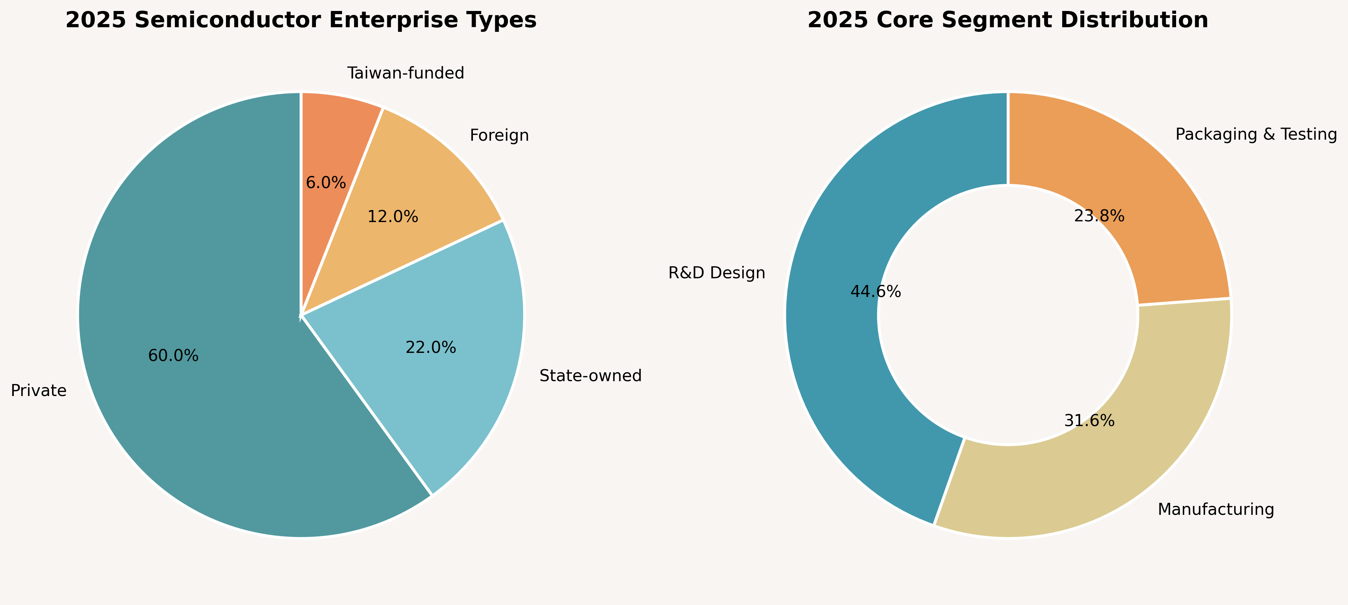
Figure 1. Enterprise Type Distribution and Core Segment Distribution

1. Enterprise Type Distribution
Private enterprises account for approximately 60% of semiconductor-related companies in China, mainly concentrated in fabless chip design, AI chips, automotive semiconductors, and IC applications. State-owned enterprises represent around 22%, primarily controlling heavy-asset sectors such as wafer fabrication, memory manufacturing, and industrial infrastructure. Foreign enterprises maintain technological leadership in EDA software, semiconductor equipment, and advanced materials, while Taiwan-funded companies remain influential in foundry and packaging/testing services.

2. Core Segment Distribution
R&D and chip design contribute the largest share of the industry structure (44.6%), reflecting the rapid expansion of China’s fabless ecosystem. Manufacturing accounts for approximately 31.6%, driven by national policies supporting domestic wafer fabs and advanced process capability. Packaging and testing represent about 23.8%, an area where Chinese firms have already developed strong international competitiveness.

3. Industry Characteristics
- “Design-driven, manufacturing-catching-up, packaging-leading” has become the dominant industry pattern.
- Private firms dominate innovation in AI chips, RISC-V, and automotive semiconductors.
- State-backed capital remains critical in wafer fabrication due to high investment requirements.
- Foreign firms still hold advantages in advanced semiconductor equipment and EDA software.

Data Sources
- China Semiconductor Industry Association (CSIA), 2025 industry statistics.
- Qianzhan Industry Research Institute semiconductor market reports.
- SemiAnalysis and IC Insights industry trend reports.
- Public disclosures from SMIC, Hua Hong Semiconductor, and Yangtze Memory Technologies.

