Research Report on Guangdong Integrated Circuit Industry
1. Project Background
1.1 Industry Strategic Positioning
The integrated circuit (IC) industry is a core fundamental industry underpinning the development of the digital economy and one of the key track clusters of strategic emerging industries in Guangdong Province[3].
Under the Strong Chip Initiative of Guangdong, in accordance with the Action Plan for Cultivating Strategic Emerging Industry Clusters of Semiconductors and Integrated Circuits in Guangdong Province (2021-2025), Guangdong is building a full industrial chain covering IC design, manufacturing, packaging & testing, materials and equipment. It targets an industrial scale exceeding RMB 400 billion by 2025 and aims to build a leading national innovation highland for the integrated circuit industry[4].

1.2 Current Development Status of Guangdong’s Industry
Leveraging the advantages of the Pearl River Delta electronic information industrial cluster, Guangdong’s integrated circuit industry features a pattern of design leading, packaging & testing supporting, and manufacturing making breakthroughs:
• Industrial Scale: The output of integrated circuits in Guangdong recorded a year-on-year growth of about 21% in 2025, far outpacing the national average and ranking among the top nationwide in industrial scale[1].
• Regional Layout: It has formed an IC design cluster centered in Shenzhen, manufacturing and packaging & testing bases supported by Guangzhou and Zhuhai, as well as supporting material and equipment industrial belts in Dongguan, Foshan and other cities[2].
• Enterprise Ecosystem: It gathers leading enterprises such as HiSilicon, Goodix Technology and GigaDevice, together with a large number of specialized, refined, unique and innovative supporting enterprises, forming a sound industrial collaboration system[5].

2. Analysis of Development Characteristics (Core Data of Recent 3 Years)
2.1 Growth Trend (2023-2025)
1. Data Interpretation
• Industry Cycle Background: Affected by the global semiconductor downturn cycle in 2023, the national growth rate of integrated circuit output was only 3.0%, while Guangdong reached 5.2%. Staying above the national average, Guangdong demonstrated strong counter-cyclical resilience[1].
• Recovery Inflection Point (2024): Driven by booming emerging demands such as AI and automotive electronics, the industry entered a recovery phase. The national growth rate rebounded to 12.1%, and Guangdong’s growth rate hit 18.3%, leading the country by about 6 percentage points[1].
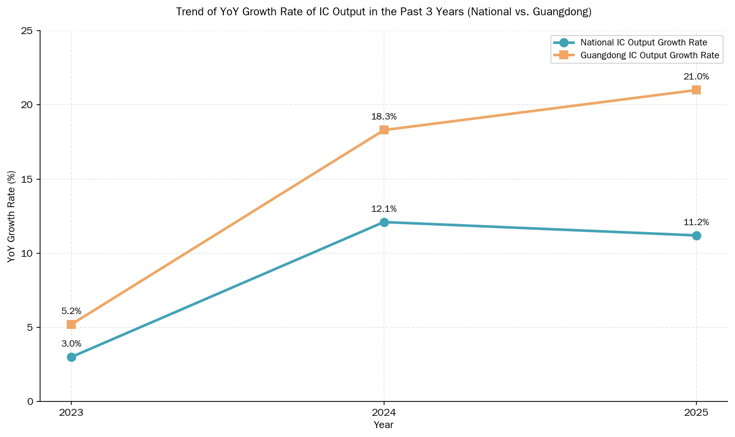
• Steady Growth (2025): Supported by continuous industrial policies and remarkable achievements of the Guangdong Strong Chip Initiative, Guangdong’s integrated circuit output achieved a year-on-year growth of 21.0%, compared with 11.2% nationwide. Guangdong’s growth advantage was further widened[3].

2.2 Technological Iteration Rhythm
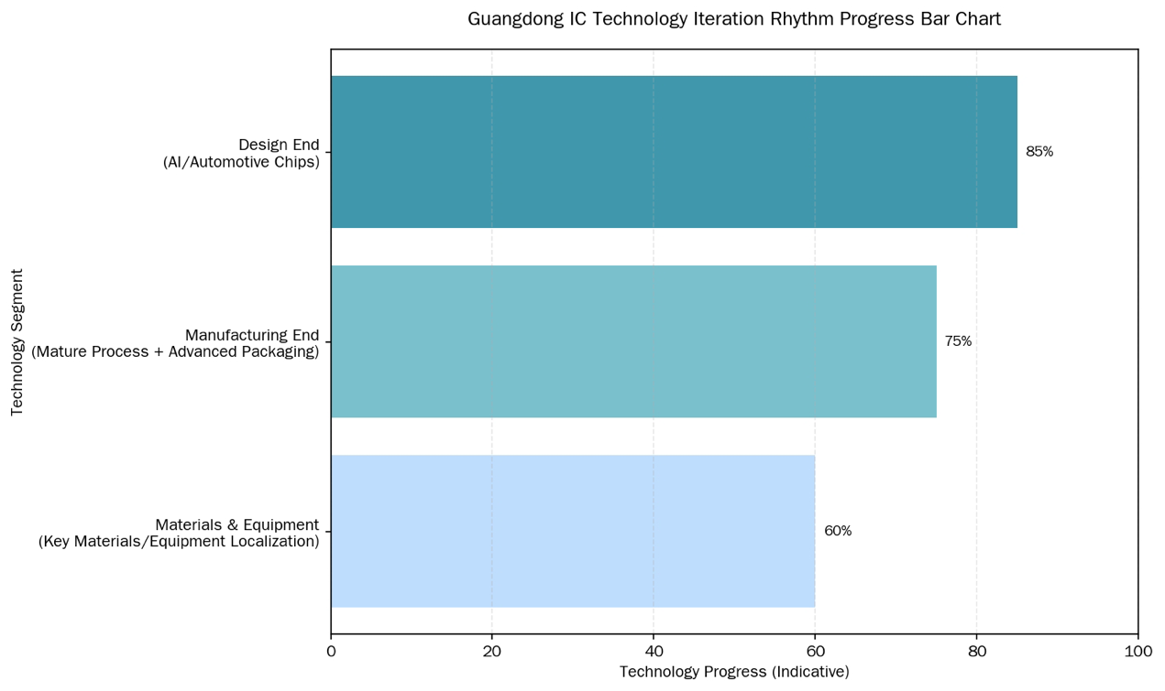
The technological iteration of Guangdong’s integrated circuit industry follows the】 rhythm of design taking the lead, manufacturing achieving breakthroughs, and materials keeping pace:
1. Design End: AI chips, power semiconductors and automotive electronic chips have become the focus of iteration. Products such as Huawei Ascend and HiSilicon Kirin have made key technological breakthroughs, and advanced process design capabilities continue to improve[2].
2. Manufacturing End: Wafer fabs represented by SMIC and Guangdong XMC are steadily expanding production capacity. Mature process capacity continues to be released, and advanced packaging technologies such as SiP and Chiplet have achieved large-scale application in Shenzhen and Guangzhou[1].
3. Materials & Equipment: Key domestic materials including photoresist, wet electronic chemicals and target materials have realized local supporting supply in Guangdong, and some equipment enterprises have achieved domestic substitution of core components[3].

2.3 Market Structure Characteristics
• Application Market: Consumer electronics and communication equipment remain the main sources of demand. Meanwhile, emerging markets such as automotive electronics, industrial control and AI servers have achieved remarkable growth, becoming new growth drivers for the industry[1].
• Export Performance: Guangdong’s IC export volume keeps growing, with its year-on-year growth rate in 2025 exceeding output growth. Local products gain rising recognition in Southeast Asia, Europe and other markets[2].
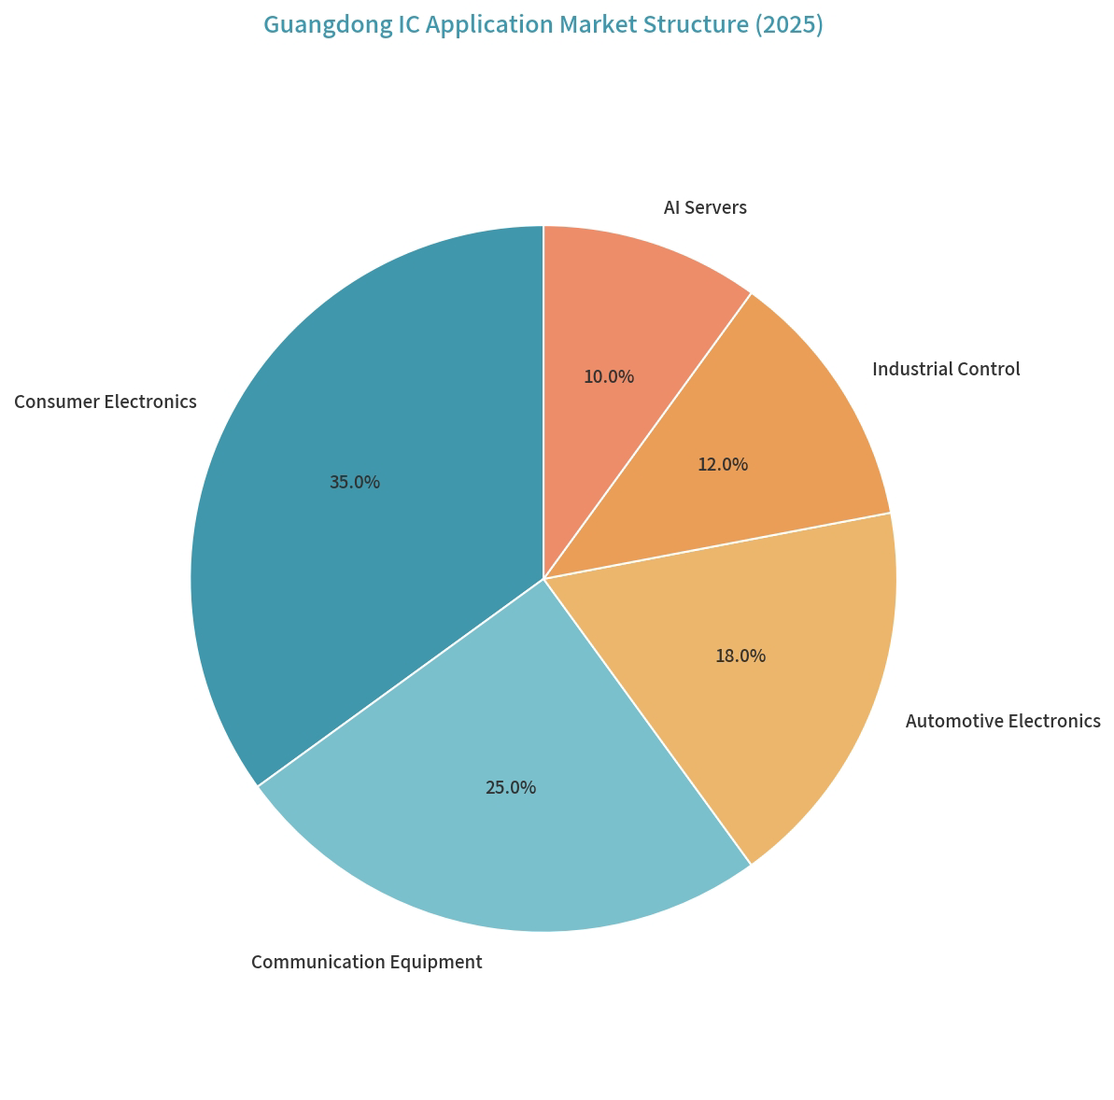
• Regional Competition: Compared with the Yangtze River Delta, Guangdong boasts outstanding advantages in IC design and complete supporting capacity in packaging & testing. However, there is still room for expanding manufacturing capacity, with huge potential for coordinated regional development[5].
3. Analysis of Competitive Advantages
3.1 Provincial Competitive Advantages
1. Industrial Cluster Advantage: Relying on the world-leading electronic information manufacturing base in the Pearl River Delta, local IC enterprises can achieve nearby supporting supply, reduce logistics and collaboration costs, and form a closed-loop ecosystem of chips → terminal applications[5].
2. Policy Support Advantage: The provincial government has issued multiple policies including industrial cluster action plans, R&D subsidies and talent introduction & cultivation. Cities including Shenzhen and Guangzhou have launched special local supporting funds, forming a joint provincial-municipal policy support system[3].
3. Abundant Innovation Resources: It hosts research platforms such as Pengcheng Laboratory, Southern University of Science and Technology and South China University of Technology, as well as enterprise R&D centers of Huawei and ZTE, featuring prominent industry-university-research collaborative innovation capabilities[4].

3.2 Domestic and International Comparative Advantages
Dimension | Guangdong Integrated Circuit Industry | Other Domestic Regions | Internationally Leading Regions
IC Design Capability | Top-tier nationwide, with prominent strengths in consumer electronics and AI chips | Shanghai and Beijing lead in high-end general-purpose chips | The US and Chinese Taiwan dominate in advanced processes and IP cores
Industrial Chain Supporting | Complete terminal supporting in the Pearl River Delta; rising localization rate of materials and equipment | The Yangtze River Delta has more mature manufacturing and packaging & testing supporting | Japan and South Korea hold advantages in materials and equipment
Market Response Speed | Close to terminal markets with fast product iteration and market adaptation speed | Some regions are geographically distant from terminal markets | European and American enterprises focus on standard formulation and ecological construction

Dimension Guangdong Integrated Circuit Industry Other Domestic Regions Internationally Leading Regions
IC Design Capability Top-tier nationwide, with prominent strengths in consumer electronics and AI chips Shanghai and Beijing lead in high-end general-purpose chips The US and Chinese Taiwan dominate in advanced processes and IP cores[1]
Industrial Chain Supporting Complete terminal supporting in the Pearl River Delta; rising localization rate of materials and equipment The Yangtze River Delta has more mature manufacturing and packaging & testing supporting Japan and South Korea hold advantages in materials and equipment[2]
Market Response Speed Close to terminal markets with fast product iteration and market adaptation speed Some regions are geographically distant from terminal markets European and American enterprises focus on standard formulation and ecological construction[5]
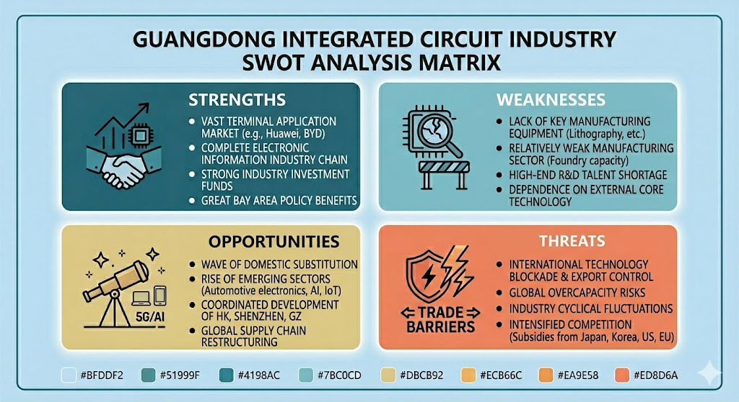

4. Challenges and Risks
1. Advanced Process Bottlenecks: Restricted by international technological blockades, bottlenecks remain in the manufacturing and equipment of advanced processes below 7nm, and the independent controllability of high-end chips needs further improvement[2].
2. Talent Supply-Demand Imbalance: There is a large talent gap in high-end IC design, manufacturing process and advanced packaging sectors, and regional talent competition continues to intensify[3].
3. Uncertain External Environment: Persistent global semiconductor trade frictions bring geopolitical risks to exports, while technological barriers of international giants in high-end sectors are difficult to break through[1].

5. Development Suggestions and Prospects
5.1 Core Development Suggestions
1. Strengthen Weaknesses in Manufacturing: Increase investment in mature process capacity expansion and advanced packaging technologies, boost the production capacity of wafer fabs such as Guangdong XMC, and build a complete closed-loop of design + manufacturing + packaging & testing[2].
2. Make Breakthroughs in Emerging Tracks: Focus on layout of incremental markets including AI chips, automotive electronics and power semiconductors. Leverage Guangdong’s terminal industry advantages to build integrated chip + scenario solutions[1].
3. Improve Talent Introduction and Cultivation System: Establish joint training mechanisms between universities and enterprises, increase policy subsidies for high-end talents, and attract overseas talent return to ease the talent shortage[3].

5.2 Future Prospects
By the end of the 15th Five-Year Plan period, Guangdong’s integrated circuit industry is expected to exceed RMB 600 billion in scale. Mature process capacity will achieve self-sufficiency, and advanced packaging technologies will reach international advanced levels. Guangdong will become a benchmark for high-quality development of China’s integrated circuit industry and provide solid core chip support for the development of Guangdong’s digital economy[4].
Future Outlook & Growth Forecast
The chart illustrates the projected growth trend of Guangdong’s integrated circuit (IC) industry scale from 2025 to 2030.
Based on current development momentum, policy support, and market demand drivers, the industry is expected to grow steadily at a compound annual growth rate (CAGR) of approximately 16%. The scale is forecast to expand from RMB 450 billion in 2025 to RMB 950 billion by 2030.
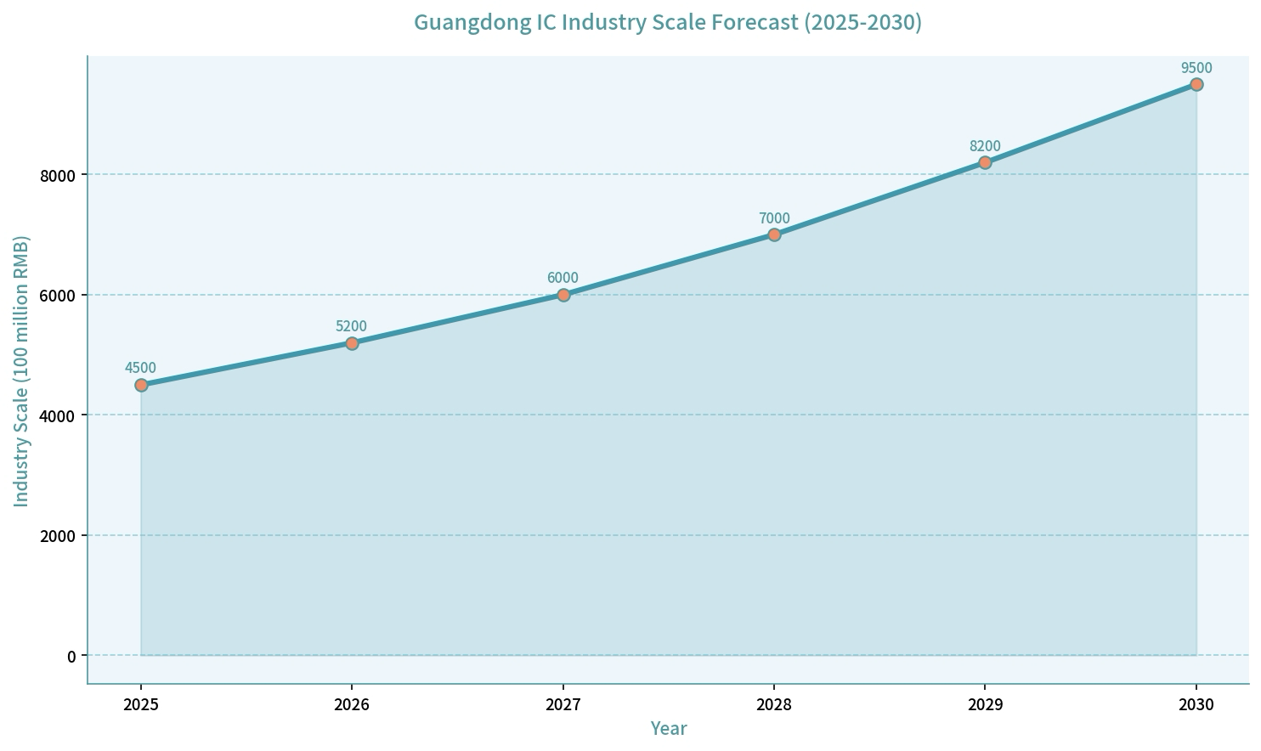
This growth trajectory reflects Guangdong’s strong foundation in IC design, expanding manufacturing capacity, and rising demand from emerging sectors such as automotive electronics, AI, and industrial control. The upward trend underscores the province’s potential to further consolidate its leading position in China’s IC industry over the next five years.

References
[1] AskCI. 2025 Guangdong Semiconductor and Integrated Circuit Industrial Chain Panorama Report[EB/OL]. https://m.askci.com/news/chanye/20250211/104829273924210960325264.shtml
[2] Shenzhen Semiconductor Industry Association. Shenzhen Integrated Circuit and Domestic Semiconductor Industry Research Report (Released Oct 2025)[EB/OL]. https://www.seccw.com/Document/detail/id/202510.html
[3] Department of Industry and Information Technology of Guangdong Province. Action Plan for Cultivating Strategic Emerging Industry Clusters of Semiconductors and Integrated Circuits in Guangdong Province (2021-2025)[EB/OL]. https://gdii.gd.gov.cn/
[4] Guangdong Provincial Chronicles Network. Strategic Emerging Industries[EB/OL]. https://dfz.gd.gov.cn/
[5] Stockstar. 2022 Big Data Panorama Analysis of Guangdong Integrated Circuit Enterprises[EB/OL]. https://wap.stockstar.com/

