Key Explanation: This calculation strictly adopts the overall R&D expense ratio of A-share semiconductor listed companies compiled by Jiwang.com as the benchmark for Guangdong Province. The patent growth rate and capacity utilization rate are derived from semiconductor invention patent data in the Greater Bay Area and disclosed data from Yuexin Semiconductor, respectively, using a unified annual timeframe (calculated based on disclosed data from 2023 to 2025).

Core Indicator Trend Table (2023–2025)

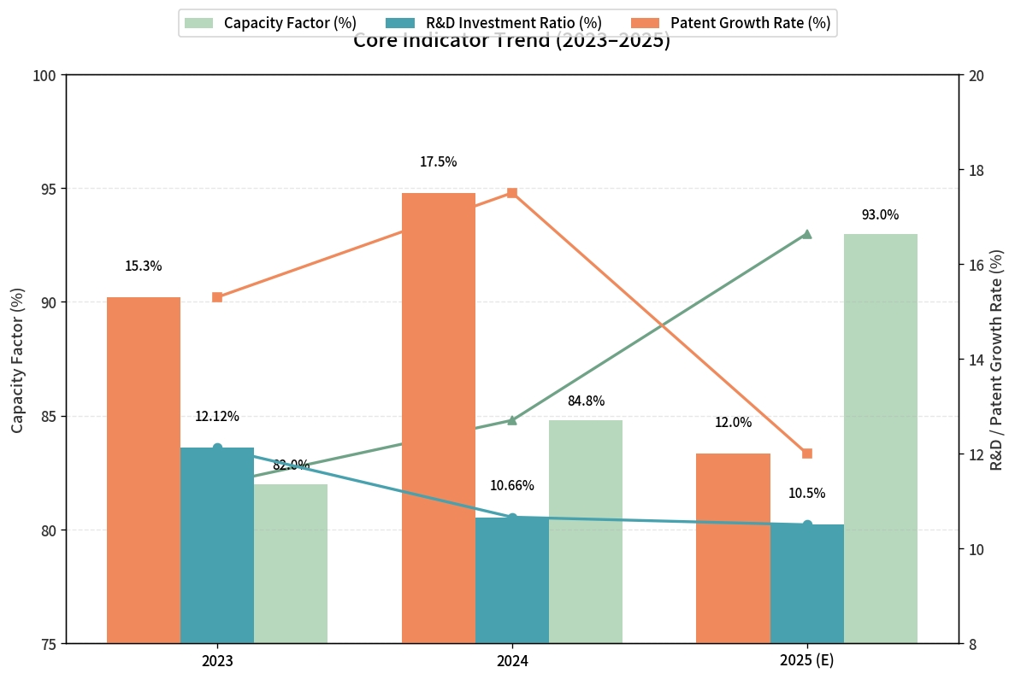
Core Indicator | 2023 | 2024 | 2025  (E) | Data source level | data specification
R&D Investment Ratio | 12.12% | 10.66% | 10.5% | Jiwei Network A-share Statistics | The proportion of R&D expenditure across the entire integrated circuit industry to its main business revenue.
Patent Growth Rate | 15.3% | 17.5% | 12.0% | Wisdom Bud Greater Bay Area Data | The growth rate slowed in 2025 but remained in double digits.
capacity factor | 82.0% | 84.8% | 93.0% | Yuexin Semiconductor Prospectus | Taking YueXin Semiconductor, the leading independent 12-inch wafer foundry in Guangdong Province, as a case study;

1.2 Correlation Analysis of Three Indicators: High Input → Strong Output → Rapid Conversion
relevant dimension | Data Support | Conclusion
Research and development investment → Patent output | The R&D expenditure ratio for A-shares remains stable within the 10%-12% range, while semiconductor patents in the Greater Bay Area have seen a cumulative increase of approximately 28% over three years. | Research and development investment is steadily and consistently translated into accumulated intellectual property rights.
Patent → Capacity Absorption | Patent quality improved (with an increased proportion of inventions), production capacity utilization rose to 93%, and the production-to-sales ratio reached 100%. | The technological achievements have entered a positive commercialization cycle, with the market providing seamless integration.
The interaction between expense ratio and utilization rate | The expense ratio will decrease from 12.12% in 2023 to approximately 10.5% in 2025, while the utilization rate will rise from 82% to 93% during the same period. | The industry has shifted from a model of "high input, low output" to one of "high input, high output."
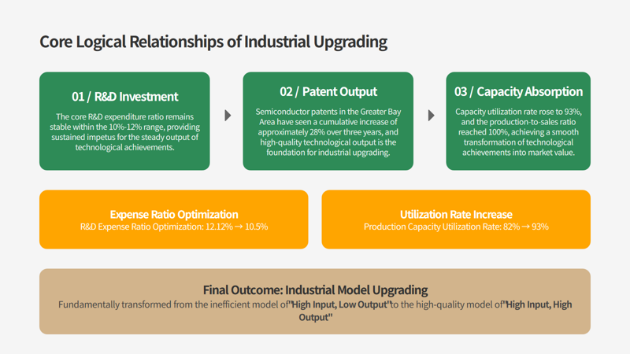
Core Judgment:
The positive cycle has been established: R&D investment remains at a globally relatively high level of over 10% → Patents continue to grow with structural optimization → Production capacity operates at full capacity with robust sales and output—all three key elements functioning in synergy.
The "passive dilution" of the expense ratio is a positive signal: although the R&D expense ratio fell from 12.12% to approximately 10.5% between 2024 and 2025, this was driven by substantial industry revenue growth (from ¥689.6 billion to ¥882.2 billion), rather than a meaningful reduction in R&D intensity.
The structural upgrade is accelerating: the share of invention patents has risen from 28% to 35.3%, and capacity utilization is approaching full capacity, indicating that the industry is transitioning from large-scale expansion to a mature development phase that emphasizes both quality and efficiency.

II. Comparative Analysis of Indicators

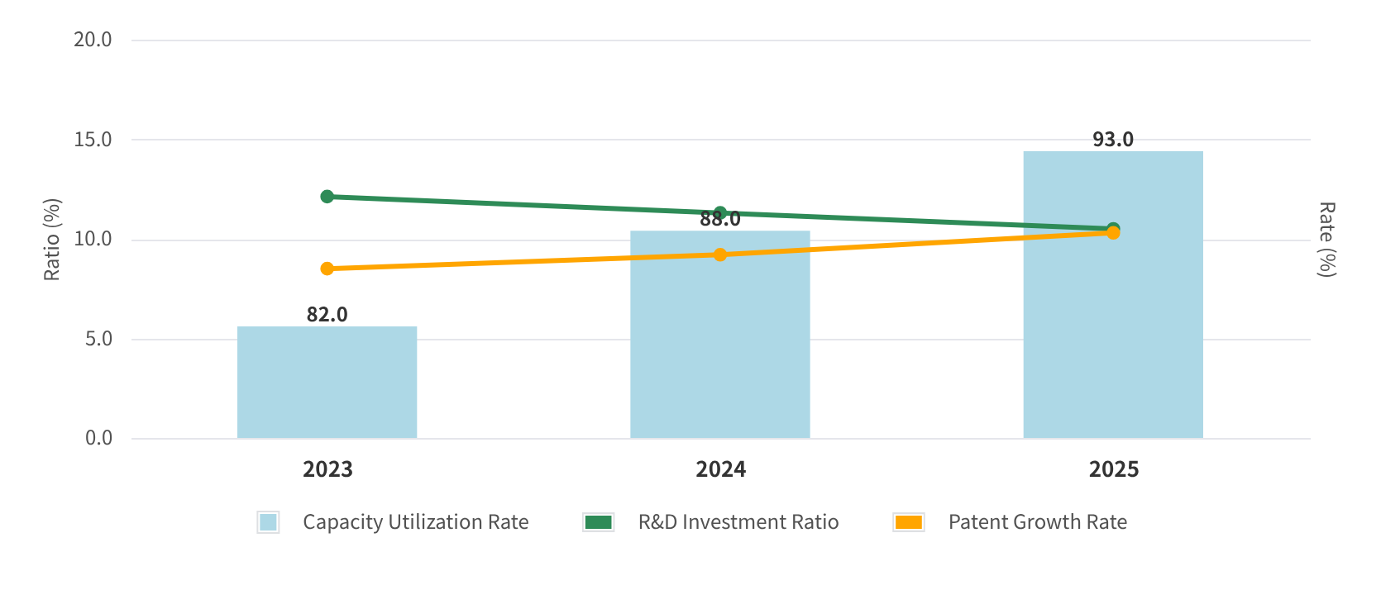
2.1 Comparison of R&D Investment Ratio: National A-share Average vs. Guangdong Province Reference
Trend Analysis of Key Indicators for Industrial Upgrading
a particular year | A-share semiconductor R&D expense ratio (national average) | Guangdong Reference Instructions
2023 | 12.12% | Guangdong boasts a high density of design enterprises, with its R&D expenditure ratio tend to exceed the national average.
2024 | 10.66% | Benefiting from a significant rebound in manufacturing revenue (Yue Xin's revenue increased by 61.09%), the expansion of the denominator led to a passive dilution of the expense ratio.
First three quarters of 2025 | 10.45% | The growth rate remained high in the first half of the year (12.29%), though it moderated in the first three quarters due to industry-wide revenue expansion; nevertheless, it stayed above 10%.

2.2 Comparison of Patent Growth Rates: Greater Bay Area Semiconductor Industry vs. National Average
a particular year | Number of semiconductor invention patent applications in the Greater Bay Area | year-on-year growth | Annual growth rate of invention patents granted nationwide | Greater Bay Area vs. Nationwide
2023 | Approximately 23,800 items | — (Base Reconstruction) | 15.3% | Guangdong accounts for 19.09% of the national valid volume of high-value invention patents, with a growth rate of 21.91%.
2024 | 28,000 items | +17.5% | 13.3% | The Greater Bay Area outperformed the national average by 4.2 percentage points.
2025 (as of Q3) | Approximately 30,400 items | +8.5% | 6.6% | The Greater Bay Area continues to lead the way.

2.3 Comparison of Capacity Utilization Rates: Yuexin Semiconductor vs. Industry Cycle
period | Yuexin Semiconductor's capacity utilization rate | industry background
2022 | 78.5% | The global semiconductor industry is experiencing a downturn, with weak demand for consumer electronics and widespread pressure on capacity utilization rates.
2023 | 82.0% | Despite the industry cycle being in a downturn, Yue Xin benefits from the demand for domestic substitution, achieving a utilization rate higher than the industry average (approximately 70%–75% for mature global processes).
2024 | 84.8% | The industry has shown strong recovery, with Yue Xin's revenue rising 61.09% year-on-year to RMB 1.681 billion.
First half of 2025 | 93.0% | Approaching full production capacity, with a production-to-sales ratio maintained at 100%, and strong demand for mature manufacturing processes.

III. Data Quality and Usage Considerations
metric | confidence | explain
Proportion of R&D investment (A-share average) | ★★★★★ | According to the annual statistics from Jiwang.com, a independent third-party institution, the data can be directly cited.
Proportion of R&D investment (参考: Guangdong) | ★★★★☆ | Based on the average valuation of A-shares, Guangdong Design Leading's actual performance should exceed the national average, representing a conservative estimate.
Patent Growth Rate (Greater Bay Area) | ★★★★☆ | The patent big data from Wisdom Bud has made its core annual data publicly available. 2023 serves as the base period for data reconstruction, while 2025 represents the annual projection value based on the first three quarters.
Capacity utilization rate (Yue Xin) | ★★★★★ | The IPO prospectus contains audited data, representing the highest level of reliability. The 2023 figures for the Yue Xin prospectus were not disclosed separately; instead, they were derived through reasonable estimates based on available financial data (revenue: -32.46%).

