Distribution and flow of talents in the integrated circuit industry in Guangdong Province

Talent distribution
The country's IC talents are highly concentrated in three large urban agglomerations -the Yangtze River Delta (Shanghai + Wuxi + Nanjing + Suzhou + Hangzhou + Hefei, about 400,000 people), the Pearl River Delta (Shenzhen + Guangzhou + Zhuhai, about 195,000 people), and the Beijing-Tianjin-Hebei region (Beijing + Tianjin, about 140,000 people), which together account for more than 85% of the country's IC employees (about 630,000). This spatial concentration far exceeds that of the general manufacturing industry and is consistent with the characteristics of high capital and high knowledge density in the IC industry.
Shanghai (approximately 200,000 people), Shenzhen (approximately 150,000 people), and Beijing (approximately 130,000 people) form the first echelon. The three cities contain approximately 48% of the country’s IC practitioners. Shanghai’s outstanding advantages come from the layout of the entire industrial chain of design, manufacturing, packaging and testing, equipment and materials; Shenzhen is strong in design + application market transformation; Beijing is famous for its design industry and scientific research talents.
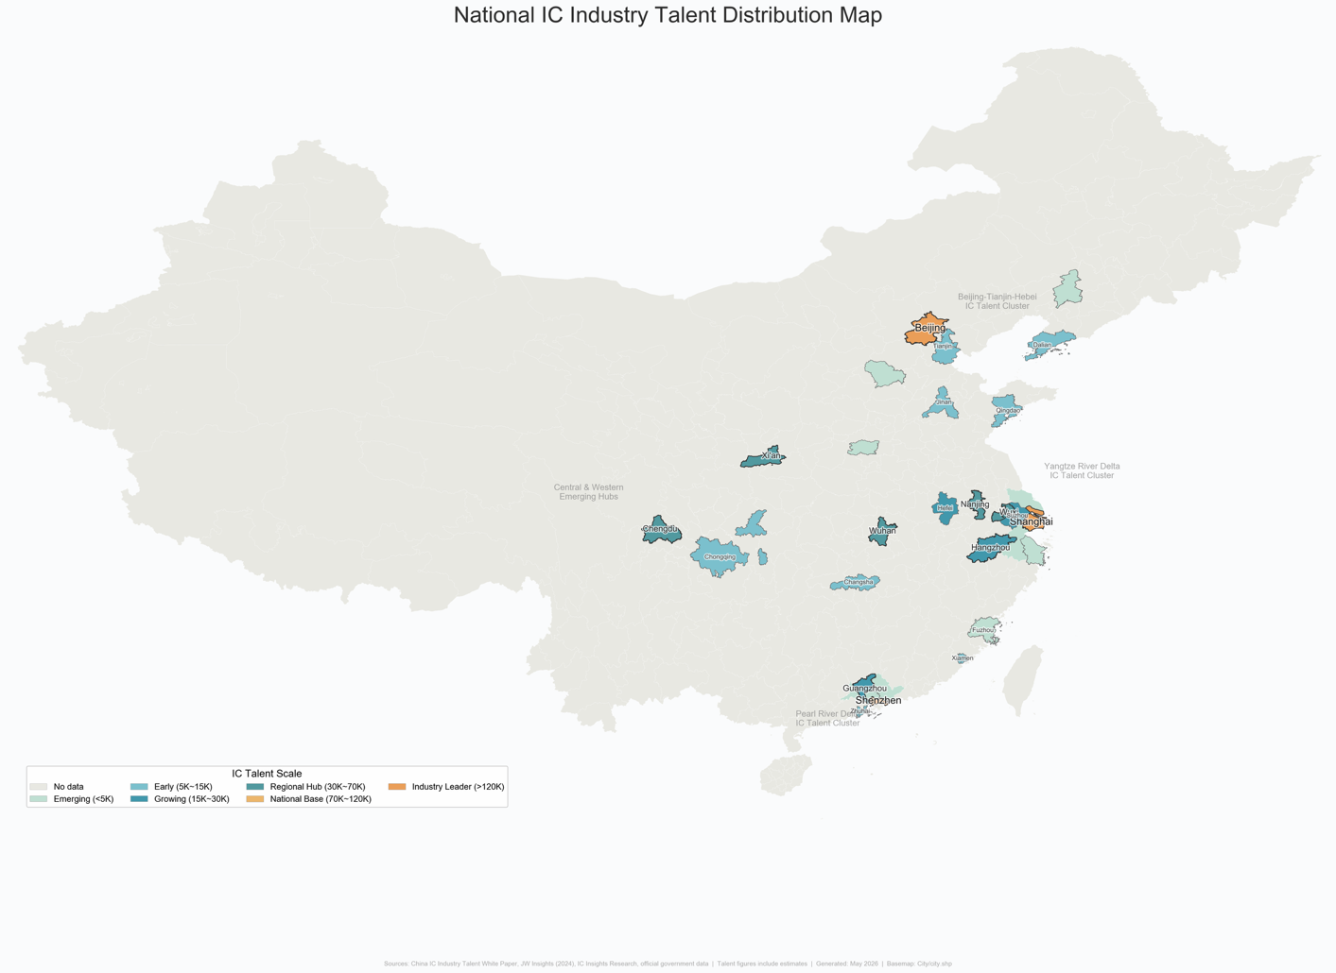

Talent mobility trendsmobility trends

Government talent attraction initiatives
In 2026, Guangdong Province's "Millions of Talents Gathering in Southern Guangdong" N-city joint recruitment will cover major IC industry towns such as Beijing, Shanghai, Nanjing, and Hangzhou. Shenzhen will bring more than 120 key enterprises in the province and more than 10,000 high-quality jobs to 8 top universities including Peking University, Tsinghua University, Fudan University, and Shanghai Jiao Tong University.
-Recruitment focuses on emerging pillar industries such as integrated circuits, artificial intelligence, biomedicine, and low-altitude economy.
-There are more than 2,000 positions with an annual salary of 500,000-1 million yuan, and more than 120 positions with an annual salary of more than 1 million yuan.
来源：深圳政府在线 - "百万英才汇南粤"招聘(https://www.sz.gov.cn/cn/xxgk/zfxxgj/zwdt/content/post_12689204.html)

Shenzhen insists on "introducing, educating and retaining" and taking multiple measures to build a multi-level IC talent team. On the one hand, it improves the talent introduction mechanism and recruits industry leaders from around the world; on the other hand, it promotes 10 universities including Southern University of Science and Technology and Shenzhen University to open IC-related majors. Shenzhen University and Southern University of Science and Technology have been awarded doctoral degree authorization points. Shenzhen has been among the top cities in the country for attracting post-95 talent for many consecutive years (lower than Beijing and Shanghai’s settlement threshold plus innovative industrial structure).

Recruitment platform talent flow reference data
The following data comes from commercial HR platforms such as Liepin (2024 data). It is only used as a trend reference and is not equivalent to official government statistics:
The IC industry talent delivery data of Liepin platform shows:
-Sources of Guangzhou delivery talents: Guangzhou local 42.13%, Shenzhen 8.17%, Foshan 3.76%, Dongguan 2.87%
-Sources of Shenzhen delivery talents: Shenzhen local 37.58%, Guangzhou 7.45%, Shanghai 4.63%, Beijing 3.86%
-Sources of Dongguan delivery talents: Dongguan local 27.46%, Shenzhen 16.12%, Guangzhou 8.91%
-Source industries for talent flow in the IC industry: the electronics/semiconductor/integrated circuit industry itself accounts for 7.86%, followed by machinery/equipment (4.96%), the Internet (4.17%), and computer software (4.05%)
来源：猎聘 - 集成电路人才供需报告（PDF）(https://cos.hrtools.club/6/58667/pdf/17469664450637dc2fb079939312cee85caa6852bb3b8.pdf)

University talents stay in Guangdong for employment
Shenzhen University has a total of 70 graduates with a master's degree in integrated circuit engineering in the past five years, with an employment rate of 100%. Among the destinations for graduates, 94.3% were contracted employment, and 4.3% were studying domestically. The employment units include Huawei HiSilicon, ZTE, ADI, Baidu, etc.
来源：深圳大学电子信息（集成电路）学科介绍
(https://ceie.szu.edu.cn/yjspy/xwdjs/dzxx_jcdl_.htm)

School-enterprise cooperation training

Six major integrated circuit talent training bases in Guangdong Province
In December 2022, the Guangdong Provincial Department of Education officially approved six universities including South China University of Technology, Sun Yat-sen University, Southern University of Science and Technology, Shenzhen University, Guangdong University of Technology, and Zhuhai Institute of Science and Technology to establish the "Guangdong Provincial Integrated Circuit Talent Training Base."
来源：
AET电子技术应用 -全省仅6所高校获批（转述广东省教育厅公示）(http://m.chinaaet.com/article/3000156085)
广东工业大学集成电路学院 - 获批设立省IC人才培养基地(https://sme.gdut.edu.cn/info/1054/1487.htm)

Student size and major distribution
The number of integrated circuit majors in Guangdong Province will increase from 7 in 2022 to 32, and the number of undergraduate, master, and doctoral students will exceed 10,000, quadrupling from 2022.

Four major models of school-enterprise cooperation

Model | Typical Cases | Cooperating Enterprises
Order Class/Customized Class | Guanggong -Yuexin's "Ingenuity Class", Guanggong -"Customized Class" of more than 30 companies | Yuexin Semiconductor, Huawei, Quanzhi Technology
Joint Laboratory | SUSTech Shenzhen-Hong Kong School of Microelectronics Joint Laboratory, Shenzhen University-Huawei EDA Joint Laboratory, Guanggong-Huawei "Kunpeng & Shengteng Developer Innovation Society" (the first in the country) | Huawei, ZTE Micro, Arm China, SMIC Group, Unisoc Group
Industrial College | Guanggong Integrated Circuit College (established in October 2021), Shenzhen University of Technology Computing Microelectronics College | Huawei, Yuexin, and the Five Electronics Institutes of the Ministry of Industry and Information Technology
Postgraduate Joint Training | Provincial Integrated Circuit Industry Association Postgraduate Joint Training Base, Engineering Master and Doctoral Reform Special Project | Foshan, Dongguan, Zhongshan, Shantou 4 cities + Provincial Academy of Agricultural Sciences; Cumulatively trained (including in training) more than 6,000 engineering masters and doctoral students

来源：
- 广东工业大学集成电路学院(https://sme.gdut.edu.cn/info/1054/1487.htm)
- 21经济网（南方都市报）- 广东培养拔尖创新人才(https://www.21jingji.com/article/20260427/herald/ee34125984756204c5e773b05d02a0e9.html)

