Core Talent Demand Analysis for the Integrated Circuit Industry in Guangdong Province

I. Introduction
As the "Third Pole" of China’s integrated circuit (IC) industry, Guangdong Province has established a powerful cluster centered around Shenzhen, Guangzhou, and Zhuhai. The regional focus is currently shifting toward overcoming "bottleneck" (ka bo zi) technologies and achieving industrial self-control. This strategic pivot is directly driving a structural evolution in talent demand: moving away from general technical workers toward multi-disciplinary professionals specialized in advanced manufacturing, emerging applications, and digital transformation.

II. Analysis of Key Talent Categories
1. Emerging Industries: Advanced Manufacturing and R&D Talent The explosive growth of sectors like New Energy Vehicles (NEVs), 5G, and AI computing has made R&D and manufacturing talent the most critical assets.

Advanced Process Talent: As technology nodes move toward 5nm, 3nm, and even 2nm, the demand for Process/Yield Engineers (PE) has reached a peak, accounting for the highest demand share at 3.3%. These experts are essential for optimizing lithography and etching in mass production.

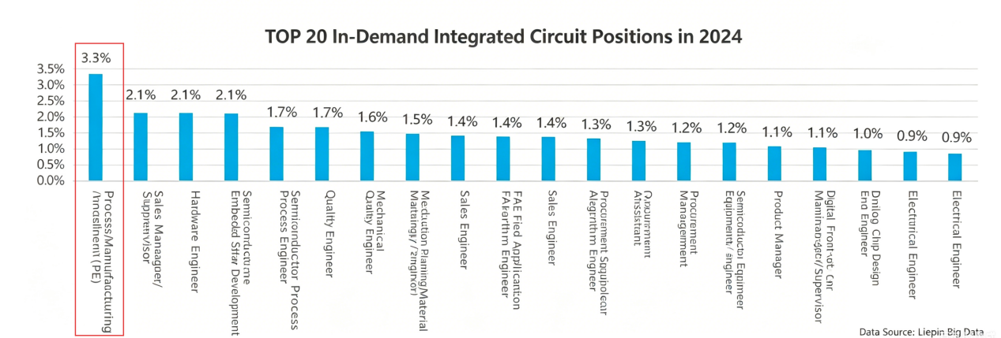

High-End Design Talent: Analog IC Design and Digital Front-end Engineers are the core drivers of innovation. Specifically for AI chips, Algorithm Engineers are needed to optimize neural network models through hardware-friendly methods like quantization and pruning.

2. Future Industries: Embodied Intelligence and Quantum Chip Engineers Future-oriented layouts like humanoid robotics and quantum computing require "forward-looking" skill sets.

AIoT and Embodied Intelligence: The development of Industrial IoT (IIoT) drives the need for low-power, high-integration AIoT chips. Engineers in this field must balance hardware computing power with software algorithms to achieve synergy between "brain" and "body".

Chiplet and Advanced Architecture: As Moore’s Law slows, Chiplet and "Computing-in-Memory" technologies are revolutionizing chip design. Architects must possess the ability to break traditional von Neumann bottlenecks to provide solutions for data centers and AI.

3. Traditional Industries: Digital Transformation and Power Semiconductors Traditional manufacturing is undergoing a digital shift, creating a surge in demand for embedded systems and third-generation semiconductor applications.

Digital Transformation Specialists: Demand for Embedded Software Development and Driver Development remains stable (around 2.1%), as these professionals integrate IC technology into traditional equipment for connectivity and intelligence.

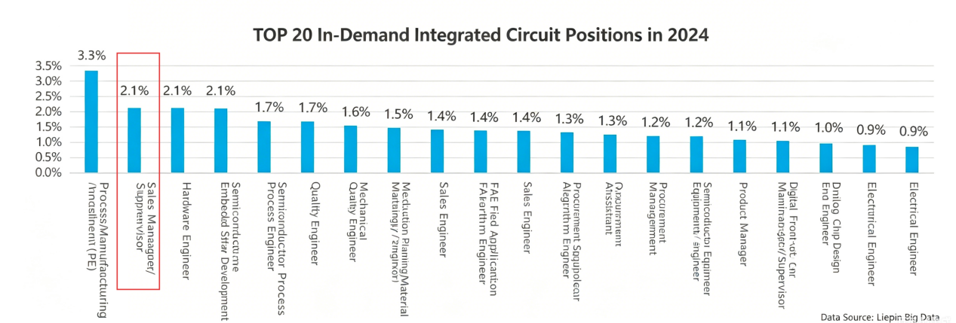

Third-Generation Semiconductors: The penetration of Silicon Carbide (SiC) and Gallium Nitride (GaN) in NEVs and fast charging requires Material R&D engineers with experience in high thermal stability and low-loss materials.

III. Core Skills and Qualifications
According to industry research, companies now emphasize a balance between "Hard Tech" and "Soft Skills":
Dimension | Specific Requirements & Description
Professional Knowledge | Must have a solid foundation in Electronic Engineering, Microelectronics, Physics, and Math. Proficiency in EDA tools like Cadence and Synopsys is mandatory.
Technical Depth | RF Engineers must master high-frequency and miniaturized designs; Verification Engineers must be proficient in UVM architectures and FPGA prototyping.
Multi-disciplinary | With the rise of SoC (System-on-Chip) complexity, "T-shaped" talent with knowledge in Electronics, CS, and Software is highly preferred.
Collaboration | The ability to communicate effectively across the "Design-Manufacturing-Testing" chain is vital to ensure design accuracy.

IV. Professional Experience and Talent Distribution
1. Experience Preference: Practice Over Theory Recruitment shows a clear "action-oriented" bias:

Project Experience: Companies prefer engineers with actual project history who can immediately solve on-site problems like yield improvement or failure analysis.

Mid-sized Firms are Most Active: Companies with 100-499 employees are the primary recruiters (25.7%), reflecting their rapid expansion phase and urgent need for "plug-and-play" talent.

- Talent Sources: Internal Domination with Cross-sector Synergy While the industry primarily relies on internal talent flow, there is a significant influx from the Machinery, Internet, and Computer Software sectors as skills become more transferable.

- Regional Characteristics: Shenzhen’s "Oligopoly" Effect Within Guangdong, Shenzhen’s talent aggregation is unrivaled. Its talent flow intention share (23.45%) significantly surpasses other hubs. As a global electronic manufacturing center, Shenzhen leverages giants like Huawei and ZTE to form a complete talent supply chain from design to packaging.

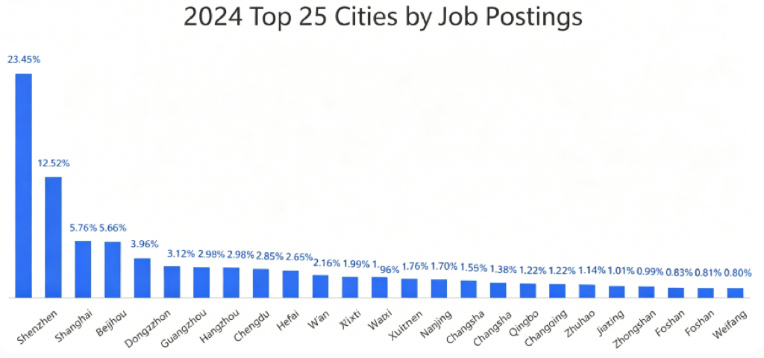

V. Conclusion and Recommendations
Guangdong’s IC industry currently faces a pattern of "Manufacturing taking the lead while Design consolidates". To meet future challenges, it is suggested to:

Strengthen School-Enterprise Cooperation: Universities should co-create practical courses with enterprises to reduce the "adjustment period" for graduates.

Establish Cross-field Training: Encourage existing engineers to learn AI chip algorithms and quantum computing to foster composite talent.

Optimize Talent Retention: Leverage the industrial cluster advantage of Tier-1 cities to attract overseas and high-skilled talent through specialized funds and livability policies.

References
Talent Supply and Demand Report for the Integrated Circuit Industry, Liepin Big Data (Published February 2025).

China Business Industry Research Institute, 2025–2030 China Integrated Circuit Market Research and Development Trend Forecast Report.

China Research Institute (Chinasir), Statistical Data on China's Integrated Circuit Market Scale in 2024.

National Policy Documents:

Decision of the Central Committee of the Communist Party of China on Further Comprehensively Deepening Reform and Advancing Chinese-style Modernization (July 2024).

Action Plan for the Construction of Information Technology Standards (2024–2027) (May 2024).

Guidelines for the Construction of the National Automotive Chip Standard System (December 2023).

Relevant Industry Websites (Recommended for further research):

Liepin Big Data Channel: https://www.liepin.com/

China Business Industry Research Institute: https://www.askci.com/

Ministry of Industry and Information Technology (MIIT) of the People's Republic of China: https://www.miit.gov.cn/

