# TEST artists and record labels

This is the bipartite network of musical artists and their record labels from DBpedia. Nodes in the network are **artists and record labels**. Each **edge connects an artist with a record label** under which the artist has performed. [LINK](http://konect.cc/networks/dbpedia-recordlabel/)

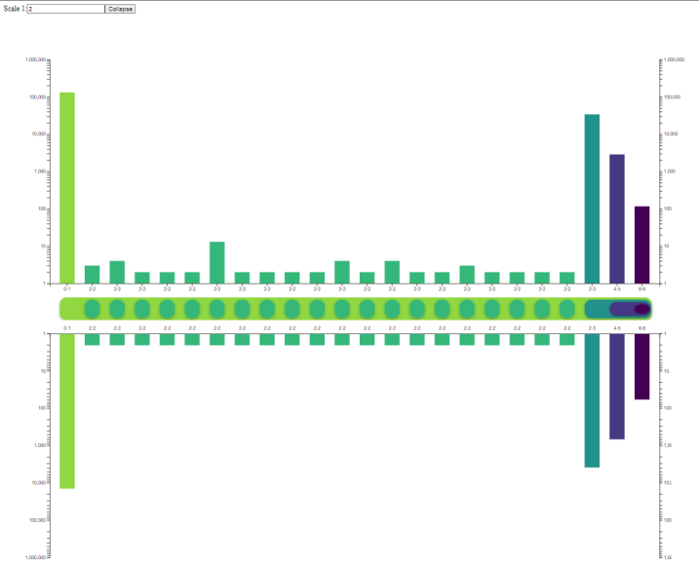

# TEST writers and works

This is the bipartite writer network of DBpedia. Nodes are **writers** (persons) and **their works**. [LINK](http://konect.cc/networks/dbpedia-writer/)

# TEST WikiGenre

Each edge connects a **work or artist to a genre**. [LINK](http://konect.cc/networks/dbpedia-genre/)

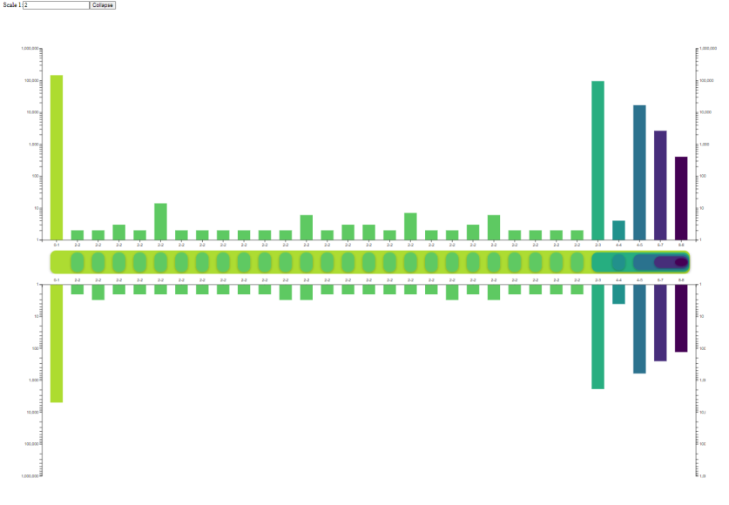

# TEST CiteSeer

Left nodes are authors and right nodes are scientific publications. [LINK](http://konect.cc/networks/komarix-citeseer/)

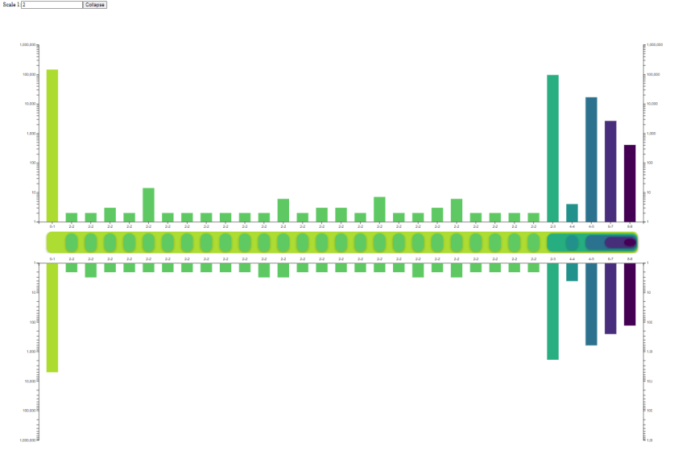

# TEST Github

The network is bipartite and contains users and projects, with links denoting that a user is a member of a project. [LINK](http://konect.cc/networks/github/)

