

CAPSTONE PROJECT REPORT
Report 2 – Project Management Plan

– Danang, September 2025 –
Table of Contents
I. Record of Changes 3
II. Project Management Plan 4
1. Overview 4
1.1 Scope & Estimation 4
1.2 Project Objectives 6
1.3 Project Risks 7
2. Management Approach 9
2.1 Project Process 9
2.2 Quality Management 10
2.3 Training Plan 11
3. Project Deliverables 11
4. Responsibility Assignments 12
5. Project Communications 13
6. Configuration Management 14
6.1 Document Management 14
6.2 Source Code Management 14
6.3 Tools & Infrastructures 16

I. Record of Changes
Date | A*  M, D | In charge | Change Description
30/08/2025 | A | NhiPTK | Init version
01/09/2025 | M | HuyNLQ,NguyetNTT | Update Scope & Estimation
03/09/2025 | M | TrungNVT | Update project process, table of contents
04/09/2025 | M | KhoiVN | Update the table of figures & tables
*A - Added M - Modified D - Deleted

II. Project Management Plan

1. Overview

1.1 Scope & Estimation
# | WBS Item | Complexity | Est. Effort  (man-days)
1 | Feature 1: User Account Management |  | 33
1.1 | Authentication & Authorization System | Complex | 10
1.2 | User Registration (Admin, Parent, Driver) | Medium | 8
1.3 | Profile Management & Avatar Upload | Simple | 5
1.4 | Password Management & Security | Medium | 6
1.5 | Account Lock/Unlock Functionality | Simple | 4
2 | Feature 2: Student Management |  | 28
2.1 | Student CRUD Operations | Medium | 8
2.2 | Student-Parent Relationship Management | Simple | 4
2.3 | Student Photo Upload for Facial Recognition | Medium | 6
2.4 | Student Information Display & Search | Simple | 5
2.5 | Student Status Tracking | Medium | 5
3 | Feature 3: Vehicle Management |  | 32
3.1 | Vehicle CRUD Operations | Medium | 8
3.2 | Driver-Vehicle Assignment | Medium | 6
3.3 | Vehicle Status Monitoring | Complex | 10
3.4 | Vehicle Maintenance Tracking | Medium | 5
3.5 | Vehicle Capacity Management | Simple | 3
4 | Feature 4: Route Management |  | 45
4.1 | Route Creation & Optimization | Complex | 15
4.2 | Pickup Point Management | Medium | 8
4.3 | Automatic Student-Route Assignment | Complex | 12
4.4 | Route Editing & Updates | Medium | 6
4.5 | Route Visualization & Mapping | Medium | 4
5 | Feature 5: Schedule Management |  | 25
5.1 | Schedule CRUD Operations | Medium | 8
5.2 | Schedule-Route Integration | Medium | 7
5.3 | Schedule Conflict Detection | Complex | 10
6 | Feature 6: Trip Management |  | 40
6.1 | Trip Creation & Management | Complex | 12
6.2 | Real-time Trip Tracking | Complex | 15
6.3 | Backup Driver Assignment | Medium | 5
6.4 | Route Adjustment for Traffic | Medium | 8
7 | Feature 7: Attendance Management |  | 35
7.1 | Facial Recognition Integration | Complex | 20
7.2 | Manual Attendance Fallback | Simple | 5
7.3 | Attendance Reporting | Medium | 6
7.4 | Attendance Analytics | Medium | 4
8 | Feature 8: Payment Management |  | 30
8.1 | Service Registration & Fee Calculation | Medium | 8
8.2 | Payment Gateway Integration | Complex | 12
8.3 | Payment History & Invoicing | Medium | 6
8.4 | Overdue Payment Notifications | Simple | 4
9 | Feature 9: Notification System |  | 25
9.1 | Real-time Notification Infrastructure | Complex | 10
9.2 | Trip Notifications (Arrival, Changes) | Medium | 5
9.3 | Student Status Notifications | Medium | 5
9.4 | Emergency Notifications | Medium | 5
10 | Feature 10: Reporting & Analytics |  | 25
10.1 | Daily/Monthly Report Generation | Medium | 8
10.2 | Attendance Analytics Dashboard | Medium | 7
10.3 | Vehicle Performance Reports | Medium | 6
10.4 | Export Functionality (Excel/PDF) | Simple | 4
11 | Feature 11: Incident Management |  | 20
11.1 | Incident Reporting System | Medium | 8
11.2 | Real-time Incident Tracking | Medium | 7
11.3 | Incident Resolution Workflow | Simple | 5
12 | Feature 12: System Configuration |  | 15
12.1 | School-based Configuration | Medium | 8
12.2 | System Settings Management | Simple | 4
12.3 | Audit Logs & Historical Records | Medium | 3
13 | Testing & Quality Assurance |  | 30
13.1 | Unit Testing | Medium | 10
13.2 | Integration Testing | Medium | 8
13.3 | System Testing | Medium | 7
13.4 | User Acceptance Testing | Simple | 5
14 | DevOps & Deployment |  | 14
14.1 | CI/CD Pipeline Setup | Medium | 8
14.2 | Production Deployment | Medium | 6
15 | Documentation & Reports |  | 28
15.1 | Project Introduction Document | Simple | 3
15.2 | Project Management Plan | Medium | 4
15.3 | Software Requirements Specification (SRS) | Complex | 6
15.4 | Software Design Document (SDD) | Complex | 6
15.5 | Software Test Document (STD) | Medium | 5
15.6 | Software User Guides | Medium | 4
Total Estimated Effort (man-days) |  |  | 425

1.2 Project Objectives
To develop a comprehensive school bus management system that ensures student safety through real-time tracking, facial recognition-based attendance, and efficient transportation management. The system will provide a seamless experience for administrators, drivers, and parents while maintaining high security standards and operational efficiency.
# | Testing Stage | Test Coverage | No. of Defects | % of Defect | Notes
1 | Reviewing | 100% | ≤ 5 | ≤ 2% | All code must be reviewed before merge
2 | Unit Test | ≥ 80% | ≤ 10 | ≤ 5% | Critical business logic coverage
3 | Integration Test | ≥ 70% | ≤ 15 | ≤ 8% | API and database integration
4 | System Test | ≥ 60% | ≤ 20 | ≤ 10% | End-to-end functionality
5 | Acceptance Test | 100% | ≤ 5 | ≤ 3% | User acceptance criteria

Milestone Timeliness (%): 95% (All major milestones delivered on time)
Allocated Effort (man-days):
- Requirements Analysis & Design: 61 man-days (15%)
- Development & Coding: 244 man-days (60%)
- Testing & Quality Assurance: 61 man-days (15%)
- Project Management & Coordination: 20 man-days (5%)
- Documentation & Training: 21 man-days (5%)

1.3 Project Risks
# | Risk Description | Impact | Possibility | Response Plans
1 | Facial Recognition Technology Integration Challenges | High | Medium | - Research and test multiple facial recognition APIs early  - Implement fallback manual attendance system  - Allocate extra time for integration testing  - Consider alternative biometric solutions
2 | Real-time GPS Tracking Accuracy Issues | High | Medium | - Test GPS accuracy in various environments  - Implement multiple location tracking methods  - Use offline caching for poor connectivity areas  - Regular calibration and testing procedures
3 | Team Member Backend .NET Knowledge Gap | Medium | High | - Provide intensive .NET Core training sessions  - Pair programming with experienced developers  - Allocate extra time for learning curve  - Use online resources and documentation
4 | Payment Gateway Integration Complexity | Medium | Medium | - Research multiple payment providers  - Implement sandbox testing environment  - Ensure PCI compliance requirements  - Have backup payment solutions ready
5 | Database Performance with Large Student Data | Medium | Medium | - Implement database indexing and optimization  - Use connection pooling and caching  - Regular performance monitoring  - Consider database scaling strategies
6 | Mobile App Performance on Older Devices | Medium | Low | - Test on various device specifications  - Optimize app size and memory usage  - Implement progressive loading  - Provide device compatibility guidelines
7 | Third-party API Dependencies and Downtime | Medium | Low | - Implement API fallback mechanisms  - Monitor third-party service status  - Cache critical data locally  - Have alternative service providers ready
8 | Security Vulnerabilities in Student Data | High | Low | - Implement comprehensive security testing  - Regular security audits and penetration testing  - Follow OWASP security guidelines  - Encrypt sensitive data at rest and in transit
9 | Project Timeline Delays Due to Scope Creep | High | Medium | - Maintain strict scope control  - Regular sprint reviews and retrospectives  - Clear communication with stakeholders  - Buffer time allocation for unexpected issues
10 | Team Coordination and Communication Issues | Medium | Medium | - Implement daily standup meetings  - Use project management tools (Jira)  - Regular team building activities  - Clear role definitions and responsibilities
11 | Integration Challenges Between Frontend, Backend, and Mobile | Medium | Medium | - Define clear API contracts early  - Implement comprehensive integration testing  - Use API documentation tools (Swagger)  - Regular integration testing sessions
12 | User Acceptance and Adoption Issues | Medium | Low | - Conduct user research and feedback sessions  - Implement user-friendly interface design  - Provide comprehensive user training  - Gradual rollout with pilot testing

2. Management Approach
The EduBus project will be managed using the Scrum Agile methodology to ensure iterative development, continuous feedback, and adaptive planning. This approach allows for flexibility in handling changing requirements while maintaining high quality standards.

2.1 Project Process
Our team selected the Scrum framework, an Agile methodology, to guide the development process of the ARMS project. Here’s why we chose Scrum:
- Greater Flexibility (and Lower Risk):
- Scrum’s iterative sprints enable us to adapt quickly to evolving user needs and feedback in the ARMS project. By working in short cycles, we can regularly reassess priorities, refine the product backlog, and ensure alignment with current requirements. This approach reduces the risk of developing irrelevant features and keeps the project responsive to user and mentor input.
- Ongoing Enhancement:
- Scrum promotes continuous improvement through sprint reviews and retrospectives, which is critical for a complex vaccine management system. Each sprint allows us to refine components like scheduling, inventory tracking, and user interfaces, addressing issues early to enhance system quality and reliability before problems grow.
- Quicker Deliveries:
- By dividing the project into smaller tasks via sprint planning, Scrum enables focused development of specific features, such as vaccine inventory or user registration. This incremental approach facilitates early testing and issue resolution, leading to smoother and faster delivery of functional components while minimizing future integration challenges.
- Stronger Team Dynamics:
- Scrum encourages collaboration, transparency, and ownership through defined roles like Product Owner and Scrum Master, as well as daily stand-ups. This fosters open communication and problem-solving, boosting team morale. In a project with intricate technical and regulatory demands, this empowers team members to tackle challenges creatively and stay engaged.
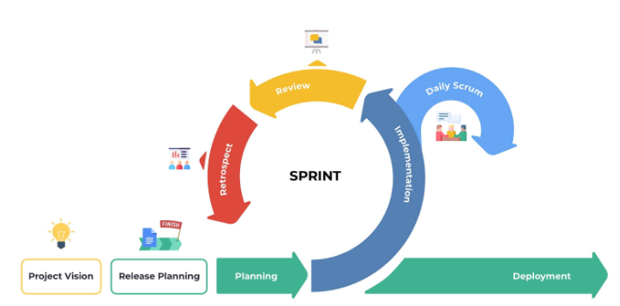

2.2 Quality Management
Quality Assurance Approach:
- Defect Prevention:
- Code review process for all pull requests
- Pair programming for complex features
- Early requirement validation with stakeholders
- Continuous integration to catch issues early
- Reviewing:
- Code Reviews: Mandatory for all code changes
- Design Reviews: Architecture and system design validation
- Documentation Reviews: Technical documentation accuracy
- Security Reviews: Regular security assessment
- Unit Testing:
- Minimum 80% code coverage for critical business logic
- Test-driven development (TDD) for complex algorithms
- Automated unit test execution in CI/CD pipeline
- Mock objects for external dependencies
- Integration Testing:
- API integration testing between frontend, backend, and mobile
- Database integration testing
- Third-party service integration testing
- End-to-end workflow testing
- System Testing:
- Performance testing under load
- Security penetration testing
- User acceptance testing with real users
- Cross-platform compatibility testing
Quality Metrics:
- Defect density: ≤ 2 defects per 1000 lines of code
- Test coverage: ≥ 80% for critical modules
- Code review coverage: 100%
- Performance benchmarks: API response time ≤ 2 seconds

2.3 Training Plan
Training Area | Participants | When, Duration | Waiver Criteria
.NET Core & ASP.NET Core | HuyNLQ | Week 1-2, 16 hours | Mandatory
Entity Framework Core | HuyNLQ | Week 2, 8 hours | Mandatory
React Native Development | All team members | Week 3, 12 hours | Mandatory
Next.js & React | NguyetNTT, TrungNVT, KhoiVN, NhiPTK | Week 3, 8 hours | Mandatory
Git & GitHub | All team members | Week 1, 4 hours | Mandatory
Jira Project Management | All team members | Week 1, 2 hours | Mandatory
Facial Recognition | NhiPTK, NguyetNTT | Week 4, 6 hours | Mandatory
Payment Gateway Integration | NhiPTK, NguyetNTT | Week 5, 4 hours | Mandatory
Real-time Communication (SignalR) | NhiPTK, HuyNLQ | Week 4, 4 hours | Mandatory
CI/CD Pipeline Setup | NhiPTK, KhoiVN | Week 6, 4 hours | Mandatory
Testing Frameworks | All team members | Week 3, 6 hours | Mandatory

3. Project Deliverables
# | Deliverable | Due Date | Notes
1 | Project Charter & Requirements Document | 11/09/2025 | Initial project scope and requirements
2 | System Architecture Design | 13/09/2025 | Technical architecture and database design
3 | API Documentation & Contracts | 22/10/2025 | Swagger documentation and API specifications
4 | Database Schema & Migration Scripts | 17/09/2025 | SQL Server and MongoDB database setup
5 | Backend API Core Modules | 07/10/2025 | Authentication, User Management, Student Management
6 | Backend API Business Logic | 21/10/2025 | Vehicle, Route, Schedule, Trip Management
7 | Backend API Advanced Features | 05/11/2025 | Payment, Notification, Reporting modules
8 | Web Frontend Admin Dashboard | 06/11/2025 | Next.js admin interface with all management features
9 | Mobile App Core Features | 06/11/2025 | React Native app with authentication and basic features
10 | Mobile App Advanced Features | 06/11/2025 | Real-time tracking, notifications, parent features
11 | Facial Recognition Integration | 21/10/2025 | Attendance system with facial recognition
12 | Payment Gateway Integration | 05/11/2025 | Secure payment processing system
13 | Real-time Notification System | 21/10/2025 | SignalR implementation for live updates
14 | Testing & Quality Assurance | 10/12/2025 | Unit, integration, and system testing completion
15 | User Acceptance Testing | 10/12/2025 | UAT with real users and stakeholders
16 | Production Deployment | 12/12/2025 | Live system deployment and go-live
17 | User Training & Documentation | 14/12/2025 | User manuals and training materials
18 | Project Closure & Handover | 15/12/2025 | Final documentation and project closure

4. Responsibility Assignments
D~Do; R~Review; S~Support; I~Informed; <blank>- Omitted
Responsibility | NhiPTK | HuyNLQ | NguyetNTT | TrungNVT | KhoiVN
Project Planning & Tracking | D | S | S | S | S
Prepare Project Introduction Document | D | S | S | S | S
Prepare SRS Document (Overview Part) | D | R | R | R | R
Prepare SRS Document (User Requirements) | I | D | S | S | S
Prepare Use Case Specifications | I | D | S | S | S
Prepare Software Design Document | D | D | D | D | D
Coding Front-end | D | D | D | D | D
Coding Back-end | D | D | D | D | D
Prepare Software Test Documentation | D | S | S | S | S
Prepare Unit Test Document | I | D | S | S | S
Testing | D | D | D | D | D
Prepare Software User Guides | I | D | S | S | S
Deployment | D | S | S | S | S
Prepare Project Report | D | S | S | S | S
Prepare Presentation Slides | D | S | D | S | S

5. Project Communications
Communication Item | Who/ Target | Purpose | When, Frequency | Type, Tool, Method(s)
Daily Standup Meetings | All Team Members | Progress updates, impediment identification | Daily, 15 minutes | Face-to-face / Video call, Slack
Sprint Planning | All Team Members | Define sprint goals, select user stories | Every 2 weeks, 4 hours | Face-to-face, Jira
Sprint Review | All Team Members | Demo completed features, gather feedback | End of each sprint, 2 hours | Presentation, Live demo
Sprint Retrospective | All Team Members | Process improvement, lessons learned | After sprint review, 1 hour | Discussion
Weekly Team Meeting | All Team Members | Project status, technical discussions | Weekly, 1 hour | Face-to-face / Video call, Slack
Code Review Sessions | Developers | Code quality, knowledge sharing | As needed, 30-60 minutes | Pull requests, GitHub
Issue Escalation | Team Members → NhiPTK | Problem resolution, decision making | As needed | Slack
Technical Discussions | Developers | Problem solving, best practices | Daily | Slack channels, GitHub issues

6. Configuration Management

6.1 Document Management
All documents for the EduBus project are managed on Google Drive, with edit permissions restricted to team members only. Additionally, we always prepare a backup in case of accidental deletion or other unforeseen issues. The folder structure is organized as shown below:
- Dev Guideline: Coding standards, branching strategy, commit conventions, review checklist, environment setup guides.
- Ideas: Product ideas, feature proposals, brainstorming notes, feasibility assessments.
- Meetings: contains agendas.
- Notes: contains daily/weekly notes, technical findings, troubleshooting logs, decision records
- Report: contains project reports.
- UI/UX: contains wireframes, mockups, design systems, assets, prototypes, usability findings

Folder | Meaning
Dev Guideline | This folder includes development guidelines, particularly regarding SQL Server provisioning and API design.
Ideas | This folder holds documents outlining project ideas.
Meetings | This folder includes meeting minutes and notes.
Notes | This folder includes notes on system features.
Report | This folder includes project report documents.
UI/UX | This folder contains documents related to user interface and user experience design.

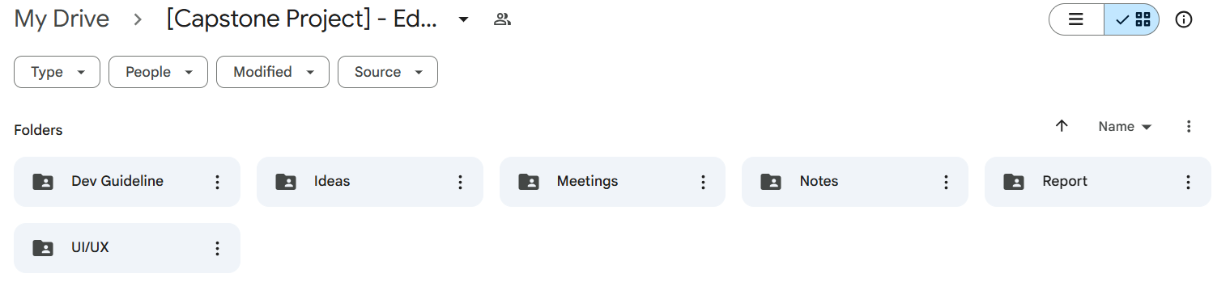

6.2 Source Code Management
Source Code Management Strategy:
- Repository Structure: Multi-repo approach with separate repositories for each component
- Repository Organization:
- EduBus-Backend: .NET Core API, Database, Business Logic
- EduBus-Web: Next.js Admin Dashboard, Web Frontend
- EduBus-Mobile: React Native Mobile Application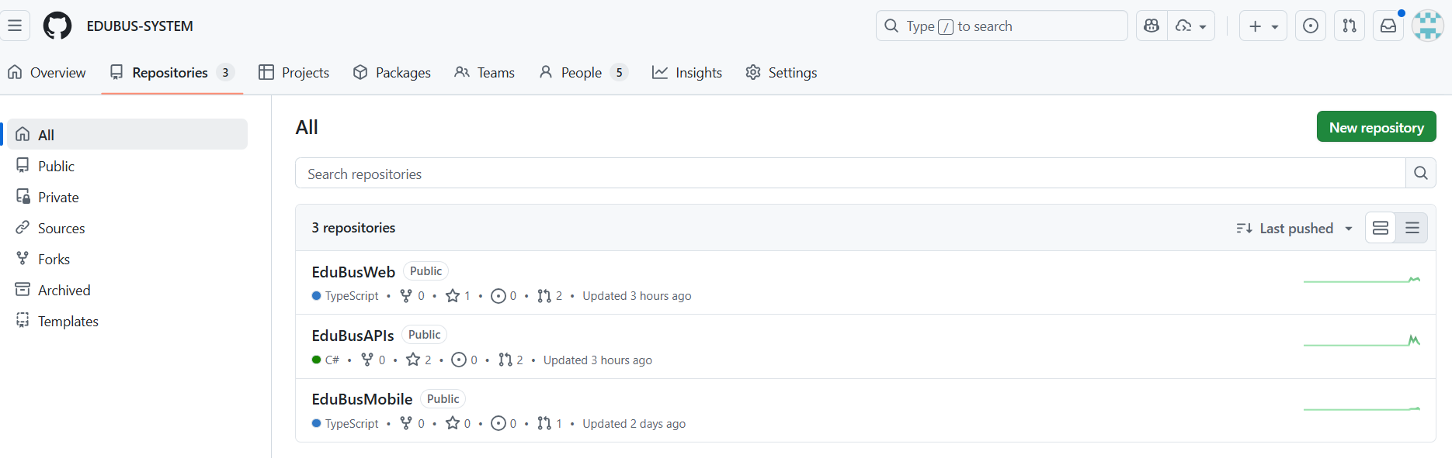
- Branching Strategy: GitFlow with main, develop, feature, and release branches for each repository
- Code Review Process: Mandatory pull request reviews before merging
- Commit Standards: Conventional commits with clear messages
- Automated Testing: CI/CD pipeline with automated testing on every commit
- Code Quality: ESLint, Prettier, SonarQube for code quality checks
- Repository Structure:
- EduBus-Backend Repository:
- .NET Core Web API
- Entity Framework Core Models
- Business Logic Services
- Database Migrations
- API Documentation (Swagger)
- Unit Tests (xUnit)
- EduBus-Web Repository:
- Next.js Admin Dashboard
- React Components
- State Management (Redux/Zustand)
- UI/UX Components
- API Integration
- Unit Tests (Jest)
- EduBus-Mobile Repository:
- React Native Application
- Mobile Components
- Navigation (React Navigation)
- State Management
- API Integration
- E2E Tests (Detox)
- Branching Model (Applied to each repository):
- main: Production-ready code
- develop: Integration branch for features
- feature/[feature-name]: Individual feature development
- release/[version]: Release preparation
- hotfix/[issue]: Critical bug fixes
- Code Review Requirements:
- Minimum 2 reviewers for critical changes
- All tests must pass before merge
- Code coverage requirements met
- Security scan passed

6.3 Tools & Infrastructures
Category | Tools / Infrastructure
Technology | .NET 8.0 (Backend), Next.js 15 (Frontend), React Native (Mobile)
Database | SQL Server, MongoDB
IDEs/Editors | Visual Studio 2022, Visual Studio Code, Android Studio
Diagramming | StarUML, DrawIO
Documentation | Ms Office, Google Docs/Sheets/Slides
Version Control | GitHub (Source Code), Google Drive (Documents)
Project management | Jira (Tasks, Sprints, Defects), Slack (Communication)
CI/CD | GitHub Actions
Cloud Services | Microsoft Azure, AWS (Backup)

