User Manual

Analysing Airbnb Data in Sydney

Georgia Platt

Jackson Scown

Gia Huy Lieu

Table of Contents

1.0 Main Page 3

2.0 Price Distribution Chart 3

3.0 Keyword Analysis 3

4.0 Suburb Specific Information 3

# Main Page

# Price Distribution Chart

On opening, the window opens up like this:

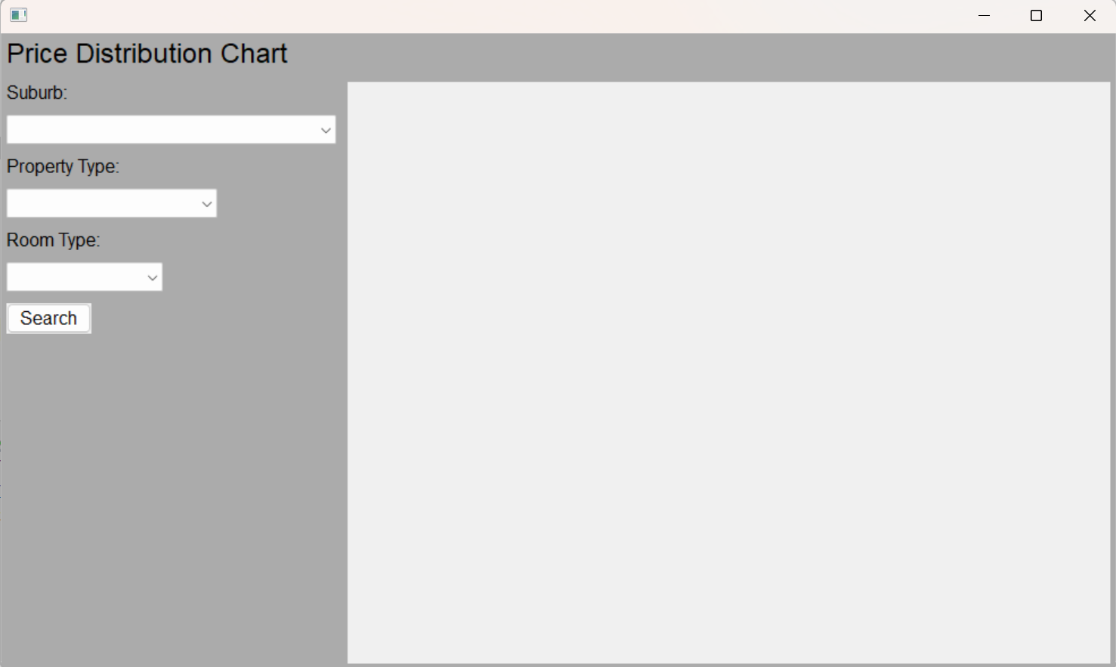

To show the price distribution chart, the user needs to choose the suburb they are wanting to look, property type and room type from the relevant drop down menu.

# Keyword Analysis

# Suburb Specific Information