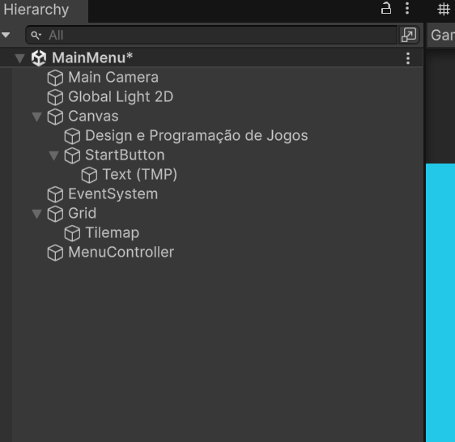
In this scene we have:
main camera that gives the image and sound the player will experience
Canvas that contains the UI elements meaning the objects that are always in sight (unless deactivated) despite the camera position
Design e Programação de Jogos is a label that just displays text
Start button is a button when pressed will execute the MenuController.StartGame
Both the Start Button and the label are on the Canva
The grid is what contains the tile map that is on the view of the camera

TileMap: 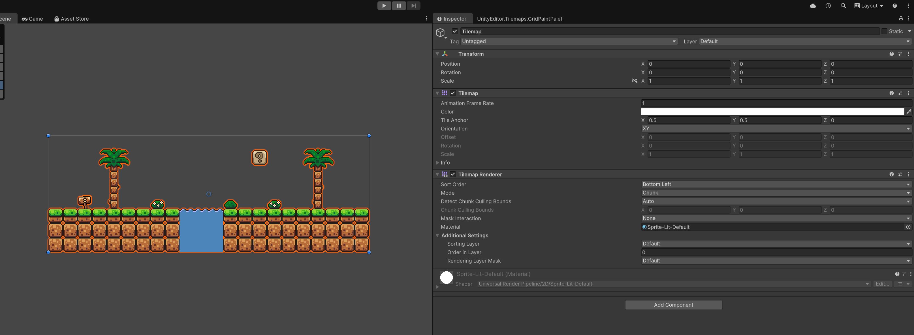

Start Button
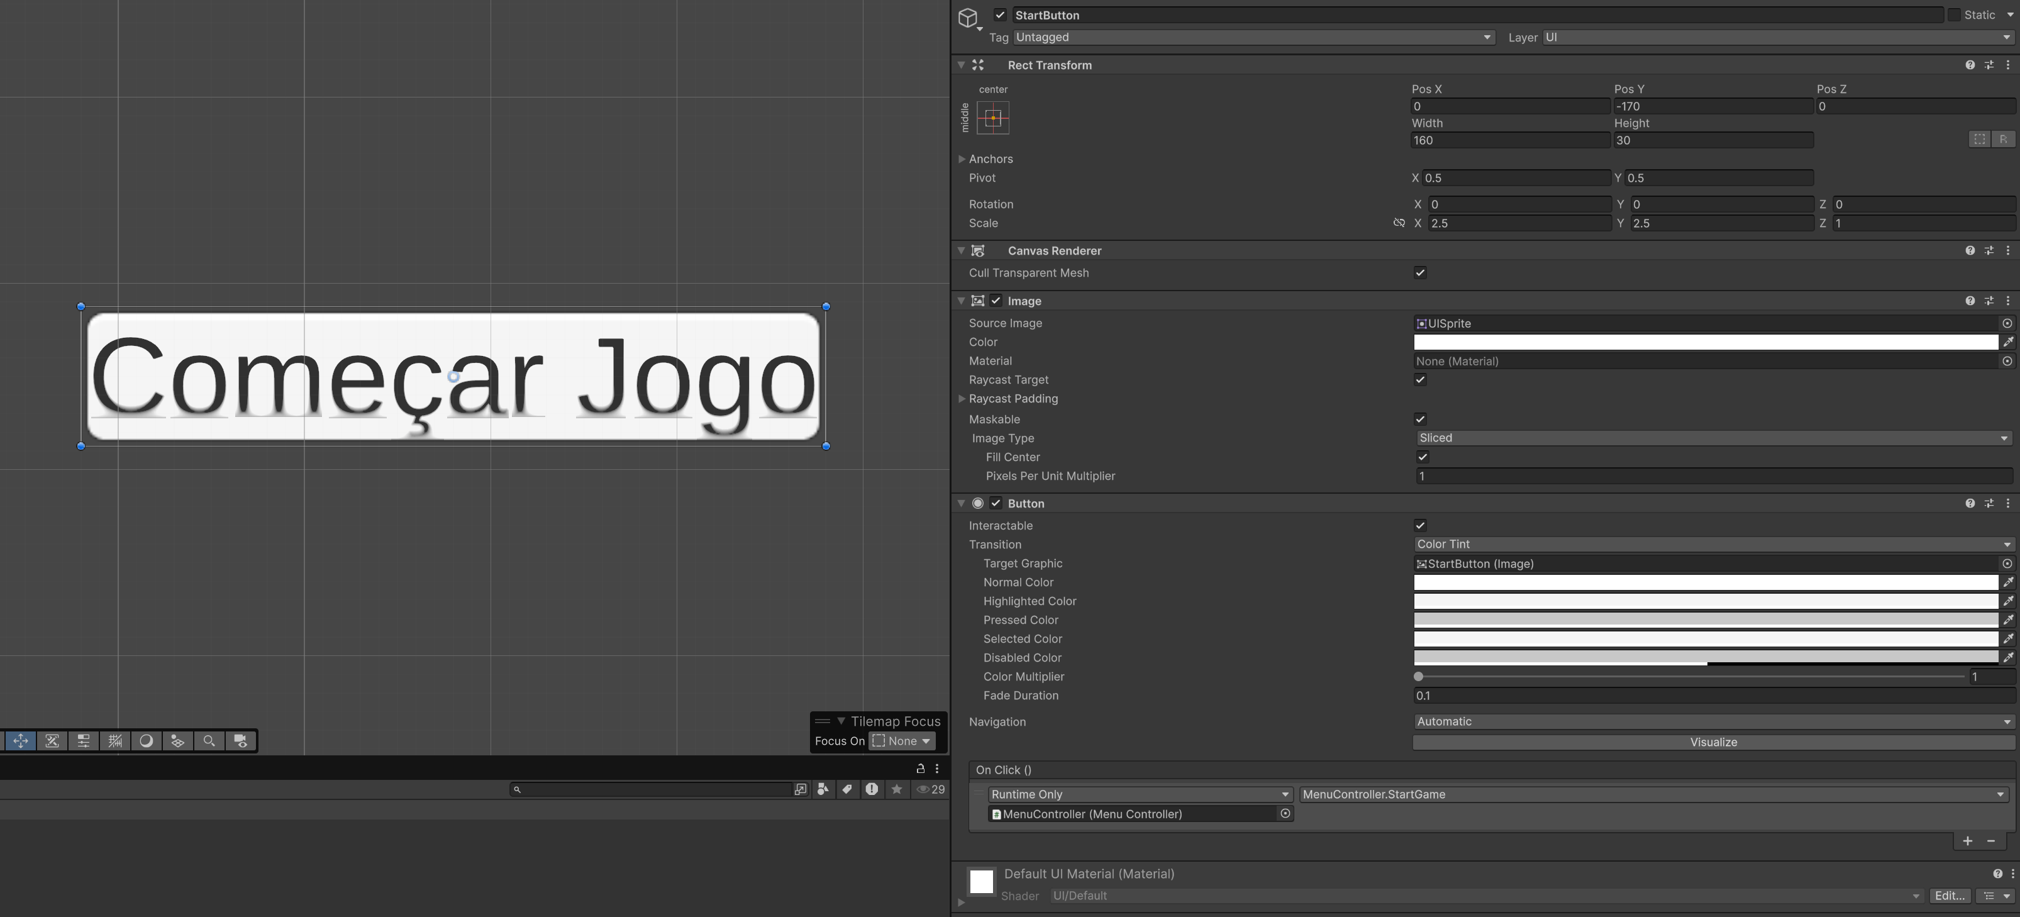
Label
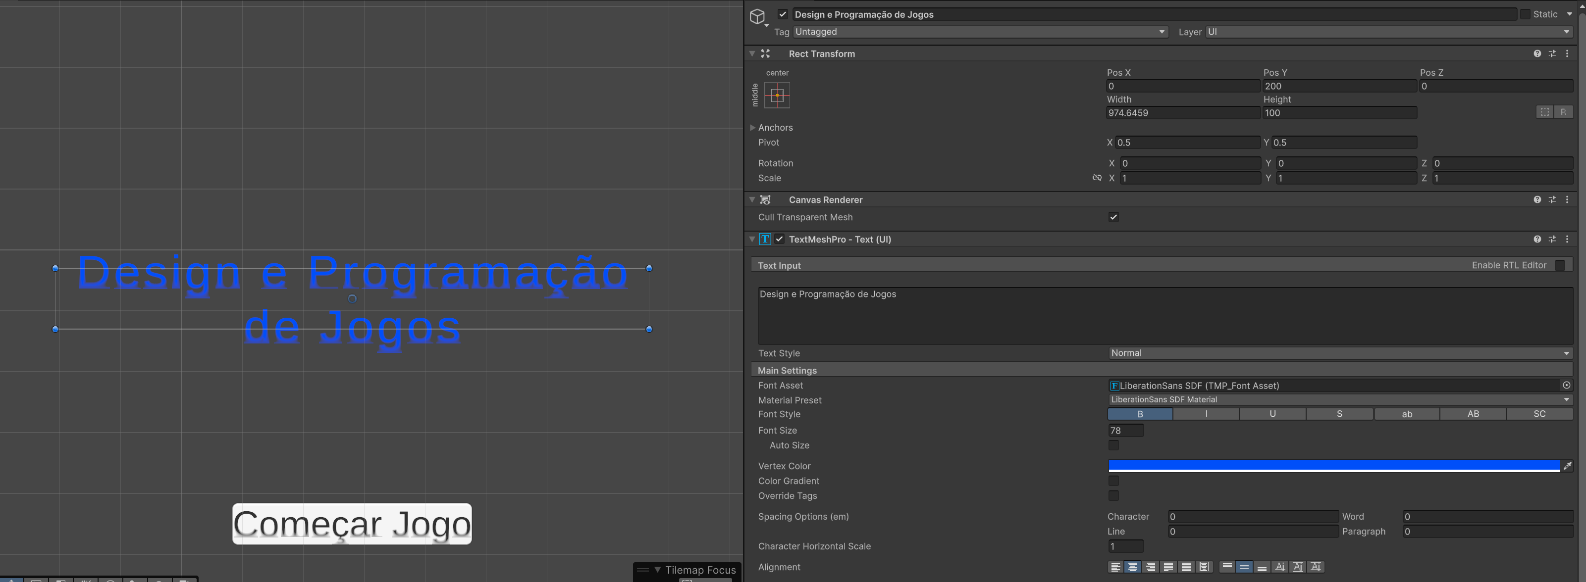
Canva

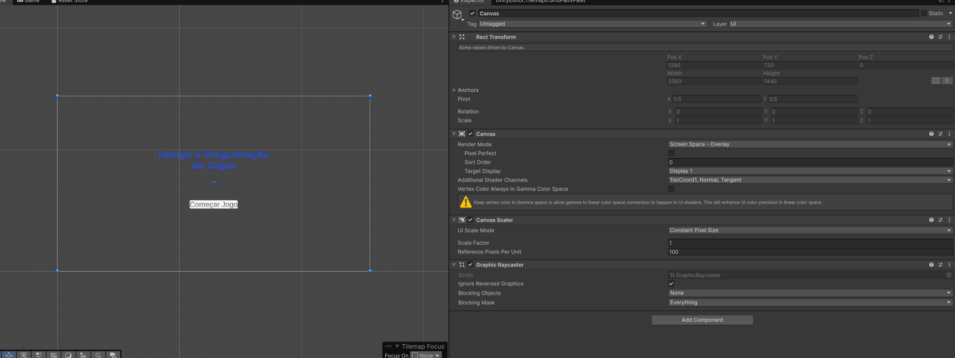
When starting game…
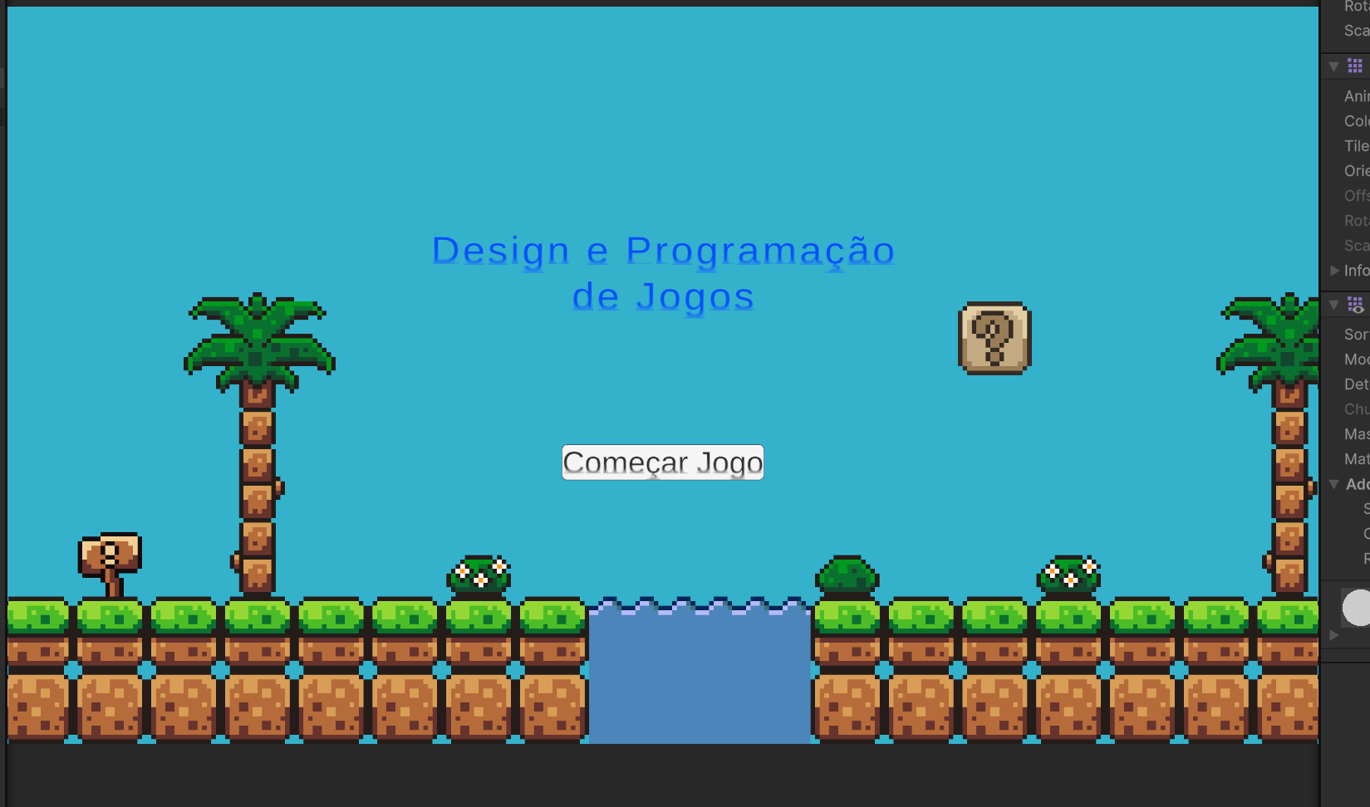
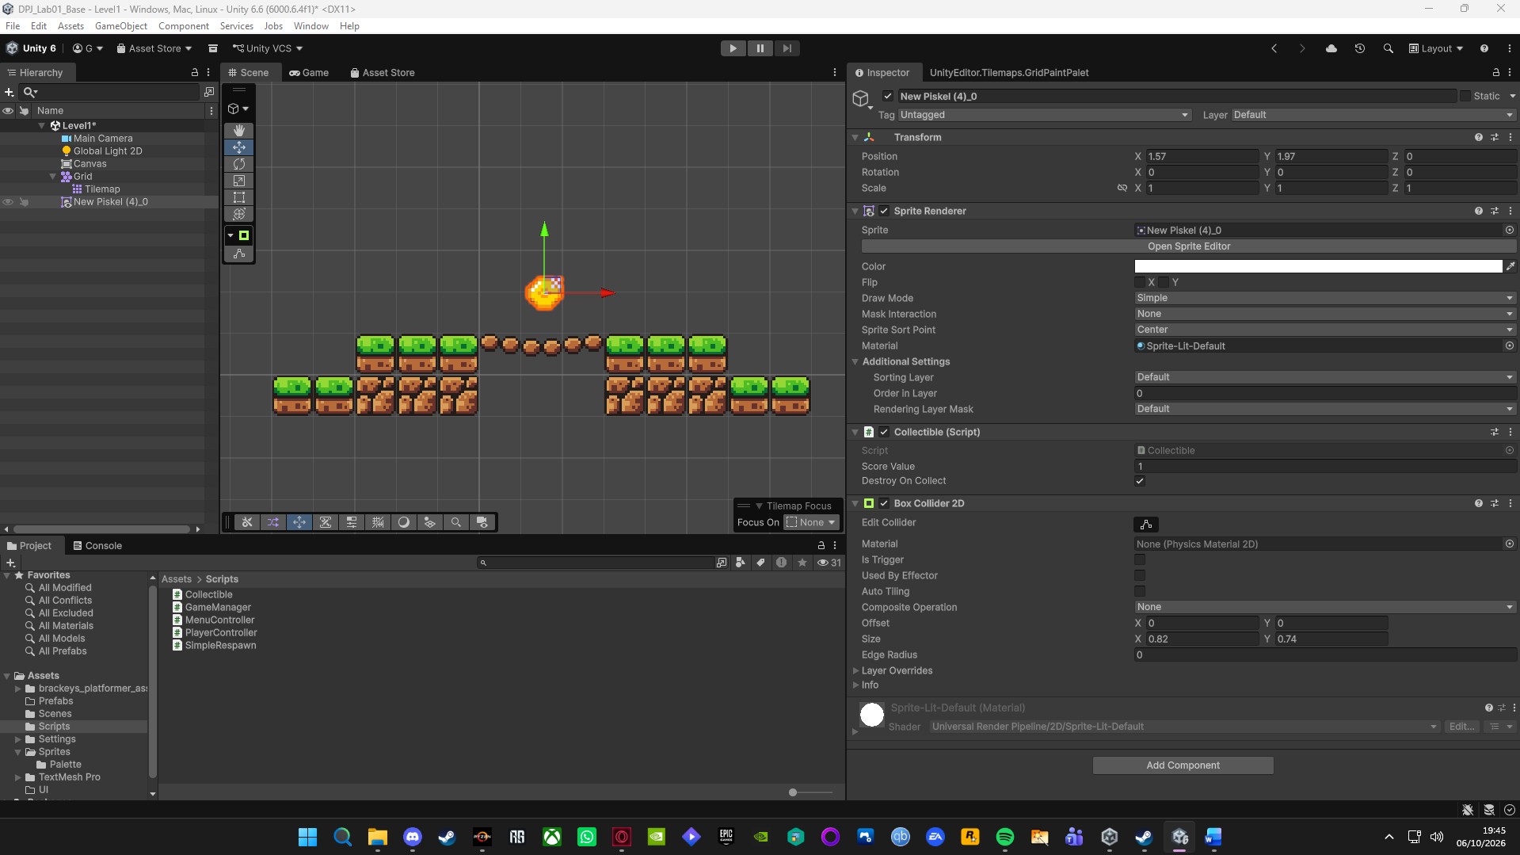
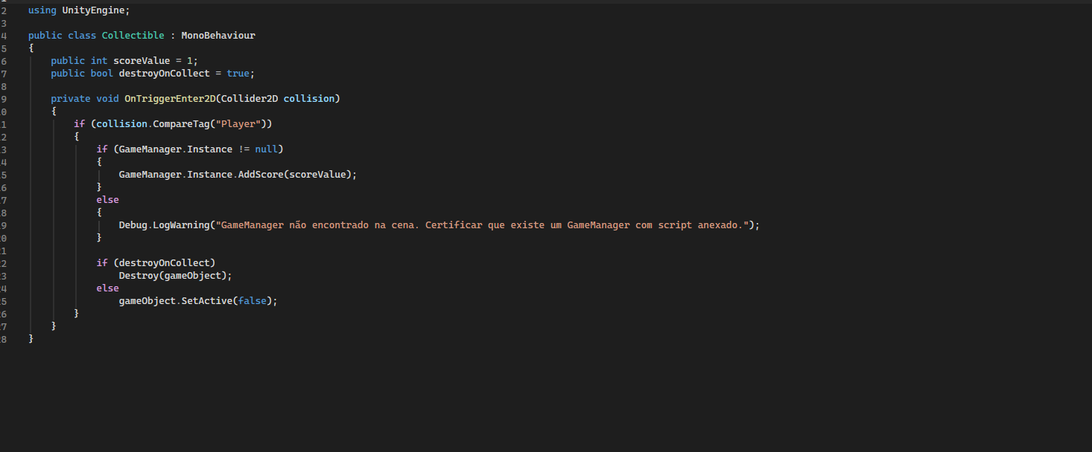
The collectible script makes it so if the object gets in collision with another game object with the game tag “Player” it will increase the total score by 1 and destroy the collectible object or if destroy on collect is at value false will just deactivate it making it invisible for the user
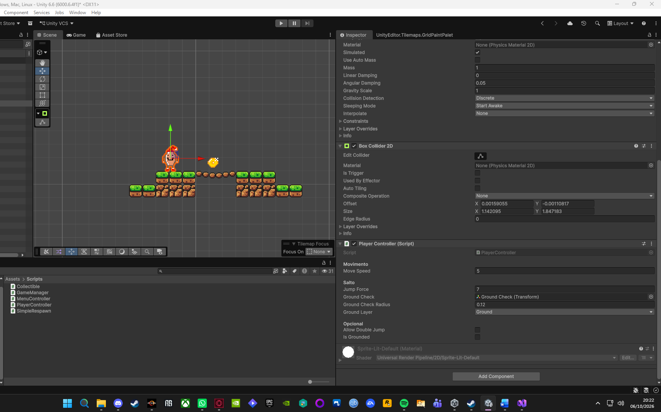
There are 2 types of Rigid bodies:
Rigid Bodie 3D/Rigid Bodie:better used for 3D projects as it acts on all axis(x,y,z)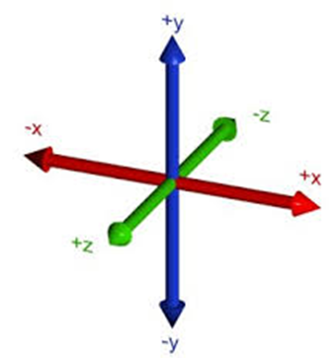

Rigid Bodie 2D:better used for 2D projects as it only acts on the x and y axis
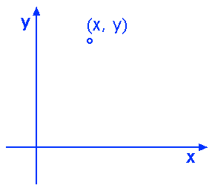
Body Types:
Dynamic: is the default Body Type for a Rigidbody is the default Body Type for a Rigidbody
2D, because it is the most common Body Type for things that need to move and is designed to move under simulation. All Rigidbody 2D properties are available with this Body Type, such as finite mass and drag, and is affected by gravity and forces. A Dynamic body will collide with every other Body Type, and is the most interactive of Body Types. It’s also the most performance-expensive Body Type, because of its dynamic nature and interactivity with everything around it.

Kinematic: 2D is designed to move under simulation, but only under very explicit user control. While a Dynamic Rigidbody 2D is affected by gravity and forces, a Kinematic Rigidbody 2D is not. Because of this, the Kinematic Rigidbody 2D has a lower demand on system resources than a Dynamic Rigidbody 2D, allowing it to be simulated faster.
To reposition a Kinematic Rigidbody 2D, it must be repositioned explicitly via Rigidbody2D.MovePosition or Rigidbody2D.MoveRotation. Use physics queries to detect collisions
, and scripts
to decide where and how the Rigidbody 2D should move.
A Kinematic Rigidbody 2D can still move via its velocity, but the velocity is not affected by forces or gravity. A Kinematic Rigidbody 2D does not collide with other Kinematic Rigidbody 2Ds or with Static Rigidbody 2Ds and will only collide with Dynamic Rigidbody 2Ds. A Kinematic Rigidbody 2D behaves like an immovable object (as if it has infinite mass) during collisions, and mass-related properties are not available with this Body Type.
Static: A Static Rigidbody
2D is designed to not move under simulation at all. If anything collides with it, a Static Rigidbody 2D behaves like an immovable object (as though it has infinite mass). It is also the least resource intensive Body Type 2D is designed to not move under simulation at all. If anything collides with it, a Static Rigidbody 2D behaves like an immovable object (as though it has infinite mass). It is also the least resource intensive Body Type
. A Static body only collides with Dynamic Rigidbody 2Ds. Note: Having two Static Rigidbody 2Ds collide is not supported, since they are not designed to move.
Due to their limited behavior, only a very limited set of properties are available for this Body Type.
All this information was taken out of the oficial unity documentation https://docs.unity3d.com/2022.3/Documentation/Manual/rigidbody2D.html

Technical Task Summary
To complete the implementation of the game loop and mechanics in this laboratory session, the following technical steps were executed:
- Scene and Component Analysis: Explored the MainMenu scene to analyze the core properties of GameObjects, documenting their default components via the Inspector.
- Level Design and Prefab Creation: Designed a basic level layout using the Tilemap system and created a reusable Collectible Prefab equipped with a Collider2D configured as a trigger.
- Player Setup and Physics: Configured the Player GameObject by adding necessary components (SpriteRenderer, Rigidbody2D, BoxCollider2D, and the PlayerController script), assigned the "Player" Tag, and thoroughly analyzed the behavior of different Rigidbody2D Body Types.
- Ground Check Implementation: Created an empty child GameObject named Ground Check at the player's feet and adjusted the script parameters in the Inspector to fix and enable grounded detection for jumping mechanics.
- UI and Game Management: Setup a Canvas with TextMeshPro for the score system and created a GameManager to update the UI text whenever the player interacts with a collectible.
- Respawn System and Game Loop: Implemented a death/fall zone using a Respawn Trigger (with a trigger collider and the SimpleRespawn script) and defined a Respawn Point to reset the player's position, finalizing the loop by testing the transition from the MainMenu to Level1.
Final Look:

