EXPLANATORY NOTES

Stresses and deformations in the channel threaded end

The height of the threads is chosen sufficiently high in order to eliminate any risk of disengagement in service conditions. The portion of the thread height which remains tight under load is calculated by calculating the radial displacement of the channel threads, and disregarding the radial displacement of the ring threads.
The radial displacement of the channel in the threaded portion is calculated by taking into account the longitudinal moment generated by the total axial force applied to the threads by the lock ring and the internal pressure that would be installed in case of leakage through the channel gasket.
The said longitudinal moment at the basis of the channel threaded portion is utilised in order to evaluate the combined stresses at that point in the different operating conditions, and so to establish the channel minimum allowable thickness.

1
2
3
i^{th} thread
W
4
Q₁
M₂
Q₂
+ θ
+ w
M₁
Sections 1 1nd 2: centraline of the i^{th} thread.
Section 3: free end of the channel of thickness s
Section 4: junction between the threaded and unthreaded parts of the channel, at the level of the seat for the channel gasket, of restricted thickness s_{r}
Length of the threaded part (1/2 to 4): L
Total number of threads: n
Distance between 1/2 and 3: 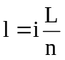

Remaining symbols as per ASME VIII div.2 4-210, with the exception of the thickness s.
Moreover we define:
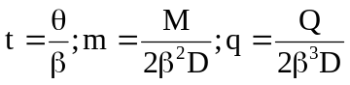
According to ASME VIII div.2 4-232 we have the following displacements in 2 in function of the edge forces and moments (Q₂ and M₂):
(1) 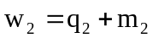
(2) 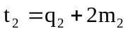

According to ASME VIII div.2 4-231 we have the following forces and displacements in section 3. The functions F are evaluated at x=l.
(3) 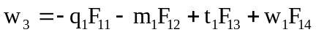
(4) 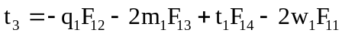
(5) 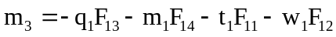
(6) 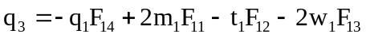
The four hyperstatic unknown forces and moments are given by the following implicit system of equations:
(7) 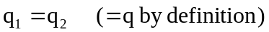
(8) 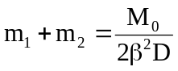
(9) 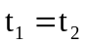
(10) 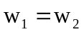
In equation (8) M₀ is the moment of the force W (total end force on the lock ring divided by the number of threads) with respect to the root of the thread. The exact value of the arm of the force W is not known at the beginning of the calculation because it depends from the radial deformation of the threaded end: this implies an iterative calculation procedure. The line of action of W is defined at midway of the surface of contact between the tooth on the bore and the tooth on the shaft, taking in account the worst combination of the machining tolerances.
We solve (5) and (6) with respect to t₁ and w₁:
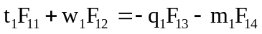
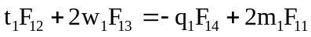

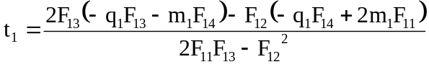
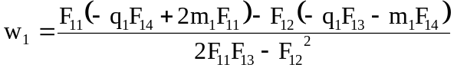
Rearranging, and by substitution of (1), (2), (7), (9) and (10) we obtain:
(11) 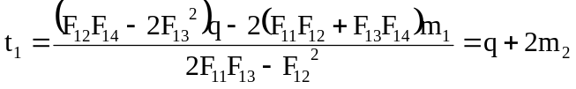
(12) 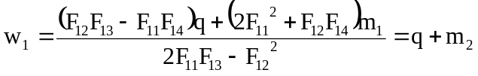
(13)
Equations (11), (12) and (13) constitute the explicit solving system in the unknown q, m₁ and m₂. We adopt the following auxiliaries definitions:
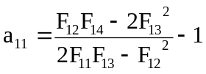
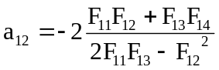
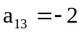
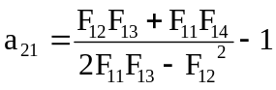
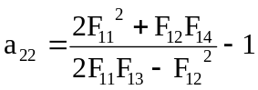
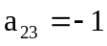
With that the solving system becomes:
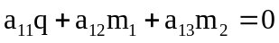
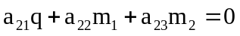
The solution of this system and the substitution in (1), (2), (3) and (4) to find out the displacements too, is now straightforward. Finally the results for each tooth shall be summed together in order to obtain the final results: radial displacement at the top and bending moment at the bottom of the threaded channel end.
The longitudinal membrane and bending stresses at the bottom section 3 are finally combined with the radial and circumferential stresses due to the internal pressure (in the ‘leaking’ load condition) to give the final stress intensity according to the Tresca failure criterion.

