EXPLANATORY NOTES
==========================

Usage of the App.14 calculation for the transition piece of DEU closures

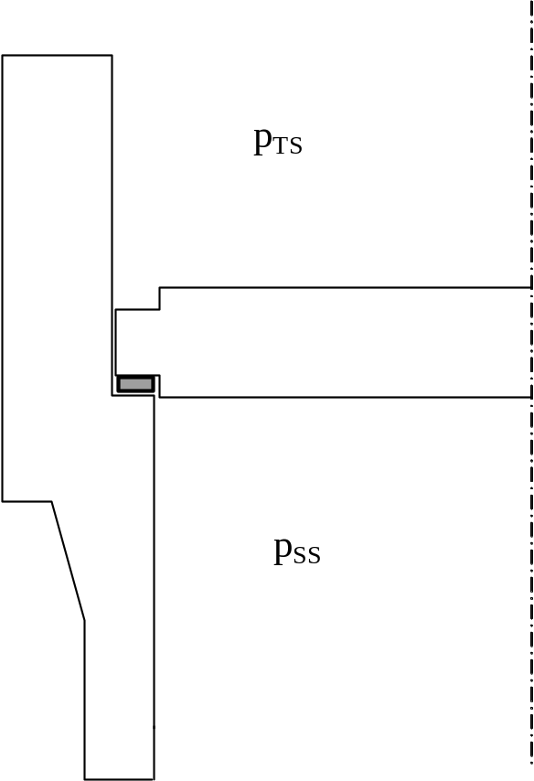
This figure represents the common features of a tubesheet bolted on the bottom of the channel (bolts not represented) and of a tubesheet pushed against the gasket on the bottom of the channel as in the breech-lock type closures (pushing devices not represented).
The goal of the present calculation of the transition piece is to assess the stress effects of the longitudinal forces induced by the pressures and by their offsets.
The shell-side pressure (p_{SS}) does not produce bending moments on the transition piece, and therefore it shall not intervene in the present calculation (even if it is greater than the tube side pressure, p_{TS}).
The tube-side pressure produces the forces H_{D} and H (see App.14-5(d)), which in this case revert to:
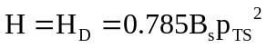
The flange moment is here:
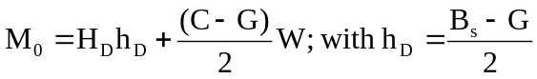
The term with W represents the bolting moment, which is absent for the breech-lock case.
The symbols are defined in App.2 and 14

