LIFTING LUG MATERIALS

Shell material mat1
Yield stress S_{y1} Sy1 MPa Sy1_07 Psi
Tensile stress S_{a1} Sa1 MPa Sa1_07 Psi
Lifting lug material mat2
Yield stress S_{y2} Sy2 MPa Sy2_07 Psi
Tensile stress S_{a2} Sa2 MPa Sa2_07 Psi
Lifting pad material mat3
Yield stress S_{y3} Sy3 MPa Sy3_07 Psi
Tensile stress S_{a3} Sa3 MPa Sa3_07 Psi
Lifting rib material mat4
Yield stress S_{y4} Sy4 MPa Sy4_07 Psi
Tensile stress S_{a4} Sa4 MPa Sa4_07 Psi
Tailing lug material mat5
Yield stress S_{y5} Sy5 MPa Sy5_07 Psi
Tensile stress S_{a5} Sa5 MPa Sa5_07 Psi

LUG DIMENSIONS (See fig.2)

Inside shell diameter d_{i} di mm di_254 in
Nominal shell thickness t_{s} ts mm ts_254 in
Lug thickness T T mm T_254 in
Lug radius R R mm R_254 in
Lug width A A mm A_254 in
Lug height H H mm H_254 in
External diameter of the ring d₁ d1 mm d1_254 in
Lug hole diameter d d mm d_254 in
Ring thickness t₁ t1 mm t1_254 in
Pad height F F mm F_254 in
Pad width E E mm E_254 in
Pad thickness t₂ t2 mm t2_254 in
Rib height l₇ l7 mm l7_254 in
Rib width l l mm l_254 in
Rib thickness t₃ t3 mm t3_254 in
Dimension G (see fig. 2) G G mm G_254 in
Dimension h (see fig. 2) h h2 mm h2_254 in
Dimension l₆ (see fig. 2) l₆ l6 mm l6_254 in
Dimension l₃ (see fig. 2) l₃ l3 mm l3_254 in
Fillet weld leg W_{l} wl mm wl_254 in
Fillet weld efficiency W_{e} we %
Rib angle α alpha °
Lifting angle horiz. pos. θ₁ theta1 °
Lifting angle vert. pos. θ₂ theta2 °
Max. length (see fig. 1) l₁ l1 mm l1_254 in
Centre of g. distance (see fig. 1) l₂ l2 mm l2_254 in
Total mass W W Kg W_2 lb
Impact factor c ff --

Lifting lug calculations sh. 1 of 6

ALLOWABLES

Tensile
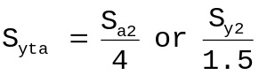, the smaller S_{yta} te MPa te_07 Psi
Shearing
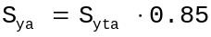 S_{ya} shea MPa shea_07 Psi
Bending
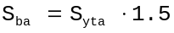 S_{ba} bend MPa bend_07 Psi

CHECK OF STRENGTH IN HORIZONTAL CONDITION

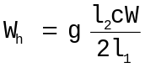 (see fig.1) W_{h} wh N wh_2 lb
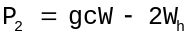 P₂ p2 N p2_2 lb
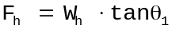 F_{h} fh N fh_2 lb

SECTION A – A

Shear stress due to load W_{h}
R_{x}=R (if no ring) or d₁/2 R_{x} rx mm rx_254 in
T_{x}=T (if no ring) or T+2t₁ T_{x} tx mm tx_254 in
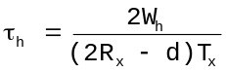 < S_{ya} τ_{h} ss MPa ss_07 Psi

SECTION B – B

M_{h} = W_{h}l₆ M_{h} mh Nmm mh_B lb.in
Bending stress due to load moment M_{h}
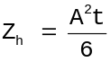, section modulus Z_{h} zh mm³ zh_254 in³
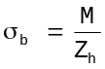 < S_{ba} σ_{b} hb MPa hb_07 Psi
Shearing stress due to load F_{h}
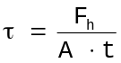 < S_{ya} τ h1 MPa h1_07 Psi
Combined stress
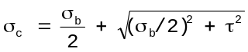 < S_{ba} σ_{c} hcom MPa hcom_07 Psi

SECTION C – C

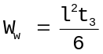, fillet section modulus W_{w} ww mm³ ww_254 in³
A_{w} = lt₃, fillet section area A_{w} ars2 mm² ars2_254 in²
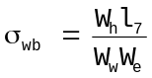 < S_{ba} σ_{wb} stp3 MPa stp3_07 Psi
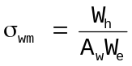 < S_{yta} σ_{wm} stp31 MPa stp31_07 Psi

Lifting lug calculations sh. 2 of 6

CHECK OF STRENGTH IN VERTICAL CONDITION

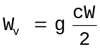 W_{v} Wv N Wv_2 lb
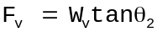 F_{v} fv N fv_2 lb

SECTION A – A

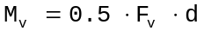 M_{v} mv1 Nmm mv1_B lb.in
Bending stress due to moment M_{v}
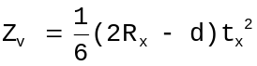, section modulus Z_{v} zv mm³ zv_254 in³
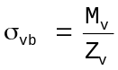 < S_{ba} σ_{vb} vb MPa vb_07 Psi
Tensile stress
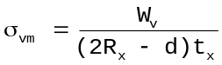 < S_{yta} σ_{vm} vt MPa vt_07 Psi
Combined stress
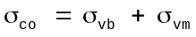 < S_{ba} σ_{c} vcom MPa vcom_07 Psi

SECTION B – B

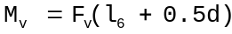 M_{v} mv2 Nmm mv2_B lb.in
Bending stress due to moment Mv mv2 Kg/mm²
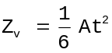, section modulus Z_{v} zv1 mm³ zv1_254 in³
< S_{ba} σ_{vb} vb2 MPa vb2_07 Psi
Tensile stress
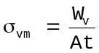 < S_{yta} σ_{vm} vt2 MPa vt2_07 Psi
Combined stress
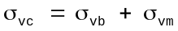 < S_{ba} σ_{c} vcom2 MPa vcom2_07 Psi

SECTION D – D

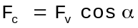 F_{c} fc N fc_2 lb
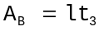 A_{B} ab mm² ab_254 in²
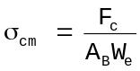 σ_{cm} sc MPa sc_07 Psi
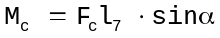 M_{vc} mc Nmm mc_B lb.in
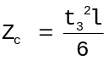, section modulus Z_{c} zc mm³ zc_254 in³
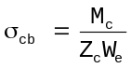 σ_{cb} sc2 MPa sc2_07 Psi
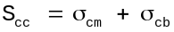 < S_{yta} σ_{cc} sccom MPa sccom_07 Psi

Lifting lug calculations sh. 3 of 6

CHECK OF STRENGTH AT WELD PART

Horizontal condition (see fig. 3)
Throat thickness W_{s} ws mm ws_254 in
Y=(R + l₂ + l₆ + F) – H, or 0 when F=0: Y mm Y_254 in
, or 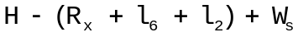 when F=0:
U U mm U_254 in
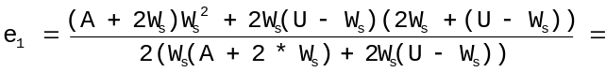 e1 mm e1_254 in
l₅ = l₂ + l₆ +U – e₁ l₅ l5 mm l5_254 in
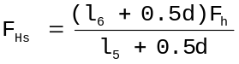 F_{Hs} fhs N fhs_2 lb
A’ az mm² az_254 in²
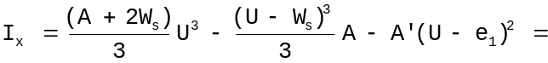 i1 mm⁴ i1_254 in⁴
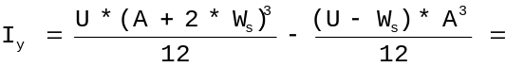 i2 mm⁴ i2_254 in⁴
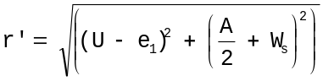 r’ rg mm rg_254 in
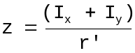 z zz mm³ zz_254 in³
Shearing stress due to torsional moment
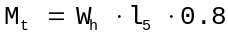 M_{t} mt1 Nmm mt1_B lb.in
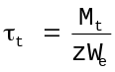 < S_{ya} τ_{t} ssp MPa ssp_07 Psi
Bending stress due to load F_{Hs}
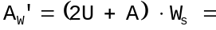 ars mm² ars_254 in²
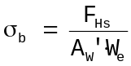 < S_{ba} σ_{b} stp1 MPa stp1_07 Psi
Shearing stress due to load W_{h}
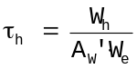 < S_{ya} τ_{h} stp2 MPa stp2_07 Psi
Combined stress
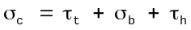 < S_{ba} σ_{c} stcom MPa stcom_07 Psi
Vertical condition
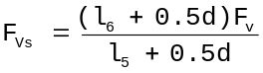 F_{Vs} fvs N fvs_2 lb
Shearing stress due to load W_{v}
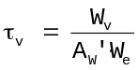 < S_{ya} τ_{v} ftp MPa ftp_07 Psi
Bending stress due to load F_{Vs}
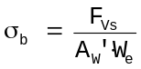 < S_{ba} σ_{b} ftp2 MPa ftp2_07 Psi
Combined stress
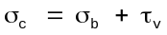 < S_{ba} σ_{c} ftcom MPa ftcom_07 Psi

Lifting lug calculations sh. 4 of 6

TAILING LUG CALCULATION

LUG DIMESION (see fig. 4)

Lug radius R₁ r11 mm r11_254 in
Lug thickness t₄ t4 mm t4_254 in
Lug width l₁₀ l10 mm l10_254 in
Lug hole diameter d_{f} dff mm dff_254 in
Fillet weld leg W_{e2} we2 mm we2_254 in

ALLOWABLES

Tensile
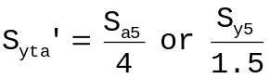, the smaller S_{yta}’ sytl MPa sytl_07 Psi
Shearing
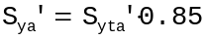 S_{ya}’ sy22 MPa sy22_07 Psi

CHECK OF STRENGTH IN HORIZONTAL CONDITION

A_{W}’ arr MPa arr_254 in²
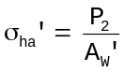 < S_{ya}’ σ_{ha}’ sha2 MPa sha2_07 Psi
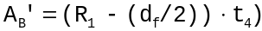 A_{B}’ arrr mm² arrr_254 in²
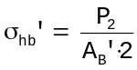 < S_{yta}’ σ_{hb}’ sha3 MPa sha3_07 Psi

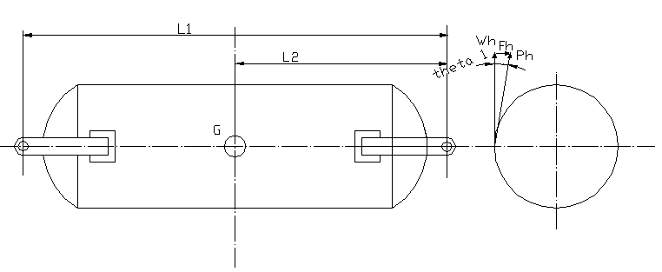
FIGURE 1

Lifting lug calculations sh. 5 of 6

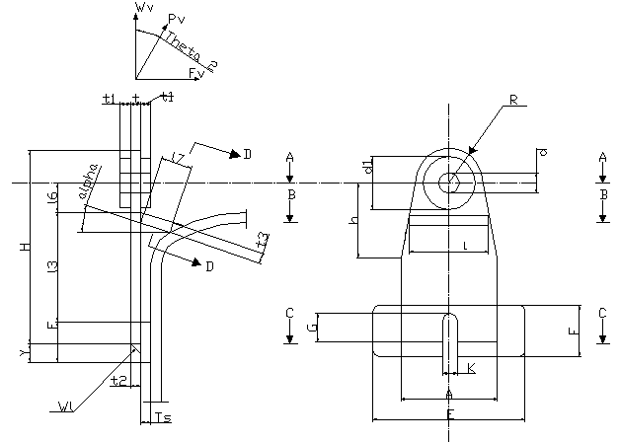
FIGURE 2

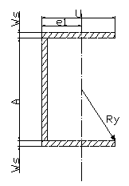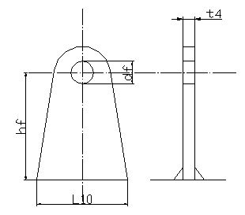
FIGURE 3 FIGURE 4

Lifting lug calculations sh. 6 of 6

