**<Scheduler> Overview Use case**

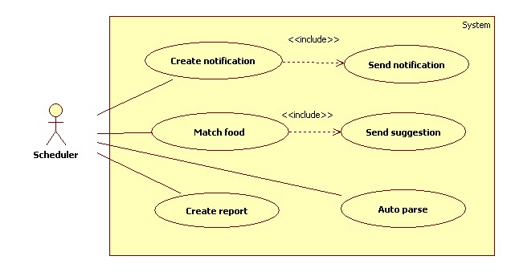

**Figure: <Scheduler> Overview Use case**

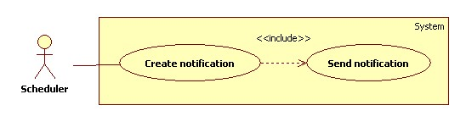

**Figure: <Scheduler> Show notification use case diagram**

|  |  |  |  |
| --- | --- | --- | --- |
| **USE CASE - <UC Number>** | | | |
| **Use Case No.** |  | **Use Case Version** | 1.0 |
| **Use Case Name** | Send notification | | |
| **Author** | Phan Hoàng Giáp | | |
| **Date** | 19/01/2016 | **Priority** | High |
| **Actor:**   * Scheduler   **Summary:**   * This use case allows scheduler to create notifications for all users about all expiring foods in their refrigerator and notify user at specified time.   **Goal:**   * Scheduler can create notifications and show it to user.   **Triggers:**   * Every day at 0 o’clock.   **Preconditions:**   * Notification time has been configured by user.   **Post Conditions:**   * Success: Notifications are sent to user. Log file is generated. * Fail: Log file is generated.   **Main Success Scenario:**   |  |  |  | | --- | --- | --- | | **Step** | **Actor Action** | **System Response** | | **1** | Server checks the current time. If it is after 0 o’clock and create notification process has not been started, create notification process starts. | System gets all foods information of all users from storage:   * Food name * Food expiring day * Food notification day   If expiring day minus current time is less than or equal to notification day:   * Create notifications * Insert notifications to storage * Generate log file. | | **2** | Server checks the current time. If it hits notification time, send notification process starts. | System sends notifications to account of all users. |   **Alternative Scenario:**   |  |  |  | | --- | --- | --- | | **No** | **Actor Action** | **System Response** | | **1** |  |  | | **2** |  |  |   **Exception**   |  |  |  | | --- | --- | --- | | **No** | **Actor Action** | **System Response** | | **1** |  |  |   **Relationships:** Create notification  **Business Rules:**   * Every day at 0 o’ clock, system will check all food expiring day of all users. * If foods are about to expired, system will create notifications. * At notification time, system will send notifications to account of all users. * Log file structure:   NOTIFICATION PROCESS LOG FILE  Tạo file lúc: {Created date}, {Create time}   |  |  |  | | --- | --- | --- | | STT | User account | Số notification | |  |  |  | |  |  |  |   Tổng thời gian process: {Total elapsed time} | | | |

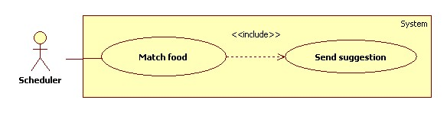

**Figure: <Scheduler> Send suggestion use case diagram**

|  |  |  |  |
| --- | --- | --- | --- |
| **USE CASE - <UC Number>** | | | |
| **Use Case No.** |  | **Use Case Version** | 1.0 |
| **Use Case Name** | Send suggestion | | |
| **Author** | Phan Hoàng Giáp | | |
| **Date** | 19/01/2016 | **Priority** | High |
| **Actor:**   * Scheduler   **Summary:**   * This use case allows scheduler to suggest dishes based on food in user’s refrigerator at specified time.   **Goal:**   * Scheduler can match food in refrigerator and suggest dishes to all users.   **Triggers:**   * Every day at 0 o’clock.   **Preconditions:**   * Dish suggest time has been configured by user.   **Post Conditions:**   * Success: Dishes information is sent to mobile app. Log file is generated. * Fail: Log file is generated.   **Main Success Scenario:**   |  |  |  | | --- | --- | --- | | **Step** | **Actor Action** | **System Response** | | **1** | Server checks the current time. If it is after 0 o’clock and match ingredient process has not been started, matching process starts. | System gets all foods name of all users from storage.  System matching foods name with recipe database.  If foods match with recipes:   * Creates dishes. * Insert dishes to storage. * Generate log file. | | **2** | Server checks the current time. If it hits configured time, scheduler start send suggestion process. | System sends dishes information to account of all users. |   **Alternative Scenario:**   |  |  |  | | --- | --- | --- | | **No** | **Actor Action** | **System Response** | | **1** |  |  | | **2** |  |  |   **Exception**   |  |  |  | | --- | --- | --- | | **No** | **Actor Action** | **System Response** | | **1** |  |  |   **Relationships:** Match ingredient  **Business Rules:**   * Every day at 0 o’ clock, system will check all foods in all users account. * System match food with recipe database to create dishes for users. * At suggestion time, system will send dishes information to account of all users. * Log file structure:   SUGGESTION PROCESS LOG FILE  Tạo file lúc: {Created date}, {Create time}   |  |  |  |  | | --- | --- | --- | --- | | STT | User account | Thời gian matching | Tổng số dish suggestion | |  |  |  |  | |  |  |  |  |   Tổng thời gian: {Total elapsed time} | | | |

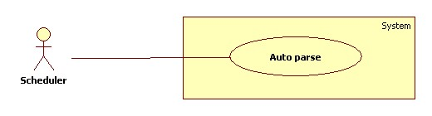

**Figure: <Scheduler> Get recipes by HTML parsing use case diagram**

|  |  |  |  |
| --- | --- | --- | --- |
| **USE CASE - <UC Number>** | | | |
| **Use Case No.** |  | **Use Case Version** | 1.0 |
| **Use Case Name** | Parse periodically | | |
| **Author** | Phan Hoàng Giáp | | |
| **Date** | 19/01/2016 | **Priority** | High |
| **Actor:**   * Scheduler.   **Summary:**   * System can parse resource automatically from many websites at specified time.   **Goal:**   * Get resources from many websites.   **Triggers:**   * Every day at 0 o’clock.   **Preconditions:**   * Configuration files has been created by staff.   **Post Conditions:**   * Success: New data is inserted to storage. Log file is generated. * Fail: Nothing is changed in the storage. Log file is generated.   **Main Success Scenario:**   |  |  |  | | --- | --- | --- | | **Step** | **Actor Action** | **System Response** | | **1** | Server checks the current time. If it is after 0 o’clock and parse process has not been started, parse process starts. | Send request to the chosen websites.  Fetch data from the response based on the inputted XPaths in configuration files.  Validate data [Exception 1].  If data is valid, insert to storage [Alternative 1].  Generate log file. |   **Alternative Scenario:**   |  |  |  | | --- | --- | --- | | **No** | **Actor Action** | **System Response** | | **1** | Server checks the current time. If it is after 0 o’clock and parse process has not been started, parse process starts. | If fetched link resource is already in the storage, update its information.  Generate log file. |   **Exception**   |  |  |  | | --- | --- | --- | | **No** | **Actor Action** | **System Response** | | **1** | Data is invalid | Generate log file. |   **Relationships:** N/A  **Business Rules:**   * Every day at 0 o’ clock, system will send request to parsed websites. * System fetch data and insert to storage. * Recipes data mush be validate before saved to database. * If link resource exists in storage, update its information. * Log file structure:   AUTO PARSE PROCESS LOG FILE  Tạo file lúc: {Created date}, {Create time}   |  |  |  |  |  |  | | --- | --- | --- | --- | --- | --- | | STT | Website parse | Thời gian parse | Số thực đơn nhận được | Insert thành công | Insert thất bại | |  |  |  |  |  |  | |  |  |  |  |  |  |   Tổng thời gian parse:{Total elapsed time}  Tổng sản phẩm parse được:{Total parsed recipes} | | | |

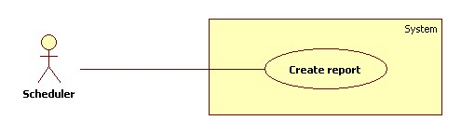

**Figure: <Scheduler> Create report use case diagram**

|  |  |  |  |
| --- | --- | --- | --- |
| **USE CASE - <UC Number>** | | | |
| **Use Case No.** |  | **Use Case Version** | 1.0 |
| **Use Case Name** | Create report | | |
| **Author** | Phan Hoàng Giáp | | |
| **Date** | 19/01/2016 | **Priority** | Normal |
| **Actor:**   * Scheduler   **Summary:**   * System can get user behavior as their searching foods.   **Goal:**   * System can get user searching keywords.   **Triggers:**   * The time at 0 o’clock once per day.   **Preconditions:**   * N/A   **Post Conditions:**   * Success: New data is saved into storage. Log file is generated. * Fail: Nothing is changed in the storage. Log file is generated.   **Main Success Scenario:**   |  |  |  | | --- | --- | --- | | **Step** | **Actor Action** | **System Response** | | **1** | Server checks the current time. If it is after 0 o’clock and create report process has not been started, create report process starts. | Send request to account of all users.  Fetch search keywords.  Validate data. [Exception 1]  If data is valid, insert to storage.  Generate log file | | **2** |  |  |   **Alternative Scenario:**   |  |  |  | | --- | --- | --- | | **No** | **Actor Action** | **System Response** | | **1** |  |  | | **2** |  |  |   **Exception**   |  |  |  | | --- | --- | --- | | **No** | **Actor Action** | **System Response** | | **1** | Data is invalid | Generate log file | | **2** |  |  |   **Relationships:** N/A  **Business Rules:**   * Every day at 0 o’clock system request search keywords from all users account. * Search keywords will be stored in database of the system as a user attribute. * Log file structure:   CREATE REPORT LOG FILE  Tạo file lúc: {Created date}, {Create time}   |  |  |  | | --- | --- | --- | | STT | User account | Search keyword | |  |  |  | |  |  |  |   Tổng thời gian: {Total elapsed time} | | | |