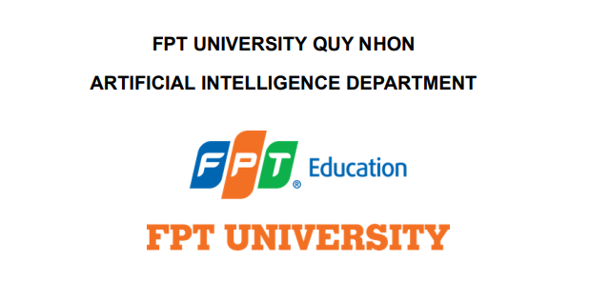

**Employee Manager System**

**DPL302m-AI17C**

March 2024

**Member:**

- Phạm Thế Anh

- Lê Văn Chương

- Lê Quang Mỹ

- Võ Thái Hoàng Anh

- Hồ Trọng Ninh

- Nguyễn Trường Giang



**CONTENT**

1. **BUSINESS CASE**
2. **Problem statement ………………………………………………………………………………………………**
3. **System features …………………………………………………………………………………………………….**
4. **Customer and user ………………….………………………………………………………………………….**
5. **Value of the system …………………………………………………………………………………………….**
6. **WORK PLAN**
7. **Workflow ………………………………………………………………………………………………**
8. **Task**

**………….…………………………………………………………………..**

1. **TECHNICALS**
2. **Collect and process data ……………………………………………………………………………………**
3. **Model ……………………………………………………………………………………………………………**
4. **FUTURE**

# BUSINESS CASE

## 1.Problem statement

- We live in a digital age, where technology has driven progress and created new opportunities in every field, especially in human resource management. In an era where work never stops, employee monitoring systems have become an indispensable tool to ensure efficiency and effectiveness in business operations.

The employee monitoring system is not only a tool to control labor activities, but also a tool to support and develop the organization's human resources. The flexibility and interoperability of modern technologies such as artificial intelligence, machine learning and the Internet of Things (IoT) have opened up new opportunities in the development of smart employee monitoring systems.



However, implementing and managing an employee monitoring system also poses many challenges. We need to ensure that the collection and use of employee personal information is carried out properly and in compliance with security and privacy regulations. In addition, we also need to ensure that the use of technology does not take away humanity and respect for workers.

## 2. System features

-Our monitoring system will have 2 main features: identifying employees and monitoring working employees (uniforms, gestures,..)

-Firstly, employee identification: This feature includes a mechanism to search and identify employees in the frame. The system will verify the identities of all people in the frame and identify which employees and customers are present to ensure that there are always employees in the frame when there are customers.

-Secondly, about monitoring working employees: the system, after identifying the employee, will monitor whether the employee complies with the rules on uniforms and gestures (greeting guests) given by the head when there is a problem. customer no.

- If at any step the system detects an abnormality (no employee, employee in wrong uniform, etc.), a warning will immediately be issued to the supervisor or manager.

## 3.Customer and user

**-Client:**

In this case, the "customer" is usually the organization or business that uses the employee monitoring system to manage and monitor their personnel.

Customers can be managers, directors or human resources departments of the organization.

The main task of the customer is to manage and operate the supervisor system, review reports and information from the system to make effective management decisions.

**-User:**

Users are employees in the organization using the supervisor system.

In this case, users include all employees in the organization, from junior to senior employees.

The main task of the end user is to comply with the rules and procedures established by the system supervisor, provide necessary information and data, and supplement directives and warnings from the system to ensure work efficiency and labor safety.

## 4.Value of the system

-Increase labor productivity: Employee monitoring and management systems can help increase employee performance by providing detailed information about their activities. This helps organizations identify and solve specific problems in the work process and optimize process tasks.

-Improve service quality: By monitoring and evaluating employee performance, organizations can ensure that they are providing high quality service to customers. System monitoring can help detect and resolve problems in service delivery, thereby increasing customer satisfaction.

-Optimize human resource management: The employee monitoring and management system provides the necessary tools and information to manage human resources in an optimally effective way. From planning and assigning work to time management and employee training, the system helps organizations optimize the human resource management process.

**WORK PLAN**

**1.Workflow**

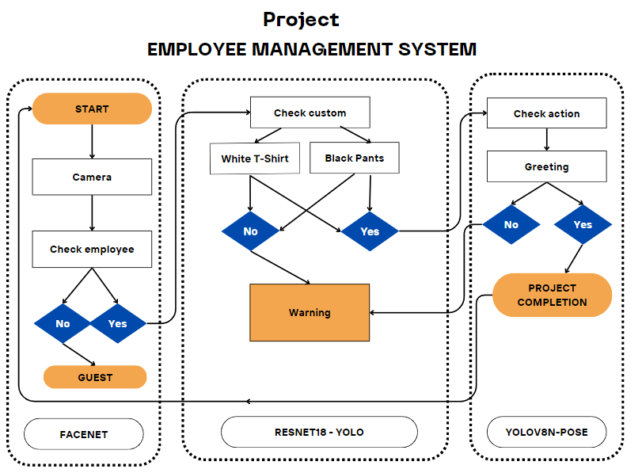

**2.Task**

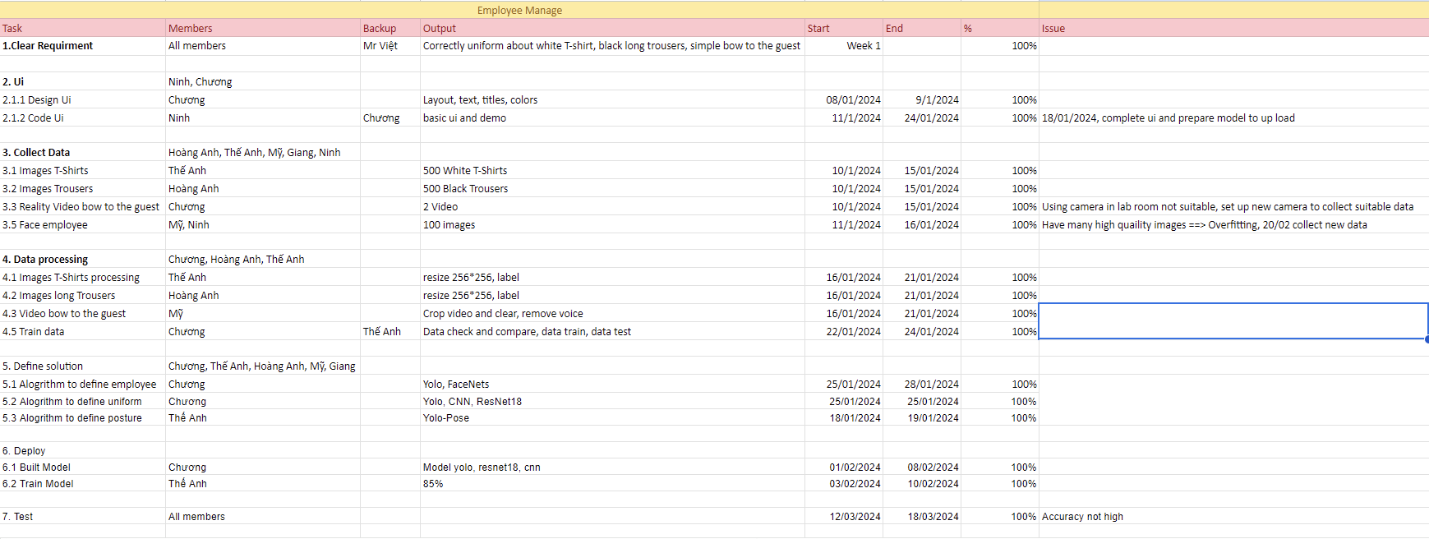

**Technicals**

**1.Data**

-Source: Google, Kaggle, Roboflow,…

**1.Employee data:**

-Face: 2 employees 30 photos each

-Hello: About 600 photos

-No greeting: About 1200 photos

**2.Other data:**

-Black pants: 600 photos

-Other pants: 600 photos

-White shirt: 600 photos

- Shirts of different colors: 600 photos2. Data processing

-Resize: 512x512

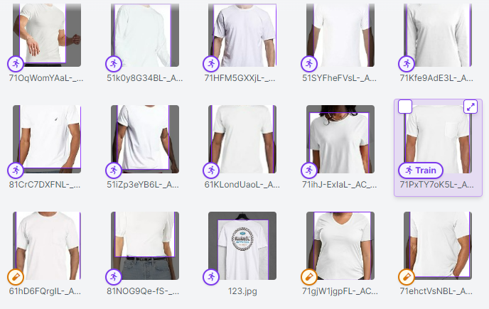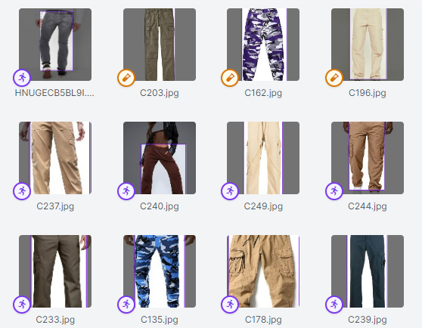

**3.Train data :**

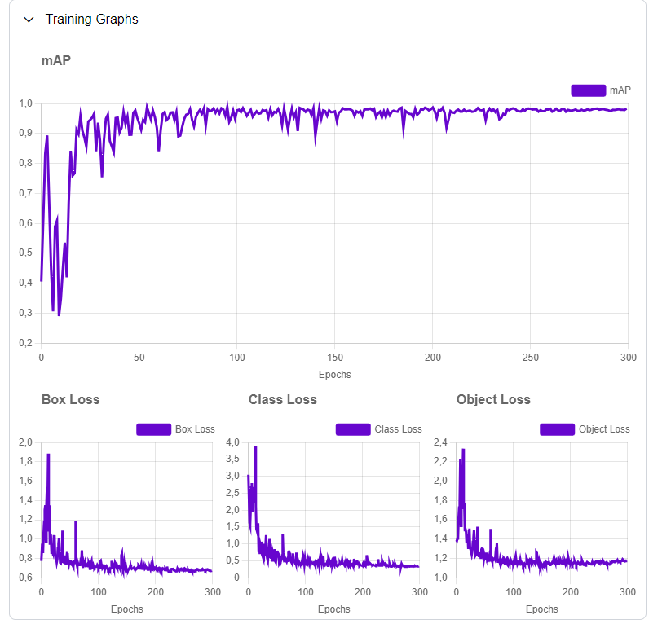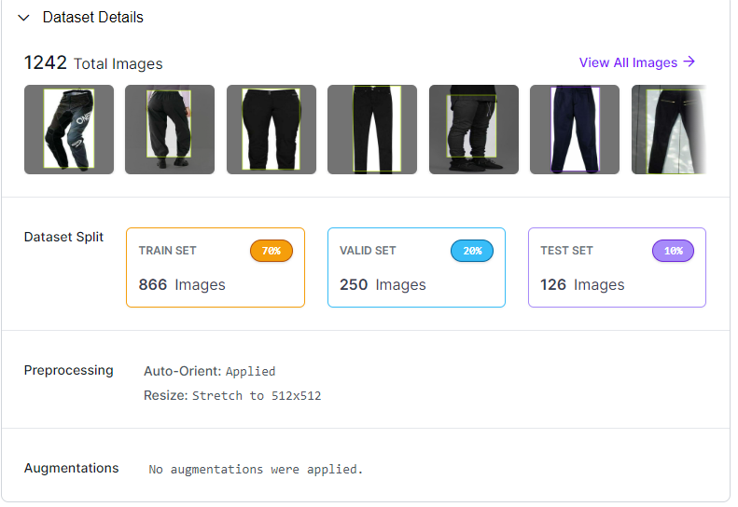

**3.Model**

**1. Video stream:**

- Get continuous video stream with opencv.

**2. Yolo :**

- Use YOLO to detect humans in video streams.

**3. Get cell coordinates (xyxy):**

- Retrieve bounding box coordinates (xyxy) for each detected person.

**4. Cut frames for each individual:**

- Use the obtained coordinates to crop individual frames, each containing one person.

**5. Face recognition module:**

- Use the Face Detection module (MTCNN) on cropped frames to isolate the face region.

**6. Face embedding (Facenet):**

- Pass the isolated face through Facenet to create an embedding (feature vector) of the face.

**7. Compare cosine distance:**

- Compare the feature vector created by cosine distance with the set of facial feature vectors in the database.

**8. Similarity threshold:**

- Set similarity score threshold; individuals above this threshold are considered potential matches.

**9. Name scheme:**

- If a match is found, draw the name on the video along with the YOLO human detection box.

**10. Customer testing:**

- Run a loop for a certain period of time to detect if there are any strange faces that are not in the database (customers)

**11. If there are customers:**

- Check if anyone else matches a person in the database (Employee), if not warn

**12. If there are customers and employees:**

12.1 Uniform identification:

- If the person is identified in the database, retrieve the YOLO box coordinates and feed them into a classification model (CNN, Resnet) to detect whether the person is wearing the correct uniform or not.

12.2 Detecting greetings:

- If the uniform is correct, use the same coordinate box to put into the model to detect whether the person salutes or not.

**\*Model accuracy:**

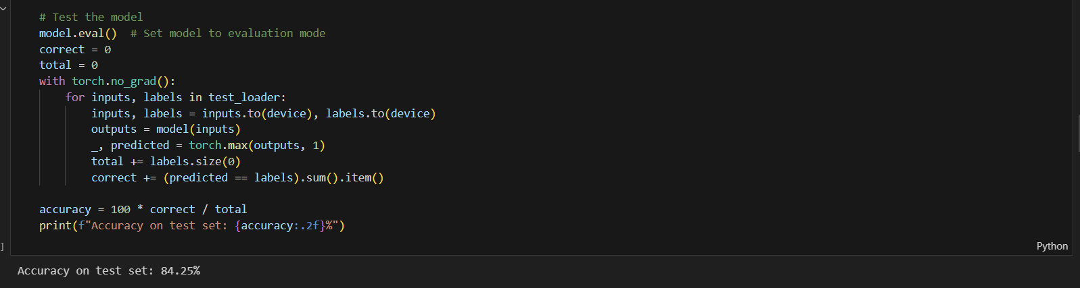

**FUTURE OF THE SYSTEM**

-Integration of artificial intelligence and machine learning: In the future, the system will be improved by integrating advanced technologies such as artificial intelligence and machine learning. This helps the system become smarter in analyzing data, predicting trends, and offering problems or action tools based on collected data.

- Developments in the field of data analytics and artificial intelligence: Developments in the field of data analytics and artificial intelligence will open up new opportunities in understanding and expecting customer behavior and needs. staff. This helps organizations optimize the human resources management process and create a positive and supportive work environment for employees.

-Flexible and remote management: Flexibility and the ability to work remotely have become a major trend in the modern work environment. In the future, employee monitoring and management systems will develop features and technology to support operational and effective human resources management in a remote work environment.