JDBC EXERCISE

Exercise 1: Using script DB_Muahang.sql to create DB.
- Form Login:
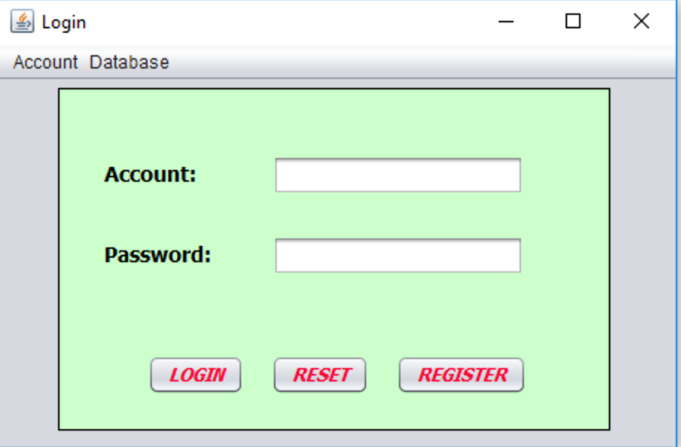
Requirement:
- When click RESET button, TextFields are empty.
- When cllick REGISTER button, move to Register form.
- When click LOGIN button:
+ Check input
+ Check the information of accoutn in DB, if exist, show messagebox “Login successfully!” and move to Main form. Otherwise, show messagebox “Login fail!” and stop.

- Form Register:
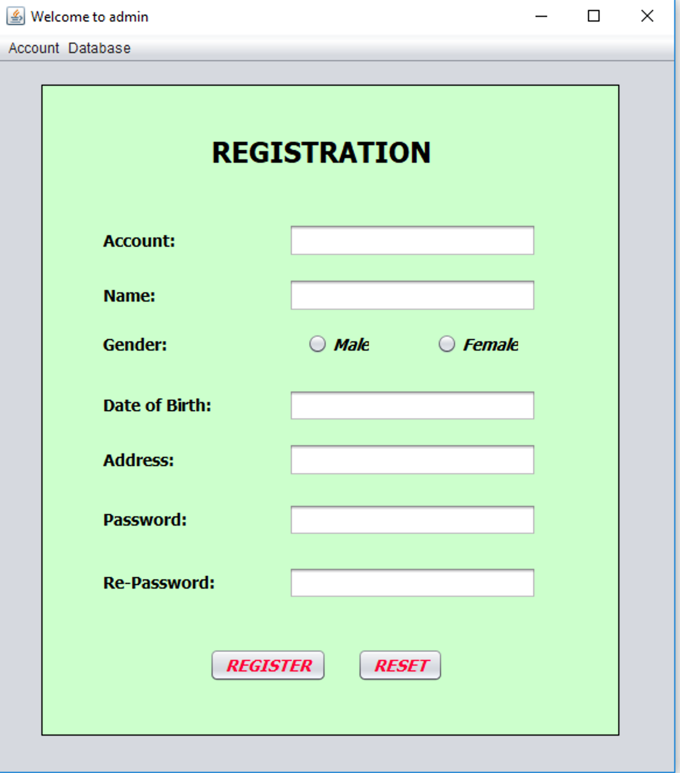

- When click RESET button, TextFields are empty.
- When click REGISTER button:
+ Check input.
+ Check the existance of the account.
+ Add the information of that account into DB

- Form main_Product:
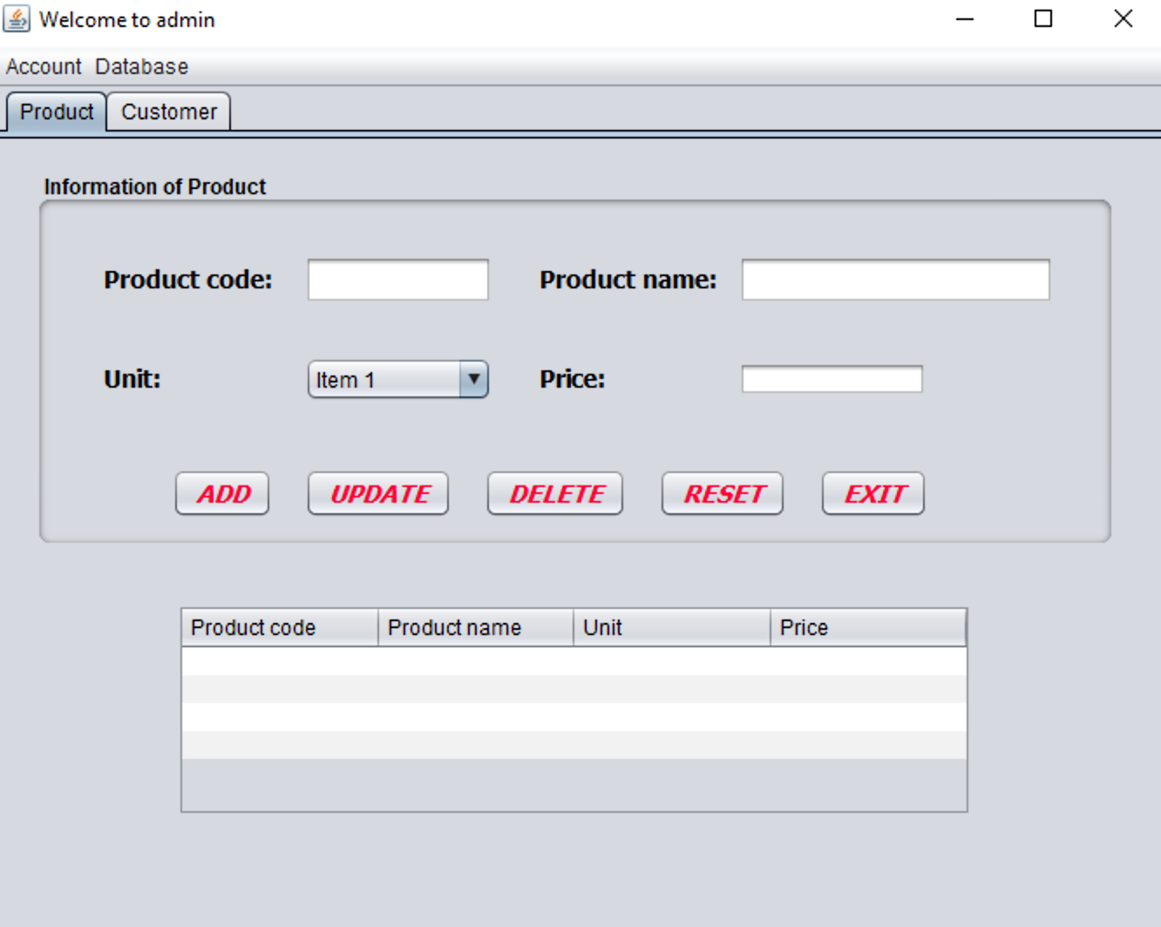
Requirement:
- When load form, show the information of products to the table
- Control the state of the buttons so that logic with the related handling.
- Select a record on the table, display the details on the above items.
- When click RESET button, TextFields are empty.
- When click EXIT button, close the program
- When click ADD button:
+ Check input.
+ Check the existance of the product code.
+ Add the information of that product into DB.
- When click UPDATE button, update the information of the product.
- When click DELETE button, delete the information of the product in DB.
* Note: Check the handling, manipulation and data carefully.

- Form main_Customer

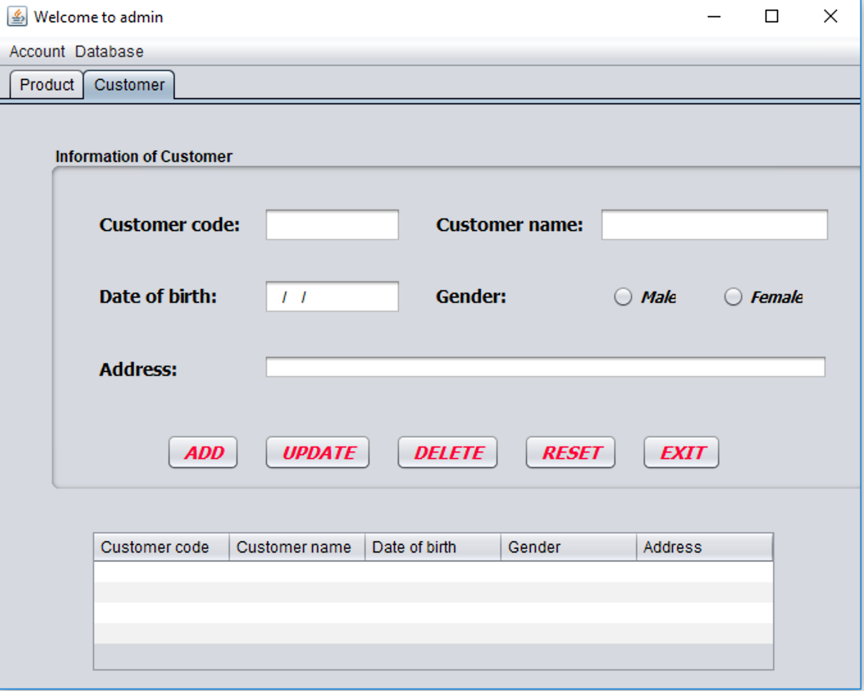
Perform the corresponding requirements as on the Product form

Exercise 2: Write an Java application with the following requirements:
- Use JDBC to store data.
- Implement functions related to buttons

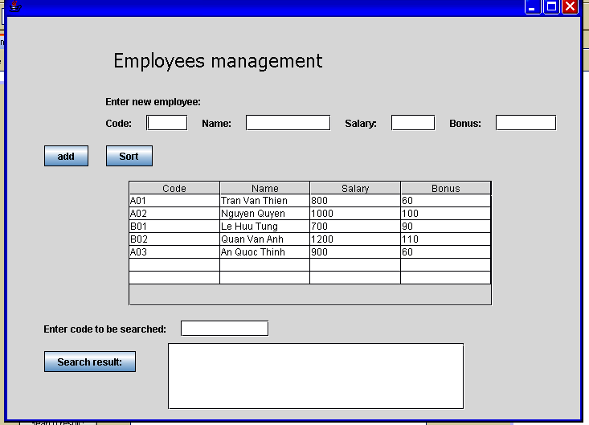

*Note: Add the following components
- ComboBox: Code, Name,Salary
- RadioButton: Asc, Des

