

**CENTRAL ZOO**

|  |  |  |
| --- | --- | --- |
| **Supervisor:** | *LÊ THANH NHÂN* | |
| **Semester:** | *01* | |
| **Batch No:** | *T1.2209.M0* | |
| **Group No:** | *06* | |
| **Order:** | **Full name** | **Roll No.** |
| *1.* | *Phạm Giang* | *Student1420697* |
| *2.* | *Nguyễn Quang Huy* | *Student1416042* |
| *3.* | *Phan Gia Minh* | *Student1420693* |

***Month****: 01* ***Year****: 2002*



This is to certify that

|  |  |
| --- | --- |
| **Mr.** | **Phạm Giang** |
| **Mr.** | **Nguyễn Quang Huy** |
| **Mr.** | **Phan Gia Minh** |

Have successfully Designed & Developed

|  |  |  |
| --- | --- | --- |
|  |  |  |
| **Central Zoo** | | |

Submitted by:

|  |
| --- |
| **Mr. LE THANH NHAN** |

Date Of Issue:

|  |  |
| --- | --- |
|  |  |

Authorized Signature:

|  |  |
| --- | --- |
|  |  |

|  |
| --- |
| **Content** |

Content

Acknowledge

Synposis

Review1 (điền số trang theo thực tế)

|  |
| --- |
| **Acknowledge** |

As we understand that the eProject is a step-by- step learning environment that closely simulates the class-room and Lab based learning environment into actual implementation. It is a projectimplementation at your fingertips!! An electronic, live juncture on the machine that allows you to.

CENTRAL zoo is one of the biggest zoo in the town. The land area of the zoo is 33 acres. CENTRAL zoo was established in the year 1980 with 10 acre land but lately it was modified and land area was also added in the year 2000. Proper residing space for all the type of animals has been made and maintains human security at high rate. Proper supply of food for all the animals is maintained and checked at regular intervals. You need to develop a website for the CENTRAL zoo which will provide the information about all the animals (like species, animal classification) which are kept and along with their image.

* Practice step by step i.e. laddered approach.
* Build a larger more robust application.
* Usage of certain utilities in applications designed by user.
* Single program to unified code leading to a complete application.
* Learn implementation of concepts in a phased manner.
* Enhance skills and add value.
* Work on real life projects.
* Give a real life scenario and help to create applications more complicated and useful.
* Mentoring through email support.

We would like to send a great thank to our professor and others student for the addorable supports during the time in project.

Beside serveral mistakes we had made in the project, we hope to have more oppotunities to widen our knownledge in web developing world.

We also thank you so much for your infomation and the “demo” project from India APTECH to help us get more reality experience in this project. Since we have gained more experience from this project, we will not stop learning any thing as much as we can to be more successful in the future.

Your Sincerely,

Team Group 06.

|  |
| --- |
| **Synposis** |

The Objective of this program we aim is to give a sample project to work on real life projects. These applications help us build a larger more robust application.

The objective is not to teach us HTML/JavaScript but to provide us with a real life scenario and help us create basic applications using the tools.

Hence, we can revise the chapters before we start with the project.

This project is meant for students like us who have completed the module of HTML5. These programs should be done in the Lab sessions with assistance of the faculty if required.

|  |
| --- |
| The website (in this project) is a tool that brings everything in the world to you as information natural knowledge |

It is very essential for us that will have a clear understanding of the subject. We think we should go through the project and solve the assignments as per requirements given.

And get back ***eprojects@aptech.ac.in*** as the assigned schedule.

|  |
| --- |
| **Problem Definition** |

In 1995, Government of Nepal entrusted the management of Nepal’s Central Zoo, the only zoo in Nepal, located at Jawalakhel in the Kathmandu Valley to NTNC for 30 years. Established as a private zoo in 1932 by the late Rana Prime Minister Juddha Samsher, it came under the ownership of Government of Nepal after the political changes of 1950 and remained under the management of various government departments before it’s management was handed over to NTNC on the occasion of the Golden Jubilee Birthday Celebration of the Late Majesty King Birendra Bir Bikram Shah in December 1995.

The Trust aims to develop the Central Zoo as a center for ex-situ wildlife research and conservation education. The Central Zoo, with an area of about 6 ha., provides shelter to a total of 942 individual mammal, bird, fish and reptile of 127 species. It also serves as recreational center for the visitors. Central Zoo uniquely serves as a historical cultural site for diverse groups of people.

Over one million visitors come to enjoy the displays at the Central Zoo annually. The main source of income has been the revenue collected from the entry ticket sales. With an aim of generating public awareness and participation in nature and wildlife conservation, the Central Zoo has been successfully running a special membership based program called the “Friends of Zoo” (FOZ) with a network of schools in Kathmandu Valley. The animal management unit is improving and enriching the enclosures to provide better habitats for the zoo animals and are now in a better situation with the operation of a recently established “Animal Hospital”. New displays, of national and international species, are often added in order to educate and to introduce the visitors to the different wild species from within the country and abroad. Increasingly the Central Zoo's role in wildlife rescue, release and rehabilitation is being recognized as an indispensible role for enhancing the wildlife national responsiveness capacity of the country, especially with growing incidents related to problem animal management, animal emergency, animal shelter and refuge, disease among others.

- Identify the problem

1. Provide information about CENTRAL ZOO to users and members

2. Provide information on conservation and care animal

3. Get feedback from users and members to increase quality and get more Complete information about animals

4. Give administrators the ability to update animal information quickly and exactly 5. Give admins the ability to manage members

5. Provide content for members and members to download and read on their site personal device

Guest:

1. You can visit the website to see information about animals, conservation and Hunting prevention.

2. Can register as a member

3. Can give feedback to the administrato

|  |  |  |  |  |  |  |  |  |  |  |  |  |  |  |  |  |
| --- | --- | --- | --- | --- | --- | --- | --- | --- | --- | --- | --- | --- | --- | --- | --- | --- |
| |  |  | | --- | --- | | **Customer Requirements Specifications** | | | **User:** | | |  | **input:** | |  | * Member registration data * Information about user-selected animals * Feedback to administrator | |  | **Process:** | |  | * Search information animals * Check member registration information * Check feedback information | |  | **Output:** | |  | * Notification of successful of failed registration * Information about selected animals * Information about the location of animals | |

|  |  |
| --- | --- |
| **Webmaster:** | |
|  | **input:** |
|  | * Login information * Information about animals need create/update/delete * Answer feedback’s member |
|  | **Process:** |
|  | * Create/Update/Delete information animals * Delete feedback * Delete member |
|  | **Output:** |
|  | * Notification login successful/fail * Notification Create/Update/Delete successful/fail * Reply feedback, query |

|  |  |
| --- | --- |
| **Hardware / software requirement:** | |
|  | **Software:**   * A minimum computer system that will help you access all the tools in the courses is a Pentium 166 or better * 64 Megabytes of RAM or better |
|  |  |
|  | **Hardware:**   * Notepad/HTML editor * Dreamweaver * IE 5.0/ Netscape 6.0 |
|  |  |

|  |
| --- |
| **Architecture and design of the project** |

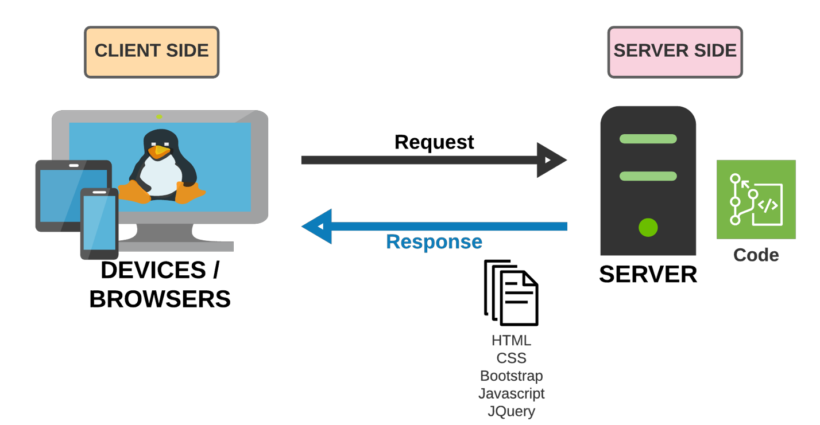

|  |
| --- |
| **SiteMap** |

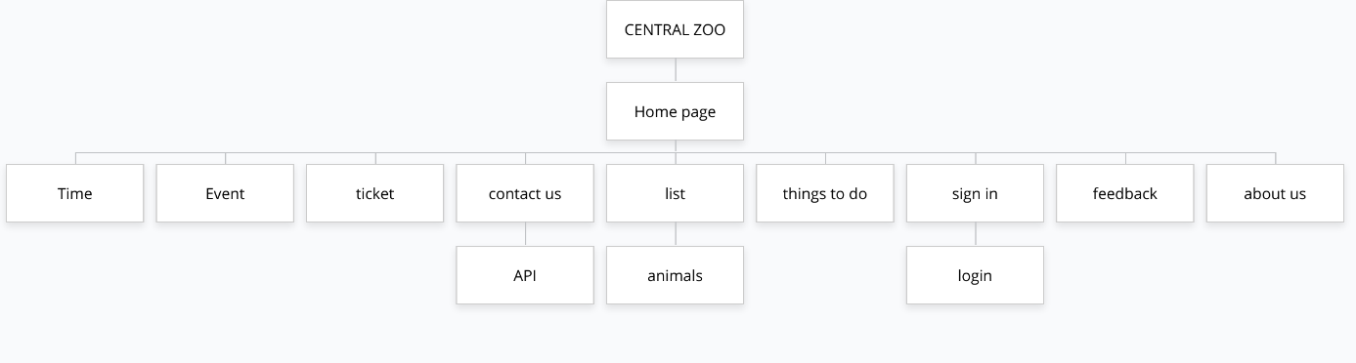

|  |
| --- |
| **Screen shots** |

Các layout mô tả màn hình. Sinh viên có thể vẽ layout. Nếu không thể thì code HTML cơ bản rồi chụp lại hình màn hình.

**Ví dụ cách thứ nhất:** (Khuyến cáo sử dụng)

1. **Homepage:**

|  |  |  |  |  |  |  |  |
| --- | --- | --- | --- | --- | --- | --- | --- |
| logo | Things to do | List  animals | booking | Sign in | About us | Feedback | |
| Time | | | | Event | | |  |
| OUR WORK  Review zoo | | | | | | | |
| Contact us | | | | | | | |

**Description** : the plan CENTRAL ZOO

**From** : Home page,Navbar Menu

**To** : Things to do, list animals , booking,…

|  |
| --- |
| **Testing document** |

|  |  |  |
| --- | --- | --- |
| **Sr.No** | **Features Tested** | **Remarks** |
| 1 |  |  |
| 2 |  |  |
| 3 |  |  |
| 4 |  |  |
| 5 |  |  |
| 6 |  |  |
| 7 |  |  |
| 8 |  |  |
| 9 |  |  |
| 10 |  |  |
| 11 |  |  |
| 12 |  |  |
| 13 |  |  |
| 14 |  |  |
| 15 |  |  |

|  |
| --- |
| **Final checklist** |

|  |  |  |
| --- | --- | --- |
| **Sr.No** | **Aspected Tested** | **Suggestion/**  **Remarks** |
| 1 | Are all the users able to view the images and links? |  |
| 2 | Have all the views, modules and controllers been properly integrated and is the site function as a single page application? |  |
| 3 | Are the GUI content devoid of spelling mistakes? |  |
| 4 | Is the application user-friendly? |  |
| 5 | Is the Website launching correctly in all popular browsers? |  |
| 6 | Are all the forms validated with proper criteria? |  |
| 7 | Do all text links lead to the appropriate website? |  |
| 8 | Do all image links lead to the appropriate website? |  |
| 9 | Are all the images and links clearly visible on the page? |  |
| 10 | Does the Web page work properly in all the tested browsers? |  |
| 11 | Does the Web page take too long to be loaded fully? |  |
| 12 | Is the navigation sequences correct through all the Web pages on the site? |  |
| 13 | Is the JavaScript code working as expected in all click events? |  |
|  |  |  |
|  | (Sinh viên ghi thêm…) |  |

|  |  |  |  |  |  |  |  |
| --- | --- | --- | --- | --- | --- | --- | --- |
| **No** | **Member** | **Contents** | **Page Name** | **Activity Plan** | **Date of Preparation of Activity Plan** | | |
| **Planed Start Date** | **Actual Start Date** | **Actual Days** | **Status** |
| 1 | Phạm Giang | Hompage | Hompage.html | 12/07/2022 | 12/12/2022 | 5 | OK |
| 2 | Animals list | List.html | 12/07/2022 | 12/12/2022 | 5 | OK |
| 3 | Booking | Ticket.html | 12/07/2022 | 12/12/2022 | 5 | OK |
| 4 | Event | Event.html | 12/07/2022 | 12/12/2022 | 5 | OK |
|  | | | | | | | |
| 1 | Nguyễn Quang Huy | Timing of zoo | time.html | 12/07/2022 | 12/12/2022 | 5 | OK |
| 2 | Things to do | Thingtodo.html | 12/07/2022 | 12/12/2022 | 5 | OK |
| 3 | About us | About us.html | 12/07/2022 | 12/12/2022 | 5 | OK |
|  | | | | | | | |
| 1 | Phan Gia Minh | Login | Sign in.html | 12/07/2022 | 12/12/2022 | 5 | OK |
| 2 | Contact us | Feedback.html | 12/07/2022 | 12/12/2022 | 5 | OK |
| 3 | Feedback | Contact us.html | 12/07/2022 | 12/12/2022 | 5 | OK |