# xmlHttpRequests/fetch - **POKEAPI**

Your task for today is as follows:

You will be using the following URL “<https://pokeapi.co/docs/v2#pokemon-section>” this is the for the **documentation** that you need to show you how to use each of the different http requests. The aim for today is to create a front end that is aesthetically pleasing and easy to use for a customer’s point of view.

The aim is to get as many of the following done as possible starting with **Abilities** and then as many of the other ones that you can do the aim should be to do **3 or more**.

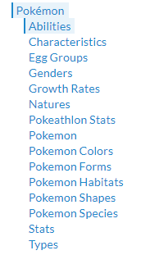

You will use xmlHttpRequests and/or fetch API to make these requests.

**Please make sure the data that is returned is being printed to the screen into html elements.**

**You will have the entire day to this.**

Towards the end of the day I would like you to present your website and talk to the class about what you have done.

* The presentation will last **10 minutes**
* Please tell us what each member of the team was in charge of and how you went about carrying out this project.
* Show all functionality that you have implemented and talk us a little bit through it.
* Also there may be some questions also from either the trainers or peers.

## PLEASE MAKE SURE YOUR ARE USING GIT 😊

LUNCH IS AT **12pm!**

**Throughout the day me and alan will be doing 1 to 1 for a short time.**

PLEASE MAKE SURE FINALY COMMIT IS DONE BY 3pm – Anything after this will not be considered.