Tlc marketing ltd  Harcourt Street London w1h 4hf

Summative Portfolio – “Gianluca Meola”

Level 3 Software Development Technician

# Contents Page

# **Introduction**

Within the introduction section you will be required to write up something with the following information.

1. **Name the company you work for, where it is based**
2. **Describe the aims and objectives of the company,**
3. **Describe the specific products and services that it offers**
4. **Describe the customer base that purchases the products / services**
5. **Describe your role in the company**
6. **Describe why you have decided to complete an apprenticeship.**
7. I work for TLC Marketing Worldwide, based in central London, close to Baker Street.
8. TLC Marketing Worldwide is a global marketing agency. The company is formed by a team of people that are a specialist marketing agency helping global brands influence consumer choice by providing on-brand rewards to every person who engages with the promotion.
9. The company provides to the client microsites where they can manage their promotional campaigns.
10. Most of the clients are international brands like Vodafone, Huggies, Time Out, etc.
11. My role in the company as a Junior .Net and full stack developer is to create a new feature for the Content Management System that the company uses to edit the microsites, and as front end developer I create some new template microsite for new campaign.
12. From the first day that I arrived in TLC, I started to learn many new features from the seniors, I learn about technologies and methodologies that they do not teach you during the courses, and this is the advantage to start an apprenticeship because you can learn and grow as a developer while you work. I can approach to real word tasks and build good habits and strong skills.

# **Logic**

writes code following an appropriate logical approach to agreed standards (whether web, mobile or desktop applications).

**Work activities demonstrating the minimum expected level of competence (Pass)**

* Designs simple programs and program modifications from supplied specifications, using agreed standards and tools, to achieve a well-engineered result.
* Creates and amends simple programs in accordance with the design.
* Documents all work in accordance with agreed standards.
* Takes part in reviews of own work.

**Work activities demonstrating competence beyond the minimum expected (Merit/Distinction)**

* Designs moderately complex programs and program modifications from supplied specifications, using agreed standards and tools, to achieve a well-engineered result.
* Creates, amends and keeps track of moderately complex programs in accordance with the design.
* Documents all work in accordance with agreed standards.
* Takes part in reviews of own work. Takes part in reviews of the work of colleagues.

In this project I will create a site Generator to add to the existing system of Microservices the are in Taas ( the Tlc Marketing back-end architecture system).

The solution layout, that tell us that what I’m building is a microservice. There are different project he: the service that is where the logic take action, the Model, 2 UI interface The Shell and the web application (still work in progress). To notice that I using a MockAPI to simulate the return of the data that I need.

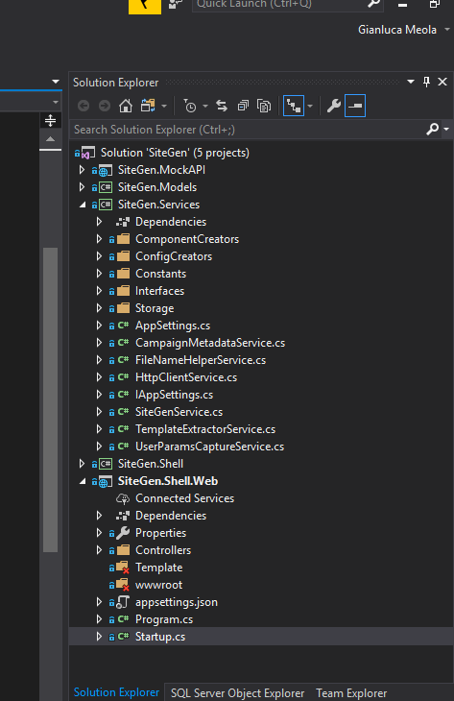

In the Startup.cs I declare all the services with a brief description, to say that this method add the services in the container.

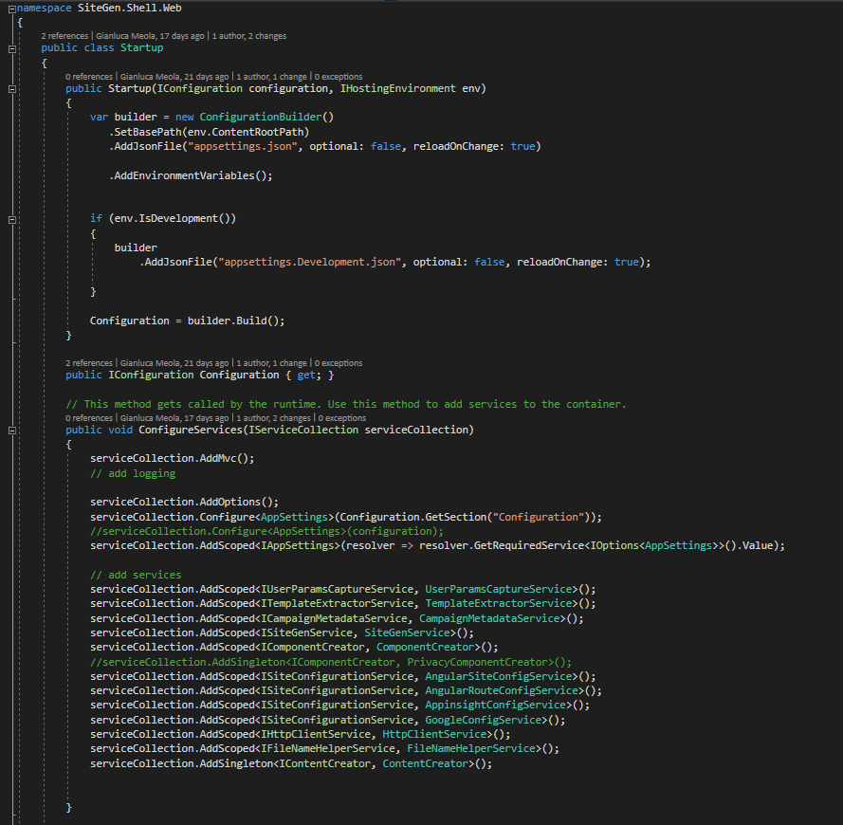

Then after That I defined the services that just exist that I will use, I created a concept mat to organize all the logic of the program that have to generate the website and the metadata. In particular is the metadata that have to be read form the database ( CosmosDB) and in the Storage (Azure Blob Storage) a JSON file have to be created.

In the next page there is the flow that I plan to follow for the development of the app.

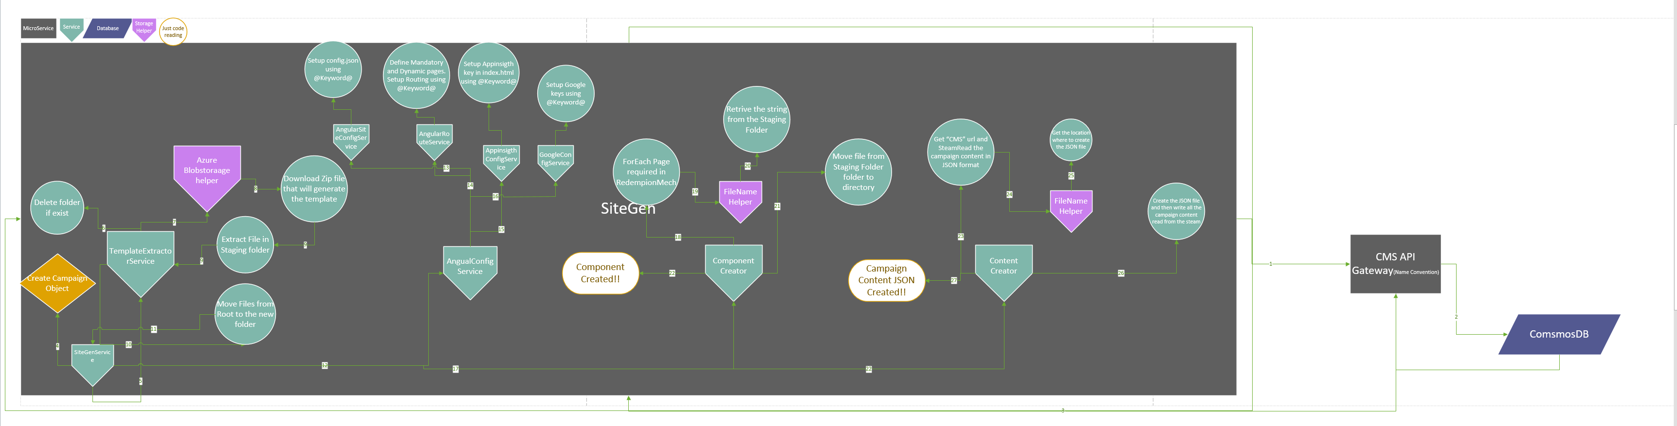

Once that the API is called the SiteGen Service will call the CMS API (in the API that I’m working on the local machine is calling the Mock API) to gather the data to create The Campaign object. The campaign object has all the information to create the new microsite.

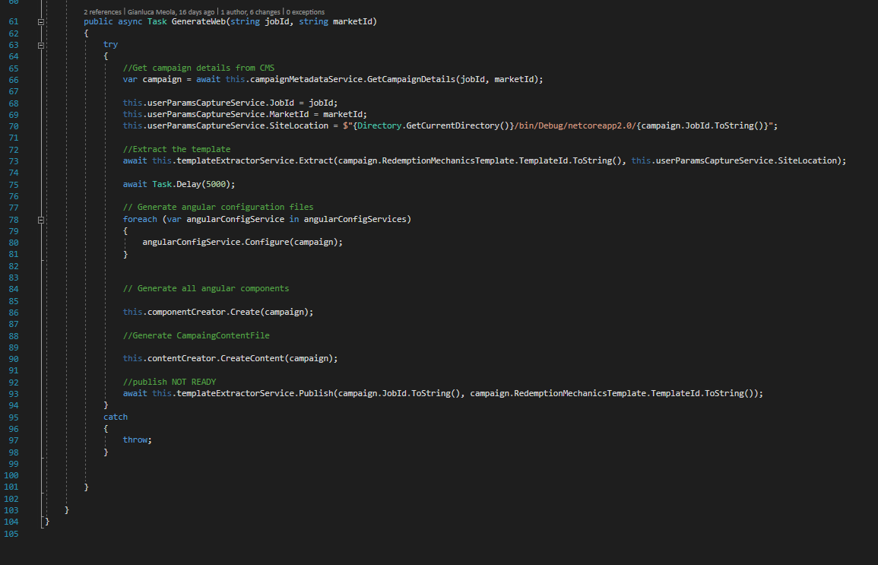

TemplateId that will create the right path to gather the zip file.

The TemplateExtractorService will download the SPA (Single Page Application) from the Azure Blob Storage and extract the file (for the local machine version) inside the bin folder. And will move the root folder in a folder with the jobId name.

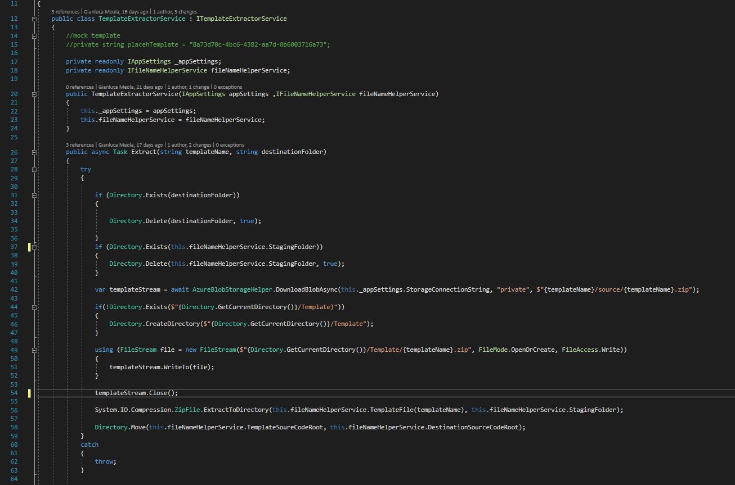

The AngularConfigurationService will print in the SPA the variable specific for the campaign, like the Angular component that the campaign need (registration or code), or the Goole API keys

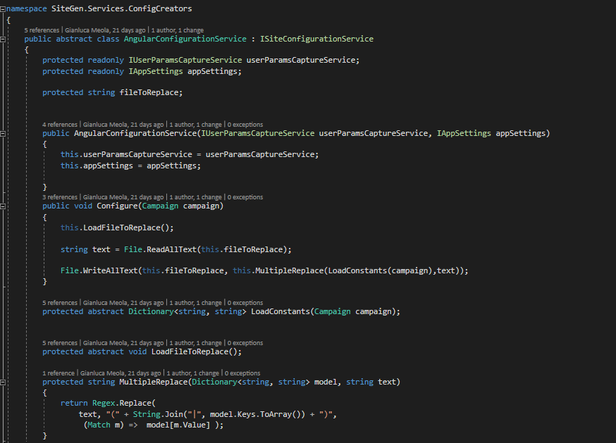

The component creator will select and copy the Angular component needed in the new SPA and will inject them one by one.

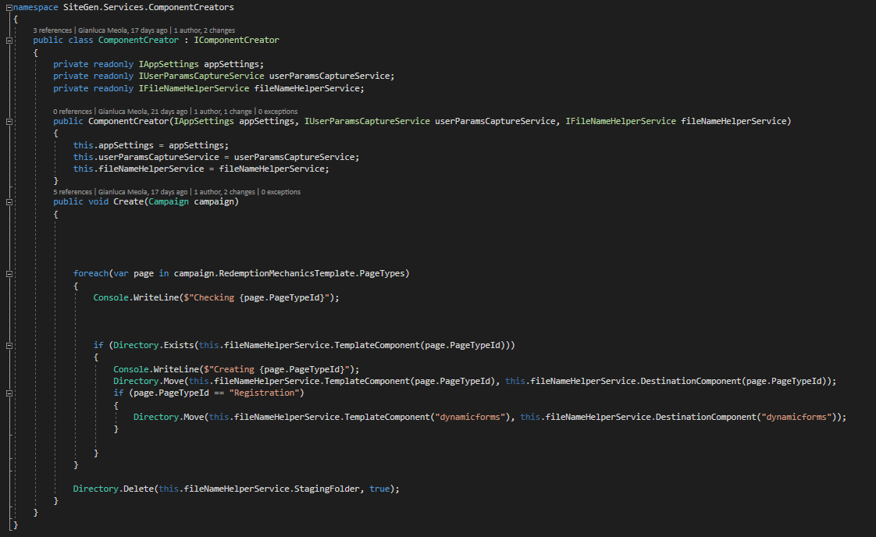

The content Creator will call the CMS again to get all the metadata from the database and will create a JSON file in the Assets of the SPA so the Spa will not have to call the CMS to get the metadata to populate the microsite.

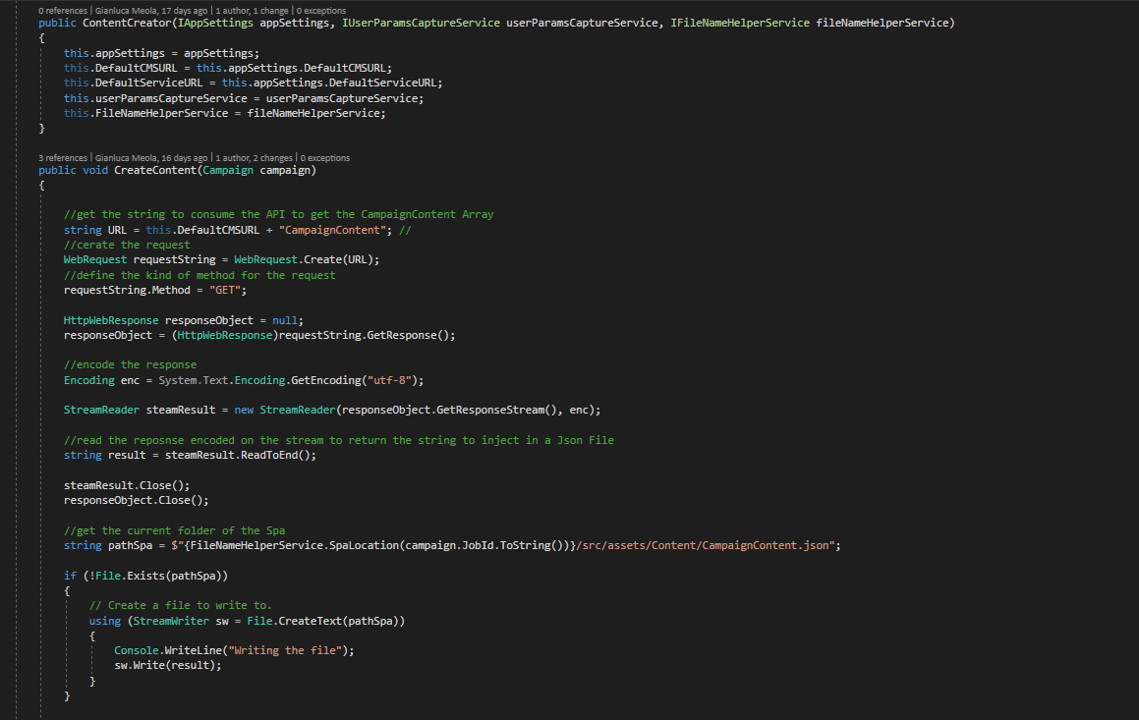

Inside the SPA I changed the API call to populate the microsite so it will read straight from the JSON file.



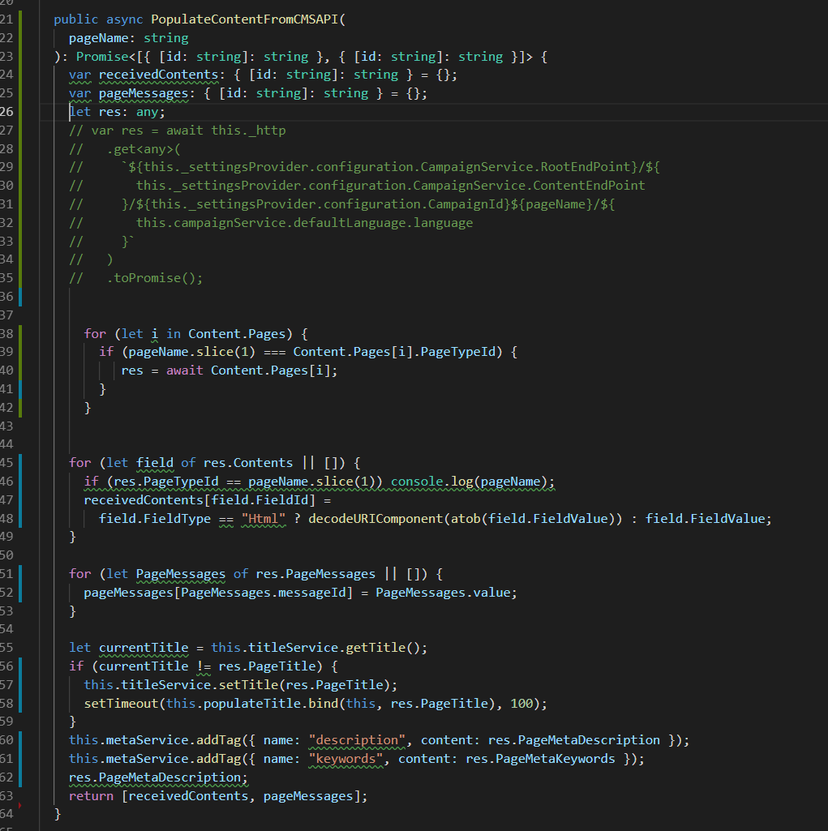

# **User Interface**

develops user interfaces as appropriate to the organisation’s development standards and the type of software development being undertaken. .

**Work activities demonstrating the minimum expected level of competence (Pass)**

* Assists in the design of simple applications using templates and tools to specify user/system interfaces including, for example: menus, screen dialogues, wireframes, boned rigs, inputs, reports, validation and error correction procedures, and processing rules.
* Contributes to user interface designs including colour, language, presentation, input methods, error handling and responses.
* Documents all work using required standards, methods and tools, including prototyping tools where appropriate.
* Assists in the execution of test plans to verify accessibility and usability of completed software.

**Work activities demonstrating competence beyond the minimum expected (Merit/Distinction)**

* Designs simple applications using templates and tools to specify user/system interfaces including, for example: menus, screen dialogues, wireframes, boned rigs, inputs, reports, validation and error correction procedures, and processing rules.
* Contributes to detailed user interface designs including colour, language, presentation, input methods, error handling and responses.
* Documents all work using required standards, methods and tools, including prototyping tools where appropriate.
* Constructs, interprets and executes test plans to verify accessibility and usability of completed software.

For the user interface project I will show you one of the most popular template that actually we have at Tlc Marketing to create the campaign.

The Design has been created by our senior front end developer for a USA campaign about the finess.

However the source code couldn’t be for other campaign because it was a stand-alone campaign. Then what I have done in 2 week is design a template that could be used for different campaign, and the clients could have full control of the content from the Admin Portal Content Management System.

What you see in the images are component that create dynamically the content (images, text or videos) if those content have been submitted from the Admin Portal.

Everything is injected from the Content Management System.

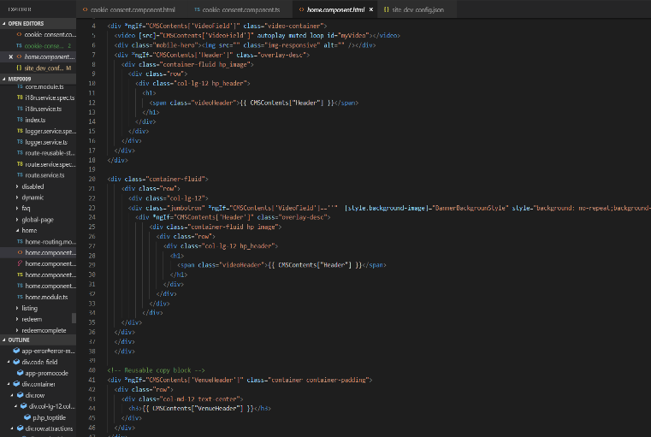

That is the metadata data file that I designed and created to display and get the values from the Admin Portal of the content manager System. This file will be edited every time that the customer will want from admin portal and trough a call to the CMS micro service.

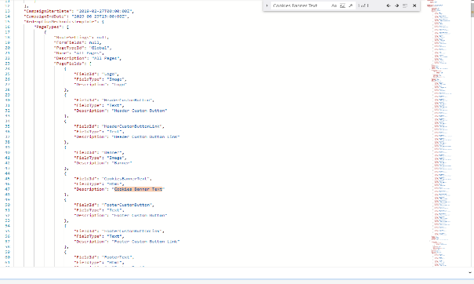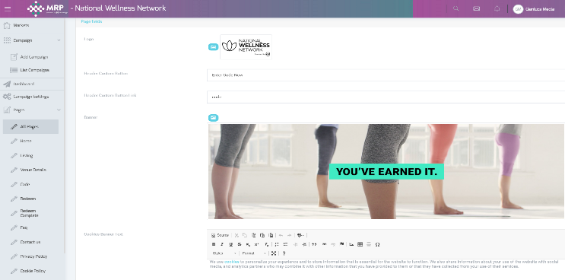

The same for the Listing page where I created a completely new layout and I add some animation with plain css.

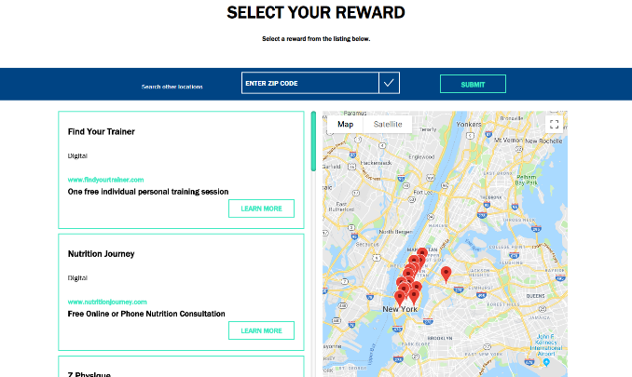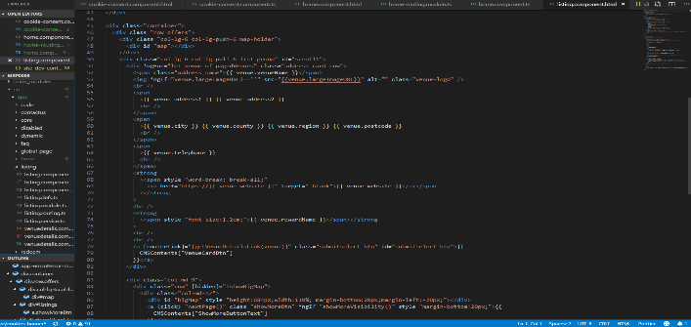

This is the redemption form where I had the dynamic validation and fields from the Admin Portal.

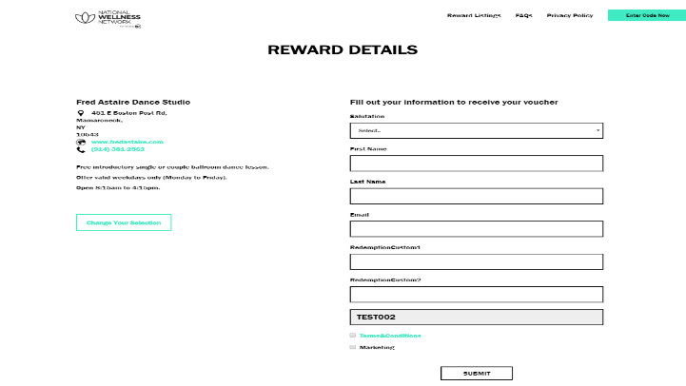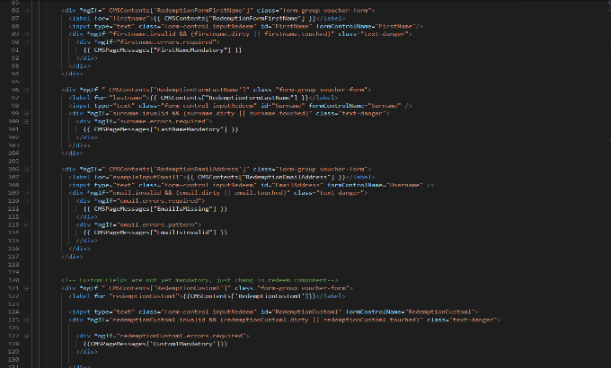

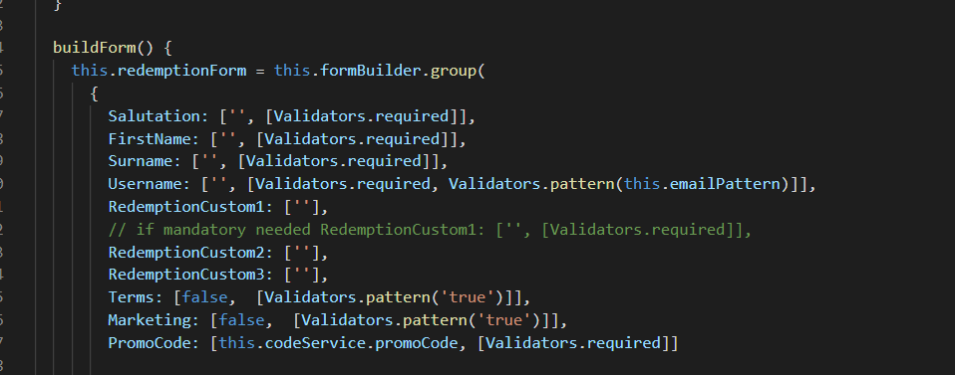 Here there are some of the fieds that are mandatory for some campaign and the email field has a regex to validate the email. 

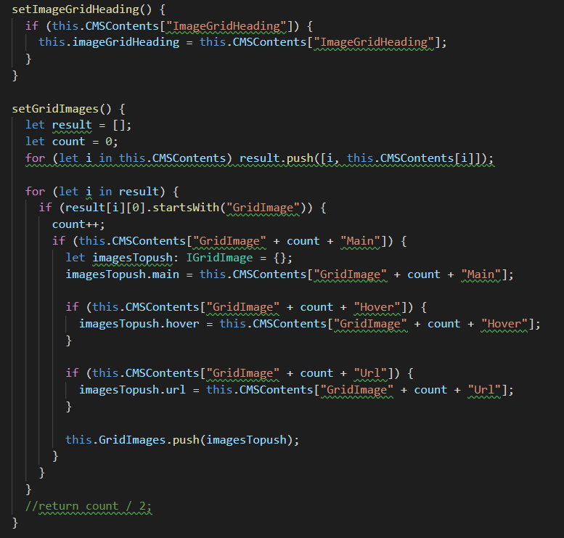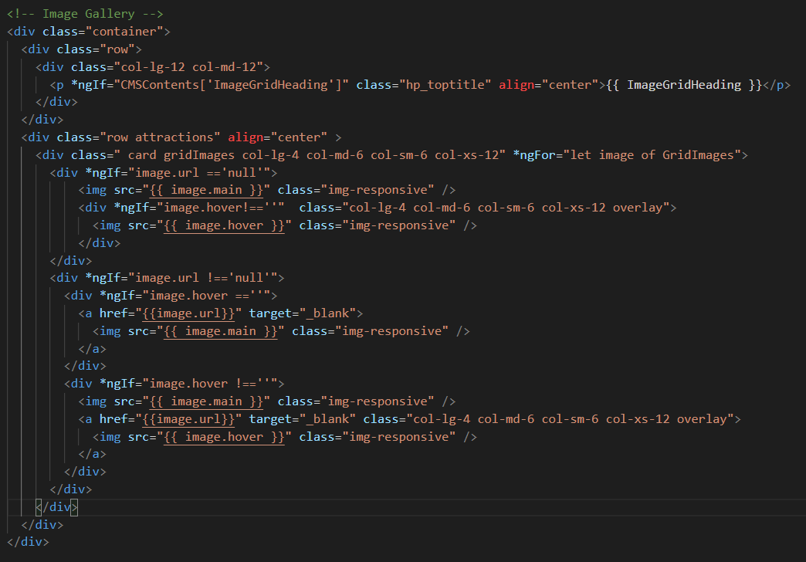

Here in the Image Gallery I build it in a dynamic way so the client are not forced to upload 9 images or upload 9 Hover image or even they have the option for each image to have an hyperlink.



To achieve a so high level of flexibility and keep a good design of each page, even if the content will be different from the original project ( e.g. in the image grid there could be just 6 images without leave withe spaces or “ugly” broken image errors) I used bootstrap, Angular 6+ features, jQuery and some personalized advanced CSS style. In particular in the grid image I use the bootstrap flex box to change dynamically the layout, and I use the angular for statement bonded to build one image after the other one and the if statement to check that the content exist before to generate the html to display on the webpage.

**Security**

applies appropriate secure development principles at all stages of development.

**Work activities demonstrating the minimum expected level of competence (Pass)**

* Assists with the application of specific procedures and security controls as required by organisational policy and local risk assessments to maintain confidentiality, integrity and availability of software.
* Identifies potential threats to the confidentiality, integrity or availability of the software and escalates to a higher level, to enhance resilience to unauthorised access.
* Assists with the application of procedures to assess compliance of software to policies, standards, legal and regulatory requirements.

**Work activities demonstrating competence beyond the minimum expected (Merit/Distinction)**

* Applies specific procedures and security controls as required by organisational policy and local risk assessments to maintain confidentiality, integrity and availability of software.
* Identifies potential threats to the confidentiality, integrity or availability of the software. Determines when security issues should be escalated to a higher level, to enhance resilience to unauthorised access.
* Applies procedures to assess compliance of software to policies, standards, legal and regulatory requirements.
* Communicates information-security issues effectively to colleagues and users.

**Development Support**

applies industry standard approaches for configuration management and version control to manage code during build and release.

**Work activities demonstrating the minimum expected level of competence (Pass)**

* Uses established techniques as directed to identify current problems and elicit, analyse, specify and document business functional, data and non-functional requirements for simple subject areas with clearly defined boundaries.
* Takes part in client/user meetings and assists in presenting issues and solutions both orally and in writing.
* Assists with software builds, for loading onto target hardware, from software source code (typically held within a configuration management system).
* Assists in the configuration of software and equipment for the systems testing of platform-specific versions of one or more software products.

**Work activities demonstrating competence beyond the minimum expected (Merit/Distinction)**

* Selects appropriate techniques for the elicitation of detailed requirements taking into account the nature of the required changes, established practice and the characteristics and culture of those providing the requirements.
* Analyses, specifies and documents business requirements as directed, ensuring traceability back to source. Analyses them for adherence to business
* objectives and for consistency, challenging positively as appropriate.
* Arranges, prepares and facilitates client/user meetings and presents issues and solutions both orally and in writing.
* Produces software builds, for loading onto target hardware, from software source code (typically held within a configuration management system).
* Participates in the configuration of software and test equipment for systems testing of platform-specific versions of one or more software products with minimum supervision.

# **Data**

makes simple connections between code and defined data sources as specified.

**Work activities demonstrating the minimum expected level of competence: (Pass)**

* Creates and amends simple programs in accordance with the design.
* Within a project environment, assists in the investigation of application data and process requirements, documenting them according to the required standards, utilising the prescribed methods and tools.
* Produces components of detailed designs, such as: physical data flows, class diagrams, file layouts, common routines and utilities, program specifications or prototypes, and backup, recovery and restart procedures.
* Documents all work using required standards, methods and tools, including prototyping tools where appropriate.

**Work activities demonstrating competence beyond the minimum expected: (Merit/Distinction)**

* Creates, amends and keeps track of moderately complex programs in accordance with the design.
* Within a project environment, applies data analysis and data modelling techniques, based upon a general understanding of the business process, to establish, modify or maintain a data structure and its associated components (e.g. entity descriptions, relationship descriptions, attribute definitions).
* Produces detailed designs including for example: physical data flows, class diagrams, file layouts, common routines and utilities, program specifications or prototypes, and backup, recovery and restart procedures.
* Documents all work using required standards, methods and tools, including prototyping tools where appropriate.

# **Test**

Apprenticescan functionally test that the deliverables have/have not been met.

**Work activities demonstrating the minimum expected level of competence: (Pass)**

* Plans, designs and conducts tests of simple programs; corrects errors and retests to achieve an error-free result.
* Defines test conditions for given requirements.
* Designs test cases and creates test scripts and supporting data, working to the specifications provided. Understands techniques for prioritising tests (e.g. based upon risk or the area of change). Optimises value of testing within limited time-boxes.
* Interprets and executes supplied sets of simple test scripts using agreed methods and standards, in accordance with project test plans.
* Checks test results, and documents test failures and successes compared with pre-determined criteria.
* Analyses and reports test activities and results to supervisor and/or other colleagues in a clear and concise manner.

**Work activities demonstrating competence beyond the minimum expected: (Merit/Distinction)**

* Plans, designs and conducts tests of moderately complex programs; corrects errors and re-tests to achieve an error free result.
* Reviews requirements and specifications, and defines test conditions.
* Analyses test requirements, designs and builds simple test-case suites, test scripts, and test procedures, with expected results.
* Interprets and executes sets of moderately complex test scripts using agreed methods and standards, recording and reporting outcomes.
* Checks test results, and documents test failures and successes compared with pre-determined criteria, in accordance with agreed standards.
* Analyses and reports test results to supervisor and/or other colleagues in a clear and concise manner. Identifies and reports issues and risks associated with own work.

# **Analysis**

Apprentices follows basic analysis models such as use cases and process maps.

**Work activities demonstrating the minimum expected level of competence: (Pass)**

* Assists colleagues and clients/users to investigate and model business functions, processes, information flows and data structures, using various methodical and consistent techniques.
* Assists colleagues and clients/users in specifying information flows, processes/procedures and data objects that align with the needs of the business.
* Takes part in client/user meetings and assists in presenting issues and solutions both orally and in writing.
* Records work with appropriate documentation, meeting the required standards, and uses suitable methods and tools.

**Work activities demonstrating competence beyond the minimum expected: (Merit/Distinction)**

* Works with colleagues and clients/users to investigate and model business functions, processes, information flows and data structures, using various methodical and consistent techniques.
* Works with colleagues and clients/users in specifying information flows, processes/procedures and data objects that will meet the business requirements.
* Arranges, prepares and facilitates client/user meetings and presents issues and solutions both orally and in writing.
* Records work with appropriate documentation, meeting the required standards, and uses suitable methods and tools.
* Understands the purpose and benefits of modelling, and uses established techniques as directed to model simple subject areas with clearly defined boundaries.
* Elicits and records business/context rules and concepts, and confirms them with business experts.

# **Development Life Cycle**

supports the software developers at the build and test stages of the software development life cycle.

**Work activities demonstrating the minimum expected level of competence: (Pass)**

* Takes part in reviews of supplied specifications.
* Takes part in reviews of own work.
* Identifies and reports issues and risks.
* Assists other members of the software development team in improving software functionality and performance by discussing test results.

**Work activities demonstrating competence beyond the minimum expected: (Merit/Distinction)**

* Conducts reviews of supplied specifications with others, as appropriate.
* Takes part in reviews of own work. Takes part in reviews of the work of colleagues.
* Records explicit details of failing test cases, such that delivery teams can understand and reproduce issues found.
* Provides guidance and assistance to colleagues in any aspect of program design, creation, testing, documentation, debugging and maintenance.

**Quality**

follows organisational and industry good coding practices (including for naming, commenting, etc.).

**Work activities demonstrating the minimum expected level of competence: (Pass)**

* Designs simple programs and program modifications from supplied
* specifications, using agreed standards and tools, to achieve a well-engineered result.
* Documents all work in accordance with agreed standards.
* Takes part in reviews of supplied specifications.
* Takes part in reviews of own work.

**Work activities demonstrating competence beyond the minimum expected: (Merit/Distinction)**

* Designs moderately complex programs and program modifications from supplied specifications, using agreed standards and tools, to achieve a well-engineered result.
* Documents all work in accordance with agreed standards.
* Conducts reviews of supplied specifications with others, as appropriate.
* Takes part in reviews of own work. Takes part in reviews of the work of colleagues.

# **Problem Solving**

1. solves logical problems, seeking assistance when required (including appropriate mathematical application);
2. responds to the business environment and business issues related to software development.

**Work activities demonstrating the minimum expected level of competence: (Pass)**

* Plans, designs and conducts tests of simple programs; corrects errors and re-tests to achieve an error free result.
* Within own area of competence investigates issues and other requests for application support and determines appropriate actions to take.
* Within own area of competence and working closely with more senior colleagues, provides correct responses to requests for application support.
* Carries out fault diagnosis relating to simple software failures, reporting the results of the diagnosis in a clear and concise manner.

**Work activities demonstrating competence beyond the minimum expected: (Merit/Distinction)**

* Plans, designs and conducts tests of moderately complex programs; corrects errors and re-tests to achieve an error-free result.
* Within own area of competence, provides correct responses to requests for application support by means of, for example: making modifications to software, developing workarounds, training users or operations staff, producing additional documentation, or escalating requests to colleagues.
* Carries out fault diagnosis relating to moderately complex software problems, reporting the results of such diagnosis in a clear and concise manner.

**Communication**

clearly articulates the role and function of software components to a variety of stakeholders (including end users, supervisors etc.).

**Work activities demonstrating the minimum expected level of competence: (Pass)**

* Takes part in client/user meetings and assists in presenting issues and solutions both orally and in writing.
* Documents all work in accordance with agreed standards.

**Work activities demonstrating competence beyond the minimum expected: (Merit/Distinction)**

* Arranges, prepares and facilitates client/user meetings and presents issues and solutions both orally and in writing.
* Documents all work in accordance with agreed standards.

**CONCLUSION**