

CS 7345 ADVANCED APPLICATIONS: LAB 4

Qing Gao 48358925

1. Document API and Networking features for library:

The directory of the file is as follow:

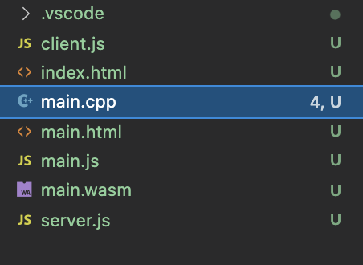

First, we implement the client in C++. Sending the message of client in main.cpp with several function:

1. Emscripten WebSocket Open Event

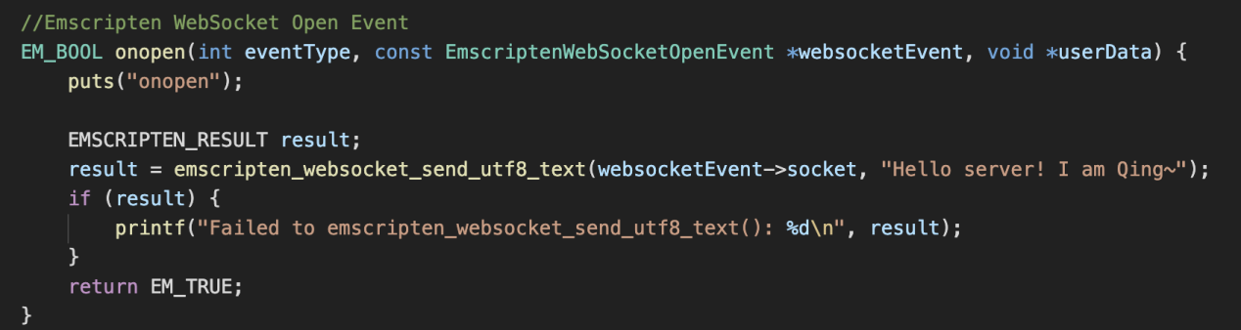

1. Emscripten WebSocket Error Event

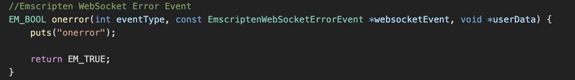

1. Emscripten WebSocket Close Event

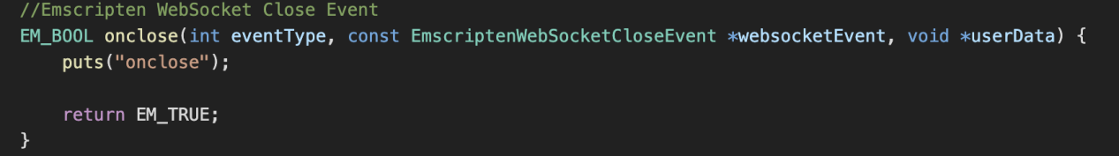

1. Emscripten WebSocket Message Event

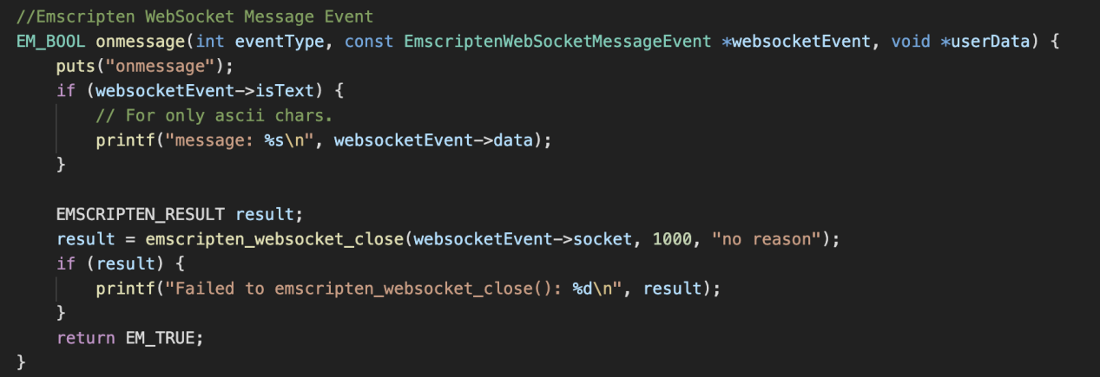

1. Main function

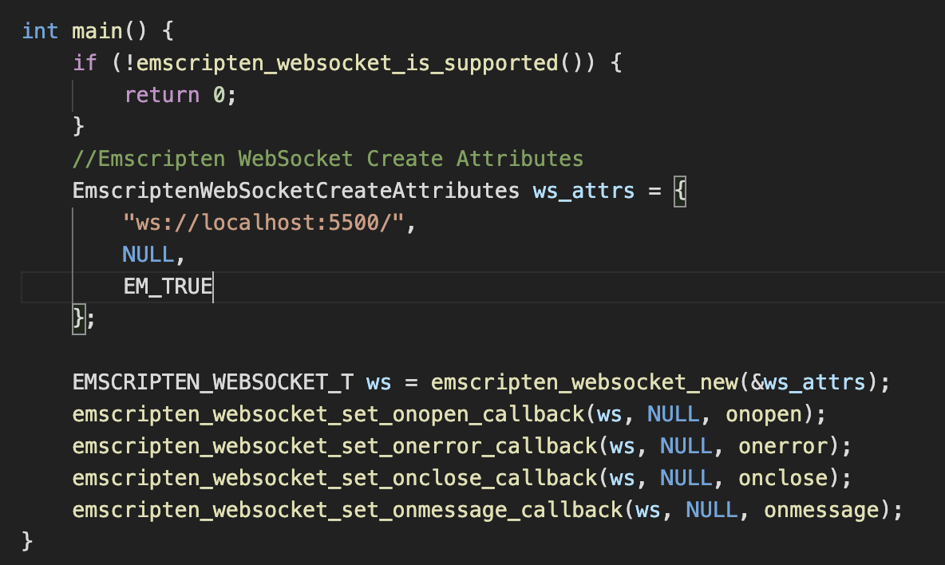

Next, I use “emcc main.cpp -lwebsocket.js -o main.html” to convert CPP to HTML. At that time, I could use main.js to communicate with the server.

I use Node.js as server part. Reading message from client and reply message to the front end.

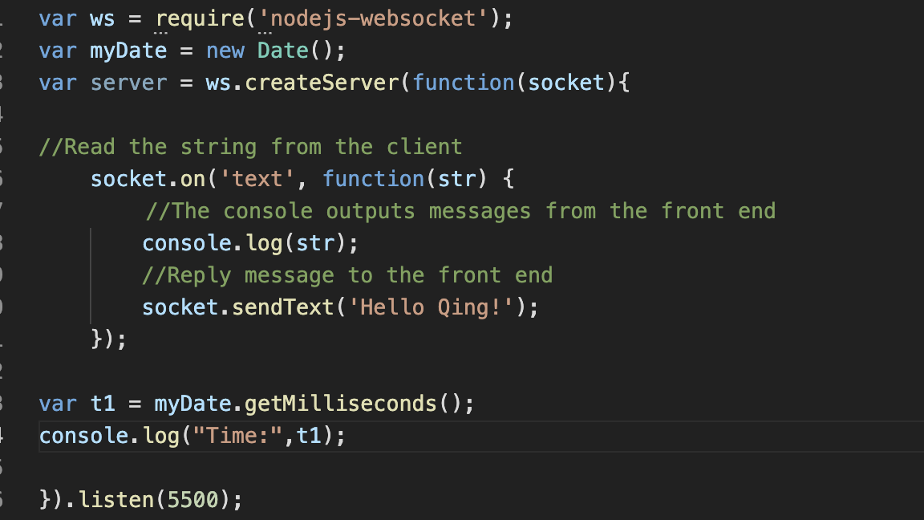

I use Js as the comparison program, as shown in the figure below: Sending message to server and accepting message from server.

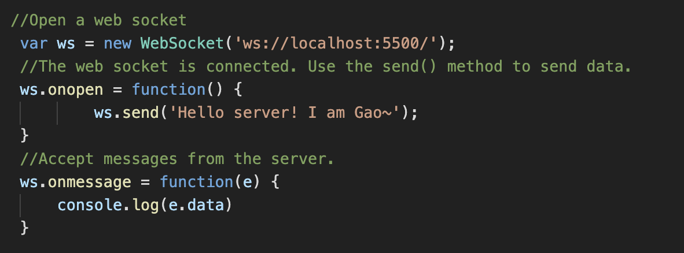

The operation results are as follows:

Client(c++) accept message come from server.

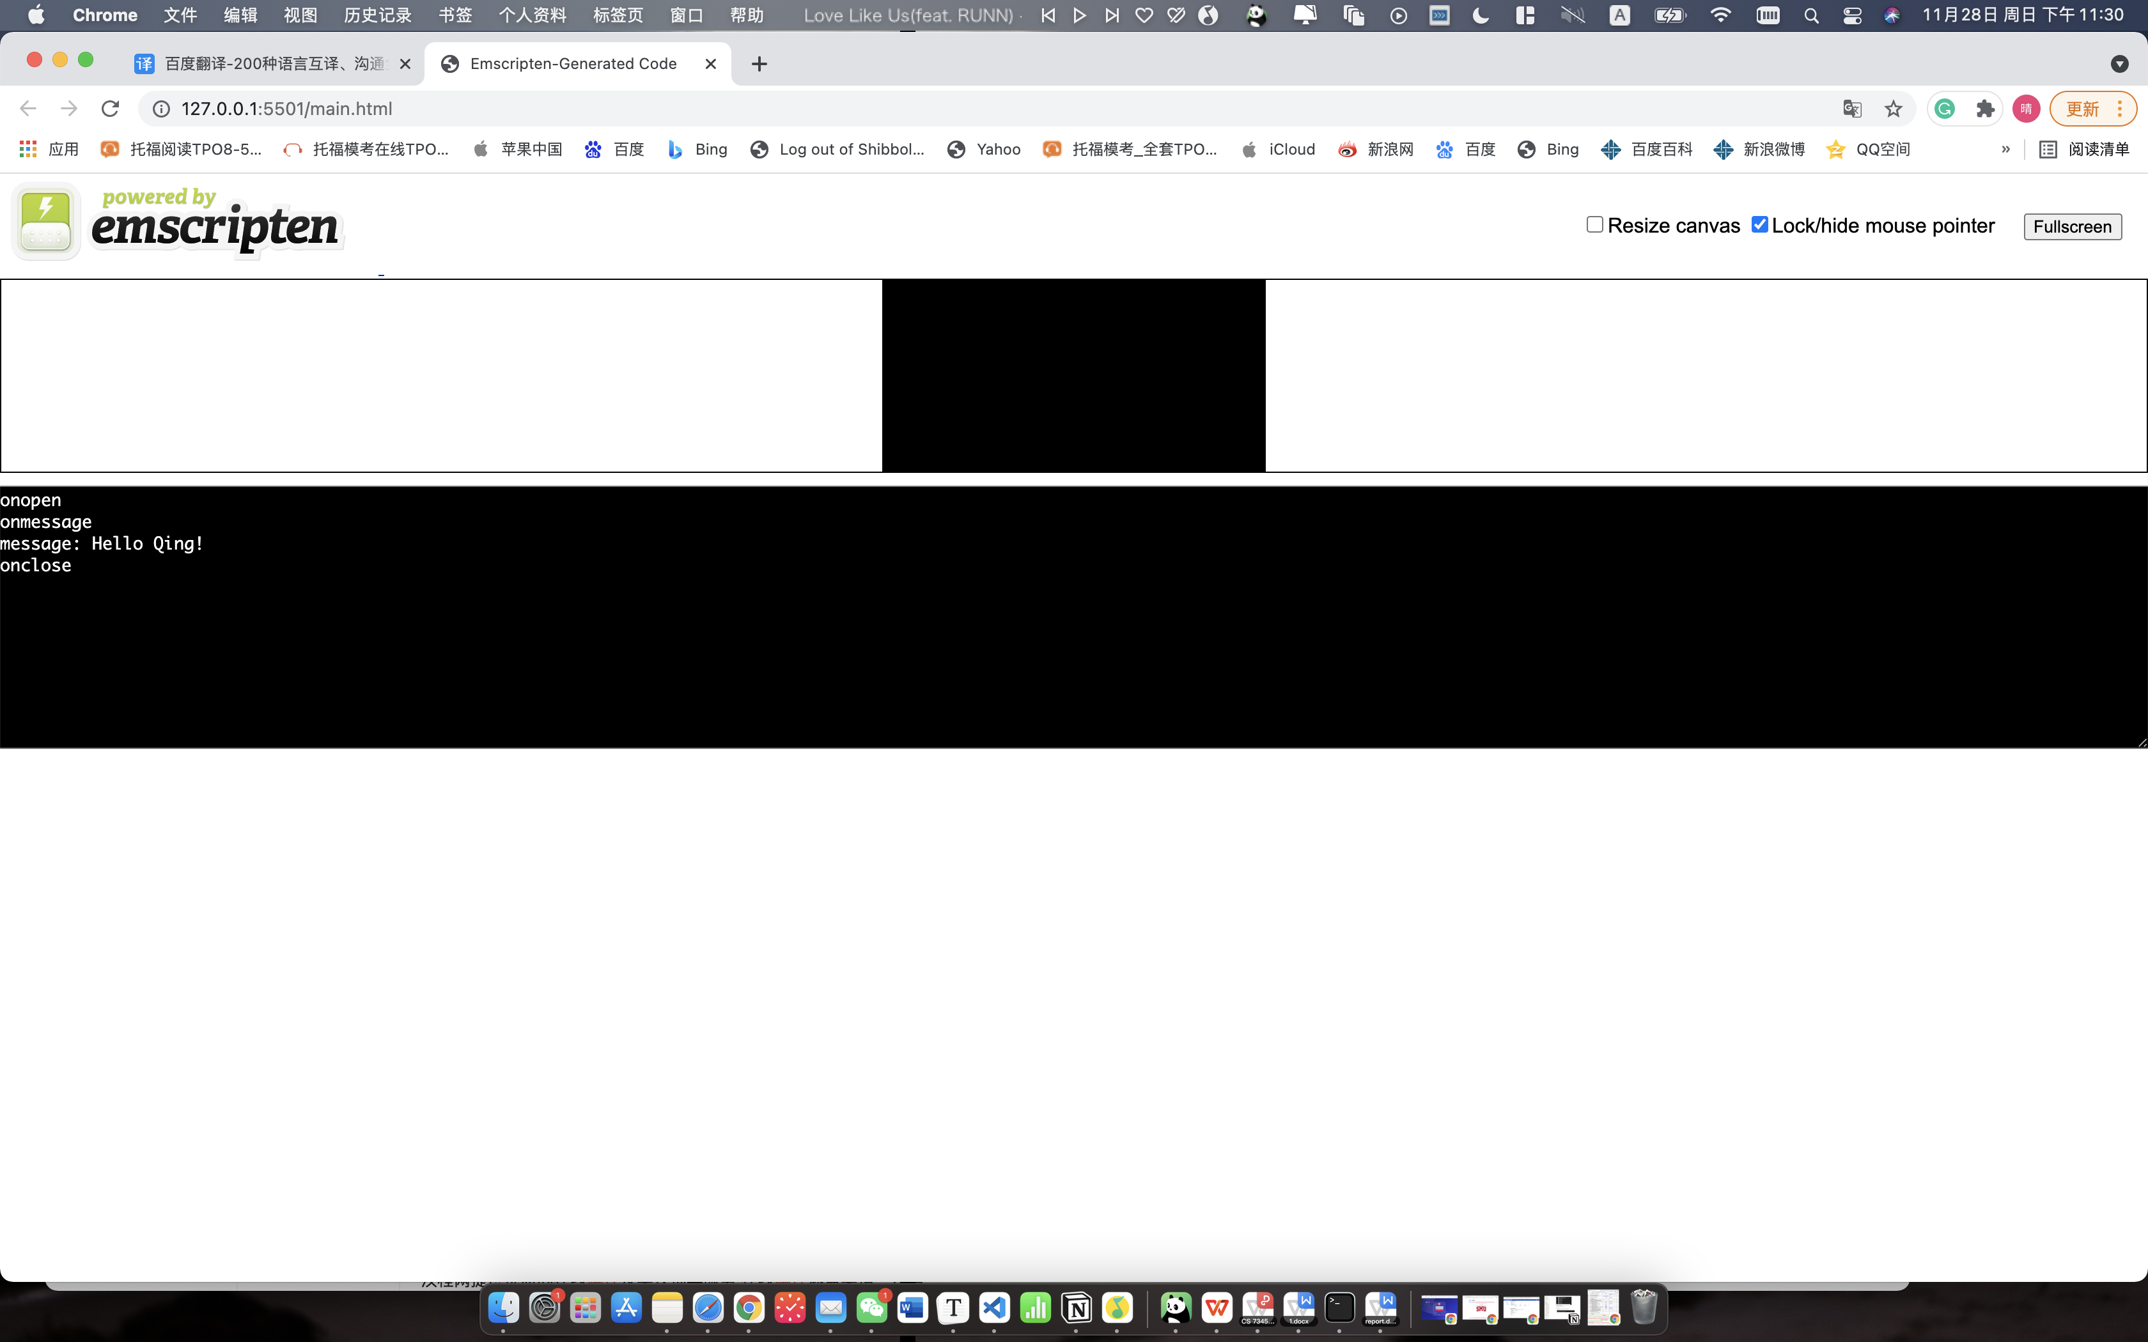

Server accept message come from client(c++).

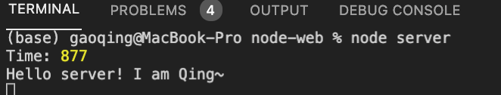

Client(Js) accept message come from server.

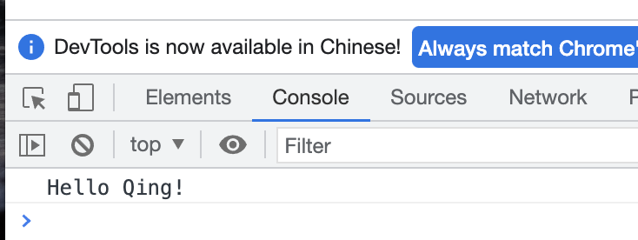

Server accept message come from client(Js).

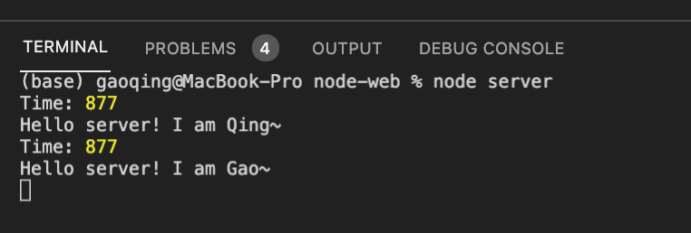

High-level class layout/UML:

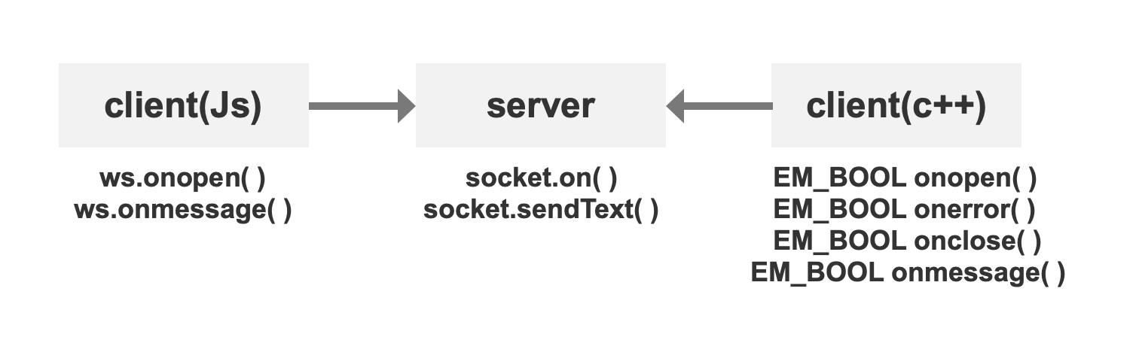

1. Compare and Contrast execution time :

Whether C + + or JS is the client, the information transfer between the server and the client is very fast and can not be calculated in milliseconds. But the response of C + + as the client to the server is slower than that of JS as the client to the server.However, the speed of acceptance by the server is almost the same