CS 7345 ADVANCED APPLICATIONS: LAB 1

NAME: Qing Gao

ID: 48358925

Setup the Emscripten pipeline

1. Download emsdk through git's clone command



1. Enter folder



1. Get the latest emsdk version

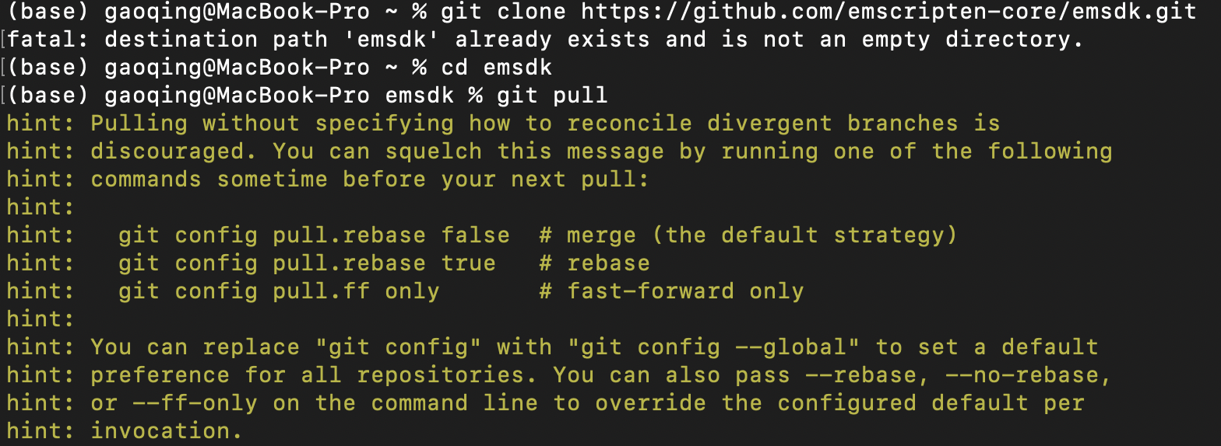

1. Download and install the latest tools

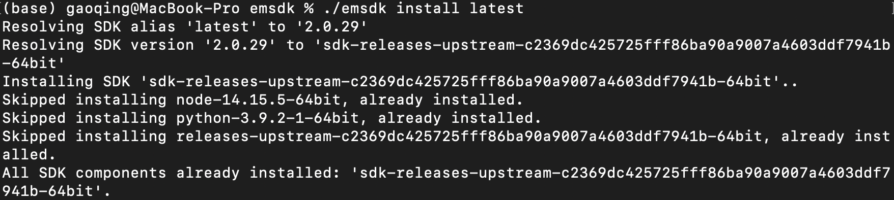

1. Activate tool

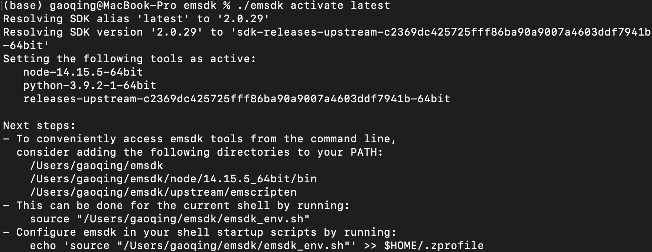

1. Run to see if the installation is successful

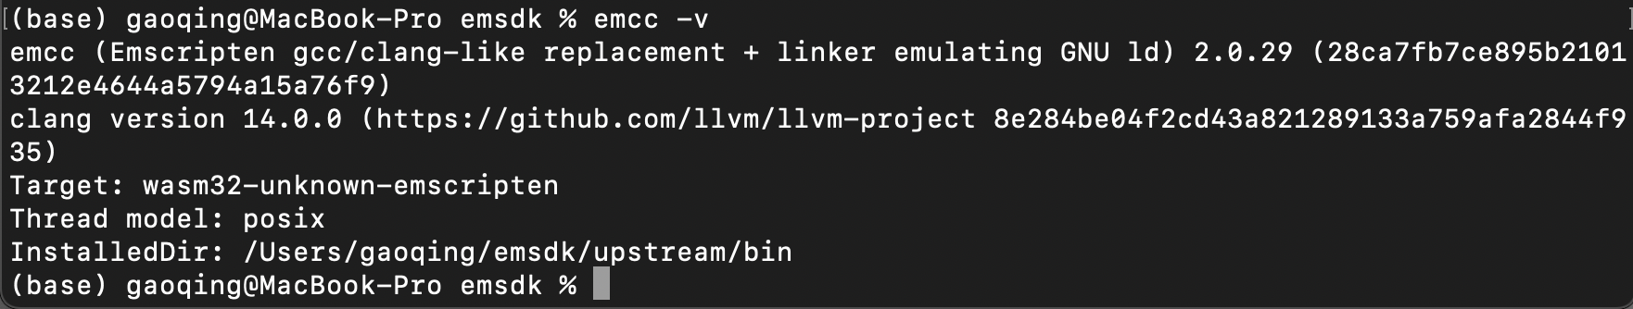

Verify with hello world project

1. Create c++ file
2. Run emcc hello.c -s WASH=1 -o hello.html

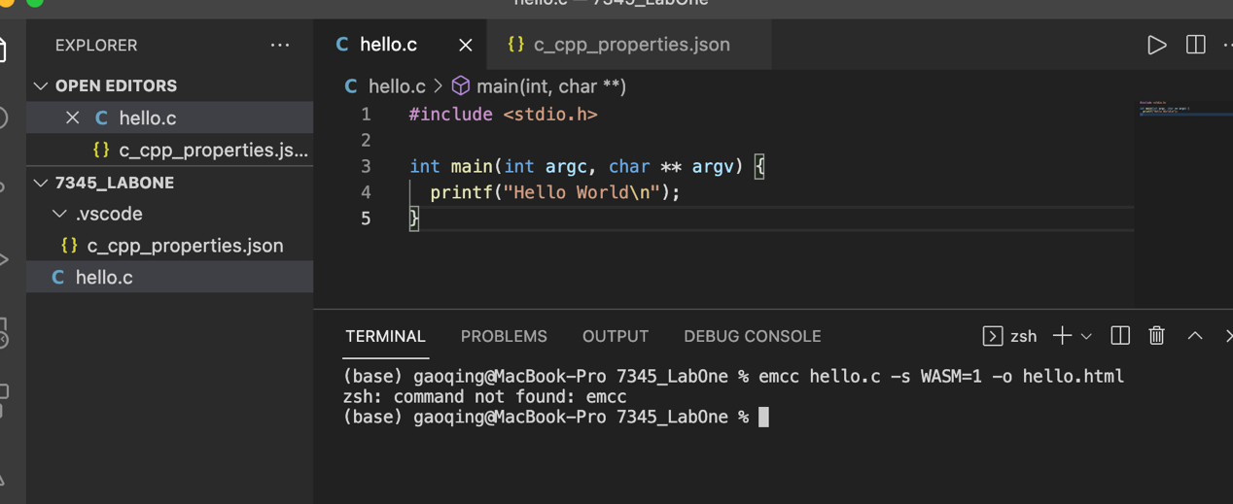

Error: ‘zsh command not found: emcc’

Reason: EMCC is not configured in the current path

Solution：Put the hello.c file into emsdk file, and active the emcc

1. Enter emsdk file environment, and activate environment variable



1. Go back to the file path where hello.c is located, and run



1. File generated successfully

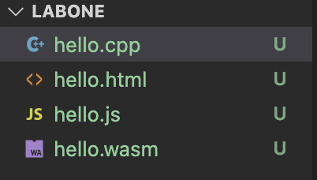

1. Open file with browser

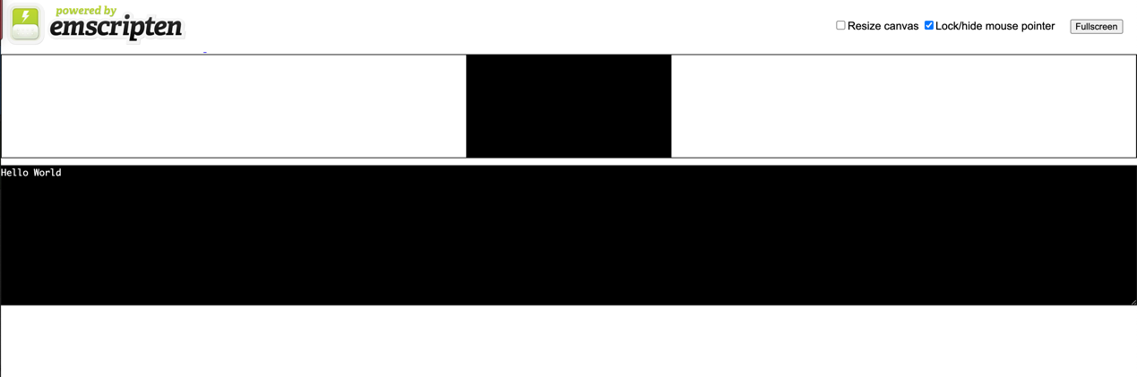

Compare and Contrast execution time between native and wasm based code bases

1. My .cpp Code

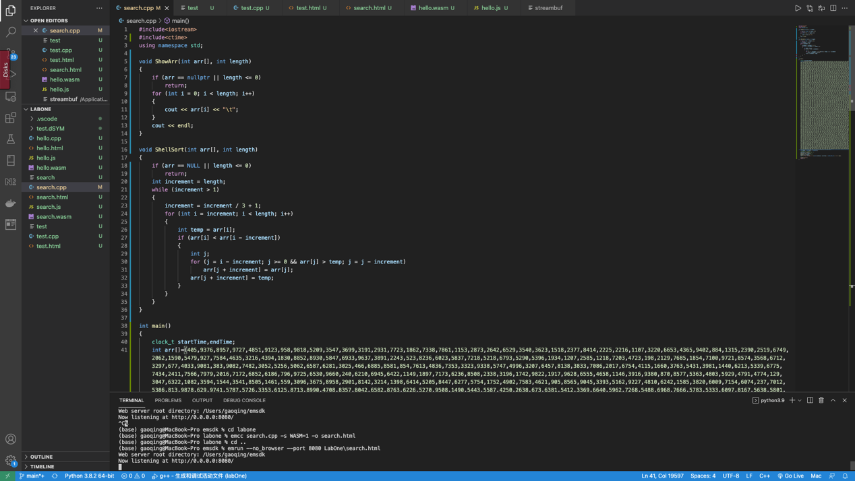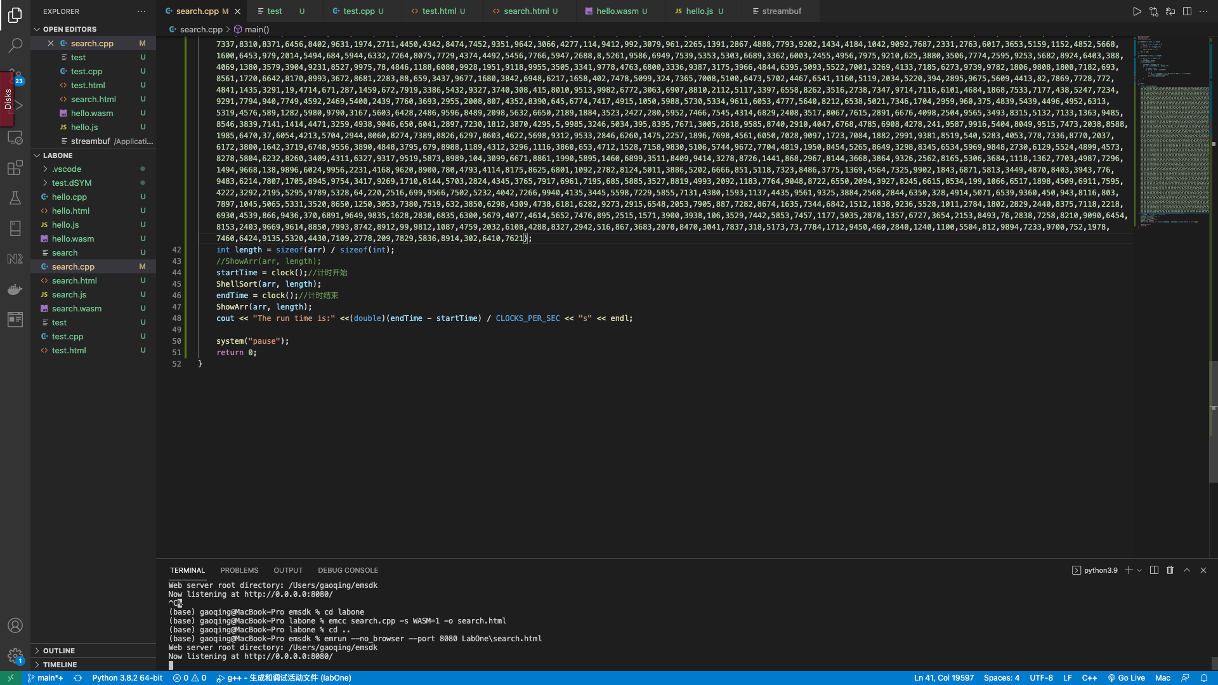

1. Test code base compiling with emcc to native executable code

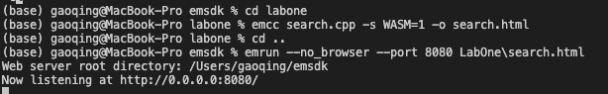

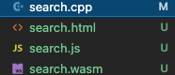

1. Build code base to WebAssembly

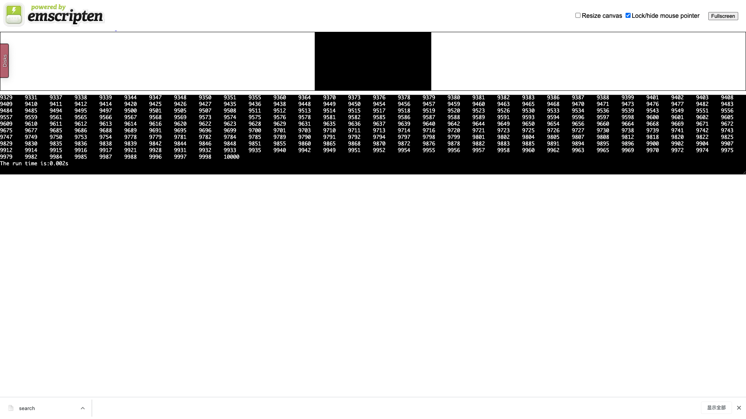

1. Analysis

