12/29/2016

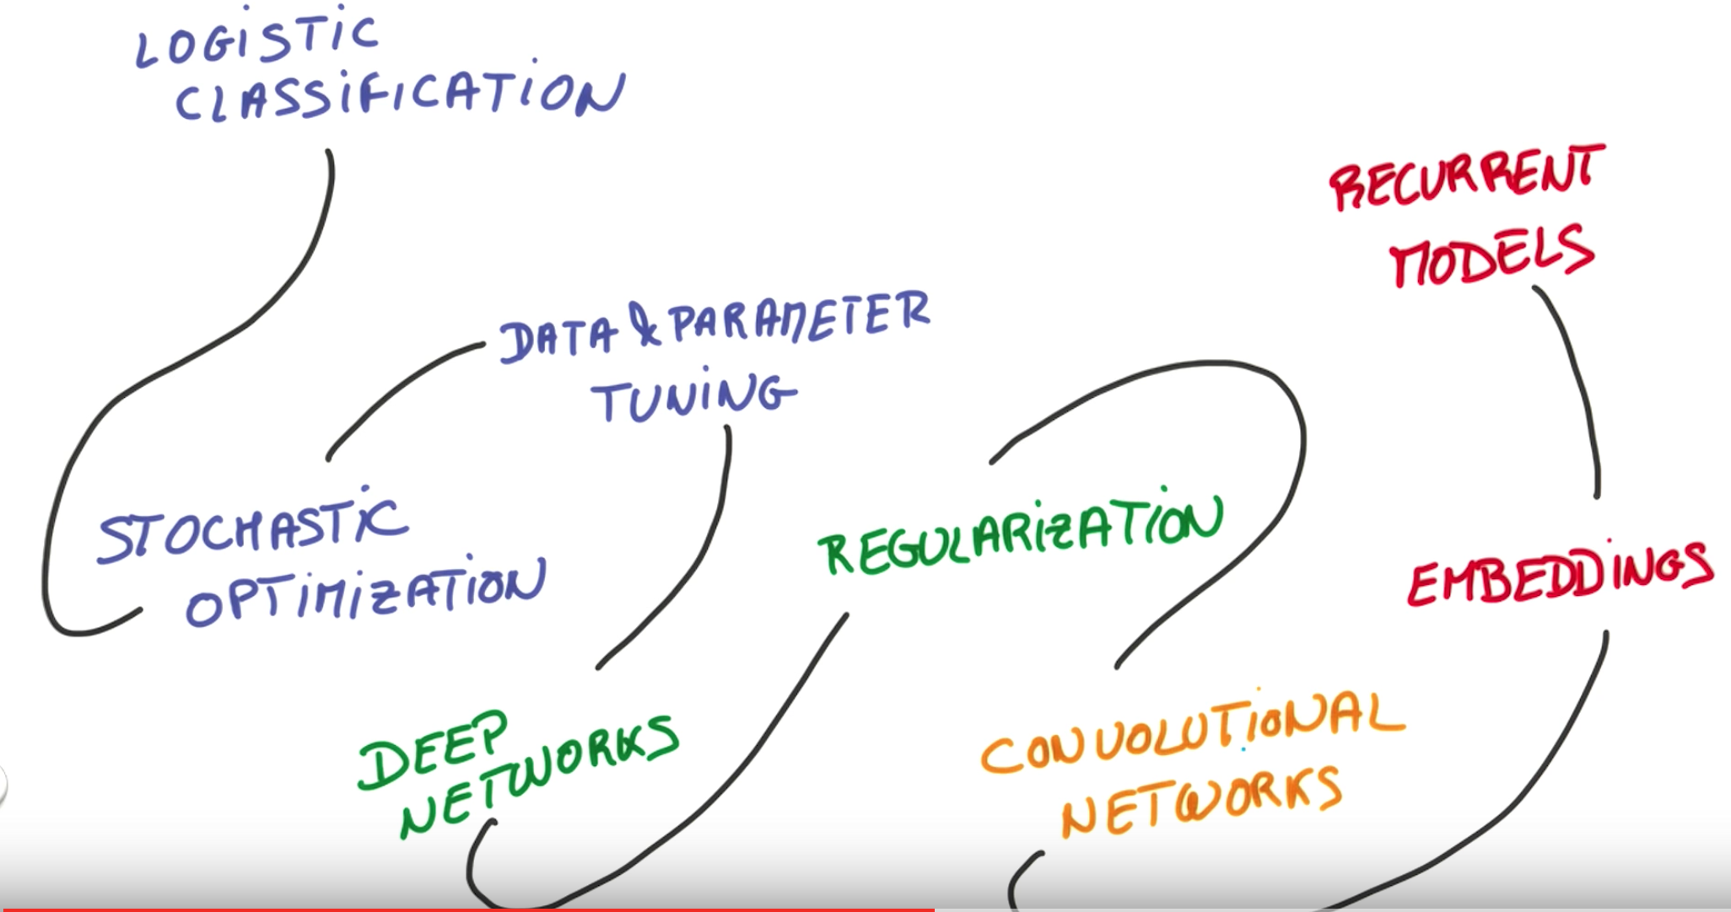

use softmax to change scores(WX + b = Y) to probabilities

\*scores are also called Logits in logistic regression