PowerBI - Day 5

Collaboration

Contents

Introduction 3

Power BI Service – Collaboration and Distribution 4

Power BI Mobile – Accessing Report on Mobile Device 8

References 12

## Introduction

This document is lab five of five total labs.

Please continue to use your file after completing Lab 4. If you are joining the DIAD at this point or were unable to complete previous labs, please start this lab with the provided **DIAD Final Report.pbix** file located in the Reports folder.

At the end of this lab, you will have learned how to share your dashboard and collaborate with other users. You will also have learned how to access your dashboard on your mobile device.

The lab includes steps for the user to follow along together with associated screenshots that provide a visual aid. In the screenshots, sections are highlighted with red or orange boxes to indicate the area the user needs to focus on.

**NOTE:** This lab uses real, anonymized data provided by ObviEnce, LLC. Visit their site to learn about their services: www.obvience.com[.](http://www.obvience.com/) This data is the property of ObviEnce, LLC and has been shared to demonstrate Power BI functionality with industry sample data. Any use of this data must include this attribution to ObviEnce, LLC.

Power BI Service – Collaboration and Distribution

You have built the dashboard and are now ready to get feedback and collaborate with your team members.

1. Sign in to PowerBI.com to access your workspace.
2. From the left panel, click **Workspaces**.
3. Click the **ellipsis** next to **DIAD_<youremailaddress>.**
4. Click **Workspace access**.
5. The **Access** dialog opens. Enter the email addresses of the colleagues with whom you want to collaborate. Each user can belong to one of three roles as follows:

|  |  |
| --- | --- |
| Contributor | Add/edit/delete content within workspace. |
| Member | Everything a Contributor can do. Re-share. Publish & update Apps. |
| Admin  Viewer | Everything a member can do. Can change/delete workspace. Can add Admins.  View/interact  Read data stored in workplace Data Flows |

1. Select the appropriate role and then click **Add**.
2. Once you have finished adding your colleagues, click **Close**.

**Note**: If you don’t have a colleague’s email please close without submission.

**Note**: You can ask your colleague to login and access the workspace.

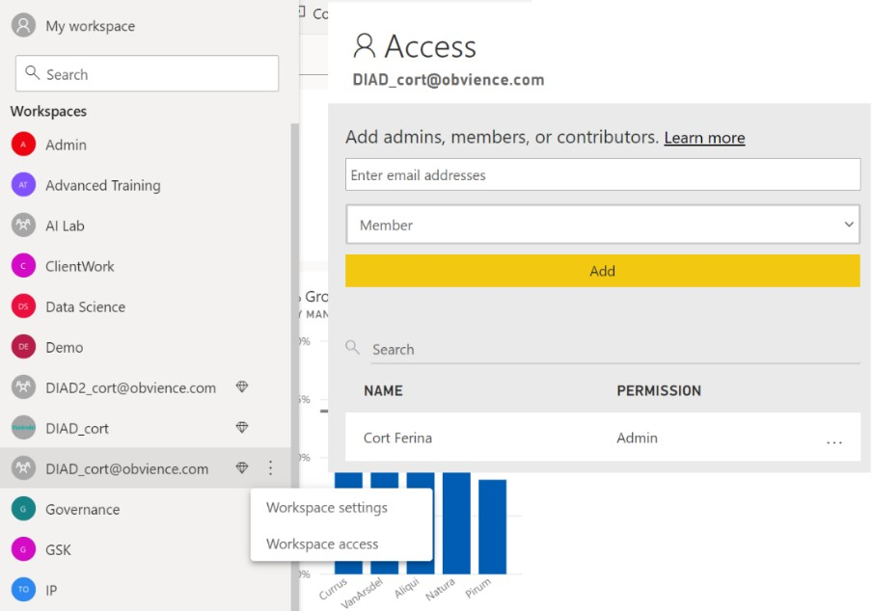

Now let’s share the content we have created with report viewers and consumers. To start, we need to publish an app. An App can include multiple dashboards and reports.

1. In the left panel select the **DIAD_<youremailaddress> workspace**.
2. In the **Dashboard** page, notice there is an option named **Included in App** which can be selected to include the Dashboard in the App.

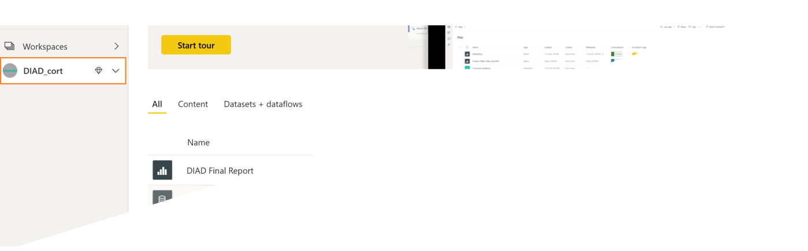

1. Navigate to the **Reports** page.
2. Notice there is an option named **Included in App** which can be selected to include the Reports in the App.

If you have reports and dashboards in your workspace that you do not want to share with report viewers, uncheck this box. In our case we would like to include the DIAD Final Report, so we will leave the box checked. Ensure you have checked the report and not the dataset.

1. In the left panel, click the **DIAD_<youremailaddress>** workspace.
2. In the upper right corner, click the **Create app** button.

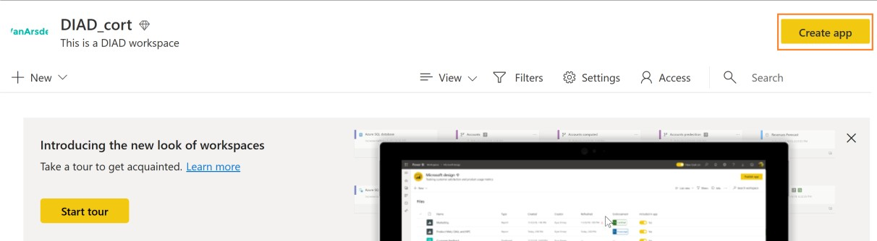

1. In the **Setup** page, type **This is DIAD app** in the description field.
2. Click the **Navigation** tab.

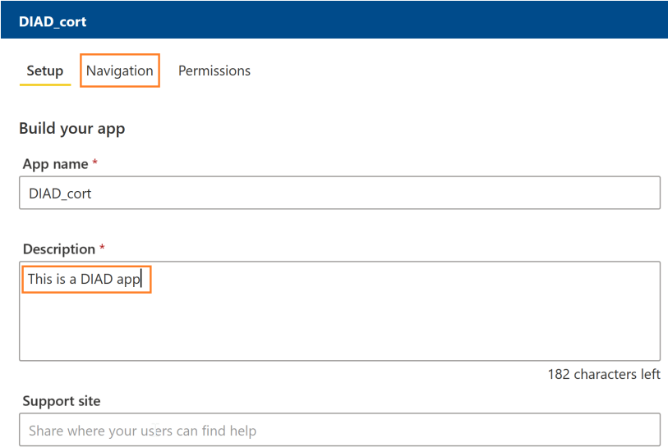

1. From the **Navigation** menu, click **VanArsdel (dashboard)**.
2. When a user accesses the DIAD app, we want them to land on the **VanArsdel** dashboard.
3. Navigate to the **Permissions** page.

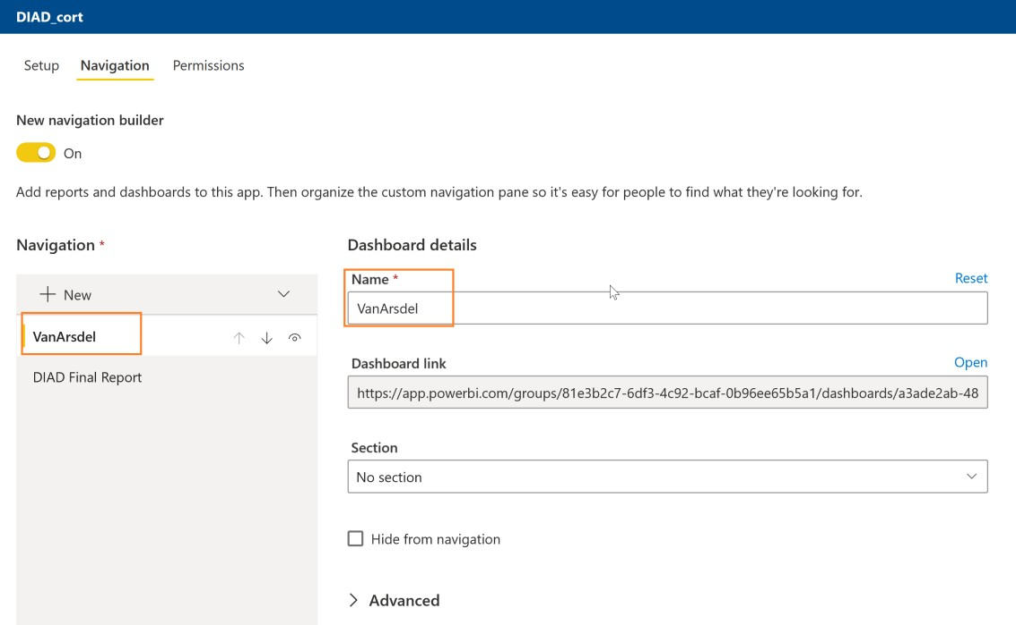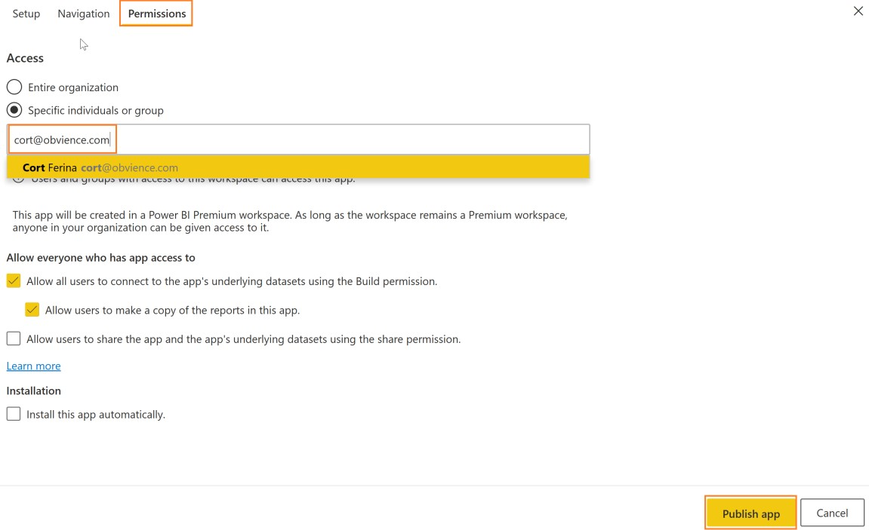

1. Enter the email addresses of the users or groups to whom you want to give access.

**Note**: If you didn’t enter an email address previously, no need to enter one here.

1. On the bottom right corner, click **Publish App**.
2. The **Ready to publish** dialog appears, click **Publish**.
3. Once the App is published a success dialog appears.

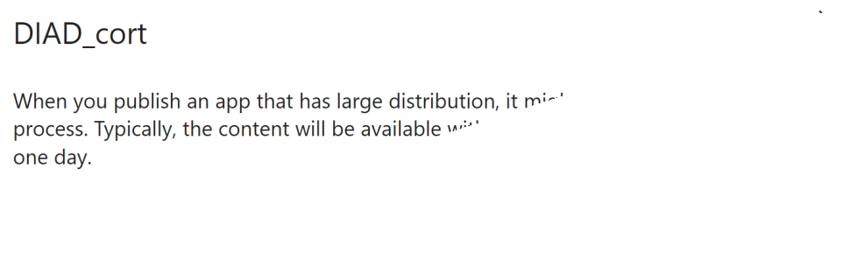

You can copy the link to the App after it’s been successfully published and share it with individuals via

email. A better way for report viewers to consume the App is by logging onto Power BI Service and

registering the App. Let’s impersonate a report viewer:

1. From the left menu, click **Apps**.
2. Click **Get Apps**.

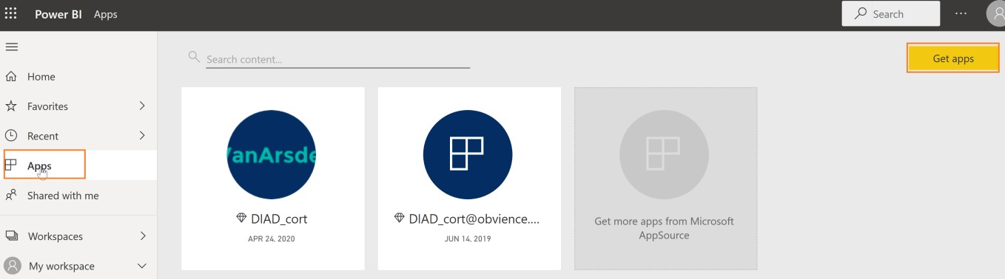

1. The **AppSource** dialog opens. You will notice the **DIAD_<youremailaddress>** app is listed. Select the newly added app.

This is a one-time registration. Going forward when you select **Apps** in the left panel, you will see the **DIAD_<youremailaddress>** app in the list of Apps you have registered, and then you can click **Get it now.**

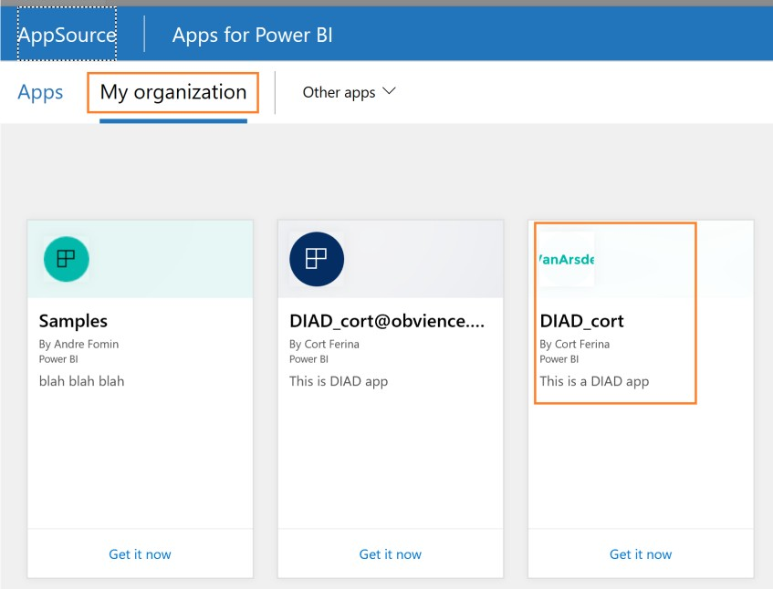

Power BI Mobile – Accessing Report on Mobile Device

1. Open the Power BI Mobile app on your mobile device

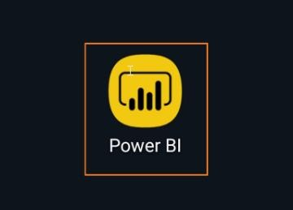

1. Click **Get Started** after the app is open.

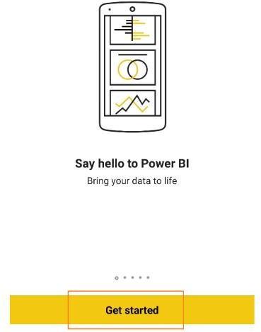

1. Click **Power BI** to connect to your report.

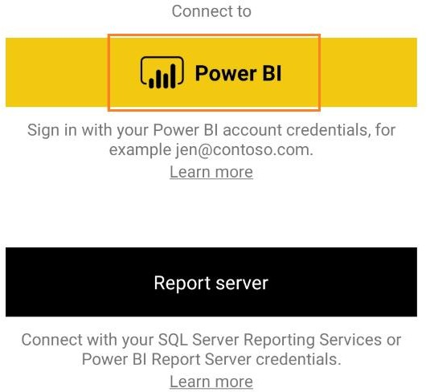

1. Click **Sign in** and enter your credentials.

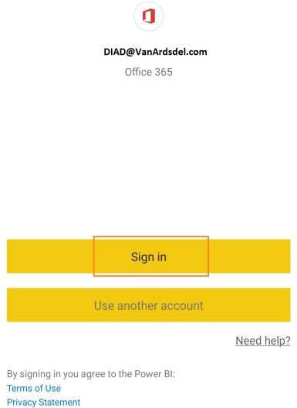

1. Verify you have successfully signed in and then click **Start exploring**.

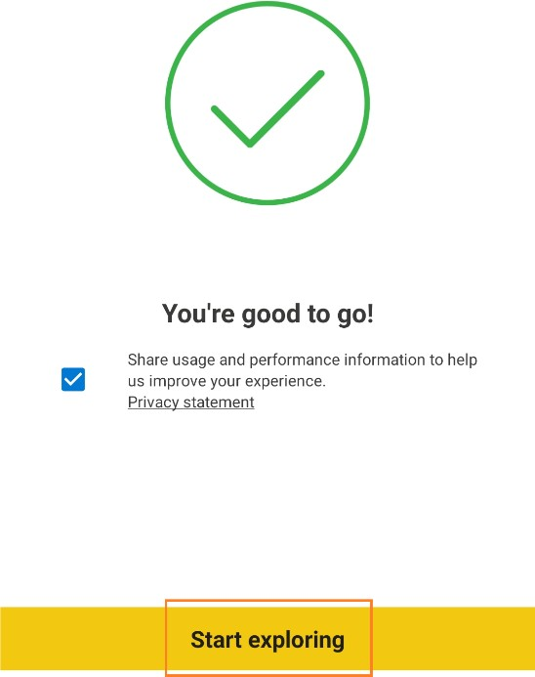

1. Click the **DIAD Final Report** that you published from Power BI Desktop.

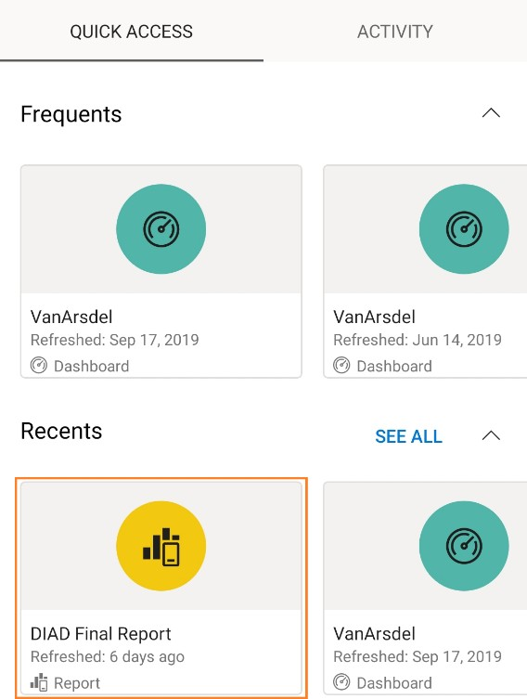

1. Verify that you see the mobile view you published from Power BI Desktop.

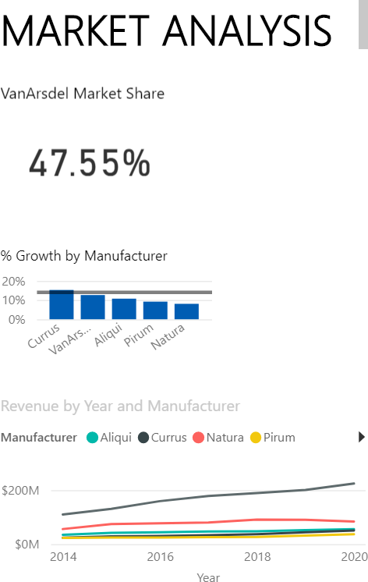

# References

Here are more references that will help you with your next steps with Power BI. Getting started: [http://powerbi.com](http://powerbi.com/)

Power BI Desktop: <https://powerbi.microsoft.com/desktop> Power BI Mobile: <https://powerbi.microsoft.com/mobile> Community site <https://community.powerbi.com/>

Power BI Getting started support page: <https://support.powerbi.com/knowledgebase/articles/430814-get-started-with-power-bi>

Support site <https://support.powerbi.com/>

Feature requests <https://ideas.powerbi.com/forums/265200-power-bi-ideas> New ideas for using Power BI <https://aka.ms/PBI_Comm_Ideas>

Power BI courses <http://aka.ms/pbi-create-reports>