Influence of the evolving car sector on climate change

Gianni Monteban & Martijn Vogelaar

s1047546 & s1047391

# Abstract

Global warming is a much talked about topic which concerns many people around the globe. The main cause of the global warming is the emission of greenhouse gasses by various sectors. One of the sectors with a high quantity of greenhouse gas emission is the transportation sector. Within this sector, the car sector is growing very fast. This subject will be treated in this paper. More specific, in this paper the cars from eight years ago will be compared with the cars from nowadays. The cars will be compared on the amount of greenhouse gasses they produce using the amount of kilometers that they drive and the amount of greenhouse gasses that they produce per kilometre. This will be used to check if cars did get more efficient and if the car sector has a bigger influence on the climate then eight years ago.

The result of the paper is that the growing car sector has a bigger influence than the cars getting more efficient. Due to the fact that the car sector has grown very fast in the last eight years, the fact that the cars did get more efficient could not prevent the sector from producing more greenhouse gasses than before.

This paper only covers the car sector in Europe, in the future car sectors from other regions can be researched.

Another limitation of this paper is that the data used is not gathered by ourselves. In the future it would be better to measure the greenhouse gas emissions ourselves. By gathering the data yourselves, you know for sure that the car manufactures can not manipulate the results of the research.

# Introduction

The climate change is a hot topic nowadays due to the fact that the environment on Earth is changing very fast. If the climate changes too much it could mean that the Earth will endure a lot of irreparable damage. The climate change is caused by many factors. One of the biggest factor is the increase in greenhouse gasses (such as: CO2, CH4, N2O, CFC and O3) (Tzu-Ping, 2010) which are emitted by the combustion of fuel. The combustion of fuel happens in many sectors such as the generation of energy, transportation, agriculture and in factories.   
The transportation sector is used by the most of the people, for example when people are traveling to work or going on a holiday. These processes all cause greenhouse gasses. The way in which people travel has a big difference in the amount of greenhouse gasses emitted.

In Great Britain, of all fuel used for transport 76% is used by private road transport, cars and lorries (Potter, 2003). Due to the fact that the number of cars is growing, it is very likely that the greenhouse gas emissions are also growing. On the other hand the new cars are becoming more and more efficient and need a lot less fuel than the cars from eight years ago.

In this paper we will look further into the following research question: “What is the impact of making the cars more efficient in combination with the growth of the car sector on the total greenhouse gas emissions in Europe?”. Our hypotheses is that the total greenhouse gas emissions will not grow, we expect that the growing car sector will not have a very big influence since the cars getting more efficient.

To answer this question, we first need to look how much greenhouse gasses the cars emitted in a certain year. Then we need to find out how much every car has driven and how many of the cars are sold. With this data we can calculate the difference in total emission to answer the main question.

# Literature review

For this paper, besides our own research we will also look into literature which will be used to answer this paper’s research question. Since the global warming has been developing a lot since last two decades, we have decided to only use sources that are released after 2000. Using this literature we want to create an overview of the influence the person transportation sector has on the climate.

“*There are many different ways to transport yourself to your destination. Each way got it’s pro’s and con’s. This can be seen in the table 4 from.*” (Potter, 2003). In this table Potter notes that the best way to measure the CO2 emissions is to measure the emissions per seat per kilometre instead of the emission per vehicle per kilometre. This method of measuring the CO2 emissions is also being used by Chapman (2007) and Tzu-ping (2009). Others like Ramachandra(2009) use a different method, as can be seen in Table 3 of Ramachandra(2009) the method which is being used does not differ as much but uses different units. The measurements are done per vehicle instead of emissions per vehicle type per kilometre they use emissions per vehicle type. Due to this it is unclear how many people are transported in a vehicle which makes it unclear which is more efficient in transporting people with the least amount of gas emissions per person. We will thus be using the method which is also used by Potter, Chapman and Tzu-ping: amount of gas emitted per vehicle per person per kilometre.   
“*Since CO2  is not the only greenhouse gas it is important to look at all greenhouse gasses and the effect on the environment of all of these gasses*”(Chapman, 2007). Chapman points out that different greenhouse gasses have different causes on the environment. It is thus important to not only look at the CO2 emissions per vehicle but also the emissions of other greenhouse gasses. A higher CO2 emission does not necessarily lead to a higher NOx(NO1, NO2 etc) emission as can be seen in table 1 of Potter(2003). Ramachandra (2009) also uses more greenhouse gasses than only CO2 for example: CO, NOx CH4 and SO2.

To decrease the amount of greenhouse gas emissions multiple things can be done. One solution which is presented is taxing cars on it’s emissions. In Australia in the amount of CO2 was reduced by taxing the emission of greenhouse gasses Hensher(2008).

Another solution is presented by Barkenbus (2010), by reducing the maximum speed on motorways to 55 MPH (88 KPH). Currently this is around 65-70 MPH (104 - 112 KPH).

The most important conclusions we can draw the scientific publications are that is very important to not only look at the emissions of CO2 but also many other important greenhouse gasses besides CO2. It is furthermore important to choose the right units for the measurements, we have discussed the unit which we will be used for the emissions of greenhouse gasses by vehicles which has become: greenhouse-gasses emitted /per person /per kilometer.

# 

# Methodology

## Materials/ Methods

To give an answer to our research question we will be using datasets. We will be using two kinds of datasets, one which lists the average amount of greenhouse gas emissions of a car and another which describes the carsales each year. To calculate the greenhouse gasses emitted by these cars we will generalize that every car has an economical lifespan of eight years. These datasets will furthermore be of two different years, ne from 2010 and the other from 2018.

Two datasets from different years will be used since we want to know how the total amount of greenhouse gasses emitted changes of the years. We have chosen two datasets which are 8 years apart since this is the economical lifespan of a car.

A potential problem which may occur is the reliability, this problem is caused by the fact that we only take data from two years to answer the research question.

## Data collections

The data which will be used will only consist out of data from Europe. The growth of the car sector will thus only contain data about the car sector in Europe. The data about the emissions of cars will also be the average emission of cars located in Europe. The duration of which this data has been collected is exactly one year(1 January - 31 December). In these datasets the same kind of data will be represented but in one dataset the data will be from 2010 and in the other from 2018. The data is represented with the average greenhouse gasses/ km, the average number of kilometers in eight years and the number of cars that have been sold. These data is all measured with only one person in the car.

## Data analysis

The data will be used to calculate the average greenhouse gasses/ km for the cars from the different years. This will be combined with the number of cars that are sold during that year which can give us the total amount greenhouse gas emissions for the different years. After calculating this we can easily see if the growing car sector has a bigger influence on the climate then the cars becoming more efficient. The outcome of these calculations will then be used to answer the research question.

# Results

As said in the methodology, we use have used a data set (attached as [Data.xlsx](https://docs.google.com/spreadsheets/d/17QSWEeEuDI52ZIXDziHAGqRZB4x98OAUW0WUtgoHsKw/edit?usp=sharing)). In this file you can see the data which has been used to create graph 1 and graph 2. This data consists out of thousands different types of cars. From these cars all greenhouse gasses that the car emit per kilometer are registered, also the number of sales of the car and average number of kilometers driven is registered.   
One of the problems which has to be kept in mind is that the data concerning the greenhouse gas emissions is supplied by the car manufactures. In 2015 the Volkswagen-group supplied data about the greenhouse gasses, the greenhouse gas emissions in this dataset were much lower than the actual emitted greenhouse gasses. If this would happen to one of the car manufactures used in the dataset that used in this paper, the paper could then be seen as invalid.

In the figure Graph 1 which is shown below the output of the data analysis can be seen.

In Graph 1 can be seen the car sales have drastically increased over the last 8 years. Since the amount of driven kilometers per car has stayed unchanged and the car sales have increased over 16.2 % the total driven kilometers has also increased drastically. One could say that because of the growth in total kilometers driven the total amount of emitted greenhouse gasses would also grow. The average emission of greenhouse gasses of a single car has however decreased since the last years. This is due to the fact that cars which are being mode nowadays are more efficient than the cars made in the past.  
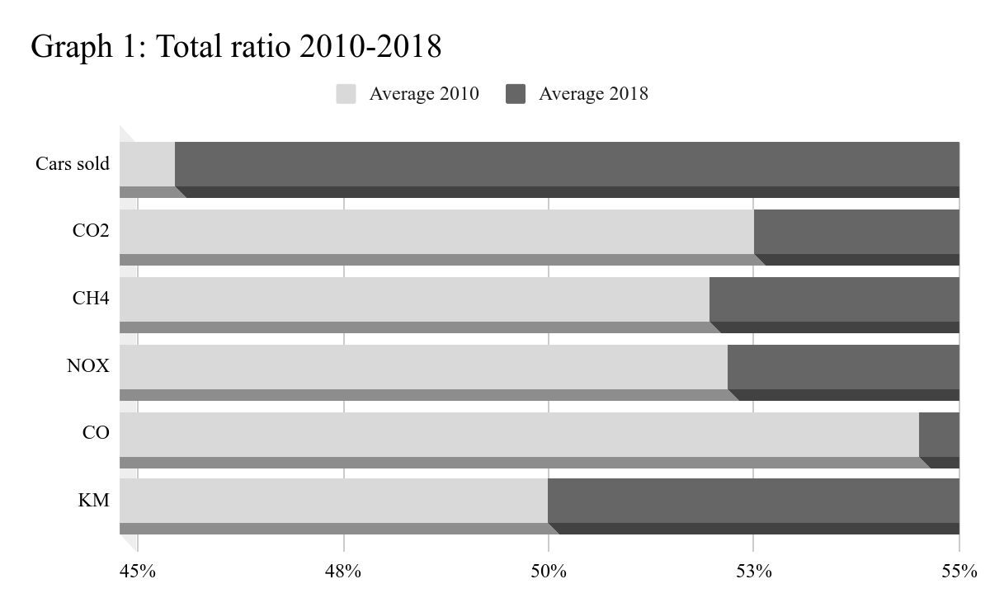

To answer the research question, we need to calculate the total amount of greenhouse gasses produced in both years. This is done by calculating the average emission of greenhouse gasses and calculating the average amount of driven kilometers per car. Then we multiply the number of greenhouse gasses with the average driven kilometers and with the total number of driven kilometers of all cars. The result of this can be seen in graph 2.

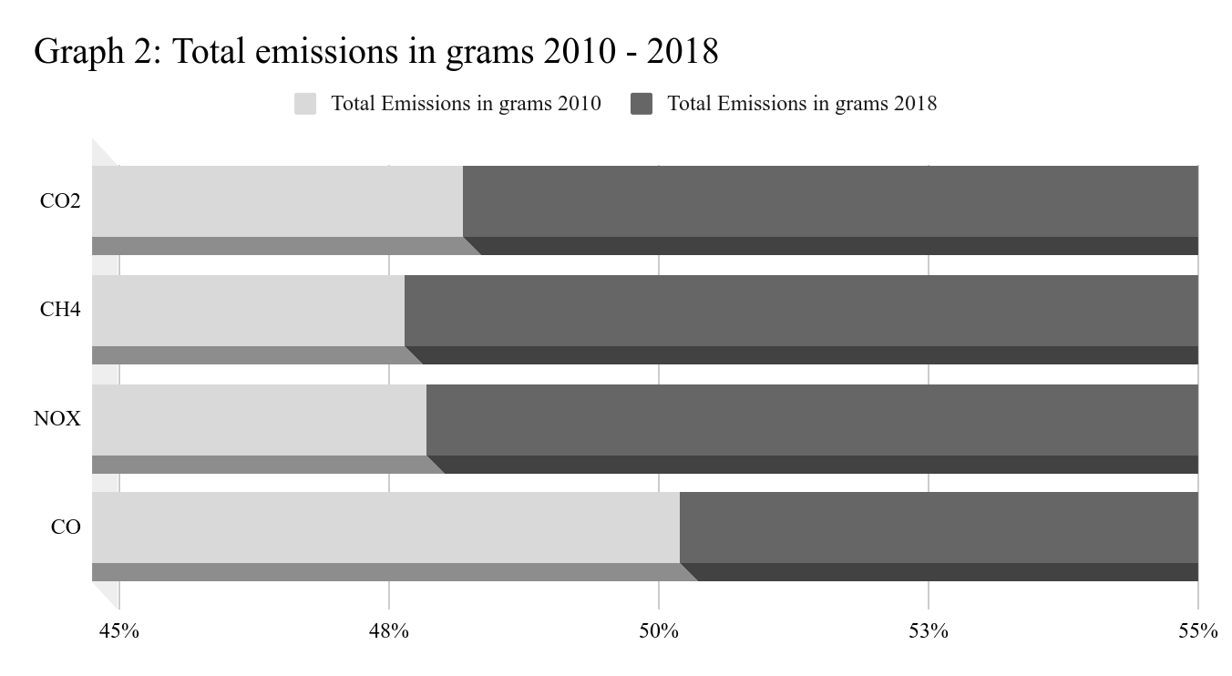

In Graph 2 can be seen that the CO2, CH4, and NOX emissions in 2010 are lower than in 2018, while the CO emissions decreased a bit in 2018. When we wrote our hypothesis we did not expect that the total emissions in 2010 would be lower than those in 2018. Since the cars in the car-sector are getting much more efficient.  
As can be seen in Graph 2, the difference in CO2 has drastically changed, in 2018 6.4% more CO2 was emitted than in 2010. This would mean that if the growth rate would remain the same, within 12 decades the total amount of CO2 emissions per year would be doubled. The total emissions of CH4 and NOx per year will be doubled even faster within respectively 9 and 10 years. Taking in consideration that in 2010 the amount of CO2 already has a great impact on the climate double the amount of CO2 will have an even greater consequences on the climate.

With this result we can say that the amount of greenhouse gasses has significantly grown in the last 8 years. This means that the car sector has a bigger impact on the climate then before. On the other hand, since the car did come more efficient the greenhouse gasses did not grow as fast as it would have if the cars wouldn’t have become more efficient. The cars becoming more efficient thus has a positive influence but the growth of the car sector outweighs this.

# Conclusion

To answer our research question: “What is the impact of making the cars more efficient in combination with the growth of the car sector on the total greenhouse gas emissions in Europe?”. the following can be concluded.

We have seen that the total amount of greenhouse gas emissions has significantly grown over the past 8 years. On an average the total emissions of greenhouse gasses have grown with 5.23%(see data.xls → statistics → 03). Looking at all the different greenhouse gasses only the total amount CO emitted has decreased. All other greenhouse gasses have increased over the past 8 years. We can thus conclude that the more efficient becoming cars at the moment do not compensate the growing car sector for all different greenhouse gasses. This means that the combination of the more efficient becoming cars and the growing car sector has a negative effect on emissions of the person transportation sector. This sector is part of the transportation sector which is not the only sector emitting greenhouse gasses. This means the car sector is not alone in emitting greenhouse gasses but the increase in the car sector isn’t helping to solve the climate change problem.

# 

# Discussion

Since the research has only been done for the car sector on Europe it is impossible to say if this is the same for the whole world, while the climate change has an effect and is caused by the whole world. Even though this is true we can still say that the cars which are becoming more efficient cannot outweigh the growing car sector in Europe.

Another thing which could be said is that the data which has been used has not been independently measured which could cause incorrect conclusions in this paper. Even though this is true we cannot remeasure or check all measurements done by the car manufactures. If in the future it appears that any of the listed car manufactured supplied incorrect data this paper would incorrect.

# References

Banister, David. “The Climate Crisis and Transport.” *Transport Reviews* 39, no. 5 (September 3, 2019): 565–68.<https://doi.org/10.1080/01441647.2019.1637113>.

“Transport Energy and Emissions: Urban Public Transport - Open Research Online.” Accessed September 19, 2019.<http://oro.open.ac.uk/4378/>.

Chapman, Lee. “Transport and Climate Change: A Review.” *Journal of Transport Geography* 15, no. 5 (September 1, 2007): 354–67.<https://doi.org/10.1016/j.jtrangeo.2006.11.008>.

“Transport Energy and Emissions: Urban Public Transport - Open Research Online.” Accessed September 19, 2019.<http://oro.open.ac.uk/4378/>.

Creutzig, Felix. “Transport: A Roadblock to Climate Change Mitigation? | Science.” Accessed September 5, 2019.<https://science.sciencemag.org/content/350/6263/911>.

Barkenbus, Jack N. “Eco-Driving: An Overlooked Climate Change Initiative.” *Energy Policy* 38, no. 2 (February 1, 2010): 762–69.<https://doi.org/10.1016/j.enpol.2009.10.021>.

Hensher, David A. “Climate Change, Enhanced Greenhouse Gas Emissions and Passenger Transport – What Can We Do to Make a Difference?” *Transportation Research Part D: Transport and Environment* 13, no. 2 (March 1, 2008): 95–111.<https://doi.org/10.1016/j.trd.2007.12.003>.

Ramachandra, T. V., and Shwetmala. “Emissions from India’s Transport Sector: Statewise Synthesis.” *Atmospheric Environment* 43, no. 34 (November 1, 2009): 5510–17.<https://doi.org/10.1016/j.atmosenv.2009.07.015>.

Lin, Tzu-Ping. “Carbon Dioxide Emissions from Transport in Taiwan’s National Parks.” *Tourism Management* 31, no. 2 (April 1, 2010): 285–90.<https://doi.org/10.1016/j.tourman.2009.03.009>.