SQL TECHNICAL DOCUMENTATION

1. Project Overview
A MySQL relational database was developed to support the analysis of a residential property management portfolio. The database consolidates tenant, unit, maintenance, payment, and rent optimization data into a centralized analytical model for reporting and business intelligence.
SQL was used for:
- Database Design
- Data Storage
- Data Staging & Cleaning
- Feature Engineering
- Analytical View Creation
- Business Intelligence & Dashboard Reporting

2. Data Flow
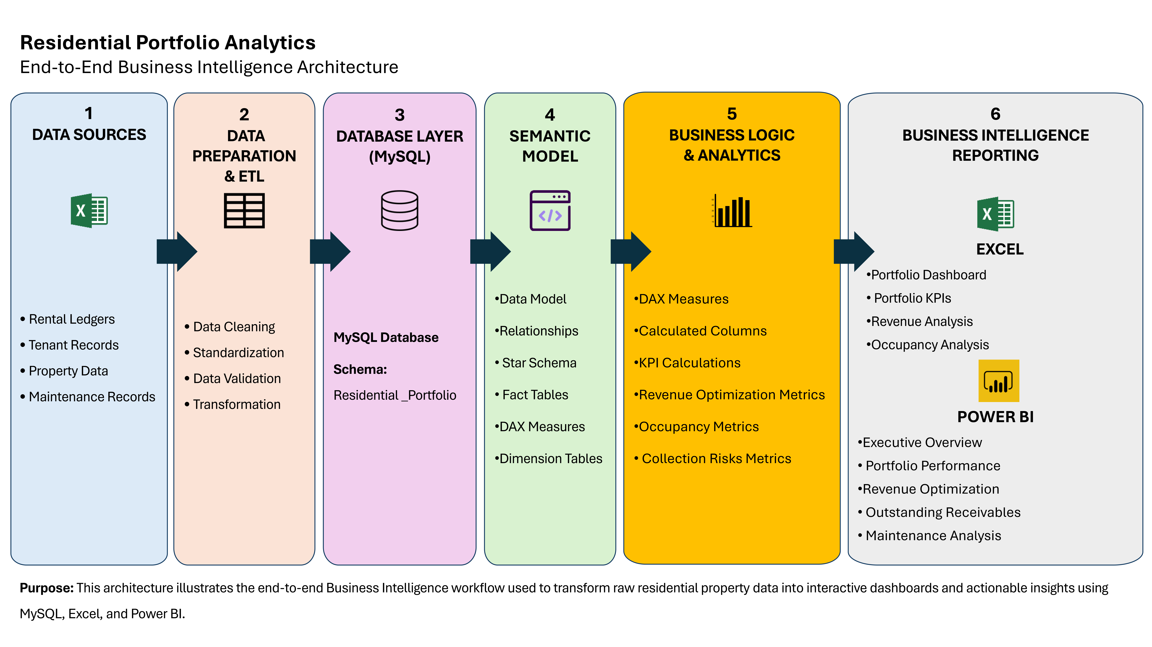

2.1 Database Structure
OBJECT | NAME | DESCRIPTION
Database | residential_portfolio | Main analytical database

2.2 Database Objects Overview
The database contains six core tables and multiple analytical views that support reporting, business intelligence, and portfolio analysis.
TABLES
Table | Tenants | Tenant and lease information
Table | Units | Property and apartment information
Table | Maintenance | Maintenance history and repair costs
Table | Detailed_Ledger | Tenant payment history
Table | Buildings | Building-level property information
Table | Rent_Optimization | Rent recommendation calculations
VIEWS
View | vw_units | Consolidated unit reporting view
View | vw_average_rent | Average rent statistics
View | vw_portfolio_summary | Portfolio-wide KPIs and executive reporting
View | vw_executive_dashboard | Executive reporting dashboard
View | vw_low_rent_opportunities | Revenue optimization opportunities
View | vw_regulation_summary | Regulated vs. market-rate analysis
View | vw_maintenance_summary | Maintenance costs, repairs, and asset management.
View | vw_high_maintenance_units | High-cost maintenance units
View | vw_arrears_summary | Tenant arrears summary
View | vw_receivables_aging | Tenant balances and receivable monitoring.
View | vw_delinquency_opportunity | Delinquency opportunity analysis
View | vw_top_delinquent_tenants | Highest delinquent tenants
View | vw_top_delinquent_tenants_regulation | Identifies the highest delinquent tenants and categorizes outstanding balances by regulation status
View | vw_unit_level_outstanding_receivables | Summarizes outstanding receivables at the individual unit level

2.3 Data Dictionary

Table: Tenants
COLUMN | DATA TYPE | DESCRIPTION
Tenant_ID | VARCHAR(50) | Unique identifier for each tenant (Primary Key).
Move_In_Date | DATE | Date the tenant moved into the unit.
Tenant_Status | VARCHAR(30) | Current tenant status (e.g., Active, Vacated).
Lease_Start_Date | DATE | Lease commencement date.
Lease_End_Date | DATE | Lease expiration date.
Lease_Duration | INT | Lease length in months.
Lease_Type | VARCHAR(50) | Lease classification.
Occupancy_Years | INT | Number of years the tenant has occupied the unit.
Tenant_Segment | VARCHAR(50) | Tenant segmentation category.
Current_Rent | DECIMAL(10,2) | Current monthly rent charged.
Legal_Rent | DECIMAL(10,2) | Maximum legal rent (regulated units).
Prior_Year_Rent | DECIMAL(10,2) | Previous year's monthly rent.
Employment_Status | VARCHAR(30) | Tenant employment status.
Income | DECIMAL(12,2) | Annual household income.
Income_Category | VARCHAR(50) | Income classification used in analysis.
Bucket | VARCHAR(20) | Analytical grouping category.

TABLE: MAINTENANCE
COLUMN | DATA TYPE | DESCRIPTION
Repair_ID | INT | Unique repair identifier (Primary Key).
Tenant_ID | VARCHAR(50) | Tenant associated with the repair.
Unit_ID | VARCHAR(30) | Apartment requiring maintenance.
Units_Status | VARCHAR(20) | Unit occupancy status.
Tenant_Status | VARCHAR(30) | Tenant occupancy status.
Repair_Type | VARCHAR(50) | Type of maintenance performed.
Repair_Date | DATE | Date of repair.
Repair_Cost | DECIMAL(10,2) | Cost of repair.
Estimated_Savings | DECIMAL(10,2) | Estimated savings generated.
Priority_Level | VARCHAR(20) | Maintenance priority.
Annualized_Savings | DECIMAL(10,2) | Annual projected savings.
Repair_ROI | DECIMAL(10,3) | Return on investment for the repair.
Useful_Life_Years | INT | Expected useful life after repair.

TABLE: RENT_OPTIMIZATION
Column | Data Type | Description
Tenant_ID | VARCHAR(50) | Tenant identifier.
Unit_ID | VARCHAR(30) | Apartment identifier.
Current_Rent | DECIMAL(10,2) | Current monthly rent.
Regulation_Status | VARCHAR(30) | Market or regulated status.
Income_Category | VARCHAR(50) | Tenant income classification.
Occupancy_Years | INT | Years occupied.
Annual_Repair_Cost | DECIMAL(10,2) | Annual maintenance cost.
Maintenance_Ratio | DECIMAL(10,4) | Maintenance cost relative to rent.
Low_Rent_Flag | INT | Indicates below-market rent.
Long_Tenure_Flag | INT | Indicates long-term tenancy.
Income_Adjustment | VARCHAR(50) | Income adjustment category.
Low_Rent_Adjustment | DECIMAL(10,4) | Rent adjustment factor.
Long_Tenure_Adjustment | DECIMAL(10,4) | Long tenancy adjustment factor.
Tenancy_Companion | VARCHAR(30) | Tenancy classification.
FM_Turnover_Risk_Adjustment | VARCHAR(10) | Market turnover adjustment.
Recommended_Increase_Percentage | DECIMAL(10,4) | Suggested rent increase.
New_Rent | DECIMAL(10,2) | Recommended monthly rent.
Monthly_Increase | DECIMAL(10,2) | Monthly increase amount.
Annual_Revenue_Impact | DECIMAL(10,2) | Annual revenue gain.
Increase_Bucket | VARCHAR(20) | Increase category.

TABLE: DETAILED_LEDGER
Column | Data Type | Description
Payment_ID | VARCHAR(80) | Unique payment transaction identifier (Primary Key).
Tenant_ID | VARCHAR(50) | Tenant identifier.
Unit_ID | VARCHAR(30) | Apartment identifier.
Ledger_Year | INT | Financial year.
Month_Number | INT | Month number.
Month_Name | VARCHAR(20) | Calendar month.
Due_Date | DATE | Payment due date.
Prior_2022_Balance | DECIMAL(10,2) | Opening balance.
Amount_Due | DECIMAL(10,2) | Rent due.
Amount_Paid | DECIMAL(10,2) | Rent received.
Past_Due_Balance | DECIMAL(10,2) | Outstanding balance.
Payment_Date | DATE | Date payment received.
Days_Past_Due | INT | Number of days overdue.
Is_Late_After_Grace | INT | Late payment flag.
Payment_Status | VARCHAR(30) | Current payment status.

TABLE: UNITS
Column | Data Type | Description
Unit_ID | VARCHAR(30) | Unique apartment identifier (Primary Key).
Building_ID | VARCHAR(20) | Building identifier (Foreign Key).
Unit_Number | VARCHAR(20) | Apartment number.
Regulation_Status | VARCHAR(30) | Market or regulated.
Bedrooms | INT | Number of bedrooms.
Bathrooms | DECIMAL(3,1) | Number of bathrooms.
Washer_Dryer | VARCHAR(10) | Washer and dryer availability.
Dishwasher | VARCHAR(10) | Dishwasher availability.
Renovated | VARCHAR(10) | Renovation status.
Floor | INT | Floor number.
Occupied_Status | VARCHAR(20) | Occupancy status.

3. SQL Views
The Property Management database contains multiple analytical views designed to separate transactional data from reporting and business intelligence. Each view supports a specific area of portfolio analysis and can be reused by reporting tools such as Power BI and Excel.
CATEGORY | VIEWS | PURPOSE
Portfolio Reporting | vw_portfolio_summary, vw_executive_dashboard, vw_average_rent | Portfolio-level KPIs and executive reporting
Rent Analysis | vw_low_rent_opportunities, vw_regulation_summary | Rent optimization and regulated unit analysis
Maintenance | vw_maintenance_summary, vw_high_maintenance_units | Maintenance costs, repairs, and asset management
Receivables | vw_arrears_summary, vw_receivables_aging, vw_unit_level_outstanding_receivables | Tenant balances and receivable monitoring
Delinquency | vw_top_delinquent_tenants, vw_top_delinquent_tenants_regulation, vw_delinquency_opportunity | Collection prioritization and delinquency analysis
Operational | vw_units | Consolidated unit-level reporting

4. Feature Engineering
Several metrics were calculated within SQL before importing the data into Power BI.
METRIC | HOW IT IS CALCULATED / USED
Occupancy Rate | Measures the percentage of occupied units in the portfolio. Calculated as occupied units divided by total units.
Vacancy Count | Measures the number of unoccupied units. Calculated as total units minus occupied units.
Average Rent | Calculates the average monthly rent across all occupied units.
Monthly Increase | Measures the difference between the recommended rent and the current rent.
Annual Revenue Impact | Measures the projected annual revenue gain from rent optimization.
Maintenance Ratio | Compares maintenance cost against rental income to identify high-cost units.
Repair ROI | Compares estimated savings against repair cost to evaluate maintenance investment value.
Total Arrears | Calculates the total outstanding tenant balances across the portfolio.
Receivables Aging | Groups unpaid balances by how long they have been outstanding.
Days Past Due | Measures how many days a payment is overdue.
Rent-to-Income Ratio | Compares tenant rent against income to evaluate affordability.
Low Rent Flag | Identifies units with below-market or unusually low rent.
Long Tenure Flag | Identifies long-term tenants for rent optimization analysis.
Total Maintenance Cost | Measures total repair and maintenance spending across the portfolio.
Annual Repair Cost | Measures yearly maintenance costs at the unit or portfolio level.
Prior 2022 Arrears | Identifies outstanding balances carried forward from 2022.
Revenue Opportunity | Calculates the total potential annual revenue increase resulting from recommended rent adjustments.
Current Annual Revenue | Estimates current yearly rental income based on existing monthly rents.
Projected Annual Revenue | Estimated annual rental revenue after applying the recommended rent increases

5. Analytical Queries
Business-focused SQL queries were developed to support operational reporting and strategic decision-making, including:
- Vacancy analysis
- Delinquent tenant identification
- Revenue opportunity analysis
- Rent affordability assessment
- Maintenance cost analysis
- Portfolio risk assessment
- Executive portfolio reporting

6. SQL Skills Demonstrated
- Relational Database Design
- Table Creation
- Primary & Foreign Keys
- Data Staging & Cleaning
- Joins
- CASE Statements
- Aggregate Functions
- Window Functions
- CTEs
- Subqueries
- Views
- SQL Views Development
- Business KPI Development
- Aggregate Reporting
- NULL Handling
- Business Intelligence Data Preparation

7. Business Value
The SQL database provides a centralized analytical platform for residential property management. By integrating tenant, maintenance, receivables, and rent optimization data into reusable analytical views, the solution enables consistent reporting, portfolio monitoring, revenue optimization, maintenance planning, and executive decision-making while serving as the data source for future Power BI dashboards.

8. Database Summary
ITEM | VALUE
Database | 1
Primary Tables | 6
Analytical Views | 14
Business Analysis Queries | 7
Reporting Platform | MySQL / Power BI Ready

