***ΑΝΑΦΟΡΑ***

BNF:

<S> ::= "{" <created_at> "," <id_str> "," <user> "}"

<created_at> ::= <Day_name> <MMM> <DD> <XX:XX:XX:YYYY>

<Day_name> ::= "Mon"|"Tue"|"Wed"|"Thu"|"Fri"|"Sat"|"Sun"

<MMM> ::= "Jan" | "Feb" | "Mar" | "Apr" | "May" | "Jun" | "Jul" | "Aug" | "Sep" | "Oct" | "Nov" | "Dec"

<DD> ::= [1-31]

<XX:XX:XX:YYYY> ::= <h> <min> <sec> <Y>

<h> ::= [0-23]

<min> ::= [0-59]

<sec> ::= [0-59]

<id_str> ::= <digit><digit><digit><digit><digit><digit><digit><digit><digit><digit>

<digit> ::= 0|1|2|3|4|5|6|7|8|9

<user> ::= "{" <id> "," <name> "," <screen_name> "," <location> "," <url> "," <description> "}"

<id> ::= <digit><digit><digit><digit><digit><digit>

<name> ::= ([A-Za-z] | ' ')+

<screen_name> ::= [A-Za-z]+

<location> ::= [A-Za-z]+

<url> ::= "http:" "\/" "\/" [a-z]+ "." [a-z]+ "." "com" "\/"

<description> ::= ([A-Za-z] | ' ')+

* Screenshot που δείχνει ότι λειτουργεί το flex και το bison

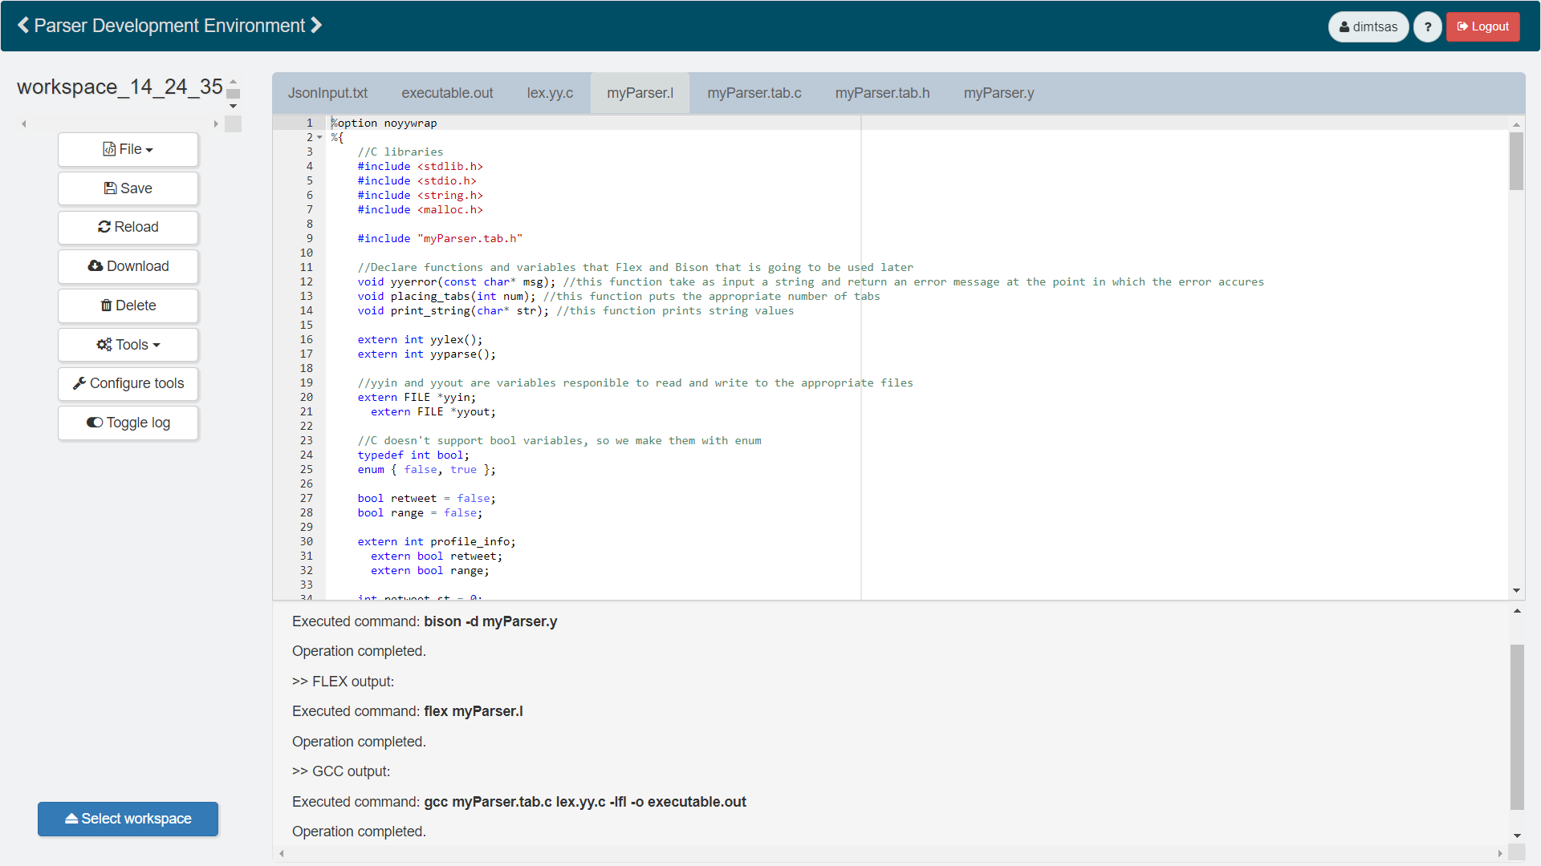

* Τα σχόλια βρίσκοντε στον κώδικα