Online Social Bookstore Application

Sprint Report



TEAM

Ιωάννης Τσόχλας ΑΜ:4993

Κωσταντίνος Λαμανιάκου ΑΜ:5110

**Versions History**

|  |  |  |  |
| --- | --- | --- | --- |
| **Date** | **Version** | **Description** | **Author** |
|  |  |  |  |

# Summary

***The objective of this project is to develop an online social bookstore application that allows individuals to exchange used books for free***. The objective was to be fulfilled using a Scrum approach to resolve organizational issues and technologies such as the Spring Boot Framework and MySQL to satisfy functional requirements. Non-functional requirements were specified in the form of design quality and best coding practices. Incomplete class diagrams describing the application architecture was the starting point. Testing was also among the requirements.

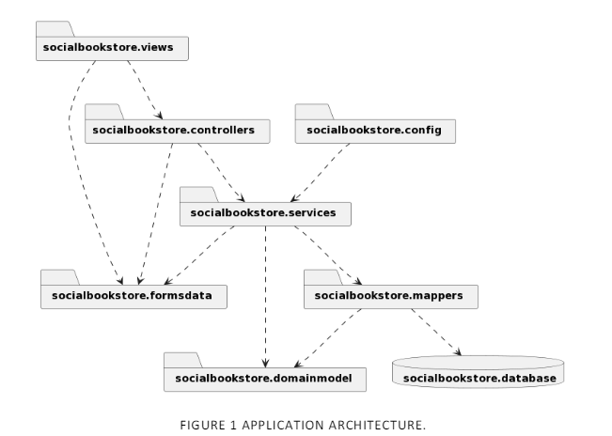

This document provides information concerning the 4 sprints of development for the Courses Web App. The development process has also been documented under the description of each commit on GitHub.

## Document Structure

The rest of this document is structured as follows. Section 2 describes out Scrum team and specifies the this Sprint's backlog. Section 3 specifies the main design concepts for this release of the project.

# Scrum team and Sprint Backlog

## Scrum team

|  |  |
| --- | --- |
| **Product Owner** | Ioannis Tsochlas,Kostantinos Lamaniakou,Swtirios Pasxalis |
| **Scrum Master** | Ioannis Tsochlas |
| **Development Team** | Ioannis Tsochlas,Kostantinos Lamaniakou,Swtirios Pasxalis |

## Sprints

**<List below the sprints that you performed and the user stories that have been realized in each Sprint>**

|  |  |  |  |  |
| --- | --- | --- | --- | --- |
| **Sprint No** | **Begin Date** | **End Date** | **Number of weeks** | **User stories** |
| **0** | **25 Feb** | **16 Mar** | **3** | **Preparation\*** |
| **1** | **17 Mar** |  |  | **User stories (US1 till US4)** |
|  |  |  |  |  |
|  |  |  |  | **\*Presentation** |

**\*Preparation** refers to tasks revolving around familiarization with new technologies such as Spring, Spring boot, MySQL Workbench, as well as building mock projects and a functional application prototype. The following preparation tasks were completed in the first sprint

* Setup MySQL
* Study Spring, Spring Boot, Maven Project Architecture
* Setup Application Architecture

**\*Presentation** refers to tasks revolving around the documentation and presentation of the application. The following presentation tasks were completed in the 4th sprint:

* Complete the report (includes: CRC cards, UML package and class diagrams, database schema)
* Write GitHub Readme
* Prepare Demo Video

Regarding the implementation of the user stories, each one was split into a checklist of 4 items:

* UI Design – HTML Styling
* Functionality Implementation
* Test (Validation)
* Use case

Once all 4 items of the checklist were completed, the user story was considered to be done.

# BACKLOG - USER STORIES

|  |  |  |  |
| --- | --- | --- | --- |
| **ID** | **AS A**  **<User Type>** | **I WANT**  **<An Action>** | **SO THAT**  **<A Benefit/Value>** |
| US1 | user | I want to create a new account | have access to the functionalities of the social bookstore application |
|  |  |  |  |
|  |  |  |  |
|  |  |  |  |
|  |  |  |  |
|  |  |  |  |
|  |  |  |  |
|  |  |  |  |
|  |  |  |  |
|  |  |  |  |
|  |  |  |  |
|  |  |  |  |
|  |  |  |  |
|  |  |  |  |

# USE CASE

<Specify the concrete Use Cases that describe the interaction of the user with the applications, as derived from the abstract user stories. Give a **UML Use Case diagram** and the **detailed use case descriptions**.>

## <Use Case 1>

|  |  |
| --- | --- |
| **Use case ID** | Unique ID for the the use case |
| **Actors** | Actor(s) related to the use case |
| **Pre conditions** | [pre conditions for the correct execution of the use case]  ...... |
| **Main flow of events** | [Main flow of events that describes the interaction between the user and the application]   1. The use case starts when the user .... 2. ... 3. ...    1. ...    2. .... |
| **Alternative flow 1** | [Alternative flow of events IF ANY that takes place in case of an exception] |
| **Alternative flow 2** | ....... |
| **Post conditions** | [Consequences on the state of the application after the correct execution of the use case] |

## <Use Case 2>

…..

# Design

## Architecture

<Specify the overall architecture for this release in terms of a **UML package diagram**.>

## Design

<Specify the detailed design for this release in terms of **UML class diagrams**.>

<Document the classes that are included in this release in terms of CRC cards according to the template that is given below.>

|  |  |
| --- | --- |
| **Class Name: ....** | |
| **Responsibilities:**   * ... * .... * ... | **Collaborations:**   * ... * .... * .... |

|  |  |
| --- | --- |
| **Class Name: ....** | |
| **Responsibilities:**   * ... * .... * ... | **Collaborations:**   * ... * .... * .... |

...................................................

...................