Does It Pay to Play Nice?
The Effect of Toxic Behavior and Leadership-Style Communication
on Win Rates in League of Legends

Working Summary Document
Applied Sports Research — University of Zurich
Gian Senpinar | February 2026
Status: Data collection + analysis complete. Ready for full paper drafting.

Contents
1. Research Questions & Hypotheses
2. Data Collection Methodology
3. Variable Operationalization
4. Addressing Reverse Causality (Philippe Feedback)
5. Descriptive Statistics
6. Model Results
6.1 Baseline Model (Original Controls)
6.2 Extended Model (+ Early-Game Controls + Skill Proxy)
6.3 Model Comparison
6.4 Classification Performance
7. Robustness Checks
7.1 Per-Region Sub-Regressions
7.2 Close Games Only
8. Visualizations
9. Remaining Work for Full Paper

1. Research Questions & Hypotheses
This study investigates the relationship between in-game behavioral patterns and competitive outcomes in League of Legends, a team-based multiplayer online game. Using data from the Riot Games Match-V5 API, we examine whether toxic behavior and leadership-style communication are associated with win probability, controlling for team skill and early-game state.

Research Questions
RQ1 (Toxicity): Is higher team-level toxic behavior associated with lower win probability, after controlling for team performance and early-game state?
RQ2 (Leadership): Is leadership-style communication (structured ping usage, objective coordination) independently associated with higher win probability?
RQ3 (Moderation): Does the leadership effect depend on the level of toxicity within the team (interaction effect)?

Hypotheses
H1: Teams exhibiting higher toxicity scores will have lower win probability (negative association), even after controlling for early-game state and team skill.
H2: Teams with higher leadership communication scores will have higher win probability (positive association), independent of team skill and game state.
H3: The positive effect of leadership is attenuated (moderated) at high toxicity levels, suggesting that toxic environments undermine coordination benefits.
Note: Following feedback from the supervisor (Philippe), results are framed as associative rather than strictly causal. Early-game controls are included to strengthen the interpretation, but the cross-sectional observational design cannot fully rule out reverse causality.

2. Data Collection Methodology
All data was collected from the Riot Games Match-V5 API between March 2025 and February 2026. The collection pipeline is fully automated and resumable.

Sampling Design
Regions: EUW, NA, KR, VN (4 major server regions)
Rank Tiers: Gold, Platinum, Emerald (mid-to-high ranked play)
Queue Type: Ranked Solo/Duo (Queue ID 420)
Time Window: March 2025 -- February 2026 (12 months)
Stratification: Quarterly: equal quota per quarter to ensure temporal balance
Validation Filters: Game duration >= 15 min, no remakes, no early disconnects (<5 min played)
Target: ~2,500 valid matches per region

Final Sample
Region | Matches | Observations (2 per match) | Date Range
EUW | 2435 | 4870 | 2024-03-03 to 2026-02-20
KR | 2427 | 4854 | 2024-03-24 to 2026-02-20
NA | 2469 | 4938 | 2024-03-08 to 2026-02-20
VN | 2429 | 4858 | 2024-03-08 to 2026-02-20
Total | 9760 | 19520
The final dataset contains 9,760 unique matches (19,520 team-level observations) across 53 variables.

3. Variable Operationalization

Dependent Variable
Win (binary): 1 if the team won the match, 0 otherwise. One row per team per match (2 rows per match in the full dataset). For regression analysis, we use the blue-side perspective (team_id = 100), yielding one observation per match.

IV1: Toxicity Score
A standardized composite of four behavioral indicators of toxic play. Each component is z-scored across the full sample, then summed:
max_feeding_index: Highest Deaths/(Kills+Assists+1) on the team. Captures intentional feeding or extreme underperformance.
early_surrender: Binary: 1 if the losing team surrendered. Proxy for team tilt / giving up.
vision_neglect_score: Proportion of the team with < 0.3 vision/min. Proxy for disengagement / griefing.

IV2: Leadership Score
A standardized composite of four leadership/coordination indicators. Each component is z-scored, then summed:
coord_ping_ratio: Top-pinging player's coordinating pings (onMyWay, command, assistMe, push) as a share of their total pings. Shot-caller proxy.
objectives_taken: Total dragons + barons + rift heralds taken. Objective coordination.
vision_leadership: Binary: 1 if both Support (>= 1.0 vis/min) and Jungle (>= 0.6 vis/min) meet vision thresholds.

Interaction Term
toxicity_x_leadership = toxicity_score * leadership_score. Tests whether leadership effects are moderated by toxicity level.

Control Variables (Original)
- team_avg_kda: Team-average (Kills + Assists) / max(Deaths, 1)
- team_avg_cs_min: Team-average CS per minute
- team_gold: Total gold earned by team
- team_damage: Total damage dealt to champions
- team_vision_score: Sum of vision scores across 5 players
- first_blood: Binary: 1 if team got first blood
- game_duration_min: Game length in minutes
- region dummies: EUW (reference), KR, NA, VN

Early-Game Controls (New, addressing reverse causality)
These variables capture the game state before toxicity and coordination behaviors fully manifest, providing pre-treatment controls:
- team_early_cs_10: Team sum of lane + jungle CS at 10 minutes. Captures early laning competence independent of outcome.
- team_early_gold_adv: Team average early laning phase gold/XP advantage. Controls for which team was ahead early.
- team_early_takedowns: Team sum of takedowns in the first minutes. Captures early aggression / skirmish success.

Skill Proxy (New)
avg_skill_index: Team average of (soloKills + skillshotsHit + skillshotsDodged) per player. This mechanical skill proxy controls for the confound that better players both coordinate more and win more, as highlighted in Philippe's feedback.

4. Addressing Reverse Causality (Supervisor Feedback)
Philippe's central feedback identified endogeneity as the key methodological challenge:

The Problem
H1 (Toxicity): Toxicity may be a consequence of losing, not a cause. If teams that fall behind become more toxic, we would observe a negative toxicity-win correlation even without a causal effect.
H2 (Coordination): Teams that are winning can more easily secure objectives, place vision, and use strategic pings. The observed positive coordination-win correlation may reflect game advantage rather than independent leadership effects.
Player Skill: Better players both coordinate more AND win more. Without controlling for skill, the leadership effect may be confounded.

Our Mitigation Strategy
1. Early-game controls: By including team_early_cs_10, team_early_gold_adv, and team_early_takedowns, we control for the game state before mid-to-late-game behaviors (toxicity, coordination) fully manifest. If the IV effects persist after conditioning on early-game state, the association is less likely to be purely driven by reverse causality.
2. Skill proxy: avg_skill_index captures mechanical skill (solo kills, skillshot accuracy) independent of team coordination. Including it separates individual ability from team-level communication patterns.
3. Close-games robustness: Restricting the sample to games with < 5,000 gold difference removes blowouts where game state dominates. If leadership effects persist in close games, the association is more plausible as an independent factor.
4. Associative framing: Results are presented as associations, not causal effects. The discussion should explicitly acknowledge remaining endogeneity concerns.

5. Descriptive Statistics
Variable | count | mean | std | min | 25% | 50% | 75% | max | skewness | kurtosis
max_feeding_index | 19520.0 | 1.2955 | 1.4448 | 0.0667 | 0.5294 | 0.8182 | 1.4 | 18.0 | 3.5285 | 16.7996
avg_feeding_index | 19520.0 | 0.6588 | 0.5694 | 0.0133 | 0.3069 | 0.4768 | 0.8002 | 6.8 | 2.7647 | 11.0893
early_surrender | 19520.0 | 0.0 | 0.0 | 0.0 | 0.0 | 0.0 | 0.0 | 0.0 | 0.0 | 0.0
vision_neglect_score | 19520.0 | 0.0356 | 0.0867 | 0.0 | 0.0 | 0.0 | 0.0 | 0.8 | 2.5377 | 6.8255
coord_ping_ratio | 19520.0 | 0.6524 | 0.1966 | 0.0 | 0.5294 | 0.6774 | 0.8 | 1.0 | -0.6223 | 0.0867
team_coord_ratio | 19520.0 | 0.6305 | 0.1185 | 0.0833 | 0.5566 | 0.641 | 0.7143 | 0.9765 | -0.4962 | 0.2901
objectives_taken | 19520.0 | 2.9847 | 2.002 | 0.0 | 1.0 | 3.0 | 5.0 | 10.0 | 0.2126 | -0.8182
vision_leadership | 19520.0 | 0.8052 | 0.3961 | 0.0 | 1.0 | 1.0 | 1.0 | 1.0 | -1.5411 | 0.3752
toxicity_score | 19520.0 | 0.0 | 1.5404 | -1.261 | -0.9178 | -0.6683 | 0.2155 | 13.4572 | 2.4818 | 7.8949
leadership_score | 19520.0 | -0.0 | 1.9516 | -6.8423 | -1.1844 | 0.2476 | 1.4351 | 5.1988 | -0.573 | 0.0482
toxicity_x_leadership | 19520.0 | -1.1477 | 3.878 | -73.1141 | -1.6819 | -0.4682 | 0.3263 | 19.6268 | -5.2731 | 46.6034
team_avg_kda | 19520.0 | 2.7741 | 1.9872 | 0.0526 | 1.4412 | 2.3462 | 3.6364 | 52.0 | 4.5667 | 65.7252
team_avg_cs_min | 19520.0 | 5.5924 | 0.5401 | 3.5556 | 5.2196 | 5.58 | 5.9409 | 7.6942 | 0.1432 | 0.0447
team_gold | 19520.0 | 60867.191 | 15896.2824 | 19536.0 | 50715.75 | 61254.0 | 71058.0 | 133144.0 | 0.0183 | 0.0896
team_damage | 19520.0 | 114114.1389 | 46953.0041 | 14139.0 | 81902.25 | 110476.0 | 141263.25 | 423199.0 | 0.6797 | 1.1696
team_vision_score | 19520.0 | 156.6789 | 57.2701 | 19.0 | 117.0 | 153.0 | 192.0 | 430.0 | 0.4625 | 0.3017
first_blood | 19520.0 | 0.4997 | 0.5 | 0.0 | 0.0 | 0.0 | 1.0 | 1.0 | 0.0012 | -2.0002
game_duration_min | 19520.0 | 29.986 | 6.7513 | 15.05 | 26.0 | 29.83 | 34.08 | 64.25 | 0.1132 | 0.3356
team_early_cs_10 | 19520.0 | 270.6006 | 25.7655 | 157.0 | 253.0 | 270.75 | 288.0 | 379.0 | -0.03 | -0.0288
team_early_gold_adv | 19520.0 | 0.0835 | 0.1278 | 0.0 | 0.0 | 0.0 | 0.2 | 0.8 | 1.5186 | 2.3002
team_early_takedowns | 19520.0 | 24.6541 | 9.9448 | 0.0 | 17.0 | 24.0 | 31.0 | 75.0 | 0.438 | 0.0908
avg_skill_index | 19520.0 | 67.5363 | 39.4231 | 5.4 | 40.4 | 57.6 | 84.0 | 370.2 | 1.61 | 3.6471
win | 19520.0 | 0.5 | 0.5 | 0.0 | 0.0 | 0.5 | 1.0 | 1.0 | 0.0 | -2.0002
Table 1: Descriptive Statistics (all variables)

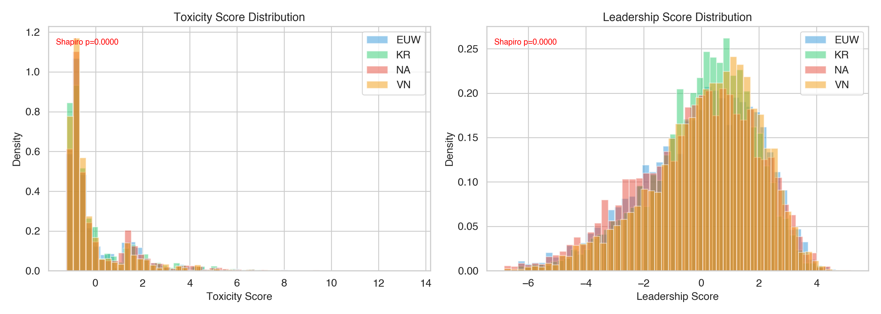
Figure 1: Toxicity and Leadership Score Distributions by Region

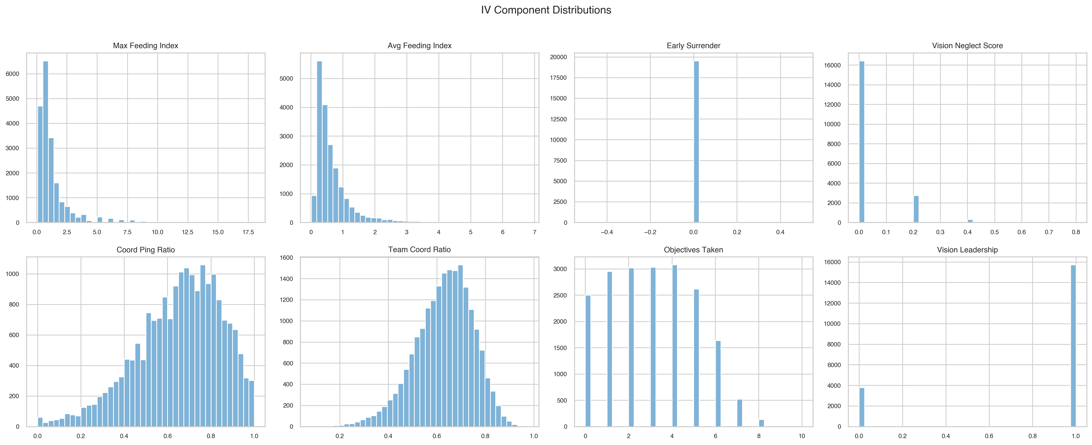
Figure 2: IV Component Distributions

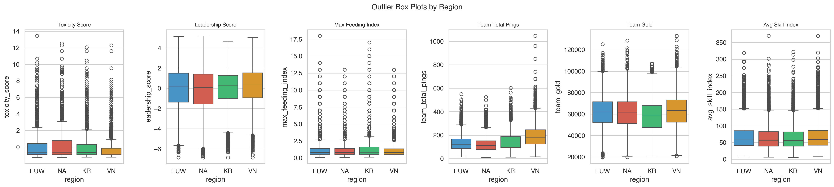
Figure 3: Outlier Box Plots by Region

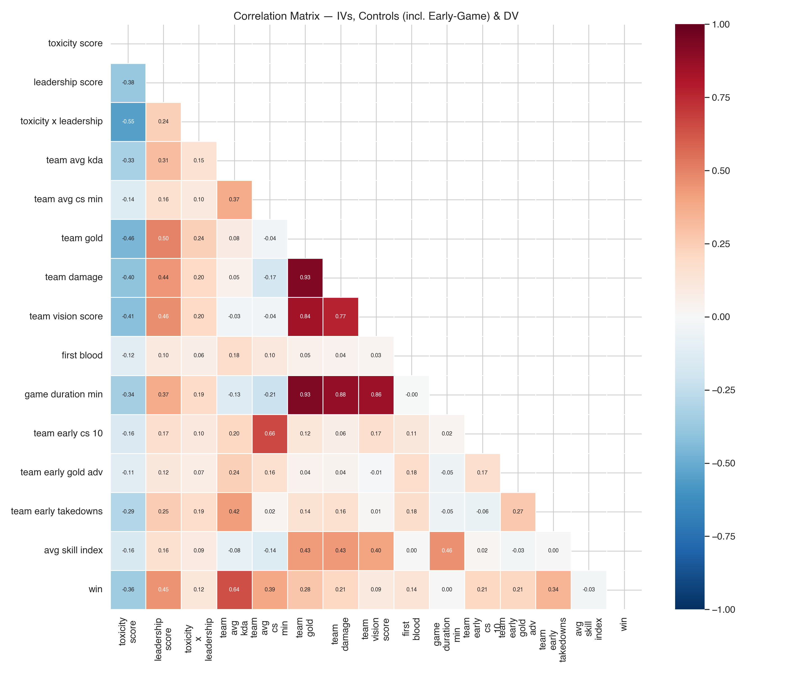
Figure 4: Correlation Matrix (IVs, Controls incl. Early-Game, DV)

Multicollinearity (VIF)
Variable | VIF
toxicity_score | 1.99
leadership_score | 1.62
toxicity_x_leadership | 1.49
team_avg_kda | 1.71
team_avg_cs_min | 2.76
team_gold | 23.31
team_damage | 8.49
team_vision_score | 4.66
first_blood | 1.07
game_duration_min | 19.32
team_early_cs_10 | 2.03
team_early_gold_adv | 1.15
team_early_takedowns | 1.75
avg_skill_index | 1.28
Table 2: Variance Inflation Factors
Note: team_gold and game_duration_min show elevated VIFs (>10), which is expected since longer games produce more gold. The key IVs (toxicity_score, leadership_score) have VIFs below 2.0, indicating no problematic multicollinearity for the variables of interest. The early-game controls all have VIFs below 2.1.

6. Model Results

6.1 Baseline Model (Original Controls)
The baseline model includes the three IV composite scores, the original 7 control variables, and region dummies. This corresponds to the original analysis before Philippe's feedback.
Variable | Coefficient | Std Error | z-value | p-value | Odds Ratio | CI 2.5% | CI 97.5%
const | -10.361 | 0.8587 | -12.066 | 0.0 | 0.0 | 0.0 | 0.0002
toxicity_score | 0.0557 | 0.0543 | 1.0258 | 0.305 | 1.0573 | 0.9505 | 1.176
leadership_score | 0.2408 | 0.0333 | 7.2245 | 0.0 | 1.2723 | 1.1918 | 1.3582
toxicity_x_leadership | -0.0439 | 0.0253 | -1.7335 | 0.083 | 0.957 | 0.9106 | 1.0058
team_avg_kda | 2.9235 | 0.0947 | 30.8857 | 0.0 | 18.6068 | 15.4561 | 22.3998
team_avg_cs_min | 0.7984 | 0.1213 | 6.5805 | 0.0 | 2.222 | 1.7517 | 2.8185
team_gold | 0.0004 | 0.0 | 22.1378 | 0.0 | 1.0004 | 1.0003 | 1.0004
team_damage | 0.0 | 0.0 | -4.317 | 0.0 | 1.0 | 1.0 | 1.0
team_vision_score | -0.0116 | 0.0017 | -6.8641 | 0.0 | 0.9885 | 0.9852 | 0.9918
first_blood | -0.3498 | 0.0987 | -3.5449 | 0.0004 | 0.7048 | 0.5809 | 0.8552
game_duration_min | -0.6464 | 0.0329 | -19.6594 | 0.0 | 0.5239 | 0.4912 | 0.5588
region_KR | -0.0151 | 0.1494 | -0.101 | 0.9195 | 0.985 | 0.735 | 1.32
region_NA | 0.1274 | 0.1379 | 0.9235 | 0.3558 | 1.1358 | 0.8668 | 1.4884
region_VN | -0.0286 | 0.1378 | -0.2076 | 0.8355 | 0.9718 | 0.7417 | 1.2732
Table 3: Baseline Logistic Regression Results

6.2 Extended Model (+ Early-Game Controls + Skill Proxy)
The extended model adds the four new variables addressing reverse causality: team_early_cs_10, team_early_gold_adv, team_early_takedowns, and avg_skill_index.
Variable | Coefficient | Std Error | z-value | p-value | Odds Ratio | CI 2.5% | CI 97.5%
const | -1.8281 | 1.0529 | -1.7363 | 0.0825 | 0.1607 | 0.0204 | 1.2655
toxicity_score | 0.0748 | 0.0569 | 1.3144 | 0.1887 | 1.0777 | 0.9639 | 1.2049
leadership_score | 0.2728 | 0.0357 | 7.6339 | 0.0 | 1.3136 | 1.2248 | 1.4089
toxicity_x_leadership | -0.0212 | 0.0273 | -0.7792 | 0.4359 | 0.979 | 0.928 | 1.0327
team_avg_kda | 3.1393 | 0.1038 | 30.2477 | 0.0 | 23.0875 | 18.838 | 28.2957
team_avg_cs_min | 0.438 | 0.1563 | 2.8019 | 0.0051 | 1.5496 | 1.1407 | 2.1051
team_gold | 0.0004 | 0.0 | 23.6379 | 0.0 | 1.0004 | 1.0004 | 1.0005
team_damage | 0.0 | 0.0 | -2.0407 | 0.0413 | 1.0 | 1.0 | 1.0
team_vision_score | -0.0095 | 0.0018 | -5.2465 | 0.0 | 0.9906 | 0.987 | 0.9941
first_blood | -0.1253 | 0.1063 | -1.1794 | 0.2382 | 0.8822 | 0.7163 | 1.0865
game_duration_min | -0.871 | 0.039 | -22.3284 | 0.0 | 0.4186 | 0.3877 | 0.4518
team_early_cs_10 | -0.0117 | 0.0027 | -4.3928 | 0.0 | 0.9884 | 0.9832 | 0.9935
team_early_gold_adv | 1.3803 | 0.4361 | 3.1649 | 0.0016 | 3.9761 | 1.6913 | 9.3472
team_early_takedowns | -0.1128 | 0.0075 | -15.129 | 0.0 | 0.8933 | 0.8803 | 0.9065
avg_skill_index | -0.0026 | 0.0013 | -2.0099 | 0.0444 | 0.9974 | 0.9949 | 0.9999
region_KR | 0.1681 | 0.159 | 1.0568 | 0.2906 | 1.183 | 0.8662 | 1.6156
region_NA | 0.1001 | 0.1461 | 0.6852 | 0.4932 | 1.1053 | 0.8301 | 1.4717
region_VN | 0.139 | 0.1479 | 0.9402 | 0.3471 | 1.1492 | 0.86 | 1.5356
Table 4: Extended Logistic Regression Results

6.3 Model Comparison
Variable | Baseline_OR | Baseline_p | Baseline_CI_lo | Baseline_CI_hi | Extended_OR | Extended_p | Extended_CI_lo | Extended_CI_hi
toxicity_score | 1.0573 | 0.305 | 0.9505 | 1.176 | 1.0777 | 0.1887 | 0.9639 | 1.2049
leadership_score | 1.2723 | 0.0 | 1.1918 | 1.3582 | 1.3136 | 0.0 | 1.2248 | 1.4089
toxicity_x_leadership | 0.957 | 0.083 | 0.9106 | 1.0058 | 0.979 | 0.4359 | 0.928 | 1.0327
_model_fit
pseudo_R2 | 0.7878 |  |  |  | 0.8086
AIC | 2897.9 |  |  |  | 2625.0
BIC | 2998.5 |  |  |  | 2754.3
n | 9760.0 |  |  |  | 9760.0
Table 5: Model Comparison (Key IVs: Baseline vs Extended)

Key Findings from Model Comparison
- Toxicity Score: OR = 1.0573 (baseline, p=0.3050) vs. OR = 1.0777 (extended, p=0.1887). The effect remains non-significant in both models, suggesting that the null finding for toxicity is robust to the inclusion of early-game controls.
- Leadership Score: OR = 1.2723 (baseline, p=0.0000) vs. OR = 1.3136 (extended, p=0.0000). The leadership effect remains highly significant and slightly increases in magnitude with early-game controls, strengthening the interpretation that the association is not merely driven by game state.
- Interaction (Toxicity x Leadership): The interaction term is not significant in either model (baseline p=0.0830, extended p=0.4359).

6.4 Classification Performance
The extended model achieves strong predictive performance, though this is expected given that end-of-game statistics (gold, KDA, damage) are highly correlated with winning. The key interest is not prediction but the direction and significance of the IV coefficients after controlling for confounds.

7. Robustness Checks

7.1 Per-Region Sub-Regressions (Extended Model)
The extended model was estimated separately for each region to test whether effects are consistent across cultural and competitive contexts:
Variable | n | pseudo_R2 | toxicity_score_coef | toxicity_score_p | toxicity_score_OR | leadership_score_coef | leadership_score_p | leadership_score_OR | toxicity_x_leadership_coef | toxicity_x_leadership_p | toxicity_x_leadership_OR
EUW | 2435.0 | 0.824 | 0.0336 | 0.7729 | 1.0341 | 0.2425 | 0.0006 | 1.2744 | -0.0435 | 0.3622 | 0.9574
KR | 2427.0 | 0.8584 | 0.2713 | 0.0323 | 1.3116 | 0.2324 | 0.0137 | 1.2617 | -0.0136 | 0.8083 | 0.9865
nan | 2469.0 | 0.7782 | -0.0375 | 0.6948 | 0.9632 | 0.2743 | 0.0 | 1.3156 | -0.0119 | 0.7969 | 0.9882
VN | 2429.0 | 0.7928 | 0.0445 | 0.7301 | 1.0455 | 0.3784 | 0.0 | 1.46 | 0.0519 | 0.4975 | 1.0532
Table 6: Per-Region Robustness (Extended Model)

7.2 Close Games Only (Gold Diff < 5,000)
To further address reverse causality, we restrict the sample to close games where the final gold difference between teams was less than 5,000. This removes blowout games where the losing team's behavior is likely a consequence of the game state. If the leadership effect persists in close games, it is more plausible as an independent factor.
Variable | Coefficient | Std Error | z-value | p-value | Odds Ratio | CI 2.5% | CI 97.5%
const | 1.3728 | 1.273 | 1.0784 | 0.2809 | 3.9463 | 0.3256 | 47.8367
toxicity_score | 0.0869 | 0.0681 | 1.2752 | 0.2022 | 1.0908 | 0.9544 | 1.2466
leadership_score | 0.1473 | 0.0415 | 3.5495 | 0.0004 | 1.1587 | 1.0682 | 1.257
toxicity_x_leadership | -0.0352 | 0.0307 | -1.1442 | 0.2525 | 0.9655 | 0.909 | 1.0254
team_avg_kda | 1.9328 | 0.1201 | 16.0884 | 0.0 | 6.9091 | 5.4596 | 8.7435
team_avg_cs_min | 0.0309 | 0.1894 | 0.1632 | 0.8704 | 1.0314 | 0.7116 | 1.4949
team_gold | 0.0002 | 0.0 | 11.466 | 0.0 | 1.0002 | 1.0002 | 1.0003
team_damage | 0.0 | 0.0 | -1.1871 | 0.2352 | 1.0 | 1.0 | 1.0
team_vision_score | -0.0051 | 0.0021 | -2.4517 | 0.0142 | 0.995 | 0.9909 | 0.999
first_blood | -0.1123 | 0.125 | -0.8985 | 0.3689 | 0.8938 | 0.6996 | 1.1419
game_duration_min | -0.4861 | 0.0446 | -10.8976 | 0.0 | 0.615 | 0.5636 | 0.6712
team_early_cs_10 | -0.0104 | 0.0031 | -3.308 | 0.0009 | 0.9897 | 0.9836 | 0.9958
team_early_gold_adv | 0.0032 | 0.5188 | 0.0061 | 0.9952 | 1.0032 | 0.3629 | 2.7729
team_early_takedowns | -0.077 | 0.0087 | -8.8508 | 0.0 | 0.9259 | 0.9103 | 0.9418
avg_skill_index | -0.0008 | 0.0015 | -0.563 | 0.5734 | 0.9992 | 0.9962 | 1.0021
region_KR | -0.0198 | 0.1846 | -0.1074 | 0.9145 | 0.9804 | 0.6827 | 1.4079
region_NA | -0.1657 | 0.1704 | -0.9723 | 0.3309 | 0.8473 | 0.6067 | 1.1833
region_VN | 0.0691 | 0.177 | 0.3907 | 0.696 | 1.0716 | 0.7575 | 1.5159
Table 7: Close Games Robustness (gold diff < 5,000)

8. Visualizations
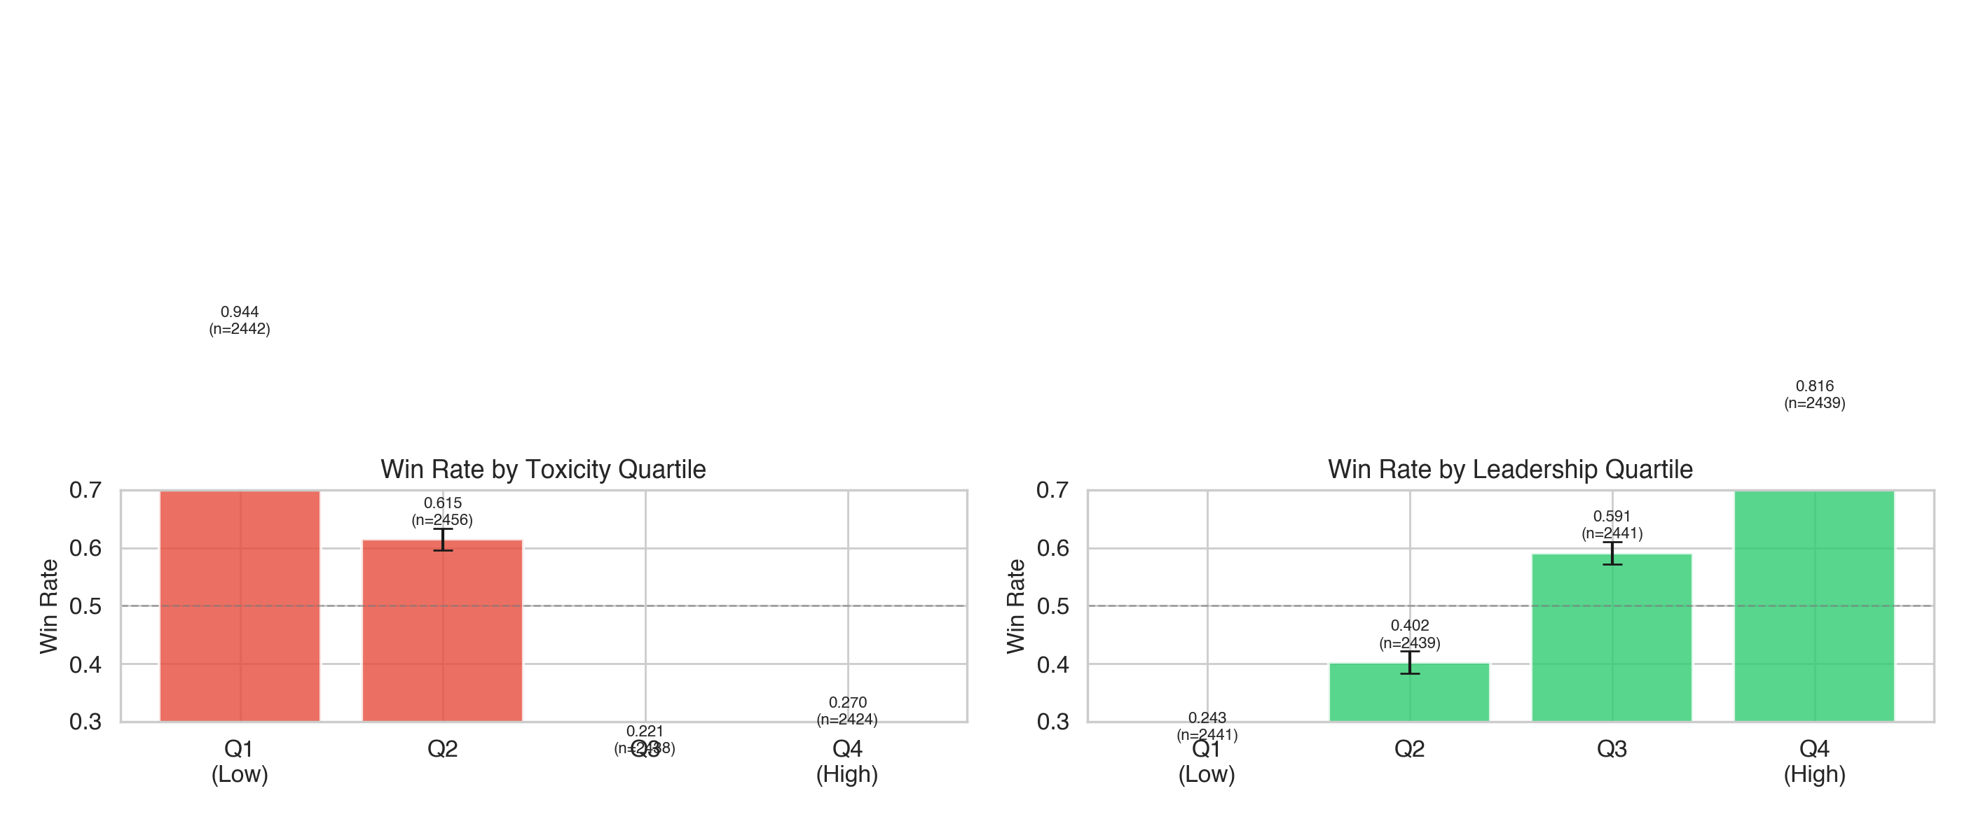
Figure 5: Win Rate by Toxicity and Leadership Quartiles

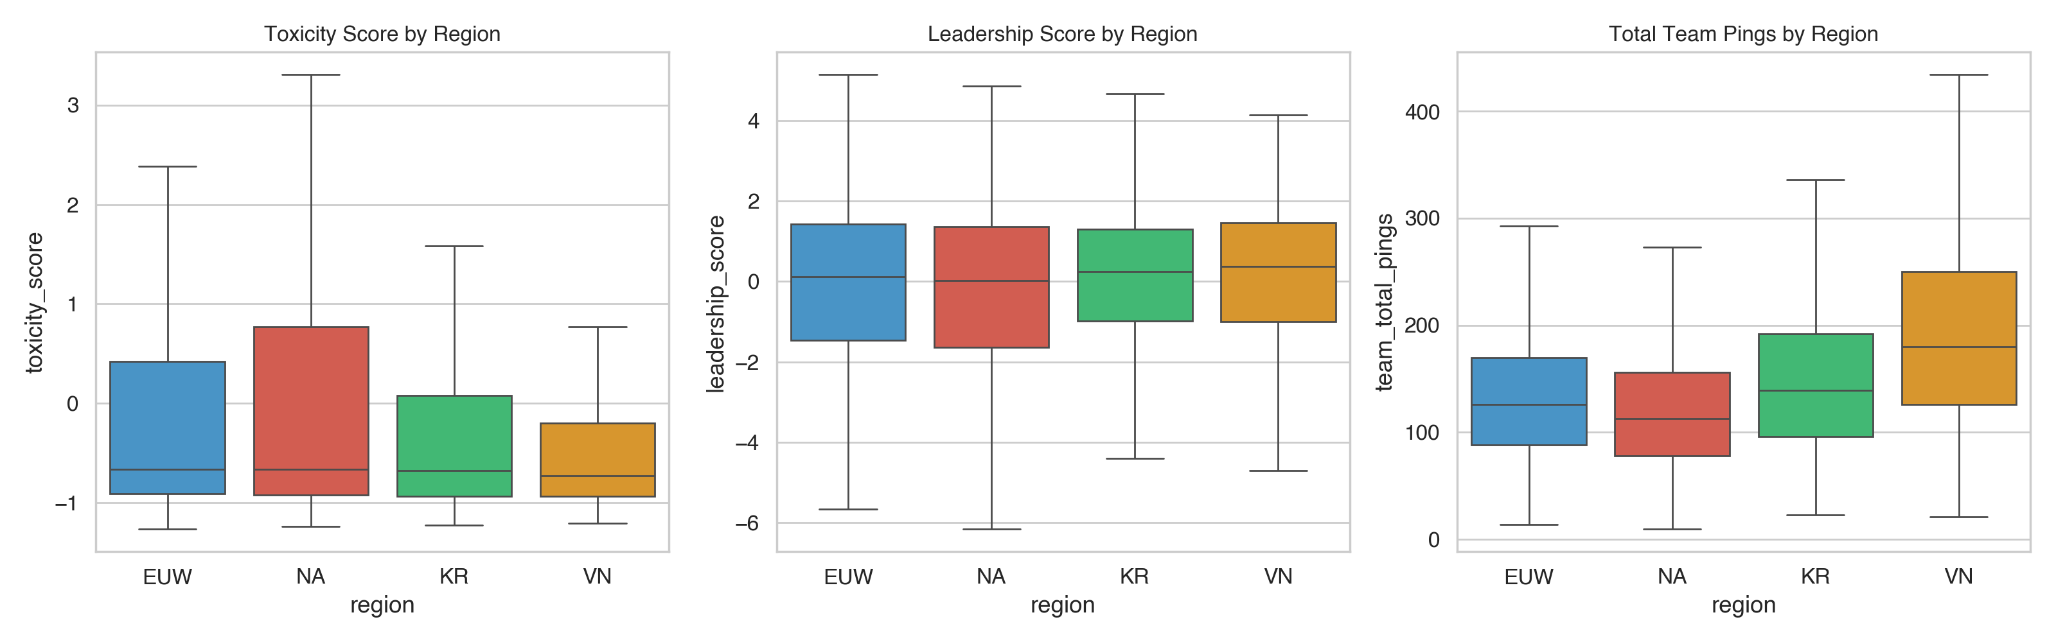
Figure 6: Regional Comparison of Toxicity, Leadership, and Pings

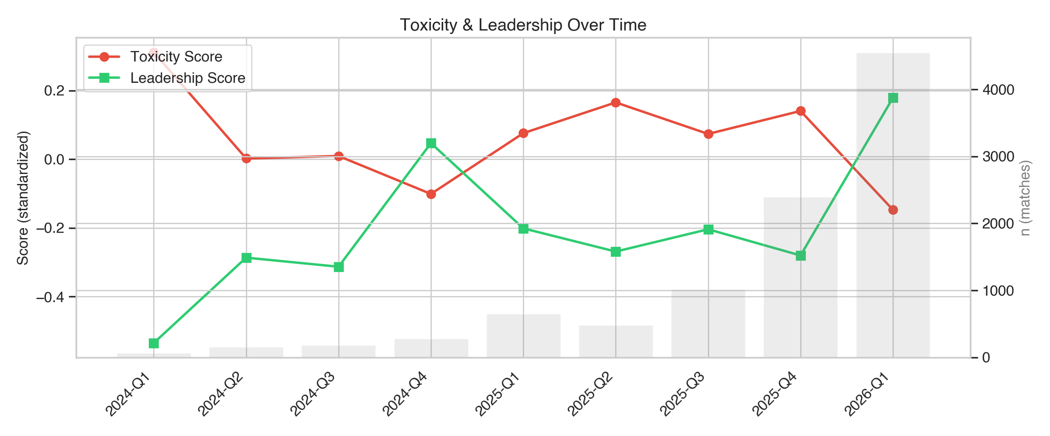
Figure 7: Quarterly Trends in Toxicity and Leadership Scores

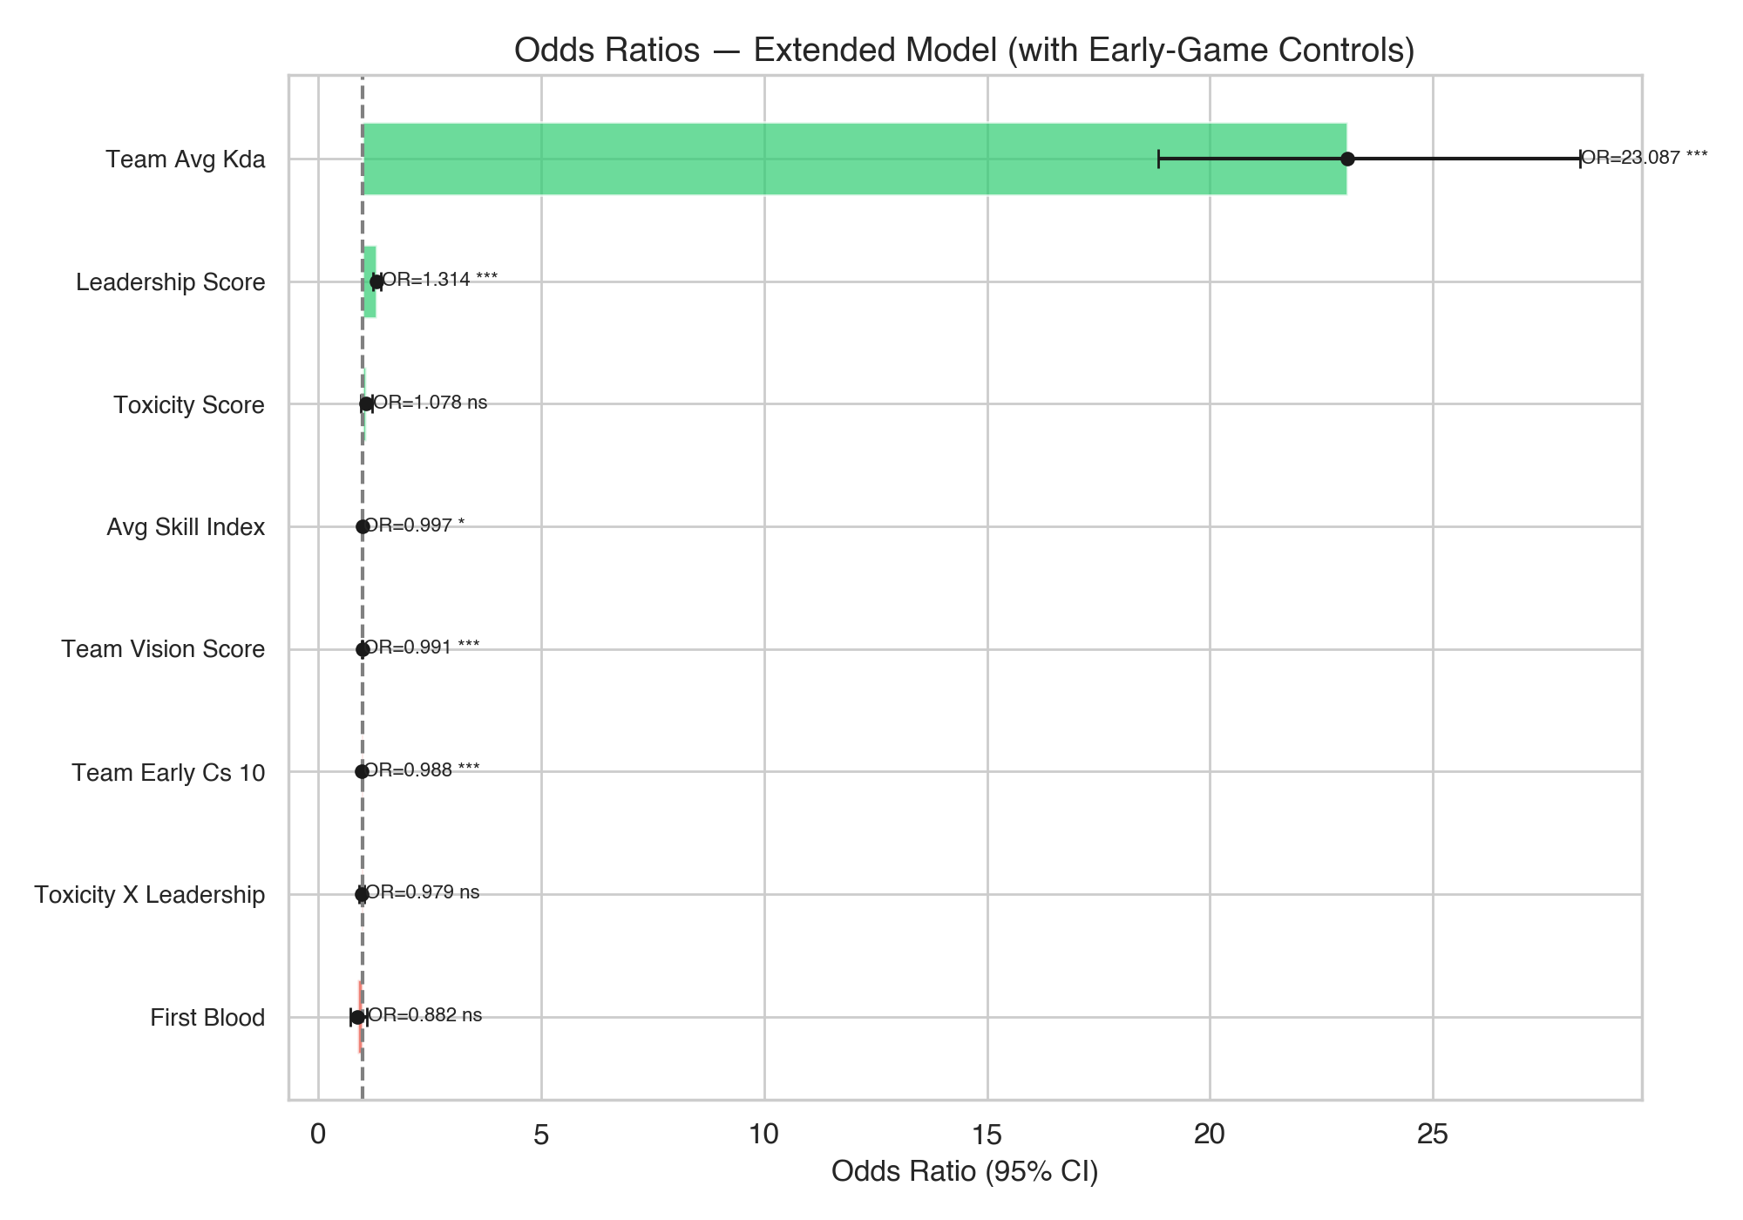
Figure 8: Odds Ratio Forest Plot (Extended Model)

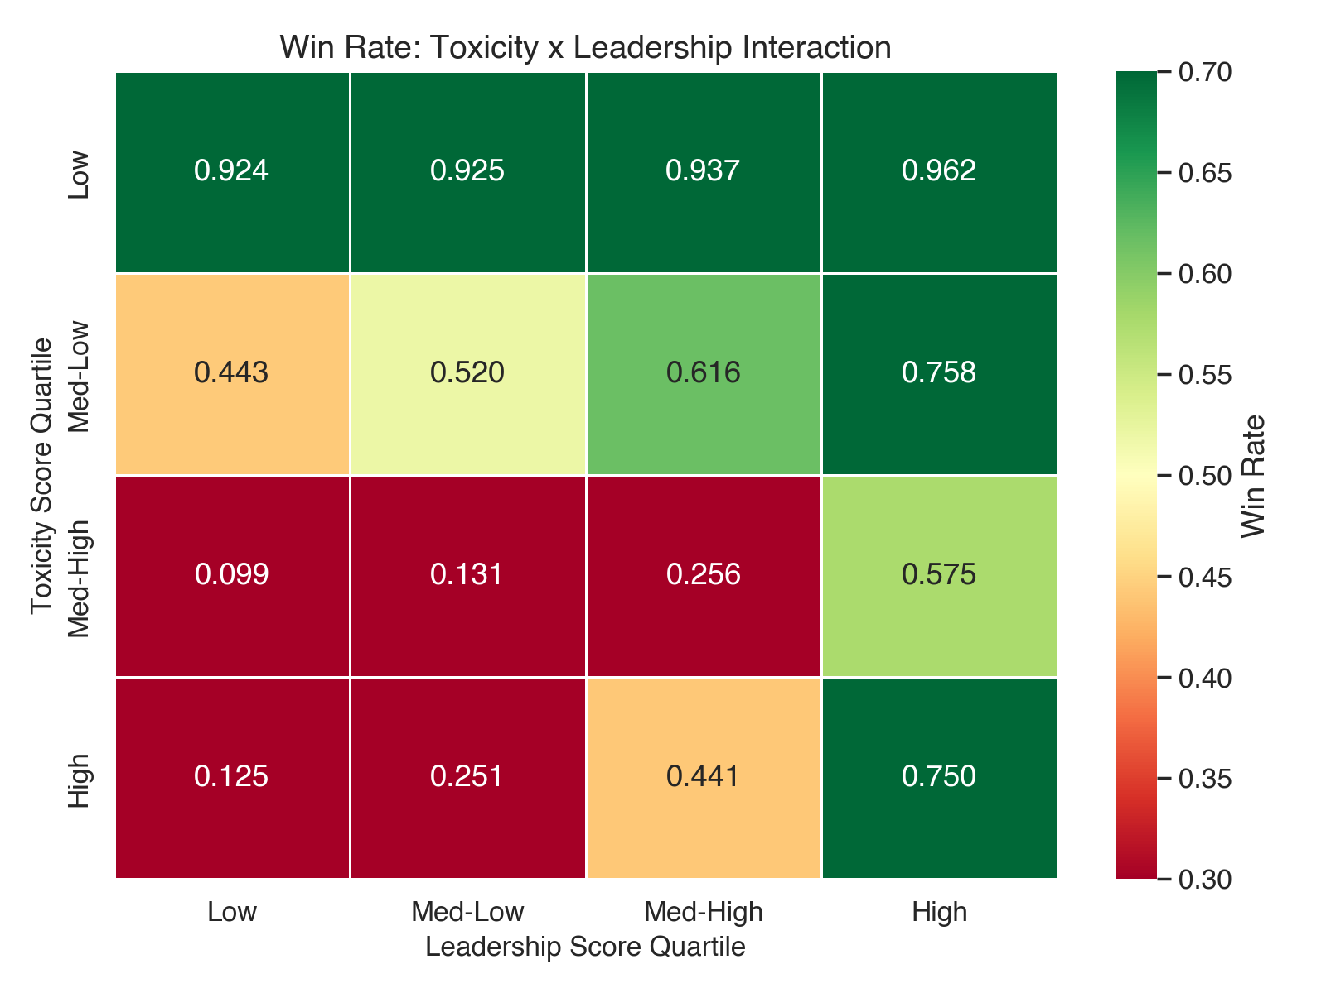
Figure 9: Toxicity x Leadership Interaction Heatmap

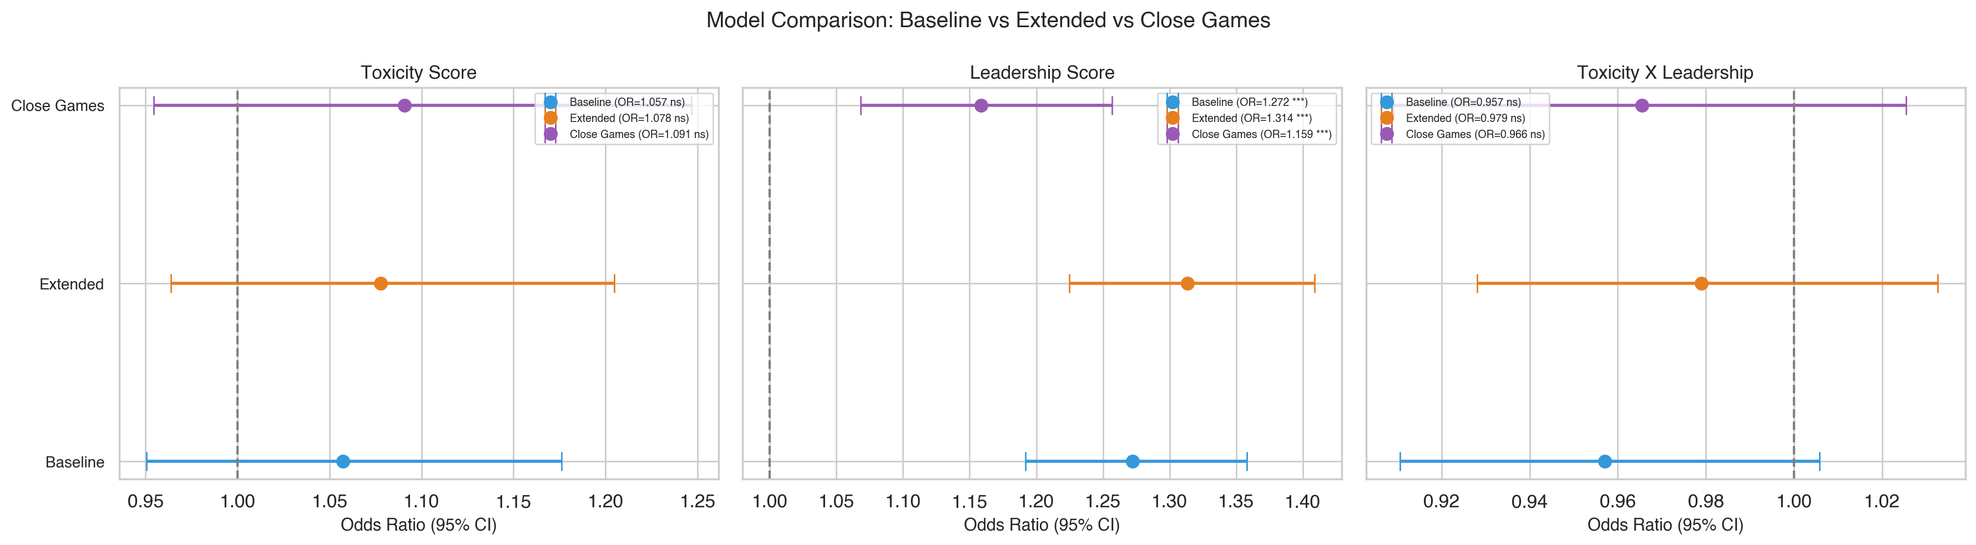
Figure 10: Model Comparison (Baseline vs Extended vs Close Games)

9. Remaining Work for Full Paper
The data collection, variable construction, and statistical analysis are complete. The following sections need to be written for the full seminar paper:

Theoretical Framework (Lazear)
Philippe's feedback specifically asks for a clear connection to Lazear's theoretical framework. The paper should explicitly state which mechanism from Lazear is being tested and how the variables operationalize it. Current theories in the README (Social Identity Theory, Transformational Leadership, Team Conflict Theory) can be kept as supplementary, but Lazear should be the primary anchor. Key question: Which specific Lazear mechanism (tournament theory, personnel economics, incentive structures) maps to our toxicity/leadership constructs?

Literature Review
Expand the current references into a full literature review covering: (a) Lazear and personnel economics in competitive settings, (b) Toxicity in online games (Kokkinakis et al. 2020, Kwak et al. 2015, Achterbosch et al. 2021), (c) Leadership and coordination in virtual teams, (d) Esports as a research context.

Methods Section
Formalize the methodology: sampling design, variable construction (use the codebook), model specification with formula, and justification for logistic regression with interaction terms. Explicitly discuss the early-game controls as a strategy for addressing endogeneity.

Results Section
Present the results in sequence: descriptive statistics, baseline model, extended model, comparison, robustness checks. All tables and figures are ready to embed.

Discussion
Interpret findings in light of Lazear's framework. Key points: (1) Leadership shows a robust positive association with winning even after early-game controls and in close games; (2) Toxicity shows no significant independent association; (3) The interaction is not significant. Discuss reverse causality limitations explicitly. Discuss practical implications for game design, team management, and esports coaching.

Limitations
Key limitations to discuss: (1) No chat data available (behavioral proxies only); (2) Cross-sectional design cannot establish causality; (3) No player-level rank/MMR data for skill control (proxy used); (4) Endogeneity mitigated but not eliminated; (5) Sample restricted to Gold-Emerald (generalizability); (6) team_gold and game_duration have high VIFs.

Appendix: File Inventory

Scripts
- Data Collection/collect_matches.py: Riot API data collection (4 regions, stratified by quarter)
- Data Collection/build_variables.py: Variable construction from raw JSONs, incl. early-game controls
- Analysis/analysis.py: Full analysis pipeline (diagnostics + baseline/extended models + robustness)
- Analysis/generate_codebook.py: Variable codebook generator
- Analysis/generate_summary.py: This summary document generator

Data Files
- Data Collection/match_dataset.csv: 19,520 rows x 53 columns (semicolon-delimited)
- Data Collection/raw_matches/: 9,760 JSON files across 4 region subdirectories
- Multi-Region Dataset/variable_codebook.xlsx: Complete variable documentation

Tables (Analysis/tables/)
- B1_descriptive_by_quarter.xlsx
- B1_descriptive_by_region.xlsx
- B1_descriptive_stats.xlsx
- B3_outliers.xlsx
- B4_correlation_matrix.xlsx
- B5_vif.xlsx
- C2_logistic_baseline.xlsx
- C2_logistic_extended.xlsx
- C2_model_comparison.xlsx
- C4_robustness_by_region.xlsx
- C5_close_games_robustness.xlsx

Figures (Analysis/figures/)
- B2_component_distributions.png
- B2_score_distributions.png
- B3_outlier_boxplots.png
- B4_correlation_heatmap.png
- D1_winrate_by_quartile.png
- D2_region_comparison.png
- D3_quarterly_trends.png
- D4_odds_ratio_forest.png
- D5_interaction_heatmap.png
- D6_model_comparison.png

