**Lab 1**

**Name: _____Jorge A. Serrano____________________________ ID#: _121260____________**

1. Copy the source code developed for Lab 1 and paste it as **text** below. (*15 points*)

Cylinder.h

#pragma once

/*

* CECS 2223, Computer Programming II Laboratory

* Fall 2022, Sec. 05

* Date: August 17, 2022

* Topic: Lab 1

* File name: Cylinder.h

* This file DECLARES a class named Cylinder

* Name: Jorge A. Serrano, ID#121260

*/

// This file contains errors, find and correct them!

// write the include statements required

#include <iostream>

// write the using declaration

using namespace std;

// The Cylinder class has two attributes, height and radius, whose values should be stored

// in a floating point variable. Declare a default constructor and the setter and getter

// methods for the field's values. All getter methods MUST be declared as constant. Declare

// a class method that computes the volume of the cylinder, named getVolume.

class Cylinder

{

private:

// declare the required fields

double height;

double radius;

public:

// declare the required methods

Cylinder();

Cylinder(double, double);

~Cylinder();

void setHeight(double);

void setRadius(double);

double getHeight() const;

double getRadius() const;

double getVolume() const;

void printCylinder();

};\

++++++++++++++++++++++++++++++++++++++++++++++++++++++++++++++++++++++++++++++++++++

Cylinder.cpp

#include "Cylinder.h"

/*

* CECS 2223, Computer Programming II Laboratory

* Fall 2022, Sec. 05

* Date: August 17, 2022

* Topic: Lab 1

* File name: Cylinder.cpp

* This file DEFINES a class named Cylinder

* Name: Jorge A. Serrano, ID#121260

*/

// write the required include statement

#include<iostream>

// Define all methods declared in Cylinder.h

Cylinder::Cylinder()

{

height = 0.0;

radius = 0.0;

}

Cylinder::Cylinder(double h,double r)

{

height = h;

radius = r;

}

Cylinder::~Cylinder()

{

cout << "Ivocando destrutendo" << endl;

}

void Cylinder::setHeight(double h)

{

height = h;

}

void Cylinder::setRadius(double r)

{

radius = r;

}

double Cylinder::getHeight() const

{

return height;

}

double Cylinder::getRadius() const

{

return radius;

}

double Cylinder::getVolume() const

{

return (3.14 * pow(getRadius(), 2)) * getHeight();

}

// The printCylinder method prints the object's field values

// and the volume in a table-ready format

// Use printf to set 10 spaces per column and a floating point

// precision of 3 digits.

// This method DOES NOT print the table's header.

void Cylinder::printCylinder()

{

//printf had %10d which doesn't return a floating point

printf("%10.3f %10.3f %10.3f", getRadius(), getHeight(), getVolume());

}

++++++++++++++++++++++++++++++++++++++++++++++++++++++++++++++++++++++++++++++++++++

labMain.cpp

/*

* CECS 2223, Computer Programming II Laboratory

* Fall 2022, Sec. 05

* Date: August 17, 2022

* Topic: Lab 1

* File name: lab01.cpp

* This file IMPLEMENTS a class named Cylinder

* Name: Jorge A. Serrano, ID#121260

*/

// write the required include statement

#include "Cylinder.h"

#include <iostream>

int main() {

// declare a Cylinder object named cyl1

Cylinder cyl1;

// assign a radius of 5.25 and a height of 10.5 to cyl1

cyl1.setRadius(5.25);

cyl1.setHeight(10.5);

// declare a Cylinder object named cyl2

Cylinder cyl2;

// assign a radius of 15.75 and a height of 5.25 to cyl2

cyl2.setRadius(15.75);

cyl2.setHeight(5.25);

// using printf, print the header for a table that will show

// all values for the objects. The header fields are "RADIUS",

// "HEIGHT", and "VOLUME", and each phrase is to be aligned to

// the left of a 10-space column.

printf("%10s %10s %10s", "RADIUS", "HEIGHT", "VOLUME"); cout<<endl;

// call the object's print method to print the values

cyl1.printCylinder(); cout << endl;

cyl2.printCylinder();

cout << endl;

// write a statement which prints the phrase

// "Program developed by [YOUR NAME], ID#[YOUR ID NUMBER]"

// where the square brackets and the text within is substituted

// with your personal information.

cout << "Program developed by Jorge A. Serrano, ID#121260";

cout << endl;

system("pause"); // For Visual Studio only!

return 0;

}

1. Paste the screenshots of the program’s execution below. (*5 points*)

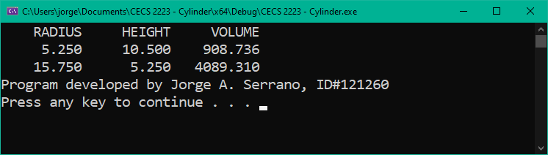

1. Comment on any warnings or errors revealed by Visual Studio. If any error messages were present, list the error and describe how you corrected it. (*5 points*)

Los errores en mi programa cconsistian en el printf. En vez de usar %10f estaba usand %10d, se me paso la diferencia entre los dos. D es para decimal point y f para floating point el cual estaba buscando.