**Lab 2**

**Name: ___Jorge A. Serrano______________________________ ID#: _121260____________**

1. Copy the source code developed for Lab 2 and paste it as **text** below. (*15 points*)

Course.h

#pragma once

/*

* CECS 2223, Computer Programming II Laboratory

* Fall 2022, Sec. 05

* Date: August 24, 2022

* Topic: Lab 2 - Parameterized constructors

* File name: Courses.h

* This file DECLARES a class named Courses

*/

#include <iostream>

using namespace std;

class Courses {

private:

string code;

string name;

int credits;

public:

//Constructors

Courses();

Courses(string);

Courses(string, string);

Courses(string, string, int);

//Method

void setCode(string);

void setName(string);

void setCredits(int);

string getCode() const;

string getName() const;

int getCredits() const;

void printCourse();

};

++++++++++++++++++++++++++++++++++++++++++++++++++++++++++++++++++++++++++++++++++++

Courses.cpp

#include <iostream>

using namespace std;

/*

* CECS 2223, Computer Programming II Laboratory

* Fall 2022, Sec. 05

* Date: August 24, 2022

* Topic: Lab 2 - Parameterized constructors

* File name: Courses.cpp

* This file DEFINES the class named Courses

* Complete the code as required.

*/

#include "Courses.h"

// Defines the constructors and class methods

Courses::Courses()

{

code="";

name = "";

credits = -1;

}

Courses::Courses(string c)

{

code = c;

name = "";

credits = -1;

}

Courses::Courses(string c, string n)

{

code = c;

name = n;

credits = -1;

}

Courses::Courses(string c, string n, int cre)

{

code = c;

name = n;

credits = cre;

}

void Courses::setCode(string aCode)

{

code = aCode;

}

void Courses::setName(string aName)

{

name = aName;

}

void Courses::setCredits(int c)

{

credits = c;

}

string Courses::getCode() const

{

return code;

}

string Courses::getName() const

{

return name;

}

int Courses::getCredits() const

{

return credits;

}

// The printCourse method print the data for a course

// in a table ready format. The data to be printed is

// course code, course name, and credits. The information

// must be printed in a single line, make sure to add

// the line termination instruction.

// This method DOES NOT print the table header

void Courses::printCourse()

{

//CODE, NAME, CREDITS

printf("%-10s%-10s%-11d\n", getCode().c_str(), getName().c_str(), getCredits());

}

++++++++++++++++++++++++++++++++++++++++++++++++++++++++++++++++++++++++++++++++++++

lab2Main.cpp

#include "Courses.h"

#include <iostream>

using namespace std;

/*

* CECS 2223, Computer Programming II Laboratory

* Fall 2022, Sec. 05

* Date: August 24, 2022

* Topic: Lab 2 - Parameterized constructors

* File name: lab02.cpp

* This file IMPLEMENTS a class named Courses

* Complete the code as required.

*/

int main() //++++++++++++++++++++++++++++++++++++++++++++++++ When Asking for "Methods" within the instructions, use the "Mutators" that are in the headers.

{//++++++++++++++++++++++++++++++++++++++++++++++++++++++++++ When saking for "Constructors" use the constructers inside the header.

// declare a Courses object named compe0 using the

// default constructor. Then use the appropriate methods

// to assign Computer Programming Fundamentals to the name,

// CECS 2200 as the code, and 1 for the credits.

Courses compe0;

compe0.setName("Computer Programming Fundamentals\t");

compe0.setCode("CECS 2200");

compe0.setCredits(1);

// declare a Courses object named compe1 using the one

// parameter constructor, and CECS 2202 as argument.

// Then use the appropriate methods to assign Computer

// Programming I to the name, and 4 for the credits.

Courses compe1("CECS 2202","Programming I\t\t\t\t");

compe1.setCredits(4);

// declare a Courses object named compe1lab using the two

// parameter constructor, and CECS 2203 and Computer

// Programming I Laboratory as arguments. Then use the

// appropriate methods to assign 0 for the credits.

Courses compe1lab("CECS 2203", "Computer Programming I Laboratory\t");

compe1lab.setCredits(0);

// declare a Courses object named compe2 using the three

// parameter constructor, and CECS 222 and Computer

// Programming II, and 4 as arguments.

Courses compe2("CECS 2202", "Computer Programming II\t\t", 4);

// Write the header for the table using the following strings:

// CODE, NAME, CREDITS

printf("%-10s%-10s%-10s\n", "CODE", "NAME", "CREDITS");

// call the print method from each of the objects to print each

// course's information.

compe0.printCourse();

compe1.printCourse();

compe1lab.printCourse();

compe2.printCourse();

cout << endl;

// write a statement which prints the phrase

// "Program developed by [YOUR NAME], ID#[YOUR ID NUMBER]"

// where the square brackets and the text within is substituted

// with your personal information.

cout << "Program developed by Jorge A. Serrano, ID#121260" << endl;

cout << endl;

system("pause"); // For Visual Studio use only

return 0;

}

1. Paste the screenshots of the program’s execution below. (*5 points*)

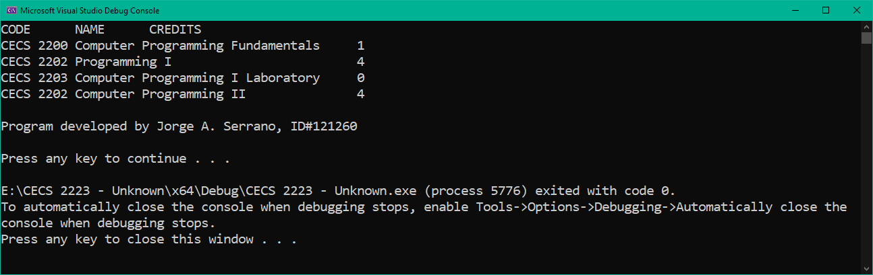

1. Comment on any warnings or errors revealed by Visual Studio. If any error messages were present, list the error and describe how you corrected it. (*5 points*)

The errors that I found were within void Courses::printCourse(). The program would print out some uncommon and/or unused characters instead of the code and names that were supposed to print in the command prompt. Afterwards I found out that I didn’t include the .c_str() function, after doing so my program ran smoothly.