Dictionary Application

(Uses a tree data structure)

Name**: Gian S. Ypil** Year & Section: **BSIT 2B**

**Introduce what is it**

-This is a console-based dictionary application. It allows users to quickly search for the definition of words using simple text commands.

**Describe what it can do**

-It allows users to save frequently used words for future references. And look up word definitions. Also, display words and definitions.

**Why did you make that kind of application and how does it contribute to you or to the community?**

-I made this application to help people especially for the students like me to improve their vocabulary easily. Many learners struggle to find reliable and tools for word meanings, especially without an internet access. This application helps individuals enhances their communication skills by learning new words. For the community, it promotes supports education, especially for those who prefer distraction-free tools.

Here’s the screenshot:

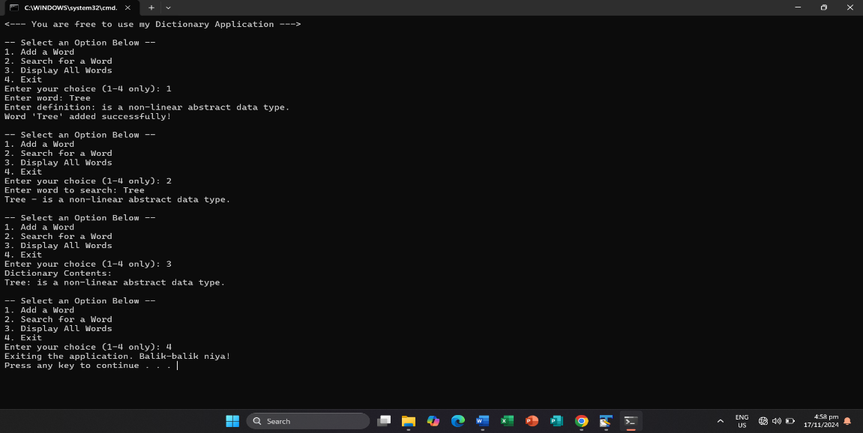

GitHub Username: **Gianzkie30**